Performance
- How fast a system responds
- It is measured relative to
  - workload (request volume or data volume)
  - hardware (capacity)

What is performance problem?
- Queue of request building somewhere
  - Network socket queue
  - OS run queue
  - Db IO queue
Causes of performance issues
- Slow processing of request compared to what resource capacity allows (UNDERPERFORMANCE)
- Resource capacity limited(resources are not enough compared to work load but system is using all it got)
- Serial resource access (lacking concurrent or parallel processing)

Performance Principles
- Efficiency
  - Efficient use of resources (CPU and memory)
  - Efficient algorithms
  - Efficient data storage
- Concurrency
  - Hardware should allow for concurrency
  - Software needs to be developed to run concurrency
- Capacity

Object of a system to perform better?
- Minimize request response latency
- Maximize throughput

Latency
- Time taken to respond to a request
- Latency = wait time for request to start processing + Processing time
Throughout
- Rate of request processing. How much we can process in a second
- Depends on
  - Latency (minimize it)
  - CAPACITY (maximize it)

Performance Metrics
- Throughout (maximize). More users supported
- Latency (minimize). Relevant for live systems.
- Resource utilization – CPU and memory
  - low means wasted resource,
  - high means saturation,
  - ideal is middle
- Errors (ideally None)

Tail Latency
- Slowest response time of a system
- It is indication of queuing of requests (requests are forced to wait before processing even starts)

Network Latency
- Data Transfer: latency when data is moved over in wires
- TCP connection: requests sent for connection to server and acknowledgements by server take time
- SSL/TLS connection: sits on top of TCP to secure the data transfer. Overhead for connection adds to latency

Minimizing Network Latency
- Data Transfer:
  - Reduce size of data with compression. Compression may increase overhead
  - cache information to reduce data transfer
  - Use binary formatted data to transfer. Google grpc protocol has less latency due to binary format
- Connections: Connections between server and browser can be saved in a pool for future use instead of creating new connections. Same for ssl connnections where server can save information exchanged when last connection was setup.

Memory Latency
- Finite Heap memory – sits on RAM
  - Condition where heap memory is filled
  - Program specific
  - Garbage collectors act to reduce heap memory but it ends up slowing application adding memory latency
- Large Heap memory
  - Condition where heap memory is large with more objects
  - Garbage collector scans more objects and algorithms runs slow due to sheer size of heap
- Database Buffer memory
  - Frequently accessed info is cached in buffer memory
  - Sits on Ram
- Garbage collector algorithms
  - Some of them are slower than others
  - Generational Garbage collector

Minimizing memory latency
- Avoid memory bloat
  - Memory bloat: excessive memory use due to inefficient allocation, memory leaks, aggressive caching(without eviction policy)
- Weak/Soft reference
  - Memory allocations that can be cleaned by garbage collector if memory is close to full
  - Programmer defines references to be weak in Java
- Smaller processes
  - Break batch processes onto smaller processes with worker nodes. Each process takes less memory, and quicker GC cycles.
- Pick good Garbage collector
  - G1 garbage collector divides heap into smaller regions (young objects, old objects, free space) and focuses collection region wise. It is fast as collection localized to region
  - Generation garbage collector: divides collections into y
    - Young objects: newly created objects are often frequently looked upon
    - Old objects: they have survived collection attempts so they are important and hence less frequently accessed for collection
- Normalization of databases
  - Reduces duplication and hence less memory and less latency
- Compute Over Cost
  - Compute info on top of raw data instead of storing computation in memory

Disk Latency
- Faced where disk is accessed.
- Hard Disk Drive has moving parts that delay data access
  - Database query is sent to disk if not stored in RAM, leading to disk latency
  - Serving web content files like CSS are accessed from disk

Minimizing Disk Latency
- Sequential IO
  - IO in an order from start to end. Like reading a book
  - Faster than random io because HDD head moves in one direction
  - Random io: HDD head jumps around on disk in diff directions leading to time waste
- Batch IO
  - Write or read many files all at once
  - Reduces context switching between io and other tasks
- Asynchronous Logging
  - Delicate IO work to child process
  - Reduces load on parent process
- Cache
  - Store web content like css in cache. Reverse proxy(nginx)
- Zero Copy
  - Copy data from disk to kernel and then to network
  - Eliminates copying data to user space before being sent over network
- Schema Optimization
  - Denormalization of databases
    - Keep all data in one table instead of 10 tables
    - Reduces jumping around tables to find information and hence reduces disk latency
    - But increases memory latency
  - Indexing
    - Instead of full table scan, map values in XYZ column to row id where they are found
    - Column id has values [“hari”, “alex”, “xay”]. We can map “hari” id to row 1 which means information about “hari” is in row 1
    - Reduces disk latency from millions of scans to few.
- Raids (Redundant Array Of Independent Disks)
  - several physical disks are grouped under a logical unit
  - Parallelize data access across disks
    - Faster performance
    - Fault tolerant

CPU Latency
- Inefficient algorithms
- Context Switching
  - Switch time between process 1 and process 2
  - As process 1 is pending, its state is saved in memory. Process 2 is loaded into CPU from memory
  - This loading onto CPU and eviction from CPU takes time.
Minimizing CPU latency
- Batch/Async IO
  - reduces context switching because we process all at once
  - Use separate thread with async io for logging to reduce load on main thread
- Single Threaded Model
  - One main thread so no context switch
  - Main thread delegates tasks to worker threads who run asynch and do not block main thread
  - Main thread can handle more request while background IO workers do work
  - Node.js is built on it
- Thread Pool Size: keep small
- Processes in dedicated Virtual Environment
  - Run each process in their own environment with fixed CPU/memory
  - Prevents processes exhausting CPU resource for other processes

Concurrent Processing
Amdahl’s Law
- Models how speed is affected by portion of parallel processing vs serial in a concurrent system.
- Speed = scaling dimension / (1 + alpha(scaling dimension – 1))
  - Where scaling dimension: cores/cpu/processors used
  - Alpha: serial portion of the process
- Serial processing: one by one
  - If 1 core takes 1 second to process, 3 cores would still take 1 second to process. Because it is serial system. Adding more cores does not help.
- Parallel Processing: many tasks at once
  - In PERFECT PARALLEL SYSTEM, each new core added increases throughput or speed linearly.
  - 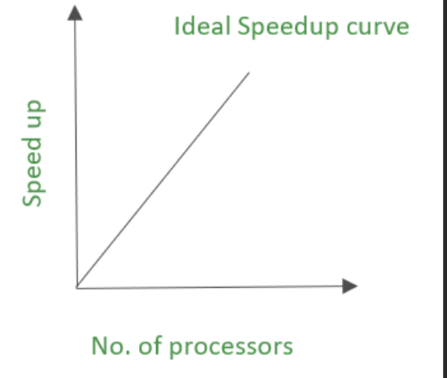
- Real concurrent systems are MIX of serial and concurrent processing.
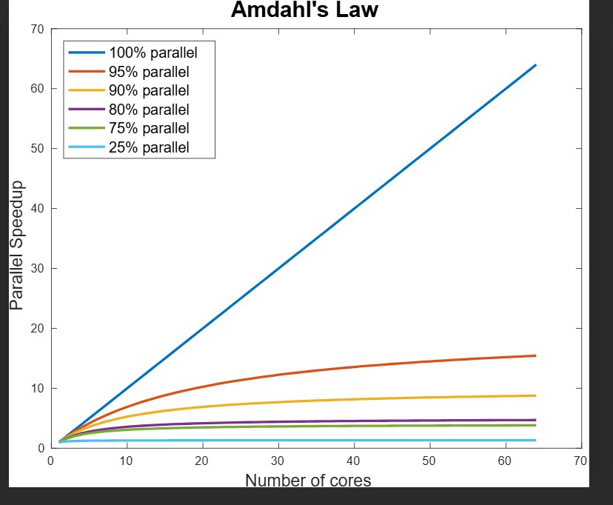
As we increase serial portion and reduce concurrent, speed increase slows as you see curves

Gunther’s Universal Scalability Law
- scaling dimension / (1 + alpha(scaling dimension – 1) + coherence delay*scaling dimension (scaling dimension - 1)
- It retains speed formula from amdahl’s law where queuing(serialization) leads to slow down and extends the formula to consider coherence (slows down process further)
- Coherence
  - when multiple cores/threads share a variable and synchronization is needed between cores.
  - It introduces delay that get worse with more cores
  - Overall throughout can decrease after some point if cores increased.
  - THIS LAW of coherence AFFECTED ME IN INTERNSHIP PROJECT. I SAW TIME TAKEN TO FINISH INCREASE AFTER I ADDED MANY MANY THREADS.
SHARED resource Contention (what slows concurrent system)
- Locks
  - Biggest source of slow down
  - Acquiring them involves waiting, building queue
- Listen/accept
  - Queue builds up at time to establishing connection
- Thread pool
  - Limited number of threads to handle request builds queue
- Connection pool
  - Limited number of available connections with backend or database builds queue
- CPU/DISK/cores
  - Limited scaling dimension leads to waiting

Minimizing shared resource dimension
CPU/DISK/CORE
- Vertically scale servers/cpu
- RAID disk: parallel redundant disk allow more threads to work at same time
Threadpool
- High threadpool slows down cpu(context switching)
- Low threadpool means very few request are processed
- Strive for right balance
Connection pool
- Same size as threadpool because each thread in threadpool would want one connection to make services to backend.
Locking
- Reduce duration of lock and scope if possible,
- Lock split: Split locks into smaller granularity in codebase
- Lock striping: Split lock into smaller lock for each portion of data
  - Concurrent hashmap has small buckets
  - Buckets grouped into partition and each partition has a lock
- Designate some locks for reading while others for writing

Pessimistic Locking
- Pessimistic means negative mindset. This locking assumes that conflict will happen(negative mindset). Hence, it locks the data ALWAYS before updating.
- Locks held for long duration.
- Use case: when high contention(usage)
Optimistic Locking
- More of a conditional write
- Optimism means positive. This locking assumes less conflict and low content.
- Reads the data (and a version number or timestamp).
- Updates the data only if the version hasn’t changed since the read.
- If the version has changed → abort/retry (because someone else updated it first)
- computation.
- If condition fails retry
- Lock acquired for shorter duration
- COMPARE AND SWAP mechanism: type of optimistic
  - Implemented in java with function compareandset(value_at_read, value_to_write)
Deadlock
- Two or more threads waiting for others to release locks to shared resources. No one leaves locks so there is infinite waiting.
- Mitigation
  - Acquire locks in global order. Get resource A then resource B and then resource C.
- Requests with multiple services in microservices can lead to deadlock if a particular service is used at more than one occasion for each request.

Coherence Delay
- Delay due to ensuring two or more threads have shared memory that is consistent for all threads and their caches
- If thread A modifies a variable in shared memory, there is some delay as thread B have to get rid of cached value and read from shared memory
- Two kinds of coherence mechanisms
  - Synchronized locking
    - Form of pessimistic locking with synchronization to ensure consistency
    - Lock the memory
    - Modify
    - Unlock
    - All other threads wait and then see modified state
    - Slow
  - Volatile variables
    - No locking hence faster
    - It forces code to always read value for variable from main memory and update in shared main memory, hence ensuring consistency without locking.
    - Race condition can happen as operations are NOT atomic
Cache
Temporary storage layer that holds frequently accessed data to speed up data fetch
- Object Cache
  - Sits between service and database
  - Stores frequently queried data objects
  - Not specific to a user
  - Dynamic in nature
  - Example: Product data like Iphone 16
- Session Cache
  - Similar to object cache but user specific
  - Dynamic in nature
  - Examples: login tokens, shopping cart chosen items
- Static Data Cache(aka reverse proxy cache)
  - Sits at load balancer level/server level
  - Example: Static files stored like CSS, JS, company about section
  - Service: CloudFront
  - Same cache for all users. Not user specific.
- HTTP Cache(browser cache)
  - Sits at http request level where if a page is accessed frequently, a new request avoid http request and browser stores and returns output.
  - Caches entire http response
  - Idempotent methods like GET are good for caching
  - Example: Browser Cache
Proxy Server Cache
- It gets hit before user reaches internet
- In corporations, companies cache your request responses from internet in proxy server cache and new request by other company employees get directed to same cache
Reverse Proxy Cache
- Sits right before actual backend server
- Example: CloudFront service.
- Kind of static data cache
- Librarian standing in front of library, handing out photocopies of popular books, so main library staff are not overloaded.

HTTP CACHE
HTTP has methods for cache configurations. SERVER assigns cache headers.
- Cache-control header
  - No-store: Do not cache at all
  - No-cache = response must be validated with original server before serving ALWAYS. Allowed to cache. Prevents data transfer if ETAG has not changed.
  - Must-revalidate = response must be validated ONLY AFTER its max-age
  - Public: response can be stored in any cache layer including proxy and reverse proxy
  - Private: Response be stored only in user cache but not in shared cache. Store in browser. Local storage and cookies.
  - Max-age: max age of a resource in cache relative to response time. I can use this cached HTTP response for X seconds without checking the server
  - Entity Tag(ETAG): hash code for indicating version of resource. When in must-revalidate or no-cache, resource is pulled from server to validate resource has not changed. ETAG helps version and compare.

Caching Dynamic Data
Exclusive Cache in DISTRIBUTED SYSTEMS
- Each node/server caches only data it is responsible for
- Multiple nodes all have their own cache
- Low latency but high duplication among diff caches on diff servers.
- We can set rules to ensure same user gets to same server to prevent cache duplication but draw back load balancing benefits are lost.
- Use CASE: small datasets
Shared Cache in DISTRIBUTED SYSTEMS
- Same cache for all nodes/servers
- Higher latency due to extra hop
- No duplication of data In cache
- Scalable with distributed cache like Redis/memcache
- Can lead to contention
- USE CASE: Large datasets

Cache Challenges
- Spacing
  - Limited cache space leading to early evictions
  - Keep cache objects as small as possible
  - Cache Hit ratio = number of cache hits / total requests
    - Should be high ideally
- Cache Invalidation and inconsistency
  - Cache value can get stale if actual value In database or server side has changed
  - Two methods to handle
    - WRITE-THOUGH CACHE. Every time the source (database) is updated, the cache is updated immediately so that it always reflects the latest value. Limitation is cache must be in system.
    - TTL: used to remove aged data. It is expiration date of cache data.
      - High time to live (TTL) means high cache hits
      - Tough to come up with correct TTL threshold value

