If you run into problems you can visit:
https://github.com/cloudydevops/devopsbuddy
Email:
e-learning@devopsfolks.com
Google group:
https://groups.google.com/a/devopsfolks.com/forum/#!forum/e-learning
AWS setup:
In the AWS console, create an IAM group ‘developers’ with policies AmazonS3FullAccess and AmazonEC2FullAccess.
In IAM, create a user ‘devopsbuddy’ and add it to group developers created in above step.
Install AWS client. You can visit amazon documentation for installing AWS client.
Run the Windows PowerShell as an administrator and type the following command:
Install_Module –Name AWSPowerShell
Then type the command
aws configure - -profile devopsbuddy
Then enter Amazon access key, Amazon secret access key id and default region.
aws configure - -profile <user name>
aws configure --profile devopsbuddy
S3
Create a bucket named ‘anandzaveri-devopsbuddy’
After that aws cli command
Aws s3 ls - -profile <user name>
aws s3 ls - -profile devopsbuddy
Output will be the name of bucket
Output-> 2018-12-31 12:58:43 anandzaveri-devopsbuddy
Value of root bucket url is like :
https://anandzaveri-devopsbuddy.s3.amazonaws.com/anandzaveri-devopsbuddy
Exception while putting image in s3 bucket.
com.amazonaws.services.s3.model.AmazonS3Exception: Access Denied (Service: Amazon S3; Status Code: 403; Error Code: AccessDenied; Request ID: F748EF7B82D13044; S3 Extended Request ID: 9tABaugx1jrzvZS4rLu3/HhN3gmiqewOMUxXeVoxYVu7KDzwy+XkkaPNz0REsU5rXGFTUx5z05k=)
Solution>
To resolve this error, change the bucket permissions.
Then it worked.
AWS architecture diagram

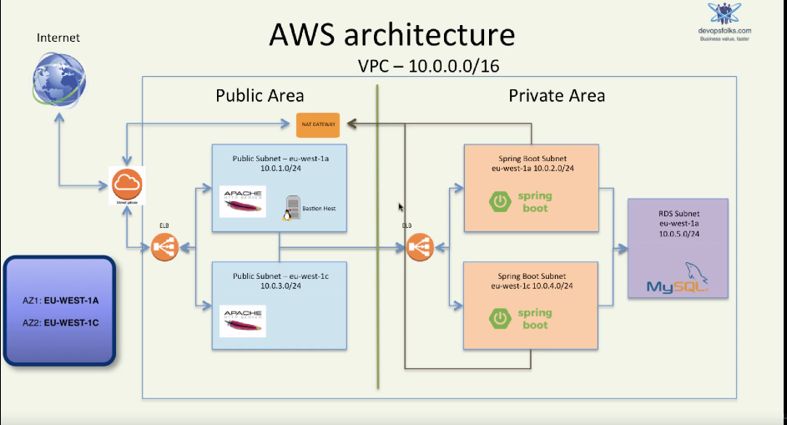
2 AZs
2 subnets in each AZ for web server and spring boot application. 1 private subnet for mysql db.
2 bastion hosts in each public subnet to do ssh to spring boot application.
NAT gateway is connected to private subnets which allows internet access from out to spring boot application but not the other way around.
Setting up VPC
We will use 2 AZs viz. eu-west-1a and eu-west-1c.
Create an elastic IP address which will be used for NAT gateway.
Note: if elastic ip address is not associated with any component, you will incur charges for EIP.
NAT gateway is a chargeable service per hour. Very cheap.
Create a new VPC with public and private VPCs. VPC IP CIDR block is 10.0.0.0/16
For this CIDR block, total IP address available are : 2^32 is the block. 32 -16 = 16. So 2^16 = 65536.
5 addresses will be reserved by AWS. So final count 65536 - 5 = 65531.
VPC name = devopsbuddy
Public subnet: 10.0.1.0/24 Private subnet: 10.0.2.0/24
AZ: eu-west-1a AZ: eu-west-1a
Name: public-subnet-eu-west-1a Name: Spring Boot subnet - eu-west-1a
Select the EIP created earlier.
Select Public and private subnets in field ‘Add endpoints for S3 to your subnets’ with policy as ‘Full Access’.
Click on create VPC button. VPC ‘devopsbuddy’ will be created.
Click on Subnets to create additional subnets.
Public subnet: 10.0.3.0/24 Private subnet: 10.0.4.0/24
AZ: eu-west-1c AZ: eu-west-1c
Name: public-subnet-eu-west-1c Name: Spring Boot subnet - eu-west-1c
VPC: devopsbuddy VPC: devopsbuddy

Private subnet: 10.0.5.0/24
AZ: eu-west-1a
Name: RDS subnet - eu-west-1a
VPC: devopsbuddy
Go to Public subnet eu-west-1a (this was the default public subnet of VPC)-> Route table
Route table:
Destination Target
10.0.0.0/16 local
Pl-kkfjdk004 (com.amazonaws.eu-west-1.s3) vpce-ckjdkfj3d
0.0.0.0/0 igw-kjdkfsdjr3e
In this table a link to public Route table is available. Click on that. It will show Route Table for Public subnets.
Click on Subnet Associations tab and associate all public subnets here by clicking on Edit.
Associate the other public subnet in this route table.
Similarly go to private subnet ‘Spring Boot subnet – eu-west-1a’ (this was the default private subnet of VPC) -> Route table
Destination Target
10.0.0.0/16 local
Pl-kkfjdk004 (com.amazonaws.eu-west-1.s3) vpce-ckjdkfj3d
0.0.0.0/0 nat-0fdkjkjkjdfbe
In this table a link to private Route table is available. Click on that. It will show Route Table for Private subnets.
Click on Subnet Associations tab and associate all private subnets here by clicking on Edit.
Associate the other private subnet ‘Spring Boot subnet – eu-west-1c’ in this route table and the RDS one called ‘RDS subnet - eu-west-1a’

Now we need to setup Security Groups. They act as firewall at server level.
Public security group Private security group
Name tag: Public SG Name tag: Spring Boot SG
Group name: Public SG Group name: Spring Boot SG
Description: Public SG Description: Spring Boot SG
VPC: devopsbuddy VPC: devopsbuddy
Public security group Private security group
Name tag: Bastion Host SG Name tag: RDS SG
Group name: Bastion Host SG Group name: RDS SG
Description: Bastion Host SG Description: RDS SG
VPC: devopsbuddy VPC: devopsbuddy
So in this VPC, there are 5 SGs, one default and other 4 are mentioned above.
In RDS SG, create following inbound rules. In RDS we will allow traffic only from Spring Boot server.
Nothing else can access RDS MySQL database.
This means that traffic from all the boxes included in Spring Boot SG will be allowed in by RDS database.
Inbound Rules
Type Protocol Port Range Source
MySQL/Aurora(3306) TCP(6) 3306 sg-dkfjkd(Spring Boot SG)
In Spring Boot SG, create following inbound rules.
Inbound Rules
Type Protocol Port Range Source
HTTP(8080) TCP(6) 8080 sg-ddfgfjkd(Public SG)
SSH(22) TCP(6) 22 sg-dkkgdkd(Bastion Host SG)

In Public SG, create following inbound rules.
Inbound Rules
Type Protocol Port Range Source
HTTP(80) TCP(6) 80 0.0.0.0/0 (here it indicates traffic from anywhere)
HTTPS(443) TCP(6) 443 0.0.0.0/0 (here it indicates traffic from anywhere)
SSH(22) TCP(6) 22 81.132.44.198/32 (IP address of my machine which uses AWS console)
In Bastion Host SG, create following inbound rules.
Inbound Rules
Type Protocol Port Range Source
SSH(22) TCP(6) 22 81.132.44.198/32 (IP address of my machine which uses AWS console)

