master-spring-boot-microservices-with-cqrs-event-sourcing

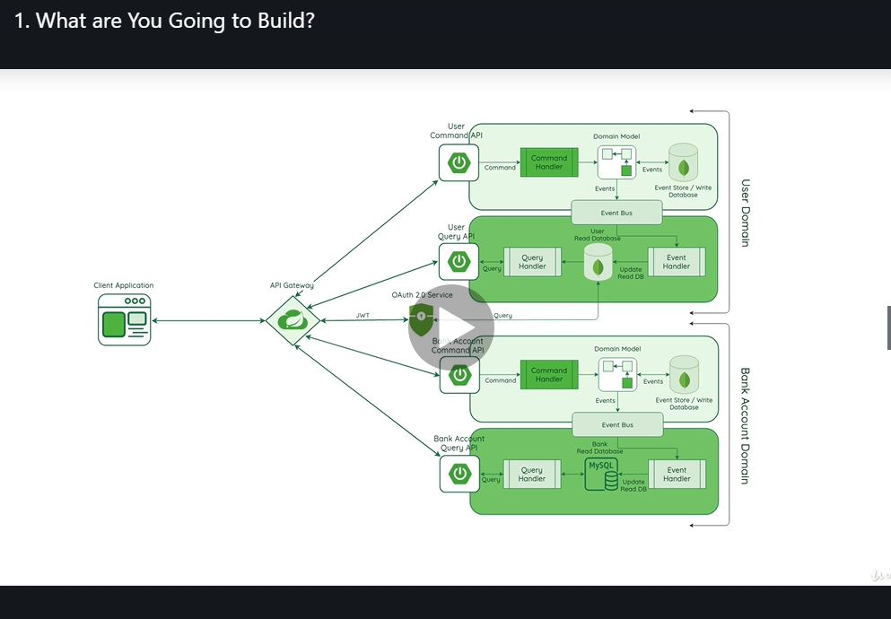

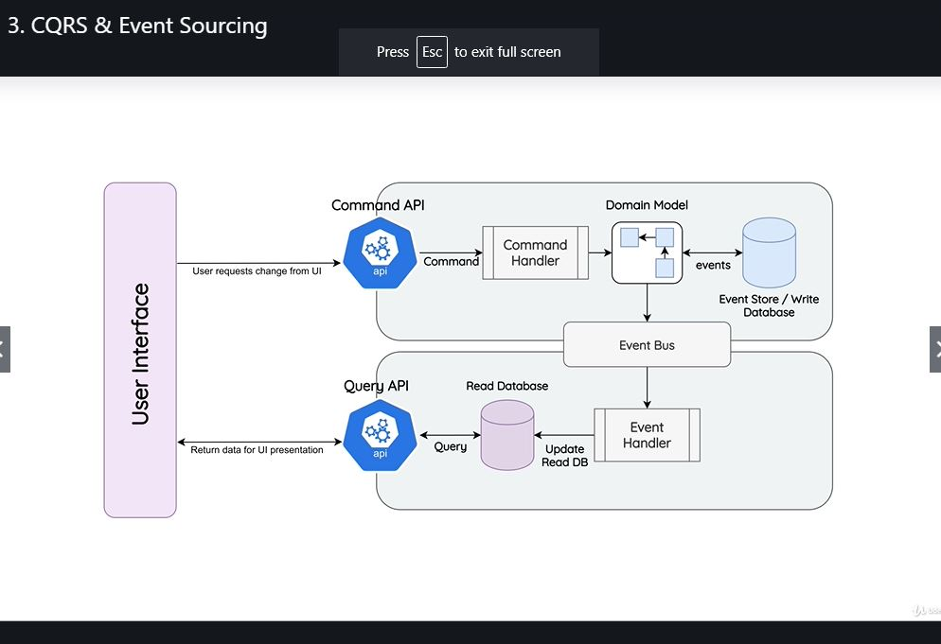

docker network create - -attachable –d overlay springBankNet

