**Uninformative prior, I(0) variable (true $ϕ=0.8, α=0.01)$**

**Gibbs sampling, data 1**

coeff mean std p-value 0.95 interval

α 0.076 0.109 0.4808 [-0.139, 0.286]

ϕ 0.823 0.057 0.0 [0.712, 0.934]

**data 2**

coeff mean std p-value 0.95 interval

α 0.066 0.098 0.4977 [-0.127, 0.258]

ϕ 0.672 0.073 0.0 [0.528, 0.814]

**Turing HMC,**

coeff mean std p-value 0.95 interval

α 0.076 0.112 0.498 [-0.137, 0.304]

ϕ 0.824 0.058 0.0 [0.713, 0.939]

**data 2**

coeff mean std p-value 0.95 interval

α 0.066 0.101 0.4993 [-0.135, 0.264]

ϕ 0.671 0.075 0.0 [0.52, 0.817]

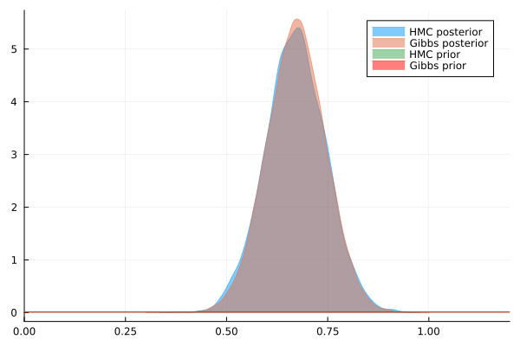

**Uninformative prior, I(1) variable (true $ϕ=1.0, α=0.01)$**

**Gibbs sampling**

coeff mean std p-value 0.95 interval

α -0.571 0.295 0.0543 [-1.149, 0.012]

ϕ 0.925 0.038 0.0 [0.849, 1.0]

coeff mean std p-value 0.95 interval

α -0.561 0.299 0.0597 [-1.132, 0.025]

ϕ 0.926 0.038 0.0 [0.851, 1.001]

We know, more often than not (and if we think about the DGP), the AR(1) coefficient for economics and finance data is usually positive and close to one, so a prior with $ϕ∼Truncated(Normal\left(1.0,0.2\right), 0.0, 1.1)$ might be a good idea!

coeff mean std p-value 0.95 interval

α -0.558 0.3 0.0683 [-1.144, 0.047]

ϕ 0.926 0.039 0.0 [0.851, 1.005]

Highly informative prior for phi!

coeff mean std p-value 0.95 interval

α -0.5 0.286 0.08 [-1.056, 0.058]

ϕ 0.934 0.037 0.0 [0.863, 1.006]