BANA7051 Assignment 1

Ang Zhang

2024-08-30

## A. Sample size of the data.

first load the data, and then take the sample size with nrow() function.

wine <- read.csv("data/winequality-red.csv", sep = ";")  
wine <- select(wine, c("fixed.acidity", "volatile.acidity", "citric.acid"))  
sample_size <- nrow(wine)  
print(paste('sample size is ', sample_size))

## [1] "sample size is 1599"

## B. Identify outliers

Draw a plot for each of the variables:

for (col_name in colnames(wine))  
 plot(wine[[col_name]], main = paste("distribution of", col_name), ylab = col_name)

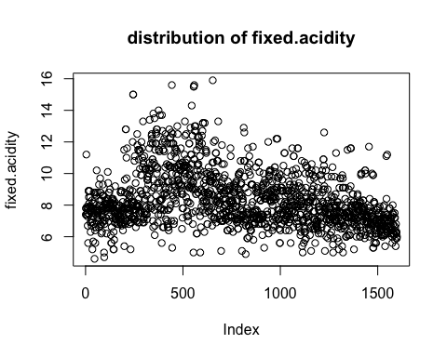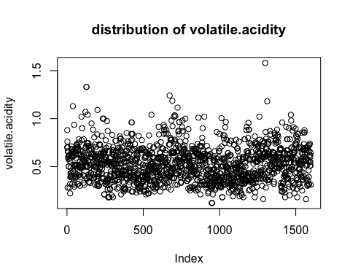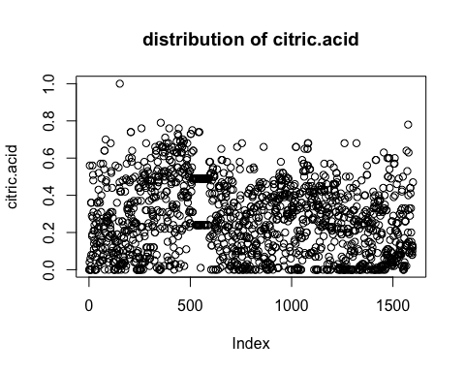

One outlier can be observed in the citric.acid variable.

## C. Summarize of data.

The summary() function provides a basic summary of Min, 1st Quantile, median, third quntile, max:

summary(wine)

## fixed.acidity volatile.acidity citric.acid   
## Min. : 4.60 Min. :0.1200 Min. :0.000   
## 1st Qu.: 7.10 1st Qu.:0.3900 1st Qu.:0.090   
## Median : 7.90 Median :0.5200 Median :0.260   
## Mean : 8.32 Mean :0.5278 Mean :0.271   
## 3rd Qu.: 9.20 3rd Qu.:0.6400 3rd Qu.:0.420   
## Max. :15.90 Max. :1.5800 Max. :1.000

Moreover, I would like to include standard deviation to give a little bit more insight:

for (col_name in colnames(wine)) {  
 sd = sd(wine[[col_name]])  
 print(paste("standard deviation of ", col_name, ": ", round(sd, 2)))  
}

## [1] "standard deviation of fixed.acidity : 1.74"  
## [1] "standard deviation of volatile.acidity : 0.18"  
## [1] "standard deviation of citric.acid : 0.19"

## D. Visualize the distribution of each variable.

Draw a histogram of each variable with hist() function, and draw a density curve on top of it.

for (col_name in colnames(wine)) {  
 hist(wine[[col_name]], main = paste("histogram of", col_name), freq = F, xlab = col_name, ylab = "density")  
 lines(density(wine[[col_name]]), lwd = 5, col = "blue")  
}

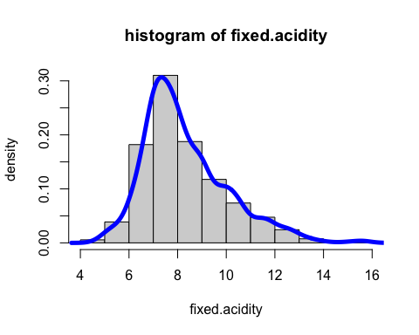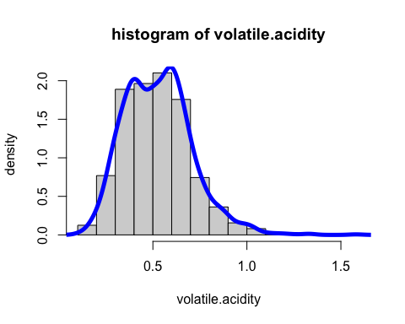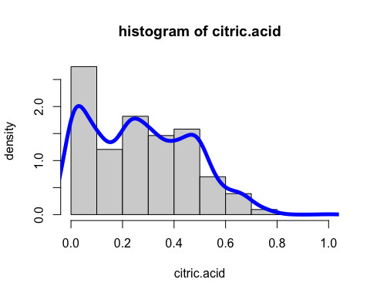

## E. Any skewed distribution in D?

The fixed.acidity variable appears to be right skewed. So does the citric.acid variable.

## F. What data mining methods are used in this paper?

The author discussed linear/multiple regression (MR), neural networks (NN), and support vector machines (SVM). MR can be seen as a reduced form of NN when there’s no layer of hidden node. Empirical results shows that SVM outperformed NN (and also MR) in this study case, especially for white wine.