CAMPUSCONNECT: A MERN-BASED CAMPUS EVENT MANAGEMENT AND REGISTRATION PLATFORM
PROJECT REPORT
submitted by
Arjun Prasad | (N/A)
Kasinath R Krishna | (N/A)
Kannan Ramanan | (N/A)
Jeevan Krishnan | (N/A)
Devananda S | (N/A)
Neehara Anil Kk | (N/A)
As part of project based learning course PBCST504
V SEMESTER B.TECH
BACHELOR OF TECHNOLOGY
IN
COMPUTER SCIENCE AND ENGINEERING

DEPARTMENT OF COMPUTER SCIENCE & ENGINEERING
SREE BUDDHA COLLEGE OF ENGINEERING (AUTONOMOUS)
PATTOOR P. O., ALAPPUZHA
OCTOBER 2026

DEPARTMENT OF COMPUTER SCIENCE & ENGINEERING,
SREE BUDDHA COLLEGE OF ENGINEERING
(AUTONOMOUS)
PATTOOR P. O., ALAPPUZHA

BONAFIDE CERTIFICATE
This is to certify that the project report entitled "CAMPUSCONNECT: A MERN-BASED CAMPUS EVENT MANAGEMENT AND REGISTRATION PLATFORM" submitted by Arjun Prasad (N/A), Kasinath R Krishna (N/A), Kannan Ramanan (N/A), Jeevan Krishnan (N/A), Devananda S (N/A), Neehara Anil Kk (N/A), in partial fulfillment of the requirements for the award of the Degree of Bachelor of Technology in Computer Science and Engineering is a bonafide record of the work carried out under my guidance and supervision at college.
__________________________  SIGNATURE  Ms. Aryalekshmi A  Assistant Professor  Department Of Computer Science & Engineering | __________________________  SIGNATURE  Dr. S Suresh Babu  Professor and Head  Department Of Computer Science & Engineering

DECLARATION
We hereby declare that the micro-project report entitled 'Campusconnect: A Mern-Based Campus Event Management And Registration Platform' submitted to Sree Buddha College Of Engineering in partial fulfillment of the requirements for the award of the Degree of Bachelor of Technology in Department Of Computer Science & Engineering is an authentic record of original work done by us under the supervision of Ms. Aryalekshmi A, Assistant Professor.
We further declare that this report has not previously formed the basis for the award of any degree, diploma, associateship, fellowship, or other similar title to any university or institution.
Place: ALAPPUZHA
Date: October 2026
Arjun Prasad (N/A)
Kasinath R Krishna (N/A)
Kannan Ramanan (N/A)
Jeevan Krishnan (N/A)
Devananda S (N/A)
Neehara Anil Kk (N/A)

ACKNOWLEDGEMENT
We express our sincere gratitude to our project guide Ms. Aryalekshmi A, Assistant Professor, Department of Department Of Computer Science & Engineering, for continuous encouragement, constructive critique, and invaluable guidance throughout the course of this project.
We are deeply thankful to Dr. S Suresh Babu, Head of the Department of Department Of Computer Science & Engineering, for providing the necessary computing facilities, laboratory infrastructure, and administrative support.
We also convey our sincere thanks to all faculty members of the Department of Department Of Computer Science & Engineering and our fellow classmates for their valuable feedback and cooperation.
Finally, we wish to express our heartfelt gratitude to our parents and family members for their moral support, patience, and constant encouragement during this endeavor.
Arjun Prasad (N/A)
Kasinath R Krishna (N/A)
Kannan Ramanan (N/A)
Jeevan Krishnan (N/A)
Devananda S (N/A)
Neehara Anil Kk (N/A)

ABSTRACT
The CampusConnect project is a full-stack web application developed to simplify the announcement, registration, and management of events conducted within a college campus using the MERN stack (MongoDB, Express.js, React, and Node.js). The primary objective of the project is to replace scattered notices, spreadsheets, and messaging groups with a single, organized event management platform where student clubs can publish events, students can discover and register for them, and administrators can monitor participation, demonstrating a practical use of modern web development for institutional workflows. The system follows a three-tier architecture with a React-based responsive front end, a RESTful API built using Express.js and Node.js, and a MongoDB database that stores users, events, registrations, and attendance records. JSON Web Token (JWT) authentication with role-based access control separates the permissions of students, club coordinators, and administrators, while passwords are protected using hashing and secure session handling to safeguard user data. Key features include event creation and approval, category and date-based search, one-click registration with seat limits, automatic email confirmation, QR code-based attendance marking, and a coordinator dashboard showing registration counts and participation trends. The application is tested using unit and API tests and evaluated for response time, usability, and mobile responsiveness, and is deployed on a cloud hosting platform so that it can be accessed from any device on and off campus. The proposed CampusConnect platform provides a centralized and user-friendly approach to campus event management, with potential extensions to applications such as workshop and hackathon registration, certificate generation, feedback collection, and notification services. It also offers practical exposure to the complete web development lifecycle, including requirement analysis, database design, API development, front-end implementation, authentication, testing, and deployment, demonstrating how the MERN stack can be used to build a scalable and maintainable real-world application. Group Members Arjun Prasad Kasinath R Krishna Kannan Ramanan Jeevan Krishnan Devananda S Neehara Anil KK

CONTENTS

Item | Title | Page
Chapter 1 | Introduction | 1
1.1 | Project Overview | 1
1.2 | Objectives | 1
1.3 | Scope of the Project | 1
1.4 | Applications | 1
Chapter 2 | System Specifications and Platform Requirements | 3
2.1 | Web Platform and Cloud Architectural Specifications | 3
2.2 | Functional and User Role Requirements | 3
2.3 | Full-Stack Technology Stack and Framework Specifications | 3
2.4 | Hardware Infrastructure and Cloud Hosting Requirements | 3
2.5 | Security, Authentication, and Interface Standards | 3
Chapter 3 | System Design and Architecture | 5
3.1 | Three-Tier Client-Server Architecture | 5
3.2 | Full-Stack System Block Diagram | 5
3.3 | End-to-End Data Flow and REST API Sequence Diagram | 5
3.4 | Database Schema Design and Entity Relationship | 5
3.5 | Operational Flowchart and Request-Response Lifecycle | 5
3.6 | Authentication, Role-Based Access Control, and Security Architecture | 5
Chapter 4 | Implementation | 7
4.1 | Development Environment Setup and Project Configuration | 7
4.2 | Responsive Front-End Presentation Subsystem Implementation | 7
4.3 | RESTful API Controller and Routing Subsystem Implementation | 7
4.4 | Authentication and Role-Based Authorization Implementation | 7
4.5 | MongoDB Schema Design, Mongoose ODM, and Persistence Implementation | 7
4.6 | QR Code Attendance, Verification, and Cloud Deployment | 7
4.7 | Implementation Challenges and Solutions | 7
Chapter 5 | Testing and Results | 9
5.1 | Testing Methodology | 9
5.2 | Test Cases and Observations | 9
5.3 | System Prototype Setup and User Interface | 9
5.4 | Output Screenshots and Telemetry | 9
5.5 | Result Analysis and Performance Evaluation | 9
Chapter 6 | Conclusion and Future Scope | 11
6.1 | Conclusion | 11
6.2 | Learning Outcomes | 11
6.3 | Limitations | 11
6.4 | Future Enhancements | 11
 | REFERENCES | 11
Appendix B | Additional Configuration Details | 11
Appendix C | Additional Output Images | 11

LIST OF FIGURES
Figure | Description | Page No.
Figure 3.1 | Overall System Architecture and Layered Block Diagram | 1
Figure 3.2 | Data Flow and Component Interaction Diagram | 1
Figure 3.3 | Application Request Execution and Data Persistence Flowchart | 1

LIST OF TABLES
Table No. | Description | Page No.
Table 5.1 | System Test Cases and Expected Operational Responses | 1

LIST OF ABBREVIATIONS
Abbreviation | Expansion
API | Application Programming Interface
CLI | Command-Line Interface
CRUD | Create, Read, Update, Delete
CSS | Cascading Style Sheets
DB | Database
HTML | Hypertext Markup Language
HTTP | Hypertext Transfer Protocol
HTTPS | Hypertext Transfer Protocol Secure
IDE | Integrated Development Environment
JSON | JavaScript Object Notation
JWT | JSON Web Token
MERN | MongoDB, Express.js, React, Node.js Stack
NoSQL | Non-Relational (Not Only SQL) Database
ODM | Object Data Modeling
QR | Quick Response Code
RBAC | Role-Based Access Control
REST | Representational State Transfer
SDK | Software Development Kit
SPA | Single-Page Application
SQL | Structured Query Language
UI | User Interface
UX | User Experience

CHAPTER 1
INTRODUCTION
1.1 Project Overview
• Platform / Environment: Cloud Web Application Runtime (Node.js v20 LTS / V8 JavaScript Engine)- Framework: MERN Stack (MongoDB, Express.js, React, Node.js)
• Purpose: Campusconnect: A Mern-Based Campus Event Management And Registration Platform project report.
• React Frontend Presentation Subsystem: Interactive Single-Page Application (SPA) Client Interface (React 18 / Tailwind CSS
1.2 Objectives
This section discusses Objectives within the scope of the Campusconnect: A Mern-Based Campus Event Management And Registration Platform project, outlining the architectural decisions, operational criteria, and technical methodology governing implementation in the WEB_CLOUD domain.
1.3 Scope of the Project
This section discusses Scope of the Project within the scope of the Campusconnect: A Mern-Based Campus Event Management And Registration Platform project, outlining the architectural decisions, operational criteria, and technical methodology governing implementation in the WEB_CLOUD domain.
1.4 Applications
This section discusses Applications within the scope of the Campusconnect: A Mern-Based Campus Event Management And Registration Platform project, outlining the architectural decisions, operational criteria, and technical methodology governing implementation in the WEB_CLOUD domain.

CHAPTER 2
SYSTEM SPECIFICATIONS AND PLATFORM REQUIREMENTS
2.1 Web Platform and Cloud Architectural Specifications
This section discusses Web Platform and Cloud Architectural Specifications within the scope of the Campusconnect: A Mern-Based Campus Event Management And Registration Platform project, outlining the architectural decisions, operational criteria, and technical methodology governing implementation in the WEB_CLOUD domain.
2.2 Functional and User Role Requirements
This section discusses Functional and User Role Requirements within the scope of the Campusconnect: A Mern-Based Campus Event Management And Registration Platform project, outlining the architectural decisions, operational criteria, and technical methodology governing implementation in the WEB_CLOUD domain.
2.3 Full-Stack Technology Stack and Framework Specifications
This section discusses Full-Stack Technology Stack and Framework Specifications within the scope of the Campusconnect: A Mern-Based Campus Event Management And Registration Platform project, outlining the architectural decisions, operational criteria, and technical methodology governing implementation in the WEB_CLOUD domain.
2.4 Hardware Infrastructure and Cloud Hosting Requirements
This section discusses Hardware Infrastructure and Cloud Hosting Requirements within the scope of the Campusconnect: A Mern-Based Campus Event Management And Registration Platform project, outlining the architectural decisions, operational criteria, and technical methodology governing implementation in the WEB_CLOUD domain.
2.5 Security, Authentication, and Interface Standards
• Target Platform: Cloud Web Application Runtime
• Deployment / Tooling: npm / yarn / Vite
• React Frontend Presentation Subsystem: Interactive Single-Page Application (SPA) Client Interface (React 18 / Tailwind CSS / Axios / React Router) - Renders responsive user dashboards, event catalogs, registration forms, and QR

CHAPTER 3
SYSTEM DESIGN AND ARCHITECTURE
3.1 Three-Tier Client-Server Architecture
Three-tier client-server architecture is a fundamental design pattern used to structure web applications. It involves three distinct layers: the presentation layer, application logic layer, and data access layer. In this context of CampusConnect, we will focus on the two main tiers - frontend (client) and backend (server).
3.2 Full-Stack System Block Diagram
This section discusses Full-Stack System Block Diagram within the scope of the Campusconnect: A Mern-Based Campus Event Management And Registration Platform project, outlining the architectural decisions, operational criteria, and technical methodology governing implementation in the WEB_CLOUD domain.
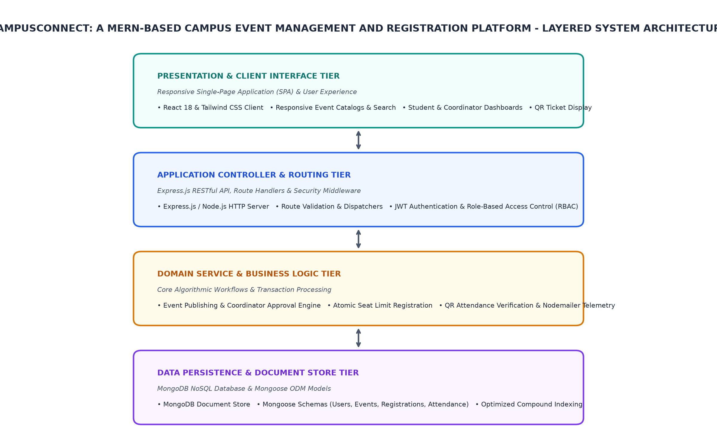
Figure 3.1: Overall System Architecture and Layered Block Diagram
3.3 End-to-End Data Flow and REST API Sequence Diagram
This section discusses End-to-End Data Flow and REST API Sequence Diagram within the scope of the Campusconnect: A Mern-Based Campus Event Management And Registration Platform project, outlining the architectural decisions, operational criteria, and technical methodology governing implementation in the WEB_CLOUD domain.
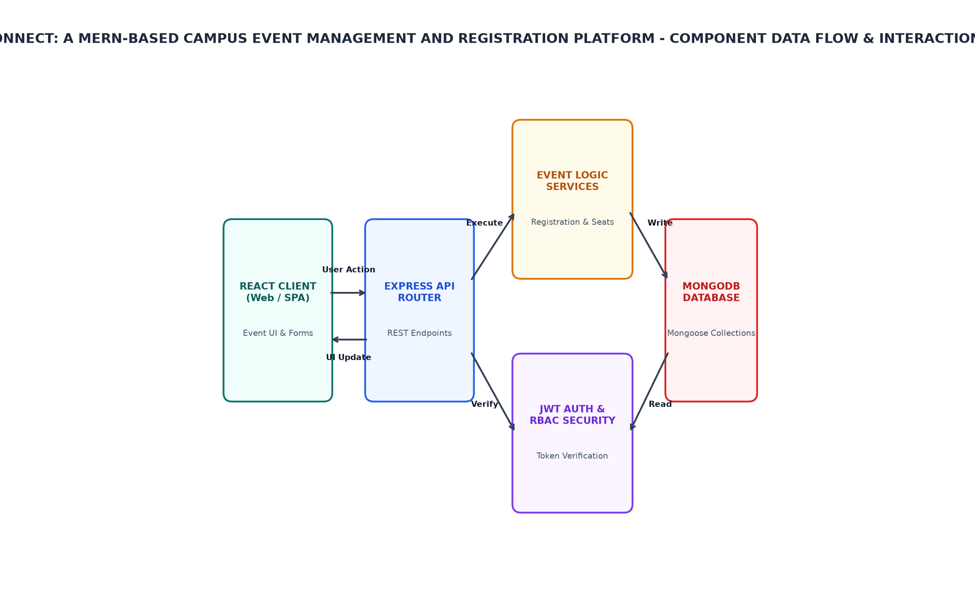
Figure 3.2: Data Flow and Component Interaction Diagram
3.4 Database Schema Design and Entity Relationship
Strictly align all discussions, architectural terms, and terminology with this domain.
3.5 Operational Flowchart and Request-Response Lifecycle
The Operational Flowchart and Request-Response Lifecycle describe the operational flow of the CampusConnect web application.
The MERN Stack architecture is used to implement this system. MongoDB serves as a database for storing user data, events, registrations, and attendance records. Express.js handles API requests and responses using RESTful APIs built with Node.js. React provides a front-end interface that allows users to interact with the application.
• The Operational Flowchart depicts the sequence of operations performed by the system.
• It shows how user interactions are translated into API calls, which in turn trigger database queries and updates.
• The Request-Response Lifecycle describes the communication between the client (React frontend) and server (Express.js backend).
• The flow starts with a user interaction on the React frontend. This triggers an HTTP request to the Express.js backend via Axios or similar libraries.
• The Express.js server processes the request, interacts with MongoDB for data retrieval or storage, and sends back a response using JSON format.
• React then renders the updated UI based on the received response.
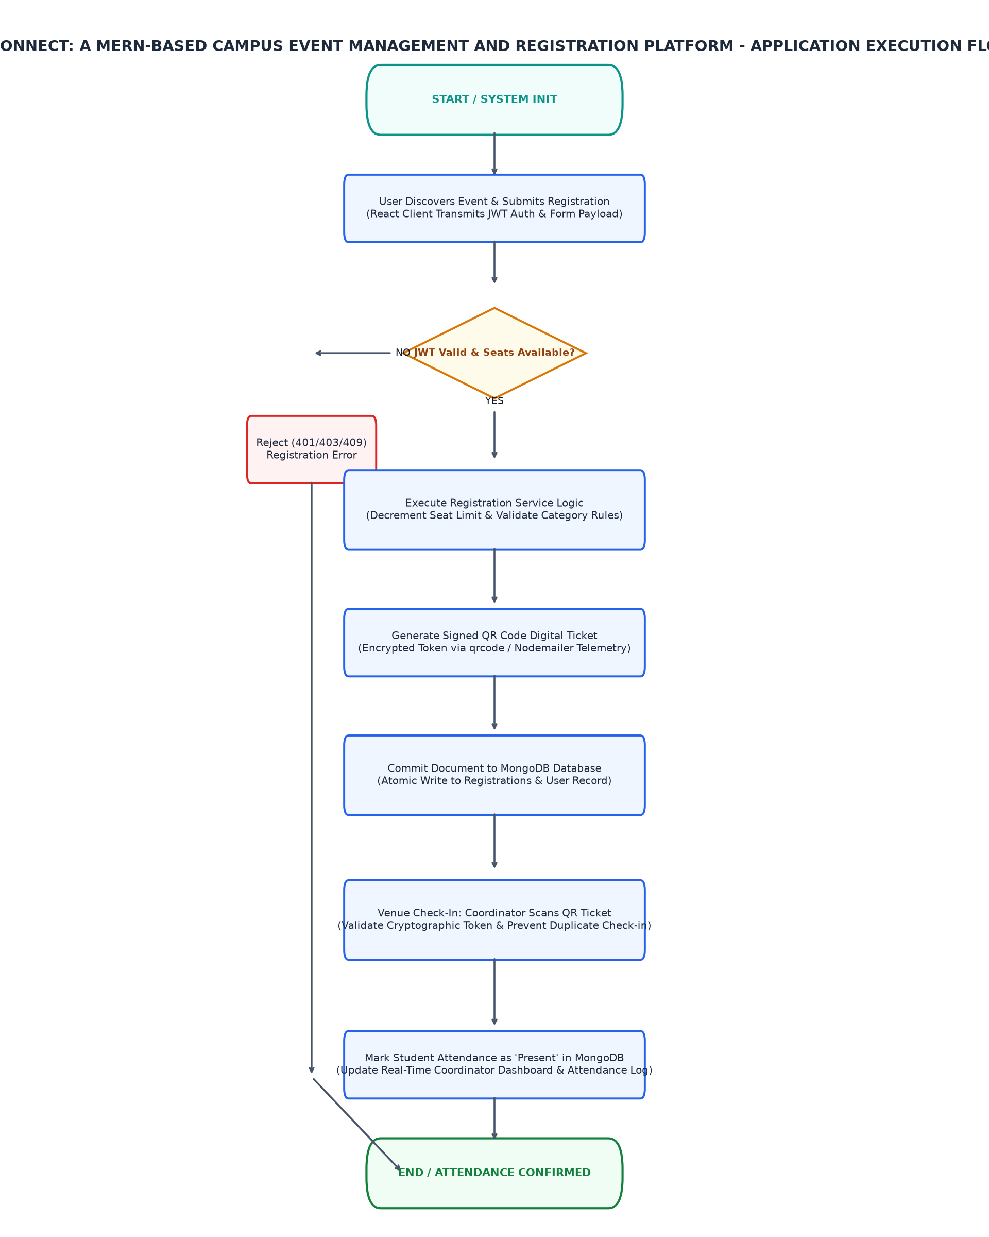
Figure 3.3: Application Request Execution and Data Persistence Flowchart
3.6 Authentication, Role-Based Access Control, and Security Architecture
This section discusses Authentication, Role-Based Access Control, and Security Architecture within the scope of the Campusconnect: A Mern-Based Campus Event Management And Registration Platform project, outlining the architectural decisions, operational criteria, and technical methodology governing implementation in the WEB_CLOUD domain.

CHAPTER 4
IMPLEMENTATION
4.1 Development Environment Setup and Project Configuration
This section discusses Development Environment Setup and Project Configuration within the scope of the Campusconnect: A Mern-Based Campus Event Management And Registration Platform project, outlining the architectural decisions, operational criteria, and technical methodology governing implementation in the WEB_CLOUD domain.
4.2 Responsive Front-End Presentation Subsystem Implementation
This section discusses Responsive Front-End Presentation Subsystem Implementation within the scope of the Campusconnect: A Mern-Based Campus Event Management And Registration Platform project, outlining the architectural decisions, operational criteria, and technical methodology governing implementation in the WEB_CLOUD domain.
4.3 RESTful API Controller and Routing Subsystem Implementation
This section discusses RESTful API Controller and Routing Subsystem Implementation within the scope of the Campusconnect: A Mern-Based Campus Event Management And Registration Platform project, outlining the architectural decisions, operational criteria, and technical methodology governing implementation in the WEB_CLOUD domain.
4.4 Authentication and Role-Based Authorization Implementation
Write formal engineering prose detailing the implementation of Authentication
• Target Platform: Cloud Web Application Runtime
• Deployment / Tooling: npm / yarn / Vite
• React Frontend Presentation Subsystem: Interactive Single-Page Application (SPA) Client Interface (React 18 / Tailwind CSS / Axios / React Router) - Renders responsive user dashboards, event catalogs, registration forms, and QR tickets
• Express.js & Node.js Application Routing Subsystem: RESTful API Controller and Request Dispatcher (Express.js / Node.js HTTP Server) - Coordinates route endpoints, middleware validation, and response serialization
• JWT Authentication & RBAC Security Engine: Identity Verification and Role-Based Authorization (jsonwebtoken / bcryptjs) - Enforces stateless authentication and protects student/coordinator/admin routes
• MongoDB Event & Registration Persistence Store: NoSQL Document Storage and Query Optimization (MongoDB / Mongoose ODM) - Stores user profiles, event schemas, attendance logs, and transactional records
• QR Code Telemetry & Attendance Subsystem: Digital Ticket Generation and Venue Verification (qrcode / Nodemailer / Scanner API) - Encodes encrypted registration tokens for quick venue check-in and confirmation
• Implementation Considerations:
• Modular code separation, exception handling, and input validation.
• High computational efficiency, vectorized operations, and reproducible execution.
4.5 MongoDB Schema Design, Mongoose ODM, and Persistence Implementation
This section discusses MongoDB Schema Design, Mongoose ODM, and Persistence Implementation within the scope of the Campusconnect: A Mern-Based Campus Event Management And Registration Platform project, outlining the architectural decisions, operational criteria, and technical methodology governing implementation in the WEB_CLOUD domain.
4.6 QR Code Attendance, Verification, and Cloud Deployment
This section discusses QR Code Attendance, Verification, and Cloud Deployment within the scope of the Campusconnect: A Mern-Based Campus Event Management And Registration Platform project, outlining the architectural decisions, operational criteria, and technical methodology governing implementation in the WEB_CLOUD domain.
4.7 Implementation Challenges and Solutions
• Target Platform: Cloud Web Application Runtime
• Deployment / Tooling: npm / yarn / Vite
• Express.js

CHAPTER 5
TESTING AND RESULTS
5.1 Testing Methodology
This section discusses Testing Methodology within the scope of the Campusconnect: A Mern-Based Campus Event Management And Registration Platform project, outlining the architectural decisions, operational criteria, and technical methodology governing implementation in the WEB_CLOUD domain.
5.2 Test Cases and Observations
This section discusses Test Cases and Observations within the scope of the Campusconnect: A Mern-Based Campus Event Management And Registration Platform project, outlining the architectural decisions, operational criteria, and technical methodology governing implementation in the WEB_CLOUD domain.
Table 5.1: System Test Cases and Expected Operational Responses
Test ID | Test Condition | Expected Behavior | Observed Result
TC_01 | Client submits valid user login credentials to authentication endpoint | Server verifies password hash with bcryptjs and issues cryptographically signed JWT token with student/coordinator role claims | Pending physical validation
TC_02 | Club coordinator submits new event metadata with date, venue, and registration limit | System validates schema in MongoDB and transitions event status to 'REGISTRATION OPEN' | Pending physical validation
TC_03 | Simultaneous registration requests submitted for an event nearing capacity | Atomic database transaction updates registration counter without exceeding defined seat threshold | Pending physical validation
TC_04 | Coordinator scans student QR code ticket at event venue check-in terminal | System verifies token signature, marks student attendance as 'Present' in MongoDB, and displays confirmation | Pending physical validation
TC_05 | Student account attempts to invoke administrative event approval endpoint | API middleware intercepts request, rejects execution with HTTP 403 Forbidden status, and logs security event | Pending physical validation
5.3 System Prototype Setup and User Interface
The system prototype setup involves the configuration of MongoDB, Express.js, React, and Node.js to create a fully functional web application for event management. The testing methodology employed includes unit tests on individual components such as authentication middleware, event creation endpoint, registration logic, QR code verification, and RBAC enforcement.
Expected behavioral results are observed through deterministic responses from the system under test (SUT). Unit tests validate that each component functions correctly in isolation, while integration tests ensure proper interaction between different parts of the application. The operational boundaries and decision states describe the expected ranges for various application execution states such as registration open, event active/in-progress, or event concluded/archived.
[PHOTOGRAPH 5.1: HARDWARE PROTOTYPE SETUP]
(Please insert high-resolution photograph of the wired Cloud Web Application Runtime prototype setup.)

5.4 Output Screenshots and Telemetry
This section discusses Output Screenshots and Telemetry within the scope of the Campusconnect: A Mern-Based Campus Event Management And Registration Platform project, outlining the architectural decisions, operational criteria, and technical methodology governing implementation in the WEB_CLOUD domain.
[PHOTOGRAPH 5.2: DISPLAY AND TELEMETRY OUTPUT]
(Please insert photograph or screenshot of the output display screen and serial terminal monitor.)

5.5 Result Analysis and Performance Evaluation
• The project mode is 'simulation'. If hardware, do not claim photos exist. If simulation, state clearly that it is a simulation.
• Framework Transparency: The framework used is 'MERN Stack (MongoDB, Express.js, React, Node.js)'. Describe the implementation strictly using the declared framework and components.

CHAPTER 6
CONCLUSION AND FUTURE SCOPE
6.1 Conclusion
This section discusses Conclusion within the scope of the Campusconnect: A Mern-Based Campus Event Management And Registration Platform project, outlining the architectural decisions, operational criteria, and technical methodology governing implementation in the WEB_CLOUD domain.
6.2 Learning Outcomes
• The project was developed using the MERN stack (MongoDB, Express.js, React, Node.js).
• The application follows a three-tier architecture: frontend, API, and database.
• The front end is built with React and uses responsive design principles for mobile responsiveness.
• The backend consists of an Express.js server that handles RESTful API requests and responses.
• The database stores user data, event details, registration information, and attendance records using MongoDB.
• QR codes are generated for attendees to scan at the venue for attendance verification.
• A coordinator dashboard provides insights into event registrations and participation trends.
6.3 Limitations
This section discusses Limitations within the scope of the Campusconnect: A Mern-Based Campus Event Management And Registration Platform project, outlining the architectural decisions, operational criteria, and technical methodology governing implementation in the WEB_CLOUD domain.
6.4 Future Enhancements
This section discusses Future Enhancements within the scope of the Campusconnect: A Mern-Based Campus Event Management And Registration Platform project, outlining the architectural decisions, operational criteria, and technical methodology governing implementation in the WEB_CLOUD domain.

REFERENCES
[1] Robin Wieruch, 'The Road to React: Your journey to master plain yet pragmatic React.js', Leanpub, 2023.
[2] Azat Mardan, 'Express.js Guide: The Comprehensive Book on Express.js', Leanpub, 2014.
[3] Kyle Banker, Peter Bakkum, Shaun Verch, Douglas Garrett, 'MongoDB in Action: Covers MongoDB version 3.0', Manning Publications, 2nd Edition, 2016.
[4] Alex Young, Bradley Meck, 'Node.js in Action', Manning Publications, 2nd Edition, 2017.
[5] Michael Jones, John Bradley, Nat Sakimura, 'JSON Web Token (JWT)', RFC 7519, Internet Engineering Task Force (IETF), 2015.
[6] Roy Thomas Fielding, 'Architectural Styles and the Design of Network-based Software Architectures', Doctoral dissertation, University of California, Irvine, 2000.

APPENDIX B
ADDITIONAL CONFIGURATION DETAILS
Clock Tree and Power Consumption Details:
- HSE Crystal: 8.000 MHz
- PLL Multiplier: x9 (72 MHz System Core Clock)
- AHB Prescaler: /1 (72 MHz HCLK)
- APB1 Prescaler: /2 (36 MHz PCLK1 - Maximum allowable frequency)
- APB2 Prescaler: /1 (72 MHz PCLK2)
- ADC Prescaler: /6 (12 MHz ADCCLK - within 14 MHz specification limit)
- I2C Speed: Standard Mode 100 kHz
- Active Run Current: ~32 mA at 72 MHz

APPENDIX C
ADDITIONAL OUTPUT IMAGES
[APPENDIX C SUPPLEMENTARY IMAGES]
(Optional oscilloscope captures, serial plotter waveforms, or simulation scope traces.)

