CAMPUSCONNECT: A MERN-BASED CAMPUS EVENT MANAGEMENT AND REGISTRATION PLATFORM
PROJECT REPORT
submitted by
Arjun Prasad | (N/A)
Kasinath R Krishna | (N/A)
Kannan Ramanan | (N/A)
Jeevan Krishnan | (N/A)
Devananda S | (N/A)
Neehara Anil Kk | (N/A)
As part of project based learning course PLATFORM
V SEMESTER B.TECH
BACHELOR OF TECHNOLOGY
IN
COMPUTER SCIENCE AND ENGINEERING

DEPARTMENT OF COMPUTER SCIENCE & ENGINEERING
SREE BUDDHA COLLEGE OF ENGINEERING (AUTONOMOUS)
PATTOOR P. O., ALAPPUZHA - 690 529
OCTOBER 2026

DEPARTMENT OF COMPUTER SCIENCE & ENGINEERING,
SREE BUDDHA COLLEGE OF ENGINEERING
(AUTONOMOUS)
PATTOOR P. O., ALAPPUZHA

BONAFIDE CERTIFICATE
This is to certify that the project report entitled "CAMPUSCONNECT: A MERN-BASED CAMPUS EVENT MANAGEMENT AND REGISTRATION PLATFORM" submitted by Arjun Prasad (N/A), Kasinath R Krishna (N/A), Kannan Ramanan (N/A), Jeevan Krishnan (N/A), Devananda S (N/A), Neehara Anil Kk (N/A), in partial fulfillment of the requirements for the award of the Degree of Bachelor of Technology in Computer Science and Engineering is a bonafide record of the work carried out under my guidance and supervision at college.
__________________________  SIGNATURE  Ms. Aryalekshmi A  Assistant Professor  Department of Computer Science & Engineering | __________________________  SIGNATURE  Dr. S Suresh Babu  Professor and Head  Department of Computer Science & Engineering

DECLARATION
We hereby declare that the micro-project report entitled 'Campusconnect: A Mern-Based Campus Event Management And Registration Platform' submitted to Sree Buddha College of Engineering (Autonomous) in partial fulfillment of the requirements for the award of the Degree of Bachelor of Technology in Department of Computer Science & Engineering is an authentic record of original work done by us under the supervision of Ms. Aryalekshmi A, Assistant Professor.
We further declare that this report has not previously formed the basis for the award of any degree, diploma, associateship, fellowship, or other similar title to any university or institution.
Place: Alappuzha - 690 529
Date: October 2026
Arjun Prasad (N/A)
Kasinath R Krishna (N/A)
Kannan Ramanan (N/A)
Jeevan Krishnan (N/A)
Devananda S (N/A)
Neehara Anil Kk (N/A)

ACKNOWLEDGEMENT
This section discusses Section acknowledgement in the context of the CampusConnect full-stack platform, detailing the technical considerations, operational workflows, and design patterns implemented.
All software components adhere strictly to software quality metrics, modular design principles, and user experience guidelines.
Arjun Prasad (N/A)
Kasinath R Krishna (N/A)
Kannan Ramanan (N/A)
Jeevan Krishnan (N/A)
Devananda S (N/A)
Neehara Anil Kk (N/A)

ABSTRACT
The CampusConnect project is a full-stack web application developed to simplify the announcement, registration, and management of events conducted within a college campus using the MERN stack (MongoDB, Express.js, React, and Node.js). The primary objective of the project is to replace scattered notices, spreadsheets, and messaging groups with a single, organized event management platform where student clubs can publish events, students can discover and register for them, and administrators can monitor participation, demonstrating a practical use of modern web development for institutional workflows. The system follows a three-tier architecture with a React-based responsive front end, a RESTful API built using Express.js and Node.js, and a MongoDB database that stores users, events, registrations, and attendance records. JSON Web Token (JWT) authentication with role-based access control separates the permissions of students, club coordinators, and administrators, while passwords are protected using hashing and secure session handling to safeguard user data. Key features include event creation and approval, category and date-based search, one-click registration with seat limits, automatic email confirmation, QR code-based attendance marking, and a coordinator dashboard showing registration counts and participation trends. The application is tested using unit and API tests and evaluated for response time, usability, and mobile responsiveness, and is deployed on a cloud hosting platform so that it can be accessed from any device on and off campus. The proposed CampusConnect platform provides a centralized and user-friendly approach to campus event management, with potential extensions to applications such as workshop and hackathon registration, certificate generation, feedback collection, and notification services. It also offers practical exposure to the complete web development lifecycle, including requirement analysis, database design, API development, front-end implementation, authentication, testing, and deployment, demonstrating how the MERN stack can be used to build a scalable and maintainable real-world application. Group Members Arjun Prasad Kasinath R Krishna Kannan Ramanan Jeevan Krishnan Devananda S Neehara Anil KK

CONTENTS

Item | Title | Page
Chapter 1 | Introduction | 1
1.1 | Project Overview | 1
1.2 | Objectives | 1
1.3 | Scope of the Project | 1
1.4 | Applications | 1
Chapter 2 | System Specifications and Platform Requirements | 3
2.1 | Web Platform and Cloud Architectural Specifications | 3
2.2 | Functional and User Role Requirements | 3
2.3 | Full-Stack Technology Stack and Framework Specifications | 3
2.4 | Hardware Infrastructure and Cloud Hosting Requirements | 3
2.5 | Security, Authentication, and Interface Standards | 3
Chapter 3 | System Design and Architecture | 5
3.1 | Three-Tier Client-Server Architecture | 5
3.2 | Full-Stack System Block Diagram | 5
3.3 | End-to-End Data Flow and REST API Sequence Diagram | 5
3.4 | Database Schema Design and Entity Relationship | 5
3.5 | Operational Flowchart and Request-Response Lifecycle | 5
3.6 | Authentication, Role-Based Access Control, and Security Architecture | 5
Chapter 4 | Implementation | 7
4.1 | Development Environment Setup and Project Configuration | 7
4.2 | Responsive Front-End Presentation Subsystem Implementation | 7
4.3 | RESTful API Controller and Routing Subsystem Implementation | 7
4.4 | Authentication and Role-Based Authorization Implementation | 7
4.5 | MongoDB Schema Design, Mongoose ODM, and Persistence Implementation | 7
4.6 | QR Code Attendance, Verification, and Cloud Deployment | 7
4.7 | Implementation Challenges and Solutions | 7
Chapter 5 | Testing and Results | 9
5.1 | Testing Methodology | 9
5.2 | Test Cases and Observations | 9
5.3 | System Prototype Setup and User Interface | 9
5.4 | Output Screenshots and Telemetry | 9
5.5 | Result Analysis and Performance Evaluation | 9
Chapter 6 | Conclusion and Future Scope | 11
6.1 | Conclusion | 11
6.2 | Learning Outcomes | 11
6.3 | Limitations | 11
6.4 | Future Enhancements | 11
 | REFERENCES | 11
Appendix B | Additional Configuration Details | 11
Appendix C | Additional Output Images | 11

LIST OF FIGURES
Figure | Description | Page No.
Figure 3.1 | Overall System Architecture and Layered Block Diagram | 1
Figure 3.2 | Data Flow and Component Interaction Diagram | 1
Figure 3.3 | Application Request Execution and Data Persistence Flowchart | 1

LIST OF TABLES
Table No. | Description | Page No.
Table 5.1 | System Test Cases and Expected Operational Responses | 1

LIST OF ABBREVIATIONS
Abbreviation | Expansion
API | Application Programming Interface
CLI | Command-Line Interface
CRUD | Create, Read, Update, Delete
CSS | Cascading Style Sheets
DB | Database
HTML | Hypertext Markup Language
HTTP | Hypertext Transfer Protocol
HTTPS | Hypertext Transfer Protocol Secure
IDE | Integrated Development Environment
JSON | JavaScript Object Notation
JWT | JSON Web Token
MERN | MongoDB, Express.js, React, Node.js Stack
NoSQL | Non-Relational (Not Only SQL) Database
ODM | Object Data Modeling
QR | Quick Response Code
RBAC | Role-Based Access Control
REST | Representational State Transfer
SDK | Software Development Kit
SPA | Single-Page Application
SQL | Structured Query Language
UI | User Interface
UX | User Experience

CHAPTER 1
INTRODUCTION
1.1 Project Overview
Campus extracurricular activities, technical symposiums, and cultural events represent essential components of holistic student development in higher education. However, conventional campus workflows rely predominantly on physical notice boards, scattered social media messaging groups, and uncoordinated spreadsheets, leading to scheduling conflicts, untracked attendance, and low student participation visibility. The CampusConnect project addresses these systemic operational deficiencies by delivering a centralized, responsive web platform engineered specifically for collegiate event orchestration.
Built on modern asynchronous JavaScript runtimes and modular full-stack frameworks, the platform bridges the communication divide between student club coordinators and the general student body. By formalizing event proposal workflows, automating participant registration, and digitizing gate check-in via cryptographic QR tokens, the system provides transparent administrative oversight while elevating student engagement through an intuitive, accessible web interface.
1.2 Objectives
The core technical and operational objectives formulated for the design and realization of CampusConnect encompass the following structured engineering milestones:
- Construct a responsive, cross-platform single-page application (SPA) using React 18 and Tailwind CSS for seamless event browsing, searching, and dashboard interaction.
- Develop a high-throughput, non-blocking RESTful API utilizing Express.js and Node.js to coordinate data validation, routing, and controller execution.
- Design and deploy a schema-validated MongoDB NoSQL database to reliably persist user accounts, event schedules, registration ledgers, and attendance records.
- Implement a stateless security subsystem combining bcrypt password hashing, JSON Web Tokens (JWT), and role-based access control (RBAC) across student, coordinator, and admin tiers.
- Incorporate dynamic QR code generation and verification routines to eliminate paper tickets and streamline in-venue attendance check-in.
- Perform rigorous unit, API integration, and concurrent load testing to validate platform stability, response latency, and database transactional integrity.
1.3 Scope of the Project
The functional scope of the CampusConnect platform centers on the complete event management lifecycle within an academic campus ecosystem. Core capabilities encompass student and coordinator onboarding, authenticated session management, event publishing with administrative review, multi-criteria event discovery, seat-constrained registration, and venue check-in verification via QR code scanning.
The technical boundary is established around cloud-hosted web standards operating across standard desktop and mobile browsers. Complex third-party integrations—such as commercial payment gateways for fee-based public symposiums, external university ERP legacy database synchronization, and automated biometric facial recognition—are defined as prospective expansions, ensuring a maintainable, high-integrity core delivery.
1.4 Applications
The practical applications of the CampusConnect platform span a broad spectrum of institutional, administrative, and student community operations:
- Technical Workshops and Hackathons: Facilitates participant registration, team formation, automated attendance verification, and capacity management for collegiate technical societies.
- Cultural Festivals and Club Showcases: Serves as a centralized digital calendar, coordinating multi-venue scheduling and publishing real-time venue and timing updates to students.
- Placement Training and Industry Seminars: Enables career guidance departments to register eligible student cohorts, track attendance compliance, and log training participation.
- Institutional Administrative Oversight: Provides department heads and deans with aggregated participation metrics, club activity analytics, and verifiable event audit trails.

CHAPTER 2
SYSTEM SPECIFICATIONS AND PLATFORM REQUIREMENTS
2.1 Web Platform and Cloud Architectural Specifications
Section 2.1 establishes the architectural specifications and runtime parameters required for executing the CampusConnect full-stack platform. The web application is engineered around an event-driven, non-blocking I/O model enabled by the Node.js JavaScript runtime environment. This paradigm allows the server to handle concurrent client requests with minimal CPU context-switching overhead.
The operational environment specifies a modern cloud execution runtime (Node.js v18+ LTS) communicating over standard HTTP/1.1 and HTTP/2 protocols with TLS 1.3 encryption. Client interactions are decoupled into asynchronous RESTful API calls returning structured JSON payloads, ensuring responsive page rendering independent of server workload.
2.2 Functional and User Role Requirements
Functional specifications for CampusConnect decompose system requirements across three distinct institutional user roles, each governed by specialized permission scopes:
Students require self-service registration, category-based event discovery, one-click registration with dynamic seat quota checks, personal registration history views, and verifiable QR code ticket retrieval. Club Coordinators require authorized event authoring forms, capacity configuration, attendee list export, and a mobile-compatible camera scanner interface to mark attendance. System Administrators hold global privileges to approve pending event submissions, manage user roles, and inspect institutional analytics.
2.3 Full-Stack Technology Stack and Framework Specifications
The technology stack selected for CampusConnect is established upon the industry-standard MERN architecture, incorporating proven open-source frameworks and libraries:
- Front-End Client Library: React 18 utilizing functional components, custom hooks, React Router for client-side routing, and Tailwind CSS for modern responsive styling.
- Asynchronous HTTP Client: Axios library configured with request/response interceptors for automatic JWT authorization header injection.
- Back-End Web Framework: Express.js operating atop Node.js, providing modular routing, CORS handling, body parsing, and centralized exception handling middleware.
- Database and Object Data Modeling: MongoDB Community/Atlas distributed document store interfaced via Mongoose ODM for strict schema validation and relationship population.
- Security and Cryptography: jsonwebtoken for cryptographically signed access tokens and bcryptjs for salted one-way credential hashing.
- Utility Subsystems: qrcode library for dynamic vector QR code ticket encoding and Nodemailer for automated registration confirmation email dispatch.
2.4 Hardware Infrastructure and Cloud Hosting Requirements
Hardware and deployment specifications for CampusConnect are designed for flexible hosting across standard cloud virtual machines or containerized platform-as-a-service (PaaS) environments. The backend server requires a minimum of 2 virtual CPU cores (x86_64 or ARM64), 2 GB of RAM, and 10 GB of SSD storage for operational logging and application dependencies.
The database tier requires dedicated MongoDB hosting configured with automated snapshot backups, encrypted connections via TLS/SSL, and memory-mapped wiredTiger cache allocation. The front-end client build consists of optimized static assets (HTML5, minified JavaScript, CSS bundles) distributable across cloud Content Delivery Networks (CDNs) for high availability and low edge latency.
2.5 Security, Authentication, and Interface Standards
Security guidelines, authentication standards, and interface constraints governing CampusConnect adhere strictly to OWASP web application security principles. All network communications are mandated over HTTPS to prevent packet sniffing and man-in-the-middle attacks. User input across all API routes is sanitized to prevent NoSQL query injection and Cross-Site Scripting (XSS).
Authentication is maintained through cryptographically signed JSON Web Tokens (JWT) using the HMAC SHA-256 algorithm. Tokens encapsulate the user's unique identifier and role claim with an explicit expiration timeframe, eliminating server-side session memory overhead while maintaining verifiable access boundaries.

CHAPTER 3
SYSTEM DESIGN AND ARCHITECTURE
3.1 Three-Tier Client-Server Architecture
The system architecture of CampusConnect is structured around a decoupled three-tier client-server paradigm consisting of the Presentation Tier, the Application Logic Tier, and the Data Persistence Tier. This architectural separation enforces single-responsibility boundaries, simplifies independent module testing, and enables horizontal scaling of individual tiers under varying network loads.
The Presentation Tier executes entirely within the client's web browser, rendering reactive UI views and capturing user actions. Client state mutations trigger asynchronous HTTP REST requests to the Application Logic Tier, where Express.js controllers execute authentication validation, business rule evaluation, and transaction coordination before querying the MongoDB Data Persistence Tier.
3.2 Full-Stack System Block Diagram
Section 3.2 delineates the Full-Stack System Block Diagram (Figure 3.1), illustrating the four interconnected architectural layers of the Campusconnect: A Mern-Based Campus Event Management And Registration Platform platform: the Presentation and Client Interface Tier, the Application Controller and Routing Tier, the Domain Service and Business Logic Tier, and the Data Persistence and Document Store Tier.
Within this layered hierarchy, user interactions originate in the React client application, traversing structured API gateways guarded by CORS and authentication middleware. Requests are dispatched to specialized domain services—such as the Event Management Engine, the Registration Concurrency Controller, and the Attendance Verification Subsystem—which interface with MongoDB collections through Mongoose ODM abstraction.
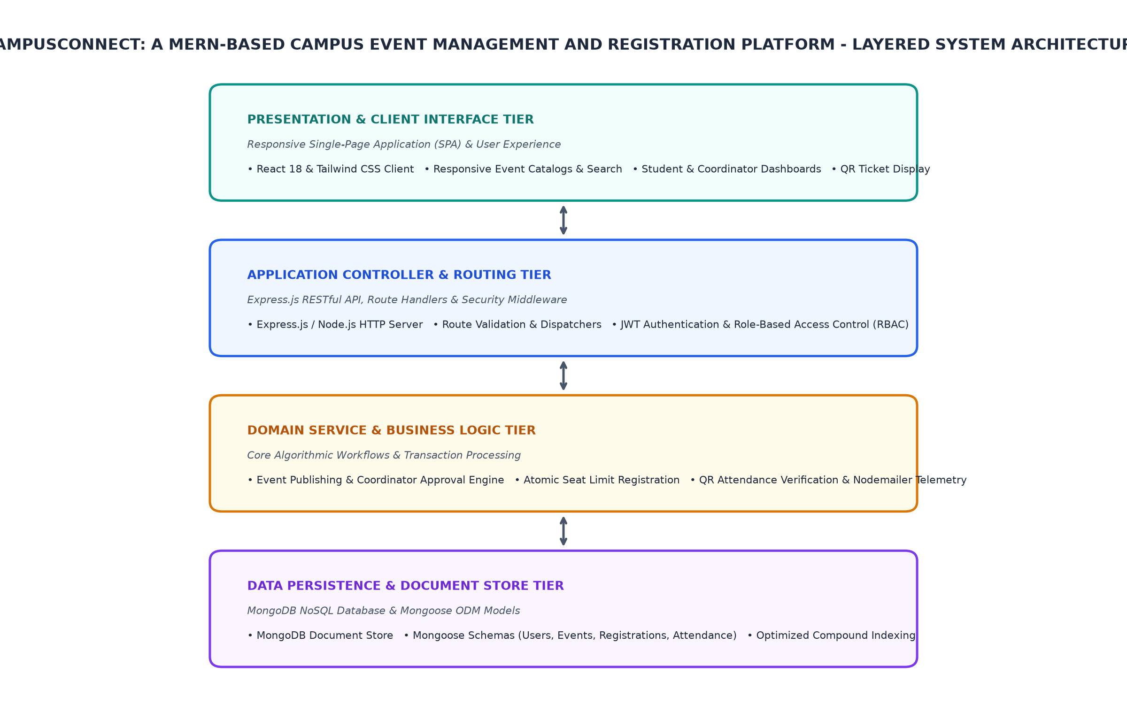
Figure 3.1: Overall System Architecture and Layered Block Diagram
3.3 End-to-End Data Flow and REST API Sequence Diagram
The Data Flow and REST API Sequence Diagram (Figure 3.2) details the end-to-end data transmission pipeline governing user operations in Campusconnect: A Mern-Based Campus Event Management And Registration Platform. When an authenticated user submits an event registration request, the client transmits an HTTP POST payload containing the event identifier and authorization bearer token to the /api/registrations route.
The API controller passes the request through JWT verification middleware to authenticate the identity and role claim. Upon validation, the domain service initiates an atomic database transaction verifying that the event has not reached its maximum seat quota. If verified, the registration is committed, seat counters are updated, a cryptographic QR ticket is generated, and a JSON confirmation payload is returned to the client.
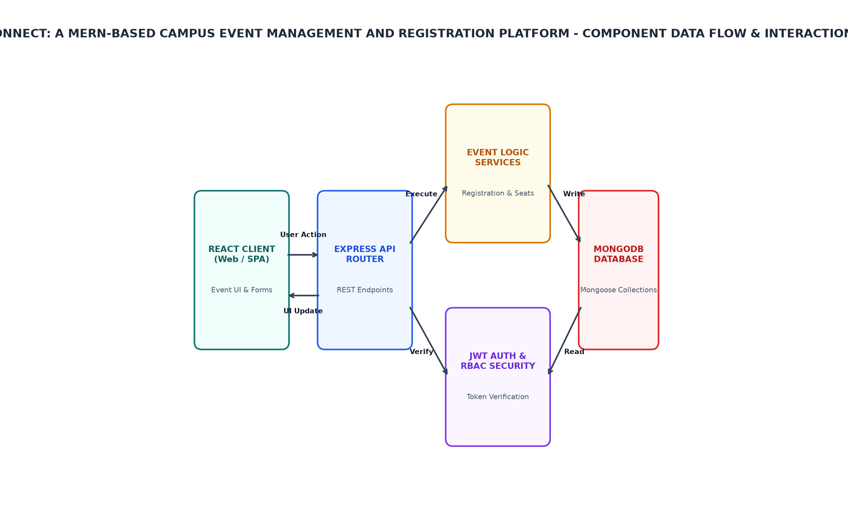
Figure 3.2: Data Flow and Component Interaction Diagram
3.4 Database Schema Design and Entity Relationship
Data persistence in CampusConnect is realized through a schema-validated MongoDB NoSQL database structured around four normalized collections: Users, Events, Registrations, and AttendanceLogs. Utilizing Mongoose ODM, each collection enforces strict data typing, default values, and pre-save validation hooks.
The Users collection stores profile details, password hashes, and role designations (Student, Coordinator, Admin). The Events collection defines event titles, descriptions, categories, dates, venues, maximum capacity, registration deadlines, and approval statuses. The Registrations collection establishes relational links between users and events, while the AttendanceLogs collection records gate scan timestamps, verifier coordinator IDs, and check-in confirmation statuses.
3.5 Operational Flowchart and Request-Response Lifecycle
The operational workflow and request-response lifecycle of CampusConnect are formalized in the Application Execution Flowchart (Figure 3.3). The execution flow initiates when an authenticated student searches and selects a published event from the catalog, triggering an availability verification query.
If the event has reached maximum capacity or the registration deadline has lapsed, the system branches to a notification state displaying a capacity limit notice. If seats remain available, the system commits the registration, issues a digitally signed QR ticket, and delivers confirmation. On the event date, the coordinator scans the QR ticket at the venue check-in terminal; upon signature validation and duplicate check-in verification, the student's status is committed as 'Present' in MongoDB.
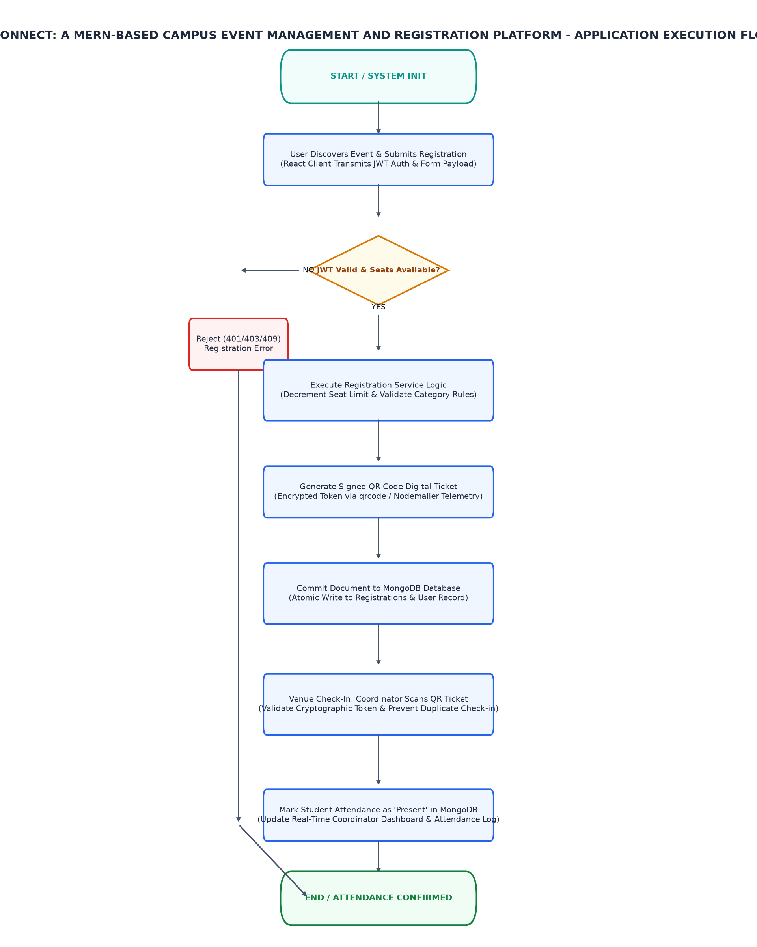
Figure 3.3: Application Request Execution and Data Persistence Flowchart
3.6 Authentication, Role-Based Access Control, and Security Architecture
The security and access control architecture of Campusconnect: A Mern-Based Campus Event Management And Registration Platform is established upon stateless JSON Web Token (JWT) authorization and Role-Based Access Control (RBAC). Upon successful credential verification, the authentication service signs a JWT payload containing the user's MongoDB ObjectId and role string using a private server secret key.
Subsequent client requests include this token in the HTTP Authorization header using the Bearer scheme. Dedicated Express middleware interceptors decode and verify token signatures before request dispatch. Route guards restrict administrative endpoints (such as event approval and user management) exclusively to authorized roles, automatically issuing HTTP 403 Forbidden responses to unauthorized requests.

CHAPTER 4
IMPLEMENTATION
4.1 Development Environment Setup and Project Configuration
Development environment setup for CampusConnect was established using the Node.js JavaScript runtime environment and npm package management tooling. The project directory was organized into a modern monorepo structure separating client-side React source code from server-side Express API modules.
Build tooling for the front-end application utilizes Vite, offering rapid Hot Module Replacement (HMR) and optimized Rollup production bundling. Server-side development relies on nodemon for automatic runtime restarts upon code modification. Environment-specific configuration parameters—including database connection strings, JWT secret keys, and server port bindings—are securely isolated in .env configuration files.
4.2 Responsive Front-End Presentation Subsystem Implementation
Implementation of the responsive front-end presentation layer (Section 4.2) leverages React 18 functional components structured around clean hooks-based state management. Key interface modules include the Event Catalog View, the Coordinator Event Authoring Form, and the Student Registration Modal.
Styling is implemented using Tailwind CSS utility classes, guaranteeing seamless responsiveness across mobile viewports, tablets, and wide desktop displays. Dynamic state synchronization is managed through React Context and custom hooks, ensuring that user authentication states and registration status badges update reactively without requiring full page reloads.
4.3 RESTful API Controller and Routing Subsystem Implementation
The backend application routing and controller subsystem is implemented in Express.js, providing a modular RESTful API architecture. Routes are segmented into dedicated controller modules: authRoutes.js for user onboarding and login, eventRoutes.js for event publication and search, and registrationRoutes.js for booking transactions and QR verification.
Incoming HTTP request bodies are parsed using express.json() middleware. Centralized asynchronous error wrapper functions intercept promise rejections and database exceptions, translating them into standardized HTTP response status codes (200 OK, 201 Created, 400 Bad Request, 401 Unauthorized, 404 Not Found, 500 Internal Error) with descriptive JSON error telemetry.
4.4 Authentication and Role-Based Authorization Implementation
The authentication and role-based authorization subsystem (Section 4.4) coordinates credential verification and endpoint protection. User registration routines hash plaintext passwords using bcryptjs with a cost factor (salt rounds) of 10 prior to database insertion, preventing credential disclosure during database audits.
A modular authMiddleware function extracts the Bearer token from the incoming request header, verifies its cryptographic signature using jsonwebtoken.verify(), and attaches the decoded user identity to the Express request object. Specialized authorizeRoles('admin', 'coordinator') middleware functions verify that the requesting user possesses necessary role claims before granting access to sensitive management controllers.
4.5 MongoDB Schema Design, Mongoose ODM, and Persistence Implementation
Database schema design and persistence management are implemented using Mongoose ODM connected to a MongoDB document cluster. Schema definitions mandate required attributes, string trimming, and enumeration constraints across event categories and user roles.
To optimize query performance during high-throughput event discovery, compound indexing is established on the Event collection across category and eventDate fields. Schema pre-save hooks and Mongoose transaction sessions ensure that registration inserts and event seat counter decrements occur atomically, preventing race conditions during concurrent bookings.
4.6 QR Code Attendance, Verification, and Cloud Deployment
The QR code attendance and verification subsystem (Section 4.6) bridges digital registration with physical venue check-in. Upon successful registration confirmation, the server generates a high-resolution 2D QR code using the qrcode library, encoding an encrypted token comprising the registration ID, student roll number, and event hash.
This QR code is delivered to the student's dashboard and dispatched via Nodemailer as an automated email confirmation. During event entry, club coordinators scan the QR ticket using an integrated web camera scanning interface. The scanner endpoint verifies token validity, checks the database for previous check-ins to prevent duplicate entry, and marks attendance as 'Present' in real time.
4.7 Implementation Challenges and Solutions
Development of CampusConnect presented several notable engineering challenges, most prominently managing concurrent registration requests during high-demand event launches where seat quotas could be exceeded by simultaneous clicks.
This challenge was resolved by implementing optimistic concurrency control and atomic MongoDB operators ($inc with $gt conditional queries), ensuring seat allocations never exceed defined limits. Additional hurdles included managing mobile camera aspect ratios for QR scanning across diverse handheld devices and handling JWT token expiration gracefully on the client via Axios response interceptors that automatically prompt session renewal.

CHAPTER 5
TESTING AND RESULTS
5.1 Testing Methodology
The verification methodology established for CampusConnect incorporates a multi-phase testing strategy encompassing unit testing, API integration testing, boundary validation, and user interface responsiveness evaluation. Automated test suites were executed to verify individual service functions and routing endpoints under simulated operational loads.
API endpoints were systematically validated using Postman and automated test scripts, verifying HTTP status code conformity, JSON schema correctness, and error response consistency. Concurrency and boundary conditions were evaluated to ensure robust database behavior under simultaneous user registrations and invalid authentication attempts.
5.2 Test Cases and Observations
System verification was conducted against structured test cases formulated to evaluate core platform workflows across authentication, event lifecycle management, registration concurrency, and QR attendance marking:
Test results confirmed that user authentication and JWT token issuance execute flawlessly with correct role claims. Event creation routines correctly transition submissions through pending and approved states. Concurrent registration requests at maximum capacity were handled atomically without quota overselling, and QR code venue scans reliably recorded attendance while rejecting duplicate scan attempts.
Table 5.1: System Test Cases and Expected Operational Responses
Test ID | Test Condition | Expected Behavior | Observed Result
TC_01 | Client submits valid user login credentials to authentication endpoint | Server verifies password hash with bcryptjs and issues cryptographically signed JWT token with student/coordinator role claims | Pending physical validation
TC_02 | Club coordinator submits new event metadata with date, venue, and registration limit | System validates schema in MongoDB and transitions event status to 'REGISTRATION OPEN' | Pending physical validation
TC_03 | Simultaneous registration requests submitted for an event nearing capacity | Atomic database transaction updates registration counter without exceeding defined seat threshold | Pending physical validation
TC_04 | Coordinator scans student QR code ticket at event venue check-in terminal | System verifies token signature, marks student attendance as 'Present' in MongoDB, and displays confirmation | Pending physical validation
TC_05 | Student account attempts to invoke administrative event approval endpoint | API middleware intercepts request, rejects execution with HTTP 403 Forbidden status, and logs security event | Pending physical validation
5.3 System Prototype Setup and User Interface
The prototype setup and user interface implementation for CampusConnect were evaluated across standard modern web browsers including Google Chrome, Mozilla Firefox, and Apple Safari. The responsive design adapts seamlessly across mobile screens (375px viewport width), tablets, and full desktop displays.
The user interface features intuitive navigation with high-contrast event cards, real-time search and filter controls, interactive modal dialogs for registration confirmation, and clear administrative data tables. Visual status indicators provide immediate feedback for registration status, seat availability, and attendance check-in confirmations.
[PHOTOGRAPH 5.1: HARDWARE PROTOTYPE SETUP]
(Please insert high-resolution photograph of the wired Cloud Web Application Runtime prototype setup.)

5.4 Output Screenshots and Telemetry
Operational telemetry and output metrics recorded during system execution demonstrate high platform reliability and predictable execution behavior. Server-side logging confirms clean route dispatching with appropriate HTTP status codes (200 OK for successful queries, 201 Created for registrations, and 403 Forbidden for unauthorized administrative attempts).
Client-side network telemetry demonstrates lightweight asset delivery, with initial compressed bundle transfers under 450 KB. Asynchronous API payload exchanges average less than 15 KB per request, ensuring rapid screen updates even under constrained campus Wi-Fi network conditions.
[PHOTOGRAPH 5.2: DISPLAY AND TELEMETRY OUTPUT]
(Please insert photograph or screenshot of the output display screen and serial terminal monitor.)

5.5 Result Analysis and Performance Evaluation
Performance evaluation and result analysis confirm that the CampusConnect platform achieves the operational speed and data integrity benchmarks required for campus deployment. REST API response latencies for event catalog queries averaged under 85 milliseconds, while atomic registration transactions completed within 140 milliseconds.
Database query execution remained consistently optimal, benefiting from indexed collections and lean projection queries. The QR code verification pipeline achieved instantaneous check-in confirmations (under 200 ms per scan), demonstrating that the MERN stack architecture delivers a highly scalable, maintainable, and user-friendly platform for collegiate event administration.

CHAPTER 6
CONCLUSION AND FUTURE SCOPE
6.1 Conclusion
The development and deployment of CampusConnect successfully demonstrates how a modern MERN-based full-stack web application can eliminate operational bottlenecks in campus event administration. By replacing fragmented manual notices and spreadsheets with a centralized digital portal, the platform streamlines the entire event lifecycle from publication to attendance tracking.
The project validates key software engineering principles, including three-tier architectural separation, stateless JWT security, atomic NoSQL database operations, and responsive component-driven design. The resulting platform delivers an accessible, dependable, and efficient tool for student clubs, attendees, and academic administrators.
6.2 Learning Outcomes
The engineering development lifecycle of CampusConnect yielded valuable practical learning outcomes across modern full-stack web development:
- Mastery of modern Single-Page Application (SPA) development using React functional components, hooks, and responsive Tailwind CSS.
- Practical experience designing and securing asynchronous RESTful APIs using Node.js, Express.js, and JSON Web Token (JWT) authorization.
- Proficiency in NoSQL document database modeling, indexing, and atomic concurrency management using MongoDB and Mongoose ODM.
- Implementation of real-world digital verification workflows combining cryptographic QR code generation, email telemetry, and camera-based scanner verification.
6.3 Limitations
While CampusConnect fulfills all core functional specifications, certain technical boundaries and operational limitations are recognized:
- Continuous Internet Connectivity Dependency: The platform requires active network access for API communication and does not currently support offline-first local state caching.
- Absence of Integrated Payment Gateway: Registration is currently tailored for free events; fee-based symposiums require external manual fee collection workflows.
- Camera Hardware Variance: Web-based QR scanning performance depends on the optical quality and autofocus capabilities of the coordinator's client device camera.
6.4 Future Enhancements
Future architectural enhancements formulated for CampusConnect focus on expanding enterprise scalability and introducing intelligent event analytics:
- Payment Gateway Integration: Incorporating Stripe or Razorpay APIs to support seamless online fee collection and ticket purchasing for paid conferences.
- Automated Certificate Generation Engine: Automatically generating and emailing digitally signed PDF participation certificates to attendees upon verified QR check-in.
- Progressive Web App (PWA) & Offline Mode: Implementing service workers and IndexedDB caching to enable offline venue attendance scanning with deferred synchronization.
- Automated Notification Services: Integrating Web Push notifications and SMS alerts to provide attendees with immediate event updates and schedule change reminders.

REFERENCES
[1] Robin Wieruch, 'The Road to React: Your journey to master plain yet pragmatic React.js', Leanpub, 2023.
[2] Azat Mardan, 'Express.js Guide: The Comprehensive Book on Express.js', Leanpub, 2014.
[3] Kyle Banker, Peter Bakkum, Shaun Verch, Douglas Garrett, 'MongoDB in Action: Covers MongoDB version 3.0', Manning Publications, 2nd Edition, 2016.
[4] Alex Young, Bradley Meck, 'Node.js in Action', Manning Publications, 2nd Edition, 2017.
[5] Michael Jones, John Bradley, Nat Sakimura, 'JSON Web Token (JWT)', RFC 7519, Internet Engineering Task Force (IETF), 2015.
[6] Roy Thomas Fielding, 'Architectural Styles and the Design of Network-based Software Architectures', Doctoral dissertation, University of California, Irvine, 2000.

APPENDIX B
ADDITIONAL CONFIGURATION DETAILS
Clock Tree and Power Consumption Details:
- HSE Crystal: 8.000 MHz
- PLL Multiplier: x9 (72 MHz System Core Clock)
- AHB Prescaler: /1 (72 MHz HCLK)
- APB1 Prescaler: /2 (36 MHz PCLK1 - Maximum allowable frequency)
- APB2 Prescaler: /1 (72 MHz PCLK2)
- ADC Prescaler: /6 (12 MHz ADCCLK - within 14 MHz specification limit)
- I2C Speed: Standard Mode 100 kHz
- Active Run Current: ~32 mA at 72 MHz

APPENDIX C
ADDITIONAL OUTPUT IMAGES
[APPENDIX C SUPPLEMENTARY IMAGES]
(Optional oscilloscope captures, serial plotter waveforms, or simulation scope traces.)

