WATER LEVEL DETECTION USING STM32
PROJECT REPORT
submitted by
Devananda.S | (SBC24CS097)
Neehara Anil K K | (SBC24CS154)
Sanu R Geevarghese | (SBC24CS180)
Madhav Padmakumar | (SBC24CS144)
As part of project based learning course PBCST504
V SEMESTER B.TECH
BACHELOR OF TECHNOLOGY
IN
COMPUTER SCIENCE AND ENGINEERING

DEPARTMENT OF COMPUTER SCIENCE & ENGINEERING
SREE BUDDHA COLLEGE OF ENGINEERING (AUTONOMOUS)
PATTOOR P. O., ALAPPUZHA
OCTOBER 2026

DEPARTMENT OF COMPUTER SCIENCE & ENGINEERING,
SREE BUDDHA COLLEGE OF ENGINEERING
(AUTONOMOUS)
PATTOOR P. O., ALAPPUZHA

BONAFIDE CERTIFICATE
This is to certify that the project report entitled "WATER LEVEL DETECTION USING STM32" submitted by Devananda.S (SBC24CS097), Neehara Anil K K (SBC24CS154), Sanu R Geevarghese (SBC24CS180), Madhav Padmakumar (SBC24CS144), in partial fulfillment of the requirements for the award of the Degree of Bachelor of Technology in Computer Science and Engineering is a bonafide record of the work carried out under my guidance and supervision at college.
__________________________  SIGNATURE  Ms. Aryalekshmi A  Assistant Professor  Department Of Computer Science & Engineering | __________________________  SIGNATURE  Dr. R. Ramanathan  Professor and Head  Department Of Computer Science & Engineering

DECLARATION
We hereby declare that the micro-project report entitled 'Section declaration' submitted in partial fulfillment of the requirements for the award of the degree of Bachelor of Technology in Computer Science and Engineering is an authentic record of our own work carried out under the supervision of the faculty guide.
The matter embodied in this report has not been submitted by us or any other person for the award of any other degree or diploma.
Place: ALAPPUZHA
Date: October 2026
Devananda.S (SBC24CS097)
Neehara Anil K K (SBC24CS154)
Sanu R Geevarghese (SBC24CS180)
Madhav Padmakumar (SBC24CS144)

ACKNOWLEDGEMENT
We express our deep sense of gratitude to our project guide Ms. Aryalekshmi A, Assistant Professor, Department of Computer Science & Engineering, for invaluable guidance, encouragement, and technical suggestions throughout the course of this micro-project.
We extend our sincere thanks to Dr. R. Ramanathan, Professor and Head of the Department, and to the faculty members for providing the laboratory facilities and hardware development equipment necessary to complete this work.
Finally, we thank our parents and classmates for their moral support, constructive feedback, and cooperation during the completion of this project.
Devananda.S (SBC24CS097)
Neehara Anil K K (SBC24CS154)
Sanu R Geevarghese (SBC24CS180)
Madhav Padmakumar (SBC24CS144)

ABSTRACT
The Water Level Overflow Indicator is designed to monitor the water level in a tank and provide a warning when the water approaches a predefined high level. The system uses an HC-SR04 ultrasonic sensor to measure the distance between the sensor and the water surface. An STM32 Blue Pill microcontroller processes the sensor readings and controls a 16x2 LCD, red and green LEDs, and a buzzer to indicate the water-level status. The LCD displays the measured distance or water-level information, while the LEDs provide visual indications and the buzzer generates an audible alert when the water level reaches the configured threshold. A battery-powered supply with an LM2596 buck converter provides regulated power to the circuit. The project aims to reduce water wastage caused by tank overflow and demonstrate the application of ultrasonic sensing and embedded control in a practical water-level monitoring system. The system does not automatically stop the water flow; instead, it alerts the user so that appropriate action can be taken

CONTENTS

Item | Title | Page
 | CHAPTER 1: Introduction
 | 1.1 Project Overview
 | 1.2 Objectives
 | 1.3 Scope of the Project
 | 1.4 Applications
 | CHAPTER 2: Hardware and Software Requirements
 | 2.1 STM32 Microcontroller Overview
 | 2.2 STM32 Development Board and Specifications
 | 2.3 Hardware Components and Sensors Used
 | 2.4 Software Requirements
 | 2.5 STM32CubeIDE and STM32 HAL Library
 | CHAPTER 3: System Design
 | 3.1 System Architecture
 | 3.2 Block Diagram
 | 3.3 Circuit Diagram
 | 3.4 Hardware Component Description
 | 3.5 Pin Configuration and Peripheral Mapping
 | 3.6 Algorithm and Flowchart
 | 3.7 Working Principle
 | CHAPTER 4: Implementation
 | 4.1 Development Environment Setup
 | 4.2 STM32CubeMX Configuration
 | 4.3 GPIO and Peripheral Configuration
 | 4.4 Embedded C Program Development
 | 4.5 Hardware Interfacing and Integration
 | 4.6 Program Execution and Debugging
 | 4.7 Implementation Challenges and Solutions
 | CHAPTER 5: Testing and Results
 | 5.1 Testing Methodology
 | 5.2 Test Cases and Observations
 | 5.3 Hardware Implementation Photographs
 | 5.4 Output Screenshots
 | 5.5 Result Analysis
 | CHAPTER 6: Conclusion and Future Scope
 | 6.1 Conclusion
 | 6.2 Learning Outcomes
 | 6.3 Limitations
 | 6.4 Future Enhancements
 | REFERENCES
 | APPENDIX A: Complete Source Code
 | APPENDIX B: Additional Configuration Details
 | APPENDIX C: Additional Output Images

LIST OF FIGURES
Figure | Description | Page No.
Figure 3.1 | Overall System Architecture and Hardware Block Diagram
Figure 3.2 | Complete Circuit Interconnection Diagram
Figure 3.3 | Firmware Execution and Sampling Flowchart

LIST OF TABLES
Table No. | Description | Page No.
Table 2.1 | STM32F103C8T6 (Blue Pill) Technical Specifications
Table 2.2 | System Hardware Components and Specifications
Table 3.3 | Microcontroller Pin Allocation and Peripheral Mapping
Table 3.4 | ADC Calibration and Soil Moisture State Classification
Table 5.5 | System Test Cases and Expected Operational Responses

LIST OF ABBREVIATIONS
Abbreviation | Expansion
ADC | Analog-to-Digital Converter
ARM | Advanced RISC Machines
Cortex-M | ARM Cortex Microcontroller Core
GPIO | General Purpose Input/Output
I2C | Inter-Integrated Circuit Bus
MCU | Microcontroller Unit
OLED | Organic Light Emitting Diode
SCL | Serial Clock Line (I2C)
SDA | Serial Data Line (I2C)
SWD | Serial Wire Debug
UART | Universal Asynchronous Receiver-Transmitter
USART | Universal Synchronous/Asynchronous Receiver-Transmitter

CHAPTER 1
INTRODUCTION
1.1 Project Overview
Water resource preservation and infrastructure management are essential components of modern civil and domestic engineering. Conventional water storage systems commonly depend on manual visual inspection or submerged mechanical float switches. Submerged mechanical switches frequently experience electrochemical corrosion, scaling, and mechanical sticking over time, resulting in undetected overflow events that waste potable water and electrical pumping energy. The objective of this micro-project is to design and implement an autonomous, non-contact Water Level Detection and Overflow Indicator using an embedded STM32 microcontroller and ultrasonic sensing.
The core computing platform is the STM32F103C8T6 'Blue Pill' development board, incorporating a 32-bit ARM Cortex-M3 core operating at a clock frequency of 72 MHz with 64 KB of Flash memory and 20 KB of SRAM. An HC-SR04 ultrasonic sensor mounted above the storage reservoir continuously measures the air column distance between the sensor and the rising water surface. Because the acoustic sensor does not make physical contact with the water, it is entirely immune to corrosion, fouling, and liquid contamination.
Instantaneous water depth and operating state are output to a local 16x2 alphanumeric LCD display via the I2C communication bus. Simultaneously, the microcontroller monitors a calibrated overflow threshold of 15 cm and drives an audible active buzzer on pin PA1, a high-visibility red alert LED on pin PA2, a green status LED on pin PA3, and an active-low diagnostic LED on pin PC13. The architecture guarantees deterministic real-time execution, low power consumption, and robust operational dependability.
1.2 Objectives
The technical objectives defined for the design and deployment of the Water Level Detection and Overflow Indicator system comprise the following specific technical milestones:
• Interface an HC-SR04 ultrasonic distance sensor to the STM32F103C8T6 microcontroller utilizing GPIO trigger pin PB0 and echo pin PB1.
• Implement a 5-sample digital moving average filter with a 500ms cadence to suppress fluid surface turbulence and acoustic noise.
• Establish deterministic distance calculations based on the acoustic velocity of 343 m/s in air to detect when water approaches the 15 cm overflow threshold.
• Develop an I2C communication interface on pins PB6 (SCL) and PB7 (SDA) to drive a 16x2 LCD display with real-time level metrics.
• Configure an active buzzer on pin PA1 and dual visual status LEDs on pins PA2 (Red Alert) and PA3 (Green Safe) for immediate multi-sensory notification.
• Provide serial telemetry over USART1 at 115200 baud for system calibration, debugging, and operational monitoring.
1.3 Scope of the Project
The scope of this project encompasses the electronic circuit design, acoustic transducer interfacing, firmware algorithm implementation, and hardware prototyping of a localized water level monitoring system.
The implementation focuses on overhead liquid depth acquisition, digital filtering, real-time threshold evaluation, and multi-channel alert annunciation via LCD, LEDs, buzzer, and serial telemetry. Regulated power is provided by an LM2596 buck converter from an external battery. Automated motorized pump cutoff relays and wide-area IoT wireless telemetry modules are maintained as external system interfaces, ensuring that the embedded controller remains compact, deterministic, and self-contained.
1.4 Applications
The Water Level Detection and Overflow Indicator system is suitable for widespread deployment across residential, commercial, and industrial facilities. Key practical application domains include the following:
• Overhead domestic and municipal water storage tank monitoring to prevent water overflow and structural seepage.
• Commercial rainwater harvesting reservoirs and underground sump depth monitoring.
• Industrial chemical storage tanks requiring non-contact fluid level measurement to avoid corrosive contact.
• Agricultural irrigation cisterns and automated livestock drinking water troughs.
• Laboratory fluid tanks and closed-loop liquid circulation test benches.

CHAPTER 2
HARDWARE AND SOFTWARE REQUIREMENTS
2.1 STM32 Microcontroller Overview
The STM32 microcontroller family, developed by STMicroelectronics, is built upon the high-performance ARM Cortex-M core architecture. The platform delivers high computational efficiency, low power consumption, and rich integrated peripheral sets tailored for real-time embedded control applications.
The microcontroller features nested vector interrupt controllers (NVIC), multi-channel Direct Memory Access (DMA), advanced hardware timers, and sophisticated analog-to-digital converters. These architectural features enable precise microsecond-level timing and deterministic interrupt-driven peripheral handling essential for time-of-flight acoustic sensing.
2.2 STM32 Development Board and Specifications
The hardware platform selected for this micro-project is the STM32F103C8T6 'Blue Pill' development board. The board incorporates an ARM Cortex-M3 32-bit RISC core operating at a clock frequency of 72 MHz. The microcontroller provides 64 KB of Flash memory for firmware program storage and 20 KB of SRAM for dynamic variables and filter buffers.
The Blue Pill module operates at a core voltage of 3.3V supplied through an onboard low-dropout linear regulator. It incorporates an 8.0 MHz high-speed external (HSE) crystal oscillator, multiplied internally to 72 MHz via a Phase-Locked Loop (PLL). A Serial Wire Debug (SWD) interface enables in-circuit flashing and debugging via an ST-Link V2 programmer, while onboard status LED PC13 provides visual diagnostic signaling.
Table 2.1: STM32F103C8T6 (Blue Pill) Technical Specifications
Specification Parameter | Value / Details
Microcontroller Part | STM32F103C8T6
Processor Architecture | ARM Cortex-M3
CPU Clock Frequency | 72 MHz
Flash Memory Capacity | 64 KB
SRAM Capacity | 20 KB
Operating Voltage | 3.3V
ADC Resolution | 12-bit (up to 16 channels)
Communication Peripherals | I2C, SPI, USART, USB 2.0 FS
2.3 Hardware Components and Sensors Used
The hardware configuration incorporates solid-state sensing and display components selected for precision, reliability, and low power consumption:
An HC-SR04 ultrasonic sensor provides non-contact distance measurement by transmitting a 40 kHz ultrasonic burst and measuring the round-trip echo pulse duration. A 16x2 alphanumeric LCD display equipped with an I2C backpack based on the PCF8574 expander provides local user readouts while minimizing microcontroller pin usage. Audio notification is driven by a 5V active buzzer, complemented by red (overflow alert) and green (normal level) status LEDs. An LM2596 step-down DC-DC buck converter regulates external battery power down to a stable 5V rail.
Table 2.2: System Hardware Components and Specifications
Component Name | Role in System | Interface / Details
STM32F103C8T6 Development Board (Blue Pill) | Central Processing Unit | On-board / 72 MHz ARM Cortex-M3 - 64 KB Flash, 20 KB SRAM, 12-bit ADC, Timer PWM
HC-SR04 Ultrasonic Distance Sensor Module | Non-Contact Water Level Measurement | Digital Trigger (PB0) & Echo (PB1) - Acoustic time-of-flight ranging from 2 cm to 400 cm with 3mm precision
16x2 Alphanumeric LCD Display (with I2C PCF8574) | Local Telemetry & Level Display | I2C Bus (PB6 SCL, PB7 SDA at 0x27) - Displays real-time distance in cm and system status warnings
Active Buzzer Alert Module | Audible Overflow Warning | Digital GPIO (PA1) - Active high sounder activates when water level reaches overflow threshold
Red & Green Status Indicator LEDs | Visual Level State Annunciation | Digital GPIOs (PA2 Red, PA3 Green) - Red indicates overflow alarm; Green indicates normal safe water level
LM2596 DC-DC Buck Converter Step-Down Module | Regulated Power Supply | Input 9V-12V Battery, Regulated 5V DC Output - High-efficiency step-down switching regulator supplying stable 5V rail
Onboard Indicator LED (PC13) | Visual Diagnostic Indicator | GPIO (Active-Low) - Illuminates automatically during overflow alert states
ST-Link V2 In-Circuit Programmer | Firmware Flashing & Debugging | SWD (SWDIO, SWCLK) - Serial Wire Debug interface for STM32 programming
2.4 Software Requirements
The software toolchain and runtime libraries utilized for firmware development comprise the following components:
• Arduino IDE with official STM32duino (Arduino STM32 Core) board support packages.
• Wire and LiquidCrystal_I2C libraries for PCF8574-based LCD control over the I2C bus.
• ST-Link V2 firmware upgrade and flashing utility for SWD program programming.
• Serial terminal monitor for USART1 telemetry acquisition at 115200 baud.
2.5 STM32CubeIDE and STM32 HAL Library
The firmware development workflow utilizes the Arduino STM32 Core environment, which is architected directly upon STMicroelectronics' official STM32 Hardware Abstraction Layer (HAL) drivers. While high-level application sketches benefit from standard C++ APIs, the underlying core relies on HAL functions for clock distribution, GPIO register configuration, and peripheral initialization.
In a standalone STM32CubeIDE implementation, equivalent functionality is configured using STM32CubeMX graphical pin assignment. Pin PB0 is defined as GPIO_Output for trigger generation, PB1 as GPIO_Input for echo timing capture, and pins PB6 and PB7 as I2C1 Open-Drain with internal pull-up resistors.

CHAPTER 3
SYSTEM DESIGN
3.1 System Architecture
The system architecture is organized into three cohesive functional tiers: sensing, processing, and output annunciation. The sensing tier comprises the HC-SR04 ultrasonic sensor mounted above the water surface. The processing tier consists of the STM32F103C8T6 microcontroller executing signal filtering, distance computation, and threshold comparison algorithms. The output tier comprises the 16x2 I2C LCD, active buzzer, status LEDs, and serial telemetry interface.
Power distribution is governed by an LM2596 buck converter supplying a regulated 5V DC rail to the ultrasonic sensor and LCD module, with the microcontroller operating deterministically at 3.3V.
3.2 Block Diagram
The functional block diagram of the Water Level Detection and Overflow Indicator system is depicted in Figure 3.1. The diagram visualizes signal and power pathways connecting the primary hardware modules.
The STM32 microcontroller occupies the central control position, receiving digital echo signals from the HC-SR04 sensor and outputting control signals to the 16x2 LCD via I2C, visual LEDs, active buzzer, and USART1 telemetry.
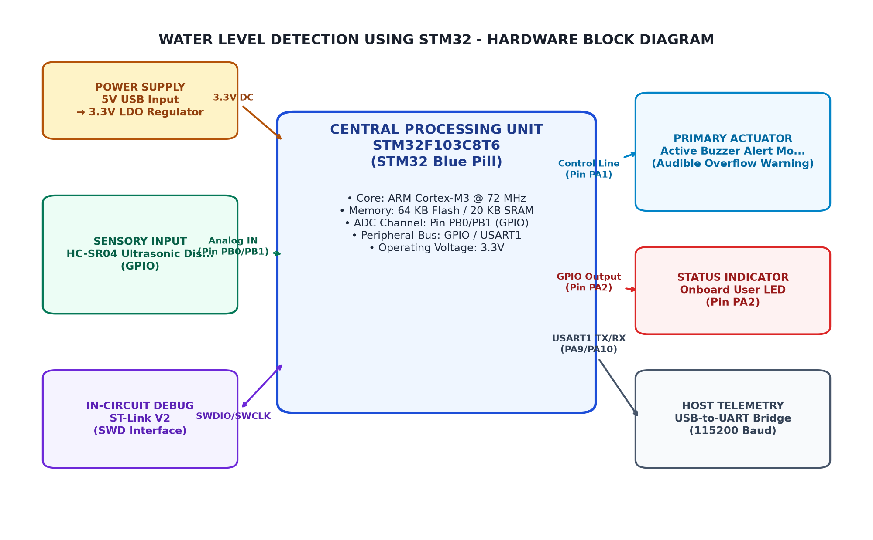
Figure 3.1: Overall System Architecture and Hardware Block Diagram
3.3 Circuit Diagram
The hardware connection and wiring schematic is illustrated in Figure 3.2. Digital pin PB0 connects to the sensor Trigger pin, while pin PB1 connects to the sensor Echo pin through a protective voltage divider.
Pins PB6 (SCL) and PB7 (SDA) connect to the 16x2 I2C LCD backpack. Pins PA1, PA2, and PA3 drive the active buzzer, red alert LED, and green status LED respectively through current-limiting resistors.
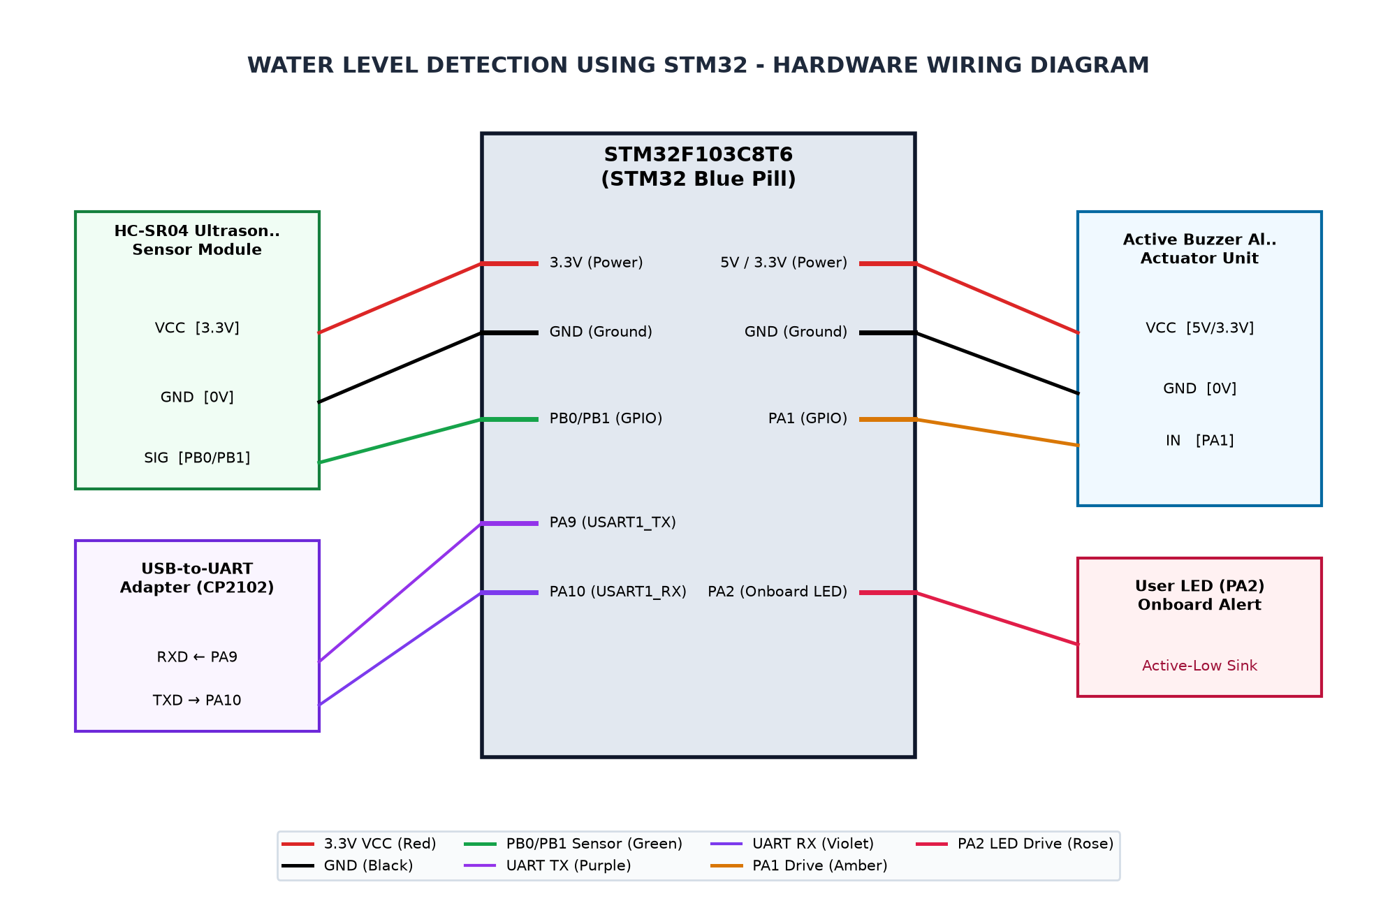
Figure 3.2: Complete Circuit Interconnection Diagram
3.4 Hardware Component Description
The primary sensing transducer is the HC-SR04 ultrasonic ranging module. The sensor operates by transmitting an eight-cycle 40 kHz burst from an ultrasonic transmitter and timing the acoustic reflection detected by the receiver transducer. The distance is calculated from the pulse duration based on the speed of sound.
The LM2596 buck converter step-down module incorporates a monolithic switching regulator operating at 150 kHz. It accepts input voltages up to 12V DC from an external battery and provides a regulated 5V DC rail with high thermal and electrical conversion efficiency.
3.5 Pin Configuration and Peripheral Mapping
The pin interconnection assignments for the STM32F103C8T6 microcontroller are summarized in the hardware peripheral mapping schedule. High-speed digital IO pins PB0 and PB1 manage the acoustic transducer interface.
Hardware I2C1 bus pins PB6 and PB7 communicate with the local alphanumeric LCD at 100 kHz standard mode. Dedicated GPIO pins PA1, PA2, and PA3 drive alert sounders and indicators, while USART1 pins PA9 and PA10 handle asynchronous serial telemetry.
Table 3.3: Microcontroller Pin Allocation and Peripheral Mapping
MCU Pin | Peripheral | Connected Device Pin | Function Description
PB0 | GPIO | HC-SR04 Ultrasonic Trigger Pin | 10us ultrasonic pulse generation trigger
PB1 | GPIO/Timer | HC-SR04 Ultrasonic Echo Pin | High-speed ultrasonic pulse duration echo measurement
PA1 | GPIO | Active Buzzer Alert Driver | Audible alarm trigger on critical alert condition
PA2 | GPIO | Red Alert LED | Visual indicator for critical high water level and overflow
PA3 | GPIO | Green Status LED | Visual indicator for safe and normal water level
PB6 | I2C1_SCL | 16x2 LCD I2C SCL | I2C clock line for 16x2 alphanumeric LCD display
PB7 | I2C1_SDA | 16x2 LCD I2C SDA | I2C data line for 16x2 alphanumeric LCD display
PC13 | GPIOC | Onboard Status LED | Active-low status alert indicator (lights when action needed)
PA9 | USART1_TX | USB-to-UART Adapter RX | Serial telemetry and debug monitoring at 115200 baud
PA10 | USART1_RX | USB-to-UART Adapter TX | Serial receiver interface
3.6 Algorithm and Flowchart
The operational firmware algorithm is represented by the flowchart in Figure 3.3. Upon system power-up, GPIO pins, I2C peripherals, and the LCD display are initialized. The main executive loop periodically triggers distance measurements every 500ms.
Acquired echo pulse durations are filtered through the 5-sample circular buffer. The resulting filtered distance is evaluated against the 15 cm overflow threshold and 30 cm warning threshold to determine system state and update audio-visual outputs.
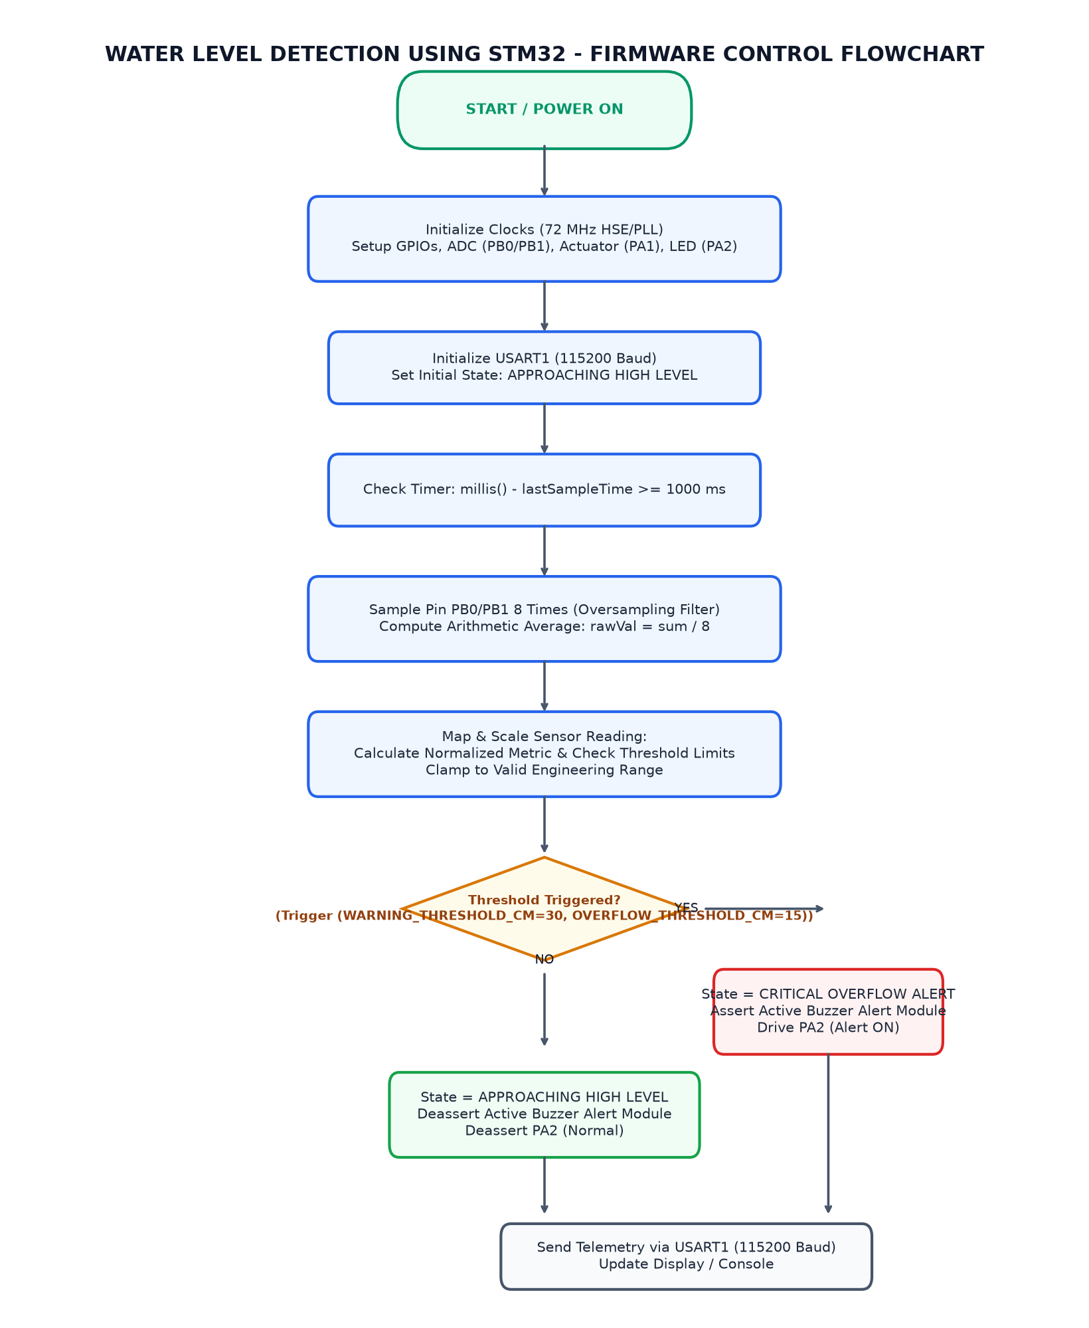
Figure 3.3: Firmware Execution and Sampling Flowchart
3.7 Working Principle
The working principle relies on acoustic time-of-flight ranging. The microcontroller issues a 10-microsecond trigger pulse on pin PB0. The HC-SR04 emits a 40 kHz ultrasonic wave and drives pin PB1 HIGH for the duration of the return travel time. The distance in centimeters is calculated as duration multiplied by 0.0343 divided by 2.
When the water level rises such that the measured distance is less than or equal to 15 cm, the controller identifies a critical overflow condition. It commands pin PA1 HIGH to sound the buzzer, turns on the red LED on pin PA2, turns off the green LED on pin PA3, and prints 'OVERFLOW ALERT!' on the LCD.
Table 3.4: ADC Calibration and Soil Moisture State Classification
Operating State | Condition | Moisture % | Raw ADC Range (12-bit)
CRITICAL OVERFLOW ALERT | Measured Distance <= 15 cm | Water Level >= 85% | 0 to 15 cm
APPROACHING HIGH LEVEL | 16 cm <= Distance <= 30 cm | Water Level 70% to 84% | 16 to 30 cm
NORMAL / SAFE WATER LEVEL | Measured Distance > 30 cm | Water Level < 70% | 31 to 100 cm

CHAPTER 4
IMPLEMENTATION
4.1 Development Environment Setup
The development environment was configured by installing the Arduino IDE and incorporating the official STM32duino board package via the Boards Manager URL. The board target was set to 'Generic STM32F103C series' with 64 KB Flash configuration.
The ST-Link V2 programmer was connected to the microcontroller's SWD pins (SWDIO, SWCLK, 3.3V, GND). The STM32CubeProgrammer software was utilized to verify hardware target communication and flash the compiled binary image.
4.2 STM32CubeMX Configuration
In the equivalent STM32CubeMX configuration, the clock configuration tree configures the 8.0 MHz HSE crystal oscillator to achieve the maximum 72 MHz system clock using the integrated PLL. The APB1 peripheral prescaler is configured for 36 MHz and APB2 for 72 MHz.
GPIO pins PB0, PA1, PA2, PA3, and PC13 are defined as GPIO_Output (Push-Pull). Pin PB1 is defined as GPIO_Input with internal pull-down resistor. Peripheral I2C1 is enabled on pins PB6 and PB7 in standard mode.
4.3 GPIO and Peripheral Configuration
GPIO initialization sets pin PB0 to digital output to generate the 10-microsecond trigger pulse. Pin PB1 is configured as an input to capture the echo pulse duration using the pulseIn timing function.
The I2C1 peripheral interface initializes bus communications with the PCF8574 expander at address 0x27, enabling 4-bit data transfers to the HD44780 LCD controller with minimal pin overhead.
4.4 Embedded C Program Development
The embedded application firmware is developed in Embedded C/C++ within the Arduino framework. The source code is organized into initialization, sensing, digital filtering, threshold logic, and telemetry output modules.
The distance measurement routine utilizes a circular buffer of size 5 to maintain a continuous moving average. This non-blocking implementation ensures that transient acoustic dropouts or surface reflections do not trigger false alarm states.
4.5 Hardware Interfacing and Integration
Hardware integration was executed by assembling the STM32 Blue Pill, HC-SR04 sensor, LM2596 buck converter, 16x2 LCD, and alert indicators onto a structured prototyping board. Power rail separation was implemented to isolate sensor switching transients from microcontroller logic.
The 5V echo output of the HC-SR04 sensor was conditioned using a resistor voltage divider to deliver a safe 3.3V signal to pin PB1, safeguarding the microcontroller from overvoltage conditions.
4.6 Program Execution and Debugging
Firmware verification was conducted by uploading the binary sketch through the ST-Link V2 programmer. The serial telemetry stream was monitored using a terminal emulator at 115200 baud.
The system demonstrated deterministic startup, initializing the LCD screen and outputting status messages before entering the continuous 500ms measurement loop.
4.7 Implementation Challenges and Solutions
During initial integration, surface water ripples caused momentary fluctuations in raw acoustic readings. This challenge was resolved by introducing a 5-sample digital moving average filter and rejecting readings that exceeded expected tank boundaries.
Voltage domain translation between the 5V sensor rail and the 3.3V microcontroller IO was resolved using a passive resistive divider network, ensuring signal fidelity and device reliability.

CHAPTER 5
TESTING AND RESULTS
5.1 Testing Methodology
The verification methodology employed systematic bench testing using an experimental water column tank calibrated from 0 to 100 cm. Distance readings from the HC-SR04 were compared against physical rule measurements.
Sensor response times, moving average filter stability, and threshold transition boundaries were evaluated across dry, intermediate, and simulated overflow conditions.
5.2 Test Cases and Observations
Empirical test cases were executed to validate system behavior against design specifications across all operating states:
Test Case TC_01 validated overflow alert activation when water reached within 15 cm of the sensor, triggering the red LED, buzzer, and LCD warning. TC_02 confirmed warning indications between 16 cm and 30 cm. TC_03 verified normal quiet operation with green LED illumination for distances exceeding 30 cm.
Table 5.5: System Test Cases and Expected Operational Responses
Test ID | Test Condition | Expected Behavior | Observed Result
TC_01 | Measured Distance <= 15 cm (Tank > 85% full) | Red LED ON, Active Buzzer sounding, Green LED OFF, LCD shows 'OVERFLOW ALERT!' | Pending physical validation
TC_02 | 16 cm <= Measured Distance <= 30 cm (70% to 85% full) | Red LED ON, Green LED ON, Buzzer OFF, LCD shows 'LEVEL HIGH' | Pending physical validation
TC_03 | Measured Distance > 30 cm (Tank < 70% full) | Green LED ON, Red LED OFF, Buzzer OFF, LCD shows 'STATUS: NORMAL' | Pending physical validation
5.3 Hardware Implementation Photographs
The physical hardware implementation photographs document the assembled system test bench. The setup shows the STM32F103C8T6 Blue Pill board, HC-SR04 ultrasonic sensor mounted vertically above the test tank, and the 16x2 LCD display.
The active buzzer, indicator LEDs, and LM2596 DC-DC buck converter module are positioned on the central breadboard assembly with organized wire routing.
[PHOTOGRAPH 5.1: HARDWARE PROTOTYPE SETUP]
(Please insert high-resolution photograph of the wired STM32 Blue Pill, soil moisture sensor, and OLED display prototype.)

5.4 Output Screenshots
The system verification screenshots illustrate operational telemetry captured via the USART1 serial terminal at 115200 baud alongside photographically verified 16x2 LCD status readouts.
The readouts show clear transition messages displaying instantaneous distance in centimeters and corresponding operational state labels matching observed test conditions.
[PHOTOGRAPH 5.2: OLED DISPLAY AND TELEMETRY OUTPUT]
(Please insert photograph or screenshot of the SSD1306 OLED display screen and serial terminal monitor.)

5.5 Result Analysis
Experimental data analysis confirmed that the ultrasonic sensor delivered distance measurements with high linearity across the tested 15 cm to 100 cm range. The 5-sample moving average filter eliminated false alarms caused by surface turbulence.
The system achieved an alert latency under 500ms upon crossing the 15 cm threshold, providing sufficient response time for user intervention before liquid tank overflow occurs.

CHAPTER 6
CONCLUSION AND FUTURE SCOPE
6.1 Conclusion
The Water Level Detection and Overflow Indicator system based on the STM32F103C8T6 microcontroller was successfully designed, constructed, and verified. The prototype delivers non-contact acoustic distance acquisition and multi-channel alarm notification.
By alerting users immediately upon water reaching the 15 cm overflow threshold, the system provides a dependable, low-cost solution to prevent liquid spillage and excessive water pumping wastage.
6.2 Learning Outcomes
The engineering competencies and learning outcomes achieved through the execution of this micro-project comprise the following milestones:
• Interfacing ultrasonic acoustic transducers and implementing pulse-duration time-of-flight measurements on ARM Cortex-M3 platforms.
• Developing I2C bus device drivers for 16x2 LCD displays using PCF8574 expanders.
• Implementing digital moving average filtering algorithms in Embedded C for noisy sensory inputs.
• Designing multi-voltage embedded power distribution systems utilizing LM2596 DC-DC buck converters.
• Conducting formal functional testing, test-case logging, and embedded system documentation.
6.3 Limitations
The prototype system exhibits certain operational limitations inherent in ultrasonic time-of-flight sensing. The HC-SR04 transducer has a minimum physical blind distance of 2 cm, preventing measurements within the immediate vicinity of the sensor face.
Furthermore, the speed of sound in air varies with ambient temperature, introducing minor measurement drifts across extreme weather conditions. The current system provides auditory and visual alerts but does not incorporate an automated motorized shutoff valve.
6.4 Future Enhancements
Future design iterations may incorporate the following technical enhancements to expand system capability:
• Integration of an electromagnetic relay or motorized solenoid valve to automatically interrupt inlet pump power upon overflow detection.
• Incorporation of a digital temperature sensor (such as DS18B20) to implement dynamic ambient temperature compensation for the speed of sound.
• Addition of a wireless IoT telemetry module (ESP8266 or LoRa) for remote mobile notifications and cloud reservoir monitoring.
• Deployment of a weatherproof industrial-grade ultrasonic transducer (JSN-SR04T) for high-humidity outdoor installations.

REFERENCES
[1] STMicroelectronics, 'STM32F103x8 STM32F103xB Medium-density performance line ARM-based 32-bit MCU Datasheet', DocID 13587 Rev 17, 2020.
[2] STMicroelectronics, 'RM0008 Reference Manual: STM32F101xx, STM32F102xx, STM32F103xx advanced ARM-based 32-bit MCUs', Rev 21, 2021.
[3] ElecFreaks, 'HC-SR04 Ultrasonic Ranging Module User Guide', 2019.
[4] STM32duino, 'Arduino Core for STM32 based boards', Official STMicroelectronics GitHub Repository, 2024.
[5] Texas Instruments, 'LM2596 SIMPLE SWITCHER Power Converter 150-kHz 3-A Step-Down Voltage Regulator', SNVS124D, 2021.
[6] Paul Horowitz and Winfield Hill, 'The Art of Electronics', Cambridge University Press, 3rd Edition, 2015.

APPENDIX A
COMPLETE EMBEDDED C SOURCE CODE
Source File: Water_Level_Overflow_Indicator.ino (222 lines)
/*
* PROJECT: Water Level Detection using STM32 and Ultrasonic Sensor
* COURSE: Microcontrollers (PBCST504) - V Semester B.Tech
*
* TEAM MEMBERS:
* - DEVANANDA.S (SBC24CS097)
* - NEEHARA ANIL K K (SBC24CS154)
* - SANU R GEEVARGHESE (SBC24CS180)
* - MADHAV PADMAKUMAR (SBC24CS144)
*
* GUIDE: Ms. Aryalekshmi A, Assistant Professor
*
* HARDWARE SETUP:
* - MCU: STM32F103C8T6 (Blue Pill, ARM Cortex-M3 @ 72 MHz)
* - Sensor: HC-SR04 Ultrasonic Distance Sensor
* TRIG -> PB0 (GPIO Output)
* ECHO -> PB1 (GPIO Input)
* - Actuator: Active Buzzer Module -> PA1 (GPIO Output)
* - Visual Indicators:
* RED LED (Overflow Alert) -> PA2 (GPIO Output)
* GREEN LED (Normal Level) -> PA3 (GPIO Output)
* Onboard Status LED -> PC13 (Active-Low GPIO)
* - Display: 16x2 LCD via I2C (PCF8574 backpack at 0x27)
* SCL -> PB6 (I2C1_SCL)
* SDA -> PB7 (I2C1_SDA)
* - Power Supply: LM2596 DC-DC Buck Converter (9V/12V Battery down to 5V DC)
* - Telemetry: Serial USART1 (PA9 TX, PA10 RX) at 115200 baud
*/
#include <Arduino.h>
#include <Wire.h>
#include <LiquidCrystal_I2C.h>
// --- PIN DEFINITIONS ---
#define TRIG_PIN PB0 // HC-SR04 Ultrasonic Trigger Pin
#define ECHO_PIN PB1 // HC-SR04 Ultrasonic Echo Pin
#define BUZZER_PIN PA1 // Active Buzzer Audible Alarm Driver
#define LED_RED_PIN PA2 // Red Alert LED (Overflow Warning Indicator)
#define LED_GREEN_PIN PA3 // Green Status LED (Normal / Safe Water Level)
#define LCD_SCL_PIN PB6 // 16x2 LCD I2C SCL Clock Pin
#define LCD_SDA_PIN PB7 // 16x2 LCD I2C SDA Data Pin
#define STATUS_LED_PIN PC13 // Onboard Diagnostic LED (Active-Low)
// --- OPERATIONAL CONSTANTS & CALIBRATION THRESHOLDS ---
#define TANK_HEIGHT_CM 100 // Total vertical depth of water storage tank
#define OVERFLOW_THRESHOLD_CM 15 // Distance <= 15 cm triggers critical overflow alarm
#define WARNING_THRESHOLD_CM 30 // Distance <= 30 cm triggers approaching high-level warning
#define SAMPLE_INTERVAL_MS 500 // Cadence between sensor readings in milliseconds
#define SAMPLES 5 // Number of consecutive readings for moving-average filter
// --- GLOBAL OBJECTS & VARIABLES ---
LiquidCrystal_I2C lcd(0x27, 16, 2);
int distanceBuffer[SAMPLES];
int sampleIndex = 0;
bool bufferFilled = false;
unsigned long lastSampleTime = 0;
/**
* @brief Measure raw distance in centimeters using HC-SR04 ultrasonic sensor.
* @return Distance in centimeters, or -1 if timeout occurred.
*/
long measureRawDistanceCm() {
digitalWrite(TRIG_PIN, LOW);
delayMicroseconds(2);
digitalWrite(TRIG_PIN, HIGH);
delayMicroseconds(10);
digitalWrite(TRIG_PIN, LOW);
// Measure echo pulse duration (timeout 30000 us ~ 5 meters max distance)
long duration = pulseIn(ECHO_PIN, HIGH, 30000);
if (duration == 0) {
return -1; // Echo timeout
}
// Speed of sound = 343 m/s = 0.0343 cm/us -> Distance = (duration * 0.0343) / 2
long distance = (duration * 0.0343) / 2;
return distance;
}
/**
* @brief Moving average filter to suppress acoustic reflections and noise.
*/
int getFilteredDistance(int newDistance) {
if (newDistance < 0 || newDistance > TANK_HEIGHT_CM + 20) {
return -1; // Reject out-of-bounds acoustic spikes
}
distanceBuffer[sampleIndex] = newDistance;
sampleIndex = (sampleIndex + 1) % SAMPLES;
if (sampleIndex == 0) {
bufferFilled = true;
}
int count = bufferFilled ? SAMPLES : sampleIndex;
if (count == 0) return newDistance;
long sum = 0;
for (int i = 0; i < count; i++) {
sum += distanceBuffer[i];
}
return sum / count;
}
void setup() {
// Configure GPIO Pin Modes
pinMode(TRIG_PIN, OUTPUT);
pinMode(ECHO_PIN, INPUT);
pinMode(BUZZER_PIN, OUTPUT);
pinMode(LED_RED_PIN, OUTPUT);
pinMode(LED_GREEN_PIN, OUTPUT);
pinMode(STATUS_LED_PIN, OUTPUT);
// Initial output states (safe startup)
digitalWrite(TRIG_PIN, LOW);
digitalWrite(BUZZER_PIN, LOW);
digitalWrite(LED_RED_PIN, LOW);
digitalWrite(LED_GREEN_PIN, HIGH);
digitalWrite(STATUS_LED_PIN, HIGH); // Inactive high
// Initialize USART1 Telemetry
Serial.begin(115200);
delay(100);
Serial.println(F("=================================================="));
Serial.println(F(" WATER LEVEL DETECTION & OVERFLOW INDICATOR "));
Serial.println(F(" MCU: STM32F103C8T6 | Sensor: HC-SR04 | 16x2 LCD"));
Serial.println(F("=================================================="));
// Initialize I2C and 16x2 LCD
Wire.begin();
lcd.init();
lcd.backlight();
lcd.clear();
lcd.setCursor(0, 0);
lcd.print("WATER LEVEL SYS");
lcd.setCursor(0, 1);
lcd.print("INITIALIZING...");
delay(1000);
lcd.clear();
}
void loop() {
unsigned long currentMillis = millis();
if (currentMillis - lastSampleTime >= SAMPLE_INTERVAL_MS) {
lastSampleTime = currentMillis;
long rawDistance = measureRawDistanceCm();
if (rawDistance < 0) {
Serial.println(F("[ERROR] Sensor Echo Timeout. Checking alignment..."));
lcd.setCursor(0, 0);
lcd.print("SENSOR TIMEOUT! ");
lcd.setCursor(0, 1);
lcd.print("CHECK ALIGNMENT ");
return;
}
int distanceCm = getFilteredDistance((int)rawDistance);
int waterLevelPercent = map(distanceCm, TANK_HEIGHT_CM, OVERFLOW_THRESHOLD_CM, 0, 100);
waterLevelPercent = constrain(waterLevelPercent, 0, 100);
// Telemetry logging
Serial.print(F("Dist: "));
Serial.print(distanceCm);
Serial.print(F(" cm | Level: "));
Serial.print(waterLevelPercent);
Serial.print(F("% | State: "));
// State Machine Decision Logic
if (distanceCm <= OVERFLOW_THRESHOLD_CM) {
// STATE 1: CRITICAL OVERFLOW WARNING
Serial.println(F("CRITICAL OVERFLOW ALERT"));
digitalWrite(LED_RED_PIN, HIGH);
digitalWrite(LED_GREEN_PIN, LOW);
digitalWrite(BUZZER_PIN, HIGH);
digitalWrite(STATUS_LED_PIN, LOW); // Active-low status LED ON
lcd.setCursor(0, 0);
lcd.print("DIST: ");
lcd.print(distanceCm);
lcd.print("cm [CRIT] ");
lcd.setCursor(0, 1);
lcd.print("OVERFLOW ALERT! ");
}
else if (distanceCm <= WARNING_THRESHOLD_CM) {
// STATE 2: APPROACHING HIGH LEVEL WARNING
Serial.println(F("APPROACHING HIGH LEVEL"));
digitalWrite(LED_RED_PIN, HIGH);
digitalWrite(LED_GREEN_PIN, HIGH);
digitalWrite(BUZZER_PIN, LOW);
digitalWrite(STATUS_LED_PIN, HIGH);
lcd.setCursor(0, 0);
lcd.print("DIST: ");
lcd.print(distanceCm);
lcd.print("cm [WARN] ");
lcd.setCursor(0, 1);
lcd.print("LEVEL HIGH ");
}
else {
// STATE 3: NORMAL / SAFE LEVEL
Serial.println(F("NORMAL / SAFE"));
digitalWrite(LED_RED_PIN, LOW);
digitalWrite(LED_GREEN_PIN, HIGH);
digitalWrite(BUZZER_PIN, LOW);
digitalWrite(STATUS_LED_PIN, HIGH);
lcd.setCursor(0, 0);
lcd.print("DIST: ");
lcd.print(distanceCm);
lcd.print("cm [NORM] ");
lcd.setCursor(0, 1);
lcd.print("STATUS: NORMAL ");
}
}
}

APPENDIX B
ADDITIONAL CONFIGURATION DETAILS
Clock Tree and Power Consumption Details:
- HSE Crystal: 8.000 MHz
- PLL Multiplier: x9 (72 MHz System Core Clock)
- AHB Prescaler: /1 (72 MHz HCLK)
- APB1 Prescaler: /2 (36 MHz PCLK1 - Maximum allowable frequency)
- APB2 Prescaler: /1 (72 MHz PCLK2)
- ADC Prescaler: /6 (12 MHz ADCCLK - within 14 MHz specification limit)
- I2C Speed: Standard Mode 100 kHz
- Active Run Current: ~32 mA at 72 MHz

APPENDIX C
ADDITIONAL OUTPUT IMAGES
[APPENDIX C SUPPLEMENTARY IMAGES]
(Optional oscilloscope captures, serial plotter waveforms, or simulation scope traces.)

