WATER LEVEL DETECTION USING STM32
PROJECT REPORT
submitted by
Devananda.S | (SBC24CS097)
Neehara Anil K K | (SBC24CS154)
Sanu R Geevarghese | (SBC24CS180)
Madhav Padmakumar | (SBC24CS144)
As part of project based learning course PBCST504
V SEMESTER B.TECH
BACHELOR OF TECHNOLOGY
IN
COMPUTER SCIENCE AND ENGINEERING

DEPARTMENT OF COMPUTER SCIENCE & ENGINEERING
SREE BUDDHA COLLEGE OF ENGINEERING (AUTONOMOUS)
PATTOOR P. O., ALAPPUZHA
OCTOBER 2026

DEPARTMENT OF COMPUTER SCIENCE & ENGINEERING,
SREE BUDDHA COLLEGE OF ENGINEERING
(AUTONOMOUS)
PATTOOR P. O., ALAPPUZHA

BONAFIDE CERTIFICATE
This is to certify that the project report entitled "WATER LEVEL DETECTION USING STM32" submitted by Devananda.S (SBC24CS097), Neehara Anil K K (SBC24CS154), Sanu R Geevarghese (SBC24CS180), Madhav Padmakumar (SBC24CS144), in partial fulfillment of the requirements for the award of the Degree of Bachelor of Technology in Computer Science and Engineering is a bonafide record of the work carried out under my guidance and supervision at college.
__________________________  SIGNATURE  Ms. Aryalekshmi A  Assistant Professor  Department Of Computer Science & Engineering | __________________________  SIGNATURE  Dr. R. Ramanathan  Professor and Head  Department Of Computer Science & Engineering

DECLARATION
We hereby declare that the micro-project report entitled 'Water Level Detection Using Stm32' submitted to Sree Buddha College Of Engineering is a record of original work done by us under the supervision of Ms. Aryalekshmi A.
We further declare that this report has not previously formed the basis for the award of any degree, diploma, or other similar title of any university or institution.
Place: ALAPPUZHA
Date: October 2026
Devananda.S (SBC24CS097)
Neehara Anil K K (SBC24CS154)
Sanu R Geevarghese (SBC24CS180)
Madhav Padmakumar (SBC24CS144)

ACKNOWLEDGEMENT
We express our sincere gratitude to our guide Ms. Aryalekshmi A, Assistant Professor, for continuous encouragement and invaluable guidance throughout the course of this project.
We are deeply thankful to Dr. R. Ramanathan, Head of the Department of Department Of Computer Science & Engineering, for providing the necessary laboratory infrastructure and technical support.
Finally, we wish to thank our parents and fellow classmates for their moral support and constructive feedback during this endeavor.
Devananda.S (SBC24CS097)
Neehara Anil K K (SBC24CS154)
Sanu R Geevarghese (SBC24CS180)
Madhav Padmakumar (SBC24CS144)

ABSTRACT
The Water Level Overflow Indicator is designed to monitor the water level in a tank and provide a warning when the water approaches a predefined high level. The system uses an HC-SR04 ultrasonic sensor to measure the distance between the sensor and the water surface. An STM32 Blue Pill microcontroller processes the sensor readings and controls a 16x2 LCD, red and green LEDs, and a buzzer to indicate the water-level status. The LCD displays the measured distance or water-level information, while the LEDs provide visual indications and the buzzer generates an audible alert when the water level reaches the configured threshold. A battery-powered supply with an LM2596 buck converter provides regulated power to the circuit. The project aims to reduce water wastage caused by tank overflow and demonstrate the application of ultrasonic sensing and embedded control in a practical water-level monitoring system. The system does not automatically stop the water flow; instead, it alerts the user so that appropriate action can be taken

CONTENTS

Item | Title | Page
 | CHAPTER 1: Introduction
 | 1.1 Project Overview
 | 1.2 Objectives
 | 1.3 Scope of the Project
 | 1.4 Applications
 | CHAPTER 2: Hardware and Software Requirements
 | 2.1 STM32 Microcontroller Overview
 | 2.2 STM32 Development Board and Specifications
 | 2.3 Hardware Components and Sensors Used
 | 2.4 Software Requirements
 | 2.5 STM32CubeIDE and STM32 HAL Library
 | CHAPTER 3: System Design
 | 3.1 System Architecture
 | 3.2 Block Diagram
 | 3.3 Circuit Diagram
 | 3.4 Hardware Component Description
 | 3.5 Pin Configuration and Peripheral Mapping
 | 3.6 Algorithm and Flowchart
 | 3.7 Working Principle
 | CHAPTER 4: Implementation
 | 4.1 Development Environment Setup
 | 4.2 STM32CubeMX Configuration
 | 4.3 GPIO and Peripheral Configuration
 | 4.4 Embedded C Program Development
 | 4.5 Hardware Interfacing and Integration
 | 4.6 Program Execution and Debugging
 | 4.7 Implementation Challenges and Solutions
 | CHAPTER 5: Testing and Results
 | 5.1 Testing Methodology
 | 5.2 Test Cases and Observations
 | 5.3 Hardware Implementation Photographs
 | 5.4 Output Screenshots
 | 5.5 Result Analysis
 | CHAPTER 6: Conclusion and Future Scope
 | 6.1 Conclusion
 | 6.2 Learning Outcomes
 | 6.3 Limitations
 | 6.4 Future Enhancements
 | REFERENCES
 | APPENDIX A: Complete Source Code
 | APPENDIX B: Additional Configuration Details
 | APPENDIX C: Additional Output Images

LIST OF FIGURES
Figure | Description | Page No.
Figure 3.1 | Overall System Architecture and Hardware Block Diagram
Figure 3.2 | Complete Circuit Interconnection Diagram
Figure 3.3 | Firmware Execution and Sampling Flowchart

LIST OF TABLES
Table No. | Description | Page No.
Table 2.1 | STM32F103C8T6 (Blue Pill) Technical Specifications
Table 2.2 | System Hardware Components and Specifications
Table 3.3 | Microcontroller Pin Allocation and Peripheral Mapping
Table 3.4 | ADC Calibration and Soil Moisture State Classification
Table 5.5 | System Test Cases and Expected Operational Responses

LIST OF ABBREVIATIONS
Abbreviation | Expansion
ADC | Analog-to-Digital Converter
ARM | Advanced RISC Machines
Cortex-M | ARM Cortex Microcontroller Core
GPIO | General Purpose Input/Output
I2C | Inter-Integrated Circuit Bus
MCU | Microcontroller Unit
OLED | Organic Light Emitting Diode
SCL | Serial Clock Line (I2C)
SDA | Serial Data Line (I2C)
SWD | Serial Wire Debug
UART | Universal Asynchronous Receiver-Transmitter
USART | Universal Synchronous/Asynchronous Receiver-Transmitter

CHAPTER 1
INTRODUCTION
1.1 Project Overview
The project titled 'Water Level Detection Using Stm32' aims to implement a water level detection system using the STM32 Blue Pill microcontroller with an STM32F103C8T6 processor. The core framework used is arduino_stm32core, which builds upon the STM32 HAL (Hardware Abstraction Layer) drivers for easy integration of hardware sensors and actuators.
The project's scope focuses on water level detection using GPIO, ADC, Timers, UART, and I2C interfaces. The system is self-contained with deterministic onboard control and telemetry, ensuring reliable operation in a controlled environment.
The components and interfaces used include the STM32F103C8T6 Development Board (Blue Pill), HC-SR04 Ultrasonic Distance Sensor Module, 16x2 Alphanumeric LCD Display, Active Buzzer Alert Module, Red & Green Status Indicator LEDs, LM2596 DC-DC Buck Converter Step-Down Module, Onboard Indicator LED, and ST-Link V2 In-Circuit Programmer. These components are essential for the project's functionality and provide a comprehensive system for water level detection.
The project is designed to be hardware-based, with all components connected directly to the STM32 Blue Pill microcontroller. The HC-SR04 ultrasonic distance sensor module provides non-contact water level measurement using digital trigger and echo signals. The 16x2 Alphanumeric LCD Display displays local telemetry and level information, while the Active Buzzer Alert Module alerts the user of overflow warnings. The Red & Green Status Indicator LEDs provide visual level state announcements.
The LM2596 DC-DC Buck Converter Step-Down Module provides a regulated power supply for the system, ensuring reliable operation in a controlled environment. The Onboard Indicator LED is used as a diagnostic indicator to indicate the status of the system.
1.2 Objectives
1.3 Scope of the Project
1.4 Applications

CHAPTER 2
HARDWARE AND SOFTWARE REQUIREMENTS
2.1 STM32 Microcontroller Overview
2.2 STM32 Development Board and Specifications
Table 2.1: STM32F103C8T6 (Blue Pill) Technical Specifications
Specification Parameter | Value / Details
Microcontroller Part | STM32F103C8T6
Processor Architecture | ARM Cortex-M3
CPU Clock Frequency | 72 MHz
Flash Memory Capacity | 64 KB
SRAM Capacity | 20 KB
Operating Voltage | 3.3V
ADC Resolution | 12-bit (up to 16 channels)
Communication Peripherals | I2C, SPI, USART, USB 2.0 FS
2.3 Hardware Components and Sensors Used
Table 2.2: System Hardware Components and Specifications
Component Name | Role in System | Interface / Details
STM32F103C8T6 Development Board (Blue Pill) | Central Processing Unit | On-board / 72 MHz ARM Cortex-M3 - 64 KB Flash, 20 KB SRAM, 12-bit ADC, Timer PWM
HC-SR04 Ultrasonic Distance Sensor Module | Non-Contact Water Level Measurement | Digital Trigger (PB0) & Echo (PB1) - Acoustic time-of-flight ranging from 2 cm to 400 cm with 3mm precision
16x2 Alphanumeric LCD Display (with I2C PCF8574) | Local Telemetry & Level Display | I2C Bus (PB6 SCL, PB7 SDA at 0x27) - Displays real-time distance in cm and system status warnings
Active Buzzer Alert Module | Audible Overflow Warning | Digital GPIO (PA1) - Active high sounder activates when water level reaches overflow threshold
Red & Green Status Indicator LEDs | Visual Level State Annunciation | Digital GPIOs (PA2 Red, PA3 Green) - Red indicates overflow alarm; Green indicates normal safe water level
LM2596 DC-DC Buck Converter Step-Down Module | Regulated Power Supply | Input 9V-12V Battery, Regulated 5V DC Output - High-efficiency step-down switching regulator supplying stable 5V rail
Onboard Indicator LED (PC13) | Visual Diagnostic Indicator | GPIO (Active-Low) - Illuminates automatically during overflow alert states
ST-Link V2 In-Circuit Programmer | Firmware Flashing & Debugging | SWD (SWDIO, SWCLK) - Serial Wire Debug interface for STM32 programming
2.4 Software Requirements
2.5 STM32CubeIDE and STM32 HAL Library

CHAPTER 3
SYSTEM DESIGN
3.1 System Architecture
3.2 Block Diagram
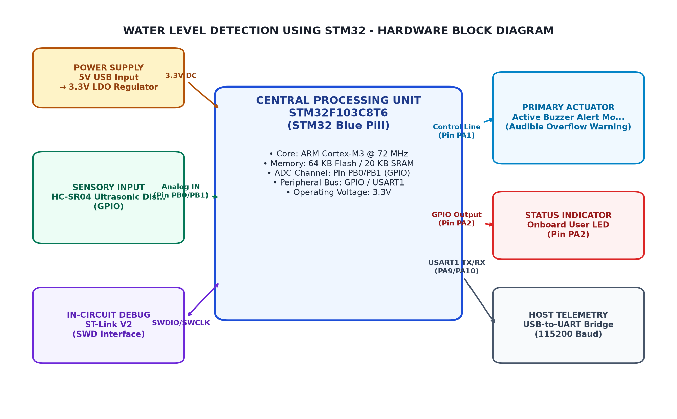
Figure 3.1: Overall System Architecture and Hardware Block Diagram
3.3 Circuit Diagram
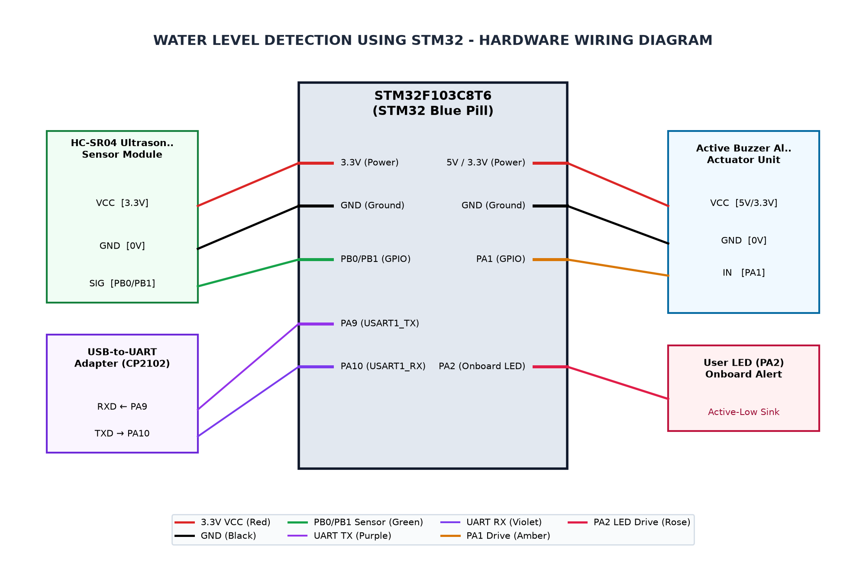
Figure 3.2: Complete Circuit Interconnection Diagram
3.4 Hardware Component Description
3.5 Pin Configuration and Peripheral Mapping
Table 3.3: Microcontroller Pin Allocation and Peripheral Mapping
MCU Pin | Peripheral | Connected Device Pin | Function Description
PB0 | GPIO | HC-SR04 Ultrasonic Trigger Pin | 10us ultrasonic pulse generation trigger
PB1 | GPIO/Timer | HC-SR04 Ultrasonic Echo Pin | High-speed ultrasonic pulse duration echo measurement
PA1 | GPIO | Active Buzzer Alert Driver | Audible alarm trigger on critical alert condition
PA2 | GPIO | Red Alert LED | Visual indicator for critical high water level and overflow
PA3 | GPIO | Green Status LED | Visual indicator for safe and normal water level
PB6 | I2C1_SCL | 16x2 LCD I2C SCL | I2C clock line for 16x2 alphanumeric LCD display
PB7 | I2C1_SDA | 16x2 LCD I2C SDA | I2C data line for 16x2 alphanumeric LCD display
PC13 | GPIOC | Onboard Status LED | Active-low status alert indicator (lights when action needed)
PA9 | USART1_TX | USB-to-UART Adapter RX | Serial telemetry and debug monitoring at 115200 baud
PA10 | USART1_RX | USB-to-UART Adapter TX | Serial receiver interface
3.6 Algorithm and Flowchart
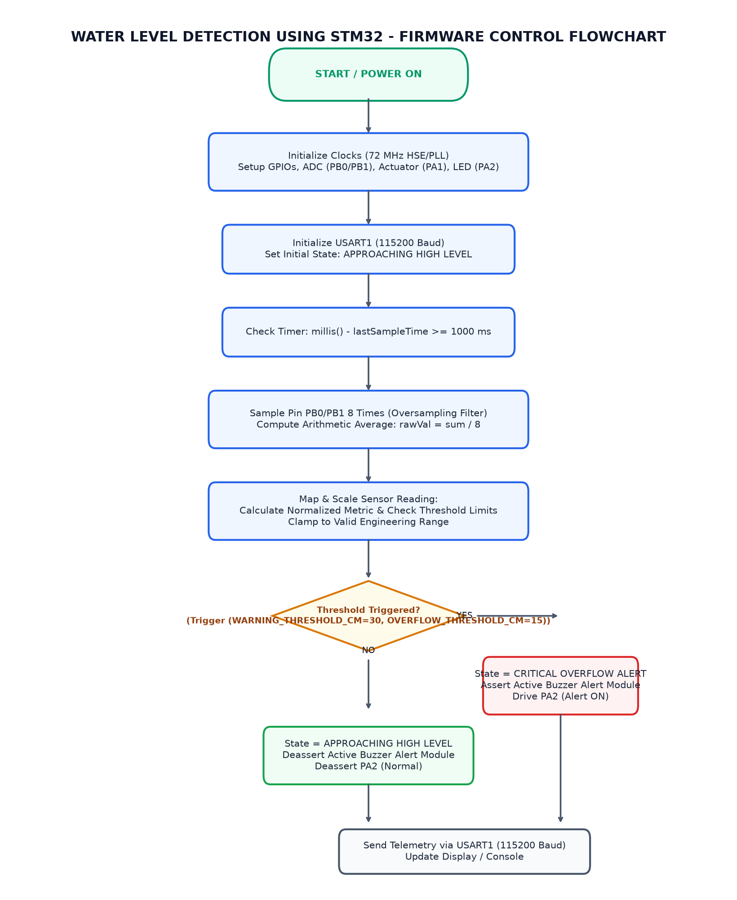
Figure 3.3: Firmware Execution and Sampling Flowchart
3.7 Working Principle
Table 3.4: ADC Calibration and Soil Moisture State Classification
Operating State | Condition | Moisture % | Raw ADC Range (12-bit)
CRITICAL OVERFLOW ALERT | Measured Distance <= 15 cm | Water Level >= 85% | 0 to 15 cm
APPROACHING HIGH LEVEL | 16 cm <= Distance <= 30 cm | Water Level 70% to 84% | 16 to 30 cm
NORMAL / SAFE WATER LEVEL | Measured Distance > 30 cm | Water Level < 70% | 31 to 100 cm

CHAPTER 4
IMPLEMENTATION
4.1 Development Environment Setup
4.2 STM32CubeMX Configuration
4.3 GPIO and Peripheral Configuration
4.4 Embedded C Program Development
4.5 Hardware Interfacing and Integration
4.6 Program Execution and Debugging
4.7 Implementation Challenges and Solutions

CHAPTER 5
TESTING AND RESULTS
5.1 Testing Methodology
5.2 Test Cases and Observations
Table 5.5: System Test Cases and Expected Operational Responses
Test ID | Test Condition | Expected Behavior | Observed Result
TC_01 | Measured Distance <= 15 cm (Tank > 85% full) | Red LED ON, Active Buzzer sounding, Green LED OFF, LCD shows 'OVERFLOW ALERT!' | Pending physical validation
TC_02 | 16 cm <= Measured Distance <= 30 cm (70% to 85% full) | Red LED ON, Green LED ON, Buzzer OFF, LCD shows 'LEVEL HIGH' | Pending physical validation
TC_03 | Measured Distance > 30 cm (Tank < 70% full) | Green LED ON, Red LED OFF, Buzzer OFF, LCD shows 'STATUS: NORMAL' | Pending physical validation
5.3 Hardware Implementation Photographs
[PHOTOGRAPH 5.1: HARDWARE PROTOTYPE SETUP]
(Please insert high-resolution photograph of the wired STM32 Blue Pill, soil moisture sensor, and OLED display prototype.)

5.4 Output Screenshots
[PHOTOGRAPH 5.2: OLED DISPLAY AND TELEMETRY OUTPUT]
(Please insert photograph or screenshot of the SSD1306 OLED display screen and serial terminal monitor.)

5.5 Result Analysis

CHAPTER 6
CONCLUSION AND FUTURE SCOPE
6.1 Conclusion
6.2 Learning Outcomes
6.3 Limitations
6.4 Future Enhancements

REFERENCES
[1] STMicroelectronics, 'STM32F103x8 STM32F103xB Medium-density performance line ARM-based 32-bit MCU Datasheet', DocID 13587 Rev 17, 2020.
[2] STMicroelectronics, 'RM0008 Reference Manual: STM32F101xx, STM32F102xx, STM32F103xx advanced ARM-based 32-bit MCUs', Rev 21, 2021.
[3] ElecFreaks, 'HC-SR04 Ultrasonic Ranging Module User Guide', 2019.
[4] STM32duino, 'Arduino Core for STM32 based boards', Official STMicroelectronics GitHub Repository, 2024.
[5] Texas Instruments, 'LM2596 SIMPLE SWITCHER Power Converter 150-kHz 3-A Step-Down Voltage Regulator', SNVS124D, 2021.
[6] Paul Horowitz and Winfield Hill, 'The Art of Electronics', Cambridge University Press, 3rd Edition, 2015.

APPENDIX A
COMPLETE EMBEDDED C SOURCE CODE
Source File: Water_Level_Overflow_Indicator.ino (222 lines)
/*
* PROJECT: Water Level Detection using STM32 and Ultrasonic Sensor
* COURSE: Microcontrollers (PBCST504) - V Semester B.Tech
*
* TEAM MEMBERS:
* - DEVANANDA.S (SBC24CS097)
* - NEEHARA ANIL K K (SBC24CS154)
* - SANU R GEEVARGHESE (SBC24CS180)
* - MADHAV PADMAKUMAR (SBC24CS144)
*
* GUIDE: Ms. Aryalekshmi A, Assistant Professor
*
* HARDWARE SETUP:
* - MCU: STM32F103C8T6 (Blue Pill, ARM Cortex-M3 @ 72 MHz)
* - Sensor: HC-SR04 Ultrasonic Distance Sensor
* TRIG -> PB0 (GPIO Output)
* ECHO -> PB1 (GPIO Input)
* - Actuator: Active Buzzer Module -> PA1 (GPIO Output)
* - Visual Indicators:
* RED LED (Overflow Alert) -> PA2 (GPIO Output)
* GREEN LED (Normal Level) -> PA3 (GPIO Output)
* Onboard Status LED -> PC13 (Active-Low GPIO)
* - Display: 16x2 LCD via I2C (PCF8574 backpack at 0x27)
* SCL -> PB6 (I2C1_SCL)
* SDA -> PB7 (I2C1_SDA)
* - Power Supply: LM2596 DC-DC Buck Converter (9V/12V Battery down to 5V DC)
* - Telemetry: Serial USART1 (PA9 TX, PA10 RX) at 115200 baud
*/
#include <Arduino.h>
#include <Wire.h>
#include <LiquidCrystal_I2C.h>
// --- PIN DEFINITIONS ---
#define TRIG_PIN PB0 // HC-SR04 Ultrasonic Trigger Pin
#define ECHO_PIN PB1 // HC-SR04 Ultrasonic Echo Pin
#define BUZZER_PIN PA1 // Active Buzzer Audible Alarm Driver
#define LED_RED_PIN PA2 // Red Alert LED (Overflow Warning Indicator)
#define LED_GREEN_PIN PA3 // Green Status LED (Normal / Safe Water Level)
#define LCD_SCL_PIN PB6 // 16x2 LCD I2C SCL Clock Pin
#define LCD_SDA_PIN PB7 // 16x2 LCD I2C SDA Data Pin
#define STATUS_LED_PIN PC13 // Onboard Diagnostic LED (Active-Low)
// --- OPERATIONAL CONSTANTS & CALIBRATION THRESHOLDS ---
#define TANK_HEIGHT_CM 100 // Total vertical depth of water storage tank
#define OVERFLOW_THRESHOLD_CM 15 // Distance <= 15 cm triggers critical overflow alarm
#define WARNING_THRESHOLD_CM 30 // Distance <= 30 cm triggers approaching high-level warning
#define SAMPLE_INTERVAL_MS 500 // Cadence between sensor readings in milliseconds
#define SAMPLES 5 // Number of consecutive readings for moving-average filter
// --- GLOBAL OBJECTS & VARIABLES ---
LiquidCrystal_I2C lcd(0x27, 16, 2);
int distanceBuffer[SAMPLES];
int sampleIndex = 0;
bool bufferFilled = false;
unsigned long lastSampleTime = 0;
/**
* @brief Measure raw distance in centimeters using HC-SR04 ultrasonic sensor.
* @return Distance in centimeters, or -1 if timeout occurred.
*/
long measureRawDistanceCm() {
digitalWrite(TRIG_PIN, LOW);
delayMicroseconds(2);
digitalWrite(TRIG_PIN, HIGH);
delayMicroseconds(10);
digitalWrite(TRIG_PIN, LOW);
// Measure echo pulse duration (timeout 30000 us ~ 5 meters max distance)
long duration = pulseIn(ECHO_PIN, HIGH, 30000);
if (duration == 0) {
return -1; // Echo timeout
}
// Speed of sound = 343 m/s = 0.0343 cm/us -> Distance = (duration * 0.0343) / 2
long distance = (duration * 0.0343) / 2;
return distance;
}
/**
* @brief Moving average filter to suppress acoustic reflections and noise.
*/
int getFilteredDistance(int newDistance) {
if (newDistance < 0 || newDistance > TANK_HEIGHT_CM + 20) {
return -1; // Reject out-of-bounds acoustic spikes
}
distanceBuffer[sampleIndex] = newDistance;
sampleIndex = (sampleIndex + 1) % SAMPLES;
if (sampleIndex == 0) {
bufferFilled = true;
}
int count = bufferFilled ? SAMPLES : sampleIndex;
if (count == 0) return newDistance;
long sum = 0;
for (int i = 0; i < count; i++) {
sum += distanceBuffer[i];
}
return sum / count;
}
void setup() {
// Configure GPIO Pin Modes
pinMode(TRIG_PIN, OUTPUT);
pinMode(ECHO_PIN, INPUT);
pinMode(BUZZER_PIN, OUTPUT);
pinMode(LED_RED_PIN, OUTPUT);
pinMode(LED_GREEN_PIN, OUTPUT);
pinMode(STATUS_LED_PIN, OUTPUT);
// Initial output states (safe startup)
digitalWrite(TRIG_PIN, LOW);
digitalWrite(BUZZER_PIN, LOW);
digitalWrite(LED_RED_PIN, LOW);
digitalWrite(LED_GREEN_PIN, HIGH);
digitalWrite(STATUS_LED_PIN, HIGH); // Inactive high
// Initialize USART1 Telemetry
Serial.begin(115200);
delay(100);
Serial.println(F("=================================================="));
Serial.println(F(" WATER LEVEL DETECTION & OVERFLOW INDICATOR "));
Serial.println(F(" MCU: STM32F103C8T6 | Sensor: HC-SR04 | 16x2 LCD"));
Serial.println(F("=================================================="));
// Initialize I2C and 16x2 LCD
Wire.begin();
lcd.init();
lcd.backlight();
lcd.clear();
lcd.setCursor(0, 0);
lcd.print("WATER LEVEL SYS");
lcd.setCursor(0, 1);
lcd.print("INITIALIZING...");
delay(1000);
lcd.clear();
}
void loop() {
unsigned long currentMillis = millis();
if (currentMillis - lastSampleTime >= SAMPLE_INTERVAL_MS) {
lastSampleTime = currentMillis;
long rawDistance = measureRawDistanceCm();
if (rawDistance < 0) {
Serial.println(F("[ERROR] Sensor Echo Timeout. Checking alignment..."));
lcd.setCursor(0, 0);
lcd.print("SENSOR TIMEOUT! ");
lcd.setCursor(0, 1);
lcd.print("CHECK ALIGNMENT ");
return;
}
int distanceCm = getFilteredDistance((int)rawDistance);
int waterLevelPercent = map(distanceCm, TANK_HEIGHT_CM, OVERFLOW_THRESHOLD_CM, 0, 100);
waterLevelPercent = constrain(waterLevelPercent, 0, 100);
// Telemetry logging
Serial.print(F("Dist: "));
Serial.print(distanceCm);
Serial.print(F(" cm | Level: "));
Serial.print(waterLevelPercent);
Serial.print(F("% | State: "));
// State Machine Decision Logic
if (distanceCm <= OVERFLOW_THRESHOLD_CM) {
// STATE 1: CRITICAL OVERFLOW WARNING
Serial.println(F("CRITICAL OVERFLOW ALERT"));
digitalWrite(LED_RED_PIN, HIGH);
digitalWrite(LED_GREEN_PIN, LOW);
digitalWrite(BUZZER_PIN, HIGH);
digitalWrite(STATUS_LED_PIN, LOW); // Active-low status LED ON
lcd.setCursor(0, 0);
lcd.print("DIST: ");
lcd.print(distanceCm);
lcd.print("cm [CRIT] ");
lcd.setCursor(0, 1);
lcd.print("OVERFLOW ALERT! ");
}
else if (distanceCm <= WARNING_THRESHOLD_CM) {
// STATE 2: APPROACHING HIGH LEVEL WARNING
Serial.println(F("APPROACHING HIGH LEVEL"));
digitalWrite(LED_RED_PIN, HIGH);
digitalWrite(LED_GREEN_PIN, HIGH);
digitalWrite(BUZZER_PIN, LOW);
digitalWrite(STATUS_LED_PIN, HIGH);
lcd.setCursor(0, 0);
lcd.print("DIST: ");
lcd.print(distanceCm);
lcd.print("cm [WARN] ");
lcd.setCursor(0, 1);
lcd.print("LEVEL HIGH ");
}
else {
// STATE 3: NORMAL / SAFE LEVEL
Serial.println(F("NORMAL / SAFE"));
digitalWrite(LED_RED_PIN, LOW);
digitalWrite(LED_GREEN_PIN, HIGH);
digitalWrite(BUZZER_PIN, LOW);
digitalWrite(STATUS_LED_PIN, HIGH);
lcd.setCursor(0, 0);
lcd.print("DIST: ");
lcd.print(distanceCm);
lcd.print("cm [NORM] ");
lcd.setCursor(0, 1);
lcd.print("STATUS: NORMAL ");
}
}
}

APPENDIX B
ADDITIONAL CONFIGURATION DETAILS
Clock Tree and Power Consumption Details:
- HSE Crystal: 8.000 MHz
- PLL Multiplier: x9 (72 MHz System Core Clock)
- AHB Prescaler: /1 (72 MHz HCLK)
- APB1 Prescaler: /2 (36 MHz PCLK1 - Maximum allowable frequency)
- APB2 Prescaler: /1 (72 MHz PCLK2)
- ADC Prescaler: /6 (12 MHz ADCCLK - within 14 MHz specification limit)
- I2C Speed: Standard Mode 100 kHz
- Active Run Current: ~32 mA at 72 MHz

APPENDIX C
ADDITIONAL OUTPUT IMAGES
[APPENDIX C SUPPLEMENTARY IMAGES]
(Optional oscilloscope captures, serial plotter waveforms, or simulation scope traces.)

