Modeling the Aquatic Carbonate System and Water Acidification
Water Chemistry course — Ben-Gurion University — Spring 2026
Students: [Name 1 — ID — email] , [Name 2 — ID — email] [ , Name 3 … , Name 4 … ]
Lecturer: Oded Nir
1. Background
The carbonate system (CO₂/H₂CO₃*, HCO₃⁻, CO₃²⁻) governs the pH and buffering capacity of nearly all natural waters. Dissolving CO₂ forms carbonic acid and lowers pH — the mechanism of ocean and freshwater acidification — while the same equilibria decide whether calcium carbonate precipitates (scaling) or dissolves (corrosion). We model how atmospheric CO₂, alkalinity, temperature and ionic strength jointly control pH, total inorganic carbon and calcite saturation.
2. Methods
We built a code-based equilibrium model (provided as an interactive HTML tool and an equivalent Python/Matplotlib script). Inputs: CO₂ partial pressure pCO₂ (open system) or total inorganic carbon Cₜ (closed system), total alkalinity, temperature, ionic strength I, and total calcium.
Equations. The model uses the two carbonic-acid dissociation constants K₁, K₂, Henry’s constant Kₕ for CO₂, the water ion product Kᵥ, and the calcite solubility product Kₛₚ. All five are evaluated as functions of temperature with the Plummer & Busenberg (1982) polynomials. Non-ideality is treated with the Davies equation, whose Debye–Hückel A-parameter is computed from the temperature-dependent dielectric constant of water; this converts thermodynamic constants into conditional (concentration) constants K₁′, K₂′, Kᵥ′. The proton condition is expressed through alkalinity:
Alk = [HCO₃⁻] + 2[CO₃²⁻] + [OH⁻] − [H⁺]
Algorithm. For a given alkalinity the model finds the hydrogen-ion concentration [H⁺] that satisfies this balance by geometric bisection over pH 1–13 (200 iterations). In the open system [H₂CO₃*] is fixed by Henry’s law ([H₂CO₃*] = Kₕ·pCO₂) and the other species follow from K₁′, K₂′; in the closed system the fixed Cₜ is distributed over the three species via the ionization fractions α₀, α₁, α₂.
Outputs. Equilibrium pH (activity scale), the concentrations of H₂CO₃*, HCO₃⁻ and CO₃²⁻, total inorganic carbon Cₜ, and the calcite saturation state, reported as the saturation index SI = log₁₀(a_Ca·a_CO₃ / Kₛₚ) and the saturation ratio Ω. SI > 0 indicates over-saturation (precipitation potential); SI < 0 indicates under-saturation (dissolution / corrosivity). The model was validated against literature constants at 25 °C (pK₁ = 6.35, pK₂ = 10.33, pKₕ = 1.47, pKₛₚ = 8.48, A = 0.51).
3. Results and Discussion
All curves below use a carbonate-buffered freshwater as the base case (Alk = 2.0 meq/L, Ca = 0.8 mM, T = 15 °C, I = 0.01 M) unless stated. Include one figure per group member.
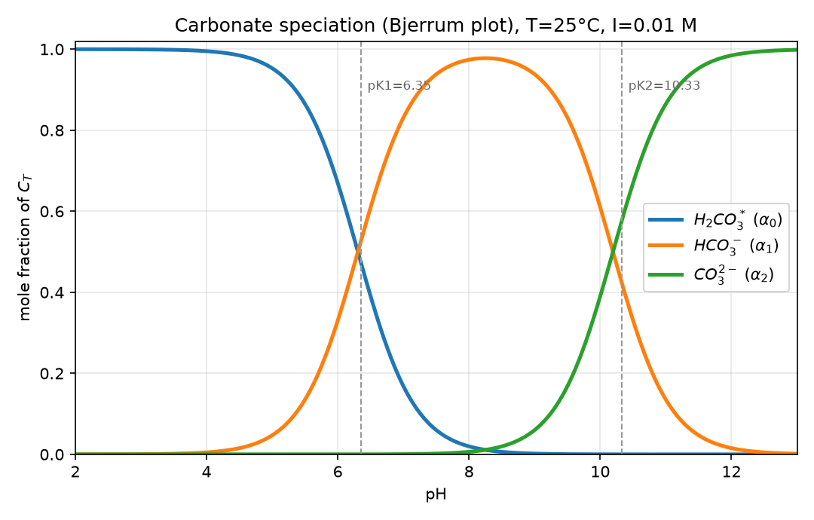
Figure 1. Bjerrum plot: carbonate speciation as a function of pH.
The relative abundance of the three carbonate species is fixed by pH. H₂CO₃* dominates below pK₁ (6.35), HCO₃⁻ dominates between the two pK values, and CO₃²⁻ takes over above pK₂ (10.33); the curves cross exactly at the pK values, where the two neighbouring species are equal. Around the circum-neutral pH of most natural waters (7–8.5) bicarbonate carries essentially all of Cₜ, which is why HCO₃⁻ is the principal contributor to alkalinity and to the buffering capacity of the system.
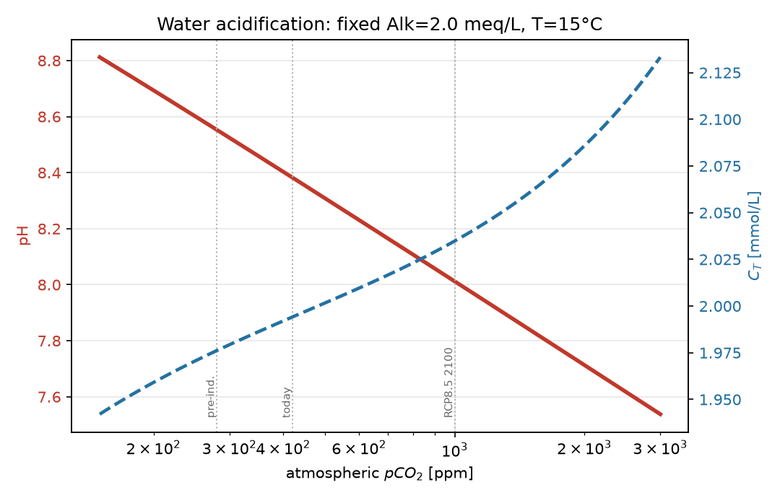
Figure 2. Acidification: equilibrium pH (red) and Cₜ (blue) versus atmospheric pCO₂ at constant alkalinity.
Raising pCO₂ drives more CO₂ into solution (Henry’s law); the added H₂CO₃* dissociates and releases H⁺, so pH falls almost linearly with log pCO₂ — the essence of ocean and freshwater acidification. Because alkalinity is conserved, the extra acidity is buffered by converting CO₃²⁻ and HCO₃⁻, and total inorganic carbon Cₜ rises. Moving from the pre-industrial (280 ppm) to a high-emission 2100 level (~1000 ppm) lowers the modelled pH by several tenths of a unit, matching observed trends.
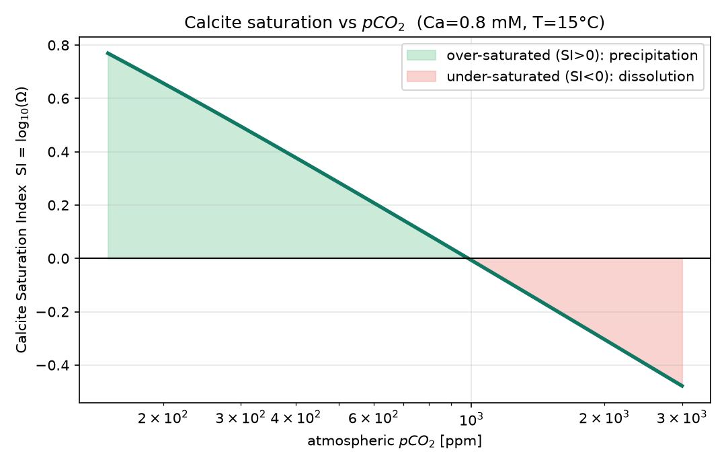
Figure 3. Calcite saturation index versus pCO₂, showing the over/under-saturation threshold.
The saturation index falls as pCO₂ rises, because acidification lowers pH and shifts speciation away from CO₃²⁻, reducing the ion-activity product a_Ca·a_CO₃. The curve crosses SI = 0 near ≈ 1000 ppm: to the left the water is over-saturated (green) and calcite tends to precipitate; to the right it becomes under-saturated (red) and calcite dissolves, i.e. the water turns corrosive to carbonate minerals and cement. This single threshold links climate-scale CO₂ to practical concerns of scaling versus corrosion in pipes and aquifers.
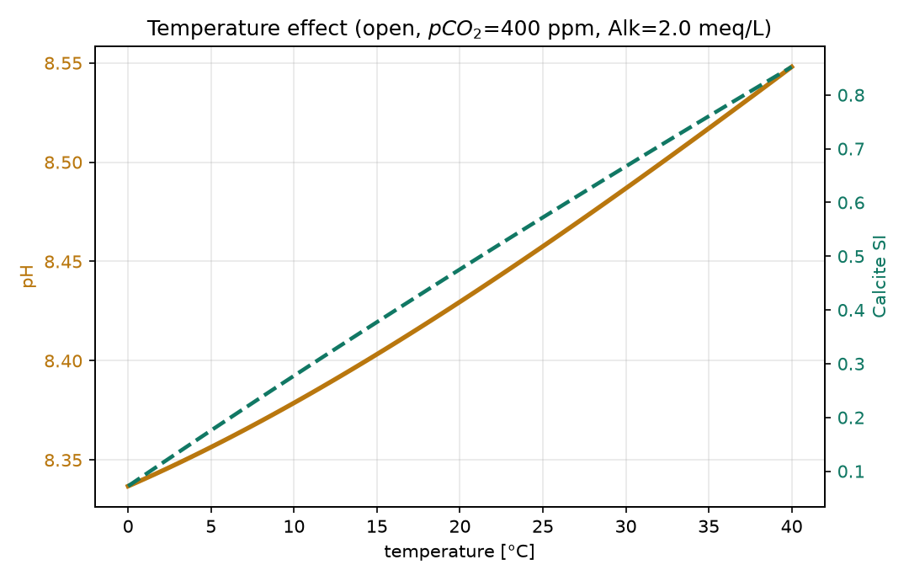
Figure 4. Effect of temperature on pH and calcite SI (open system, 400 ppm).
Warming raises both pH and calcite SI. The equilibrium constants are temperature dependent: higher temperature lowers CO₂ solubility (Kₕ) and shifts K₁, K₂ and Kₛₚ, so at fixed pCO₂ and alkalinity less CO₂ stays dissolved and pH increases. Calcite becomes markedly more over-saturated because Kₛₚ decreases with temperature (inverse solubility) — the reason warm water scales heat-exchangers and boilers more aggressively than cold water. The effect over 0–40 °C is modest for pH but substantial for SI.
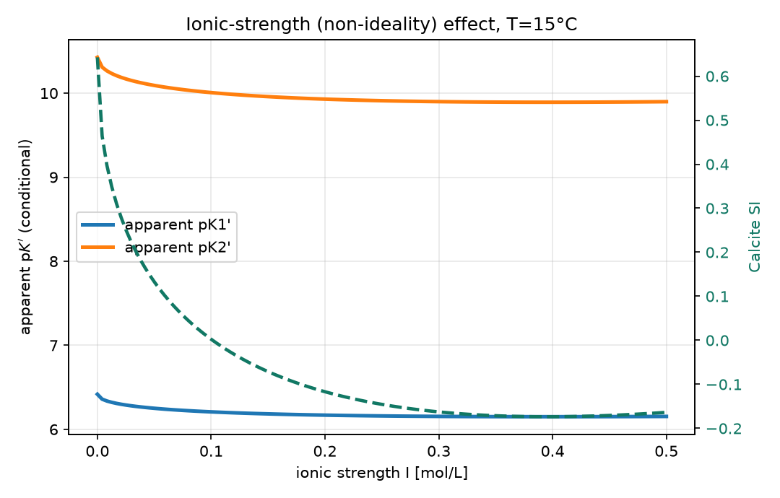
Figure 5. Effect of ionic strength on the apparent pK values and calcite SI.
Increasing ionic strength lowers activity coefficients (Davies equation), which lowers the apparent pK₁′ and pK₂′ — dissolved ions are effectively “shielded”, so the acids appear stronger. The divalent CO₃²⁻ is affected more than the monovalent species, so pK₂′ shifts most. Calcite SI first drops sharply then levels off, because the doubly-charged Ca²⁺ and CO₃²⁻ activities are strongly reduced at higher I. This explains why saline waters can hold much more dissolved carbonate before precipitating, and why ignoring non-ideality overestimates scaling potential.
4. Conclusions
A single set of carbonate equilibria, solved through the alkalinity balance, reproduces water acidification, buffering, and the precipitation–dissolution behaviour of calcite. The tool quantifies how CO₂, alkalinity, temperature and ionic strength move a water across the SI = 0 line — directly useful for predicting acidification impacts, corrosion control, carbonate scaling in desalination and cooling systems, and chemical stabilization of treated water.

