MiniMoog Clone Panel Operation Randy Parks
REV: 12/10/2017

FRONT PANEL
Knobs - Pots
LEDs
Buttons
Pwr Switch & LED
1
DECAY
CUTOFF
LO
2
3
1
2
3
OSC 1
MOD /NOISE
EXT IN
VOLUME
EMPHASIS
CONTOUR
ATTACK
DECAY
SUSTAIN
ATTACK
SUSTAIN
LOUDNESS
CONTOUR
FILTER
GLIDE
MOD MIX

CONTROLLERS
TUNE
OSCILLATORS
FREQ
2
3
NOISE
FREQ
OSC 2
OSC 3
VOLUME MIXER
MAIN OUTPUT
POWER
ON
RANGE
WAVEFORM
32
16
8
4
2
OSC MOD
FRQ MOD AMP
OSC SEL
2
3
1
TRI
RSW
SAW
SQU
PL1
PL2
1
OSC ON
FILTER MOD
KEYBRD CNTRL 1
KEYBRD CNTRL 2
FILTER MOD
KEYBRD CNTRL 1
KEYBRD CNTRL 2
MOD /NOISE
EXT IN
NOISE SEL
PINK
WHITE
A-440
KYBRD GATE
ON
OSC MOD
OSC 3 CONT
RELEASE
HOLD
The “0-10” scale indicator on the knobs are for position reference only and do not indicate an actual value

OSC SEL Selects which oscillator is being controlled by the RANGE & WAVEFORM Buttons

OSC SEL 1 Button (OSC 1 LED On & Off) enables the oscillator 1 Range and Waveform settings to be changed.

OSC SEL 2 Button (OSC 1 LED On & Off) enables the oscillator 2 Range and Waveform settings to be changed.

OSC SEL 3 Button (OSC 1 LED On & Off) enables the oscillator 3 Range and Waveform settings to be changed.

OSC RANGE Button selects the two octave frequency range for the selected Oscillator. On power up, the range is set at 16. Each press of the button steps the Range Frequency through the following values (as indicated by the RANGE LEDs) :

Range Value Frequency Hz Octave No. Other
LO 1.00 - 61.74 sub 0 - 1 Used by Oscillator 3 only
32 16.35 - 61.74 0 - 1
16 65.41 - 246.94 2 - 3
8 261.63 - 987.77 4 - 5
4 1046.50 - 3951.06 6 - 7
2 4186.00 - 12543.8 8 - 9 1/2

OSC WAVE Button selects the waveform type for the selected Oscillator. On Power Up, the wave is set at SINE. Each press of the button steps the Wave Type through the following values (as indicated by the WAVE LEDs) :

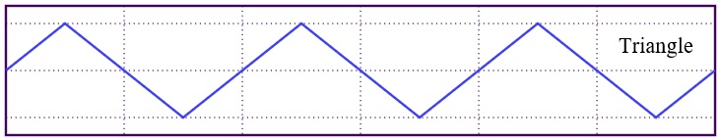
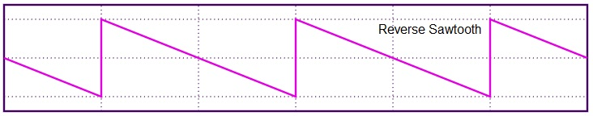
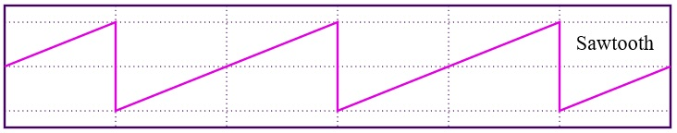
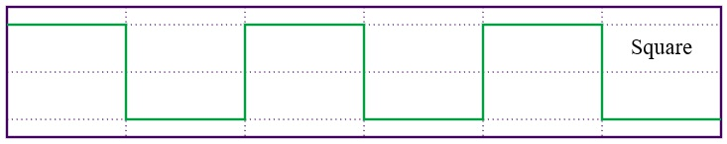
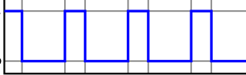
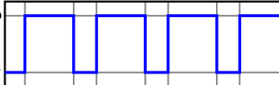
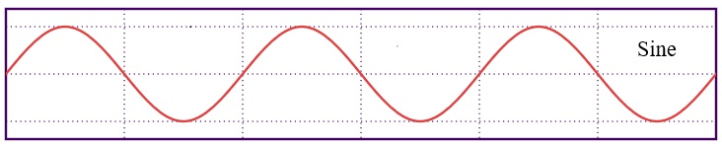
Wave Value Type Duty Cycle %

TRI Triangle 50

RSW Reverse Sawtooth 50

SAW Sawtooth 50

SQU Square 50

PL1 Pulse 1 20 20

PL2 Pulse 2 80 80

SIN SINE 50

OSC MOD Button

Push to toggle ON & OFF Oscillator Modulation (OSC MOD Led On & Off)

OSC MOD On (OSC MOD Led On) enables selection of either Amplitude Modulation of a Sine Waveform or frequency Modulation of Oscillator 2 using Oscillator 3 as the modulator. Also, when On, the Noise Generators are disabled.

If OSC MOD is off (OSC MOD Led Off), Oscillator 3 behaves as a normal keyboard controlled oscillator.

OSC 3 CONT Button is enabled when OSC MOD is On. This button selects either Oscillator Frequency Modulation (OSC MOD FRQ LED On) or Oscillator Amplitude Modulation (OSC MOD AMP LED On).

Push to toggle Oscillator 3 between the two modulation modes
OSC 3 AMP LED On or OSC 3 FREQ LED On.

CONTROLLERS GLIDE Knob adjusts the Oscillator 3 frequency up or down when in modulation mode.

CONTROLLERS MOD MIX Knob adjusts the mixture of amplitude modulation when in modulation mode.

In FREQ MODulation mode, a fourth sine wave oscillator is controlled by the keyboard and frequency modulated with Oscillator 3.

In AMP MODulation mode, Oscillator 2 controlled by the keyboard, is amplitude modulated with Oscillator 3.

FILTER

CUTOFF Knob adusts the corner frequency of a Low Pass Filter which is applied to all three Oscillators (1, 2 and 3).

EMPHASIS Knob adjusts the Q value for the Low Pass Filter.

CONTOUR Knob is not implemented at this time.
ATTACK Knob is not implemented at this time.
DECAY Knob is not implemented at this time.
SUSTAIN Knob is not implemented at this time.
FILTER MOD Button is not implemented at this time.
KEYBRD CNTRL1 Button is not implemented at this time.
KEYBRD CNTRL2 Button is not implemented at this time.

LOUDNESS CONTOUR Knobs adjust the keyboard AHDSR envelope values as shown below. This envelope is applied to all keyboard sounds (oscillators and noise).

ATTACK Knob Adjusts the keyboard AHDSR envelope Attack time.

HOLD Knob Adjusts the keyboard AHDSR envelope Hold time.

DECAY Knob Adjusts the keyboard AHDSR envelope Decay time

SUSTAIN Knob Adjusts the keyboard AHDSR envelope Sustain time.

RELEASE Knob Adjusts the keyboard AHDSR envelope Release time

All adjustments are approximately from 0 to 200 mS

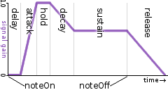

OSCILLATORS FREQ Knobs are not implemented at this time. Oscillators 1 and 2 frequencies are controlled by the keyboard only. Oscillator 3 frequency is controlled by the keyboard when not using oscillator modulation and controlled by the MOD/MIX Knob when using modulation.

NOISE FREQ Knob controls the corner frequency of a high pass Filter applied to the White Noise generator.

VOLUME MIXER contolls the mixing of all the sound sources into one signal that is output to the sound Output jacks on the back of the synthesizer.

OSC ON Button 1 (toggles the OSC ON 1 LED On & Off) when On, enables the OSC 1 Knob to adjust the amount of Oscillator 1 signal into the output.

OSC ON Button 2 (toggles the OSC ON 2 LED On & Off) when On, enables the OSC 2 Knob to adjust the amount of Oscillator 2 signal into the output.

OSC ON Button 3 (toggles the OSC ON 3 LED On & Off) when On, enables the OSC 3 Knob to adjust the amount of Oscillator 3 signal into the output.

EXT IN ON Button (toggles the EXT IN ON LED On & Off) when On, enables the EXT IN Knob to adjust the amount of External Input from the synthesizer rear panel jack into the output.

NOISE ON Button (toggles the NOISE ON LED On & Off) when On, enables the MOD/NOISE Knob to adjust the amount of Noise or Modulated signal into the output.

If the NOISE ON LED is On and the OSC MOD LED is Off, the NOISE SELECT Button will toggle between selecting Pink Noise (PINK LED On) or White Noise (WHITE LED On).

If the NOISE ON LED is On and the OSC MOD LED is On, the amount of Oscillator modulation signal applied to the output signal is controlled by the MOD/NOISE Knob.

A440 Button toggles the A440 LED On & Off and applies a note “A” at frequency 440 Hz to the signal output. It is not controlled by the keyboard.

NOTE: A signal output will only occur if one or more of these Mixer elements are On and the element volume is set above the Knob “0 value”.

MAIN OUTPUT Controls the main output signal going to the AUDIO OUT 1 / 2 jack on the rear panel.

MAIN OUTPUT Button toggles the Output Volume On & Off (MAIN OUTPUT LED On & Off).

MAIN OUTPUT Knob contols the volume level of the output signal going to the Audio output.

CAUTION: VOLUME LEVELS CAN EXCEED SAFE LIMITS FOR YOUR EARS AND EQUIPMENT IF THE OUTPUT VOLUME IS SET TOO HIGH.

It is recommended the MAIN OUTPUT VOLUME Knob be set at or near the “0 level” before beginning to use the synthesizer.

REAR PANEL
9V IN
CH 1/2
CH 3/4
MIDI IN
MIDI THRU
MIDI OUT
USB
Cable
2.5 mm Chassis Mount Power Jack

3.5 mm Stereo Chassis Mount Jack

3 mm LED

1/2 “ Hole for USB cable

5 Pin DIN Female Chassis Mount

EXT IN 1 (K31)
RCA Audio Jack

9V ON
EXT IN 2 (K32)

The output cable from the MIDI keyboard is plugged into the MIDI IN jack
The MIDI THRU and MIDI OUT connectors are implemented in the hardware but not in the software at this time.

A USB Cable, used to interface the Teensy 3.2 MicroController inside the box to an external PC for programming, is threaded thru a hole in the rear panel.

Two RCA jacks labeled EXT IN 1 and EXT IN 2 are used to provide external audio signal inputs to the synthesizer. The voltage levels for these must not exceed 3.3 VDC.

The 9V IN power jack provides 9VDC power to the synthesizer when an external regulated 9VDC power supply is connected (9VDC LED will be ON).

The CH 1 / 2 jack provides an audio connection from the synthesizer to external stereo headphones or amplifier.

The CH 3 / 4 jack is implemented in the hardware but not in the software at this time.

