Mauricio Azcona

CSCI 3340

Professor Quweider

23 February 2018

Project 3 Screenshots

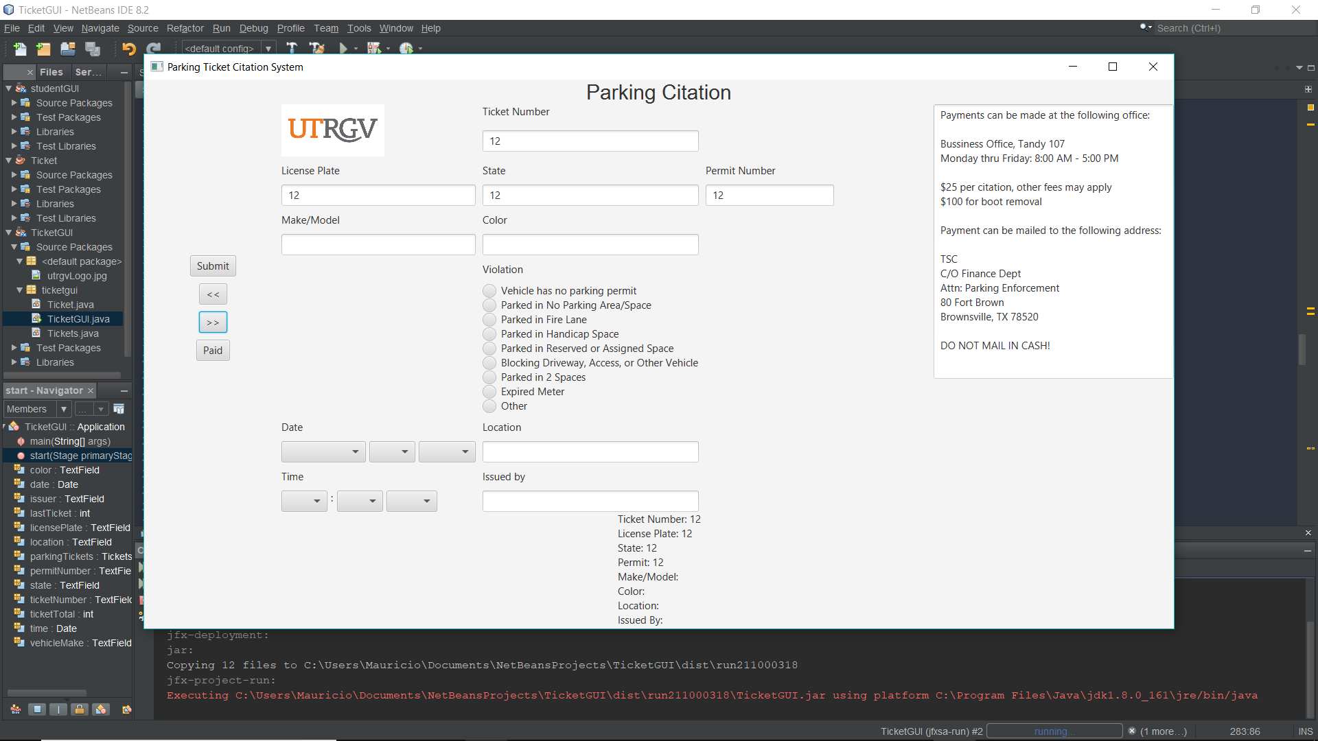

Figure 1: Filled out ticket

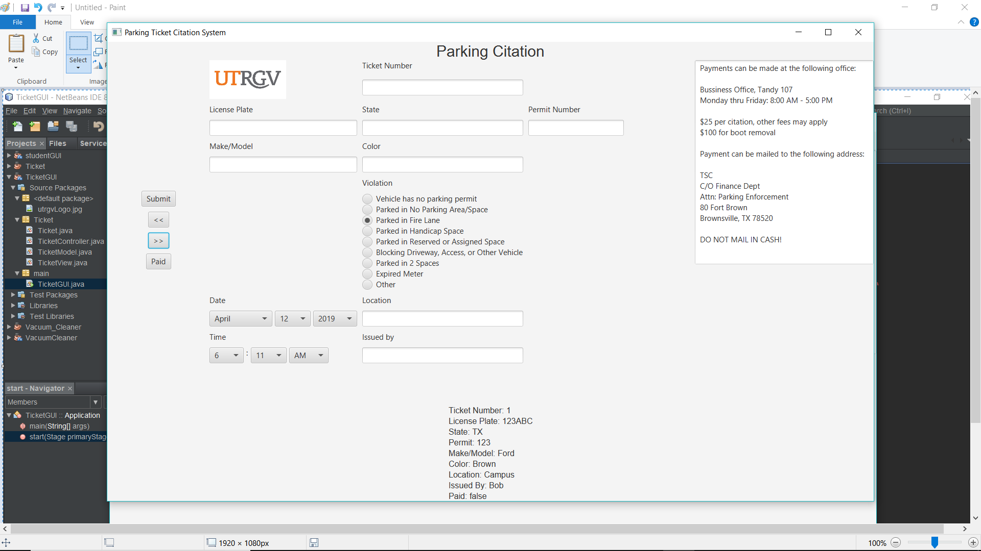

Figure 2: Unpaid ticket

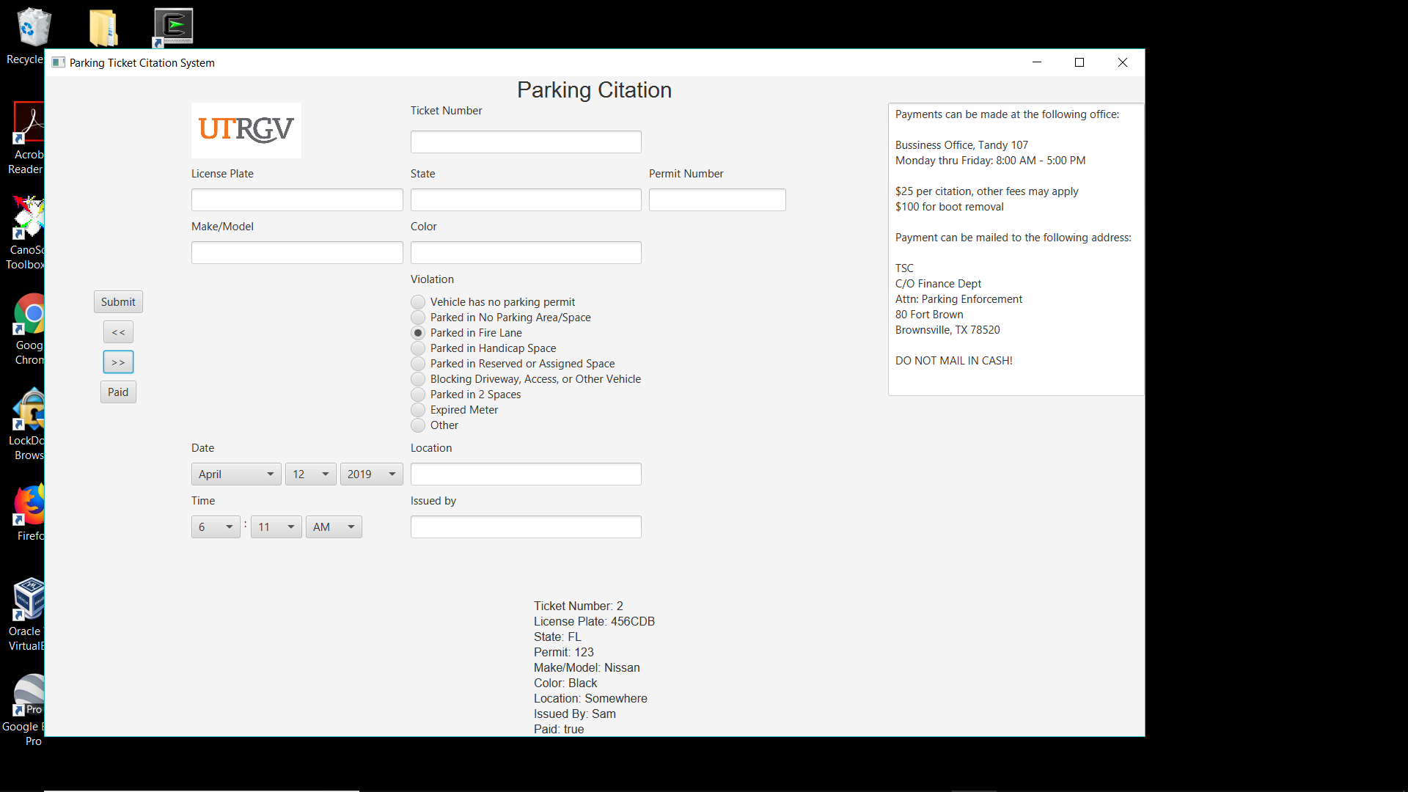

Figure 3: Paid Ticket