Pack 1: Product Design (all 4 layers)
The Paycheck Payoff System. Page-by-page and screen-by-screen structure of every product, with brand mockups. 15 Oct 2026. Builds on pack1-core-app-and-sheet-structure.docx and pack1-expert-review-layers-1-4.docx.
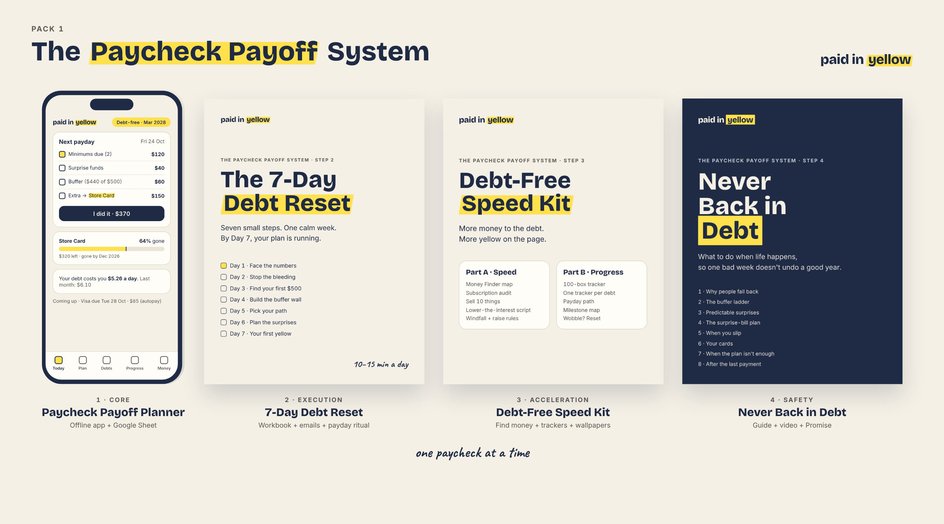

Design rules for every product
- Colors: paper #F4F0E6 background, blue ink #1F2A44 for text and lines, highlighter yellow #FFE14D only for "paid / done / the key word". No red anywhere, including in the app.
- Fonts: Bricolage Grotesque for titles, Inter for body and all numbers, Caveat only for one short handwritten line per page.
- Every page: one goal in the title, one-line "why", something to do (tick, fill, color), one warm Caveat line, footer with product name + "planning tool, not financial advice".
- Printables: US Letter and A4 versions, blank currency symbol, white page with ink lines so they print cheaply; yellow is what the buyer adds (highlighter or colored pencil).
- Head start: every tracker and checklist starts with 1-2 boxes already done (endowed progress).
- Tone: calm, warm, no shame, no "guaranteed", no borrowing advice.

Layer 1 · Core: Paycheck Payoff Planner
Formats: offline web app (PWA + single-file download) and a Google Sheet bonus. Job: "I don't know what to do" becomes "I know exactly what to pay this payday".
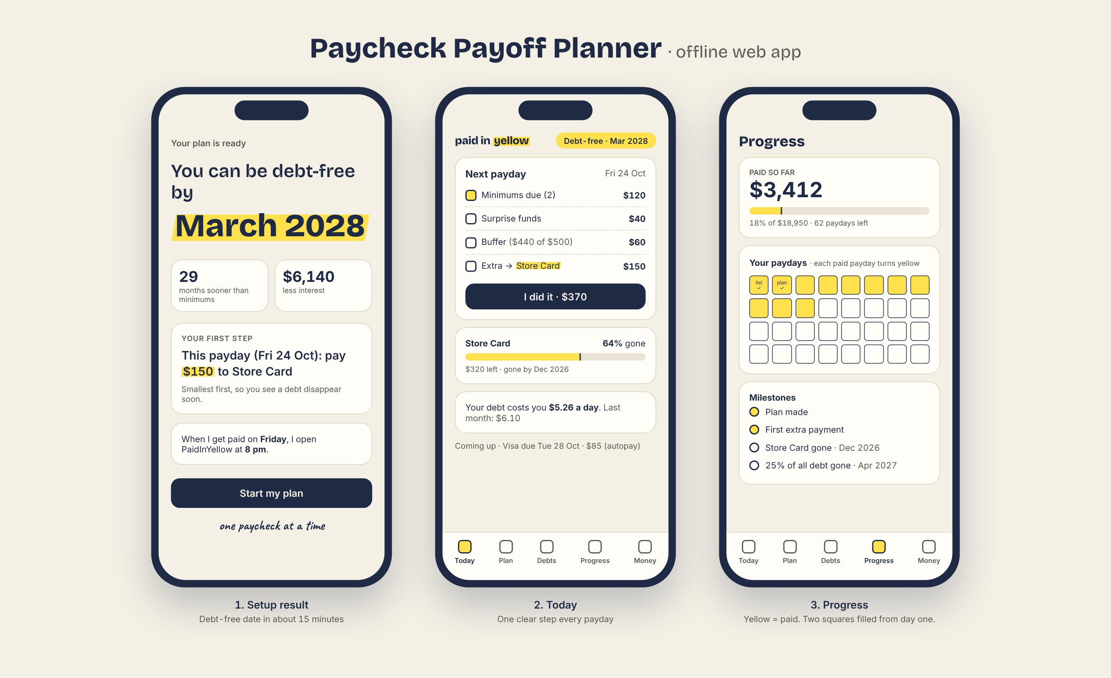

App screen map
Screen | What is on it | Research / reason
Setup wizard (8 steps, ~15 min) | Currency · pay schedule + next payday · debts (name, balance, rate, minimum, due day) · buffer now + target · extra per paycheck · method · fresh-start date · if-then payday plan | Fresh start, implementation intentions
Setup result | Debt-free date (big, yellow) · months sooner + interest saved vs minimums · first step · payday plan line · "Start my plan" | Instant win
Today | Debt-free pill · next payday list (minimums, surprises, buffer, extra to focus debt) · "I did it" · focus-debt % bar · daily interest cost · coming-up due dates | One number per payday; repayment concentration
Plan | Payday-by-payday list (paid = yellow) · method switch + compare in dollars · what-if slider + windfall · export CSV / print | Debt account aversion: show $ cost
Debts | Debt cards · add / edit / archive · log new charge with tag (everyday / emergency / one-off) · update from statement · PAID celebration | Debt labeling
Progress | Paid so far · payday grid (2 squares pre-filled) · milestones · plan vs minimums chart · planned vs actual | Endowed progress, goal gradient
Money | Buffer ladder + "I used the buffer" · predictable surprises · Find your first $500 · paycheck split | Buffer research
Settings | Backup export/import + monthly reminder · .ics calendar · dark mode · install guide · video · unlock code · privacy + disclaimer | Data safety
Special flows | Missed payday ("never miss twice", new date, no red) · "Plan needs help" when minimums > money left (links to Layer 4 ch. 7) | Self-compassion; no loans

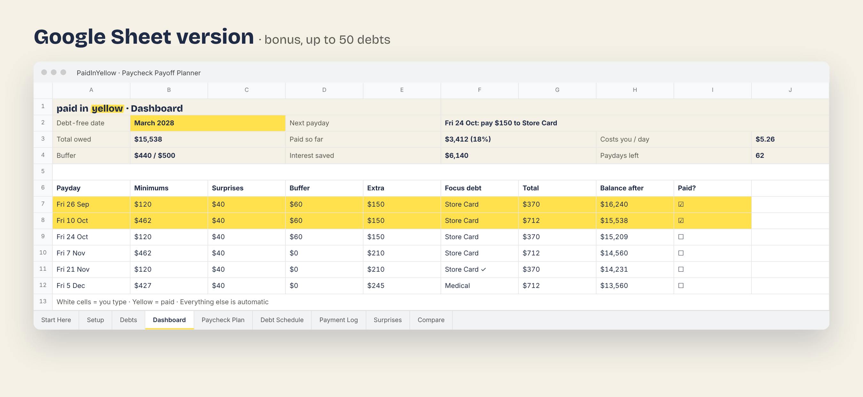

Google Sheet tabs
- Start Here (3 steps, video QR, color legend) · Setup · Debts (50 rows) · Dashboard · Paycheck Plan (tick = row turns yellow) · Debt Schedule · Payment Log · Surprises · Compare · hidden locked Engine tab. Sample data pre-filled; white cells = type here.

Layer 2 · Execution: The 7-Day Debt Reset
Formats: PDF workbook (~16 pages), 7 daily emails + payday emails for 8 weeks, Payday Ritual card, phone wallpaper, .ics reminders (made by the app). Job: start in week 1, make it a habit by week 8.
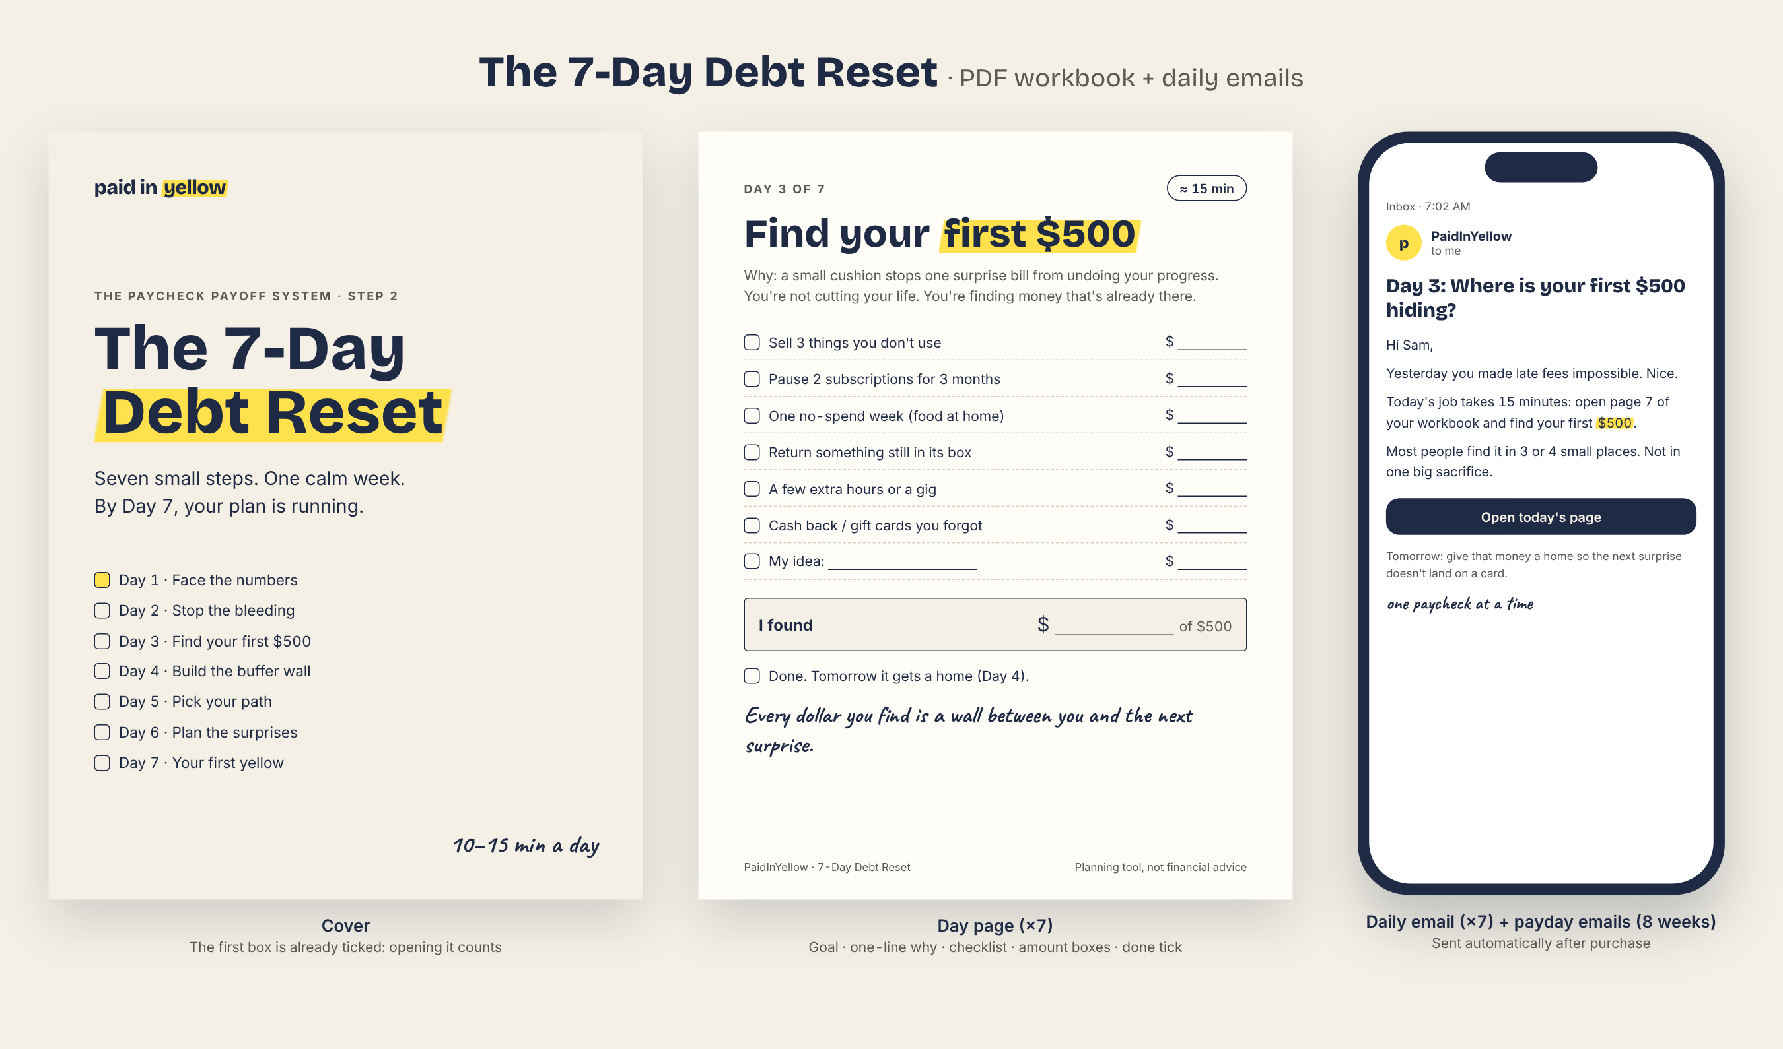

Workbook pages
Page | Content
1 Cover | Title, 7 days with Day 1 already ticked
2 How to use this | 10-15 min a day; do it in order; if you miss a day, just do the next one
3 Your start line | Fresh-start date, "why I'm doing this" (3 lines), today's total debt (just write it, no judgment)
4-5 Day 1 · Face the numbers | Debt list table (mirrors the app), "how I feel now" 1-10, read the daily interest cost once
6 Day 2 · Stop the bleeding | Autopay minimums checklist per lender; remove saved cards from apps/sites; late-fee-proof tick
7 Day 3 · Find your first $500 | Ideas checklist with $ boxes, total "I found $___ of $500"
8 Day 4 · Build the buffer wall | Open separate account/envelope, name it, move the money, starter target
9 Day 5 · Pick your path | PaidInYellow order vs biggest-interest-first, dollar difference from the app, write the debt-free date
10 Day 6 · Plan the surprises | Yearly costs list (car, school, gifts, Ramadan/holidays) → per-paycheck amounts
11 Day 7 · Your first yellow | Make the first extra payment (any amount), color the first box, write the if-then payday plan
12 The payday ritual | The 7 steps (same as the card)
13 Week 1 review | What worked, what was hard, one thing to change; "how I feel now" 1-10 again
14 Wobble? Reset | Never miss twice script
15 What happens next | 8 weeks of payday emails, where to find the Speed Kit and the Safety guide
16 Certificate | "Week 1 done" to color in + the Promise

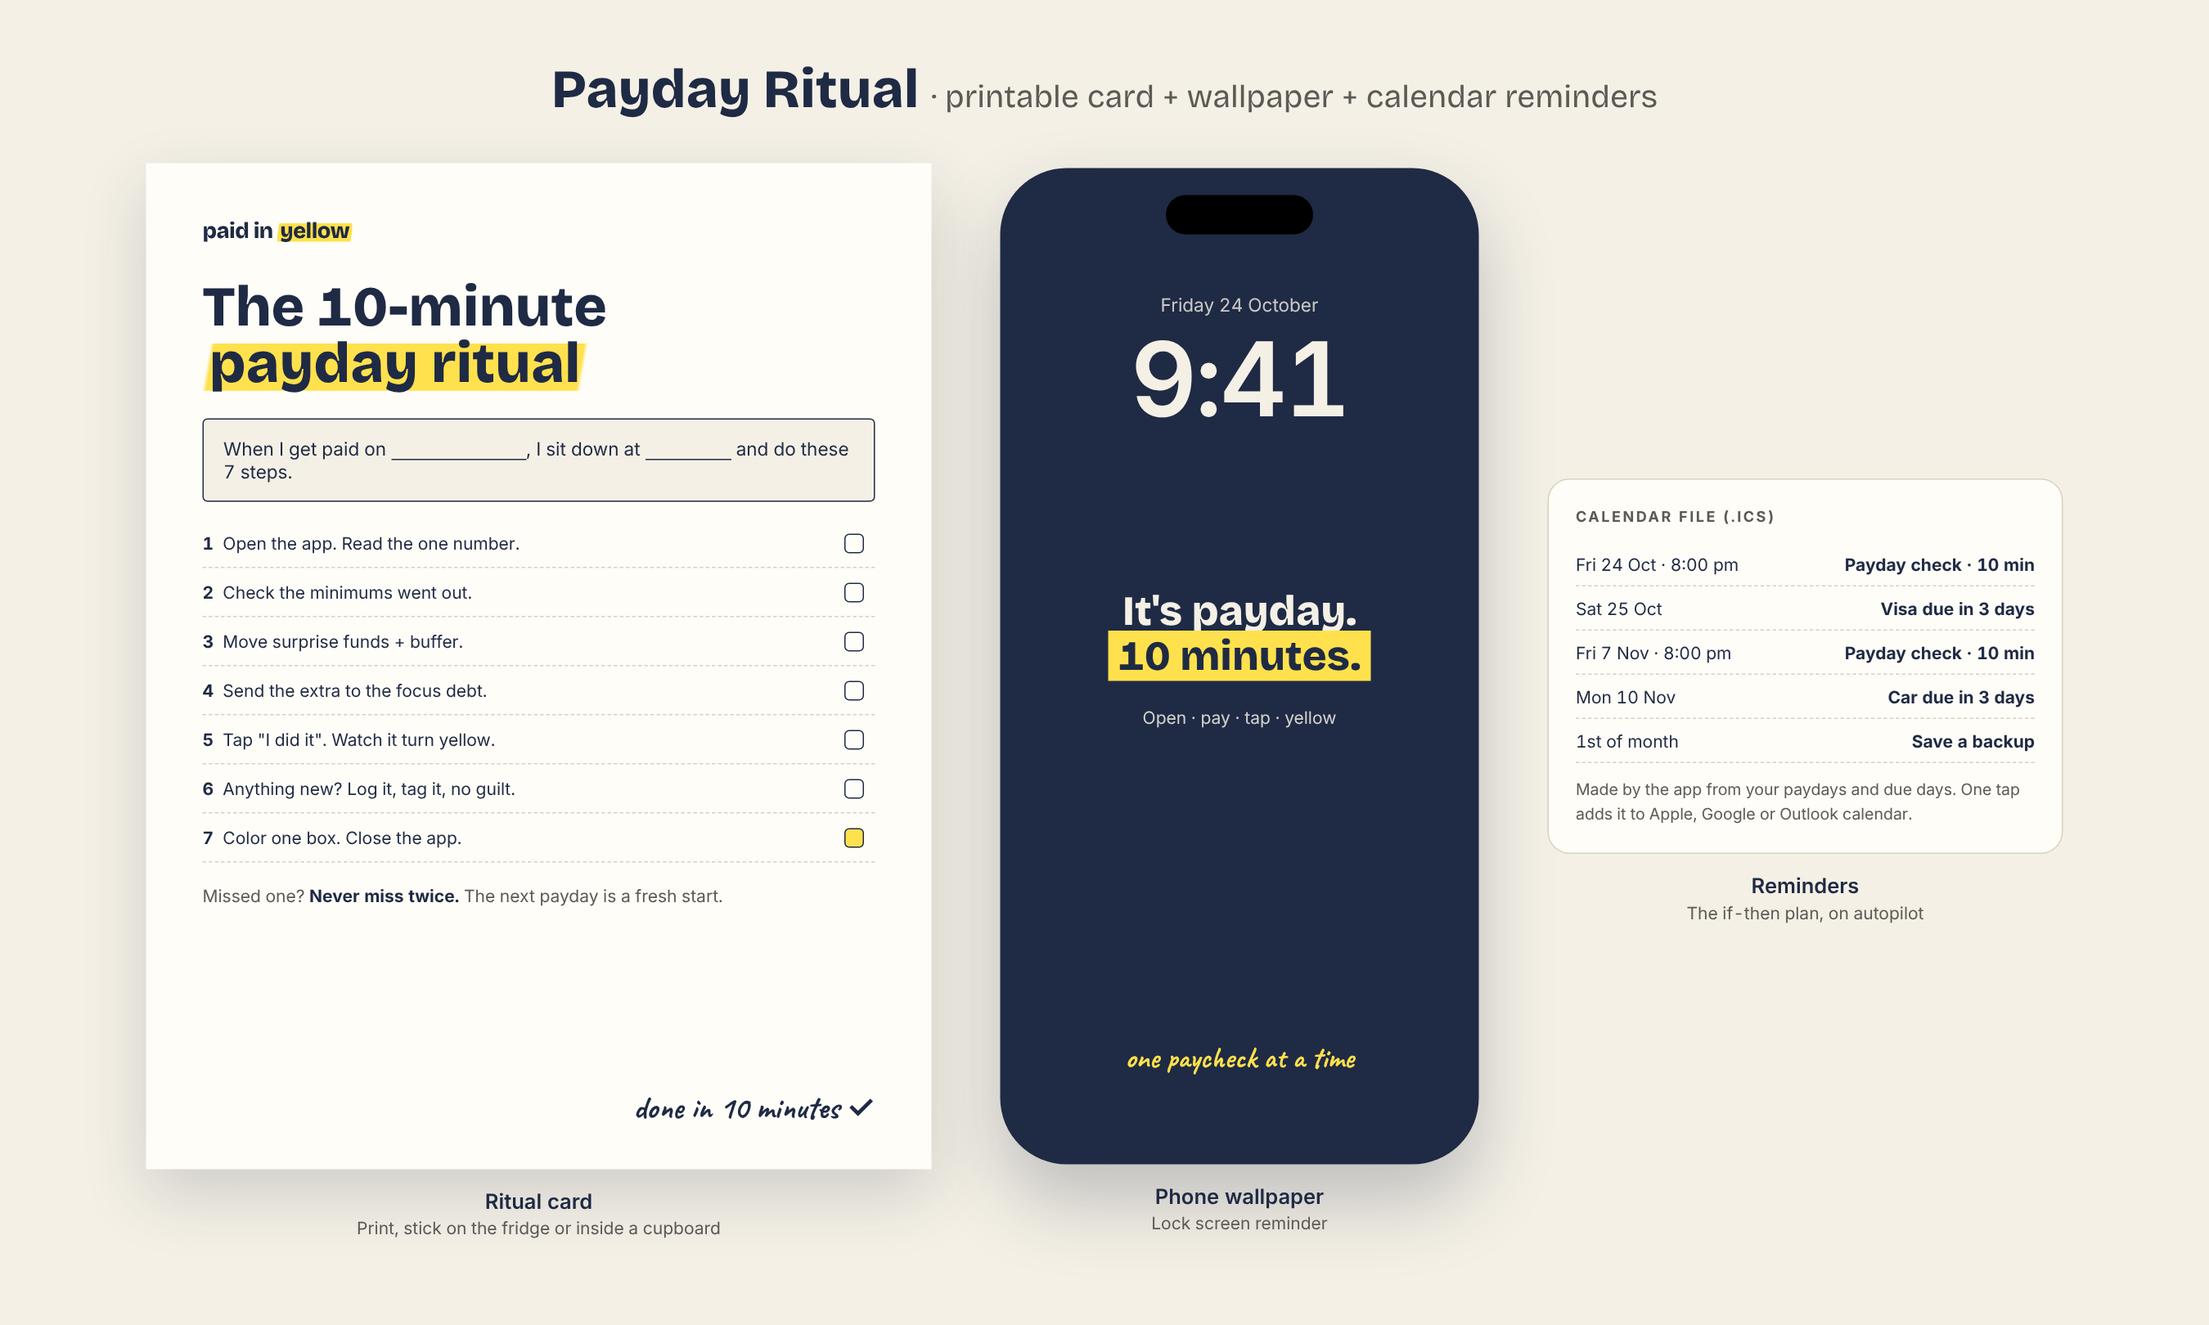

Emails
- Day 0 welcome + Day 1-7 (one task each, ~120 words, one button) · Payday check 1-8 (sent on the buyer's pay rhythm) · Week 4 "Missed one? Never miss twice" · Week 8 "Look how far you came" + review request.

Layer 3 · Acceleration: Debt-Free Speed Kit
Formats: printable PDF (~22 pages, Letter + A4) + 6 phone wallpapers (PNG). Job: more money to the focus debt (speed) and visible progress (motivation).
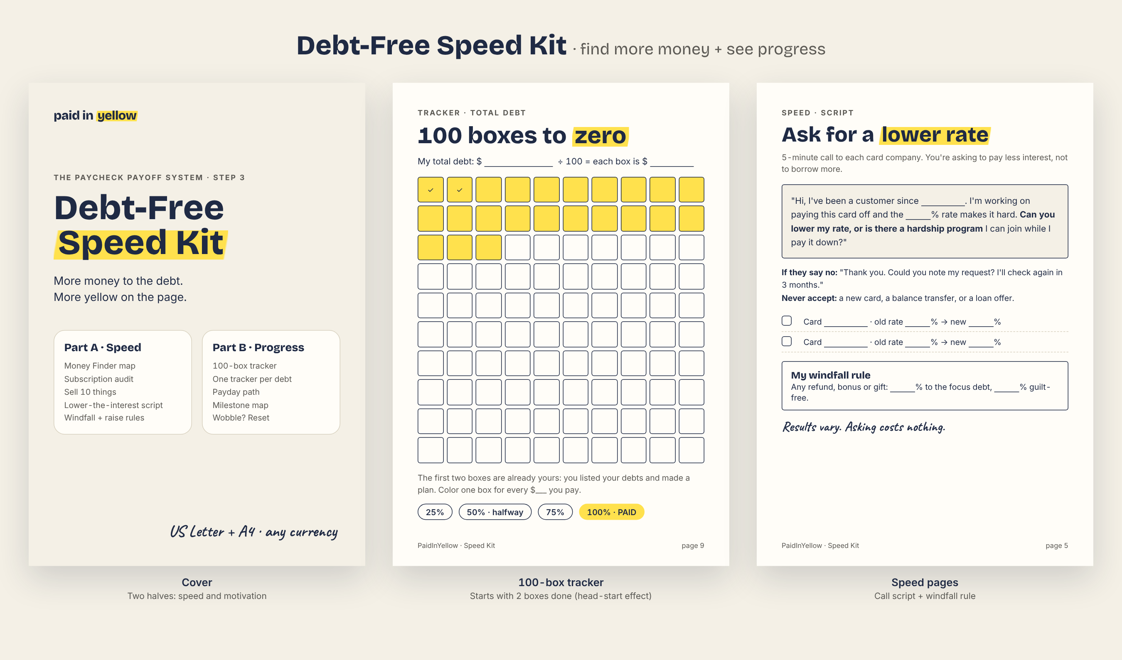

Pages
Part | Pages
Part A · Speed (find money) | Money Finder map (all ideas on one page with $ potential) · Subscription audit · Sell 10 things · Bill-lowering checklist (phone, internet, insurance quotes) · 30-day no-spend challenge · Extra income planner · Lower-the-interest call script + log · Windfall rule · Raise rule · "My speed number" (new extra per paycheck → new date from the app)
Part B · Progress (motivation) | 100 boxes to zero (2 pre-filled) · One tracker per debt (8 slots, thermometer) · Payday path (52 / 26 / 24 / 12 stops by pay frequency) · Milestone map with free reward ideas · Wobble? Reset · Remember your why · Yellow wall (final page: the day you're debt-free)

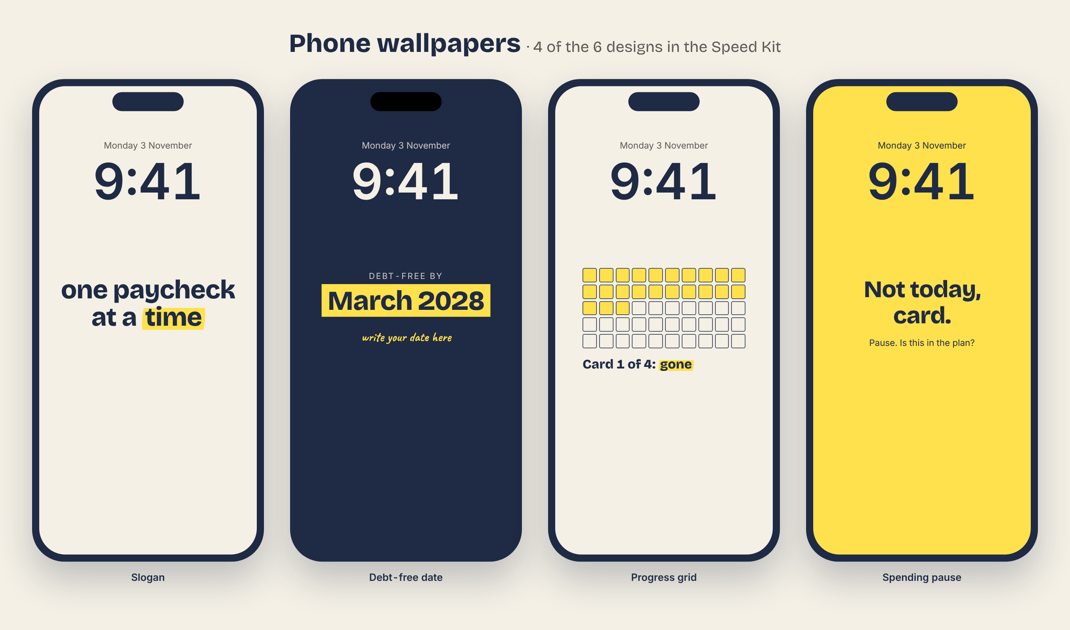
- Wallpapers (6): slogan, debt-free date (write your own), progress grid, "Not today, card" spending pause, payday reminder, milestone "1 debt gone".

Layer 4 · Safety: Never Back in Debt
Formats: PDF guide (~18 pages), Quick-Start video (3-5 min, screen recording, captions), PaidInYellow Promise. Job: remove the fear of falling back and the fear of failing setup.
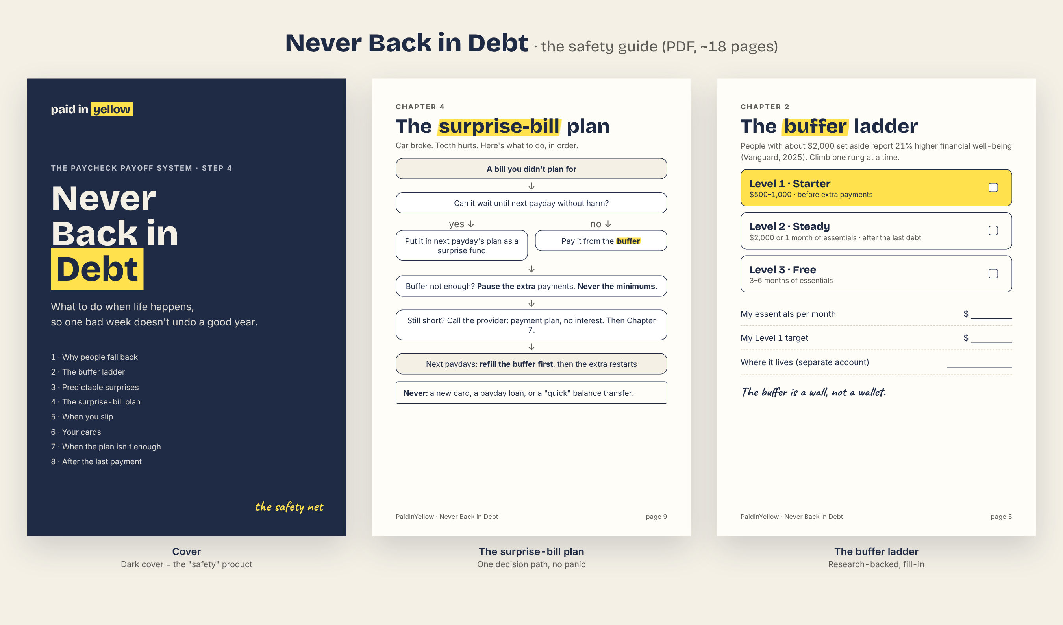

Guide chapters
Chapter | Pages · content
1 Why people fall back | 2 · surprise bills, no buffer, burnout, lifestyle creep; self-check quiz
2 The buffer ladder | 2 · Level 1 starter $500-1,000, Level 2 $2,000 or 1 month, Level 3 3-6 months (Vanguard research); fill-in
3 Predictable surprises | 2 · sinking-funds list and sizing worksheet
4 The surprise-bill plan | 2 · decision path: wait or buffer → pause extra, never minimums → refill buffer first
5 When you slip | 2 · never miss twice, self-compassion script, fresh start next payday
6 Your cards | 2 · freeze, remove from apps, keep or close (neutral pros/cons, no credit-building push)
7 When the plan isn't enough | 3 · warning signs; hardship programs; nonprofit credit counseling; scam warnings (debt settlement, payday loans, "consolidation" offers); legal help. No loans.
8 After the last payment | 2 · keep paying yourself the same amount: Level 2-3 buffer, then saving and giving goals; celebrate

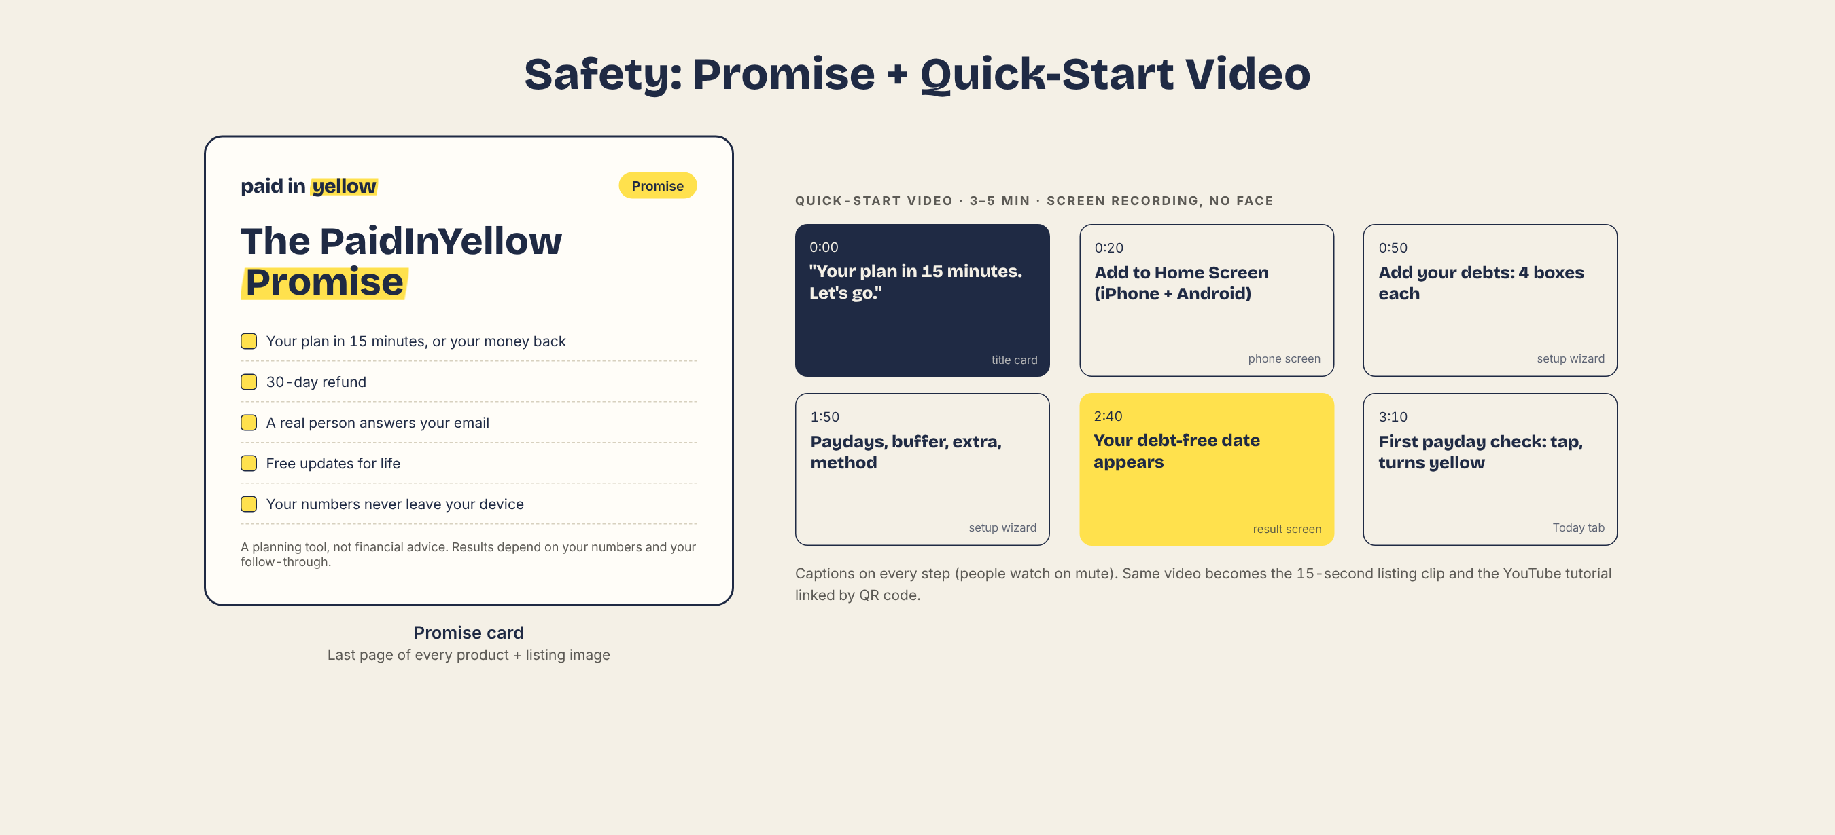

v1.1 additions (coverage audit, 15 Oct 2026)
Added after checking every competitor observation, Reddit insight, study and Trust Kit answer against this design. Source for each item: pack1-traceability.docx.
Product | Addition | From
App · Setup | Welcome screen opens with the pain line: "You pay every month, but the balance never goes down. Let's fix that, one paycheck at a time." and "You're not bad at math. The math was hidden from you." | Reddit pain #1, math anxiety
App · Today | "+ Extra payment" button: log any extra money (leftover on payday, a refund) and it goes to the focus debt, which turns yellow a bit more | AY "snowflake", validation
App · Today | "I got a different amount" on payday: type the real paycheck and that payday's plan recalculates (minimums, then buffer, then focus debt) | Trust Kit irregular-income promise
App · Debts | "Gone by" date and paydays left on every debt | My Productive Life
App · Progress | Debt by type (4-6 bars, no pie), principal vs interest bar, one-page printable summary, shareable milestone image (shows %, never amounts) | AY reports, MPL pie weakness, Reddit celebration
App · Money | "Debt payments = X% of take-home pay" line, plain number, no grade | AY debt-to-income
App · Settings | Round each payment up to $5 / $10 · optional "+ cushion %" on bills and surprises · Help screen with the 16 Pack 1 FAQ answers | AY, validation (15% cushion), Trust Kit
App · Milestones | "One month ahead" milestone (no longer living paycheck to paycheck) | Validation
Emails | After the 8 payday emails: one monthly "long haul" email with "since you started: $X paid, N paydays done" (same card in the app) | Reddit mid-journey burnout
7-Day Reset | Day 4: suggest a plain separate account or envelope for the buffer (never an interest-earning product) | Halal rule
Speed Kit | Printable "PAID" sticker sheet (yellow stamps for each debt and milestone) | Reddit "debt killed" stamps
Never Back guide | Cover line "This time it sticks." · Ch. 1 opens with $1.26T card debt (NY Fed Q2 2026) and 37% can't cover $400 (Fed SHED 2025) · Ch. 3 tip: pay yearly bills once if it avoids installment fees · line "A surprise bill becomes an annoyance, not a new debt" | Verified stats, validation
Start Here PDF | Last page: short FAQ | Trust Kit

Production checklist (Pack 1)
Product | Tool to build | Output files
Planner app | Vite + Preact/TS, IndexedDB, service worker | app.paidinyellow.com + single HTML file
Google Sheet | Google Sheets (formulas + protected ranges) | View-only template + "Make a copy" link
7-Day Reset | HTML → PDF (same templates as these mockups) or Canva | PDF Letter + A4, email texts, ritual card, wallpaper
Speed Kit | HTML → PDF | PDF Letter + A4, 6 PNG wallpapers
Safety guide | HTML → PDF | PDF Letter + A4
Video | Screen recording + captions | MP4 (3-5 min) + 15 s listing clip
Delivery | Shopify digital download | One "Start here" PDF with links + unlock code

