eKalinga+ Ayuda Management System
User Manual
Local Workflow Edition
eKalinga+
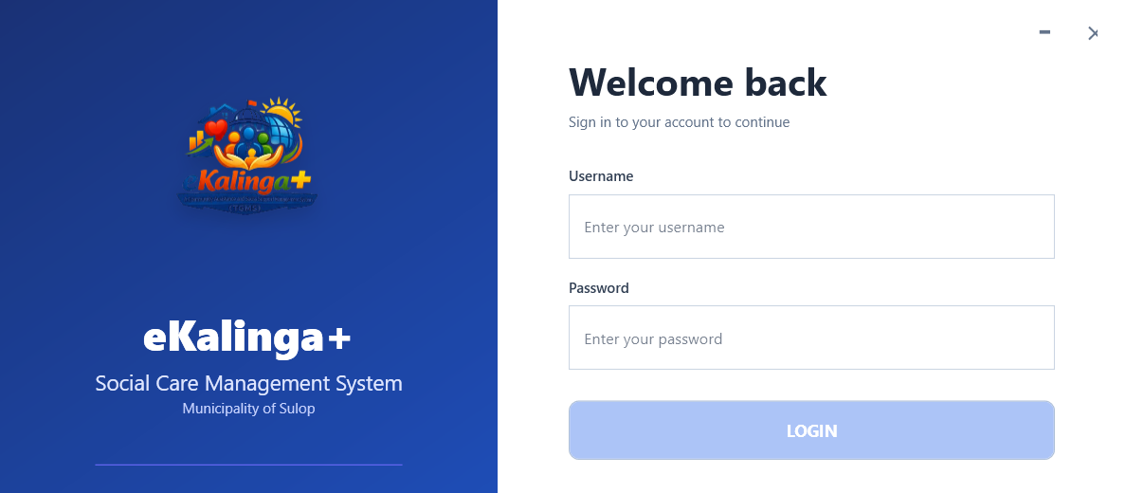
Version 1.0
Prepared on April 19, 2026

Table of Contents
Use this guide in sequence when onboarding a new operator, or jump directly to the section for the module you are working in.
Table of Contents 2
Getting Started 3
Login and User Access 4
Dashboard Overview 5
Validated Beneficiaries 6
Aid Request 7
Budget Management 8
Program Setup 8
Distribution Workflow 10
Cash-for-Work 11
Settings and Administration 12
Backup and Restore 13
Troubleshooting 14
Update the field in Word if the table of contents is not visible.

Getting Started
This manual is written for operators and administrators using the desktop application in Local mode. It focuses on the modules available in the current build: Dashboard, Validated Beneficiaries, Aid Request, Budget, Distribution, Cash-for-Work, and Settings.
Before you begin, confirm that the workstation can open the application and reach the configured local database preset.
Requirement | Notes
Application mode | Use the Local preset for routine on-site workstations.
Database access | The local MySQL or MariaDB-compatible database must be reachable from the workstation.
Account type | Use an admin or authorized operator account issued by the barangay or system owner.
Protected actions | Sensitive settings may require current-password confirmation and, in some workflows, additional verification.

- Use the left navigation to move between operational modules.
- Use search, filters, and summary cards at the top of each page to narrow large record sets quickly.
- Use Settings only when you are assigned administrative responsibility for the workstation or data source.

If the selected database has no admin account yet, the app switches to Initial Admin Setup. Create the first admin account there, then return to normal sign-in.
For standard onsite workstations, keep the active preset on Local. Use Network (LAN) only when the workstation must point to an available LAN server. Local and Remote are fixed by the shipped app configuration, while Network (LAN) is the only editable preset before sign-in.
- If you change Network (LAN) details, use Test Connection, then click Save and Continue to return to the login screen.
- On the login screen, open Connection Settings only if you need to change the active app database before sign-in.
- Launch the application after setup completes.
- Keep the default install folder unless your administrator or deployment guide specifies a different location.
- Run the current installer package provided by your administrator or release source. The shipped installer file follows the pattern eKalingaPlus-Setup-<version>.exe.
Use this section when preparing a new workstation or reinstalling the desktop application.

Installation and First-Time Setup
- Locate the downloaded file installer of eKalinga+ Setup
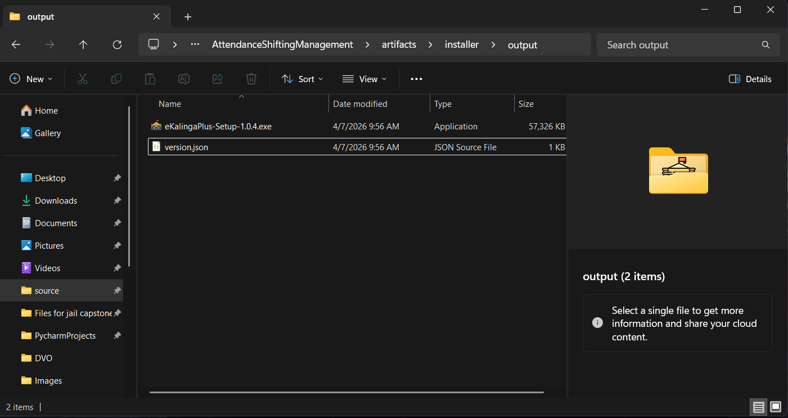

- Double click or Click+Enter setup installer to start installing

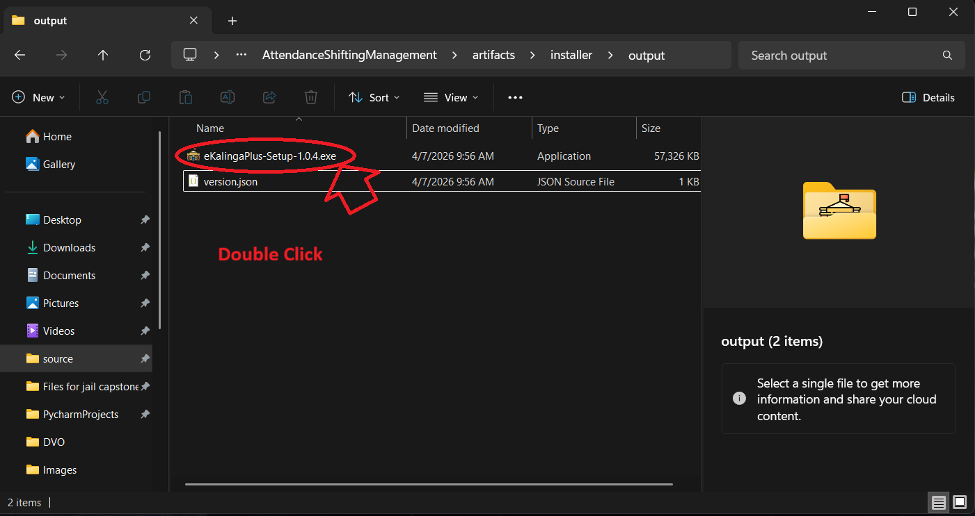

- Choose the destination of your choosing where to install the eKalinga+ app
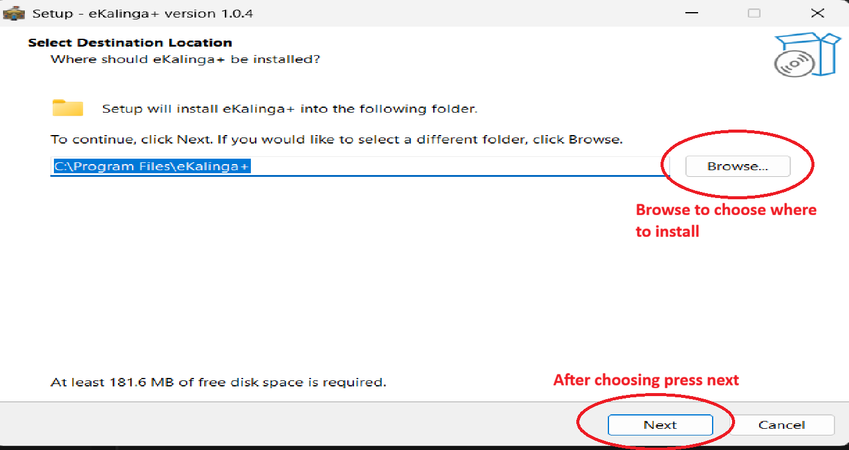

- Check the checkbox to create shortcut on Desktop
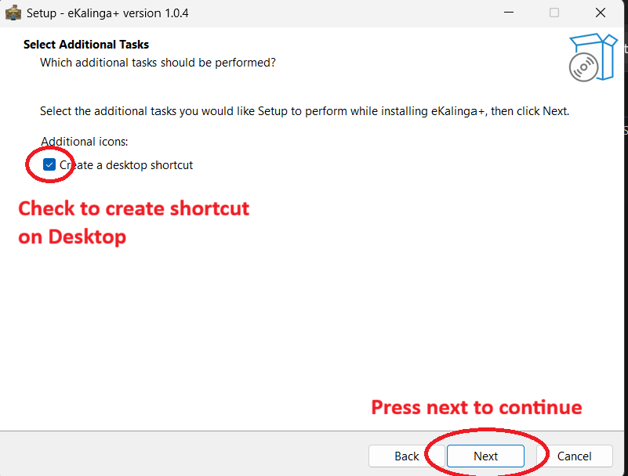

- Press install to continue
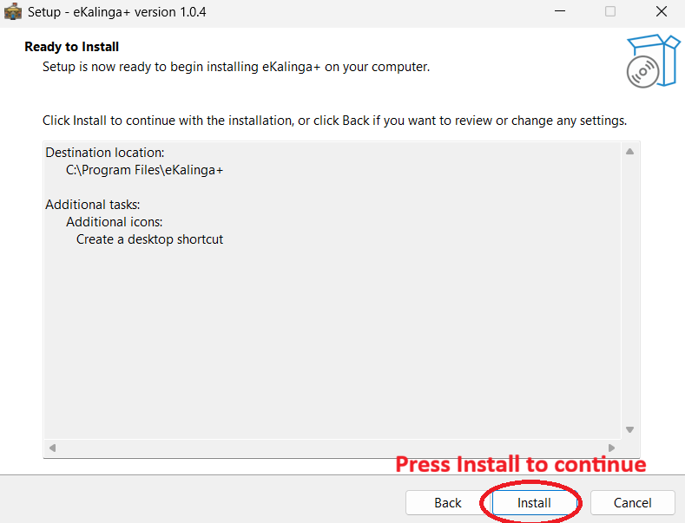

- Wait till finish
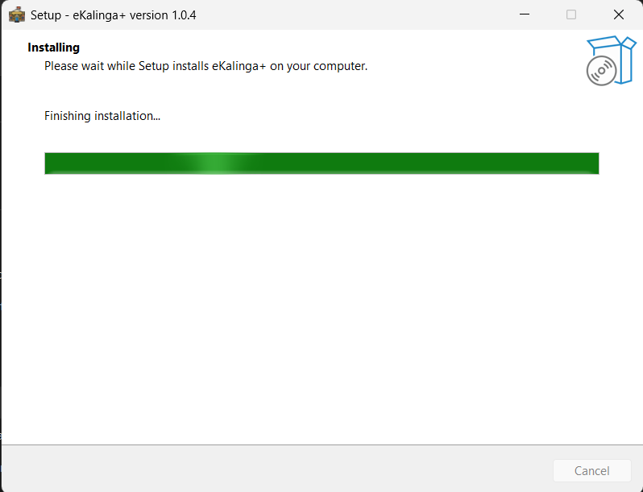

- Press Finish then search the app on desktop
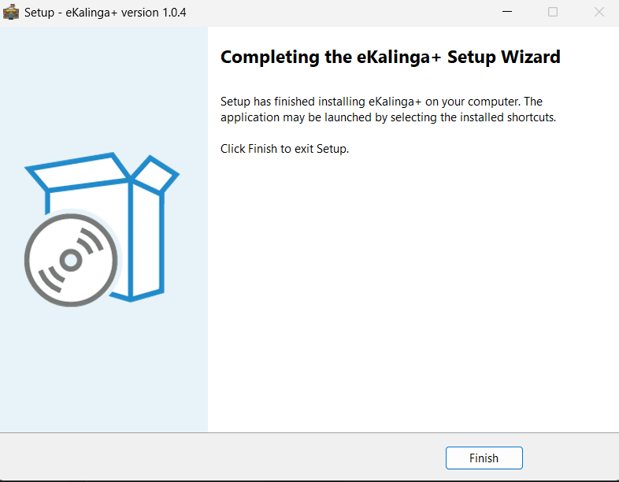

Login and User Access
Sign in with the username and password assigned to your account. After login, the system loads the main shell and opens the Dashboard by default.
- Launch the desktop application from the workstation.
- Enter your username in the Username field.
- Enter your password in the Password field.
- Click LOGIN to enter the system.
Do not publish or circulate live credentials in printed or shared copies of this manual. Replace them with demo credentials or remove them before external distribution.

Login screen for the desktop application in Local mode.

Dashboard Overview
The Dashboard is the main landing page for operators. It surfaces the primary workflow areas as large navigation cards so staff can move directly to the module they need.
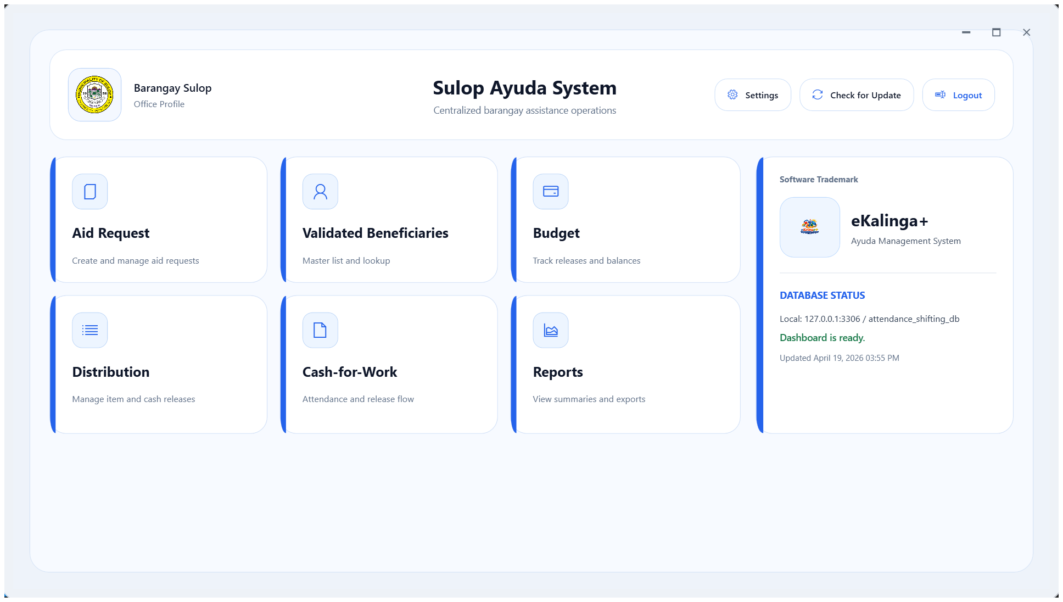
Dashboard module cards visible after successful login.
- Use Dashboard for quick entry into Validated Beneficiaries, Aid Request, Budget, Distribution, Cash-for-Work, Reports, and Settings.
- Use it as the standard starting point at the beginning of each shift.
- Return here when handing over the workstation so the next operator can navigate cleanly.

Validated Beneficiaries
The Validated Beneficiaries module is used to review and monitor beneficiary records that are ready for operational processing. This page is typically used before requests are finalized or before distribution activities are prepared.
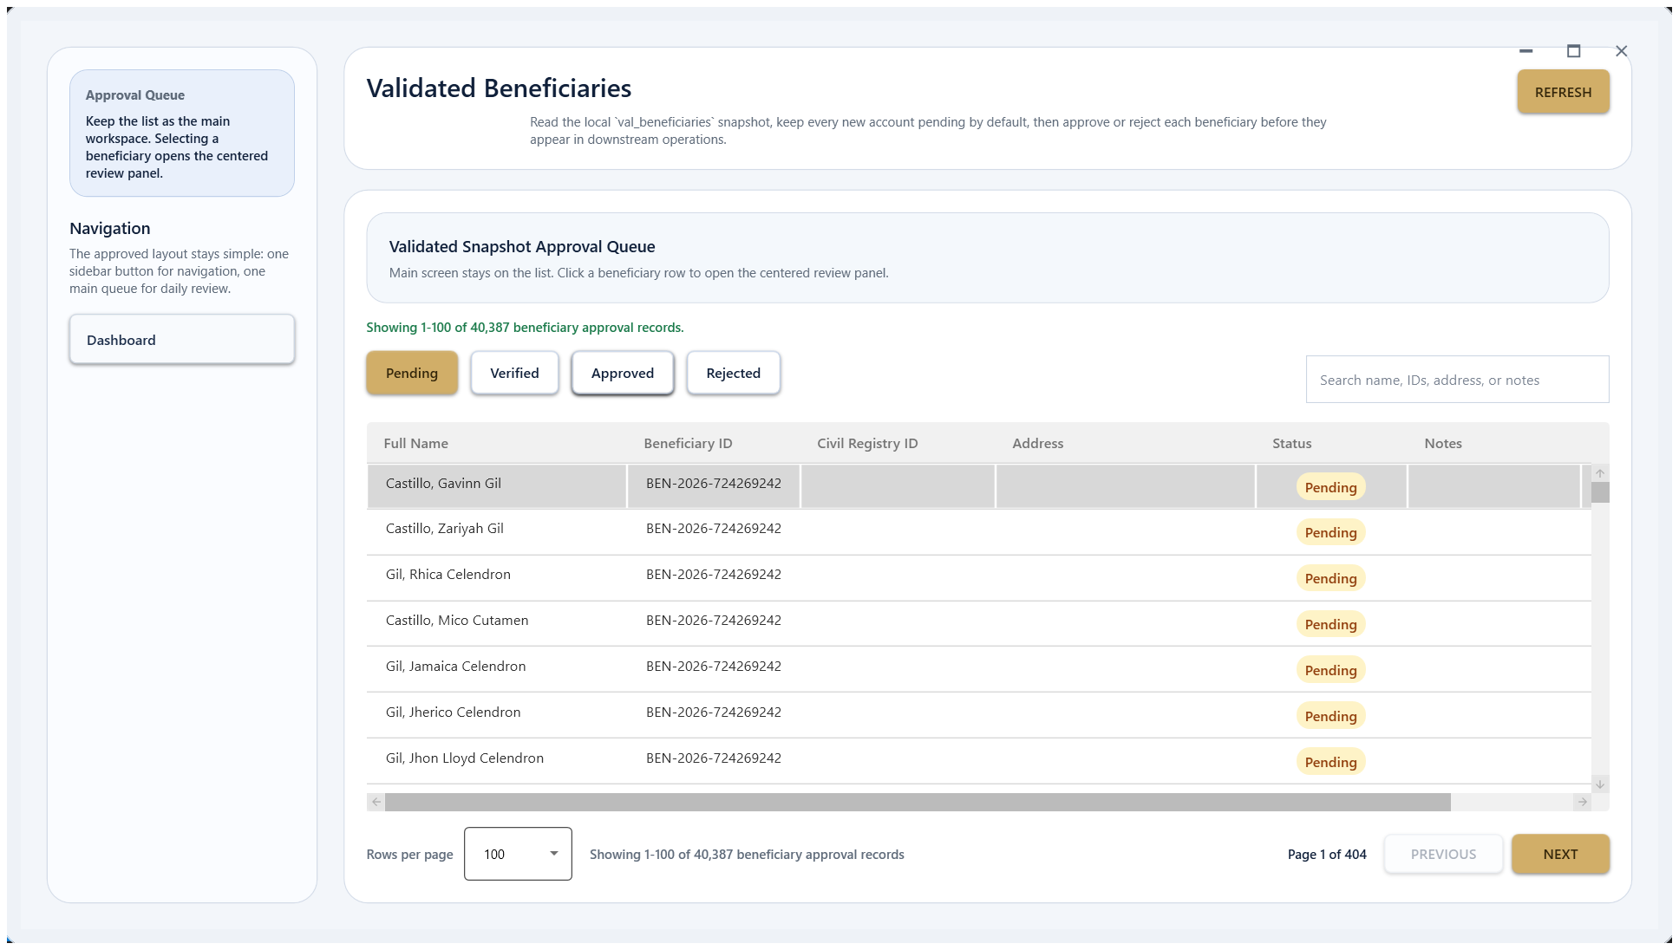
Validated Beneficiaries page showing the review queue and action area.
- Open Validated Beneficiaries from the dashboard or left navigation.
- Use the search and filters to locate a beneficiary record or batch.
- Review the status and supporting details before moving the record to the next operational step.
- Use the available actions to confirm or return items according to your office process.

Aid Request
Aid Request is the intake workspace for assistance requests. Operators use this page to create, review, and maintain requests tied to the current beneficiary and program flow.
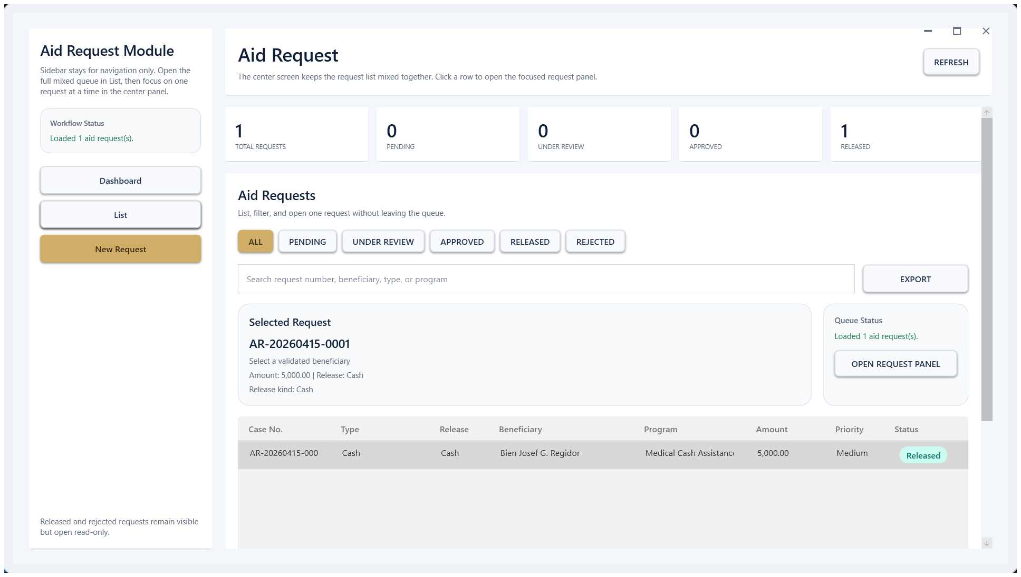
Aid Request page with list and action controls.
- Create or open a request from the main request list.
- Use the page to review request details, statuses, and linked records.
- Apply filters and search before printing, validating, or forwarding requests.

Budget Management
The Budget module tracks available funds and organizes budget records by program. Use the dashboard view for totals and current status, then switch to Program Setup when you need to define or adjust the budget structure.
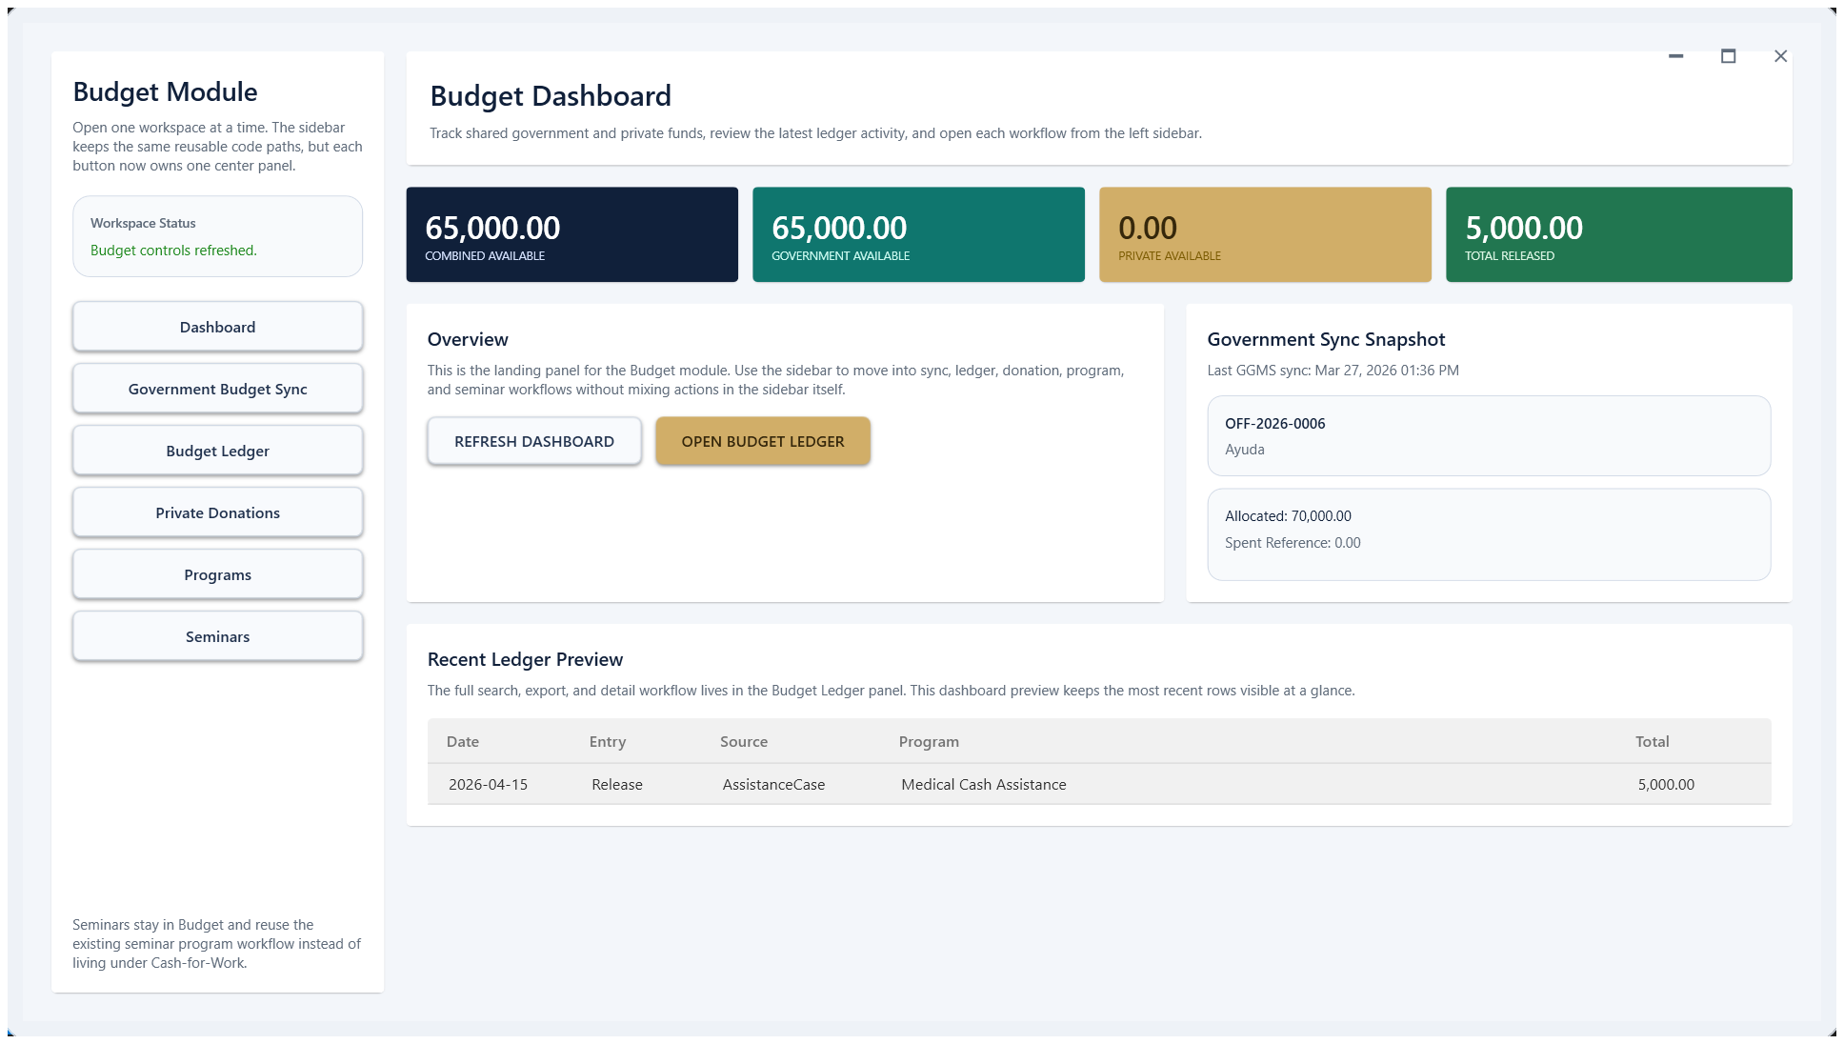
Budget overview page with summary cards and main navigation.

Program Setup
Program Setup is where administrators maintain the program list and related budget definitions that feed the operational pages.
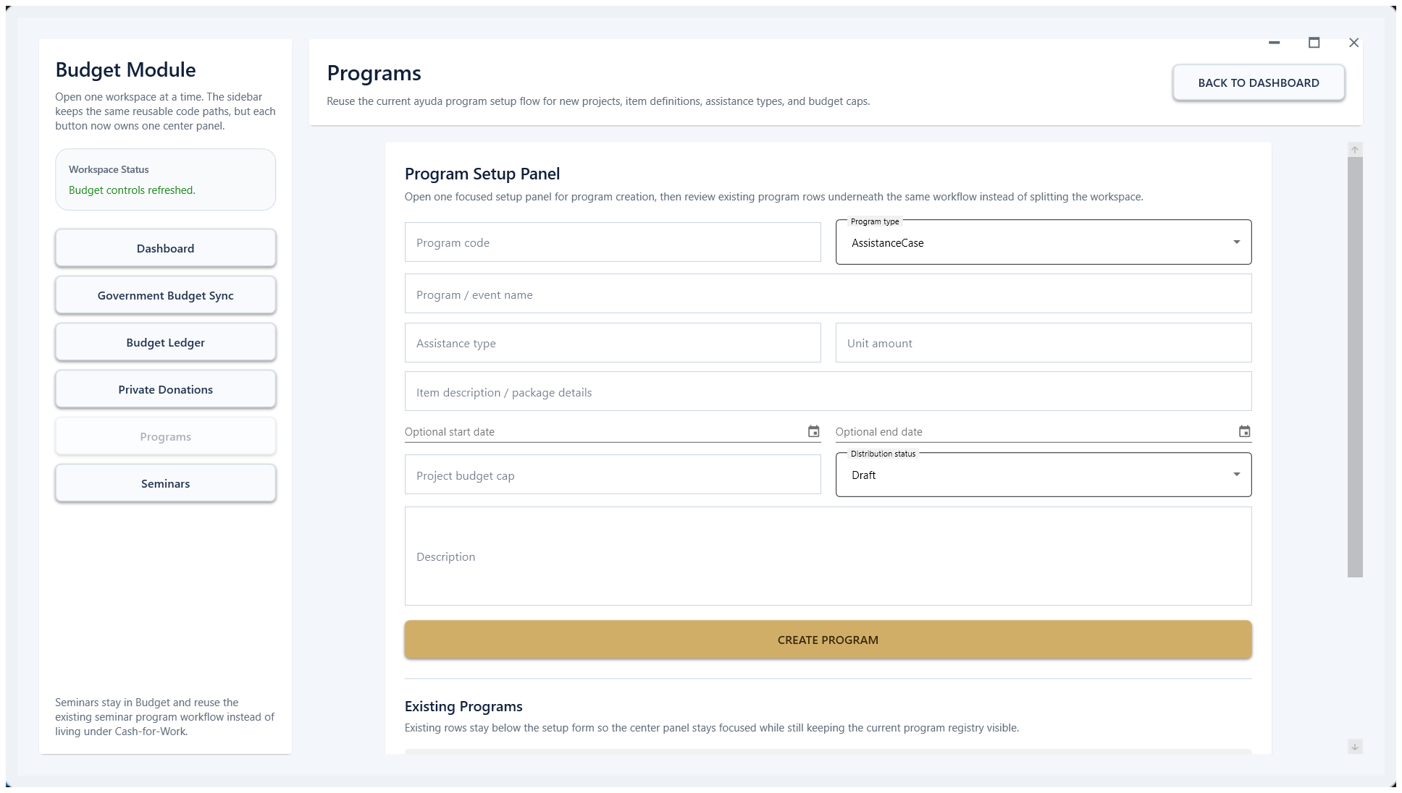
Budget Program Setup panel used for program definitions and maintenance.

Distribution Workflow
The Distribution module supports planning and releasing assistance to approved beneficiaries. The main page shows distribution records, while the distribution panel is used for the detailed handoff workflow.
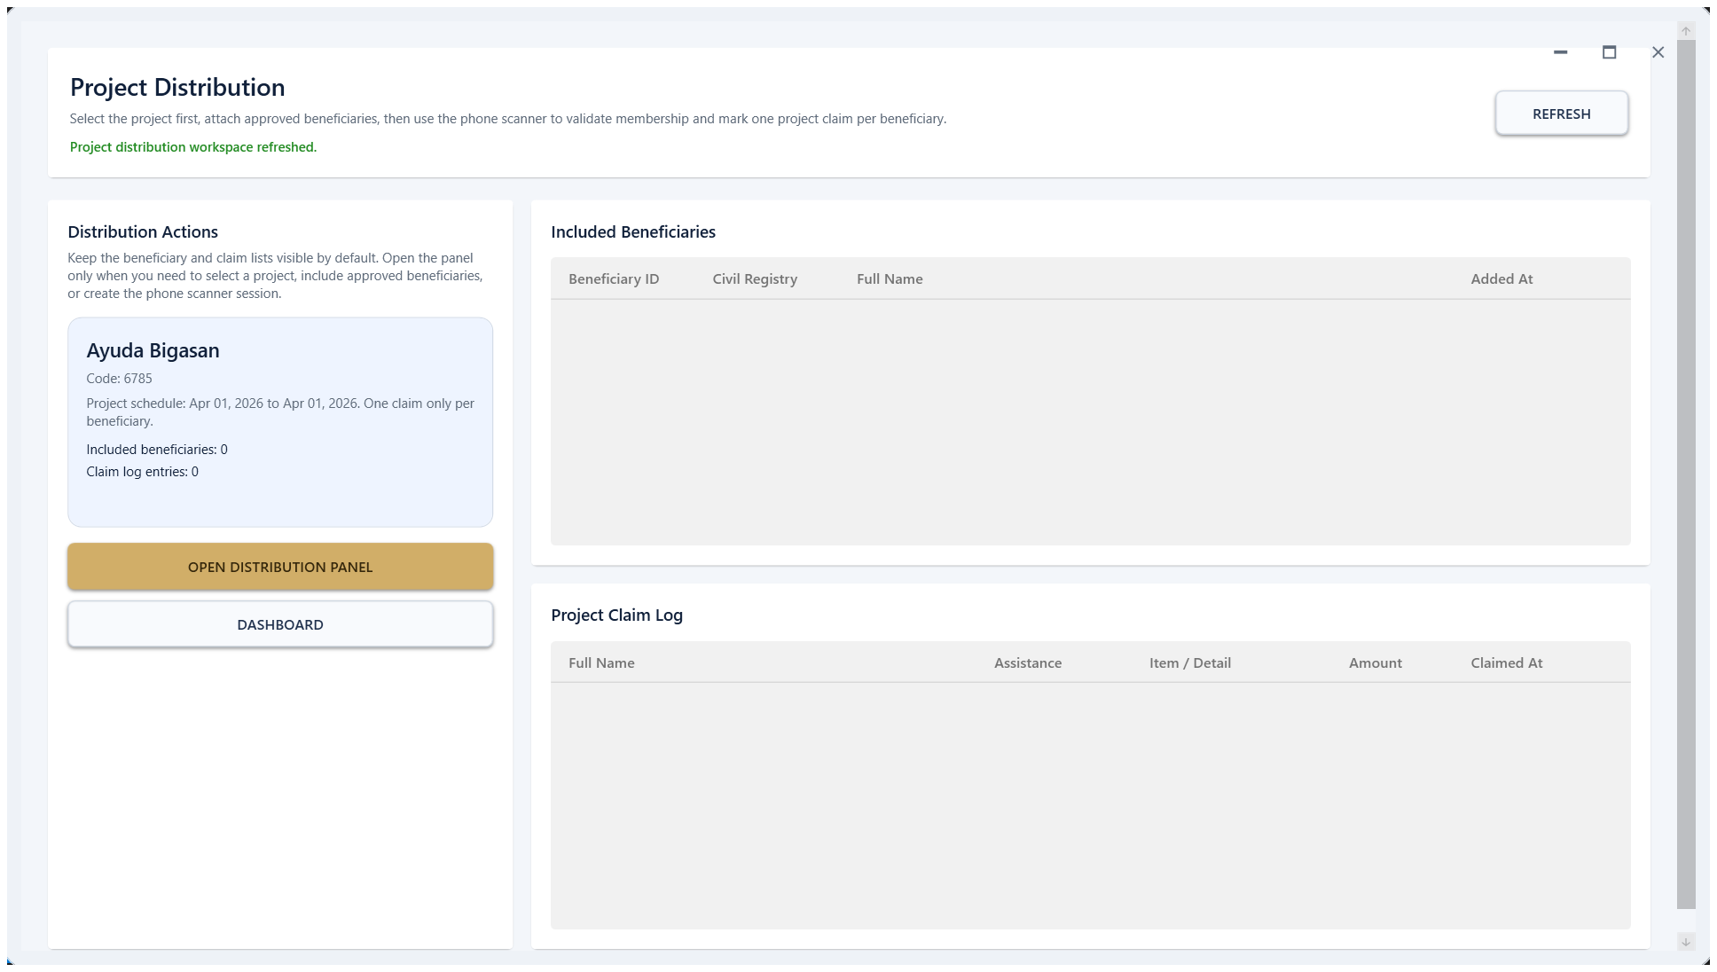 | 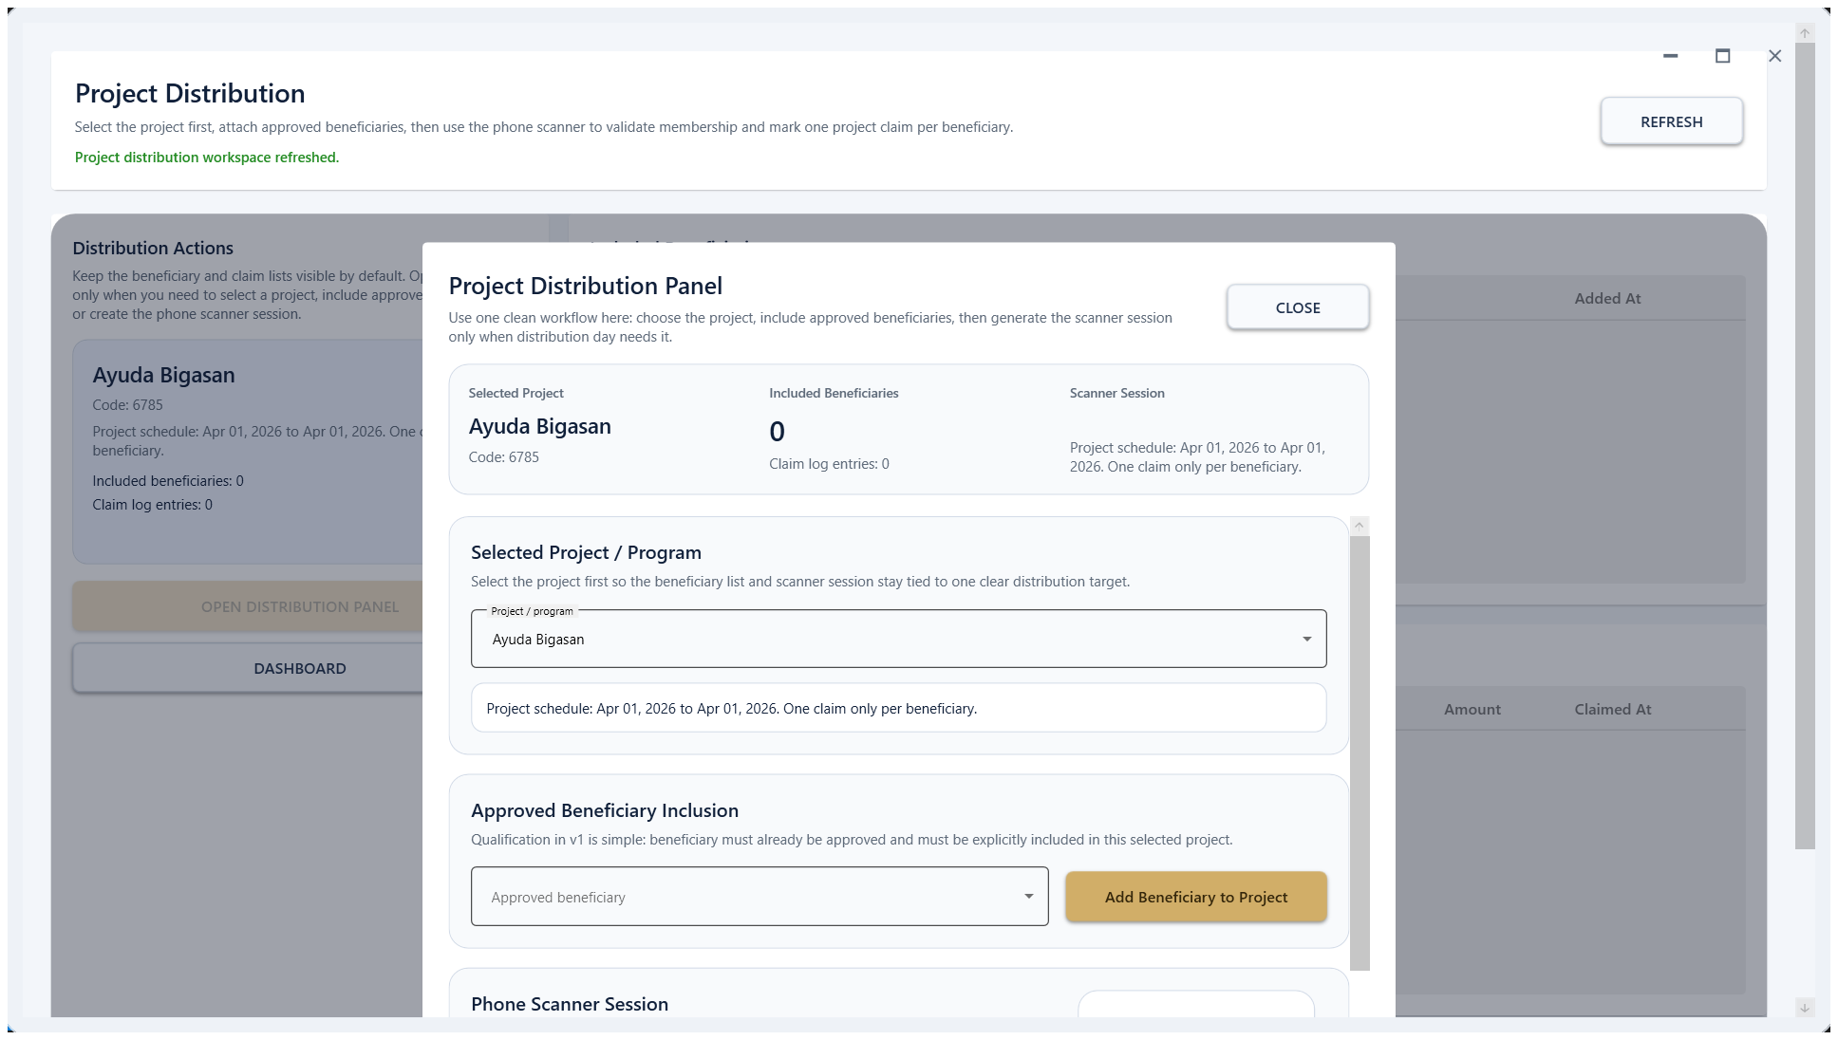

Distribution list view and the distribution panel used for the detailed release workflow.
- Open Distribution and locate the correct record, batch, or activity.
- Review the distribution status before opening the detailed panel.
- Use the distribution panel to verify beneficiary details and complete the release workflow.
- Save or confirm the transaction before moving to the next beneficiary.

Cash-for-Work
Cash-for-Work is used for attendance-based cash assistance activities. When no event is active, the page shows an empty state; once an event is configured, it becomes the workspace for monitoring attendance and related outputs.
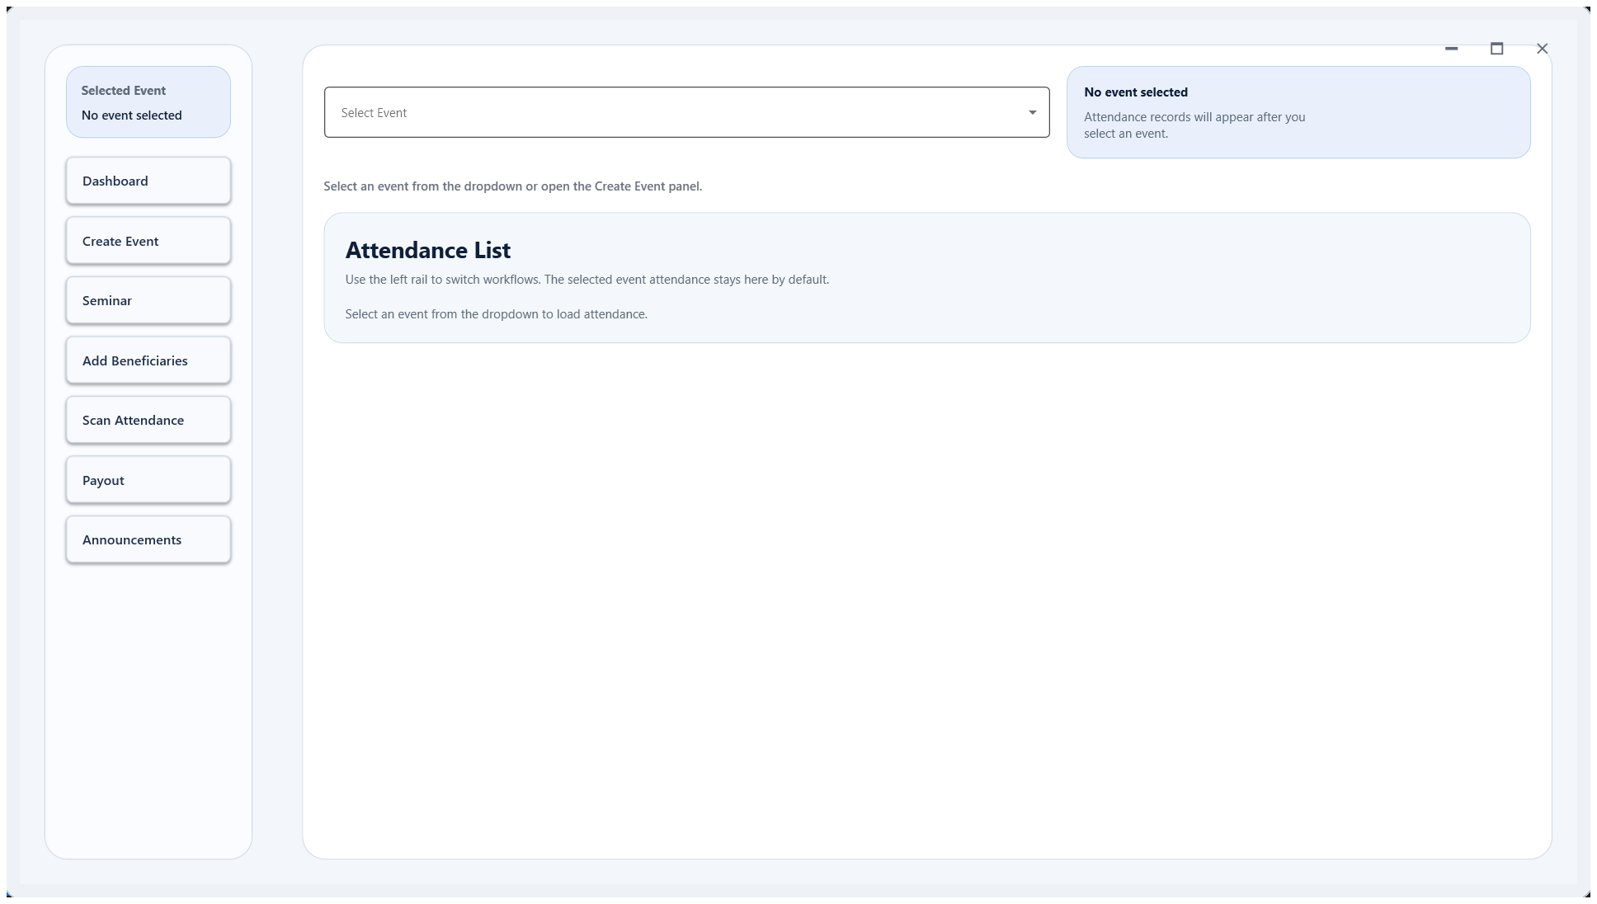
Cash-for-Work page showing the current event workspace.
- Use this page after a Cash-for-Work event or cycle has been prepared.
- Review attendance and participant records before generating any output tied to the event.
- If the page is empty, confirm that the correct event and preset are selected.

Settings and Administration
Settings centralizes workstation and administrative tools. Use this area carefully because it includes system identity, account maintenance, protected data-source settings, and recovery tools.
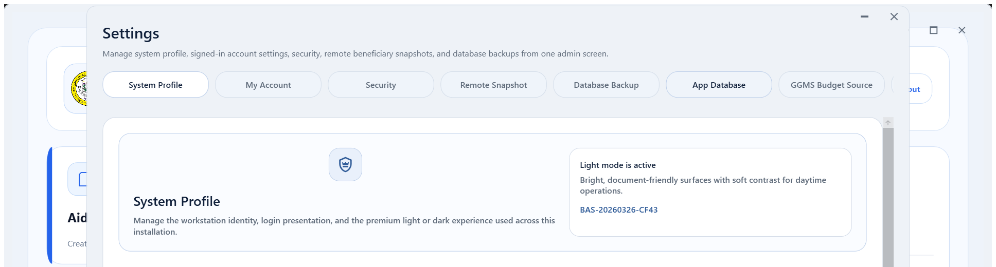
Settings overview with the System Profile page selected.
Sensitive sections do not open immediately. The system protects them behind a current-password prompt before allowing changes.
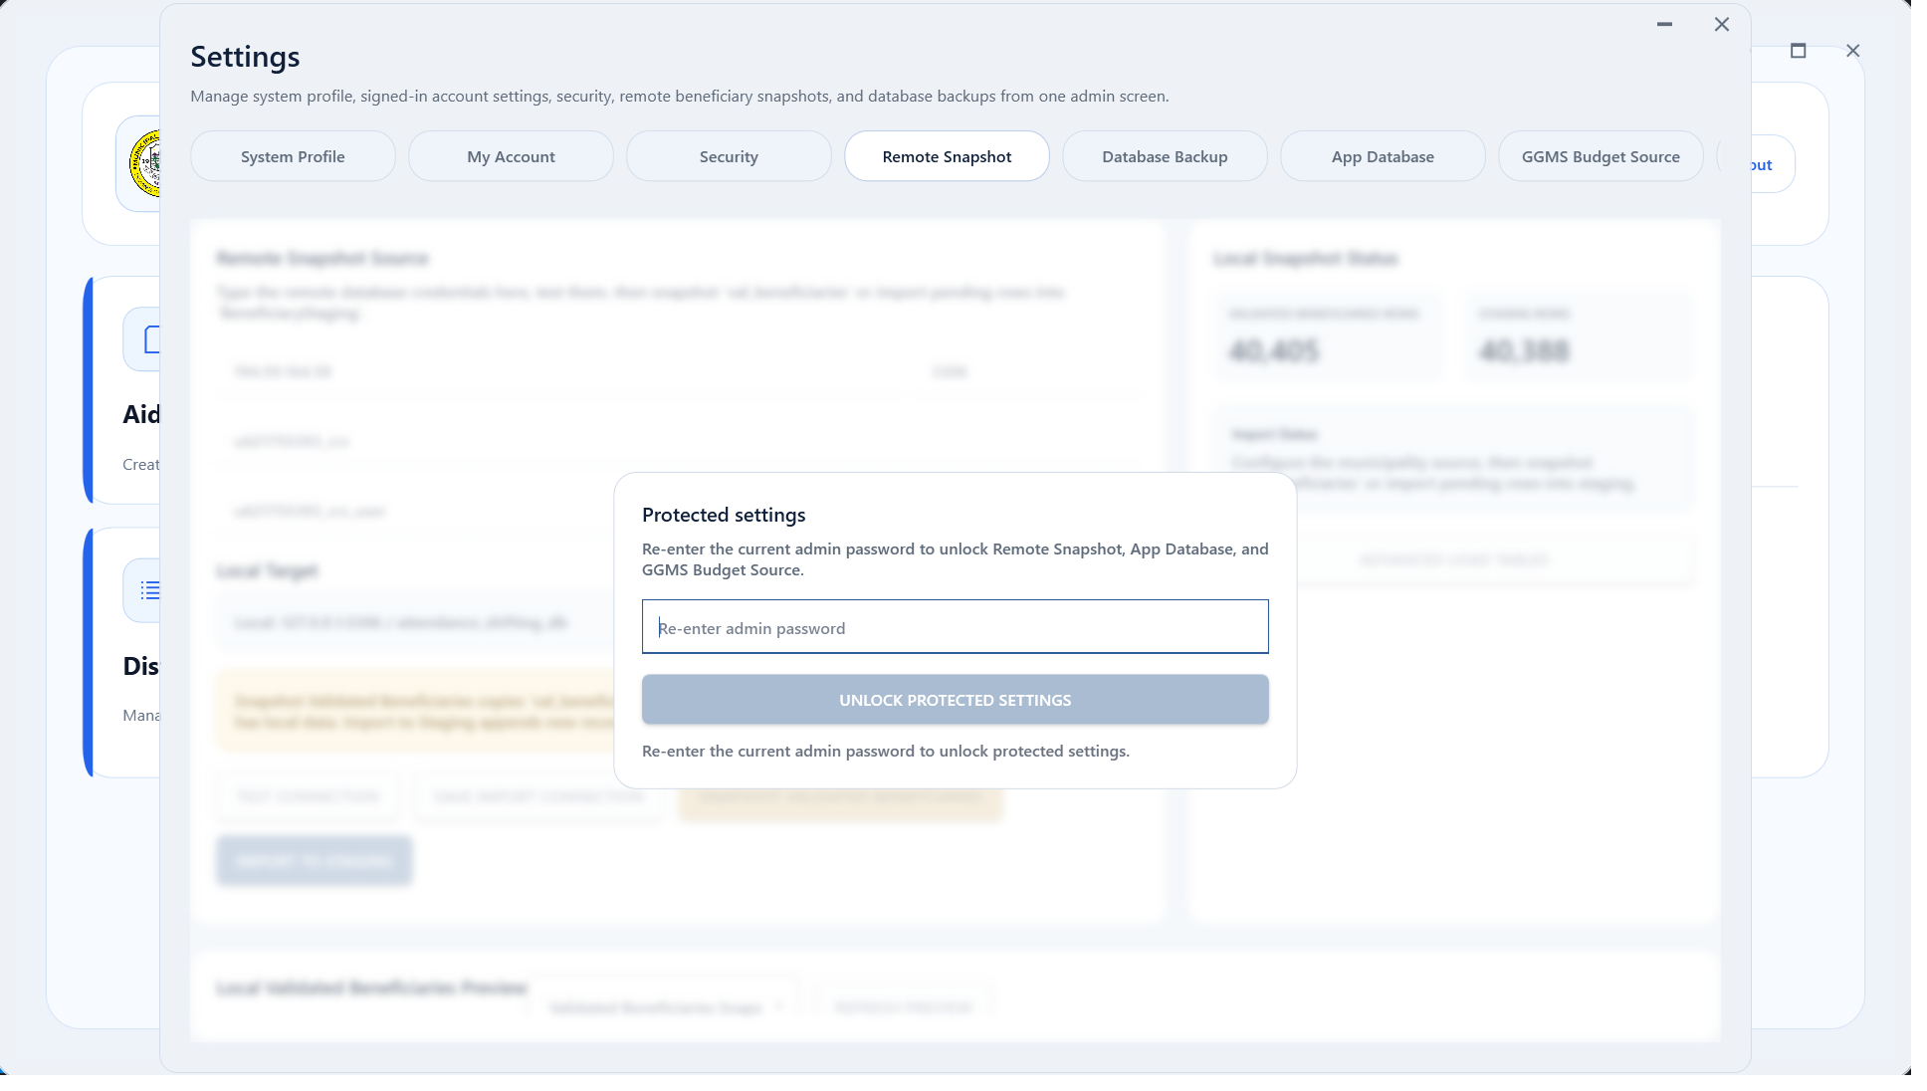
Protected settings prompt shown before accessing Remote Snapshot or other sensitive admin pages.
- System Profile controls the workstation identity and presentation details.
- Remote Snapshot, App Database, and other sensitive sections are protected for administrator use only.
- Use My Account and Security for account-level maintenance when assigned by your administrator.

Backup and Restore
Use Database Backup to create full, incremental, or differential backups for the currently selected app preset. Restore uses the selected restore point and automatically resolves the required backup chain.
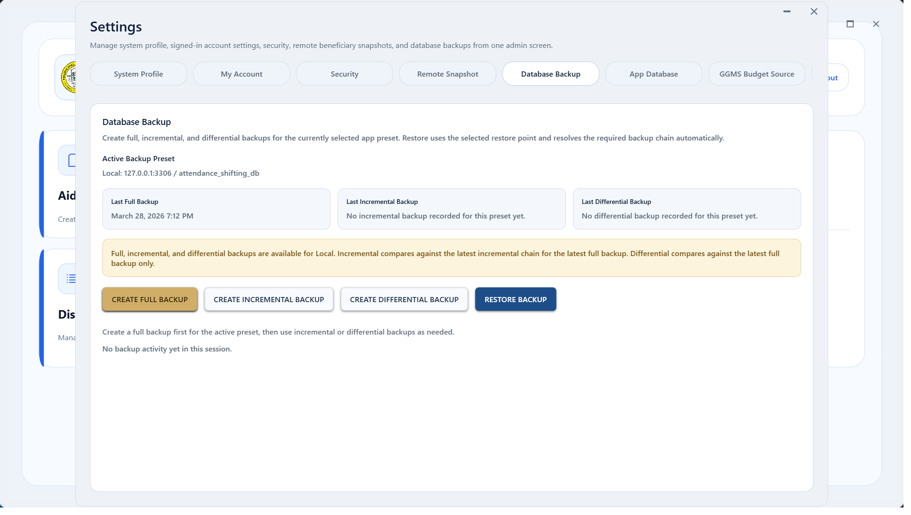
Database Backup page for Local preset backup creation and recovery.
- Open Settings and select Database Backup.
- Confirm that the active preset shown at the top of the page is correct.
- Create a full backup first before using incremental or differential backups.
- Use Restore Backup only after confirming the correct restore point and chain.
The App Database page is intentionally protected. Only administrators should edit server, database, or credential settings, and those details should be removed from any public-facing manual.

Troubleshooting
Use the table below for the most common operator-side issues before escalating to the system administrator or developer.
Issue | Action
Login fails | Verify the username, password, and active preset. If the issue persists, request an account reset from the administrator.
No data appears on a page | Check filters, selected period, and current preset. Refresh the page or reopen the module.
Protected settings stay locked | Re-enter the current admin password. If verification is required, complete the assigned security step before retrying.
Incremental or differential backup is unavailable | Create a full backup first for the active preset, then return to the backup page.
Local preset is incorrect | Open the protected App Database settings only if you are the assigned administrator. Do not guess or overwrite connection values.

End of manual. Review this guide again whenever the desktop workflow changes or when new modules are introduced.

