REPUBLIC OF THE PHILIPPINES • PROVINCE OF DAVAO DEL SUR • MUNICIPALITY OF SULOP

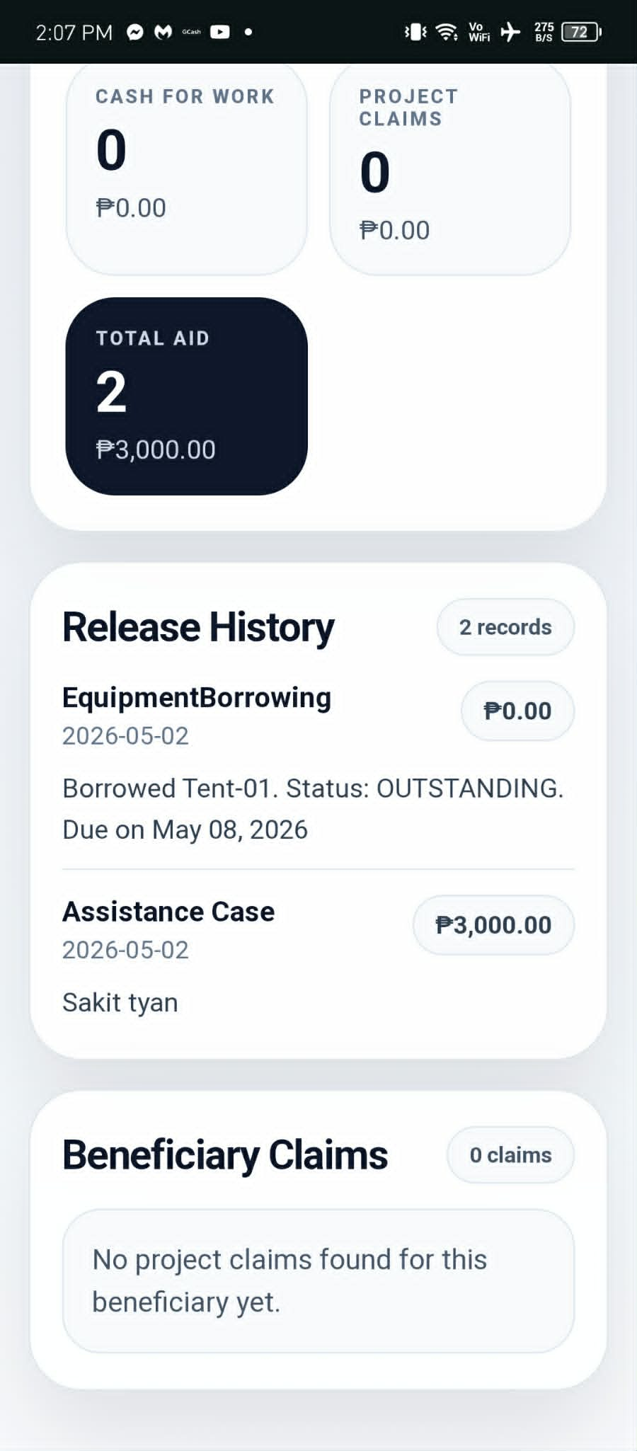 | 
eKalinga+
Ayuda Management & Unified Distribution System
Comprehensive Operational & Technical Flow User Manual
System Release Version | v1.0.6 (Desktop Enterprise Edition)
Implementing Authority | Municipality of Sulop / Barangay Social Welfare
Database Classification | Multi-Tier Dual Ledger (Local / LAN / Cloud Sync)
Official Target Audience | System Administrators, Encoders, Field Gate Officers
CONFIDENTIAL & PROPRIETARY • OFFICIAL LGU WORKSTATION USE ONLY

Table of Contents
Operational Directory & Module Navigation Matrix
Sec # | Operational Module & Procedure | Domain Tag
01 | System Architecture & Login Authentication | SYSTEM SETUP
02 | Database Connection & Offline Preset Configuration | SYSTEM SETUP
03 | Executive Dashboard & Operational Command Center | OPERATIONS
04 | Validated Beneficiaries Masterlist & Digital ID System | OPERATIONS
05 | Aid Requests & Assistance Case State Machine | FINANCIAL
06 | Budget Management & Dual-Stream Waterfall Ledger | FINANCIAL
07 | Project Distribution & Disbursement Execution | FINANCIAL
08 | Cash-for-Work Attendance & Payout Operations | FINANCIAL
09 | Cash-for-Work Payout Disbursement Ledger | FINANCIAL
10 | Seminar & Training Attendance Verification | OPERATIONS
11 | GGMS Consolidated Transactions & Sync Audit | OPERATIONS
12 | Reports, Analytics & Official Export Engine | GOVERNANCE
13 | Scanning Portal & Remote Scanner Gateway | OPERATIONS
14 | System Settings, Security & Database Backup Recovery | SECURITY

SECTION 01 • System Architecture & Login Authentication | [SYSTEM SETUP]

The eKalinga+ application launches with a dual-branded, security-hardened authentication portal linking the official LGU Seal and the eKalinga+ operational core.
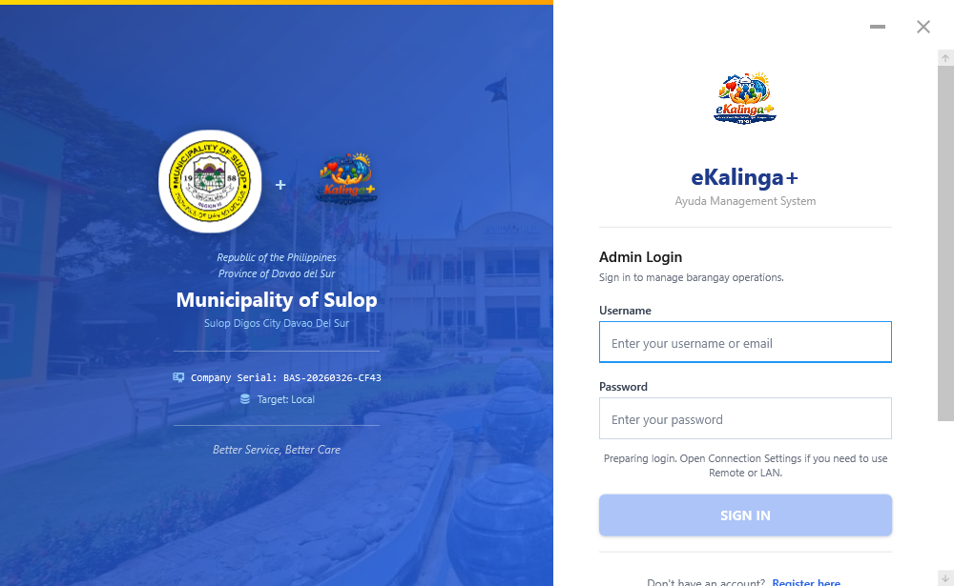
Figure 01.1: System Architecture & Login Authentication — Operational View
📋 Operational Step-by-Step Workflow:
1. Identity & Connectivity Display: The left panel surfaces the Province of Davao del Sur / Municipality of Sulop seal, system serial, and active database connection indicator.
2. Credentials Entry: Enter your assigned username/email and password. The system supports full keyboard navigation (Press Enter to execute sign in).
3. Demo & Default Credentials: For local offline deployment, pre-configured roles are available (`admin@barangay.local` / `admin123`).
4. OTP Multi-Factor Security: Operators can toggle email OTP verification for enhanced authorization during staff shifts.
🛡️ SYSTEM POLICY & INVARIANT: Only authorized staff accounts may sign in. Password lockouts occur after consecutive failed attempts.

💡 OPERATIONAL PRO-TIP: Keep the Local MySQL service running in XAMPP or Windows Services before launching the application.

SECTION 02 • Database Connection & Offline Preset Configuration | [SYSTEM SETUP]

eKalinga+ features seamless multi-tier database synchronisation across Local MySQL, LAN Server, and Remote Cloud tiers with auto-migration.
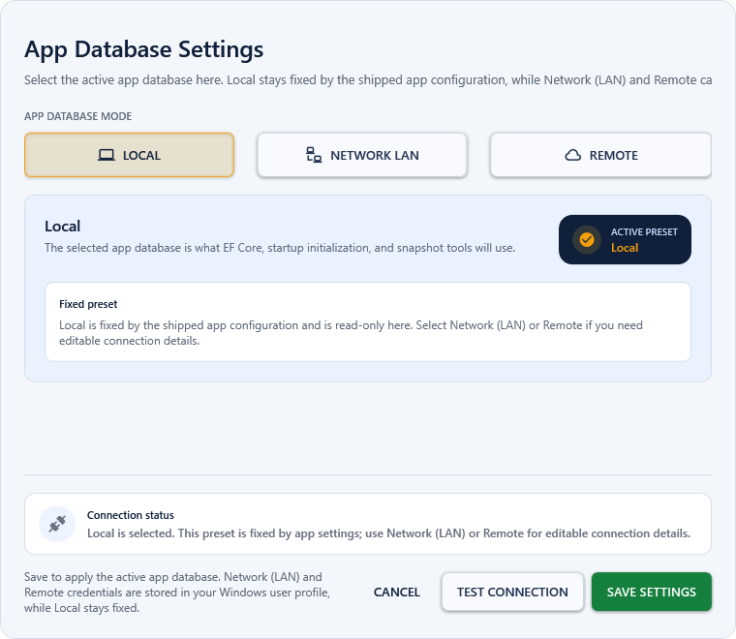
Figure 02.1: Database Connection & Offline Preset Configuration — Operational View
📋 Operational Step-by-Step Workflow:
1. Connection Presets: Switch between `Local (127.0.0.1:3306)`, `Network (LAN)`, or `Remote Cloud` directly from the login settings window.
2. Live Connectivity Test: Click 'Test Connection' to verify socket reachability, schema integrity, and response latency before committing changes.
3. Zero-Configuration Bootstrap: Missing database tables and migrations are automatically created by the `StartupMigrationCoordinator` upon initial startup.
🛡️ SYSTEM POLICY & INVARIANT: Standard workstations must keep the active preset on 'Local' unless explicitly directed by the IT Administrator.

💡 OPERATIONAL PRO-TIP: Click 'Test Connection' before saving credentials to prevent authentication lockouts.

SECTION 03 • Executive Dashboard & Operational Command Center | [OPERATIONS]

The centralized landing hub providing real-time KPI metrics, assistance totals, remaining budget capacity, and one-click navigation to all active modules.
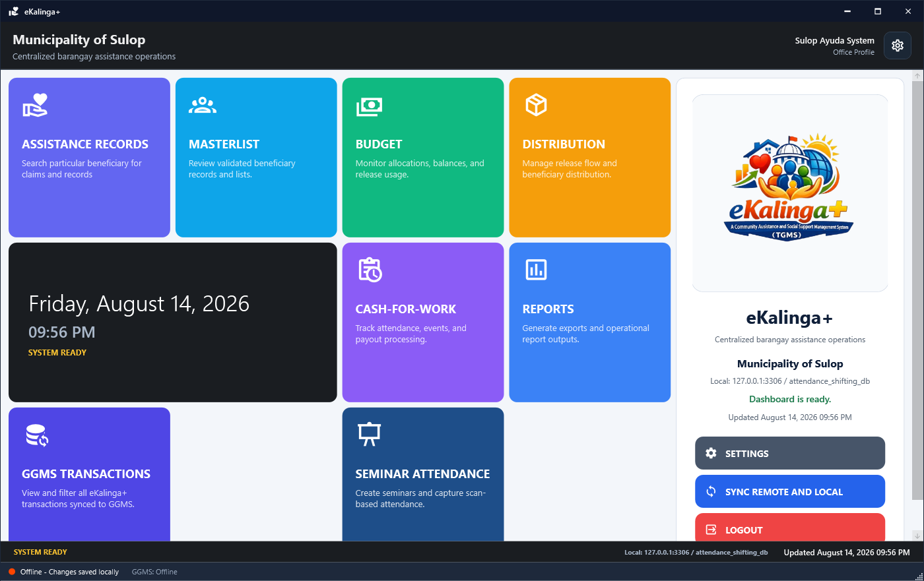
Figure 03.1: Executive Dashboard & Operational Command Center — Operational View
📋 Operational Step-by-Step Workflow:
1. Summary Analytics: Review total registered beneficiaries (40,561), civil registry links, active assistance cases, and remaining funding pools.
2. Direct Module Dispatch: Click any module tile (Masterlist, Aid Requests, Budget Waterfall, Project Distribution, Cash-for-Work, Seminar Attendance, GGMS Transactions, Reports) to open its operational workspace.
3. Background Sync Status: Bottom indicator shows real-time online/offline and GGMS central server synchronization states.
🛡️ SYSTEM POLICY & INVARIANT: The Dashboard layout is locked to maintain interface consistency across all municipal workstations.

💡 OPERATIONAL PRO-TIP: Use the sidebar navigation drawer for rapid multitasking across different active distribution events.

SECTION 04 • Validated Beneficiaries Masterlist & Digital ID System | [OPERATIONS]

The master registry of all validated citizens in the municipality, featuring comprehensive profiling, demographic tagging, and QR/Barcode digital ID generation.
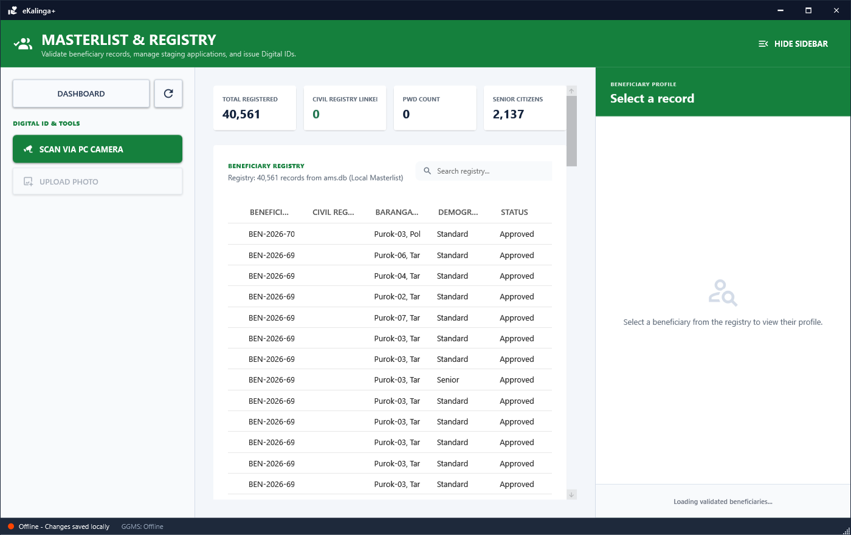
Figure 04.1: Validated Beneficiaries Masterlist & Digital ID System — Operational View
📋 Operational Step-by-Step Workflow:
1. Real-time Search & Filter: Filter by demographics (Senior Citizens, PWDs, 4Ps, Solo Parents, Youth, Farmers, Fisherfolk).
2. Photo Capture & Upload: Directly capture beneficiary portrait photos via attached USB PC Camera or upload image files with integrated square cropping.
3. Digital eKard Printing: Select a beneficiary and click 'Print Digital ID' to generate compliant QR/Barcode badges for offline rapid scanning during distribution events.
4. CRS Municipal Sync: Synchronize citizen validation status directly against the central Civil Registry System.
🛡️ SYSTEM POLICY & INVARIANT: Never create duplicate entries. Use the CRS Sync ID or National ID number for deduplication.

💡 OPERATIONAL PRO-TIP: Batch print QR digital badges prior to large distribution events to maximize onsite throughput.

SECTION 05 • Aid Requests & Assistance Case State Machine | [FINANCIAL]

Manages individual walk-in assistance claims (Medical, Burial, Educational, Emergency Food) following a strict 4-stage approval and release pipeline.
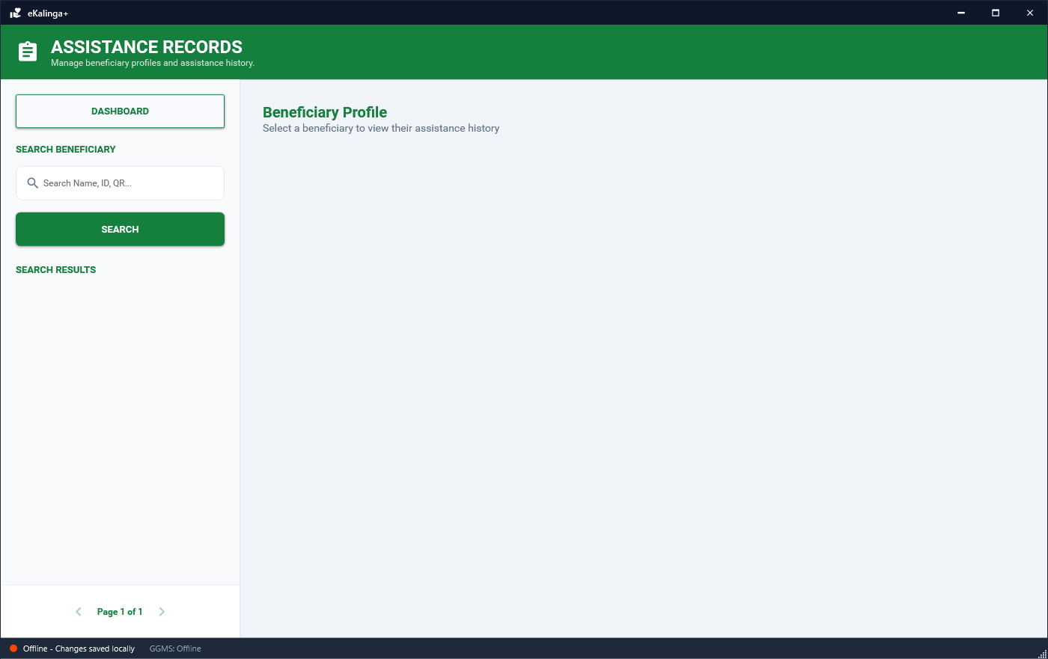
Figure 05.1: Aid Requests & Assistance Case State Machine — Operational View
📋 Operational Step-by-Step Workflow:
1. State Pipeline: Requests progress strictly through: `Pending` ➔ `Under Review` ➔ `Approved` ➔ `Released` (or `Rejected`/`Cancelled`).
2. New Request Filing: Search beneficiary from masterlist, select Assistance Category, enter requested amount, and attach required proof documents.
3. Approval & Allocation: Admin reviews the case and sets the official `Approved Amount`. Funds cannot be disbursed without prior approval.
4. Fund Release & Budget Waterfall Deduction: Releasing assistance automatically creates a `BudgetLedgerEntry` that consumes from the earmarked Assistance Case pool, maintaining strict fiscal accountability.
🛡️ SYSTEM POLICY & INVARIANT: Every released assistance case must be coupled with an explicit ApprovedAmount and authorized officer.

💡 OPERATIONAL PRO-TIP: Attach verified digital copies of hospital bills or death certificates to accelerate the approval stage.

SECTION 06 • Budget Management & Dual-Stream Waterfall Ledger | [FINANCIAL]

The financial engine of eKalinga+, orchestrating government appropriations (GGMS) and private donations through an automated waterfall disbursement hierarchy.
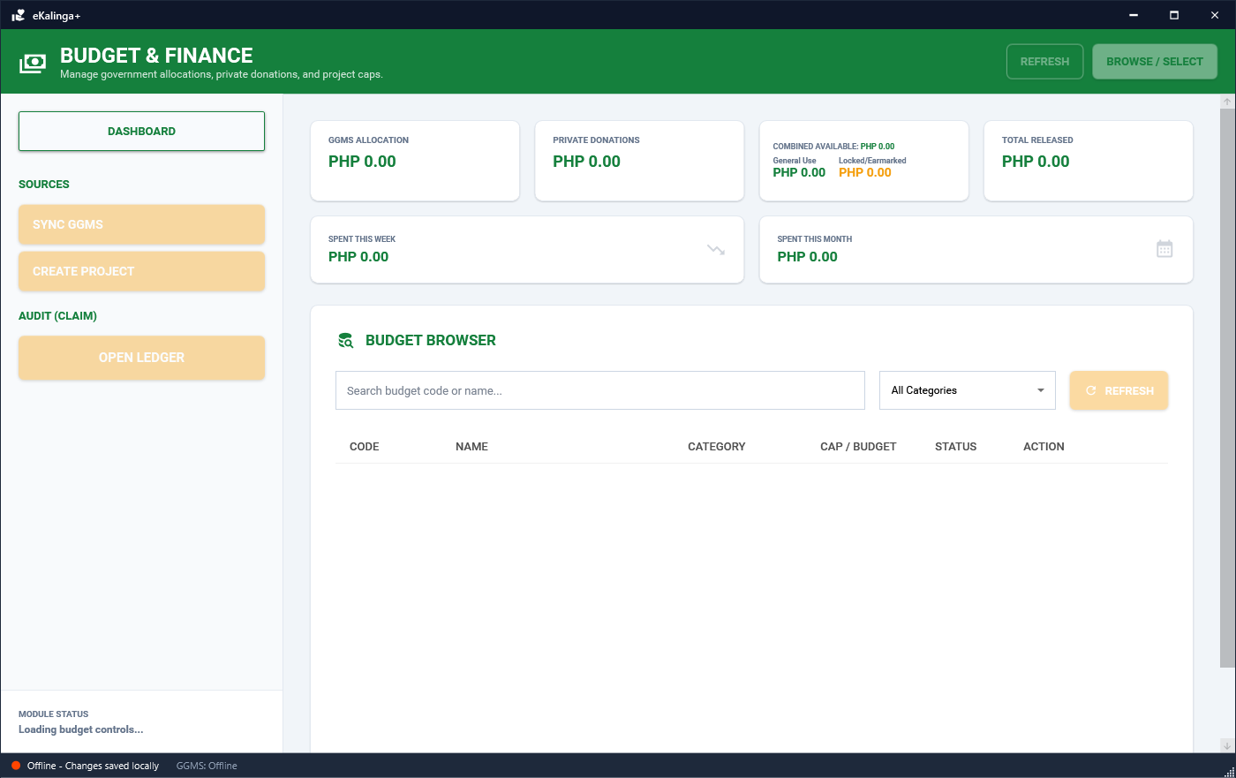
Figure 06.1: Budget Management & Dual-Stream Waterfall Ledger — Operational View
📋 Operational Step-by-Step Workflow:
1. Dual Inflow Streams: Tracks GGMS Government Allocations alongside Private Donations with reference numbers and proof receipts.
2. Budget Earmarking: Funds are categorized into sub-budgets (Aid Requests, Cash-for-Work, Project Distributions, Seminars).
3. Waterfall Hierarchy: Releases automatically deduct first from the specific earmarked project fund, then cascade to the general assistance pool.
4. Create New Project (1:1 Funding): Directly spawn projects from a selected donation/GGMS fund without breaking ledger continuity.
🛡️ SYSTEM POLICY & INVARIANT: Independent or disconnected budget records that bypass the waterfall ledger are strictly forbidden.

💡 OPERATIONAL PRO-TIP: Audit remaining project budgets weekly to ensure adequate reserve for incoming emergency claims.

SECTION 07 • Project Distribution & Disbursement Execution | [FINANCIAL]

High-throughput operational module for disbursing bulk goods and financial assistance to enrolled masterlist beneficiaries.
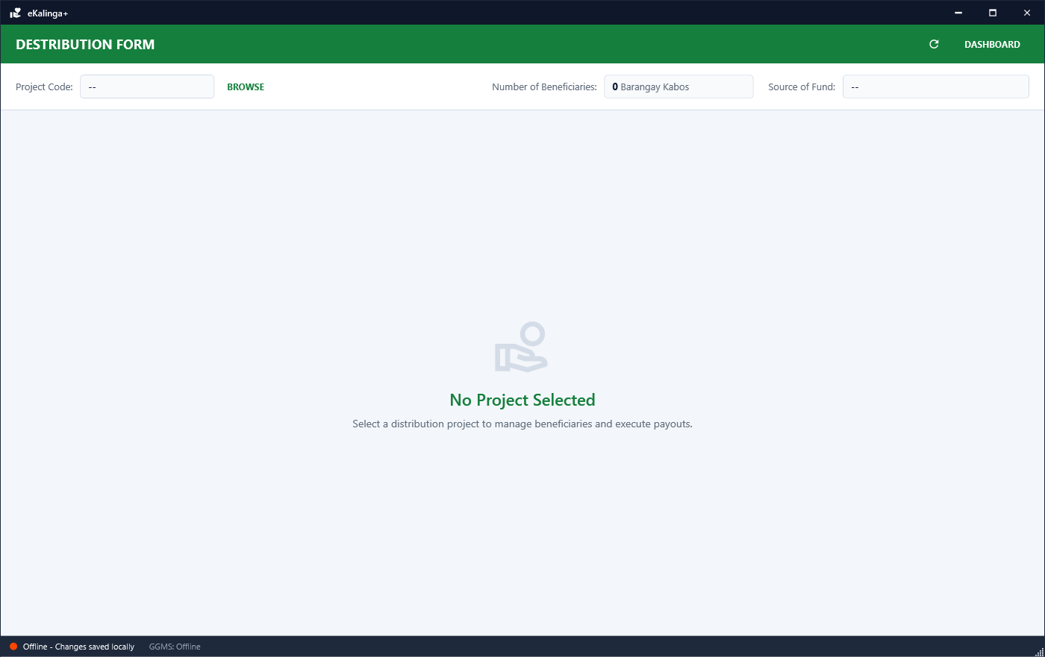
Figure 07.1: Project Distribution & Disbursement Execution — Operational View
📋 Operational Step-by-Step Workflow:
1. Project Selection: Load active distribution project (Cash / In-Kind Goods) linked to its funding source.
2. Participant Queue: Displays full participant roster categorized into `RELEASED / CLAIMED`, `PENDING (Requirements Lacking)`, and `UNRELEASED`.
3. Rapid Identification: Scan physical QR ID card, type Beneficiary ID, or double-click list item.
4. Requirements Verification: Check mandatory attachments (Cedula, Barangay Certificate). Click 'Confirm Release' to payout or 'Mark Pending' if documents are missing.
🛡️ SYSTEM POLICY & INVARIANT: Beneficiary enrollment is manual or batch-selected from approved masterlist records only (no demographic auto-enrollment).

💡 OPERATIONAL PRO-TIP: Use a 2D barcode scanner gun set to USB HID mode for sub-second verification per beneficiary.

SECTION 08 • Cash-for-Work Attendance & Payout Operations | [FINANCIAL]

Complete lifecycle management for Cash-for-Work community projects, daily worker attendance logging, and automated wage payout disbursement.
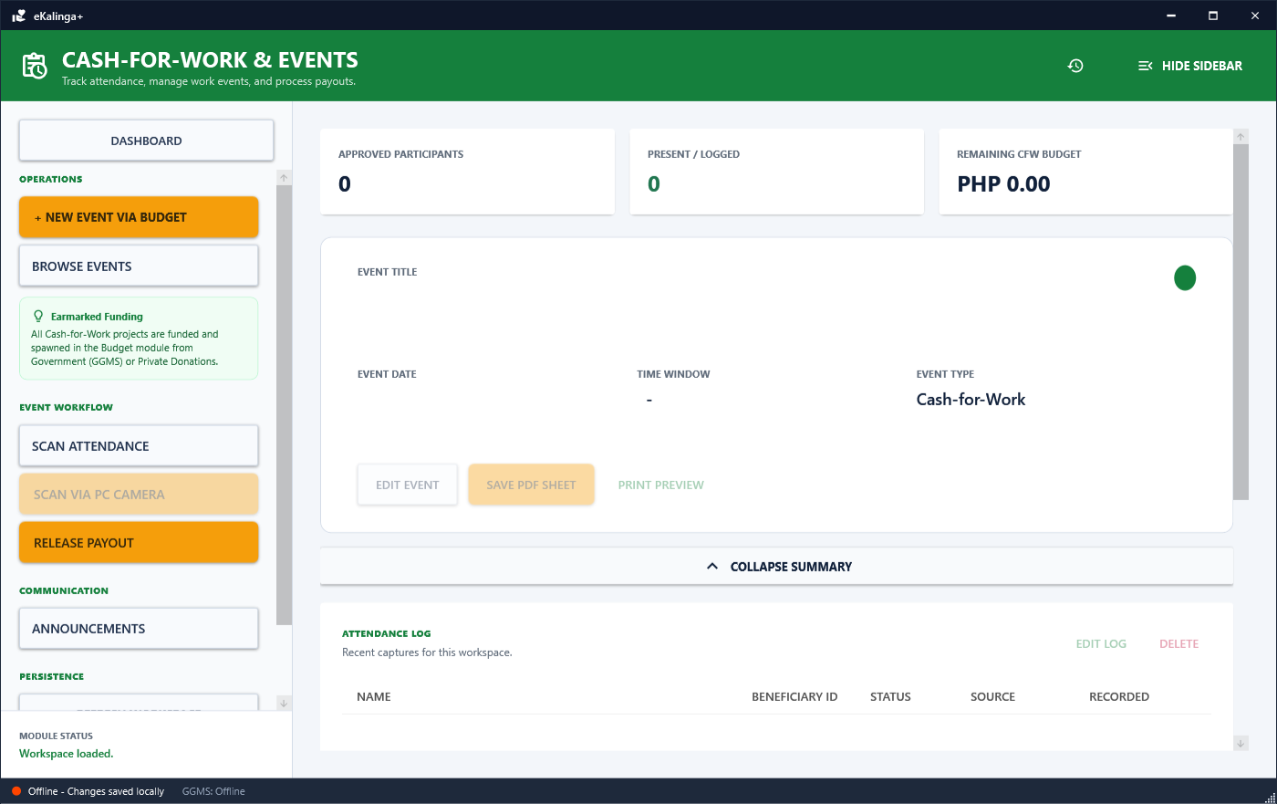
Figure 08.1: Cash-for-Work Attendance & Payout Operations — Operational View
📋 Operational Step-by-Step Workflow:
1. Event Workspace: Create work activity (e.g. Barangay Clean-up, Tree Planting), assign daily wage rate and scheduled days.
2. Beneficiary Enrollment: Add registered workers from the masterlist to the event roster.
3. Barcode/OCR Attendance Scan: Capture morning time-in and afternoon time-out using USB barcode gun or live PC camera OCR.
4. Automated Payroll Calculation: System aggregates verified attendance logs into the Payout view (Calculates Days Rendered × Daily Wage Rate).
🛡️ SYSTEM POLICY & INVARIANT: Payouts require verified attendance records and pull directly from the CashForWork budget bucket.

💡 OPERATIONAL PRO-TIP: Ensure camera lighting is adequate when utilizing the built-in OCR visual scanner.

SECTION 09 • Cash-for-Work Payout Disbursement Ledger | [FINANCIAL]

The payroll disbursement terminal for releasing wages to Cash-for-Work participants upon event completion.
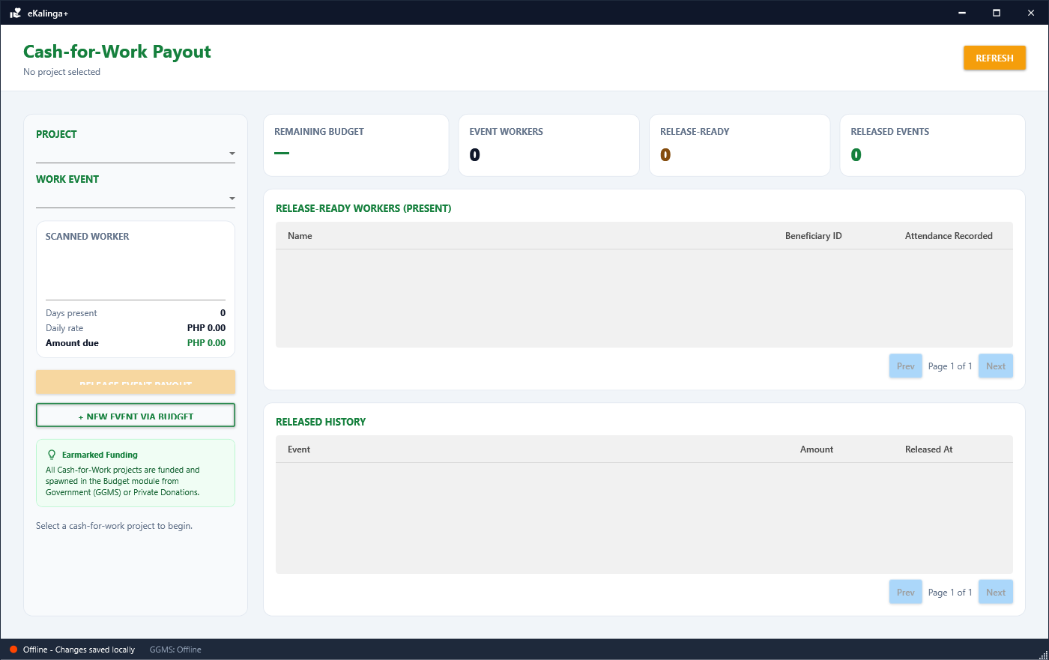
Figure 09.1: Cash-for-Work Payout Disbursement Ledger — Operational View
📋 Operational Step-by-Step Workflow:
1. Review Earned Wages: System computes exact payout per participant based on logged attendance days.
2. Disbursement Confirmation: Process individual or batch payouts with receipt generation.
3. Audit Trail: Every released wage logs a ledger entry tied to the Cash-for-Work budget stream.
🛡️ SYSTEM POLICY & INVARIANT: Ensure all daily attendance logs are finalized before initiating payout disbursement.

💡 OPERATIONAL PRO-TIP: Print the disbursement liquidation summary immediately after completing payroll.

SECTION 10 • Seminar & Training Attendance Verification | [OPERATIONS]

Specialized module for conducting training sessions, workshops, and livelihood seminars with real-time barcode/QR scan tracking.
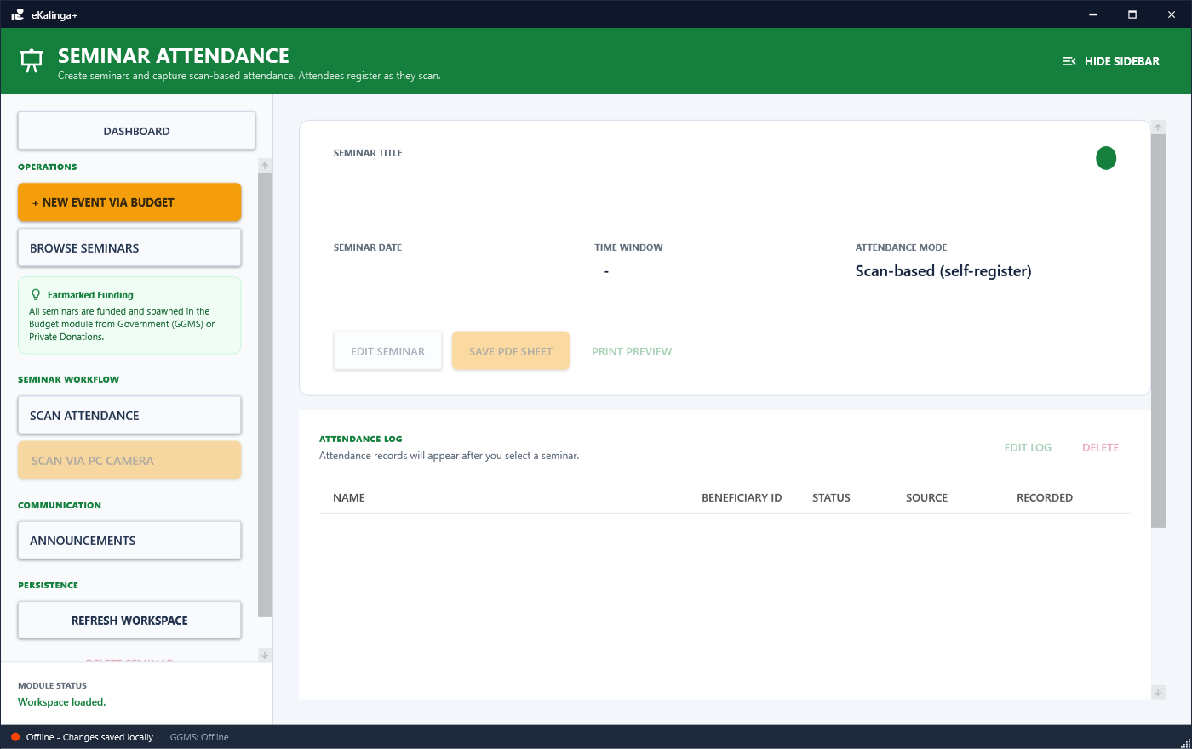
Figure 10.1: Seminar & Training Attendance Verification — Operational View
📋 Operational Step-by-Step Workflow:
1. Seminar Setup: Define seminar topic, venue, date, and target participants.
2. Rapid Scanner Entry: Position camera or handheld scanner to log attendees as they arrive.
3. Instant Attendance Summary: Real-time stats surface total attendees, check-in timestamps, and demographic breakdown.
🛡️ SYSTEM POLICY & INVARIANT: All seminar projects originate from an earmarked funding stream in the Budget module.

💡 OPERATIONAL PRO-TIP: Keep the live log window open to verify successful scans as attendees enter the venue.

SECTION 11 • GGMS Consolidated Transactions & Sync Audit | [OPERATIONS]

Centralized transaction monitoring linking local eKalinga+ disbursements with the municipal Government Grants Management System (GGMS).
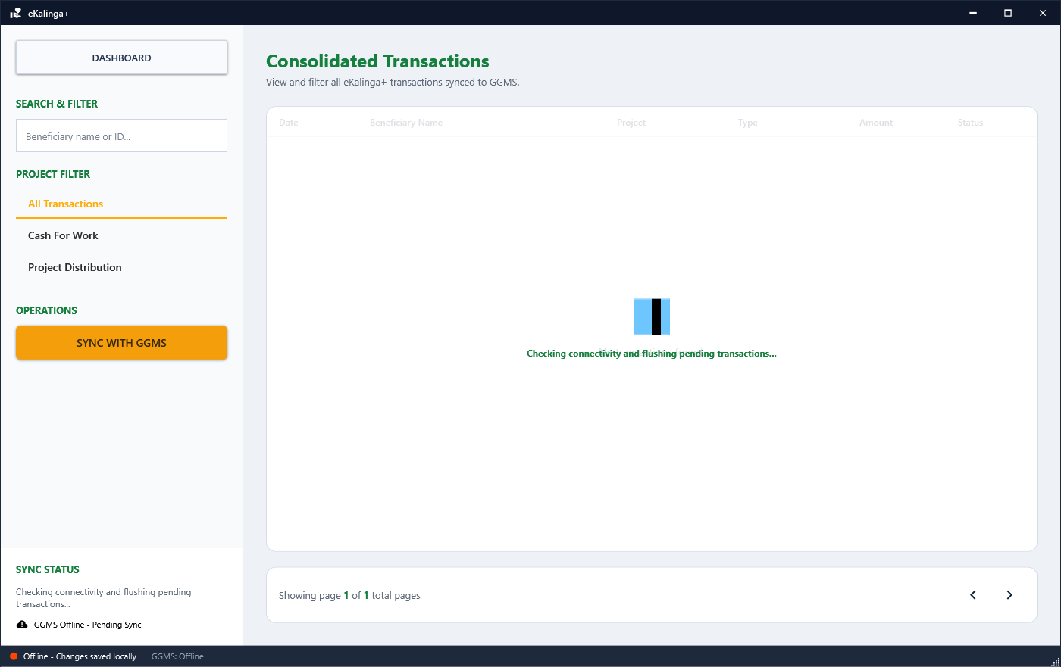
Figure 11.1: GGMS Consolidated Transactions & Sync Audit — Operational View
📋 Operational Step-by-Step Workflow:
1. Synced Record Inspection: Review all assistance claims, distributions, and payouts transmitted to GGMS.
2. Filter by Sync State: Filter by Synchronized, Pending Sync, or Conflict.
3. Reconciliation Audit: Inspect timestamp, batch reference, transaction hash, and approving officer details.
🛡️ SYSTEM POLICY & INVARIANT: Ensure periodic sync is active when operating on connected LAN/Remote networks.

💡 OPERATIONAL PRO-TIP: Check the conflict tab after reconnecting an offline workstation to resolve duplicate claims.

SECTION 12 • Reports, Analytics & Official Export Engine | [GOVERNANCE]

Comprehensive document generation engine creating formatted government reports, audit sheets, and statistical summaries.
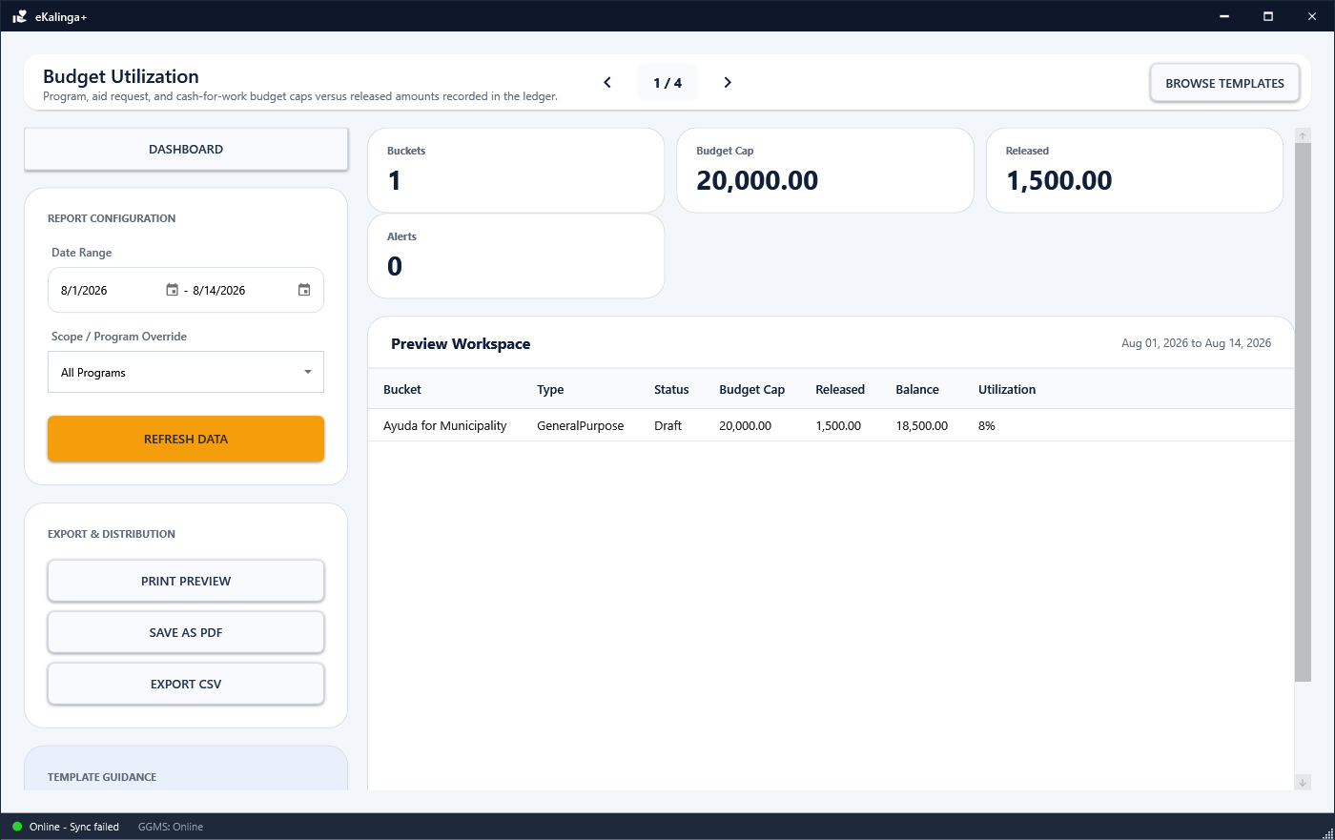
Figure 12.1: Reports, Analytics & Official Export Engine — Operational View
📋 Operational Step-by-Step Workflow:
1. Select Report Template: Masterlist Summary, Distribution Liquidation Sheet, Aid Assistance Ledger, or Cash-for-Work Payroll.
2. Date & Category Filtering: Define report timeframes and program categories.
3. Print Preview & Export: Preview formatted documents with official LGU headers and export directly to PDF or Excel.
🛡️ SYSTEM POLICY & INVARIANT: All official exported reports automatically include the municipal watermark and signature fields.

💡 OPERATIONAL PRO-TIP: Use PDF export for archived official submissions and Excel for statistical aggregation.

SECTION 13 • Scanning Portal & Remote Scanner Gateway | [OPERATIONS]

Network terminal for connecting mobile devices and secondary hardware scanners across the local barangay hall network.
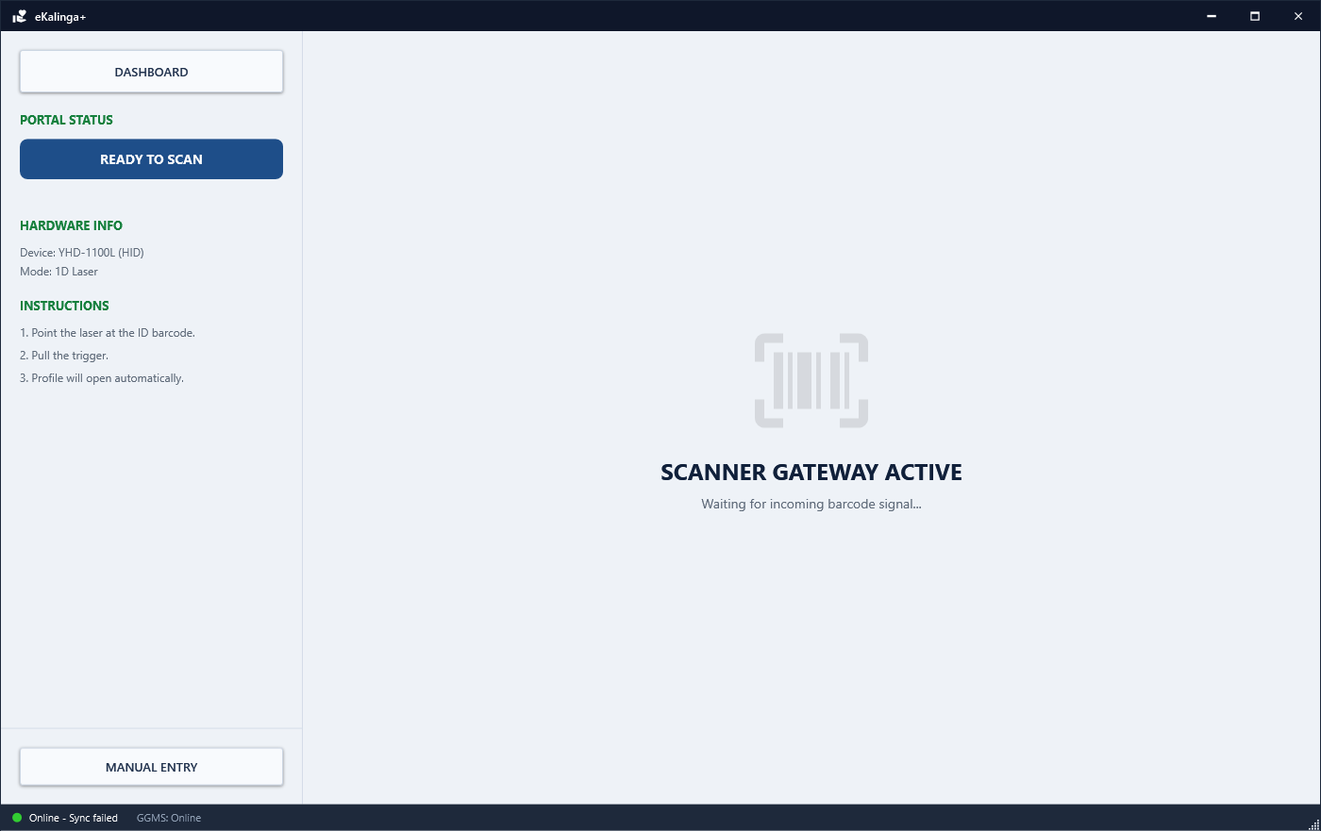
Figure 13.1: Scanning Portal & Remote Scanner Gateway — Operational View
📋 Operational Step-by-Step Workflow:
1. Scanner Session PIN: Generate secure, time-expiring PIN codes to pair remote Android/iOS scanning terminals.
2. Live Feed Monitoring: Monitor multiple active scanner gates simultaneously during massive distribution events.
3. Hardware Scanner Integration: Compatible with USB 1D/2D Barcode Guns, PC Webcams, and Serial scanners without extra drivers.
🛡️ SYSTEM POLICY & INVARIANT: Session PINs automatically expire after the configured timeout period for security.

💡 OPERATIONAL PRO-TIP: Assign separate scanner PINs to each gate operator during municipal-wide relief operations.

SECTION 14 • System Settings, Security & Database Backup Recovery | [SECURITY]

Central administration console governing system identity, SuperAdmin user management, password-protected overlays, and database backup chains.
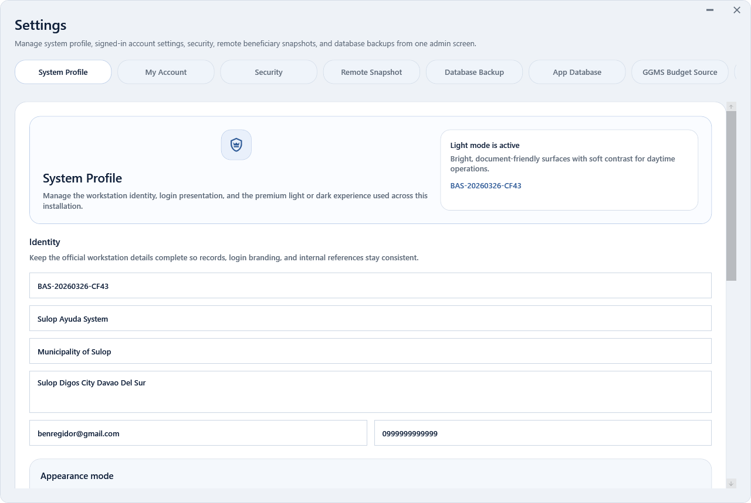
Figure 14.1: System Settings, Security & Database Backup Recovery — Operational View
📋 Operational Step-by-Step Workflow:
1. System Profile: Set municipal name, address, branding logo, and theme preferences.
2. User Management & Granular Permissions: SuperAdmin manages staff accounts and assigns granular module access checkboxes.
3. Password Protection: Sensitive areas (App Database, Remote Snapshot, GGMS Source) require admin password re-entry.
4. Database Backup & Recovery: Execute Full Baseline Backups, Incremental Backups, and point-in-time Restores directly from the UI.
🛡️ SYSTEM POLICY & INVARIANT: Never delete database rows. Only soft deletions (`IsDeleted`) are permitted. Always create a Full Backup before major server migrations.

💡 OPERATIONAL PRO-TIP: Schedule incremental daily backups to an external encrypted USB drive for disaster recovery.

