


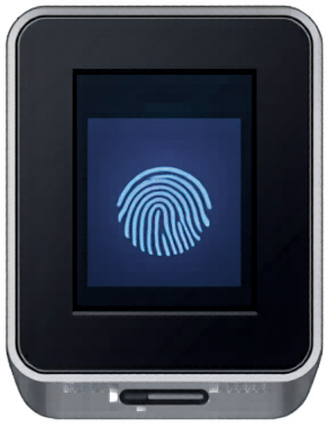




User Manual Guide Book

Electronic Timekeeping and Payroll Management System

Version 1.0

March 2026

Developed by: Abegail Delicano – Developer
Sonny Boy Navarez – Writer/Graphic Artist Barbie Jane Baldomero – Promoter/System Analyst

Doc No: HRM-BIO-001




1
Getting Started 2
2
Login & User Access 3
3
Dashboard Overview 4
4

5
Employee Management 5
Biometric Device Management 6
Table of
CONTENTS

6 Attendance Management 7
₇ Payroll Management 8
8 Transaction History 9
9 Employee Portal 10
₁₀ Daily Time Record (DTR) 11
11 Troubleshooting 13
12 System Setting 14
13 Backup & Restore 15
14 Glossary 16

1



System Overview

Introduction
The Electronic Timekeeping and Payroll Management System is a comprehensive solution designed to manage employee attendance, payroll processing, and HR records. The system supports biometric device integration, manual attendance entry, and automated payroll calculations.

Key Features
Description
Feature

System Requirements
Employee Management

Biometric Integration Attendance Tracking Payroll Processing Leave Management Reporting
Transaction Audit
Complete employee profile management with photo upload
Support for fingerprint/face recognition devices Manual and automated attendance logging Automated salary computation with deductions Employee leave request and approval workflow Exportable reports in CSV format
Complete system activity log
Component Minimum Requirement
Operating System Windows 7/8/10/11 (64-bit recommended)
Database MySQL 5.7 or higher
.NET Framework .NET Framework 4.7.2 or higher
RAM Minimum 4GB (8GB recommended)
Storage 500MB for application, additional space for database

2

How to Start the Application

Step 1: Install the Application
- Double-click the installer file: ABS HRM SYSTEM Setup.exe
- Follow the installation wizard
- Choose installation folder (default:
C:\ProgramFiles\ABS HRM SYSTEM)
- Click "Next" to start installation.
- Wait for installation to complete
- Click "Finish"
Step 2: Launch the Application
- Double-click the BiometricAttendance icon on your desktop
- OR go to Start Menu → Biometric Attendance → Launch Application
Step 3: First-Time Login
- Username: admin
- Password: admin
- Click "Login”

Figure.1 Installer file

Figure.2 Installation folder Figure.3 Installation Confirmation

Figure.4 Application Launch


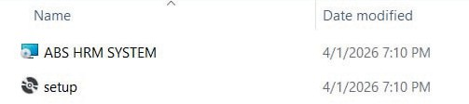
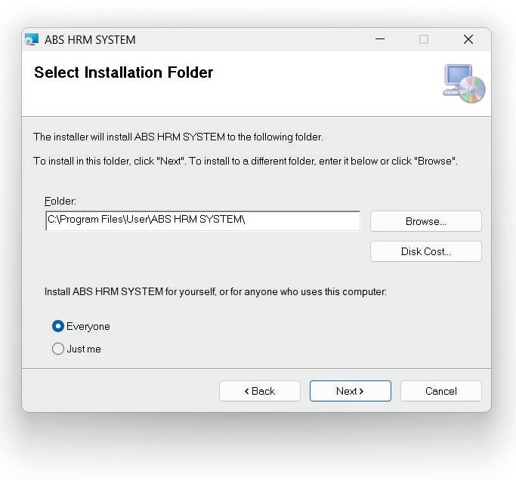
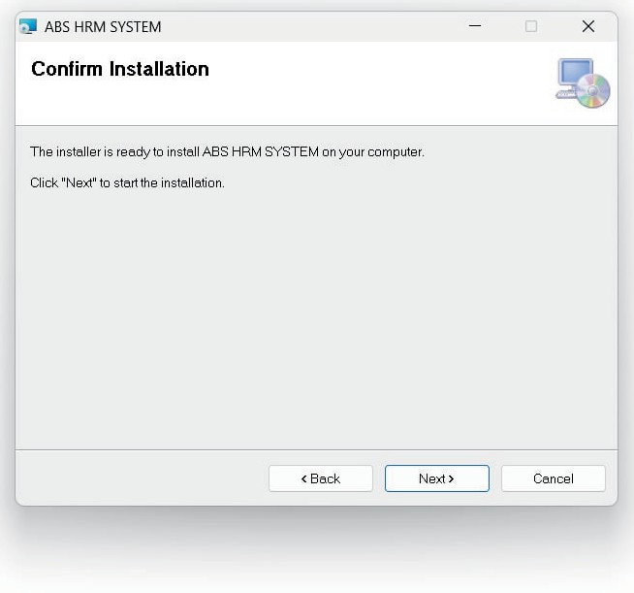
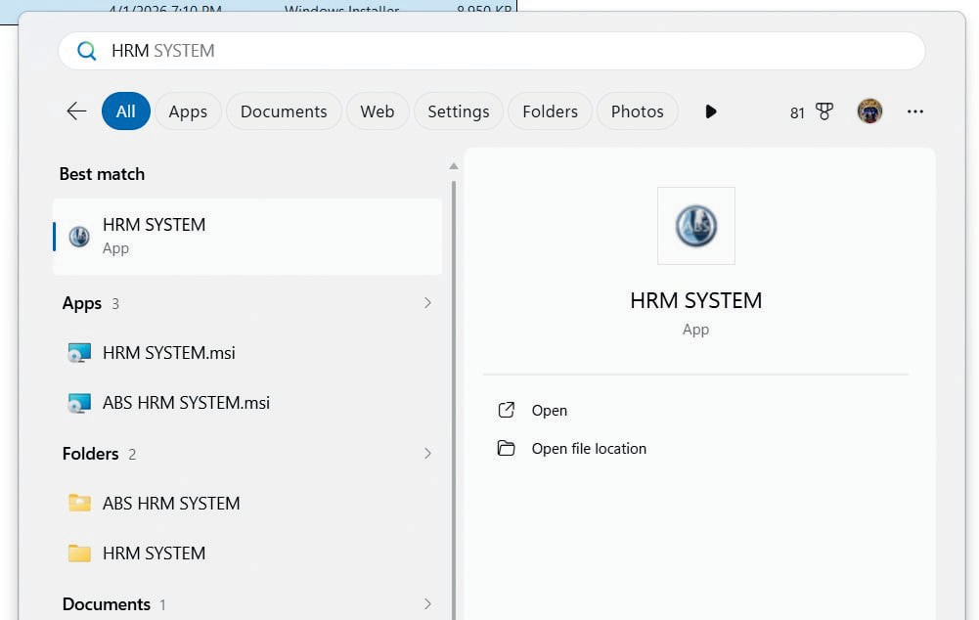
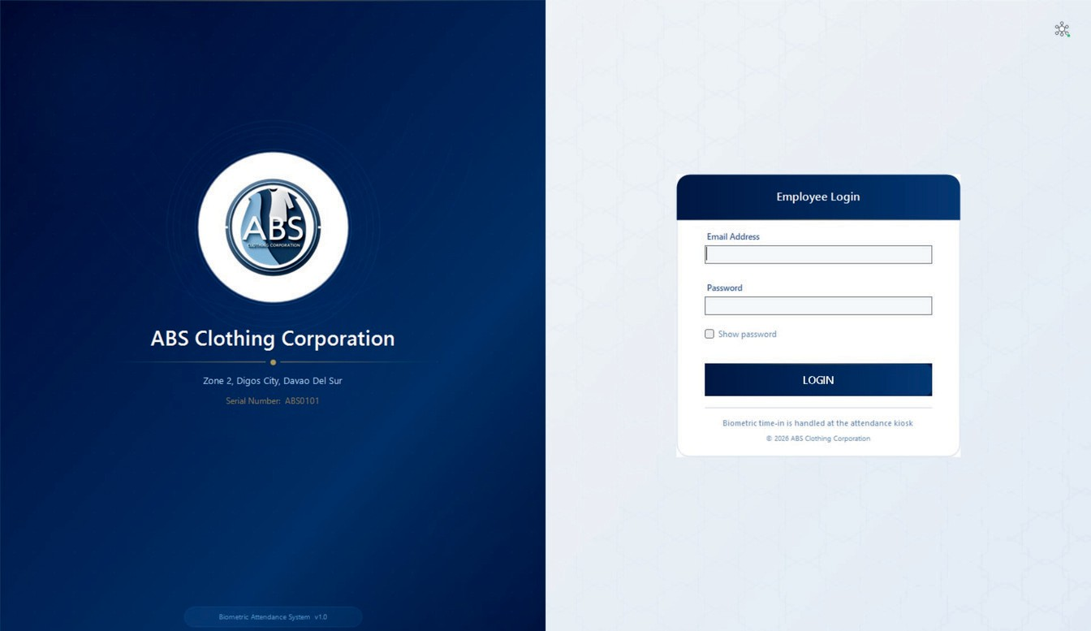
Note: The application comes with a pre-configured database. No additional setup is needed!

Login & User Access
Login Screen
The login screen features:

Figure.5 Login page Interface
Section Left Panel
Right Panel

Connection Indicator
Description
Company branding with logo and information
Login form with email and password fields
Top-right icon showing active database connection (automatic)

Login Process
- Enter Credentials
Admin: admin / admin (first login)
Employee: Email address / default password 12345
- Click "Login"
- Successful Login
Admin: Redirects to Dashboard
Employee: Redirects to Employee Portal

3

Change Default Password (First Time)
For Admin:
- After first login, go to Settings
- Click "Change Password"
- Enter old password: admin
- Enter new password (e.g., Admin2024!)
- Confirm new password
- Click "Save"

For Employees:
- Employees can change password in Employee Portal → Profile Settings
User Roles
Role | Access Level | Permissions
Admin | Full Access | All modules, user management, system settings
HR Manager | HR Access | Employee management, payroll processing, reports
Supervisor | Limited Access | Team attendance, leave approval
Employee | Basic Access | View own attendance, payslips, request leaves

Dashboard Overview
Admin Dashboard
The main dashboard provides quick access to key metrics:

Navigation Menu
Figure 6. Dashboard interface

Menu Item Description
Dashboard Main overview with statistics Employees Employee list and management Attendance Daily attendance logs
Payroll Payroll processing and records Reports Generate and export reports

Settings
System configuration


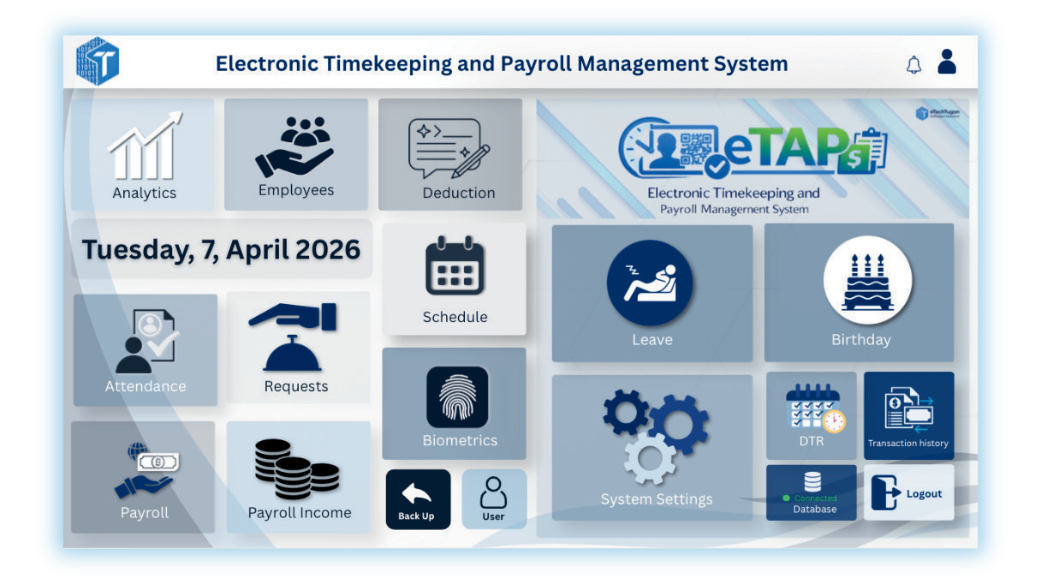
Transaction History
Audit trail of all system actions 4

Employee Management
Adding a New Employee
Navigate to Employees → Click "Add Employee"
Fill Employee Information

Personal Information
Employee Code (auto-generated) First Name, Last Name, Middle Name Date of Birth
Gender, Civil Status Home Address Mobile Number Email Address
Employment Details
Department Position/Job Title Employment Type
(Regular/Probationary/Cont ractual/Part-time)
Date Hired Work Schedule
Basic Monthly Salary Pay Frequency
Government IDs
SSS Number PhilHealth Number Pag-IBIG Number TIN Number

Emergency Contact
Contact Person Name Contact Mobile Number

Upload Profile Photo
Click the photo circle or "Browse Photo" button
Select image file (JPG, PNG, BMP - max 5MB)
Recommended: Square crop for best display
Save Employee
Click "Save Employee" button System validates required fields Employee is added to database
Employee Profile Card Fields
Editing Employee Information
Select employee from list
Click "Edit" button in profile card
Modify fields (editable fields become text boxes) Click "Save" to update

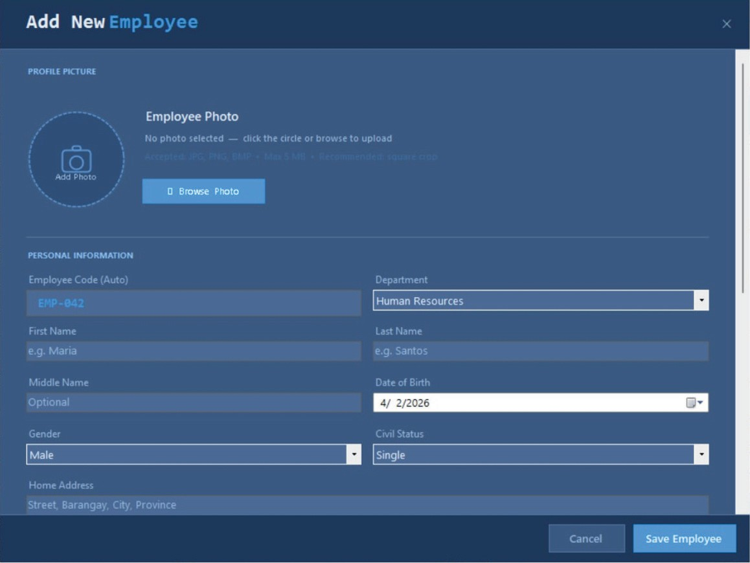
Field Editable Description

Employee Code First Name
Last Name
Department Employment Type Date Hired
Work Schedule Mobile
Email
Employment Status Civil Status Monthly Salary
SSS No.
PhilHealth Pag-IBIG TIN
Fingerprint
No YES YES YES YES YES
YES YES YES YES YES
YES YES YES YES
YES
YES
System-generated unique identifier Legal first name
Legal last name
Assigned department Employment classification Start date with company Assigned shift
Contact number Company email Active/Inactive status Marital status
Base compensation Government ID
Health insurance number Housing fund number
Tax identification number Biometric enrollment status

Figure 7. Employee Management interface


Deleting an Employee
WARNING:
Deleting an employee removes ALL associated records including attendance, payroll, and leave requests.
Select employee from list Click "Delete" button Confirm deletion in dialog
System removes employee and all related records.

5

Enroll Employee Biometrics
Enroll via System
- Go to Employees → Select employee
- Click "Enroll Biometric" button
- Enrollment Wizard appears:
Step 1: Select Finger
Choose finger to enroll (Right Thumb, Left Index, etc.)
Click "Start Enrollment" Step 2: Scan Fingerprint
Place finger on scanner
System will scan 3 times
Wait for "Enrollment successful" message Step 3: Verify
Scan finger again to verify
System confirms match Step 4: Save
Click "Save Enrollment"
Biometric data is stored

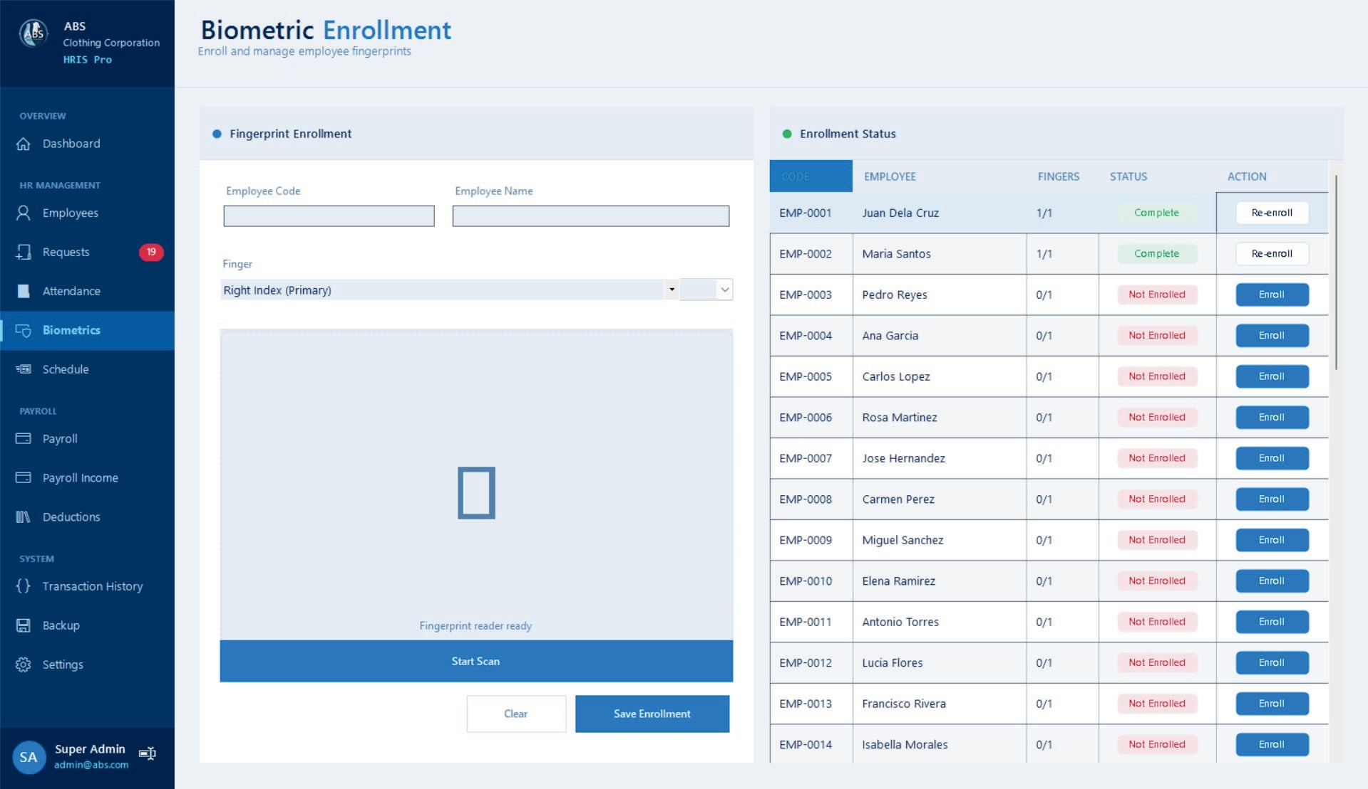

Step 5: Test Biometric Login
Figure 8. Biometric Enrollement Interface


After enrollment, go to Attendance → Test Biometric
Employee scans fingerprint on device
System displays:
Success: Employee identified, attendance logged
Failed: Try again or re-enroll
6

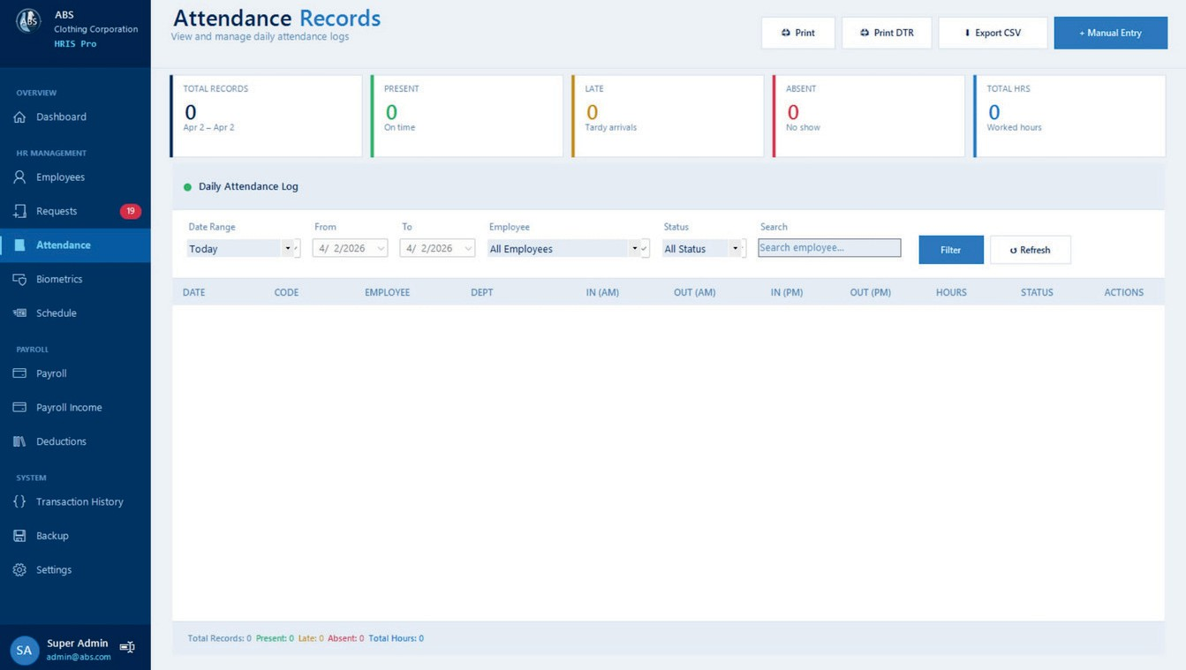
Attendance Management
Attendance Main Screen
The attendance module displays:

Feature
Date Range Filter

Status Filter

Employee Filter Search Statistics Cards
Description
Quick selects (Today, This Week, This Month, Custom)
View all employees or specific employee
Filter by attendance status
Search by employee name or code Total, Present, Late, Absent, Total Hours

Figure 9. Attendance Record Interface

Attendance Main Screen
Deleting Attendance

Export Attendance

Column
DATE CODE EMPLOYEE DEPT
IN (AM) OUT (AM) IN (PM) OUT (PM)
HOURS STATUS ACTIONS
Description
Attendance date (MMM d format) Employee code
Employee full name Department Morning shift time in
Morning shift time out Afternoon shift time in Afternoon shift time out Total worked hours
Present/Late/Absent/Undertime
Edit/Delete buttons
- Click "Del" button on attendance row
- Confirm deletion
- Record is removed
DTR Printing (Daily Time Record)
- Select a specific employee from filter
- Click "Print DTR" button
- Select month and year
- View/Print Daily Time Record
- Apply filters as needed
- Click "Export CSV" button
- Choose save location
- File includes:
  - Report header with period
  - All filtered records
  - Summary statistics

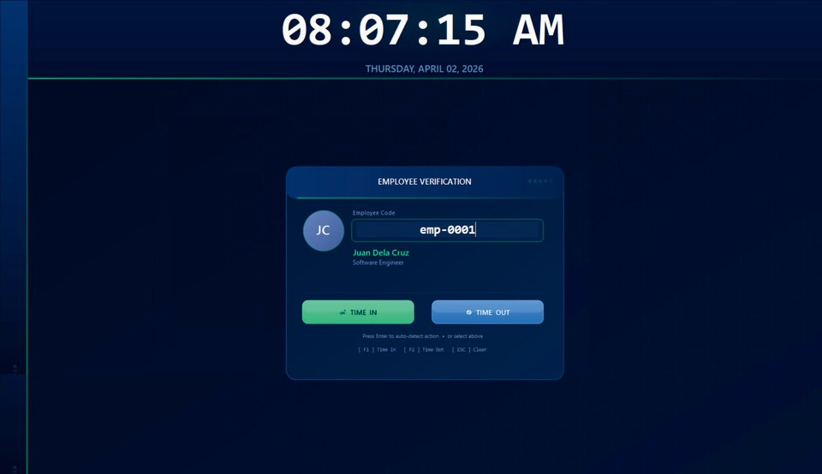
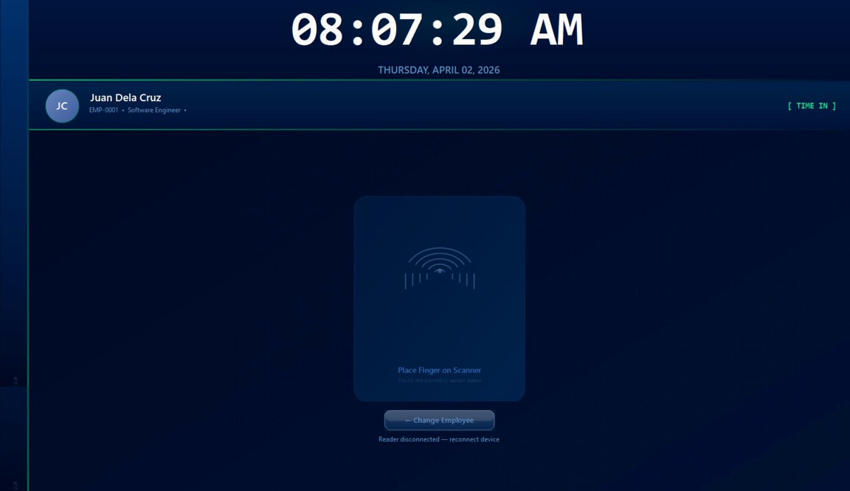

Manual Attendance Entry
To record attendance, the employee must enter their Employee Code in the input field. Once the code is entered, the system automatically retrieves and displays the employee’s name and position for verification.
After entering the employee code or selecting the employee, the system prompts the user to place their finger on the biometric scanner. The system will then verify the fingerprint against the stored biometric data.
Once verification is successful, the system automatically records the corresponding attendance action (e.g., Time In or Time Out) based on the employee’s previous record.
- Click "+ Manual Entry" button
- Fill attendance form:
- Employee & Date
Select employee from dropdown
Choose attendance date
- Time Entries (24-hour format HH:MM)
Time In (AM)
Time Out (AM)
Time In (PM)
Time Out (PM)
- Status & Remarks
Select attendance status
Add optional remarks
- System automatically calculates work hours
- Click "Save Record" Editing Attendance
- Click "Edit" button on attendance row
- Modify time entries or status
- System recalculates work hours
- Click "Save Changes"

Figure 10. Attendance Entry Interface
7

Payroll Management

Payroll Processinoft
- Navioftate to Payroll module
- Select Pay Period
Choose coverage dates
Select employees (all or specific)
- Confiofture Earninofts
Basic Pay (auto-calculated from employee salary)
Overtime Pay (based on approved OT)
Allowances (PERA, transportation, etc.)
- Confiofture Deductions
SSS Contribution

Figure 11. Payroll management Interface
Payroll Records

PhilHealth Contribution Pag-IBIG Contribution
The payroll module displays:
Field
Description

Withholding Tax
Pay Period Coverage dates

Loans (if applicable)
- Process Payroll
System calculates gross pay Deductions are applied
Net pay is computed
Pay Date Gross Pay
Total Deductions Net Pay
Date of payout
Total earnings before deductions
All deductions combined Final amount after deductions

Payroll record is saved
Status Released/Pending/Approved

Employee Payslips
Employees can view their payslips:
- Navigate to "My Payslips" in Employee Portal
- Select pay period from list
- View detailed payslip showing: Employee information Earnings breakdown Deductions breakdown
Net pay
Employer contributions
Statistics Tab
View analytics of system usage: Total transactions
Login counts Create/Update/Delete counts Failure rates
Average execution time
Print Payslip
- Select a payslip from history
- Click "Print" button
- Preview payslip
- Print or save as PDF

Audit Trail Tab
Shows detailed change tracking: Affected fields
Old data values New data values


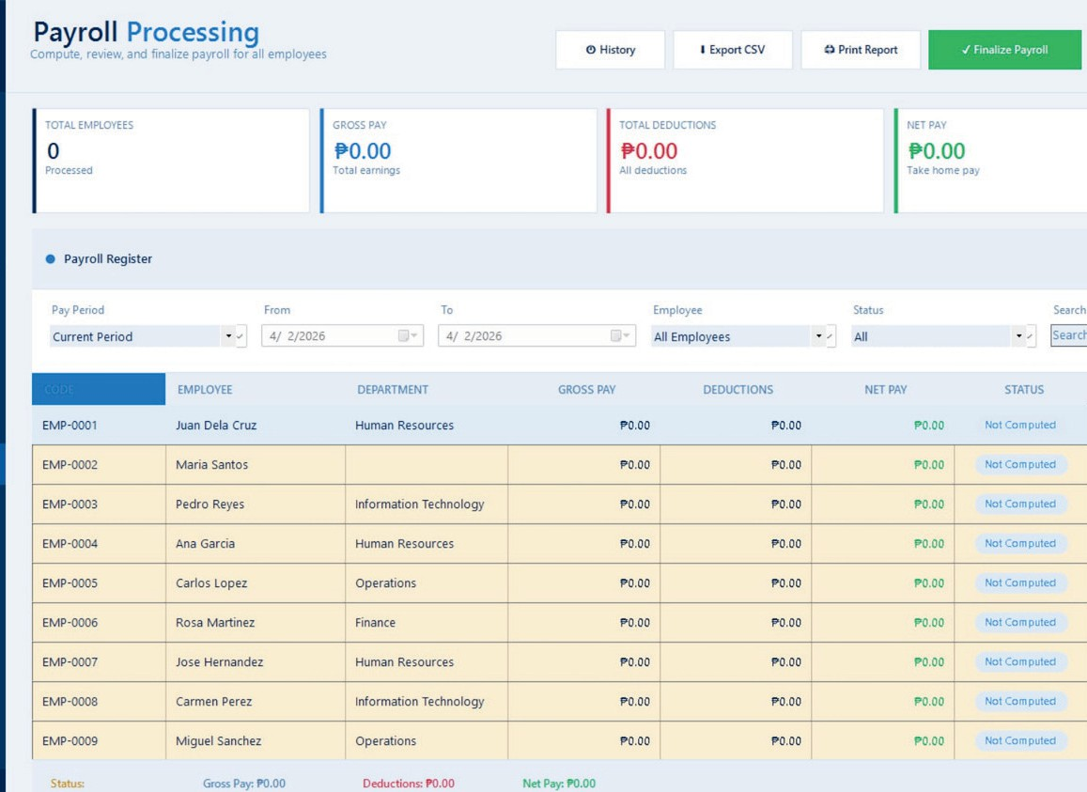
8

Transaction History
The Transaction History Viewer provides a complete audit trail of all system activities.

The Transaction History Viewer provides a complete audit trail of all system activities. Navigate to
Transaction History from the main menu

Filter
Module Action From/To User Search
Description
Filter by system module (Login, Attendance, Employees, Payroll) Filter by action type (LOGIN, CREATE, UPDATE, DELETE, APPROVE) Date range selection
Filter by specific user
Search by ID, user, or details


To refresh and update the displayed records, click the Refresh button.
Field
ID
Action Module
Record User Details Time (ms) Status
Date & Time
Description
Transaction unique identifier Type of action performed Module where action occurred
Affected record identifier User who performed action
Detailed description of changes Execution duration Success/Failed
When action occurred

This module helps administrators maintain transparency, track user behavior, and
ensure accountability within the system.
Notes
Only authorized users (e.g., Admin) can access this module Logs cannot be edited or deleted for security purposes
Transaction Display

The grid shows:
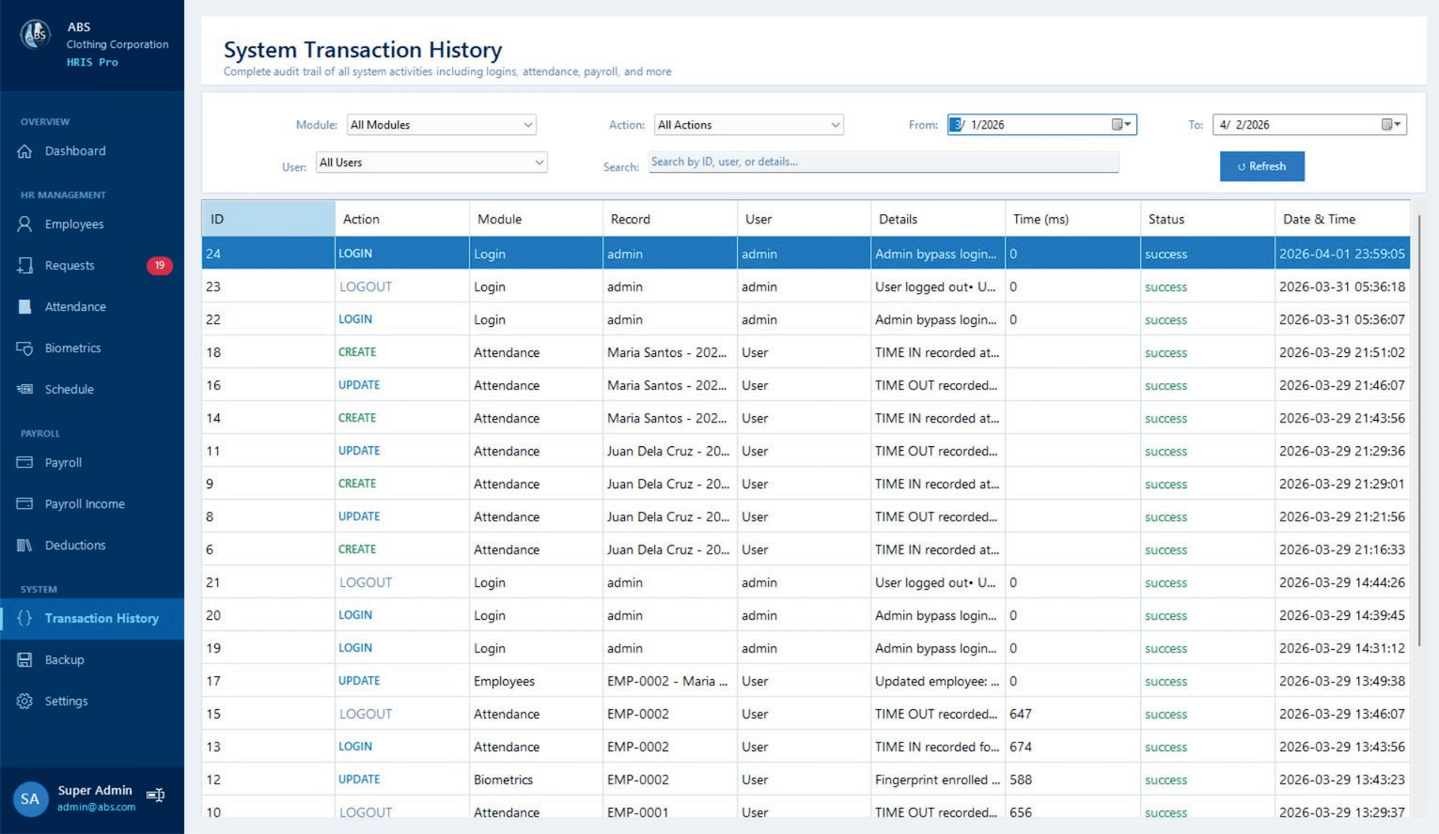
Figure 12. Transaction History Interface

9

Employee Portal
Overview
Employee Portal is the self-service interface for employees to view their personal records.
Access
Employees log in with their registered email and password (default: 12345)
Features

My Attendance
View monthly attendance log Filter by month/year
View attendance status per day See work hours and overtime Export attendance to CSV
My Payslips
View all processed payroll records
Select payslip by pay period View detailed earnings and deductions
Print payslip Export payslip data
Profile Information
View personal information View employment details View government IDs
Not editable (read-only)



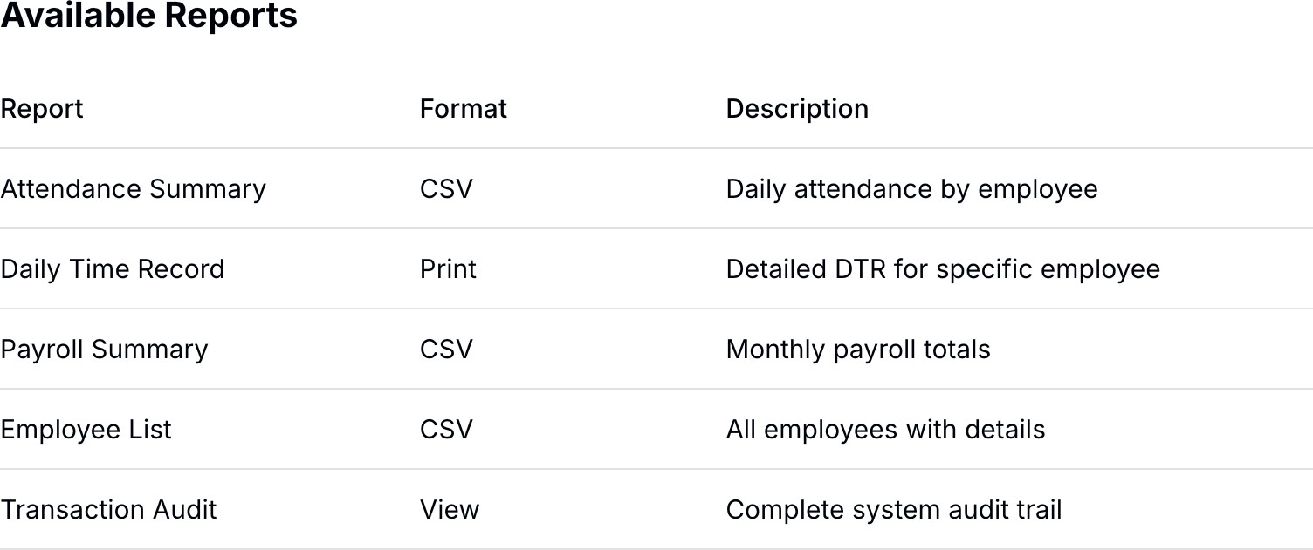

Export Process
- Apply desired filters
- Click export button (CSV or Print)
- Choose save location
- File is generated with timestamp
- Option to open file immediately

10


Time Record (DTR)

The Daily Time Record (DTR) Printing Module allows users to generate and print official attendance records in the standard Civil Service Form No. 48 format.
This module provides a monthly summary of an employee’s attendance, including daily time-in and time-out entries for both morning and afternoon sessions. It ensures compliance with government reporting standards and can be used for official documentation and record-keeping.
Users can select a specific employee, month, and year to generate the corresponding DTR. The system automatically populates the attendance data based on recorded entries.
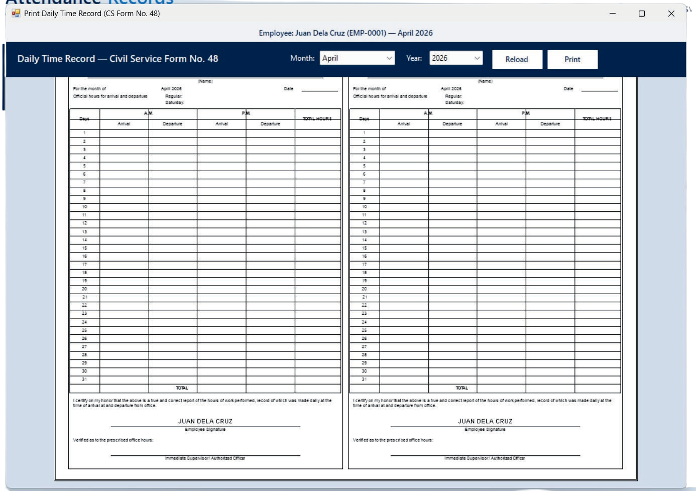
Figure 13. Daily Time Record Interface

Feature Description
Employee Information Displays the selected employee’s name and ID.
Month Selector Allows selection of the desired month.
Year Selector Allows selection of the desired year.
Reload Button Refreshes and reloads attendance data.
Print Button Generates a printable version of the DTR.
DTR Form Preview Displays the formatted Civil Service Form No. 48.

11


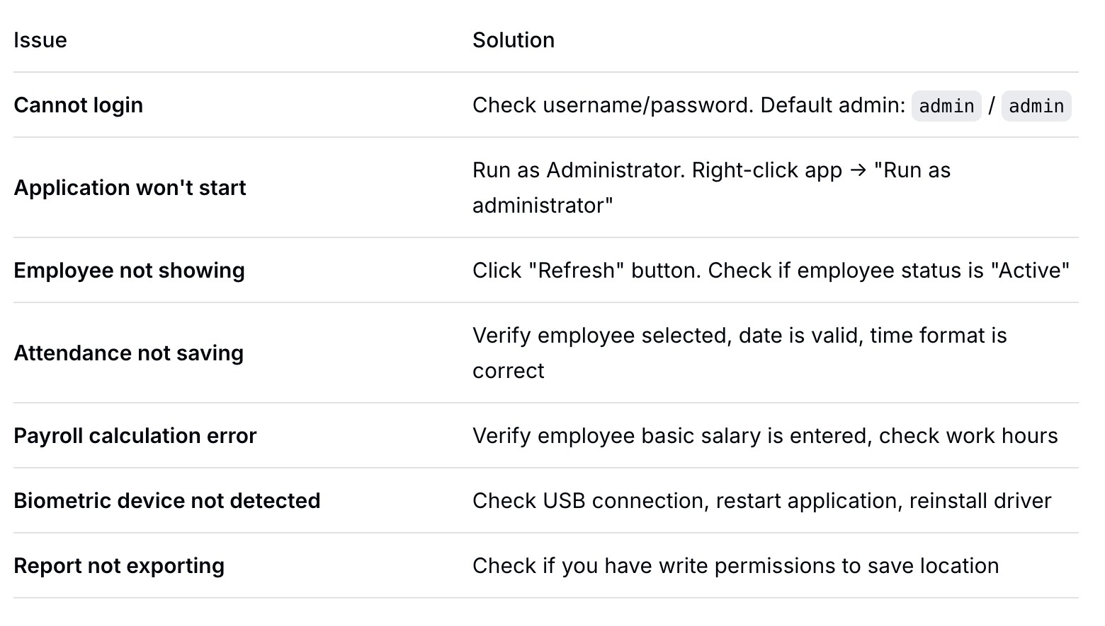
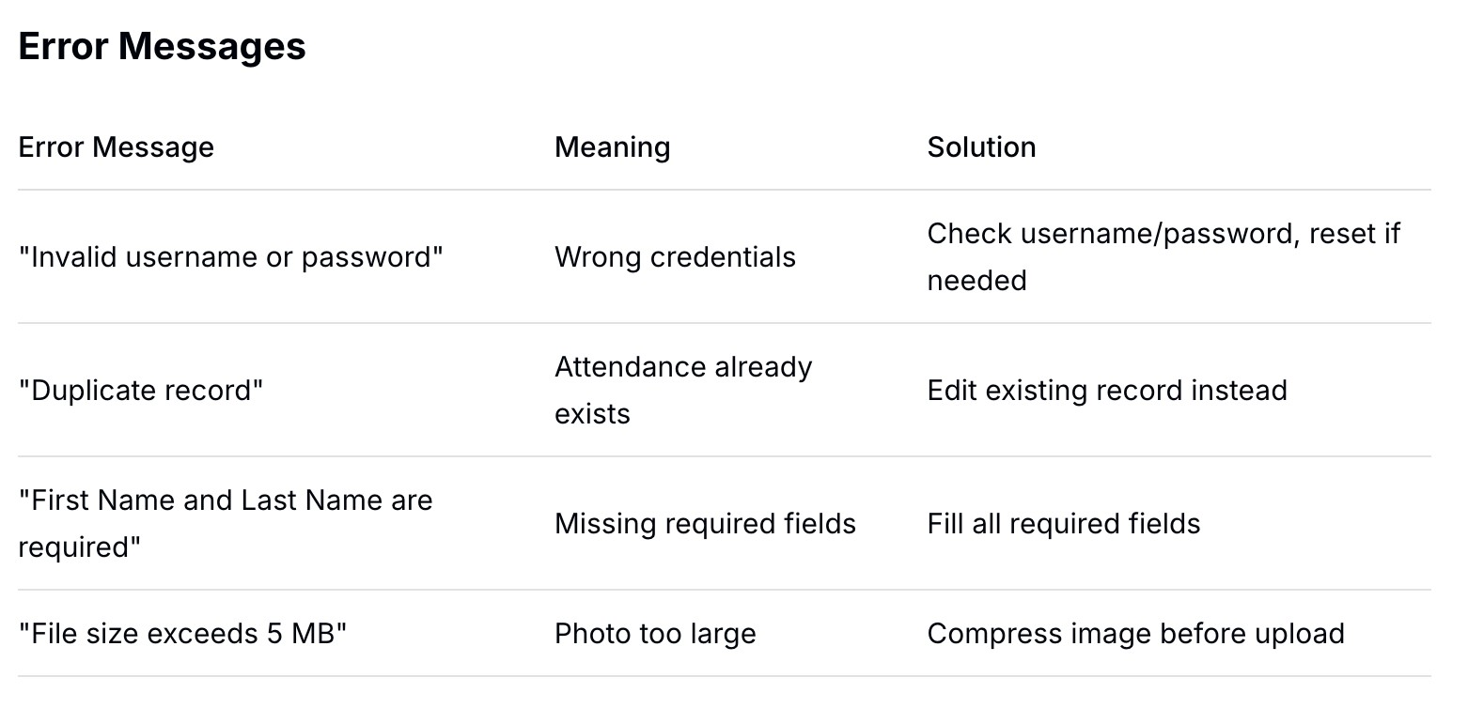
Troubleshooting
Common Issues & Solutions

12

System Settings
Overview
he System Settings module allows administrators to configure the entire system according to company policies, payroll rules, attendance schedules, and user permissions.
Access System Settings
- Log in as Admin or HR Manager
- Click Settings from the main navigation menu
- Settings sub-menu appears:

Company Profile
Company Information
Company Logo
- Click "Upload Logo"
- Select image file (JPG, PNG - max 2MB)
- Crop to fit (recommended: 200x200 pixels)
- Click "Save"

Field | Description
Legal business name | Legal business name
Address | Complete company address
Phone Number | Main contact number
Email Address | Official company email
TIN Number | Tax Identification Number
SSS Employer Number | Social Security System employer ID
PhilHealth Employer Number | PhilHealth employer ID
Pag-IBIG Employer Number | Pag-IBIG employer ID

Company Branding
Primary Color: Choose dashboard theme color
Login Page Background: Upload custom background
Report Header: Company name and logo on reports

Figure 14. System Setting Interface


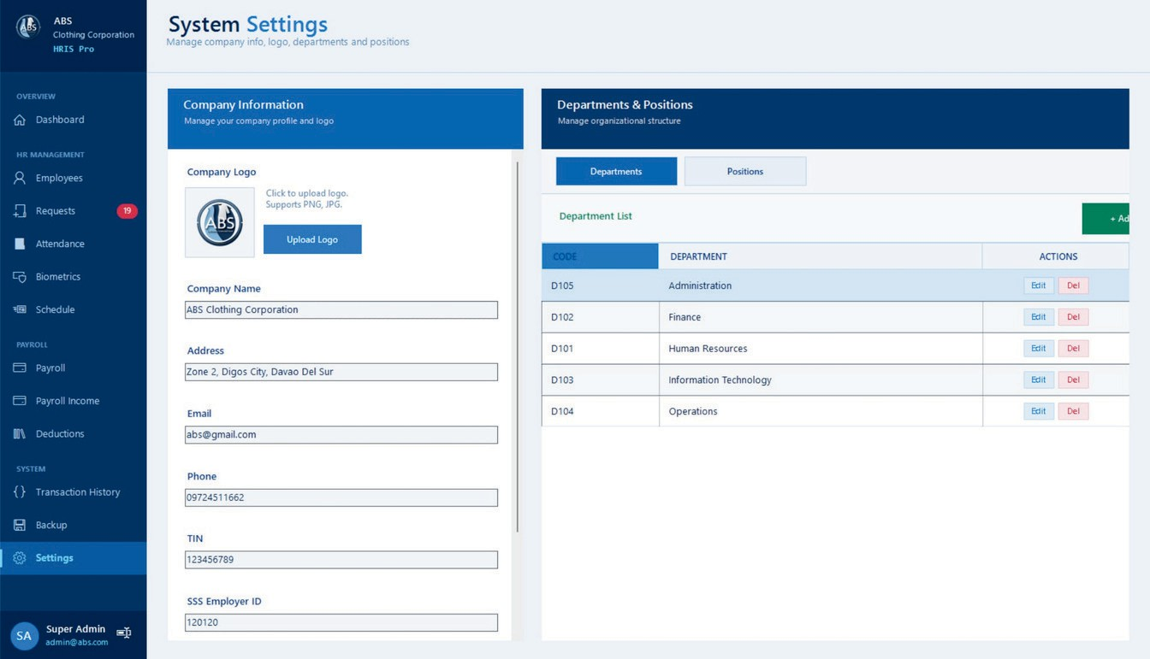

13

Payroll Settings
Basic Payroll Configuration
Setting Options Description

Pay Frequency First Cutoff Second CutOff Pay Day Currency
Monthly / Semi-monthly / Weekly 1-15 / 1-31
16-31 /1-31
15th & 30th /30th /15th PHP /USD
How often employees are paid First half of month
Second half of month When salary is released Currency for payroll

SSS Contribution Rates

Salary Range | Employee Share | Employer Share | Total
0 - 4,250 | 135 | 270 | 405
4,251 - 4,750 | 135 | 315 | 472.5
4,751 - 5,250 | 135 | 360 | 540
Action: Click "Edit Rates" to update based on SSS memorandum
PhilHealth Contribution Rates Pag-IBIG Contribution Rates

Setting Premium Rate Employee Share Employer Share
Monthly Premium Cap
Value
4.00% of monthly salary 50% of premium
50% of premium
80.000
Setting Employee Share Employer Share
Maximum Monthly Compensation
Value
2.00% of monthly salary 2.00% of monthly salary 5,000

Withholding Tax (BIR)

Tax table
Annual Tax Table Monthly Tax Table
Description
BIR TRAIN Law rates
Simplified monthly computation

Action: Click "Update Tax Table" to import new BIR rates

Overtime Rates
Type
Regular Overtime Night Differential Rest Day Overtime Holiday Overtime Special Holiday

Rate
125% of hourly rate
110% of hourly rate (10pm-6am) 130% of hourly rate
200% of hourly rate 130% of hourly rate



14

13th Month Pay
Setting Option

Computation Release Month
Pro-rated for new hires
Total basic salary ÷ 12 December (or choose month) Setting

Attendance Settings
Work Schedule
Setting Description

Shift Type Work Days Time In (AM) Time Out (AM) Time In (PM) Time Out (PM) Total Hours
Fixed / Rotating / Flexible Days employees work Start of morning shift
End of morning shift / start of break
Return from break End of work day Daily work hours

Multiple Shifts
Shift Time IN Time Out Department

Morning Shift Day Shift
Mid Shift Night Shift
6:00 AM
8:00 AM
10:00 AM
10:00 PM
2:00 PM
5:00 PM
7:00 PM
6:00 AM
Security/Utility Admin, HR, IT, Faculty Doctor
Security, Maintenance

Action: Click "Add Shift" to create new shift schedule

Grace Period & Lates
Shift
Grace Period Late Threshold
Undertime Threshold Consider Half Day

Value
15 minutes
1 minute
1 hour
Less than 4 hours

Description
Time allowed after schedule without being late Minute considered as late after grace period Minimum undertime to record
If employee works less than 4 hours



15

Overtime Settings
Setting Option

Require Approval Minimum OT Hours Maximum OT Per Day OT Pay After
Yes / No 1 hour
4 hours
8 hours (regular work hours)

Leave Settings
Leave Type | Days Per Year | With Pay | Carry Over
Sick Leave | 15 days | Yes | No
Vacation Leave | 15 days | Yes | 5 days
Emergency Leave | 5 days | Yes | No
Bereavement Leave | 3 days | Yes | No
Maternity Leave | 105 days | Yes | No
Paternity Leave | 7 days | Yes | No
Unpaid Leave | Unlimited | No | No
Action: Click "Add Leave Type" to create custom leave type

Holiday Calendar
Holiday Type Regular Holiday Regular Holiday Regular Holiday Regular Holiday Regular Holiday Regular Holiday Regular Holiday Regular Holiday Special Holiday

Date
Jan 1
Apr 9
May 1
Jun 2012
Aug 2021
Nov 2030
Dec 2025
Dec 2030
(varies)

Description
New Year's Day Araw ng Kagitingan Labor Day Independence Day Ninoy Aquino Day Bonifacio Day
Christmas Day Rizal Day
Black Saturday, etc.


Action: Click "Import Holidays" to upload annual holiday calendar

17

Backup & Restore
The Backup & Restore page allows the system administrator to create and manage database backups to prevent data loss and to restore data when needed.

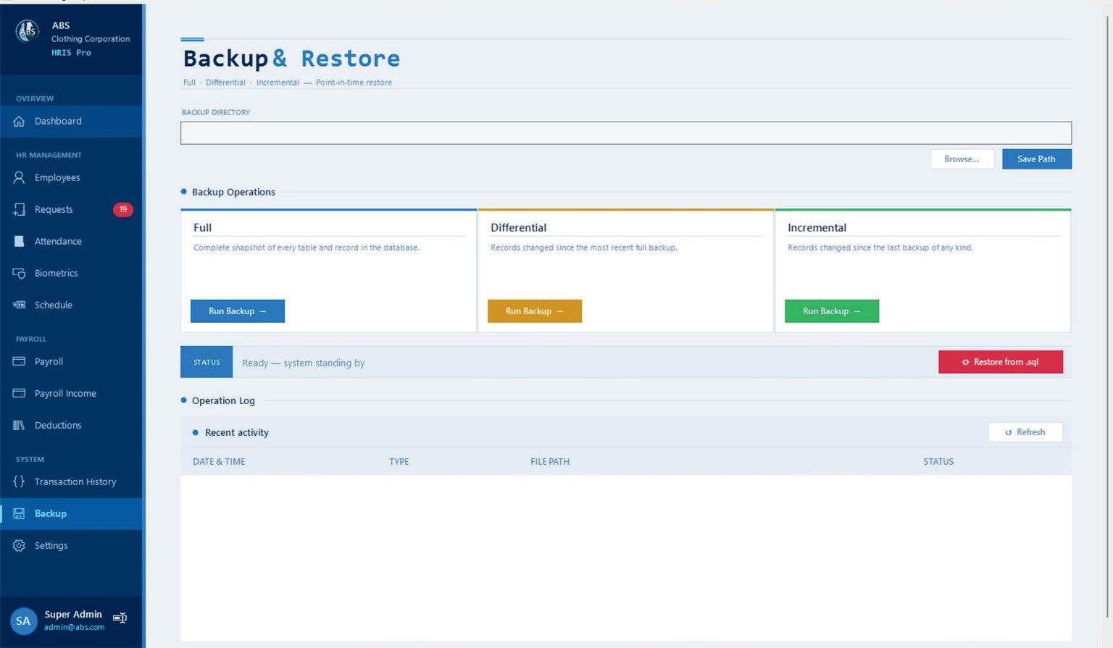

Backup Directory
Figure 15. Backup and Restore Interface


- This field specifies where the backup files will be saved.
- Click Browse to select a folder.
- Click Save Path to confirm the location.
Full Backup
- Creates a complete copy of all data in the system.
- This includes all tables and records.
- Recommended for:
  - First-time backup
  - Complete system recovery
Takes more time and storage space because it copies everything.
Click Run Backup under Full to start.
Differential Backup
- Saves all changes made since the last full backup.
- Faster than full backup
- Easier to restore than incremental
File size increases over time until the next full backup
Click Run Backup under Differential.
Incremental Backup
- Saves only the changes since the last backup (full or incremental).
- Fastest and uses least storage
Restore requires multiple backup files (full + all incrementals)
Click Run Backup under Incremental.
18


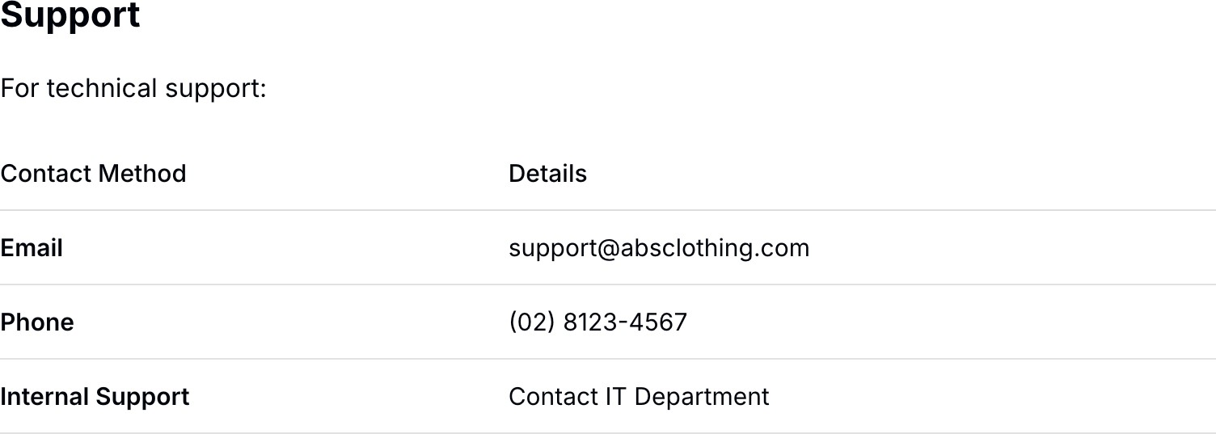

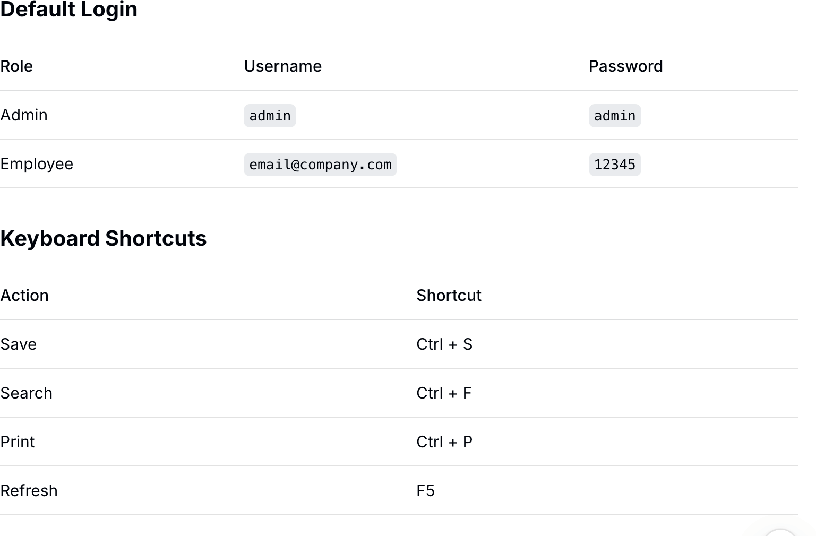

19


GLOSSARY

Attendance – The record of an employee’s presence at work, including time in, time out, and total hours worked.
Biometric – Physical characteristics used for identification, such as fingerprint, facial recognition, or iris scan.
Daily Time Record (DTR) – The official attendance log that shows an employee’s daily time in and time out.
Gross Pay – The total earnings before any deductions, including basic salary, overtime, allowances, and bonuses.
Net Pay – The take-home pay after all deductions such as SSS, PhilHealth, Pag-IBIG, and taxes have been subtracted.
Pay Period – The time interval for payroll processing (e.g., 1st–15th, 16th–31st of the month).
Payslip – A document showing the salary breakdown, including earnings, deductions, and net pay.
Social Security System (SSS) – A Philippine government-mandated pension and insurance program.
Philippine Health Insurance Corporation (PhilHealth) – The national health insurance program in the Philippines.
Home Development Mutual Fund (Pag-IBIG) – A Philippine government savings and housing loan program.
Tax Identification Number (TIN) – A unique number issued by the Bureau of Internal Revenue (BIR) for tax purposes.
Undertime – Leaving work before the scheduled time without proper authorization.
Overtime – Working beyond regular working hours, typically compensated at a higher rate.
Leave – An authorized absence from work, such as sick leave, vacation leave, or emergency leave.
Cutoff – The end date of a pay period or the last day included in payroll computation.
Allowance – Additional compensation given to employees, such as transportation, meal, or clothing allowance.
Deduction – An amount subtracted from an employee’s salary, including government contributions, loans, and taxes.
Biometric Enrollment – The process of registering an employee’s fingerprint or facial data into the biometric system.
Withholding Tax – The income tax deducted directly from an employee’s salary and remitted to the BIR.
Audit Trail – A complete record of all system activities, including who performed actions and when they occurred.
20


Electronic Timekeeping and Payroll Management System
USER MANUAL GUIDE
Document No: HRM-BIO-001 Version: 1.0

ALL RIGHTS RESERVED

No part of this document may be reproduced, distributed, or transmitted in any form or by any means, including photocopying, recording, or other electronic or mechanical methods, without the prior written permission of the publisher, except in the case of brief quotations embodied in critical reviews and certain other non-commercial uses permitted by copyright law. This software and its documentation are provided "as is" without warranty of any kind, either expressed or implied, including but not limited to the implied warranties of merchantability and fitness for a particular purpose.

© 2025-2026
Electronic Timekeeping and Payroll Management System All Rights Reserved

Published by:
Electronic Timekeeping and Payroll Management System Matti, Digos City Philippines
Tel: (02) 8123-4567
Email: etechtugonsoftwaresolution@gmail.com Website: www.eTechtugonsoftwareSolution.com

