HAJIYEV TABRIZ

Homework 1

GITHUB
https://github.com/azecoder/ASSE/tree/master/HomeWorks/HW1

REPORT

Creating routes and methods of the request
Create get_doodle and remove_doodle methods by id.
Create get_all_preferences and remove_all_preferences methods by id and person.
Get and remove the datas from the _ACTIVEPOLLS[id], also remove and get the person options from _ACTIVEPOLLS[id]

Screenshot

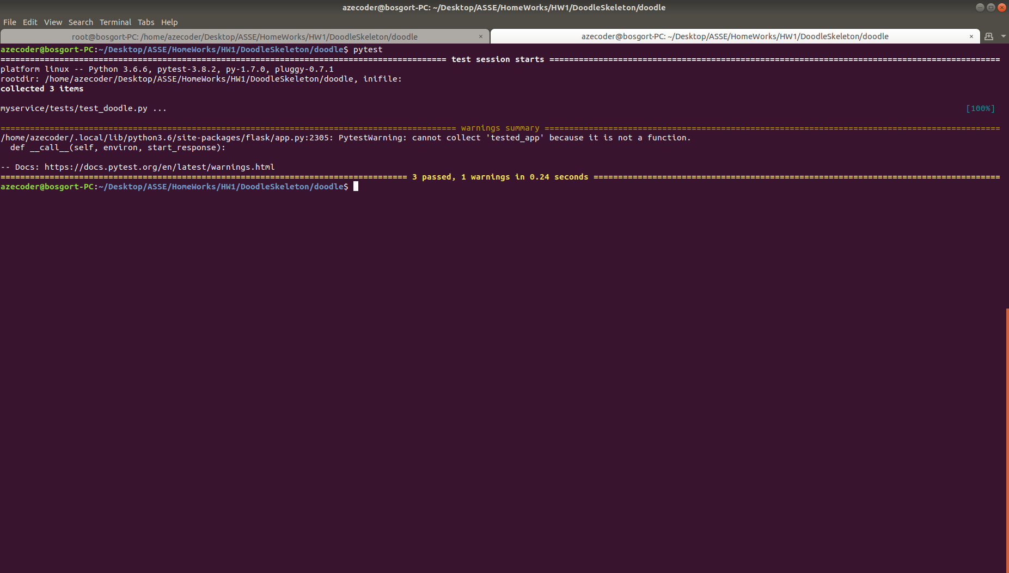

Postman Screenshot

