Tabriz Hajiyev

Report

Firstly, I used the Camunda Modeler to define the BPMN process. In inclusive gateway part of the model, I create expressions for each statement.
RiceTaken = #(rice == “available” ? 1 : 0)
FishTaken = #(fish == “available” ? 1 : 1)
But, I defined the SaladTaken = 1 as a default

In the Menu task of Worker.js , I checked the probabilities that was given 40% and 60% for fish and rice respectively.
For the beginning, I took a random number in order to check probabilities of statements. If the chosen number is less than the probability of the rice then I set status of the rice as available, else not available. The same work was done for the fish as well. However, as the salad is our default case, probability is always available for the salad.

Next, in Billl task, I got the last results and there were calculated the total price for payment.
I checked if rice taken or not by using the following code:
var riceTaken = task.variables.get('riceTaken') || 0; // that gives me 0 or 1
Again, the same work was done for the fish and salad as well

I summed all prices like:
var total = fishTaken * FISH_COST + riceTaken * RICE_COST + saladTaken * SALAD_COST;

At the end, I send the total price to program using:
processVariables.set("total", total);

Screenshot – Camunda TaskList

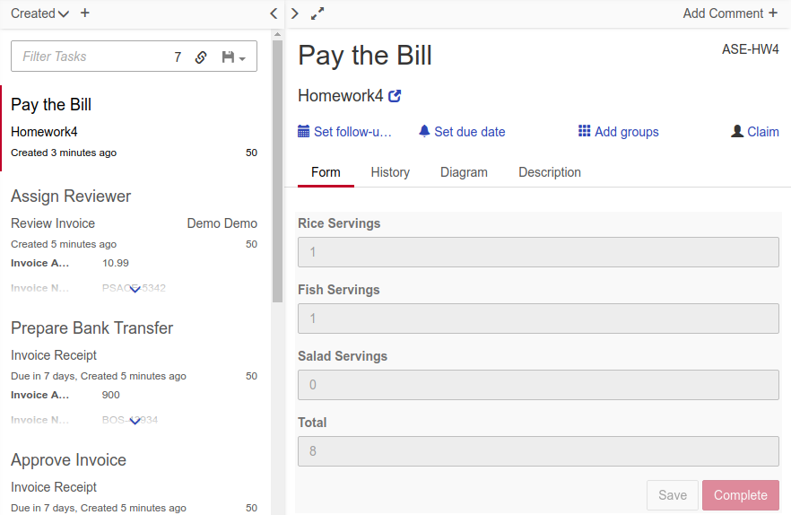

Screenshot – Camunda Cockpit

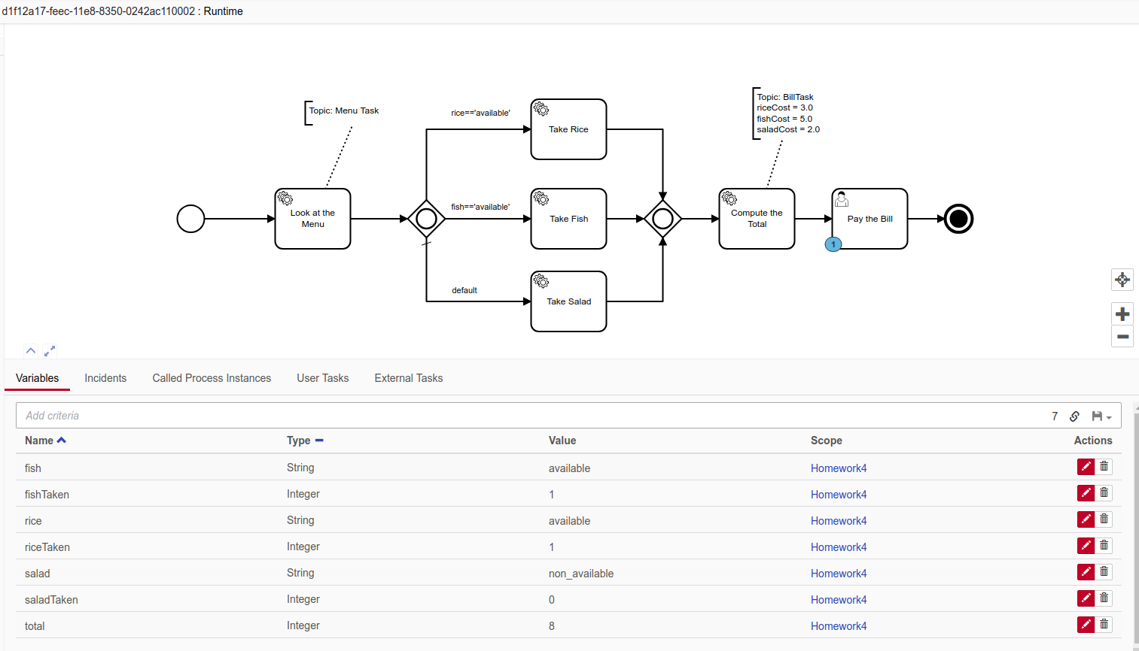
Screenshot – Terminal

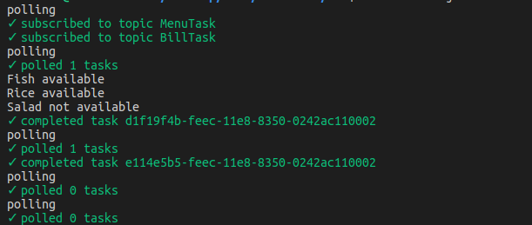

Screenshot – Woped

