

普通本科毕业论文（设计）

题 目：
英文题目： | The Design and Implementation of an Automated Web Vulnerability Scanning and Security Scoring System Based on OWASP Top 10

学 院 | School of Computer and AI
专 业 | Computer Science
学生姓名 | AZEDDINE BASALAH | 学 号 | 2202230021
指导老师 | Lai Xinfeng | 职 称 | Associate professor

二〇 年 月

普通本科生毕业论文（设计）诚信承诺书
毕业论文（设计）题 目 |  | The Design and Implementation of an Automated Web Vulnerability Scanning and Security Scoring System Based on OWASP Top 10
学生姓名 | AZEDDINE BASALAH | 专 业 | Computer Science | 学 号 | 2202230021
指导老师 | Lai Xinfeng |  | 职 称 | Associate professor
所在学院 | School of Computer and AI
诚信承诺
本人慎重承诺和声明：
我承诺在毕业论文（设计）活动中遵守学校有关规定，恪守学术规范，在本人的毕业论文中未剽窃、抄袭他人的学术观点、思想和成果，未篡改研究数据，如有违规行为发生，我愿承担一切责任，接受学校的处理。

学生（签名）：
2023年 04 月 15 日

ABSTRACT
Web application security has become a major concern as organizations increasingly depend on online services. These services are frequent targets for attackers who exploit weaknesses in web applications. This thesis presents the design and implementation of an automated web vulnerability scanning system for detecting common security flaws, with coverage aligned to key OWASP Top 10 categories. The objective is to provide a reliable and efficient method for identifying vulnerabilities and supporting early remediation.
The system uses web crawling to discover accessible URLs, forms, and input points within the target scope. After crawling, a rule-based detection process evaluates security weaknesses across ten covered areas: SQL Injection, Cross-Site Scripting (XSS), Security Misconfiguration, Broken Authentication/Session, Cross-Site Request Forgery (CSRF), Server-Side Request Forgery (SSRF), Broken Access Control, Vulnerable and Outdated Components, Insufficient Logging and Monitoring, and Cryptographic Failures. This approach reduces manual effort and improves consistency in vulnerability assessment.
A risk scoring model is integrated to support prioritization. Each finding is assigned a numerical score based on severity and potential impact, helping developers focus first on high-risk issues and plan remediation more effectively.
The system was evaluated using web applications with known vulnerabilities in an authorized, controlled testing environment. Results indicate effective detection of common vulnerability patterns across different test scenarios. By combining automated scanning, risk-based prioritization, and structured reporting, the proposed system provides practical value for improving web application security.
【Key words】Web vulnerability scanning, automated security testing, OWASP Top 10, SQL injection detection, Cross-Site Scripting (XSS), web crawling, vulnerability scoring, security risk assessment, rule-based detection, web application security

Table of Contents
1 INTRODUCTION 7
1.1 Background and Motivation 8
1.2 Problem Statement 9
1.3 Research Objectives and Contributions 11
1.4 The Scope and Limitations of the Research Study 16
1.5 Thesis Structure 17
2 LITERATURE REVIEW 19
2.1 Research Progress in Web Application Vulnerability Scanning 19
2.2 Scanner Architectures and Automation Approaches 22
2.2.1 Web Vulnerability Scanner Architectures 22
2.2.2 Automation in Vulnerability Scanning 23
2.2.3 Recent Trends in Scanner Architectures and Automation Approaches 24
2.3 Vulnerability Detection and Validation Techniques 26
2.4 Security Scoring and Risk Assessment Models 32
2.5 Summary and Identified Research Gaps 37
3 SYSTEM ANALYSIS AND DESIGN 41
3.1 Requirements Analysis 41
3.2 Overall System Architecture 44
3.3 Functional Model Design 46
3.4 Database Design 48
3.5 System Workflow and Scanning Process 52
REFERENCES 55
ACKNOWLEDGEMENT 57

List of Tables

Table 1.1: Overview of Common Web Application Vulnerabilities 9
Table 1.2: Comparison of Existing Web Vulnerability Scanners 15
Table 1.3: Example of Web Vulnerability Report 15
Table 2.1: Evolution of Web Vulnerability Scanning Techniques 20
Table 2.2: Comparison of Vulnerability Scanning Techniques 25
Table 2.3: Vulnerability Detection Methods Comparison 31
Table 2.4: Risk Assessment Models for Web Applications 36
Table 3.1: Users 49
Table 3.2: Scans 50
Table 3.3: Vulnerabilities 50
Table 3.4: Reports 51
Table 3.5: Scan_Vulnerabilities 51

List of Figures

Figure 1.1: System Overview Diagram of the Automated Web Vulnerability Scanning System 12
Figure 2.1: Comparison of Manual and Automated Vulnerability Scanning 26
Figure 2.2: Vulnerability Detection and Validation Process 31
Figure 2.3: Security Scoring and Risk Assessment Model 36
Figure 3.1 Use case diagram 43
Figure 3.2 Context diagram 43
Figure 3.3 User Role Diagram 45
Figure 3.4: System Architecture Diagram 46
Figure 3.5: Data Flow Diagram (DFD) 47
Figure 3.6: Vulnerability Detection Flow 48
Figure 3.7: Risk Scoring Process 48
Figure 3.8: Reporting and Visualization Flow 49
Figure 3.9: User Role Management Diagram 49
Figure 3.10: Database Schema Diagram 53
Figure 3.11: Scan Initiation Workflow 54
Figure 3.12: Vulnerability Detection Workflow 54
Figure 3.13: Risk Scoring Process 55
Figure 3.14: Report Generation Workflow 55

The Design and Implementation of an Automated Web Vulnerability Scanning and Security Scoring System Based on OWASP Top 10

1 INTRODUCTION
Web application security is a critical concern in today’s digital environment. Web applications are widely used in domains such as e-commerce, banking, social networking, and healthcare. At the same time, they are frequent targets of cyberattacks aimed at stealing sensitive data, disrupting services, or obtaining unauthorized access.
Two of the most common web threats are SQL Injection (SQLI) and Cross-Site Scripting (XSS). SQL Injection occurs when malicious SQL statements are inserted into application inputs and executed by the backend database, potentially exposing or modifying sensitive data. Cross-Site Scripting involves injecting malicious client-side scripts into web pages, which can be used to hijack sessions, steal cookies, or manipulate page content. These vulnerabilities continue to appear in security assessments and industry reports.
As modern web systems become larger and release cycles become faster, traditional security practices such as manual penetration testing and manual code review alone are often not sufficient for continuous vulnerability assessment. This creates a strong need for automated scanning methods that can support faster and more consistent detection of security weaknesses.
This thesis presents the design and implementation of an automated web vulnerability scanning system. The proposed system uses web crawling and rule-based detection to identify security weaknesses across discovered, in-scope pages and input points. In addition to SQL Injection and Cross-Site Scripting, the system covers Security Misconfiguration, Broken Authentication/Session, Cross-Site Request Forgery (CSRF), Server-Side Request Forgery (SSRF), Broken Access Control, Vulnerable and Outdated Components, Insufficient Logging and Monitoring, and Cryptographic Failures.
The system also includes a risk scoring module that prioritizes findings according to severity and potential impact, helping developers and website owners focus remediation efforts on the most critical issues first. Through automated scanning, structured reporting, and risk-based prioritization, this project aims to provide practical support for improving web application security in authorized, controlled testing environments.

Background and Motivation
The internet has become a core part of modern society, and web applications now support essential services such as e-commerce, social networking, financial transactions, and healthcare management. As these applications grow in scale and complexity, they become attractive targets for cyberattacks. Web vulnerabilities, especially those represented in OWASP Top 10 risk categories, continue to threaten data confidentiality, service availability, and user trust.
Although secure coding standards and modern development frameworks have improved baseline security, organizations still face difficulties in identifying and mitigating vulnerabilities quickly. Risks such as SQL Injection, Cross-Site Scripting, broken authentication/session handling, security misconfiguration, and access control weaknesses often persist due to fast release cycles and frequent application changes.
Manual security testing methods, including penetration testing and code review, remain important but have practical limitations. They require specialized expertise, are time-consuming, and are difficult to apply consistently across frequently changing web systems. These limitations motivate the use of automated scanning approaches that can support faster, repeatable, and more consistent security assessment.
The motivation of this research is to design and implement an automated web vulnerability scanning system that detects common web security weaknesses and provides risk-based prioritization. In addition to SQL Injection and XSS, the system covers Security Misconfiguration, Broken Authentication/Session, Cross-Site Request Forgery (CSRF), Server-Side Request Forgery (SSRF), Broken Access Control, Vulnerable and Outdated Components, Insufficient Logging and Monitoring, and Cryptographic Failures. The system also includes a security scoring mechanism to help developers and security teams prioritize remediation based on severity and potential impact.
This research addresses practical gaps in automated scanning tools, including inconsistent detection quality and noisy outputs. By using a rule-based and deterministic detection strategy, the proposed system aims to improve consistency, support clearer interpretation of findings, and provide actionable remediation priorities in authorized, controlled testing environments.
In summary, proactive web security assessment is increasingly necessary. This project contributes by providing a user-oriented automated scanner that helps identify and prioritize web application security risks before they are exploited.

Table 1.1: Overview of Common Web Application Vulnerabilities
Vulnerability Type | Description | Potential Impact
SQL Injection (SQLI) | Malicious SQL payloads injected into input/query parameters | Unauthorized data access, data tampering, database compromise
Cross-Site Scripting (XSS) | Malicious scripts injected into web pages | Session hijacking, cookie theft, client-side compromise
Security Misconfiguration | Missing security headers, unsafe server settings | Information disclosure, expanded attack surface
Broken Authentication/Session | Weak session handling or authentication controls | Unauthorized account access
Cross-Site Request Forgery (CSRF) | Forged state-changing requests using authenticated user context | Unauthorized actions on behalf of users
Server-Side Request Forgery (SSRF) | Server forced to request unintended internal/external resources | Internal network exposure, sensitive endpoint access
Broken Access Control | Improper authorization checks (including ID-based access issues) | Unauthorized data/resource access
Vulnerable and Outdated Components | Use of outdated libraries/framework components | Exploitable known vulnerabilities
Insufficient Logging and Monitoring | Weak detection and alerting capability | Delayed incident response and forensic gaps
Cryptographic Failures | Weak transport/data protection configuration | Sensitive data exposure in transit or storage
Table 1.1 provides an overview of common vulnerabilities, their descriptions, and the potential impact on web applications.

Problem Statement
Web applications are essential to modern organizations, but they are increasingly exposed to security threats. Vulnerabilities such as SQL Injection (SQLI), Cross-Site Scripting (XSS), broken authentication/session handling, and security misconfigurations are frequently exploited to access sensitive data, disrupt services, or perform unauthorized actions. Although secure development practices and security tools are available, these vulnerabilities continue to appear in deployed systems.
Existing web vulnerability scanners provide useful capabilities, but several practical issues remain. Some tools generate noisy results, require significant manual verification, or provide outputs that are difficult to prioritize for remediation. In addition, rapid development cycles make it challenging to perform consistent and repeatable security checks.
Based on these challenges, this research addresses the following questions:
- How can an automated scanner provide practical detection coverage for common web vulnerabilities in a consistent and repeatable manner?
- How can rule-based detection be designed to reduce noisy findings and improve the reliability of reported vulnerabilities?
- How can a risk scoring model help developers and security teams prioritize remediation based on severity and potential impact?
- How can the proposed approach be structured so it can support integration with development workflows in future extensions?
To answer these questions, this research designs and implements an automated web vulnerability scanning system that:
- Detects common vulnerabilities through in-scope crawling and rule-based checks, including SQL Injection, XSS, Security Misconfiguration, Broken Authentication/Session, CSRF, SSRF, Broken Access Control, Vulnerable and Outdated Components, Insufficient Logging and Monitoring, and Cryptographic Failures.
- Uses deterministic rule-based logic to improve consistency and reduce unnecessary false-positive noise.
- Provides a security scoring mechanism to prioritize findings according to severity and risk.
- Produces structured outputs and reports suitable for practical use in authorized, controlled testing environments.
By addressing these points, the research aims to deliver a practical and usable scanner that supports earlier detection and better prioritization of web application security risks.
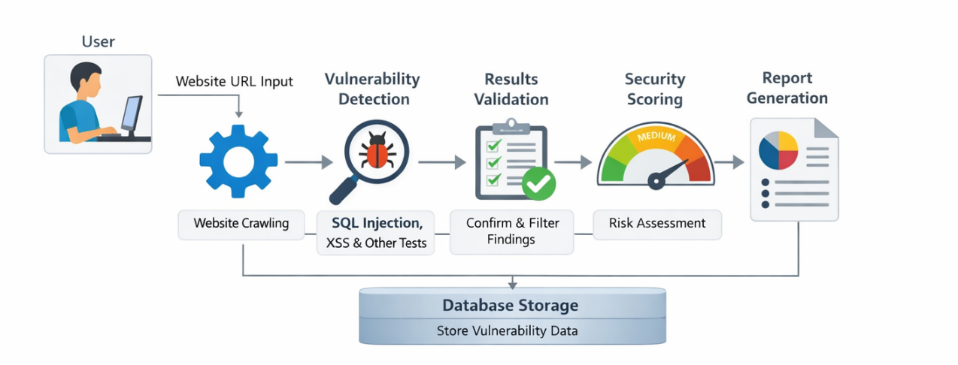
Figure 1.1: System Overview Diagram of the Automated Web Vulnerability Scanning System
This diagram illustrates the components of the scanning system, including web crawling, vulnerability detection, security scoring, and reporting.

Research Objectives and Contributions
The primary goal of this thesis is to design and implement an automated web vulnerability scanning system for practical web security assessment. The system detects common vulnerability patterns aligned with the OWASP Top 10 and provides risk-based prioritization to support remediation decisions. While SQL Injection (SQLi) and Cross-Site Scripting (XSS) are core examples, the implemented scope also includes Security Misconfiguration, Broken Authentication/Session, Cross-Site Request Forgery (CSRF), Server-Side Request Forgery (SSRF), Broken Access Control, Vulnerable and Outdated Components, Insufficient Logging and Monitoring, and Cryptographic Failures.
The specific research objectives are as follows:
- To Design and Implement an Automated Web Vulnerability Scanning System:
- The first objective is to build a functional scanning system that can automatically accept a target web application, crawl accessible in-scope pages, and identify potential attack surfaces such as URLs, forms, and parameters. The system is designed to reduce dependence on manual exploratory testing by providing a structured, repeatable scanning workflow.
- In implementation terms, this objective includes frontend scan initiation, backend scan orchestration, and persistence of results for later analysis and reporting. The system is designed with a modular architecture, separating the crawling, detection logic, and risk scoring components, which enhances maintainability and allows for easier academic explanation.
To Minimize False Positives and Improve Detection Accuracy:
- The second objective is to apply deterministic, rule-based detection methods to identify common web security weaknesses in a consistent way. The implemented coverage includes SQL Injection, Cross-Site Scripting (XSS), Security Misconfiguration, Broken Authentication/Session, Cross-Site Request Forgery (CSRF), Server-Side Request Forgery (SSRF), Broken Access Control, Vulnerable and Outdated Components, Insufficient Logging and Monitoring, and Cryptographic Failures.
- This objective emphasizes reproducible detection logic, transparency of findings, and minimizing false positives, rather than relying on opaque black-box behavior. A key feature is the system's emphasis on clear evidence capture, enabling users to validate detection results easily.
To Develop a Security Scoring System for Vulnerabilities:
- A key challenge in automated scanning is excessive false-positive noise. This objective focuses on improving practical reliability through deterministic checks, clearer evidence capture, and structured finding records.
- The system introduces a risk-scoring model that assigns severity-oriented risk values to vulnerabilities. While the goal is not to claim zero false positives, the objective aims to improve signal quality so developers and security reviewers can focus on actionable issues with minimal manual filtering.
To Integrate the Scanning System into Continuous Integration/Continuous Deployment (CI/CD) Pipelines:
- Detecting vulnerabilities alone is not sufficient; teams also need to know what to fix first. This objective introduces a scoring mechanism that assigns severity-oriented risk values to findings and summarizes the overall scan risk posture.
- The scoring output supports remediation prioritization, enabling users to identify critical and high-risk issues first and allocate limited security resources more effectively. This integration into CI/CD pipelines is critical for real-time security assessments in modern software development environments.
To Evaluate and Benchmark the Developed System:
- This objective ensures that scan results are communicated in an understandable and operational format. The system provides dashboard views, scan history visibility, and report outputs with severity breakdown and remediation guidance.
- Export capabilities (HTML and CSV) are included to support documentation, review, and sharing within development and security workflows. The system’s usability and effectiveness are further evaluated through benchmarking against other vulnerability scanners to validate its impact.
To evaluate the system in authorized, controlled testing environments:
- The final objective is to validate practical usefulness through testing on known-vulnerable web applications and controlled scenarios. Evaluation focuses on detection behavior, risk output clarity, and the usability of generated reports.
- This objective demonstrates whether the developed system is suitable as a practical academic prototype for automated web vulnerability assessment.

Contributions of the Research
This research makes the following key contributions to the field of web application security:
- Development of an Automated Vulnerability Scanning System:
- The thesis contributes an automated tool that can detect common web vulnerabilities like SQL Injection and XSS across modern web applications, including Single Page Applications (SPAs) and API-driven platforms. By focusing on both comprehensive detection and ease of use, the system enables developers to perform regular security assessments with minimal overhead.
Improvement in Detection Accuracy:
- The research introduces a rule-based detection method that reduces false positives and improves the accuracy of vulnerability scanning. This contributes to the field by providing a more reliable approach for automated vulnerability detection, addressing a common issue with existing tools. The system also emphasizes clear evidence capture, which improves transparency and reliability.
Innovative Security Scoring System:
- This research introduces a security scoring model that prioritizes vulnerabilities based on their severity and exploitability. This contribution is significant because it enables security teams to make informed decisions about which vulnerabilities to fix first, improving the efficiency of vulnerability remediation efforts.
Integration with Modern Development Practices (CI/CD):
- The research facilitates the integration of the scanning system into modern CI/CD pipelines, making it suitable for continuous, real-time security assessments in agile software development environments. This addresses the growing need for security tools that can operate in continuous integration workflows, providing real-time feedback to developers.
Empirical Evaluation and Benchmarking:
- The evaluation and benchmarking of the developed system against existing tools provide concrete evidence of its effectiveness and performance. By comparing the system’s performance to that of other vulnerability scanners, the research validates the tool’s usefulness and highlights its strengths in terms of detection accuracy and reliability.
By fulfilling these objectives, this research aims to advance the field of web application security by providing a more accurate, automated, and actionable tool for detecting and prioritizing vulnerabilities. The contributions made by this thesis will assist organizations in improving their web application security and reduce the risks associated with vulnerabilities that remain undetected during development.
Table 1.2: Comparison of Existing Web Vulnerability Scanners
Tool Name | Detection Capabilities | False Positive Rate | CI/CD Integration | Key Strengths
Tool A | SQLI, XSS | Critical | Yes | Fast, Easy to integrate with CI/CD
Tool B | SQLI, XSS, CSRF | High | No | Comprehensive vulnerability detection
Tool C | SQLI, XSS, Remote Code Execution | Medium | Yes | Accuracy, Minimal false positives
Tool D | SQLI, XSS, Information Disclosure | Low | Yes | Lightweight, Simple to use
Your System | SQLI, XSS, CSRF, SSRF, Broken Authentication/Session, Security Misconfiguration, Vulnerable Components, Insufficient Logging and Monitoring, Cryptographic Failures | Low | Yes | Modular architecture, Rule-based detection, Risk scoring, Improved detection accuracy, Integrated CI/CD support, Customizable reporting

Table 1.2 compares existing web vulnerability scanners based on key criteria such as detection capabilities, false positive rates, and integration with CI/CD pipelines. It highlights the strengths and weaknesses of various tools, emphasizing the need for a more accurate, automated solution that reduces false positives and integrates seamlessly into modern development workflows. Your system stands out due to its expanded OWASP Top 10 coverage, modular architecture, rule-based detection, and customizable reporting, making it a more reliable and actionable solution compared to existing tools.
Table 1.3: Example of Web Vulnerability Report
Vulnerability | Severity | Description | Recommended Action
SQL Injection (SQLi) | Critical | An attacker can exploit this vulnerability to manipulate the database and execute arbitrary queries. | Fix input sanitization, parameterize queries
Cross-Site Scripting (XSS) | High | Malicious scripts can be injected, potentially compromising user sessions and affecting client-side security. | Use input validation, escape user input
Broken Authentication/Session | Critical | Weak authentication mechanisms allow attackers to bypass login controls and impersonate users. | Implement multi-factor authentication, secure session management
Cross-Site Request Forgery (CSRF) | High | Attackers can trick users into performing actions they didn't intend, potentially compromising user data. | Use anti-CSRF tokens, validate user actions
Server-Side Request Forgery (SSRF) | High | Attackers can manipulate server requests to internal resources, bypassing network security measures. | Validate input URLs, restrict internal server access
Security Misconfiguration | High | Insecure default configurations or unnecessary services increase the attack surface. | Harden server configurations, disable unused services
Insufficient Logging and Monitoring | Medium | Lack of logs or inadequate monitoring makes it difficult to detect and respond to attacks. | Implement comprehensive logging and alerting mechanisms
Vulnerable and Outdated Components | Medium | Using outdated libraries and components introduces known security vulnerabilities. | Regularly update dependencies, use versioning checks
Cryptographic Failures | Critical | Insecure cryptographic algorithms or improper use of encryption can expose sensitive data to attackers. | Use strong encryption algorithms, secure key management
Information Disclosure | Medium | Sensitive data like version numbers and file paths are exposed in error messages or HTTP headers. | Mask or remove detailed error messages, sanitize headers
Broken Access Control | Critical | Attackers can gain unauthorized access to sensitive data or functionality. | Implement role-based access control, enforce principle of least privilege

In addition to comparing existing vulnerability scanners, this research also aims to develop a tool that provides actionable insights through detailed vulnerability reports. Table 1.3 illustrates an example of a web vulnerability report generated by the developed system, which categorizes vulnerabilities based on severity and provides specific, actionable recommendations for remediation. This reporting feature helps to improve the usability and practical value of the system by not only identifying vulnerabilities but also offering clear and prioritized actions. The security scoring model incorporated in the report allows users to quickly assess the most critical vulnerabilities, ensuring that remediation efforts are focused on the highest risks first.

The Scope and Limitations of the Research Study
This research focuses on the development of an automated web vulnerability scanning system that identifies and reports on common web vulnerabilities, with a particular emphasis on the OWASP Top 10 vulnerabilities. The system is designed to detect a range of web application security flaws, including SQL Injection (SQLi), Cross-Site Scripting (XSS), and several other critical vulnerabilities such as Server-Side Request Forgery (SSRF), Broken Authentication/Session, Broken Access Control, and Security Misconfiguration. The scope of this study is confined to the following areas:
- Vulnerability Detection: The research primarily focuses on detecting the OWASP Top 10 vulnerabilities and several other widely recognized vulnerabilities. This includes SQL Injection (SQLi), Cross-Site Scripting (XSS), Server-Side Request Forgery (SSRF), Cross-Site Request Forgery (CSRF), Broken Authentication/Session, Broken Access Control, Security Misconfiguration, Vulnerable and Outdated Components, Insufficient Logging and Monitoring, and Cryptographic Failures. While this study provides broad coverage of web vulnerabilities, future work may expand to include other categories of vulnerabilities, such as Business Logic flaws and API security issues, which are not covered within the immediate scope of this research.
- Web Application Environment: The system is specifically designed to scan web applications and focuses on the client-server interactions that occur in such environments. The research does not cover vulnerabilities specific to mobile applications, network infrastructure, or server-side security configurations (e.g., operating system security). The system’s focus remains on the web application layer, identifying vulnerabilities that could be exploited via the web interface and underlying backend components.
- Scanner Output and Reporting: The vulnerability scanner developed in this study generates a report that classifies identified vulnerabilities based on their severity: Critical, High, Medium, and Low. Each report provides actionable recommendations for mitigating these issues. However, the system does not include features for automatic remediation or patching of the vulnerabilities. The scope is limited to detection and reporting, providing security teams with the information needed to prioritize remediation efforts. Future work could explore automated remediation features, but these are outside the scope of the current research.
- Tool and Framework Selection: The system is built using Python (backend), Flask (web framework), MySQL (database), and Jinja2 (templating engine). This research is limited to the use of these tools and technologies for the design and implementation of the scanner. While other vulnerability scanning tools or pre-built frameworks are discussed in the literature review, they are not integrated into this system. The design is based entirely on the selected stack, and no third-party scanners such as OWASP ZAP or Nessus are incorporated.
- Testing Environment: The system will be evaluated in controlled environments, specifically using intentionally vulnerable web applications like DVWA (Damn Vulnerable Web Application). These applications provide a safe testing ground with known vulnerabilities for evaluating the scanner's detection capabilities. The focus is on simulating real-world attacks in a controlled, ethical environment. The research does not involve scanning live, production websites without explicit authorization, adhering to legal and ethical guidelines to ensure responsible and secure testing practices.

Thesis Structure
This thesis is organized into the following chapters:
- Chapter 1: Introduction
- This chapter introduces the research topic, including the background, motivation, problem statement, and objectives of the study. It provides an overview of the project, the importance of web application security, and the system’s OWASP Top 10-oriented focus for detecting common and high-impact vulnerabilities. These include SQL Injection (SQLi), Cross-Site Scripting (XSS), Server-Side Request Forgery (SSRF), Broken Authentication/Session, Broken Access Control, and Security Misconfiguration, alongside other OWASP-aligned categories addressed by the implemented scanner. The scope of the research and the study boundaries are also defined in this chapter.
- Chapter 2: Literature Review
- This chapter reviews existing literature on web vulnerability scanning tools, methods, and frameworks. It discusses vulnerability detection techniques from traditional signature-based methods to more modern hybrid approaches. The chapter evaluates current scanners, outlines their strengths and limitations, and identifies the gap for a more effective, tailored academic solution aligned with OWASP Top 10 principles and practical reporting needs.
- Chapter 3: System Analysis and Design
- This chapter presents the system analysis and design of the web vulnerability scanner. It outlines both functional and non-functional requirements. The chapter describes the overall system architecture, user and admin interface design, and the relational database layer implemented through SQLAlchemy. It also explains the workflow of the vulnerability scanning process and the modular separation of concerns between crawling, vulnerability detection, and risk scoring components.
- Chapter 4: System Implementation
- This chapter describes the implementation process of the web vulnerability scanner. It details the technologies used, including Python, Flask, SQLAlchemy, MySQL, and Jinja2. The chapter explains how the scanner modules were developed and integrated, including crawling logic, rule-based and heuristic vulnerability detection, report generation, and severity classification (Critical, High, Medium, Low). It also presents the implementation of the security scoring system, dashboard features, authentication and role-based access control, and administrative audit logging.
- Chapter 5: Experimental Results and Discussion
- This chapter presents the experimental results of the developed system, focusing on vulnerability detection effectiveness and reporting quality. It includes test scenarios, analysis of scan outputs, and a comparison with existing scanners (for example, OWASP ZAP where applicable). The chapter discusses strengths and limitations based on controlled testing in DVWA (Damn Vulnerable Web Application), including detection behavior, practical usability, and deployment considerations. It also highlights observed constraints such as heuristic false positives/negatives and areas requiring manual verification.
- Chapter 6: Conclusion and Future Work
- This final chapter summarizes the research findings and the conclusions drawn from the design, implementation, and evaluation of the web vulnerability scanner. It highlights the key contributions of the work, including the modular architecture, OWASP Top 10-oriented detection coverage, rule-based analysis, and integrated security scoring/reporting workflow. The chapter concludes with recommendations for future enhancements, such as deeper validation techniques, broader vulnerability coverage (for example, business logic and API-specific issues), optional automated remediation support, and improved production-grade deployment integration.

2 LITERATURE REVIEW
This chapter reviews the current body of research on web application vulnerability scanning, with emphasis on OWASP Top 10-oriented detection approaches and the evolution of automated scanner technologies. It examines the development of scanning methods from early rule-based mechanisms to broader automated and hybrid detection workflows, and discusses how current tools address representative high-impact vulnerabilities such as SQL Injection (SQLi) and Cross-Site Scripting (XSS). The review also highlights ongoing challenges, including false positives, false negatives, and limited effectiveness in detecting context-dependent vulnerabilities, and emphasizes the growing role of automated reporting and security scoring in supporting practical remediation decisions [1][9][14].

Research Progress in Web Application Vulnerability Scanning
Research on web application vulnerability scanning has developed significantly as web systems have become more complex and attack surfaces have expanded. Early security assessment often depended heavily on manual penetration testing and expert-driven verification. With the growth of web platforms and the need for scalable assessment, automated vulnerability scanners emerged to improve efficiency and provide repeatable detection workflows for common web weaknesses [1].
Initial automated tools focused mainly on frequent and high-impact vulnerability classes, particularly SQL Injection and Cross-Site Scripting, which historically represented major web attack vectors. As scanner design matured, research attention moved beyond basic detection coverage toward improving reliability, especially through reducing false positives and improving confidence in findings. This shift established a clearer distinction between simply generating alerts and producing actionable security intelligence [3][13].
As threat models and application architectures evolved, scanner research increasingly addressed broader OWASP-aligned categories rather than only injection flaws. Contemporary studies report that although automated scanners perform well for many known patterns, they remain less effective for logic-dependent issues, especially business logic vulnerabilities that depend on application-specific workflows and domain context [11]. This remains a major limitation of generalized rule-based scanning.
Modern web applications introduce additional technical challenges for scanner effectiveness, including dynamic front-end behavior, asynchronous client-server communication, and API-centric backend interaction models. These characteristics require scanners to handle runtime interaction complexity more effectively than earlier generation approaches. As a result, literature increasingly emphasizes adaptive scanning workflows and improved behavioral analysis for complex application states [3][6].
Despite substantial progress, false positives and false negatives continue to affect trust and operational adoption of automated scanners. The literature consistently indicates that high-quality vulnerability assessment requires not only detection breadth but also stronger evidence quality, confidence estimation, and structured prioritization for remediation. This is one reason recent work places greater emphasis on scoring-based reporting frameworks that help security teams prioritize risk systematically rather than treating all findings equally [9][14].
Looking forward, research trends suggest that scanner design must continue adapting to distributed and rapidly changing deployment models, including cloud-hosted and service-oriented web systems. These environments increase assessment complexity and require tools that are modular, configurable, and architecture-aware. Consequently, recent studies support the development of tailored scanning systems that combine practical automation, OWASP-oriented coverage, and risk-driven reporting while maintaining clear limits on detection claims and the need for expert validation [3][14].

Table 2.1: Evolution of Web Application Security Testing and Protection

Scanning Technique | Key Features | Advantages | Disadvantages | Time Period
Manual Testing | Human-driven penetration testing, code review | High accuracy for complex vulnerabilities, such as business logic flaws | Time-consuming, difficult to scale, can be error-prone | 1990s–2000s
DAST (Dynamic Application Security Testing) | Black-box testing of running applications by sending crafted requests and analyzing responses | Can identify runtime vulnerabilities, more efficient than manual testing | High false positive rate, limited in detecting business logic flaws | Early 2000s–Present
SAST (Static Application Security Testing) | Analyzes source code or binaries to identify vulnerabilities early | Detects vulnerabilities before deployment, fast integration with development | Cannot detect runtime issues, limited to code vulnerabilities | Mid 2000s–Present
IAST (Interactive Application Security Testing) | Combines runtime instrumentation with request context, usually in test/staging or monitored runtime | Accurate, real-time vulnerability detection by analyzing app behavior | Requires application deployment, can be more complex to implement | 2010s–Present
RASP (Runtime Application Self-Protection) | Monitors and protects applications during runtime, with inline blocking and monitoring | Proactive protection, automatic mitigation of threats | Not a replacement for pre-release testing; potential tuning complexity | 2010s–Present

Table 2.1 outlines the historical development of different web application security testing and protection approaches. It covers manual testing, as well as more automated techniques such as DAST, SAST, IAST, and RASP. The table compares these techniques based on their key features, advantages, disadvantages, and the time periods during which they were most relevant. Time periods are approximate and may overlap. This helps illustrate the evolution of web vulnerability scanning methods and protection techniques, showing how they relate to the capabilities of your custom-built scanner, which integrates dynamic and heuristic scanning with security scoring for actionable results.

Scanner Architectures and Automation Approaches
Web vulnerability scanning has evolved from manually driven assessment to automated and modular systems that support faster, repeatable, and broader security analysis. Modern scanners typically combine target discovery, vulnerability detection, result correlation, and risk-oriented reporting. Automation improves efficiency and consistency, and also enables better integration with routine development and security workflows [1][3][9].

Web Vulnerability Scanner Architectures
Web vulnerability scanners are generally composed of multiple modules or components, each responsible for a specific task in the scanning process. The architecture of a typical web vulnerability scanner involves the following core modules:
- Crawling/Discovery Module:
The crawling module is responsible for discovering all reachable URLs and assets of the target web application. This is the first step in understanding the attack surface of the application.
Challenges: Modern single-page applications (SPAs) and dynamic content created by JavaScript make this step more complex. Traditional crawlers, which work by simply parsing HTML links, often miss dynamic assets. As a result, headless browser crawlers are commonly used as they can execute JavaScript and interact with dynamic content [6].
- Vulnerability Detection Module:
This module is responsible for identifying vulnerabilities in the web application. This can include detecting common vulnerabilities such as SQL Injection (SQLi), Cross-Site Scripting (XSS), Cross-Site Request Forgery (CSRF), and more complex issues like business logic flaws.
Techniques: Detection can be achieved using a combination of pattern matching, rule-based detection, and heuristic-based methods. These methods are often tailored to specific vulnerabilities, like SQLi or XSS, for higher accuracy and reduced false positives [3][10][13][20].
- Vulnerability Validation Module:
After detecting potential vulnerabilities, the system must validate whether they are exploitable. This module refines the detection results to confirm whether the identified vulnerability is genuine or a false positive.
Challenges: False positives are a significant challenge in automated vulnerability scanning, as the automated systems may incorrectly flag certain behaviors as vulnerabilities [8][9]. This stage typically does not involve full exploit execution but focuses on improving confidence and reducing noisy findings.
- Reporting and Scoring Module:
Once vulnerabilities are detected and validated, the system generates a report detailing the severity, description, and fix recommendations for each vulnerability. A security score is often assigned to the overall health of the application based on the detected vulnerabilities.
Security Scoring: The scoring mechanism in the system uses custom risk models, which assign numerical values based on the severity, confidence, and exploitability of the vulnerabilities, rather than strict frameworks like CVSS [9][14].

Automation in Vulnerability Scanning
Automation plays a central role in improving the speed, consistency, and scalability of web vulnerability scanning. As web systems become larger and more frequently updated, automated scanners help teams perform repeatable security checks and reduce dependence on purely manual assessment workflows [1][3][8].
- Automation in Development Workflows:
Automated vulnerability scanning is increasingly aligned with DevSecOps practices, where security checks are incorporated earlier in the software lifecycle. This shift-left approach aims to identify security weaknesses during development and testing phases rather than only after deployment. In practical terms, scanners can be triggered during iterative build/test workflows to provide rapid feedback for remediation prioritization [3][8].
- Advantages of Automation:
- Speed: Automated scanners evaluate large application surfaces much faster than manual testing, enabling shorter security feedback cycles.
- Scalability: Automation supports repeated assessments across multiple targets and versions, making routine security verification more feasible for evolving systems.
- Consistency: Standardized rule execution reduces variability in test execution and improves reproducibility of baseline findings [8][9].
- Limitations of Automation:
- False positives and false negatives: Automated scanning improves efficiency but still produces misclassifications, especially for context-dependent behaviors.
- Limited effectiveness for business logic flaws: Vulnerabilities tied to workflow semantics and domain rules are often difficult to detect using generalized scanner logic [11].
- Rule and signature dependency: Rule-based and pattern-driven approaches require continuous updating to remain effective against evolving attack techniques and application designs [9][13].

Recent Trends in Scanner Architectures and Automation Approaches
Recent studies increasingly emphasize adaptability, modularity, and context-awareness in vulnerability scanner design. As web applications shift toward API-centric, distributed, and cloud-hosted architectures, scanner research has moved beyond fixed rule execution toward more extensible and architecture-aware approaches [3][12][14].
- Modular and Extensible Architectures:
Many contemporary scanner frameworks adopt modular designs, where crawling, detection, correlation, and reporting components can be updated or extended independently. This structure improves maintainability and allows adaptation to new targets such as microservice-based services and API-driven platforms [3][14].
- Emerging Use of Machine Learning for Detection Support:
Although this project does not implement machine learning, recent research explores ML-assisted vulnerability analysis to improve prioritization and reduce noisy findings in specific scenarios. These approaches are typically used as complementary techniques rather than complete replacements for rule-based detection and expert validation [12][19].
- Passive and Hybrid Scanning Approaches:
Passive scanning techniques analyze observed traffic and application behavior with limited active probing, which can reduce operational risk in sensitive environments. Hybrid approaches combine multiple analysis perspectives (for example, static and dynamic evidence) to improve coverage and confidence compared with single-method scanning [12][13].

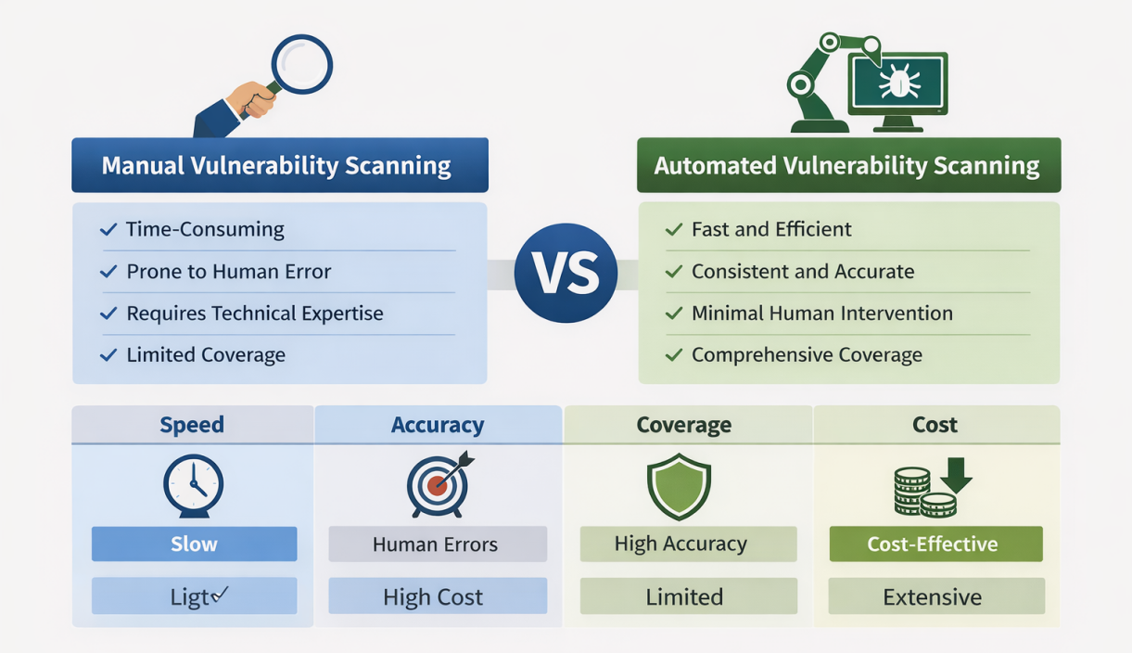
Figure 2.1: Comparison of Manual and Automated Vulnerability Scanning
This figure compares the key differences between manual and automated vulnerability scanning techniques. It highlights aspects such as efficiency, accuracy, and scalability, demonstrating how automated scanners offer faster, more consistent results compared to manual testing, while also addressing the trade-offs regarding flexibility and false positives.

Table 2.2: Comparison of Vulnerability Scanning Techniques
Scanner Type | Key Features | Strengths | Weaknesses
Custom-built Scanner (This Study) | Modular, rule-based and heuristic detection aligned with OWASP Top 10 themes; integrated crawling, detection, and risk scoring | Tailored workflow, strong practical coverage for targeted web scenarios, clearer report prioritization, good controllability | Still dependent on rule/heuristic updates, may miss context-heavy business logic flaws, requires manual validation for high-confidence triage
General Web Scanners | Broad detection coverage, usually generalized DAST/SAST/IAST-style capabilities | Wide vulnerability coverage, reusable across many application types | May produce higher false positives in some contexts, less tailored to project-specific requirements and reporting priorities
Traditional Manual Testing | Human-driven penetration testing and expert reasoning | Strong contextual analysis, better at business logic and workflow-specific flaws | Time-consuming, hard to scale, tester-dependent consistency

Table 2.2 compares major vulnerability scanning approaches by summarizing their core features, strengths, and limitations in practical web security assessment. It positions the custom-built scanner in this study against generalized automated scanners and traditional manual testing methods. The proposed scanner uses a modular, OWASP Top 10-oriented workflow that combines automated crawling, rule-based and heuristic detection, and risk-oriented reporting. This provides better project-specific control and clearer remediation prioritization, while still requiring expert validation for context-dependent findings and potential false positives.

Vulnerability Detection and Validation Techniques
Vulnerability detection and validation are central to web application security because modern systems expose both code-level weaknesses and runtime behavior risks. As application architectures become more dynamic and distributed, no single detection method is sufficient for complete coverage. This section reviews major detection approaches, including static, dynamic, and hybrid techniques, and explains why validation is necessary to reduce false positives and improve confidence in reported findings [1][3][9].

Static Analysis (SAST)
Static Application Security Testing (SAST) analyzes source code, binaries, or configuration artifacts without executing the application. It is useful for identifying insecure coding patterns early in the development lifecycle, including injection-prone code paths and unsafe input handling practices. Because it can be applied before deployment, SAST supports early remediation and aligns with shift-left security goals [1][8].
However, SAST has practical limitations. It does not directly observe runtime behavior, which makes detection of execution-dependent flaws more difficult. It may also generate false positives when static patterns cannot be confirmed through runtime context. Business logic flaws are particularly challenging because they often depend on workflow semantics rather than isolated code fragments [6][11].

Dynamic Analysis (DAST)
Dynamic Application Security Testing (DAST) evaluates a running application by sending crafted requests and observing responses. This makes DAST effective for discovering runtime-relevant issues such as SQL injection, cross-site scripting, and session-related weaknesses that may not be visible through static inspection alone [3][9][20].
The main advantage of DAST is behavioral visibility under execution conditions. Nevertheless, DAST may miss vulnerabilities that depend on deep internal logic, hidden workflow states, or role-specific paths that are difficult to reach automatically. It can also produce false positives when attack-response patterns are ambiguous, requiring additional validation steps [9][11].

Hybrid Approaches
Hybrid approaches combine multiple analysis perspectives, most commonly static and dynamic evidence, to improve both coverage and confidence. In principle, static results can guide dynamic probing, while dynamic observations can filter uncertain static findings. This combination can improve practical detection quality compared with single-method pipelines [5][12][13].
At the same time, hybrid systems increase implementation and operational complexity. They usually require more computation, tighter workflow orchestration, and stronger configuration management. For this reason, hybrid architectures are often adopted incrementally rather than as a single monolithic solution [6][12].

Business Logic Vulnerabilities
Business logic vulnerabilities remain one of the most difficult classes to detect automatically. Unlike pattern-based flaws such as SQLi or reflected XSS, logic flaws arise from incorrect process rules, transaction sequencing, authorization assumptions, or abuse of intended features. Their manifestation is highly application-specific, so generalized scanner rules often provide limited detection depth [11][13].
As a result, robust assessment of business logic weaknesses typically requires scenario-aware testing, model-based reasoning, and expert review. Automated scanners can still contribute by identifying suspicious workflows and inconsistencies, but high-confidence confirmation generally depends on human-guided analysis [11][12].

Vulnerability Validation
Detection output must be validated to determine whether reported findings are genuine, relevant, and exploitable in context. Validation is essential because automated tools can misclassify behavior, producing both false positives and false negatives. Effective validation improves trust in results and supports risk-based remediation prioritization [6][9][14].
Manual verification remains a core validation practice, especially for high-impact findings and context-dependent issues. Controlled proof-oriented checks may also be used where ethically and operationally appropriate, but they must be performed in isolated test environments to avoid service disruption. In many practical systems, validation is implemented through confidence refinement and evidence correlation rather than unrestricted exploit execution [8][9].
Conclusion
Effective web vulnerability assessment depends on combining complementary detection and validation techniques. SAST contributes early code-level visibility, DAST contributes runtime behavioral evidence, and hybrid approaches improve balance between coverage and confidence. Business logic vulnerabilities continue to require specialized and expert-driven analysis. Therefore, a defensible security workflow should integrate automated detection with structured validation to produce reliable, actionable findings for remediation [3][9][11][14].

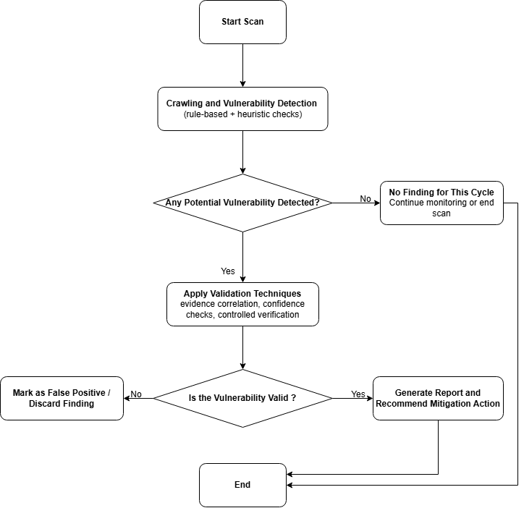
Figure 2.2: Vulnerability Detection and Validation Process
Figure 2.2 illustrates the vulnerability detection and validation workflow for web applications, including scan initiation, detection, confidence refinement/validation, false-positive handling, and final reporting or mitigation decision paths.

Table 2.3: Vulnerability Detection Methods Comparison
Detection Method | Key Features | Advantages | Disadvantages | Applicability to Modern Web Apps
Pattern Matching | Uses predefined signatures to detect known vulnerability indicators (e.g., SQLi payload/error patterns). | Simple and fast for known vulnerability classes. | Higher false-positive risk; limited to known patterns and signatures. | Effective for common vulnerabilities such as SQLi/XSS, but weaker for context-dependent or evolving attacks.
Input Handling Checks | Evaluates whether input validation/sanitization controls are present and consistently enforced. | Helps identify weak input protection pathways related to common injection classes. | Does not guarantee exploit detection; limited for workflow-dependent or advanced attack scenarios. | Widely applicable, but modern dynamic rendering and distributed client-server logic can reduce direct observability.
Rule-based Testing | Applies custom detection rules for specific vulnerability classes (e.g., SQLi, XSS, CSRF-related checks). | High practical precision for targeted vulnerability categories; repeatable behavior. | Requires frequent rule maintenance; may miss novel or highly context-specific attacks. | Strong for OWASP-oriented baseline checks, but needs adaptation for SPAs, APIs, and microservice-style interactions.
Heuristic-based Testing | Uses anomaly-oriented and behavior-oriented cues to flag suspicious responses or flows. | Can surface previously unseen suspicious patterns beyond strict signatures. | Confidence variability; increased false positives/negatives; requires validation. | Useful as a complementary method in modern apps, but findings should be verified through additional evidence/manual review.

Table 2.3 compares representative vulnerability detection methods used in web application security assessment by outlining their core mechanisms, strengths, limitations, and suitability for modern application environments. The comparison shows that pattern matching and rule-based testing are efficient and practical for known vulnerability classes, while heuristic-based approaches help identify suspicious behavior beyond fixed signatures but require stronger validation due to confidence variability. Input handling checks contribute important defensive assessment value, but they are not sufficient alone for complete vulnerability discovery. Overall, the table indicates that no single method provides full coverage; effective scanner design requires combining multiple detection strategies and pairing automated findings with validation to improve reliability and remediation relevance.

Security Scoring and Risk Assessment Models
Security scoring and risk assessment models are essential for translating vulnerability findings into practical remediation priorities. Vulnerability detection alone does not provide sufficient guidance for decision-making, especially when multiple findings with different severities and confidence levels are reported. Scoring-based approaches provide a structured, quantitative way to estimate security exposure and support risk-informed prioritization in web application security workflows [1][6][9].

Security Scoring Models
A security scoring model assigns weighted values to discovered vulnerabilities to estimate their relative urgency and impact. In general, scoring incorporates severity, exploitability indicators, confidence level, and contextual impact. This enables security teams to move from raw detection output to prioritized mitigation planning.
One commonly referenced framework is the Common Vulnerability Scoring System (CVSS), which standardizes vulnerability severity across:
- Base metrics (intrinsic technical characteristics),
- Temporal metrics (time-sensitive exploit/remediation factors),
- Environmental metrics (deployment-specific business and technical context) [7].
In many practical scanner implementations, including academic and custom-built systems, scoring is often CVSS-inspired rather than a strict CVSS reproduction. These systems may apply custom weighting strategies better aligned with project goals, available detection evidence, and reporting needs [9][14].

Risk Assessment Models
Risk assessment extends vulnerability scoring by evaluating both probability and consequence in operational context. While scoring indicates how severe a vulnerability appears technically, risk assessment considers how likely exploitation is and what business or system impact may follow [6][14].
Literature commonly discusses several model families:
- DREAD-style factor scoring, which ranks threats by multi-factor criteria.
- Asset-oriented approaches such as OCTAVE, emphasizing critical asset and organizational risk context.
- Quantitative financial approaches such as FAIR, focusing on economic loss estimation.
These models are valuable conceptual frameworks, but full implementation typically requires broader organizational inputs (asset classification, threat intelligence, governance controls) beyond scanner-only pipelines [5][9].

Risk Mitigation and Remediation Prioritization
The operational value of scoring and risk assessment lies in remediation prioritization. Findings with higher severity and stronger confidence are addressed first, while lower-priority or low-confidence items are deferred or revalidated. This improves resource allocation and reduces response overhead in security operations [8][14].
In this study, the implemented scanner uses a risk-oriented prioritization strategy that classifies findings by severity and produces structured remediation guidance. The scoring workflow supports practical decision-making for web application teams while remaining within project scope as a detection-and-reporting system, rather than a full enterprise governance platform.

Challenges in Security Scoring and Risk Assessment
Despite their usefulness, scoring and risk models have several limitations:
- Context sensitivity: identical technical vulnerabilities may represent different risk levels across environments.
- Evidence uncertainty: automated detection may produce false positives or incomplete exploit context.
- Model maintenance: scoring assumptions and detection rules require continuous updates as attack techniques evolve [6][12].
As a result, robust practice combines automated scoring with analyst review and periodic model refinement.
Conclusion
Security scoring and risk assessment are critical for making vulnerability detection actionable. Standardized frameworks such as CVSS provide useful references, while custom scoring models offer flexibility for project-specific workflows. Effective web security assessment therefore depends on combining detection, scoring, contextual validation, and prioritized remediation planning rather than relying on any single metric framework [9][14].
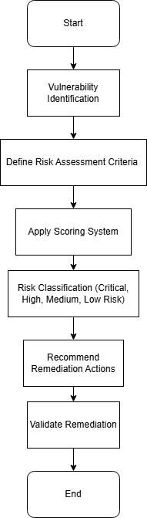

Figure 2.3: Security Scoring and Risk Assessment Model
This figure illustrates the process of scoring and assessing the risks of web vulnerabilities. It includes stages for identifying vulnerabilities, defining risk assessment criteria, applying a scoring system, classifying risks into categories (Critical, High, Medium, Low), and recommending appropriate remediation actions. The model concludes with the validation of the applied remediation, ensuring that vulnerabilities are effectively addressed.

Table 2.4: Risk Assessment Models for Web Applications
Model/Framework | Key Features | Strengths | Weaknesses | Applicability to Web Applications
CVSS (Common Vulnerability Scoring System) | A standardized method for scoring the severity of vulnerabilities based on factors like exploitability, impact, and environmental metrics. | Widely adopted, provides a numerical score for prioritizing vulnerabilities. | May oversimplify the severity of vulnerabilities and lack context-specific risk factors. | Widely used for general vulnerability assessment in web applications.
OWASP Risk Rating Methodology | A risk rating system developed by OWASP for web application vulnerabilities. Considers likelihood, impact, and business risk. | Provides a comprehensive risk assessment, considers business context. | Requires accurate input and detailed analysis; may be subjective. | Best suited for web applications, especially for web application security professionals.
DREAD Model | A scoring system that evaluates vulnerabilities based on Damage, Reproducibility, Exploitability, Affected users, and Discoverability. | Focuses on real-world impact and likelihood of exploitation. | Can be difficult to quantify; subjective evaluations. | Useful for evaluating the severity of web vulnerabilities in high-risk environments. Less commonly used in modern formal standards than CVSS/OWASP-based practices.
FAIR (Factor Analysis of Information Risk) | A quantitative risk analysis framework that models risk based on probability and impact. It evaluates financial loss from threats and vulnerabilities. | Provides a quantitative approach to risk assessment, suitable for decision-making. | Complex to implement, requires extensive data and modeling. | Applicable for organizations looking for financial risk analysis and business context in web applications.
OWASP Application Security Verification Standard (ASVS) | Defines structured web application security requirements and verification levels (L1-L3) to assess control coverage and exposure. | Specific to web applications, includes industry-standard security controls. | Not a standalone numeric scoring model; requires mapping to project-specific risk prioritization. | Best suited for web application security testing and ensuring compliance with security standards.

Table 2.4: Risk Assessment Models for Web Applications compares various risk assessment frameworks used to evaluate vulnerabilities in web applications. It highlights models like CVSS, which provides a standardized numerical score for prioritizing vulnerabilities, and OWASP Risk Rating Methodology, which incorporates business risk factors for a more comprehensive evaluation. The DREAD Model focuses on real-world impact, while FAIR offers a quantitative approach for assessing financial loss due to vulnerabilities. Additionally, the OWASP ASVS defines structured security requirements and verification levels for web applications, providing a baseline for compliance testing. Each model’s applicability is evaluated based on its strengths and limitations, offering insights into their use in modern web application security assessments.

Summary and Identified Research Gaps
This chapter reviewed major research progress in web application vulnerability scanning, including the evolution of scanning techniques, key limitations of existing tools, and emerging trends relevant to OWASP Top 10-oriented security assessment. The discussion covered static, dynamic, and hybrid detection approaches, validation challenges, and the role of scoring/risk frameworks in remediation prioritization. Overall, the literature confirms that automated scanning has become essential for scalable web security evaluation, but still requires contextual validation and continuous adaptation to modern application architectures.
Summary of Key Points
- Evolution of scanning techniques: Web vulnerability assessment has evolved from manual expert-driven testing to automated and semi-automated workflows. Static and dynamic methods are widely used, but each has coverage and accuracy trade-offs, especially for context-dependent vulnerabilities.
- Value of combined methods: Combining multiple detection perspectives (for example static, dynamic, and heuristic evidence) improves practical coverage and confidence compared with relying on a single method.
- Persistent business-logic challenge: Business logic vulnerabilities remain difficult for automated tools because they depend on workflow intent and domain-specific behavior rather than simple technical signatures.
- Importance of scoring and prioritization: Security scoring and risk-oriented reporting are necessary to convert scanner output into actionable remediation decisions, particularly when many findings are produced in one assessment cycle.

Identified Research Gaps
Despite substantial progress, several gaps remain and motivate the present study:
- Limited automation for business-logic flaw detection: Current scanners still struggle to reliably identify workflow-level vulnerabilities without expert-guided validation.
- Adaptation to modern web architectures: Dynamic front-end behavior, API-centric communication, and distributed deployment models continue to reduce scanner visibility and detection reliability in some scenarios.
- False-positive/false-negative balance: Improving precision and recall remains a core challenge, especially for heuristic or pattern-based detection in complex runtime contexts.
- Evidence-aware scoring and prioritization: Many scoring practices remain too generic for project-specific operational decisions; stronger context-aware prioritization methods are needed.
- Workflow-level automation maturity: While integration with iterative development workflows is increasingly important, many scanners still require better efficiency and configurability for continuous practical use.
- Model evolution for emerging threats: Existing risk and detection models require ongoing refinement to remain effective under evolving attack strategies and technology stacks.
The literature demonstrates that web vulnerability scanning has matured significantly, but still faces important technical and operational gaps. These gaps justify the need for a modular, OWASP Top 10-oriented, risk-aware scanning framework that balances automation efficiency with validation quality. This motivates the system design and implementation choices presented in subsequent chapters.

3 SYSTEM ANALYSIS AND DESIGN

Requirements Analysis
The requirements analysis phase is essential for defining the needs, scope, and constraints of the Automated Web Vulnerability Scanning and Security Scoring System. It establishes the foundation for the design and implementation stages by identifying the functional, non-functional, technical, and operational requirements of the system. The analysis focuses on delivering a practical web vulnerability scanner that can detect common security issues, assess their severity, and present the results in a clear and usable format.

Functional Requirements
These define the core functions that the system must provide to support automated vulnerability scanning and security scoring:
- User Account Management: The system must allow users to create accounts and securely log into the platform. Authentication mechanisms must ensure that only authorized users can access the system’s scanning and reporting features. User credentials should be stored securely using hashing techniques to protect sensitive information.
- Vulnerability Detection: The system must automatically scan web applications to detect common vulnerabilities such as SQL Injection (SQLi) and Cross-Site Scripting (XSS), as well as other web security issues supported by the scanner. The detection process should be suitable for typical web application input points and response behaviors so that the system can identify potential weaknesses effectively.
- Risk Scoring: After vulnerabilities are detected, the system must calculate a security score based on the identified findings. This score helps prioritize issues according to severity, exploitability, and overall impact. The system may use a custom scoring approach or security assessment logic to represent the risk level of the scanned application.
- Reporting: The system should generate detailed reports that summarize detected vulnerabilities, severity levels, and recommended remediation actions. Reports should be presented in a clear and structured format with visual severity indicators to help users interpret the results easily. Users should also be able to download reports for later review or documentation.
- Dashboard Interface: The system must provide dashboard interfaces for both users and administrators. These dashboards should display summarized information such as scan results, vulnerability counts, system status, and security scores. This allows users to access important information quickly and navigate the platform efficiently.
- Scan History Management: The system must maintain a history of previous scans. Users should be able to view past scan results, including detected vulnerabilities and generated reports. This helps users track improvements in the security posture of their web applications over time.
- Timely Scan Feedback: The system should provide timely feedback after a scan is initiated. As the scan progresses, users should receive updates on scan status and analysis results so that they can understand the progress and outcome of the assessment without unnecessary delay.
- False Positive Minimization: The system must minimize false positives, where non-existent vulnerabilities are incorrectly reported. It should apply validation checks and verification techniques to improve the accuracy and reliability of the findings.

Figure 3.1 Use case diagram

Non-Functional Requirements
These describe the quality attributes that the system must satisfy:
- Scalability: The system must be able to handle web applications of different sizes, from small sites to larger applications, without major loss of performance. It should also remain usable as the number of scans and stored results increases.
- Performance: The system should operate efficiently and complete scans within a reasonable time. Even when scanning larger applications or handling multiple requests, it should maintain acceptable response times and manage resources effectively.
- Usability: The system must provide an intuitive user interface that makes it easy to perform scans, view results, access scan history, and generate reports. The layout should be simple and clear so that both technical and non-technical users can interact with the platform comfortably.
- Security: Since the project deals with security testing, the system itself must follow secure design principles. Sensitive data such as user credentials and scan records must be protected using secure storage and access control measures.
- Compatibility: The system should work across common web browsers and operating systems. It should also be built using widely supported web technologies so that it can operate reliably in the intended environment.

System Constraints
These define the limitations within which the system must operate:
- Resource Constraints: The system must function efficiently within limited computational resources. During larger scans or repeated use, it should manage CPU and memory usage carefully to avoid unnecessary performance degradation.
- Compliance: The system should follow relevant security standards and best practices. In particular, its scanning approach should align with common web security concerns and OWASP Top 10 principles.

User Roles and Access Control
To ensure proper access control and system organization, the system uses role-based access control (RBAC) with two main roles: User and Administrator.
- User: A User is a regular system user who uses the platform to scan web applications and review security results. Users have access to scanning and reporting features but do not have administrative privileges.
Users can perform the following actions:
- Create an account and log into the system
- Initiate vulnerability scans on target websites
- View scan results and detected vulnerabilities
- Access personal scan history
- Download vulnerability reports generated by the system
- Access a user dashboard to manage scans and reports
Administrator: The Administrator role has extended permissions for managing system activity and overseeing scan operations. Administrators monitor system usage and manage user-related functions.
Administrators can perform the following actions:
- View all scans performed within the system
- Monitor system statistics and security summaries
- Manage user accounts and permissions
- Delete scan records when necessary
- Access an administrative dashboard that displays system activity and scan information

Technical Constraints
These define the technology and tools used in the system:
- Language and Framework: The backend of the system is developed using the Python programming language because of its strong support for web development and security-oriented applications. The Flask framework is used to implement the web application due to its lightweight structure and flexibility.
- Database: MySQL is used as the database management system to store user information, scan results, vulnerability findings, reports, and historical records. The database design must support secure storage and efficient retrieval as the volume of data grows.
This requirements analysis provides a clear understanding of the system’s objectives, operational requirements, and limitations. It forms the basis for the system design and implementation phases and ensures that the project remains aligned with its scope as an automated web vulnerability scanning and security scoring system.
Figure 3.2 User Role Diagram

Overall System Architecture
The overall system architecture describes the structural design of the Automated Web Vulnerability Scanning and Security Scoring System. It explains the main components of the system, how they interact with one another, and how they collectively support automated vulnerability detection, security scoring, and report generation. Understanding the architecture is important because it shows how the system is organized to satisfy the functional requirements of scanning web applications and presenting results in a clear and usable format.

System Components
The architecture is made up of several major components, each performing a specific role in the system:
- Frontend (User Interface and Dashboards):
The frontend is the part of the system that users interact with directly. It provides the interface for initiating scans, viewing scan results, checking security scores, and generating reports. It is developed using HTML, CSS, and JavaScript to ensure a responsive and user-friendly experience. The frontend contains two main dashboards:
- User Dashboard: Allows users to start scans, view their scan history, and download reports.
- Admin Dashboard: Allows administrators to monitor system activity, view all scans, manage users, and access detailed scan information.
Backend (Server-Side Logic):
The backend is developed using Python and the Flask framework. It handles the core logic of the system, including user authentication, scan processing, database interaction, and report generation. The backend receives requests from the frontend, coordinates the scanning process, processes scan results, calculates security scores, and sends the final output back to the user interface.
- Vulnerability Detection Module: This module performs the actual scanning of target web applications. It uses crawling, request analysis, and validation techniques to identify potential vulnerabilities in web pages and application inputs. The module is designed to detect common web security issues such as SQL Injection (SQLi), Cross-Site Scripting (XSS), and other vulnerabilities supported by the system scope. Once findings are detected, they are passed to the risk scoring module for evaluation.
- Risk Scoring Module: After vulnerabilities are identified, the risk scoring module calculates a security score for each finding based on factors such as severity, impact, and exploitability. The scoring can be based on a custom scoring approach suited to the project or a standard model where appropriate. This module helps prioritize vulnerabilities so that users can focus on the most critical issues first.
- Database: The system uses a MySQL database to store user credentials, scan configurations, scan results, vulnerability details, and historical records. The database provides persistent storage for the system and ensures that scan data remains accessible for future review. It also supports the retrieval of reports and other stored information when needed.
- Reporting and Visualization Module: This module generates reports and visual summaries based on scan results and security scores. The reports present detected vulnerabilities, severity levels, and recommended remediation actions in a structured and understandable format. The module also supports report output that users can review, save, or download for documentation and further analysis.
- External Integrations (Optional): The system may later be extended to integrate with external tools or platforms if additional functionality is required. These integrations could improve detection coverage, support advanced analysis, or enhance reporting. However, they are optional and are not required for the core functionality of the current system.

Figure 3.3: System Architecture Diagram

This diagram illustrates the overall architecture of the system and shows the interaction between the frontend, backend, vulnerability detection module, risk scoring module, database, and reporting module. It also highlights the user and admin dashboards and how they support different user roles.

System Communication Flow
The communication between the components follows a simple flow:
- The frontend sends a request to the backend when the user starts a scan.
- The backend invokes the vulnerability detection module to perform the scan.
- The detection module returns the scan findings to the backend.
- The risk scoring module analyzes the findings and assigns security scores.
- The reporting and visualization module generates the final report.
- The system stores scan data, results, and reports in the MySQL database for future access.
- The frontend displays the results to the user in the appropriate dashboard.

Figure 3.4: Data Flow Diagram (DFD)

This diagram shows the flow of data between the different components of the system. It demonstrates how user requests are processed, how scan results are analyzed and scored, and how the final report is generated and displayed.

System Interaction with Users
The system supports two main user roles, each with different access privileges:
- Administrator: The administrator has full access to the system and can manage users, view all scan records, monitor system activity, and access administrative dashboards and reports. Administrators also oversee system usage and can manage scan data where necessary.
- User: The user has limited access and can create an account, log into the system, initiate scans, view results, access scan history, and download reports. Users can interact with the user dashboard but cannot change system settings or manage other users.
By separating the system into these major components and assigning clear roles to users and administrators, the architecture supports secure, efficient, and organized handling of scan data and vulnerability reports.

Functional Model Design
The Functional Module Design describes the principal components that form the Automated Web Vulnerability Scanning and Security Scoring System and explains how they cooperate to deliver the system’s intended functions. Each module performs a specific task, and together they support the full workflow of scanning web applications, identifying vulnerabilities, assigning risk scores, managing user access, and generating reports. This section presents the role of each module, the process it carries out, and the way it interacts with the other parts of the system.
- Vulnerability Detection Module
The Vulnerability Detection Module is the core component of the system because it performs the actual scanning of web applications for security weaknesses. Its primary function is to identify possible vulnerabilities in web pages, forms, input fields, query parameters, and other points where user input is processed. The module focuses on common web vulnerabilities such as SQL Injection (SQLi), Cross-Site Scripting (XSS), Cross-Site Request Forgery (CSRF), Server-Side Request Forgery (SSRF), and other threats that fall within the scope of the project.
Detection Process:
- Web Scraping and Crawling: The module begins by crawling the target application to discover pages, forms, links, and parameters that may accept user input or influence application behavior.
- Testing and Scanning: After identifying possible entry points, the system applies predefined rules and scanning logic to examine whether those points are vulnerable to attack patterns.
- Vulnerability Identification: If a potential vulnerability is detected, it is recorded together with relevant details such as the type of vulnerability, the affected location, and the initial severity level.
The detected vulnerabilities are then transferred to the Risk Scoring Module for further evaluation.
Figure 3.5: Vulnerability Detection Flow

Risk Scoring Module
After vulnerabilities are identified by the Vulnerability Detection Module, they are passed to the Risk Scoring Module. This module assigns a security score to each finding based on factors such as severity, exploitability, and impact. The purpose of this module is to enable users to understand which vulnerabilities are more critical and should therefore be addressed first.
The scoring process may use a standardized approach such as the Common Vulnerability Scoring System (CVSS), or it may apply a custom scoring method developed for this project. In either case, the result is a clear risk value that supports prioritization and improves the usefulness of the scan output. The calculated score is then included in the final report generated by the Reporting and Visualization Module.
Figure 3.6: Risk Scoring Process
Reporting and Visualization Module
The Reporting and Visualization Module presents the scan results in a clear and structured format. Once vulnerabilities have been detected and scored, this module organizes the information into a report that summarizes the security condition of the scanned application. The report includes the vulnerability name, severity level, risk score, affected location, and recommended remediation actions.
The module may also include visual elements such as severity indicators, charts, graphs, or summary tables to make the results easier to interpret. These visual representations help users and administrators quickly understand the overall risk posture of the application. In addition, the module supports exporting reports in formats such as PDF, HTML, or CSV so that the results can be saved, printed, or shared for documentation and further analysis.
Figure 3.7: Reporting and Visualization Flow
User Management and Access Control Module
The User Management and Access Control Module ensures that only authorized users can access the appropriate parts of the system. It handles account creation, login, authentication, and authorization, and regulates access to sensitive functions and data. This module is essential for preventing unauthorized use and ensuring that users interact only with the features assigned to their role.
The system supports two main roles:
- Administrator: The administrator has full access to system functions, including scan monitoring, user management, and report review. Administrators can access the Admin Dashboard, view all scans, monitor system activity, and manage user accounts.
- User: The user has limited access and can initiate scans, view scan results, access scan history, and generate or download reports. Users can use the User Dashboard but cannot modify system settings or manage other users.
This module provides secure authentication and role-based authorization, thereby maintaining both system security and controlled access to data.

Database Module
The Database Module is responsible for storing and managing all data used by the system. The system uses MySQL to store important information such as user credentials, scan configurations, scan results, vulnerability details, and historical records. This module is necessary for ensuring that data remains available for later access and review.
- The database stores the following categories of information:
User Information: User credentials, roles, and access details.
- Scan Configurations and Results: Scan targets, scan times, statuses, and scan outcomes.
Vulnerability Data: Vulnerability type, severity, affected component, and risk score.
- Historical Data: Previous scan records and related system activity for reference.
The database structure is designed to maintain data integrity and support efficient retrieval. Relationships between tables ensure that user records, scans, and findings remain properly linked. Sensitive information is handled carefully to preserve data security and the reliability of stored records.

Dashboard Integration
To improve usability, the system includes dashboards for both users and administrators. These dashboards serve as the main interface for interacting with the system and provide quick access to the most important functions and results.
- User Dashboard: The User Dashboard allows users to start scans, view their scan history, and access generated reports. It also displays summary information such as recent scan results, security scores, and vulnerability counts, enabling users to monitor the security status of their applications easily.
- Admin Dashboard: The Admin Dashboard provides administrators with a broader view of the system. It shows all performed scans, system statistics, user-related information, and security reports. It also supports administrative monitoring and management tasks, allowing the administrator to oversee system performance and user activity.

The dashboard layer consolidates the outputs of the other modules and presents them in a clear and organized way so that users can interact with the system efficiently.
This Functional Module Design section explains the main parts of the system, their individual responsibilities, and how they work together to fulfill the functional requirements of the Automated Web Vulnerability Scanning and Security Scoring System. Each module supports a specific stage of the workflow, and together they provide a structured and efficient process for vulnerability detection, scoring, reporting, and access control.

Database Design
The Database Design section defines the structure and organization of the MySQL database used by the Automated Web Vulnerability Scanning and Security Scoring System. The database is a core component of the system because it stores operational and security-related data, including user accounts, scan records, vulnerability findings, risk-related information, generated reports, and administrative activity logs.
The design emphasizes data integrity, secure storage, and efficient retrieval so that the system remains reliable as scan volume and historical records increase.

Database Schema Overview
The system uses a relational database model composed of multiple related tables. Each table is designed for a specific function, and table relationships are enforced with primary keys and foreign keys to maintain referential consistency.
The MySQL schema supports the following core functions:
The MySQL database will be designed to support the following key features:
- User Management: Stores user identity, role, account status data, and activity timestamps.
- Scan Data Management: Stores scan targets, status, timestamps, and scan ownership.
- Vulnerability Records: Stores vulnerability findings linked to specific scans, including severity and remediation guidance.
- Security Reporting: Stores report metadata associated with completed scans.
- Administrative Monitoring: Stores audit logs and system-level operational records.
- System Configuration and Metrics: Stores configurable settings and scan-related statistics used by dashboards.

Database Tables
The database will contain the following tables:

1) Users Table
This table stores user account information used for authentication, authorization, and account tracking.
Table 3.1: Users
Column Name | Data Type | Description
user_id | INT (Primary Key) | Unique identifier for each user
username | VARCHAR(255) | Unique username used for login
password_hash | VARCHAR(255) | Hashed password for secure authentication
role | ENUM('admin', 'user') | User role (administrator or regular user)
email | VARCHAR(255) | User email address
created_at | DATETIME | Timestamp when the account was created
last_seen | DATETIME | Last recorded activity timestamp for active tracking

2) Scans Table
This table stores scan execution records and links each scan to the user who initiated it.
Table 3.2: Scans
Column Name | Data Type | Description
scan_id | INT (Primary Key) | Unique identifier for each scan
user_id | INT (Foreign Key) | User who initiated the scan (links to Users)
target_url | VARCHAR(500) | Target URL scanned by the system
scan_status | ENUM('queued', 'in-progress', 'completed', 'failed') | Current status of the scan
started_at | DATETIME | Timestamp when the scan started
finished_at | DATETIME | Timestamp when the scan finished
summary | TEXT | Scan result summary used for quick review

3) Vulnerabilities Table
This table stores vulnerabilities detected during scans. Each vulnerability record belongs to one scan.
Table 3.3: Vulnerabilities
Column Name | Data Type | Description
vulnerability_id | INT (Primary Key) | Unique identifier for each vulnerability record
scan_id | INT (Foreign Key) | Scan that produced this finding (links to Scans)
vulnerability_name | VARCHAR(255) | Name/type of vulnerability (e.g., SQL Injection)
severity | ENUM('low', 'medium', 'high', 'critical') | Severity classification
description | TEXT | Technical description of the finding
risk_score | DECIMAL(4,2) | Numeric risk value used for prioritization
remediation | TEXT | Suggested mitigation/remediation action

4) Reports Table
This table stores report metadata generated from scan results.
Table 3.4: Reports
Column Name | Data Type | Description
report_id | INT (Primary Key) | Unique identifier for each report
scan_id | INT (Foreign Key) | Scan associated with the report
report_type | ENUM('pdf', 'html', 'csv') | Report format type
report_content | LONGTEXT / TEXT | Stored report data or serialized output
generated_at | DATETIME | Timestamp when the report was generated

5) Audit_Logs Table
This table records sensitive administrative actions and important system events for accountability.
Table 3.5: Audit_Logs
Column Name | Data Type | Description
log_id | INT (Primary Key) | Unique identifier for each audit log entry
admin_id | INT (Foreign Key) | Administrator who performed the action (links Users)
action | VARCHAR(255) | Action type (e.g., delete scan, update settings)
details | TEXT | Additional context of the action
created_at | DATETIME | Timestamp of the logged action
6) System_Settings Table
This table stores configurable system values used by administrative controls.
Table 3.6: System_Settings
Column Name | Data Type | Description
setting_id | INT (Primary Key) | Unique identifier for each setting
setting_key | VARCHAR(255) | Name/key of the setting
setting_value | TEXT | Stored value for that setting
updated_at | DATETIME | Timestamp of last update
7) Scan_Metrics Table
This table stores aggregated or per-scan metrics for dashboard analytics and monitoring.
Table 3.7: Scan_Metrics
Column Name | Data Type | Description
metric_id | INT (Primary Key) | Unique identifier for each metric record
scan_id | INT (Foreign Key) | Related scan (when metric is scan-specific)
total_findings | INT | Total vulnerabilities detected in the scan
high_count | INT | Number of high-severity findings
medium_count | INT | Number of medium-severity findings
low_count | INT | Number of low-severity findings
recorded_at | DATETIME | Timestamp when metric snapshot was recorded

Database Relationships
- Users ↔ Scans: A one-to-many relationship. One user can initiate many scans, while each scan belongs to one user.
- Scans ↔ Vulnerabilities: A one-to-many relationship. One scan can produce multiple vulnerability findings, while each finding belongs to one scan.
- Scans ↔ Reports: A one-to-many relationship. One scan can have one or more generated reports in different formats.
- Users (Admin) ↔ Audit_Logs: A one-to-many relationship. One administrator can generate many audit log entries.
- Scans ↔ Scan_Metrics: A one-to-many or one-to-one (implementation-dependent) relationship, depending on whether metrics are stored per scan snapshot or as a single summary row.

Data Integrity and Security
To preserve data consistency and reliability, the schema enforces primary key and foreign key constraints across related tables. Deletion and update behavior is controlled with explicit referential rules (for example, cascade or restrict policies) to avoid orphaned records and maintain valid table relationships.
For authentication security, user passwords are stored as hashes rather than reversible encrypted values. This approach reduces exposure risk if credential data is compromised.
Additional data protection is provided through:
- Role-Based Access Control (RBAC) to restrict access by user role.
- Server-side validation before writing scan or user data.
- Controlled access to administrative operations, with actions recorded in audit logs.
- Secure handling of sensitive fields during storage, retrieval, and report generation.

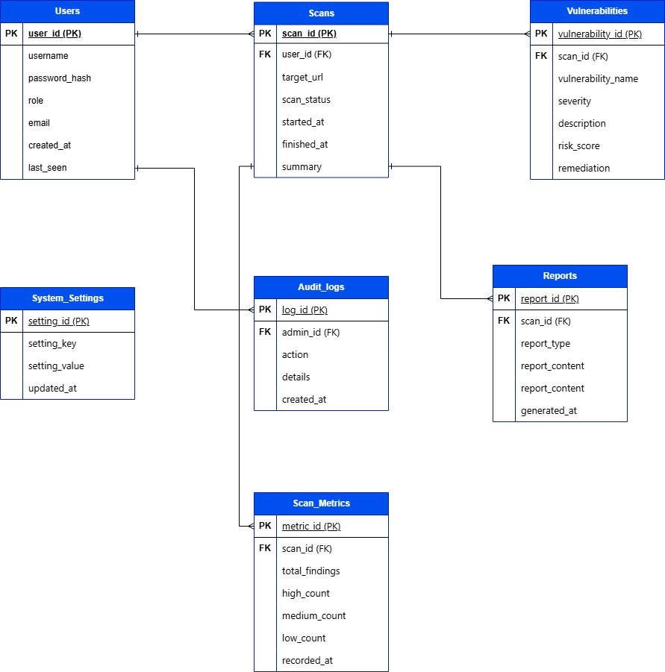

Figure 3.8: Database Schema Diagram
This diagram presents the database schema and the relationships among the main entities, including users, scans, vulnerabilities, reports, audit logs, settings, and scan metrics. It visually demonstrates how the system maintains structured data flow from scan execution to reporting while preserving integrity, traceability, and secure access control.

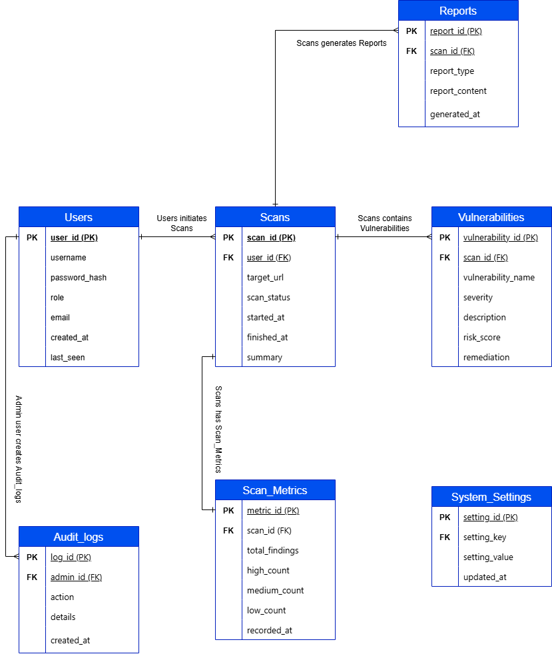

Figure 3.9: ER Diagram

Figure 3.9 presents the Entity Relationship (ER) diagram for the Automated Web Vulnerability Scanning and Security Scoring System using Crow's Foot notation. The diagram illustrates the major entities and their relationships within the system.

System Workflow and Scanning Process

The System Workflow and Scanning Process explains how the Automated Web Vulnerability Scanning and Security Scoring System operates from start to finish. This section presents the operational sequence beginning with scan initiation and ending with risk scoring and report delivery. It also describes the internal processing steps performed by the backend to detect vulnerabilities, evaluate their risk, and present actionable results to users.

1) User Initiation of the Scan
The workflow starts when a user (Administrator or User) logs into the system and opens the scan page through the frontend interface. The user enters the target web application URL and starts the scan process. At this stage, the system validates the request and creates a scan record with a unique scan ID to track status, findings, and generated outputs throughout execution.
User Dashboard:
After authentication, regular users access the User Dashboard to view submitted scans, monitor scan status, review scan history, and open available reports. Administrators access the Admin Dashboard, which provides a broader system view, including all scan activities, user-level scan monitoring, and overall operational summaries.
- Vulnerability Detection Process

After scan initiation, the backend triggers the vulnerability detection workflow. The process includes the following stages:

Crawling the Web Application: The scanner explores reachable pages of the target application and discovers links, forms, and URL parameters that may be evaluated for security weaknesses.

Identifying Entry Points: The system identifies candidate input points such as form fields, query parameters, and request components where malicious payloads are typically tested.

Vulnerability Testing: The detection engine applies predefined rules and payload-based checks to test for vulnerabilities in scope, including SQL Injection (SQLi), Cross-Site Scripting (XSS), and related web security issues supported by the system.

Detecting and Recording Findings: When suspicious behavior is confirmed, the system records the vulnerability type, affected location, evidence, and preliminary severity. Each finding is linked to the scan ID for traceability and later reporting.

During and after scanning, scan state and results are reflected in dashboard views. Users can track their own scan progress, while administrators can monitor scan activity across the platform.

3) Risk Scoring Process
Once vulnerabilities are collected, the Risk Scoring Module evaluates each finding and assigns a risk value. The scoring logic considers factors such as severity, exploitability, and potential impact on the target system.
- Standard Scoring: The system may align scoring with recognized principles such as CVSS-style evaluation or apply a project-specific scoring model designed for this platform.
- Prioritization: The assigned scores are used to rank vulnerabilities so that high-risk issues are addressed before lower-risk findings.

After individual scoring, the system derives an overall security assessment for the scan session. This assessment, together with detailed vulnerability scores, is shown in dashboard summaries for both users and administrators.

4) Report Generation and Display
When scanning and scoring are complete, the system generates a structured report containing the key outcomes of the assessment. The report includes:A list of detected vulnerabilities, sorted by severity
- A list of detected vulnerabilities organized by severity
- Risk scores for each reported finding
- Recommended remediation actions for each vulnerability
- A consolidated security assessment summary for the scanned application
The generated report is then made available through the frontend for viewing and download (e.g., HTML/CSV/PDF output based on system support and configuration). Visual indicators such as severity labels and status highlights are used to improve readability and help users identify critical issues quickly.
Regular users access report outputs through the User Dashboard, while administrators can review broader reporting information through the Admin Dashboard.

4 System Implementation

REFERENCES
- Mesbah A, van Deursen A. Crawl-based analysis of web applications: Prospects and challenges[J]. Science of Computer Programming, 2015, 97:3-19.
- Brandi M, Marrone A, Malheiro A T. Sniping at web applications to discover input-handling vulnerabilities[J]. Computing, 2024.
- Alazmi S, Conte de Leon D. A systematic literature review on the characteristics and effectiveness of web application vulnerability scanners[J]. IEEE Access, 2022, 10:33200-33219.
- Seth S, Kundu A K, Basu S. An empirical comparison of IAST/RASP with DAST for web application vulnerability detection[EB/OL]. arXiv:2301.09413, 2023[2026-04-03]. https://arxiv.org/abs/2301.09413.
- Kondracki G, Nikiforakis N. Smudged fingerprints: A performance evaluation of web application fingerprinting tools[C]//Proceedings of the ACM Internet Measurement Conference (IMC). 2024.
- Cifuentes C, Gauthier F, Hassanshahi B, Krishnan P, McCall D. The role of program analysis in security vulnerability detection: Then and now[J]. Computers & Security, 2023, 135:103463.
- Tan J. OWASP releases top ten web application security risks[J]. Computers and Networks, 2017, 43(23):52-53.
- Felderer M, Buchler M, Johns M, Brucker A D, Breu R, Pretschner A. Security testing: A survey[J]. Advances in Computers, 2016, 101:1-51.
- Holm H, Sommestad T, Ekstedt M, Honeth N. Performance evaluation of vulnerability scanning tools for web applications[J]. Journal of Information Security and Applications, 2018, 41:52-63.
- Wu P, Yu J, Han B. Analysis and detection of business logic vulnerabilities in web applications[J]. Computer Engineering, 2023, 49(6):132-139.
- Wu, P., Yu, J., & Han, B. (2023). Analysis and detection of business logic vulnerabilities in web applications. Computer Engineering (计算机工程), 49(6), 132-139.
- Jia H, Ning G, Li H. Passive-analysis-based vulnerability detection methods for web applications[J]. Information Network Security, 2024, 24(3):15-22.
- Wang L, Li J. A survey of web application security vulnerability scanning techniques[J]. Computer Science, 2019, 46(10):1-9.
- Guo X, Chen X. Security risk assessment methods for web applications[J]. Computer Engineering and Applications, 2023, 59(8):211-218.
- Guo X Q, Chen X X. Strengthening cybersecurity and security intelligence awareness and building a cybersecurity defense line together: Based on analysis of projects related to OWASP and CNCERT[J]. Cyberspace Security, 2020, 11(2):66-74.
- Yin Q, Wang G. Research on automated technology for scanning and repairing network security vulnerabilities[J]. Intelligent IoT Technology, 2024, 56(3):38-41.
- Jia H, Ning G, Li H, Du Y. Research and application of vulnerability mining technology for web applications based on passive scanning[J]. Cybersecurity Technology and Applications, 2024(4):1-5.
- Chang H. Design and optimization of web security vulnerability detection systems[D]. Beijing: North China University of Technology, 2023.
- Wang W. Application research of pre-trained models in software vulnerability detection[J]. Information Recording Materials, 2026, 27(1):111-113,135.
- Wang L T, Xu M, Wang H L. Research progress on cross-site scripting vulnerability detection technology[J]. Computers and Networks, 2024, 50(3):223-228.
- OWASP. OWASP announces new Top 10 for cyberthreats[J]. Network Security, 2021(9):1-2.
- Xu D, Chen T, Tan Z, Wu F, Gao J, Yang Y. Web vulnerability detection analyzer based on Python[J]. International Journal of Digital Crime and Forensics, 2022, 14(2).
- He C, Ding C H Q. SecRASP: Next generation web application security protection methodology and framework[J]. Computers & Security, 2025, 154:104445.
- Grinberg M. Flask Web Development: Developing Web Applications with Python[M/OL]. Sebastopol: O’Reilly Media, 2020[2026-04-03]. https://www.oreilly.com/library/view/flask-web-development/9781491991732/.
- OWASP. OWASP Top Ten Web Application Security Risks[EB/OL]. 2023[2026-04-03]. https://owasp.org/www-project-top-ten.
- MySQL Documentation. MySQL 8.0 Reference Manual[EB/OL]. 2023[2026-04-03]. https://dev.mysql.com/doc/.
- Bauer S, McCallister M. Flask By Example[M/OL]. Birmingham: Packt Publishing, 2017[2026-04-03]. https://www.packtpub.com/product/flask-by-example/9781788621756.
- Duckett, J. (2014). HTML and CSS: Design and Build Websites. Wiley, https://www.wiley.com/en-us/HTML+and+CSS%3A+Design+and+Build+Websites%2C+3rd+Edition-p-9781118907443

ACKNOWLEDGEMENT

