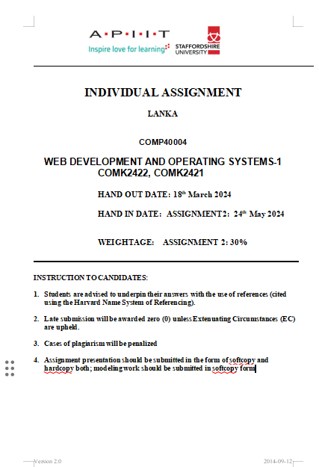

# Web development

**Name：[Azeem Azmeer]**

**CB number：[014672]**

**Name of lecture：[Pradeep Pallegama]**

**Address：[No.2 Primrose Road Kandy ]**

# and operation system