KUBERNETES – TASK -02

- Create a Simple Pod Using YAML Task: Write a YAML file to create a Pod named firstpod with an nginx container. Verify the Pod creation using kubectl get pods and check the logs of the container using kubectl logs firstpod.

1. YAML file to create the Pod
Create a file named firstpod.yaml with the following content:
apiVersion: v1
kind: Pod
metadata:
name: firstpod
spec:
containers:
- name: nginx-container
image: nginx
ports:
- containerPort: 80

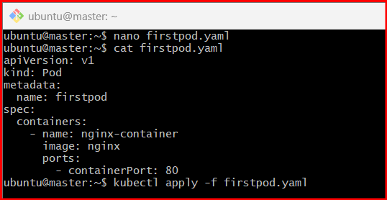

2. Create the Pod
Run the following command to create the Pod:
kubectl apply -f firstpod.yaml

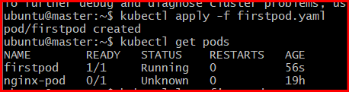

3. Verify Pod Creation
Check if the Pod is running:
kubectl get pods
Expected output (example):
NAME READY STATUS RESTARTS AGE
firstpod 1/1 Running 0 10s

4. Check Container Logs
To view logs from the nginx container:
kubectl logs firstpod

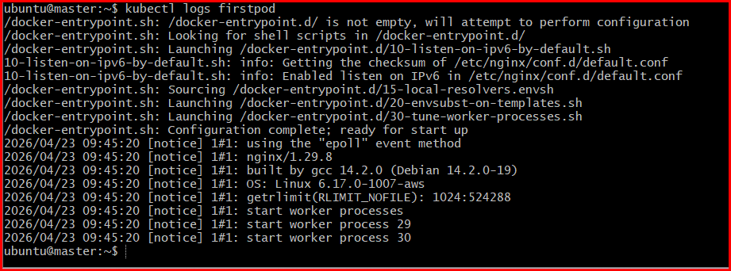
For an nginx container, logs may include startup messages or HTTP access logs once traffic hits the Pod.
Errors I am facing in the tasks

Step 1: Set kubeconfig (IMPORTANT)
Run this:
mkdir -p $HOME/.kube
sudo cp -i /etc/kubernetes/admin.conf $HOME/.kube/config
sudo chown $(id -u):$(id -g) $HOME/.kube/config

🔍 Step 2: Test connection
kubectl cluster-info
Now you should see something like:
Kubernetes control plane is running at https://<IP>:6443

🔍 Step 3: Check nodes
kubectl get nodes

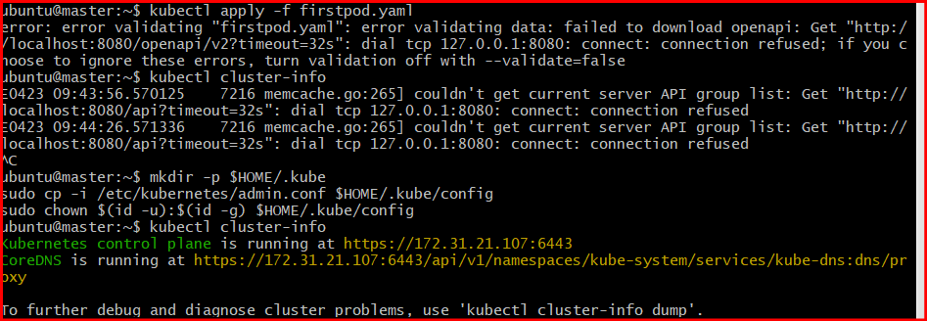
- Set Environment Variables in a Pod Task: Modify the YAML file to include environment variables myname: sabair and City: Hyderabad. Deploy the Pod and use kubectl exec <pod_name> -- env to check if the environment variables are set properly.

1. Updated YAML with Environment Variables
Edit your firstpod.yaml like this:
apiVersion: v1
kind: Pod
metadata:
name: firstpod
spec:
containers:
- name: nginx-container
image: nginx
ports:
- containerPort: 80
env:
- name: myname
value: "sabair"
- name: City
value: "Hyderabad"

2. Deploy the Pod
If the Pod already exists, delete and recreate it:
kubectl delete pod firstpod
kubectl apply -f firstpod.yaml

3. Verify Pod Status
kubectl get pods
Make sure it shows Running.

4. Check Environment Variables inside the Pod
Run:
kubectl exec firstpod -- env

5. Expected Output (snippet)
You should see:
myname=sabair
City=Hyderabad

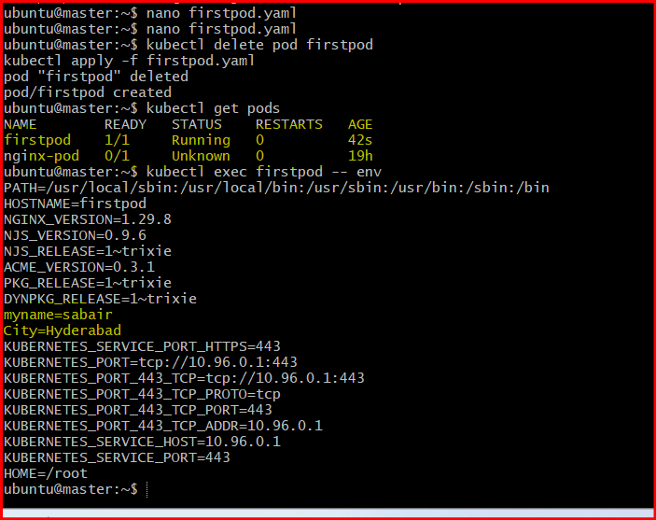

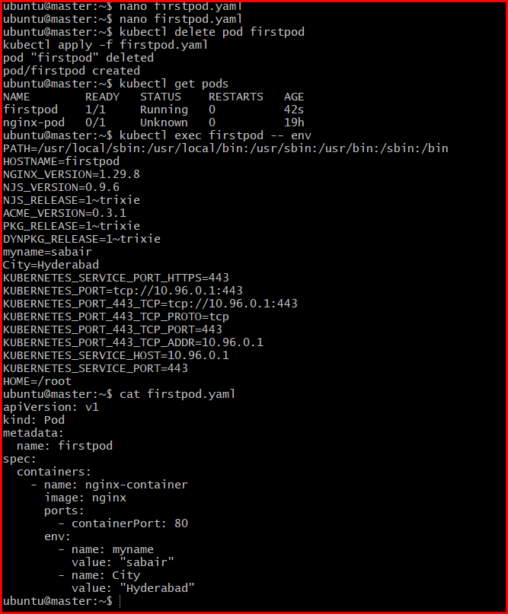

- Deploy a Pod with Commands (Args) in YAML Task: Modify the YAML file to add args that instruct the container to sleep for 50 seconds. Deploy the Pod and use kubectl describe pod to verify the args are correctly passed to the container.

Create/update sleep-pod.yaml:
apiVersion: v1
kind: Pod
metadata:
name: sleep-pod
spec:
containers:
- name: sleep-container
image: nginx
command: ["/bin/sh", "-c"]
args: ["sleep 50"]

⚠️ Important Note
- nginx normally runs a web server.
- Here we override it using:
  - command → shell
  - args → sleep 50

✅ 2. Deploy the Pod
kubectl apply -f sleep-pod.yaml

✅ 3. Verify Pod
kubectl get pods
You may see:
- Running (for a short time)
- Then Completed (after 50 seconds)

✅ 4. Verify Args using Describe
kubectl describe pod sleep-pod
Look for this section:
Containers:
sleep-container:
Command:
/bin/sh
-c
Args:
sleep 50
👉 This confirms args are correctly passed.
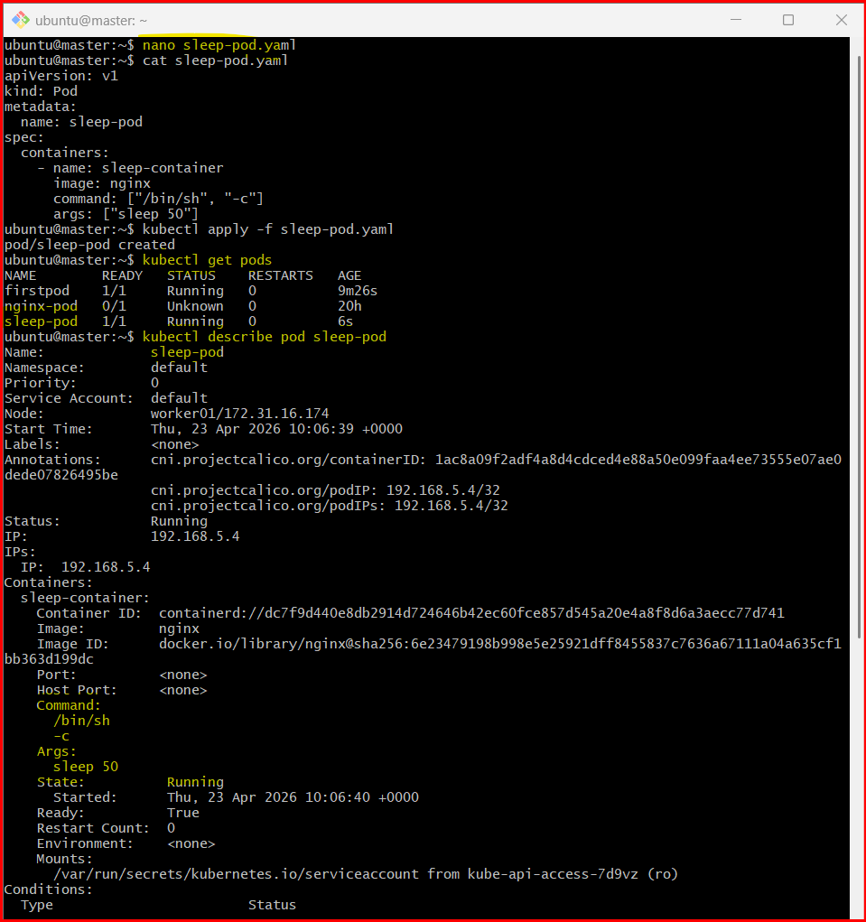

- Create a Pod with Two Containers Task: Create a YAML file to define a Pod with two nginx containers inside. Use kubectl exec to access both containers and verify that both containers can communicate through the same network (e.g., using telnet between them).

1. YAML for Pod with Two NGINX Containers
Create a file two-containers.yaml:
apiVersion: v1
kind: Pod
metadata:
name: twonginx
spec:
containers:
- name: nginx-1
image: nginx
ports:
- containerPort: 80
- name: nginx-2
image: nginx
ports:
- containerPort: 81

⚠️ Important Note
Both containers:
- Share same IP
- Can communicate via localhost
- BUT nginx runs on port 80 by default in both containers
👉 So containerPort 81 does NOT change nginx port internally.

✅ 2. Deploy the Pod
kubectl apply -f two-containers.yaml

✅ 3. Verify Pod
kubectl get pods

✅ 4. Access Each Container
kubectl exec -it twonginx -c nginx-1 -- /bin/bash
In another terminal:
kubectl exec -it twonginx -c nginx-2 -- /bin/bash

🔍 5. Test Communication (IMPORTANT)
Since both nginx run on port 80:
From nginx-1 container, run:
apt update && apt install telnet -y
telnet localhost 80
OR simpler:
curl localhost
👉 You will get nginx HTML response — this proves:
- Both containers share the same network
- localhost works between them

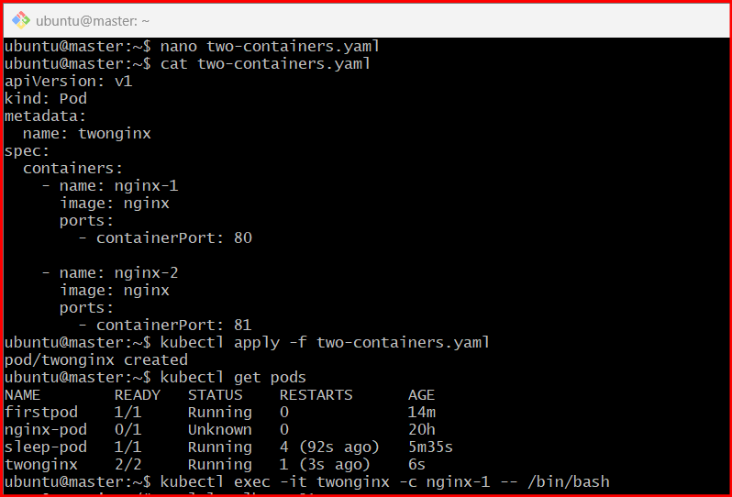

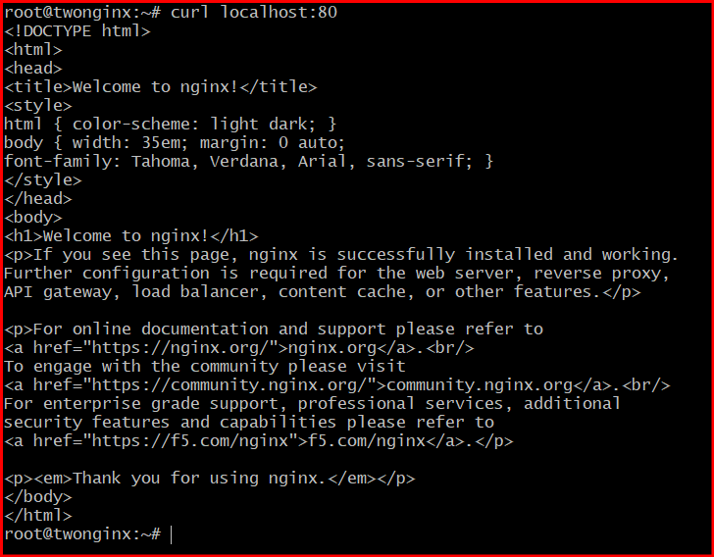

- Set Up an Init Container in a Pod Task: Modify the YAML to include an init container that sleeps for 30 seconds before the main containers start. Verify the init container's execution using kubectl describe pod and check the logs to confirm its completion.

1. YAML with Init Container
Update/create init-pod.yaml:
apiVersion: v1
kind: Pod
metadata:
name: init-nginx-pod
spec:
initContainers:
- name: init-sleep
image: busybox
command: ["sh", "-c", "sleep 30"]
containers:
- name: nginx-1
image: nginx
ports:
- containerPort: 80
- name: nginx-2
image: nginx
ports:
- containerPort: 80

✅ 2. Deploy the Pod
kubectl apply -f init-pod.yaml

🔍 3. Observe Pod Behavior
Immediately check:
kubectl get pods
You’ll see something like:
init-nginx-pod 0/2 Init:0/1 ...
👉 This means:
- Init container is running
- Main containers are waiting
After ~30 seconds:
init-nginx-pod 2/2 Running

✅ 4. Verify using Describe
kubectl describe pod init-nginx-pod
Look for:
Init Containers:
init-sleep:
State: Terminated
Reason: Completed
👉 This confirms it ran successfully before main containers started.

✅ 5. Check Init Container Logs
kubectl logs init-nginx-pod -c init-sleep
Output may be empty (since it just sleeps), but the command itself confirms:
- Container executed
- Completed successfully
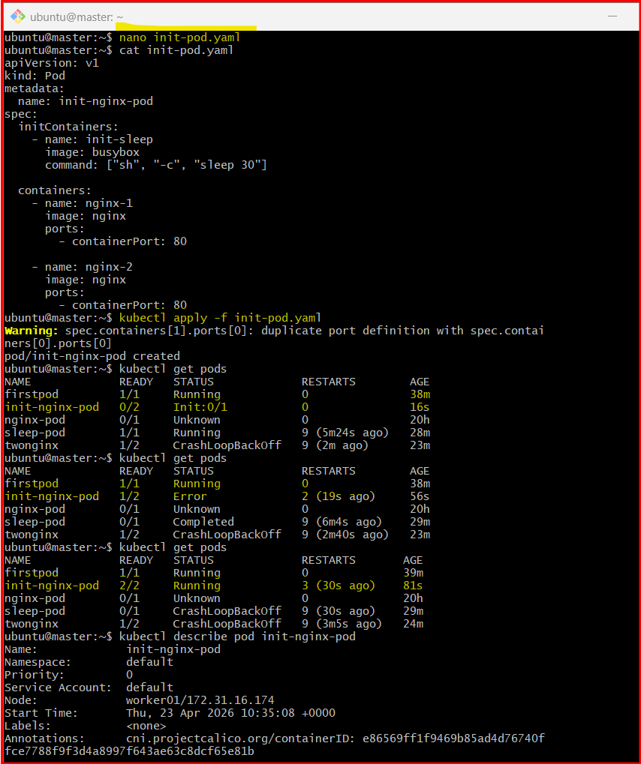
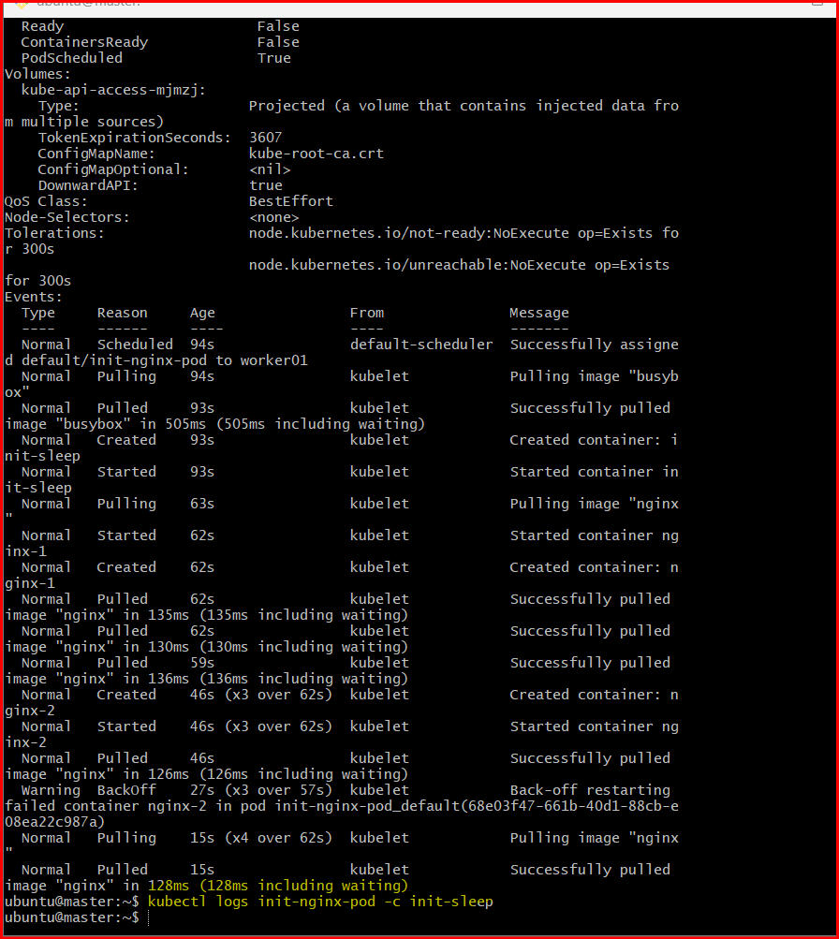

- Run a Dry Run Command to Generate YAML Task: Use the kubectl run nginx --image=nginx --dry-run=client -o yaml command to generate a Pod YAML definition. Modify the generated YAML to suit specific requirements (e.g., labels or environment variables) and deploy it.

✅ 1. Generate YAML using dry-run
Run:
kubectl run nginx --image=nginx --dry-run=client -o yaml > nginx-pod.yaml
👉 This creates a file nginx-pod.yaml without actually creating the Pod.

✅ 2. Modify the YAML
Open the file:
nano nginx-pod.yaml
Update it like this (example with labels + env vars):
apiVersion: v1
kind: Pod
metadata:
name: nginx
labels:
app: mynginx
env: dev
spec:
containers:
- name: nginx
image: nginx
ports:
- containerPort: 80
env:
- name: MY_NAME
value: "sabair"
- name: CITY
value: "Hyderabad"

✅ 3. Deploy the Pod
kubectl apply -f nginx-pod.yaml

✅ 4. Verify Pod
kubectl get pods

✅ 5. Verify Labels
kubectl get pods --show-labels
OR:
kubectl describe pod nginx

✅ 6. Verify Environment Variables
kubectl exec nginx -- env
You should see:
MY_NAME=sabair
CITY=Hyderabad

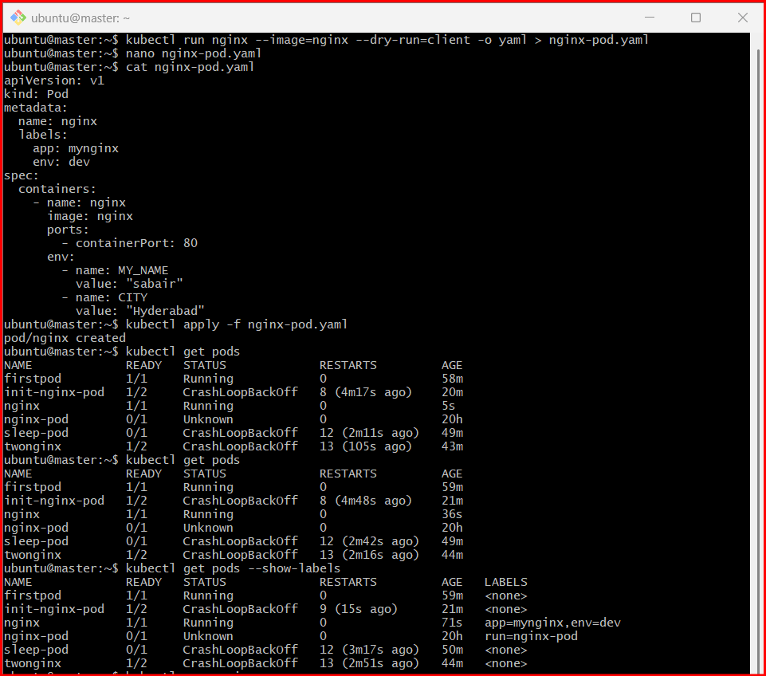

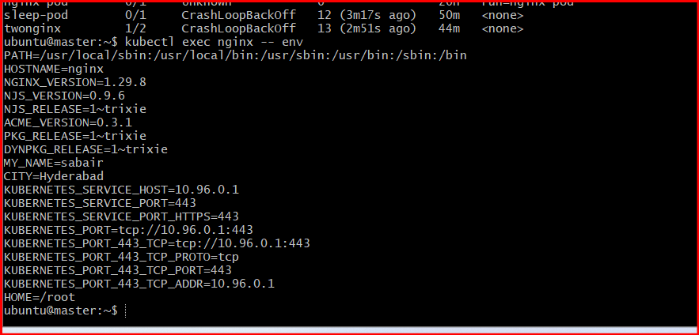

- Use kubectl apply vs kubectl create Task: Create a YAML file to define a Pod. First, deploy it using kubectl create -f <file_name>.yml and then modify the YAML (e.g., change the image version). Use kubectl apply to redeploy and verify the difference between both commands.

1. Create a Pod YAML
Create a file mypod.yaml:
apiVersion: v1
kind: Pod
metadata:
name: mypod
spec:
containers:
- name: nginx
image: nginx:1.14
ports:
- containerPort: 80

✅ 2. Deploy using kubectl create
kubectl create -f mypod.yaml
Verify:
kubectl get pods

🔍 3. Check the running image
kubectl describe pod mypod | grep Image
You’ll see:
Image: nginx:1.14

✏️ 4. Modify the YAML
Edit mypod.yaml:
image: nginx:latest

⚠️ 5. Try kubectl create again
kubectl create -f mypod.yaml
👉 You’ll get error:
Error from server (AlreadyExists): pods "mypod" already exists

✅ 6. Use kubectl apply
kubectl apply -f mypod.yaml
👉 This updates the existing resource.

❗ Important Reality Check
For Pods, some fields (like image) are immutable.
So you may see:
- No change
- OR error like:
field is immutable

🔄 7. Correct Way to Update Pod
Delete and recreate:
kubectl delete pod mypod
kubectl apply -f mypod.yaml

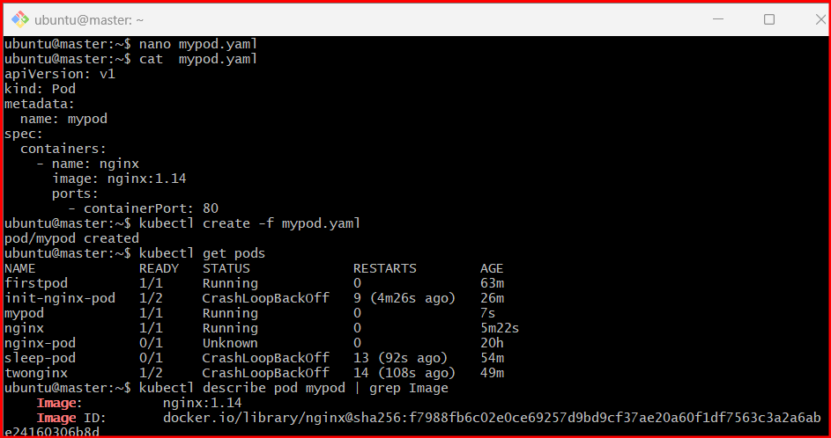

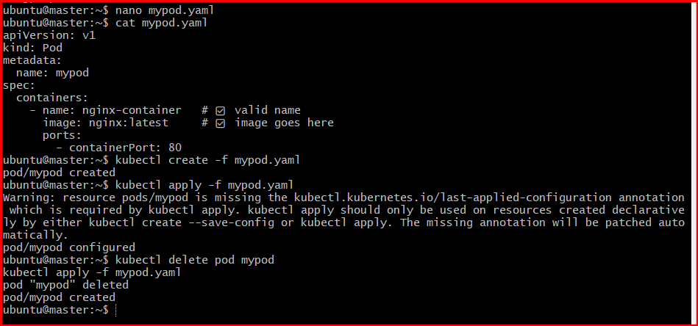

- Edit an Existing Pod Configuration Task: Use kubectl edit pod <pod_name> to modify the running Pod's environment variables or image. After making the changes, verify if they took effect by checking the container logs or environment variables using kubectl exec.

Edit Running Pod
- kubectl edit pod firstpod
Modify image or env variables.
⚠️ Important:
Some fields (like image) are editable.
Some changes require Pod recreation.
Verify:
- kubectl describe pod firstpod
- kubectl exec firstpod -- env

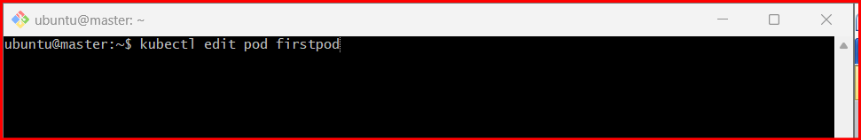

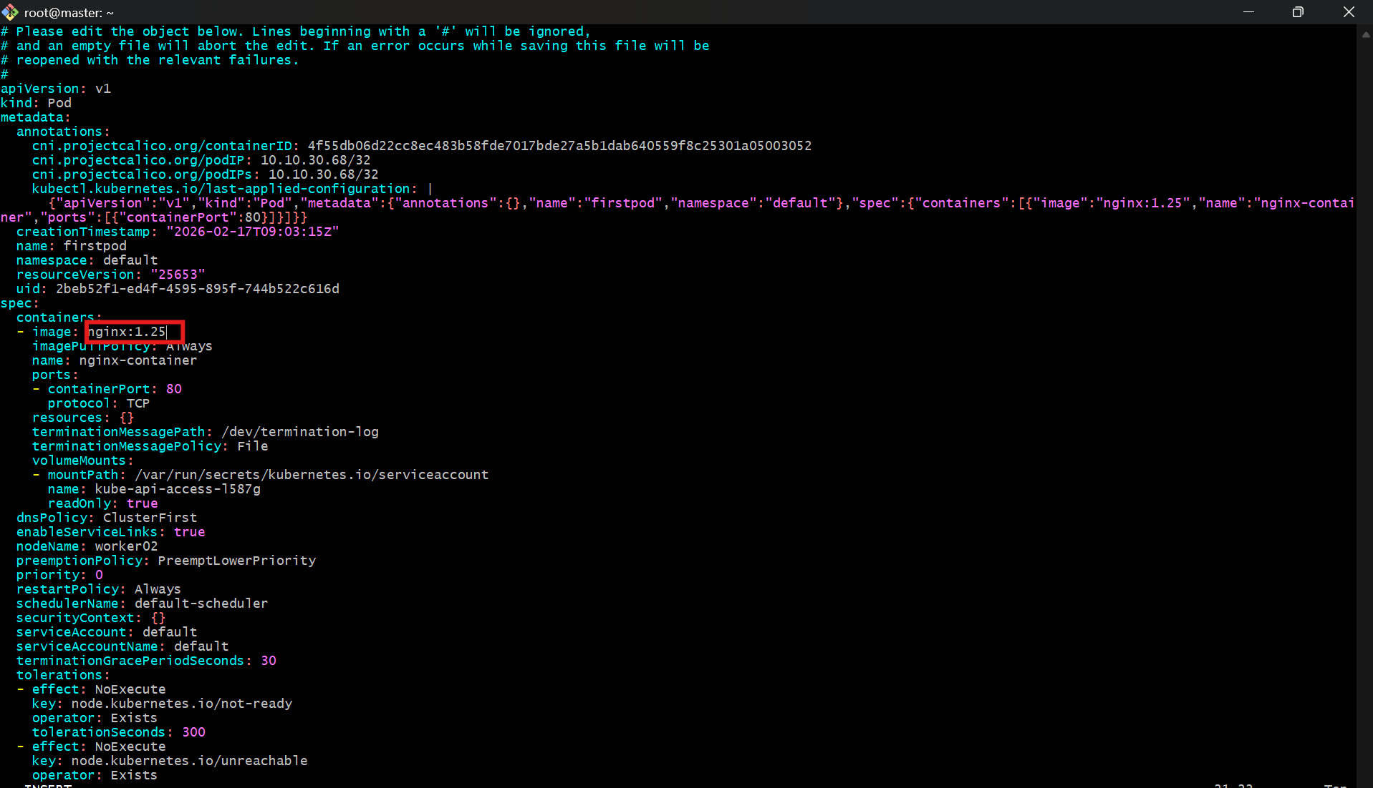

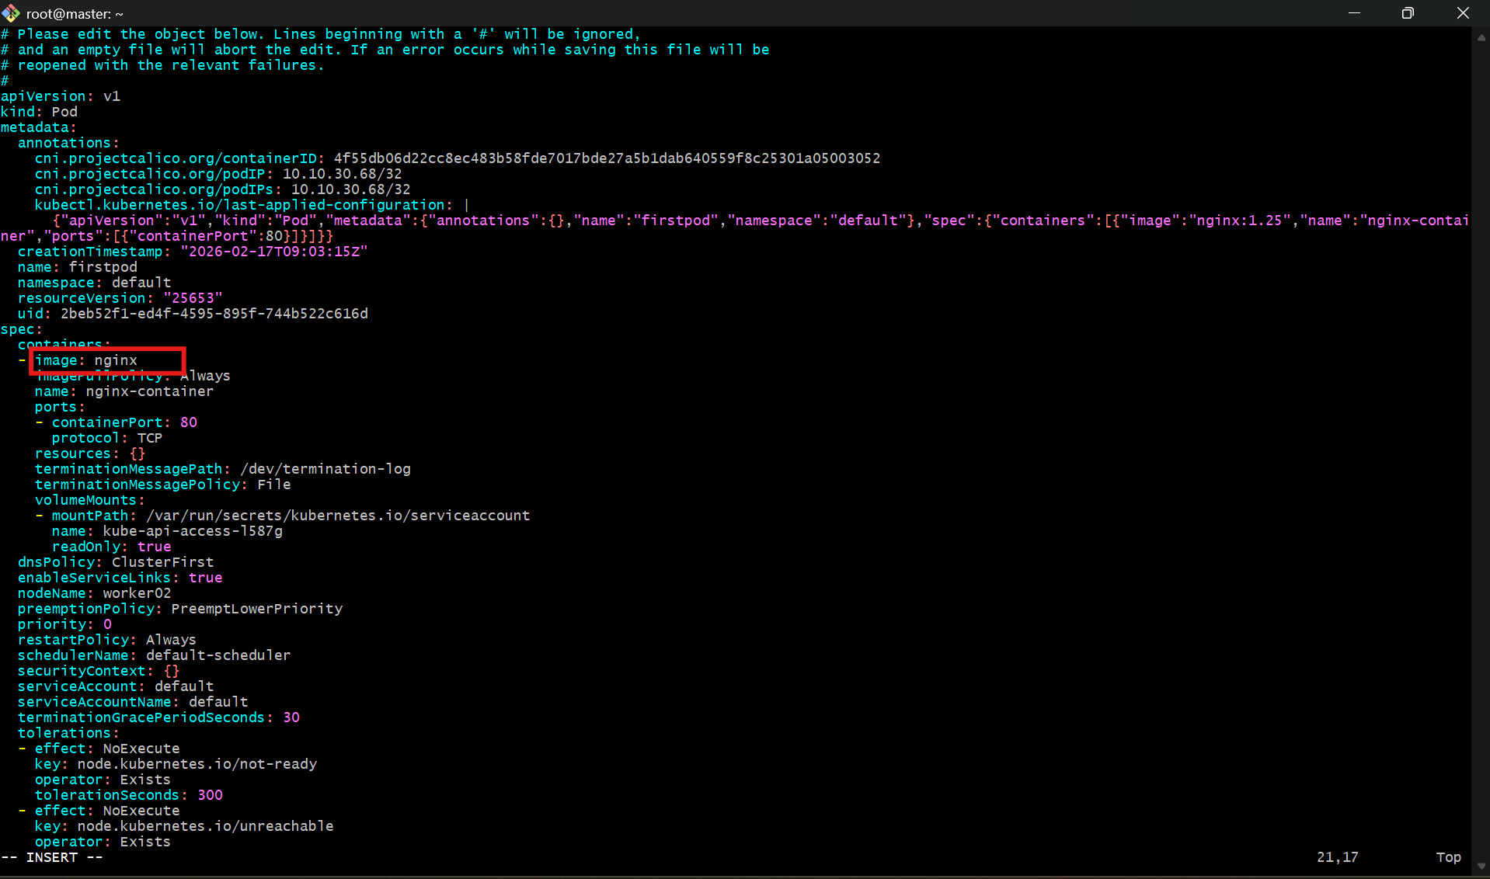

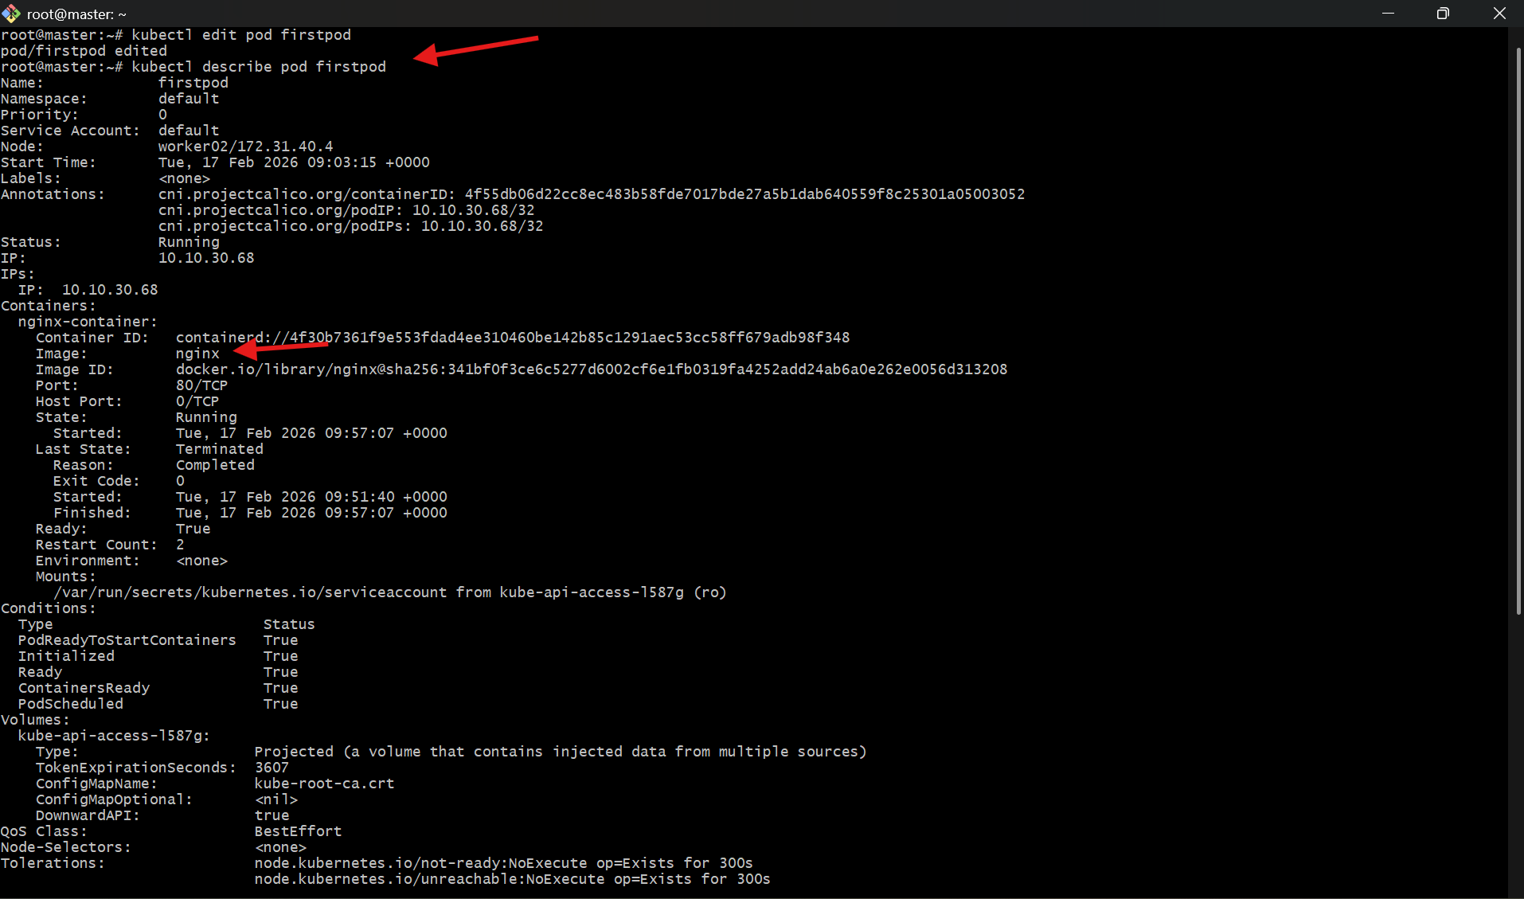

- Expose a Pod Using a Service Task: Create a YAML file to expose your firstpod using a Service (ClusterIP). Ensure that your service is exposing the Pod on port 80 and verify it using kubectl get svc.

1. Service YAML
Create a file firstpod-service.yaml:
apiVersion: v1
kind: Service
metadata:
name: firstpod-service
spec:
type: ClusterIP
selector:
app: firstpod
ports:
- protocol: TCP
port: 80 # Service port
targetPort: 80 # Pod container port

⚠️ IMPORTANT (Label Requirement)
Your Service uses a selector:
selector:
app: firstpod
👉 So your Pod must have this label, otherwise the Service won’t connect.

✅ 2. Add Label to your Pod (if missing)
Check labels:
kubectl get pod firstpod --show-labels
If no label exists, add it:
kubectl label pod firstpod app=firstpod

✅ 3. Deploy the Service
kubectl apply -f firstpod-service.yaml

✅ 4. Verify Service
kubectl get svc
Expected output:
NAME TYPE CLUSTER-IP PORT(S)
firstpod-service ClusterIP 10.x.x.x 80/TCP

🔍 5. Verify Endpoints (VERY IMPORTANT)
kubectl get endpoints firstpod-service
👉 You should see Pod IP like:
10.x.x.x:80
If EMPTY → selector/label mismatch ❌

🧠 Key Concept
- Service = stable internal access point
- ClusterIP = only accessible inside cluster
- Works via:
<service-name>:<port>

🚀 6. Test the Service (inside cluster)
kubectl run testpod --image=busybox -it --rm -- sh
Then inside:
wget -qO- firstpod-service
👉 You should see nginx HTML output

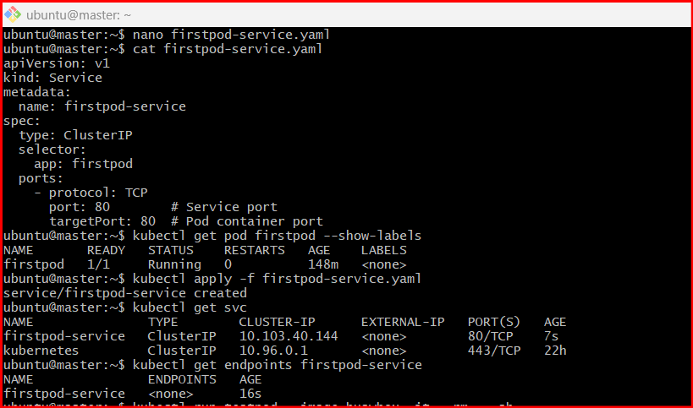

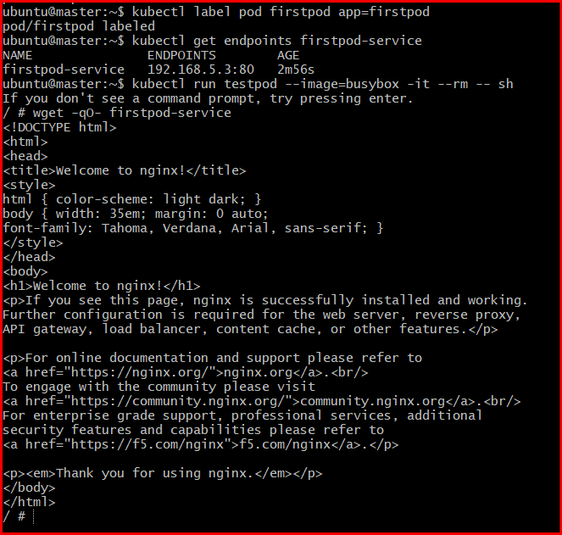

Error when I am facing

ubuntu@master:~$ kubectl get endpoints firstpod-service NAME ENDPOINTS AGE firstpod-service <none> 16s ubuntu@master:~$ kubectl run testpod --image=busybox -it --rm -- sh If you don't see a command prompt, try pressing enter. / # wget -qO- firstpod-service

kubectl label pod firstpod app=firstpod

🔍 Verify again
kubectl get endpoints firstpod-service
Now you should see something like:
10.x.x.x:80

✅ Test again
Run:
kubectl run testpod --image=busybox -it --rm -- sh
Inside the pod:
wget -qO- firstpod-service
👉 Now you should see nginx HTML page 🎉

10 Pod with Resource Limits and Requests Task: Add resource requests and limits to the containers in your YAML file. Specify CPU and memory requests/limits for both containers and deploy the Pod. Use kubectl describe pod to verify if the resource configurations are correctly applied.

YAML with Resources (two containers)
- Create/update resource-pod.yaml:
- apiVersion: v1
kind: Pod
metadata:
name: resource-pod
spec:
containers:
- name: nginx-1
image: nginx
resources:
requests:
cpu: "100m" # 0.1 CPU
memory: "128Mi"
limits:
cpu: "200m" # 0.2 CPU
memory: "256Mi"
ports:
- containerPort: 80
- name: nginx-2
image: nginx
resources:
requests:
cpu: "150m"
memory: "128Mi"
limits:
cpu: "300m"
memory: "256Mi"
ports:
- containerPort: 80

✅ 2. Deploy the Pod
- kubectl apply -f resource-pod.yaml
- Check status:
- kubectl get pods

🔍 3. Verify Resource Configuration
- kubectl describe pod resource-pod
- Look for this section:
- Containers:
nginx-1:
Requests:
cpu: 100m
memory: 128Mi
Limits:
cpu: 200m
memory: 256Mi
nginx-2:
Requests:
cpu: 150m
memory: 128Mi
Limits:
cpu: 300m
memory: 256Mi
- 👉 This confirms resources are applied correctly.
- 