LOGICAL ADDRESSING
Logical addressing is implemented by network layer. Logical addressing is a Global Addressing scheme.
Data-link layer handles the addressing problem locally, but if packets passes the network boundary there is a need for logical addressing system to help distinguish source and destination systems.
The network layer adds a header to the packet coming from the upper layer that includes the logical addresses of the sender and receiver.
There are 2 types of addressing mechanisms are present:
- IPv4 ( IPversion4)
- IPv6 (IP version6)
IPv4 ADDRESSES
An IPv4 address is a 32-bit address that uniquely and universally defines the connection of a device to the Internet.
Unique: Two devices on the Internet can never have the same address at the same time.
Universal: The addressing system must be accepted by any host that wants to be connected to the Internet.

Address Space
- An address space is the total number of addresses used by the protocol.
- If a protocol uses N bits to define an address, the address space is 2^{N}because each bit can have two different values (0 or 1) and N bits can have 2^{N}values.
- IPv4 uses32-bit addresses, which meansthattheaddressspaceis2³²or4,294,967,296
(more than 4 billion).

Notations
There are two notations to show an IPv4 address: Binary and Dotted-Decimal Notation.

Binary | Dotted-Decimal
- IPv4 address is displayed as 32 bits. Each octet is often referred to as a byte.  - It is a 4 byte address  Ex: 10000000 00001011 00000011 00011111 | - Internet addresses are written in decimal form with a dot separating the bytes.  - Each number in dotted-decimal notation is a value ranging from 0 to255.  Ex: 128.11.3.31

CLASSFUL ADDRESSING
- Initially IPv4 used the concept of Classful addressing.
- In classful addressing, the address space is divided into five classes: A, B, C, D, and E.
- If the address is given in binary notation, the first few bits can immediately tell us the class of the address.
- If the address is given in decimal-dotted notation, the first byte defines the class.
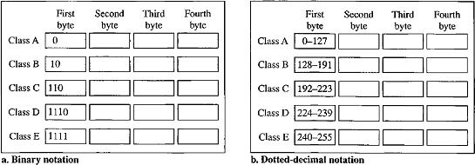

Classes and Blocks
- Each class is divided into a fixed number of blocks.
- Size of the each block is also fixed.

Class | No of Blocks | Block Size | Application
A | 128 | 16,777,216 | Unicast
B | 16,384 | 65,536 | Unicast
C | 2,097,152 | 256 | Unicast
D | 1 | 268,435,456 | Multicast
E | 1 | 268,435,456 | Reserved
Purpose of classes:
- Class A addresses were designed for large organizations with a large number of attached hosts or routers.
- Class B addresses were designed for midsize organizations with tens of thousands of attached hosts or routers.
- Class C addresses were designed for small organizations with a small number of attached hosts or routers.
- Class D addresses were designed for multicasting.
- Class E addresses were reserved for future use.
Problem with above classes and block sizes: A lot of addresses are wasted.
- A block in class A address is too large for almost any organization. (i.e) most of the addresses in class A were wasted and were not used.
- A block in class B is also very large, probably too large for many of the organizations that received a class B block.
- A block in class C is probably too small for many organizations.

- Class D addresses were designed for multicasting, each address in class D is used to define one group of hosts on the Internet. The Internet authorities wrongly predicted a need for 268,435,456groups.
- Class E addresses were reserved for future use; only a few addresses were used till now.

Netid and Hostid
- In classful addressing, an IP address in class A, B, or C is divided into Netid and Hostid.
- For Class D,E there were no Netid and Hostid.
- In class A, one byte defines the Netid and three bytes define the Hostid.
- In class B, two bytes define the Netid and two bytes define the Hostid.
- In class C, three bytes define the Netid and one byte defines the Hostid.

Mask or Default Mask
- A default mask is a 32-bit number made of contiguous 1’s followed by contiguous0’s.
- The mask can help us to find the Netid and the Hostid.
- For example, the mask for a class A address has eight 1s, which means the first 8 bits of any address in class A define the Netid; the next 24 bits define the Hostid.
The masks for classes A, B, and C are:
Class | Binary | Dotted-Decimal | CIDR
A | 11111111 00000000 00000000 00000000 | 255.0.0.0 | /8
B | 11111111 11111111 00000000 00000000 | 255.255.0.0 | /16
C | 11111111 11111111 11111111 00000000 | 255.255.255.0 | /24

Subnetting
- Subnetting is a process of dividing a large block into smaller contiguous groups and assigns each group to smaller networks (subnets) or share a part of the addresses with neighbors.
- Subnetting increases the number of 1’s in the mask.

Supernetting
- In supernetting, an organization can combine several blocks to create a larger range of addresses. Supernetting decreases the number of 1’s in the mask.
Example: an organization that needs 1000 addresses can be granted four contiguous class C blocks. The organization can then use these addresses to create one super network.
Address Depletion
- The number of available IPv4 addresses is decreasing as the number of internet users are increasing.
- We have run out of class A and B addresses, and a class C block is too small for most midsize organizations.
- One solution that has alleviated the problem is the idea of Classless Addressing.

CLASSLESS ADDRESSING
Purpose
- Classless addressing was designed and implemented to overcome address depletion and give more organizations access to the Internet.
- In this scheme, there are no classes, but the addresses are still granted in blocks.

Address Blocks
- In classless addressing, when a small or large entity, needs to be connected to the Internet, it is granted a block of addresses.
- The size of the block (the number of addresses) varies based on the nature and size of the entity.
Example:
- For a large organization may be given thousands of addresses
- For a house two addresses are sufficient
- An Internet service provider may be given hundreds of thousands based on the number of customers it may serve.

Restrictions on classless address blocks
- The addresses in a block must be contiguous, one after another.
- The number of addresses in a block must be a power of 2 (1, 2, 4, 8, ...).
- The first address must be evenly divisible by the number of addresses.
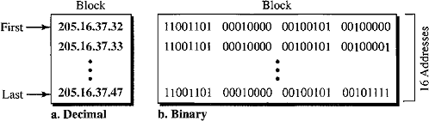
Consider the below figure for classless addressing that shows a block of addresses, in both binary and dotted-decimal notation, granted to a small business that needs 16 addresses.
It satisfies all 3 restrictions:
- The addresses are contiguous.
- The number of addresses is a power of 2 (16 =2⁴).
- The first address is divisible by 16. The first address, when converted to a decimal number, is 3,440,387,360, which when divided by 16 results in215,024,210.

Mask
A mask is a 32-bit number in which the n leftmost bits are 1’s and the 32 - n rightmost bits are 0’s, where n= 0 to32.
In 1Pv4 addressing, a block of addresses can be defined as x.y.z.t/n in which x.y.z.t defines one of the addresses and the /n defines the mask. /n is called as CIDR notation.
- First Address in the block can be found by setting the rightmost 32 - n bits to0’s.
- Last Address in the block can be found by setting the rightmost 32 - n bits to1’s.
- Number of Addresses in the block can be found by using the formula 2^{32-n}.

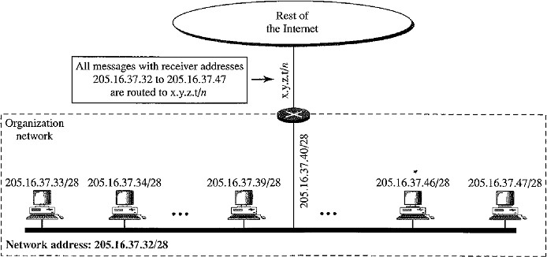
- Network Address is the first address in the block and defines the organization network. Usually the first address is used by routers to direct the message sent to the organization from the outside.

Example: 205.16.37.39/28 or 11001101 00010000 00100101 00100111
- First address: 11001101 000100000100101 0010000 or205.16.37.32
- Last address: 11001101 00010000 001001010010 1111 or205.16.37.47
- Number of Addresses: 2³²⁻²⁸ = 2⁴=16.
- Network Address (First Address) 11001101 000100000100101 0010000 or205.16.37.32

Netid and Hostid
- The n leftmost bits of the address x.y.z.t/n define the network address or prefix.
- The (32 – n) rightmost bits define the particular suffix or host address (computer or router) connected to the network.

205.16.37.39/28 or 11001101 00010000 00100101 0010 0111
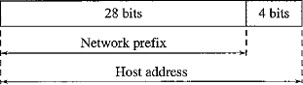
Network Address Translation (NAT)
- As the number of home users and small business users are increasing day by day it is not possible to give each and every user to one IPv4 address due to shortage of IPv4 addresses.
- In order to overcome this problem the developers designed the concepts of private IP address and Network Address Translation(NAT).
- NAT enables a user to have a large set of addresses internally (private IP addresses) and a small set of addresses externally (public IP addresses).
The Internet authorities have reserved three sets of addresses as private addresses:
Range | Total
10.0.0.0 to 10.255.255.255 | 224
172.16.0.0 to 172.31.255.255 | 220
192.168.0.0 to 192.168.255.255 | 216

- Any organization can use an address out of this set without permission from the Internet authorities.
- They are unique inside the organization, but they are not unique globally. No router will forward a packet that has one of these addresses as the destination address.
Example:
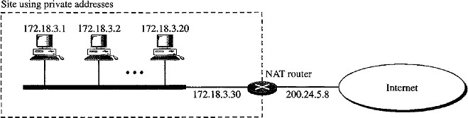
Consider the below figure describes the private network with private addresses:
- The NAT router has one public address 200.24.5.8, it is a global address.
- The internal devices having addresses from 172.18.3.1 to 172.18.3.30 these are local addresses.

Address Translation
- AlltheoutgoingpacketsgothroughtheNATrouter,whichreplacesthesourceaddress
in the packet with the global NAT address.
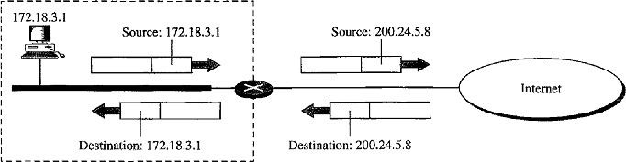
- All incoming packets also pass through the NAT router, which replaces the destination address in the packet (the NAT router global address) with the appropriate private address.

Translation Table
There are two types of translation tables:
  - Two Column translation table (Using one IP address)
  - Five column translation table (Using IP addresses and Port Numbers)

Two Column Translation Table
- It contains two columns: Private Address and External Address.
- In this strategy, communication must always be initiated by the private network.
- When the router translates the source address of the outgoing packet, it also makes note of the destination address-where the packet is going.
- When the response comes back from the destination, the router uses the source address of the packet (as the external address) to find the private address of the packet.

Translation Table
Private | External
172.18.3.1 | 25.8.2.10
… | ….
…. | ….
Five Column Translation Table
To allow a many-to-many relationship between private-network hosts and external server programs, we need more information (columns) in the translation table such as:
- Private Address
- Private Port
- External Address
- External Port
- Transport Protocol
Example: Suppose two hosts with addresses 172.18.3.1 and 172.18.3.2 inside a private network need to access the HTTP server on external host 25.8.3.2.
Translation table has five columns instead of two, that include the source and destination port numbers of the transport layer protocol the ambiguity is eliminated.
When the response from HTTP comes back, the combination of source address (25.8.3.2) and destination port number (1400) defines the-private network host to which the response should be directed.
Note: The temporary port numbers must be unique.
Private  address | Private  Port | External  Address | External  Port | Transport  Protocol
172.18.3.1 | 1400 | 25.8.3.2 | 80 | TCP
172.18.3.2 | 1401 | 25.8.3.2 | 80 | TCP
… | … | … | … | …
IPv6 ADDRESSES (Internetworking Protocol version6)
Why IPv6?
- In order to overcome the problems of address depletion.
- It eliminates the concept of NAT and Private Addresses.
- There is no need for classless addressing and DHCP.

Structure
IPv6 specifies hexadecimal colon notation (0,1,2,3,4,5,6,7,8,9,A,B,C,D,E,F).
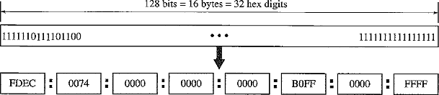
An IPv6 address consists of 16 bytes (octets); it is 128 bits long. 128 bits is divided into eight sections. Each of 4 hex digits separated by a colon.

Abbreviation
- Hexa decimal format of IPv6 is very long and many of the digits are zeros.
- We can abbreviate this address as the leading zeros of a section (four digits between two colons) can be omitted.
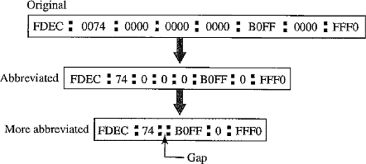
Note: Only leading zeros are omitted not trailing zeros. Example:
- In the above example: 0074 written as 74, 0000 written as 0.
- If there are consecutive sections consisting of zeros only. We can remove the zeros altogether and replace them with a double semicolon.
IPv4 Delivery Mechanism
- IPv4 delivery mechanism is used in TCP/IP protocols.
- IPv4 is an unreliable and connectionless datagram protocol.
- If reliability is important, IPv4 must be paired with a reliable protocol such as TCP.

Datagram
Packets in the IPv4 layer are called datagrams.
A datagram is a variable-length packet consisting of two parts:
  - Header
  - Data
The header is 20 to 60 bytes in length and contains information essential to routing and delivery. The header is divided into 4 sections:
- Version(VER)
- Header length(HLEN)
- Services
- Total Length

Version (VER) – 4bits
- It defines the version of the IPv4 protocol. Currently 4th version of IPv4 is using.

Header length (HLEN) – 4bits
- It defines the total length of the datagram header in 4-bytewords.
- The length of the header is variable between 20 and 60bytes.
- When there are no options, the header length is 20 bytes, and the value of this field is 5 (5x 4 =20).
- When the option field is at its maximum size, the value of this field is 15 (15 x 4 = 60).
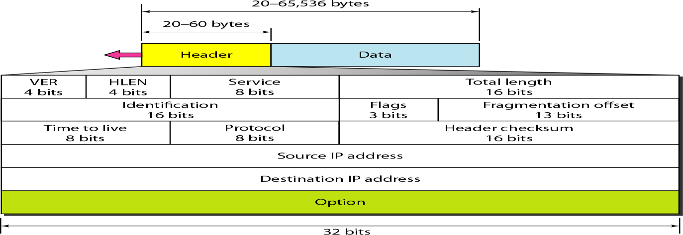

Services
IETF has changed the interpretation and name of this 8-bit field.
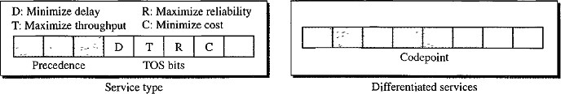
Previously this field is called Service Type but now the name changed to Differentiated Services.

Service Type
In this interpretation, the first 3 bits are called precedence bits. The next 4 bits are called type of service (TOS) bits, and the last bit is not used.

Precedence
- It is a 3-bit subfield ranging from 0 to 7 (000 to111).
- The precedence defines the priority of the datagram in issues such as congestion.
- If a router is congested and needs to discard some datagrams, those datagrams with lowest precedence are discarded first.
- Some datagrams in the Internet are more important than others.
For example a datagram used for network management is much more urgent and important than a datagram containing optional information for a group.
Note: The precedence subfield was part of version 4, but never used.

Type of Service(TOS)
It is a 4-bit subfield with each bit having a special meaning. Out of 4 bits only one bit will have the value of 1.
TOS Bits | Description
0000 | Normal (default)
0001 | Minimize Cost
0010 | Maximize Reliability
0100 | Maximize Throughput
1000 | Minimize Delay

Differentiated Services
In this interpretation, the first 6 bits make up the code-point subfield, and the last 2 bits are not used. The code-point subfield can be used in two different ways:
- When the 3 rightmost bits are 0’s, the 3 leftmost bits are interpreted the same as the precedence bits in the service type interpretation.
- When the 3 rightmost bits are not all Os, the 6 bits define 64 services based on the priority assignment by the Internet or local authorities.
Category | Code-  point | Assigning Authority | No of service  types | Numbers
1 | XXXXX0 | Internet | 32 | 0,2,4,6,8,……60,62
2 | XXXX11 | Local | 16 | 3,7,11,15,……59,63
3 | XXXX01 | Temporary or Experiment | 16 | 1,5,9,13,17...……,61

Totallength
This is a 16-bit field that defines the total length (header plus data) of the IPv4 datagram in bytes. Total length of IPv4 is 65,535 (2¹⁶-1).
Length of data = Total length - header length
FRAGMENTATION
- A datagram can travel through different networks. Each router decapsulates the IPv4 datagram from the frame it receives, processes it, and then encapsulates it in another frame.
- The format and size of the sent frame and received frame depends on the protocol used by the physical network through which the frame has been transmitted.
- For example, if a router connects a LAN to a WAN, it receives a frame in the LAN format and sends a frame in the WAN format.

Maximum Transfer Unit (MTU)
- The value of the MTU depends on the physical network protocol.
- When a datagram is encapsulated in a frame, the total size of the datagram must be less than this maximum size.
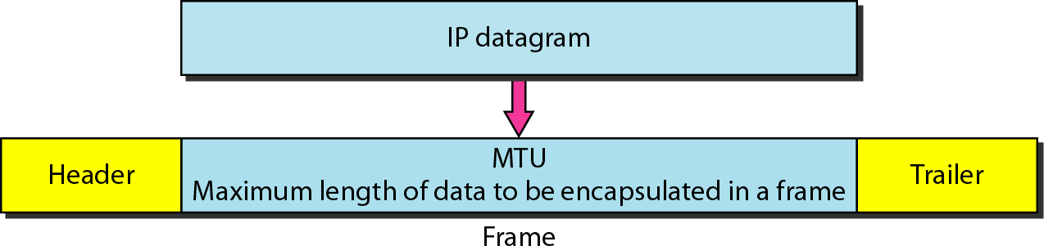
- The maximum length of IPV4 datagram is 65,535bytes.
- If the length of the datagram exceeds the MTU then the datagram must be fragmented to make it possible to pass through the networks.
- When a datagram is fragmented, each fragment has its own header with only few fields are changed. Remaining fields are copied by all fragments.

Protocol | MTU in Bytes
Hyper-channel | 65,535
Token Ring (16 Mbps) | 17,914
Ethernet | 1,500
Note: When the datagram is fragmented it is obvious that “total length, flag and flag offset” fields are changed.
- The reassembly of the datagram is done only by the destination host because each fragment becomes an independent datagram and packets received not in the order.
- If all the fragments are arrived at the destination then only the destination host starts reassembly of fragments.

Fields Related to Fragmentation: Identification, Flag, Offset. Identification (16 bits)
- It identifies a datagram originating from the source host.
- The combination of the identification and source IPv4 address must uniquely define a datagram as it leaves the source host.
- When a datagram is fragmented, all fragments have the same identification number the same as the original datagram. All fragments having the same identification value must be assembled into one datagram.
- The identification number helps the destination in reassembling the datagram.

Flags (3 bits)
The first bit is Reserved.
The second bit is called the Do Not Fragment bit.
- If its value is 1, the machine must not fragment the datagram.
- If its value is 0, the datagram can be fragmented if necessary.
The third bit is called the More Fragment bit.
- If its value is 1, it means the datagram is not the last fragment.
- If its value is 0, it means this is the last or only fragment.

Fragmentation offset (13 bits)
It shows the relative position of this fragment with respect to the whole datagram. It is the offset of the data in the original datagram measured in units of 8 bytes.
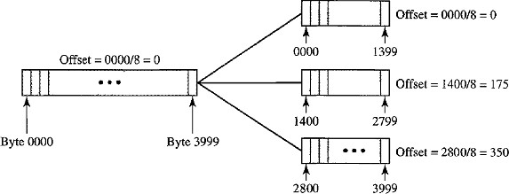
Example: Consider the below figure shows a datagram with a data size of 4000 bytes fragmented into three fragments.
The bytes in the original datagram are numbered 0 to 3999.
Fragment Number | Range | Offset Value
First | 0-1399 | 0/8=0
Second | 1400-2799 | 1400/8=175
Third | 2800-3999 | 2800/8=350

Time To Live - TTL (8 bits)
A datagram has a limited lifetime in its travel through an internet. This field can be used in two ways:
- This field was originally designed to hold a timestamp, which was decremented by each visited router. The datagram was discarded when the value became zero.
- This field is used mostly to control the maximum number of hops (routers) visited by the datagram. Each router that processes the datagram decrements this number by 1. The router discards the datagram, if TTL=0.
When a source host sends the datagram, it stores a number in TTL field. This value is approximately 2 times the maximum number of routes between any two hosts.

Protocol (8 bits)
- This field defines the higher-level protocol that uses the services of the IPv4layer.
- An IPv4 datagram can encapsulate data from several higher-level protocols such as TCP, UDP, ICMP, and IGMP.
- This field specifies the final destination protocol to which the IPv4 datagram is delivered.

Checksum (16 bits)
The checksum in the IPv4 packet covers only the header, not the data. There are two reasons:
- All higher-level protocols that encapsulate data in the IPv4 datagram have a checksum field that covers the whole packet. The checksum for the IPv4 datagram does not have to check the encapsulated data.
- The header of the IPv4 packet changes with each visited router, but the data do not changes. So the checksum includes only the part that has changed.

Options
Options are not required for a datagram. They can be used for network testing and debugging.

Source Address (32 bits) & Destination Address (32 bits)
  - These two fields define the IPv4 address of the Source and Destination respectively.
  - These fields must remain unchanged during the time the IPv4 datagram travels from the source host to the destination host.
Disadvantages of IPv4
- Despite all short-term solutions, such as subnetting, classless addressing, and NAT, address depletion is still a long-term problem in the Internet.
- The Internet must accommodate real-time audio and video transmission. This type of transmission requires minimum delay strategies and reservation of resources not provided in the IPv4 design.
- The Internet must accommodate encryption and authentication of data for some applications. No encryption or authentication is provided byIPv4.

IPV6 DELIVERY MECHANISM
  - IPV6 is introduced to overcome the deficiencies ofIPv4.
  - IPv6 is also called as IPng (Internetworking Protocol next generation).
  - In IPv6, the Internet protocol was extensively modified to accommodate the growth of the Internet. Packet format, Length of IP address, ICMP, IGMP, ARP, RARP, RIP routing protocol are also modified inIPv6.

Advantages of IPv6
  - Larger address space An IPv6 address is 128 bits long whereas IPv4 is 32-bitaddress.
  - Better header format IPv6 uses a new header format in which options are separated from the base header. when options are needed it is inserted between the base header and the upper-layer data.
  - New options IPv6 has new options to allow for additional functionalities.
  - Allowance for extension IPv6 is designed to allow the extension of the protocol if required by new technologies or applications.
  - Resource Allocation In IPv6 the type-of-service field has been removed, but a mechanism called flow label has been added to enable the source to request special handling of the packet. This mechanism can be used to support traffic such as real-time audio and video.
  - More Security The encryption and authentication options in IPv6 provide confidentiality and integrity of the packet.

Packet Format
In IPv6 each packet is composed of a mandatory base header followed by the payload. The Payload consists of two parts:
  - Optional extension headers
  - Data from an upper layer
The Base Header occupies 40 bytes, whereas the extension headers and data from the upper layer contain up to 65,535 bytes of information.

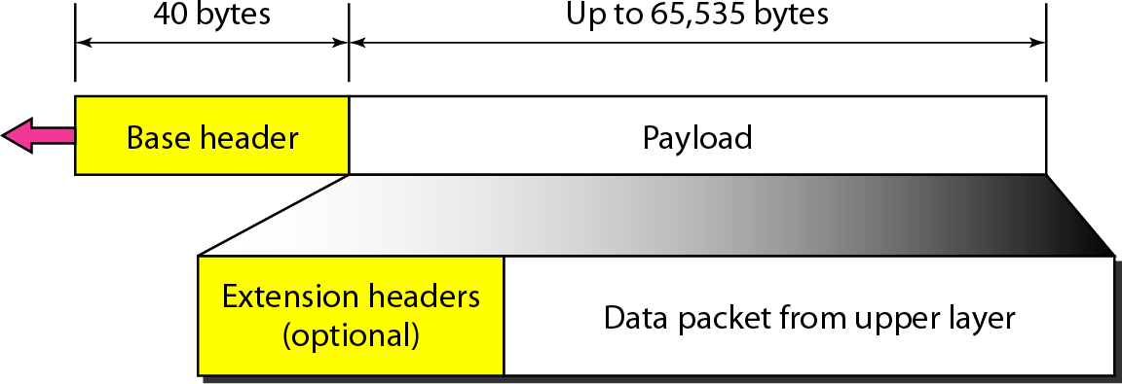
Fig: IPv6 Datagram header and payload

Base Header
Fields in IPv6 datagram are:
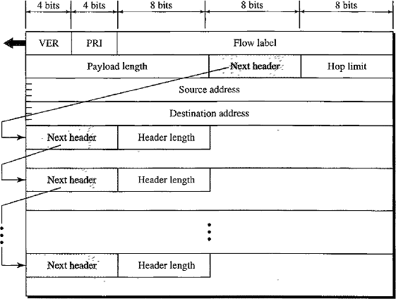

Version (4-bit)
This field defines the version number of the IP. For IPv6, the value is 6.

Priority(4-bit)
The priority field defines the priority of the packet with respect to traffic congestion.

Flow label (24-bit or 3Byte)
Flow label field that is designed to provide special handling for a particular flow of data.

Payload length (16 bit or 2Byte)
Payload length field defines the length of the IP datagram excluding the base header.

Next header(8-bit)
The next header is an 8-bit field defining the header that follows the base header in the datagram. The next header is either optional extension headers used by IP or the header of TCP or UDP encapsulated packet.
Note: This field in IPv4 is called the protocol.

Hop limit (8 bit)
Hop limit field serves the same purpose as the TTL field in IPv4

Source address (128-bit or 16 Byte) and Destination Address (128 bit or 16Byte)
The source address field is a 16-byte (128-bit) Internet address that identifies the original source of the datagram.
The destination address field is a 16-byte (128-bit) Internet address that usually identifies the final destination of the datagram. If source routing is used, this field contains the address of the next router.

Next Header codes for IPv6:
Code | Next Header
0 | Hop-by-hop option
2 | ICMP
6 | TCP
17 | UDP
43 | Source Routing
44 | Fragmentation
50 | Encrypted security payload
51 | Authentication
59 | Null (No Next Header)
60 | Destination Option

Priority
The priority field of the IPv6 packet defines the priority of each packet with respect to other packets from the same source.
Example: If one of two consecutive datagrams must be discarded due to congestion, the datagram with the lower packet priority will be discarded.
IPv6 divides traffic into two broad categories:
- Congestion-Controlled
- Non congestion-controlled

Congestion-Controlled Traffic
When there is congestion a source adapts itself to slowdown the traffic. Example: TCP uses sliding window protocol can easily respond to the traffic.
Congestion-controlled data are assigned priorities from 0 to 7
Priority | Meaning | Description
0 | No specific  traffic | Priority 0 is assigned to a packet when the process does not  define a priority.
1 | Background  data | defines data that are usually delivered in the background.  Ex: Delivery of the news.
2 | Unattended data traffic | If the user is not waiting (attending) for the data to be received, the packet will be given a priority of 2.  Ex: Email
3 | Reserved
4 | Attended bulk data  traffic | A protocol that transfers data while the user is waiting to receive the data is given a priority of 4  Ex: FTP and HTTP
5 | Reserved
6 | Interactive  traffic | Protocols that need user interaction are assigned 6.  Ex: TELNET
7 | Controlled  traffic | Routing Protocols are given Highest Priority 7.  Ex: OSPF, RIP, SNMP

Non congestion-Controlled Traffic
  - The source does not adapt itself to congestion. It is a type of traffic that expects minimum delay. Priority numbers from 8 to 15 are assigned to Non congestion-controlled traffic.
  - In this traffic Discarding of packets is not desirable and Retransmission in most cases is impossible.
Examples: Real-time audio and video.
  - Priority 15: It is given to data containing Less Redundancy (low-fidelity audio or video)
  - Priority 8: It is given to data containing More Redundancy (high-fidelity audio or video)

Flow Label
  - A sequence of packets, sent from a particular source to destination that needs special handling by routers is called a Flow of packets.
  - The combination of the source address and the value of the Flow Label uniquely define a flow of packets.
  - To a router, a flow is a sequence of packets that share the same characteristics such as traveling the same path, using the same resources, having the same kind of security etc.
  - A router that supports the handling of flow labels has a flow label table. The table has an entry for each active flow label.
  - Each entry defines the services required by the corresponding flow label.
  - When a router receives a packet it consults the flow label table instead of consulting the routing table and going through a routing algorithm to define the address of the next hop, it can easily look in a flow label table for the next hop.
  - This mechanism speed up the processing of a packet by a router.

Extension Headers
To give greater functionality to the IP datagram, the base header can be followed by up to six types of extension headers.
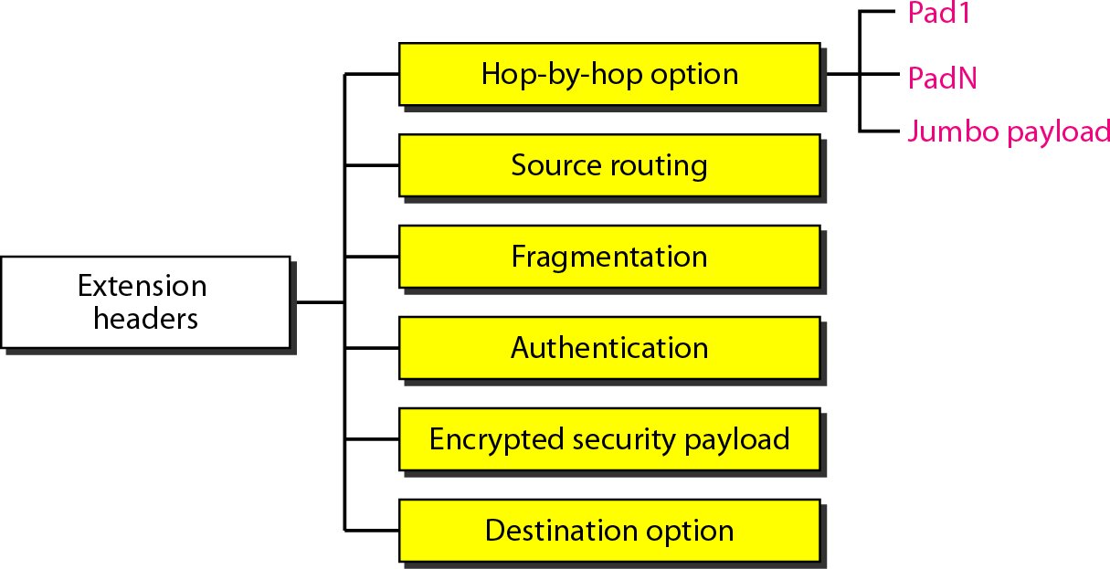

Hop-by-Hop Option
The hop-by-hop option is used when the source needs to pass information to all routers visited by the datagram.
Only three options have been defined: Pad l, Pad N, and jumbo payload.
  - The Pad l option is 1 byte long and is designed for 1 byte alignment purposes.
  - Pad N is used when 2 or more bytes is needed for alignment.
  - The jumbo payload option is used to define a payload longer than 65,535bytes.

Source Routing
  - The source routing extension header combines the concepts of the strict source route and the loose source route options ofIPv4.

Fragmentation
  - In IPv4, the source or a router is required to fragment if the size of the datagram is larger than the MTU of the network over which the datagram travels.
  - In IPv6, only the original source can fragment. A source must use a path MTU discovery technique to find the smallest MTU supported by any network on the path.
  - The source then fragments using this knowledge.

Authentication
  - The authentication extension header has a dual purpose: it validates the message sender and ensures the integrity of data.

Encrypted Security Payload (ESP)
  - ESP is an extension that provides confidentiality and guards against eavesdropping.

Destination Option
  - It is used when the source needs to pass information to the destination only.
  - Intermediate routers are not permitted access to this information.

Comparison between IPv4 Options and IPv6 Extension Headers
- The no-operation and end-of-option options in IPv4 are replaced by Pad1 and Pad N options in IPv6.
- The record route option is not implemented in IPv6 because it was not used.
- The timestamp option is not implemented because it was not used.
- The source route option is called the source route extension header inIPv6.
- The fragmentation fields in the base header section of IPv4 have moved to the fragmentation extension header inIPv6.
- The authentication and Encrypted Security Payload extension headers are new inIPv6.
TRANSITION FROM IPv4 TO IPv6
Tunneling
  - Tunneling is a strategy used when two computers using IPv6 want to communicate with each other and the packet must pass through a region that usesIPv4.
  - To pass through this region, the packet must have an IPv4address.
  - So the IPv6 packet is encapsulated in an IPv4 packet when it enters the region, and it leaves its capsule when it exits the region.
  - It seems as if the IPv6 packet goes through a tunnel at one end and emerges at the other end. The IPv4 packet is carrying an IPv6 packet as data, the protocol value is set to41.
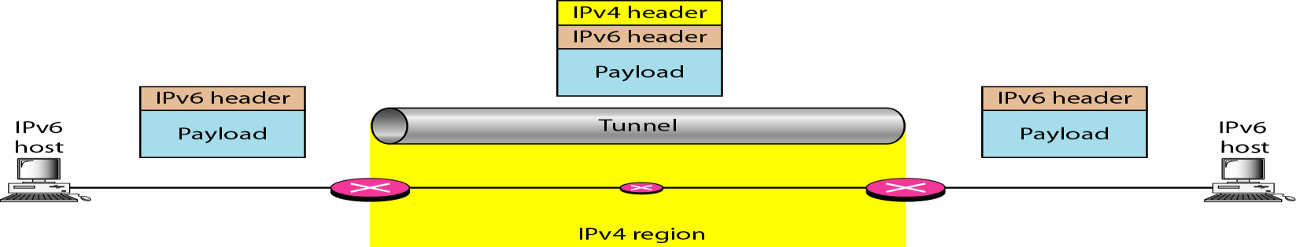

ADDRESS MAPPING
  - IP packets use Logical Addresses (Host-to-Host).
  - Frame needs Physical Addresses(Node-to-Node).
  - IP packets need to be encapsulated in a frame.
The physical address and the logical address are two different identifiers.
  - A physical network such as Ethernet can have two different protocols at the network layer such as IP and IPX (Novell) at the same time.
  - Delivery of a packet to a host or a router requires two levels of addressing: Logical and Physical.
  - We need to be able to map a Logical Address to its corresponding Physical Address and Physical address to corresponding Logical Address.
Mapping can be done by using two ways:
  - Static Mapping
  - Dynamic Mapping

Static Mapping
  - Static mapping involves in the creation of a table that associates a logical address with a physical address. This table is stored in each machine on the network.
  - Each machine that knows the IP address of another machine but not its physical address can look it up in the table.

Limitations of Static Mapping
Physical address may change in several ways:
- A machine could change its NIC, resulting in a new physical address.
- In some LANs, such as Local Talk (Apple), the physical address changes every time the computer is turned on.
- A mobile computer can move from one physical network to another, resulting in a change in its physical address.
Overhead: To implement these changes, a static mapping table must be updated periodically. This overhead could affect network performance.
In order to avoid this overhead and limitation Dynamic Mapping is introduced.

Dynamic Mapping
In this mapping each time a machine knows one of the two addresses (logical or physical) it can use a protocol to find the other one.
The address mapping protocols are:
  - Address Resolution Protocol (ARP)
  - Reverse Address Resolution Protocol(RARP)
  - Bootstrap protocol(BOOTP)
  - Dynamic Host Configuration Protocol(DHCP)

ARP (Mapping Logical to Physical address)

Need for Physical Address
  - Anytime a host or a router has an IP datagram to send to another host or router, it has the logical (IP) address of the receiver.
  - The logical (IP) address is obtained in two ways:
    - If the sender is the host then logical address is obtained from DNS.
    - If the sender is router then logical address is obtained from a routing table.
  - But the IP datagram must be encapsulated in a frame to be able to pass through the physical network.
  - This means that the sender needs the physical address of the receiver.
In order to know the physical address of the receiver the sender uses ARP protocol.

Process of ARP
  - The sender knows the IP address of the target. The host or the router sends an ARP query packet.
  - IPasksARPtocreateanARPrequestpacket.ThepacketincludesthePhysicaladdress
and IP addresses of the Sender and the IP address of the Receiver.
  - The target physical address field is filled with all 0’s. Because the sender does not know the physical address of the receiver and the query is broadcast over the network.

  - Every host or router on the network receives and processes the ARP query packet, but only the intended recipient recognizes its IP address and sends back an ARP reply packet whereas the remaining devices discard the packet.
  - The reply packet contains the recipient's IP and physical addresses.
  - The packet is unicast directly to the sender by using the physical address received in the query packet.
  - The sender receives the reply message. It now knows the physical address of the target machine.
  - The IP datagram that carries data for the target machine is now encapsulated in a frame and datagram is unicasted to the destination.

Note
- A system is normally sends several packets to same destination.
- A system that receives an ARP reply stores the mapping in the cache memory and keeps it until the space in the cache is exhausted.
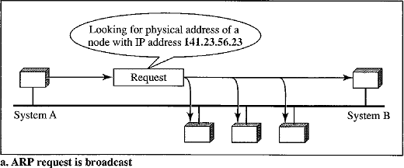
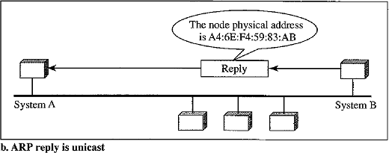
- Before sending an ARP request, the system first checks its cache to see if it can find the mapping.
The above figure describes:
  - System A has a packet that needs to be delivered to another system B with IP address 141.23.56.23.
  - System A does not know the physical address of141.23.56.23.
  - System A broadcast ARP request packet to ask for physical address of141.23.56.23
  - This packet is received by every system on the physical network, but only system B will respond by sending ARP reply packet that includes its physical address (A4:6E:F4:59:83:AB).
  - Now system A can send all the packets it has for the destination (System B) by using the physical address it received.

Packet Format
The fields are divided into fixed length fields(5) and Variable length fields(4).

Fixed length fields:
  - Hardware type (16bit)
It defining the type of the network on which ARP is running.
Each LAN has been assigned an integer based on its type. Ex: Ethernet is given type 1.

ARP can be used on any physical network.

Protocol type (16-bit)
This field defines the protocol. For IPv4 Protocol the value is 0800₁₆.

Hardware length(8-bit)
This field defines the length of the physical address in bytes. Ex: for Ethernet value = 6.

Protocol length(8-bit)
This defines the length of logical address in bytes. For IPv4 protocol the value is 4.

Operation (16-bit)
This field defines the type of packet. Two packet types are defined: ARP request (1) and ARP reply (2).
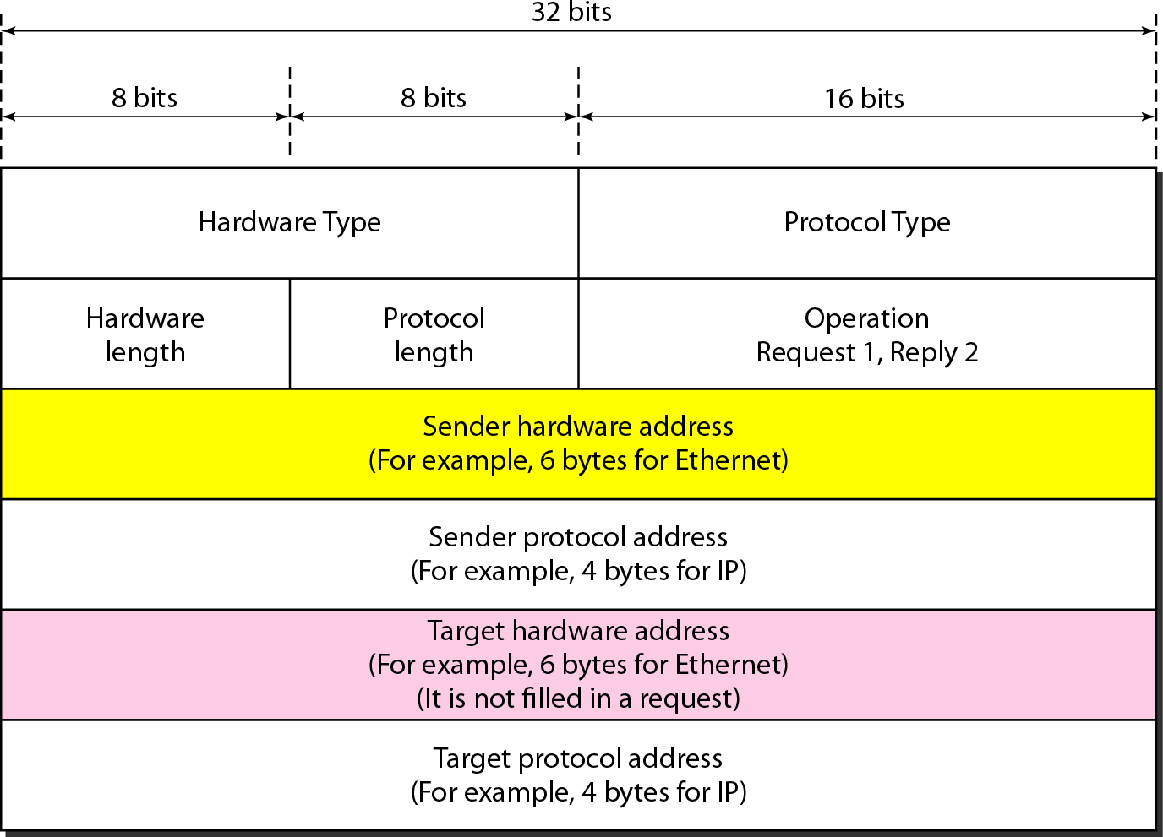

Variable length fields:
  - Sender hardware address
This is a variable length field defines the physical address of the sender. For example, for Ethernet this field is 6 bytes long.

Sender protocol address
It is a variable length field defines the logical address (IP address) of the sender. For the IP protocol, this field is 4 bytes long.

Target hardware address
This is a variable-length field defining the physical address of the target (receiver). For example, for Ethernet this field is 6 bytes long.
For an ARP request message, this field is all 0’s because the sender does not know the physical address of the target.

Target protocol address
This is a variable-length field defining the logical address of the target. For the IPv4 protocol, this field is 4 bytes long.

Encapsulation
An ARP packet is encapsulated directly into a data link frame (i.e. Ethernet frame). Note that the type field indicates that the data carried by the frame are an ARP packet.

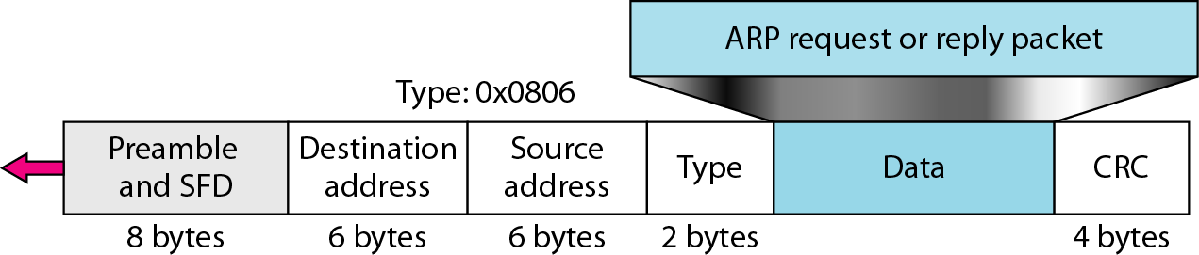

Proxy ARP
  - A technique called Proxy ARP is used to create a subnetting effect.
  - A proxy ARP is an ARP that acts on behalf of a set of hosts.
  - Whenever a router running a proxy ARP receives an ARP request looking for the IP address of one of these hosts, the router sends an ARP reply announcing its own hardware (physical)address.
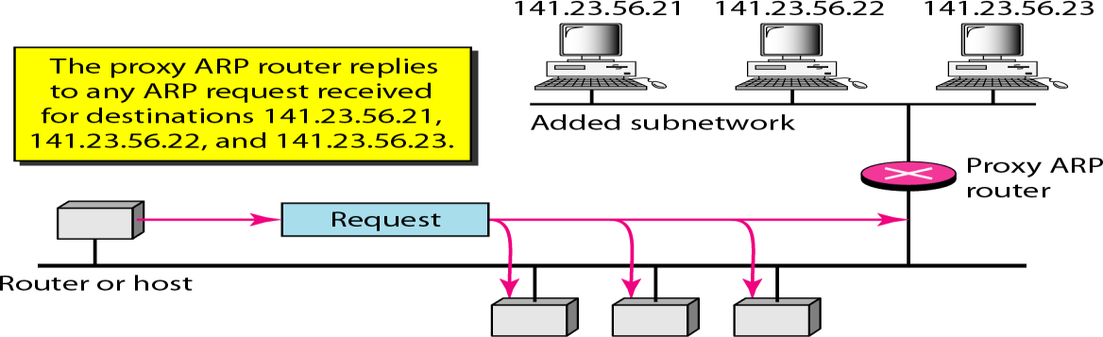
  - After the router receives the actual IP packet, it sends the packet to the appropriate host or router.
In the above figure: The ARP installed on the right-hand host will answer only to an ARP request with a target IP address of 141.23.56.23.
  - The administrator may need to create a subnet without changing the whole system to recognize subnetted addresses. One solution is to add a router running a proxy ARP.
  - In this case, the router acts on behalf of all the hosts installed on the subnet.
  - When it receives an ARP request with a target IP address that matches the address of one of its protégés (141.23.56.21, 141.23.56.22, or 141.23.56.23), it sends an ARP reply and announces its hardware address as the target hardware address.
  - When the router receives the IP packet, it sends the packet to the appropriate host.
Mapping Physical to Logical Address: RARP, BOOTP, and DHCP
There are occasions in which a host knows its physical address, but needs to know its logical address. This may happen in two cases:
- An organization does not have enough IP addresses to assign to each station; it needs to assign IP addresses on demand. The station can send its physical address and ask for a short time lease.
- A diskless station is just booted. The station can find its physical address by checking its interface, but it does not know its IP address.

Note:
A Diskless machine is usually booted from ROM, which has minimum booting information. The ROM is installed by the manufacturer. It cannot include the IP address because the IP addresses on a network are assigned by the network administrator.

REVERSE ADDRESS RESOLUTION PROTOCOL (RARP)
  - RARP finds the logical address for a machine that knows only its physical address.
  - Each host or router is assigned one or more logical (IP) addresses, which are unique and independent of the physical (hardware) address of the machine.
  - To create an IP datagram, a host or a router needs to know its own IP address.
  - IP address of a machine is usually read from its configuration file stored on a disk file.
  - The machine can get its physical address by reading its NIC, which is unique locally.
  - It can then use the physical address to get the logical address by using the RARP protocol.
  - A RARP request is created and broadcast on the local network.
  - Another machine on the local network that knows all the IP addresses will respond with a RARP reply.
Note: The requesting machine must be running a RARP client program and the responding machine must be running a RARP server program.

Problems with RARP
  - Broadcasting is done at the data link layer.
  - The physical broadcast address, all 1’s in the case of Ethernet. It does not pass the boundaries of a network. (i.e.) if an administrator has several networks or several subnets, it needs to assign a RARP server for each network or subnet.
Note: BOOTP and DHCP are implemented to solve the problems with RARP

Bootstrap Protocol (BOOTP)
  - BOOTP is a client/server protocol designed to provide physical address to logical address mapping.
  - BOOTP is an application layer protocol. The administrator may put the client and the server on the same network or on different networks.
  - BOOTP messages are encapsulated in a UDP packet, and the UDP packet itself is encapsulated in an IP packet.

Advantage of BOOTP over RARP
The client and server are application-layer processes. As in other application-layer processes, a client can be in one network and the server in another, separated by several other networks. Note:

How a client can send an IP datagram when it knows neither its own IP address (the source address) nor the server's IP address (the destination address).
The client simply uses all 0’s as the source address and all 1’s as the destination address.

Problem
The BOOTP request is broadcast because the client does not know the IP address of the server. A broadcast IP datagram cannot pass through any router.

Solution
  - There is a need for intermediary host or router.
  - One of the hosts or a router that can be configured to operate at the application layer can be used as a relay. The host is called a relay agent.

  - The relay agent knows the unicast address of a BOOTP server.
  - When it receives this type of packet, it encapsulates the message in a unicast datagram and sends the request to the BOOTP server.
  - The packet carrying a unicast destination address is routed by any router and reaches the BOOTP server.
  - The BOOTP server knows the message comes from a relay agent because one of the fields in the request message defines the IP address of the relay agent.
  - The relay agent after receiving the reply, sends it to the BOOTP client.
DYNAMIC HOST CONFIGURATION PROTOCOL (DHCP)
DHCP is a static and dynamic configuration protocol whereas BOOTP is a static configuration protocol only.

Why DHCP?
  - When a client requests its IP address, the BOOTP server consults a table that matches the physical address of the client with its IP address.
  - This implies that the binding between the physical address and the IP address of the client already exists. The binding is predetermined.
  - The binding or mapping between the physical address and IP addresses is static and fixed in a table until changed by the administrator. BOOTP is a static configuration protocol.
There are situations where BOOTP fails to handle:
- What if a host moves from one physical network to another.
- What if a host wants a temporary IP address.
DHCP has been devised to provide Static and Dynamic Address Allocation that can be manual or automatic.

Static Address Allocation
  - In this capacity DHCP acts as BOOTP.
  - It is backward compatible with BOOTP, which means a host running the BOOTP client can request a static address from a DHCP server.
  - A DHCP server has a database that statically binds physical addresses to IP addresses.

Dynamic Address Allocation
  - DHCP has a second database with a pool of available IP addresses. This second database makes DHCP dynamic.
  - When a DHCP client requests a temporary IP address, the DHCP server goes to the pool of available (unused) IP addresses and assigns an IP address for a negotiable period of time.
  - When a DHCP client sends a request to a DHCP server, the server first checks its static database.
  - If an entry with the requested physical address exists in the static database, the permanent IP address of the client is returned.
  - If the entry does not exist in the static database, the server selects an IP address from the available pool, assigns the address to the client, and adds the entry to the dynamic database.

  - The dynamic aspect of DHCP is needed when a host moves from network to network or is connected and disconnected from a network then DHCP provides temporary IP addresses for a limited time.

Temporary Addresses
  - The addresses assigned from the pool are temporary addresses.
  - The DHCP server issues a lease for a specific time. When the lease expires, the client must either stop using the IP address or renew the lease.
  - The server has the option to agree or disagree with the renewal. If the server disagrees, the client stops using the address.

Advantages of DHCP over BOOTP
  - One major problem with the BOOTP protocol is that the table mapping. The IP addresses to physical addresses needs to be manually configured.
  - This means the administrator needs to manually enter the changes every time there is a change in a physical address or IP address.
  - DHCP allows both manual and automatic configurations.
  - Static addresses are created manually whereas dynamic addresses are created automatically.
INTERNET CONTROL MESSAGE PROTOCOL (ICMP)
The IP provides unreliable and connectionless datagram delivery. (i.e.) IP does not provide any Error control mechanisms and it does not provide any host management queries.
ICMP has been designed to compensate for the above two deficiencies. It is a companion to the IP protocol.

Types of Messages
ICMP messages are divided into two broad categories:
  - Error-Reporting Messages
  - Query Messages
  - Error-reporting messages report problems that a router or a host (destination) may encounter when it processes an IP packet.
  - Query messages occur in pairs, help a host or a network manager get specific information from a router or another host.
Example: nodes can discover their neighbors, and also hosts can discover and learn about routers on their network, and routers can help a node redirect its messages.

Message Format
An ICMP message has an 8-byte header and a variable-size data section.
The general format of the header is different for each message type, the first 3 fields Type, Code, Checksum are common to all. These common fields consisting of 4 bytes.
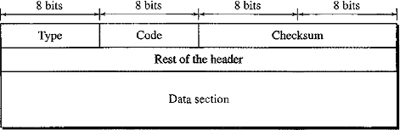

  - ICMP Type defines the type of the message.
  - Code field specifies the reason for the particular message type.
  - Rest of the header is specific for each message type.
  - Checksum is calculated over the entire message (header and data).
  - Data section in Error messages carries information for finding the original packet that had the error. Data Section in Query messages the data section carries extra information based on the type of the query.

Error Reporting
  - The main responsibilities of ICMP are to report errors. ICMP does not correct errors
  - Error messages are always sent to the original source because the only information available in the datagram about the route is the source and destination IP addresses.
  - ICMP uses the source IP address to send the error message to the original source of the datagram.

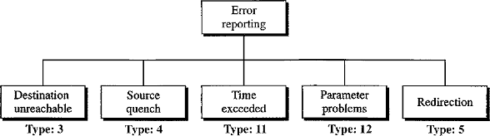
ICMP handles 5 types of errors:
Destination Unreachable (Type 3)
  - When a router cannot route a datagram or a host cannot deliver a datagram then the datagram is discarded.
  - The router or the host sends a destination-unreachable message back to the source host that initiated the datagram.
  - Note that destination-unreachable messages can be created by either a router or the destination host.

Source Quench (Type 4)
  - IP does not have a flow control mechanism embedded in the protocol.
  - The lack of flow control can create major problems such as Congestion in routers or the destination host. When there is a congestion the router or host may discard the packets.
  - When a router or host discards a datagram due to congestion, it sends a source-quench message to the sender of the datagram.
Source Quench message has two purposes.
- It informs the source that the datagram has been discarded.
- It warns the source that there is congestion somewhere in the path and that the source should slow down (quench) the sending process.

Redirection (Type 5)
  - Routing is dynamic. Routing table will be updated by routers. Host does not involve in the process of updation of routing tables.
  - The hosts usually use static routing. Routing table has a limited number of entries.

  - Host usually knows the IP address of the default router only. For this reason, the host may send a datagram, which is destined for another network to the wrong router.
  - In this case the router that receives the datagram will forward the datagram to the correct router.
  - To update the routing table of the host, it sends a redirection message to the host.

Time Exceeded (Type 11)
  - Each datagram contains a field called Time To Live(TTL).
  - When a datagram visits a router, the value of TTL field is decremented by1.
  - When the TTL value reaches 0 the router discards the datagram.
  - When the datagram is discarded, a time-exceeded message must be sent by the router to the original source.
Note: A time-exceeded message is also generated when not all fragments that make up a message arrive at the destination host within a certain time limit.

Parameter Problem (Type 12)
  - If a router or the destination host discovers an ambiguous or missing value in any field of the datagram, it discards the datagram and sends a parameter-problem message back to the source.
Note: There are some cases where ICMP error messages will not be generated.
- No ICMP error message will be generated in response to a datagram carrying an ICMP error message.
- No ICMP error message will be generated for a fragmented datagram that is not the first fragment.
- No ICMP error message will be generated for a datagram having a Multicast Address.
- No ICMP error message will be generated for a datagram having a special address such as
127.0.0.0 or 0.0.0.0.

Query Messages
  - In this type of ICMP message, a node sends a message that is answered in a specific format by the destination node.
  - A query message is encapsulated in an IP packet, which in turn is encapsulated in a data link layer frame.
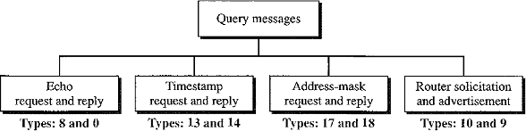
Here no bytes of the original IP are included in the message.

Echo Request and Echo Reply
  - The echo-request and reply messages can be used to determine if there is communication at the IP level.
  - These are used for diagnostic purpose, network managers and users utilize this pair of messages to identify network problems.

  - ICMP messages are encapsulated in IP datagrams.
  - The receipt of an echo-reply message by the machine that sent the echo request is proof that the IP protocols in the sender and receiver are communicating with each other using the IP datagram.
Example: ping command.

Timestamp Request and Reply
  - Two machines (hosts or routers) can use the timestamp request and timestamp reply messages to determine the round-trip time needed for an IP datagram to travel between them. It can also be used to synchronize the clocks in two machines.

Address-Mask Request and Reply
  - A host may know its IP address, but it may not know the corresponding mask.
  - To obtain its mask, a host sends an address-mask-request message to a router on the LAN.
  - Ex: A host IP address is 159.31.17.24, but it doesn’t know its corresponding mask/24.
  - If the host knows the address of the router, it sends the request directly to the router.
  - If it does not know, it broadcasts the message.
  - The router receiving the address-mask-request message responds with an address-mask- reply message, providing the necessary mask for the host.

Router Solicitation and Advertisement
  - The router-solicitation and router-advertisement messages can help whether the router is functioning or not.
  - A host can broadcast (or) multicast a router-solicitation message.
  - Routers that receive the solicitation message broadcast their routing information using the router-advertisement message.
  - In router advertisement message it announces its own presence and all routers on the network which it is aware of.
Note: A router can also periodically send router-advertisement messages even if no host has solicited.
INTERNET GROUP MANAGEMENT PROTOCOL (IGMP)
IGMP is a companion to IP protocol. IGMP is not a multicasting routing protocol. It is a protocol that manages Group Membership.
In any network, there are one or more multicast routers that distribute multicast packets to hosts or other routers. The IGMP protocol gives the multicast routers information about the membership status of hosts (routers) connected to the network.

Need for IGMP
  - A multicast router may receive thousands of multicast packets every day for different groups.
  - If a router has no knowledge about the membership status of the hosts, it must broadcast all these packets. This creates a lot of traffic and consumes bandwidth.
  - A better solution is to keep a list of groups in the network for which there is at least one loyal member.
  - IGMP helps the multicast router create and update this list.

IGMP Messages and Message Format
IGMP has 3 types of messages: Query, Membership report, Leave report. Query messages can be divided into two types: General and Special

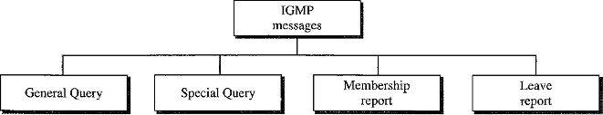
The message format of IGMP contains four fields:
- Type
- Maximum Response Time
- Checksum
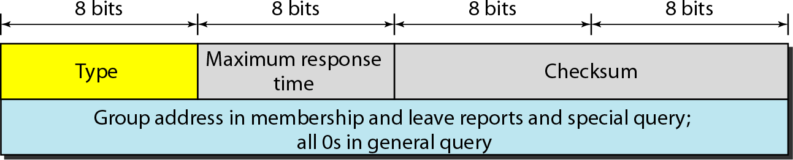
- Group Address

Type
This 8-bit field defines the type of message.
Type | Value
General or Special Query | 0x11 or 00010001
Membership Report | 0x16 or 00010110
Leave Report | 0x17 or 00010111

Maximum Response Time
This 8-bit field defines the amount of time in which a query must be answered. The value is in tenths of a second.
Example: Value=100 it means 10 sec.
The value is nonzero in the query message.
For Membership and Leave report the value is 0.

Checksum
This is a 16-bit field carrying the checksum. The checksum is calculated over the 8-byte message.

Group address
The value of this field is 0 for a general query message.
The value defines the group id (multicast address of the group) in the special query, the membership report, and the leave report messages.

IGMP Operation
  - IGMP operates locally.
  - A multicast router connected to a network has a list of multicast addresses of the groups with at least one loyal member in that network.
  - For each group, there is one router that has the duty of distributing the multicast packets destined for that group.
  - If there are three multicast routers connected to a network, their lists of group id’s are mutually exclusive.

Example: Consider the below figure the routers R, R1, R2 are connected to the network but only router R distributes packets with the multicast address of 225.70.8.20.
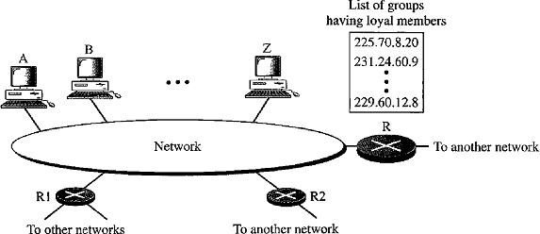
R1 and R2 are the multicast routers of other groups.

Distance Vector Routing
- In distance vector routing, the least-cost route between any two nodes is the route with minimum distance. The term Vector means a Table.
- In this protocol each node maintains a table of minimum distances to every node.
- The table at each node also guides the packets to the desired node by showing the next hop in the route.
- The table for node A shows how we can reach to any node from node A.
- Ex: From node A the least cost to reach node E is 6. The route passes through C.

To | Cost | Next
A | 0 | -
B | 5 | -
C | 2 | -
D | 3 | -
E | 6 | C

- The Distance Vector Routing protocol follows these basic steps:
1. Initialization: Each router in the network is configured with its own distance vector table, which lists the distance (in terms of hop count or other metrics) to every other network in the inter-network.
2. Sending distance vectors: Each router sends its distance vector table to its immediate neighbors.(Sharing)
3. Updating distance vectors: Upon receiving a distance vector from a neighbor, a router updates its own table by comparing the distance to a network via its neighbor with the distance currently listed in its own table. If the new distance is shorter, the router updates its table with the new information.
4. Calculating best path: Using the information in its distance vector table, each router calculates the best path to each network and updates its routing table accordingly.
- 5. Periodic updates: The sending and updating distance vectors are repeated periodically, typically every 30 seconds. This allows the network to adapt to changes in topology quickly.
- 6. Convergence: The process of sending and updating distance vectors continues until all routers in the network have the most up-to-date information and have converged on the best path to each network.
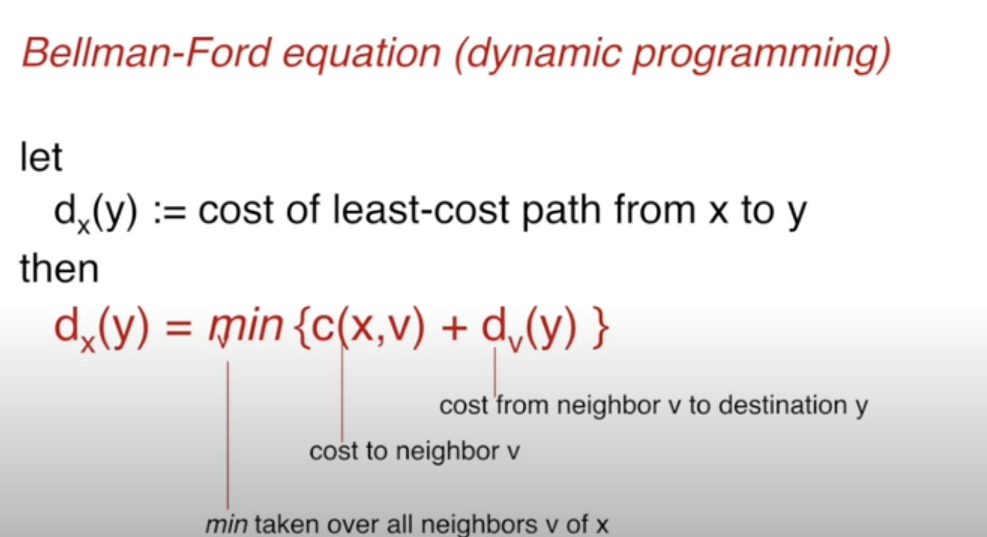
Example:
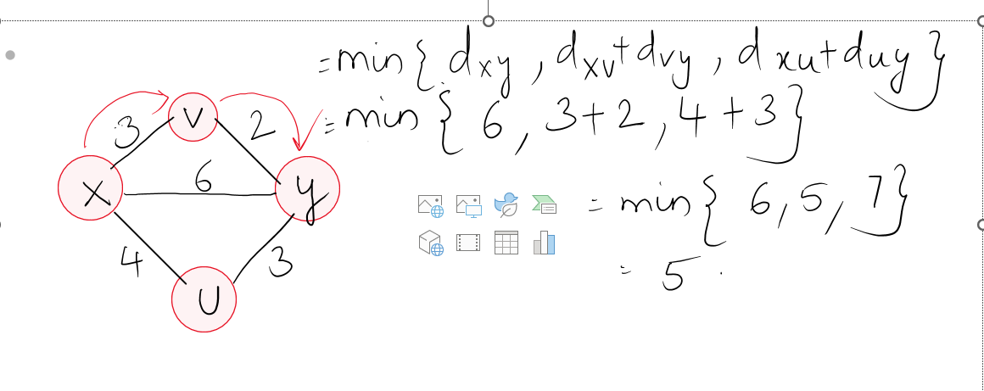
Example:
- Initialization
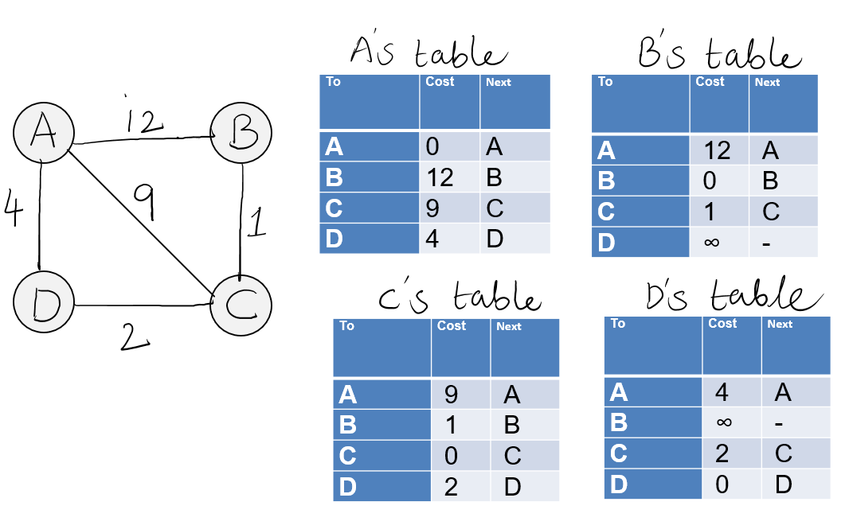
- Updation:
A receives distance vectors from B, C, and D.
It updates its table using their neighbors table.
A reaches B initially with a cost of 12.
After getting the neighbors tables A updates its table using Bellmans Ford Equation.
Example:

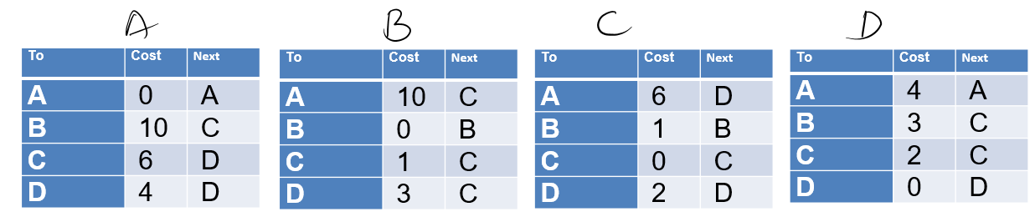
All routers use the same process to update their tables.
- Final Solution
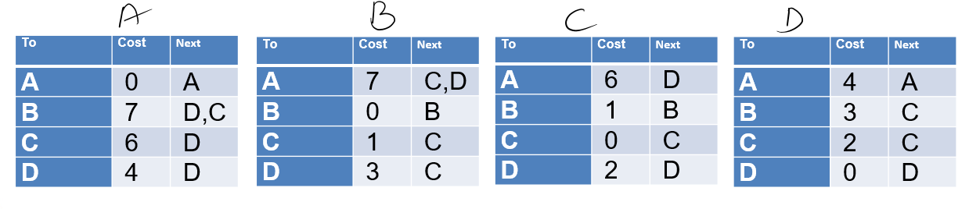
Count to Infinity Problems Two-Node Loop Instability
A problem with distance vector routing is instability, which means that a network using this protocol can become unstable.
Consider the above figure:
It shows a system with 3 nodes: X, A and B.
- At the beginning, both nodes A and B know how to reach node X.
- But suddenly, the link between A and X fails.
- Node A changes its table.
If A can send its table to B immediately there will be no problem because B can identify by looking at the table value ∞.

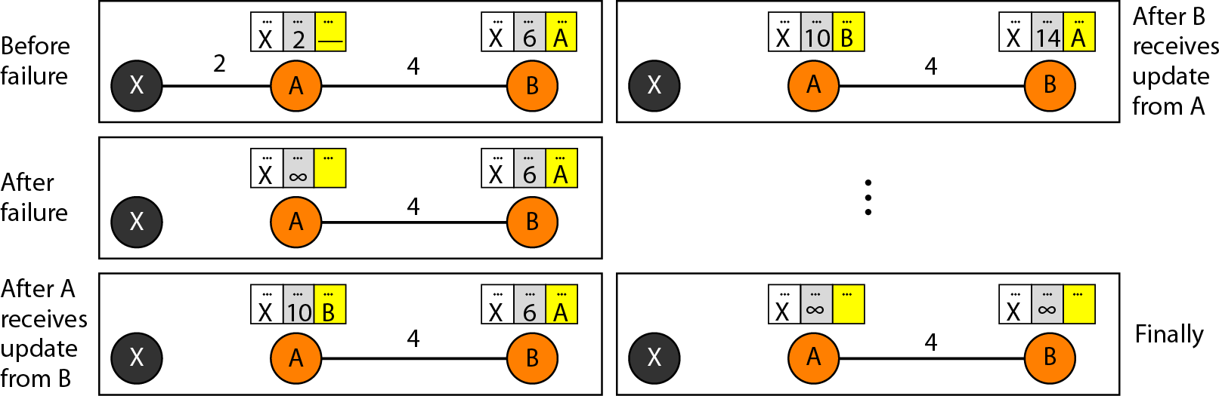

Problem is: The system becomes unstable if B sends its routing table to A before receiving A's routing table.
- Node A receives the update and, assuming that B has found a way to reach X and immediately updates its routing table.
- Based on the triggered update strategy, A sends its new update to B.
- Now B thinks that something has been changed around A and updates its routing table.
- The cost of reaching X increases gradually until it reaches infinity.
- At this moment, both A and B know that X cannot be reached.
During this counting to infinity the system is not stable:
- Node A thinks that the route to X is via B.
- Node B thinks that the route to X is via A.
- If A receives a packet destined for X, it goes to B and then comes back to A.
- If B receives a packet destined for X, it goes to A and comes back to B.
- Packets bounce between A and B, creating a two-node loop problem.

Link State Routing (LSR):
In Link State Routing, Each node in the domain has the entire topology of the domain –
- List of nodes and links
- How they are connected including the type
- Cost (metric)
- Condition of the links (up or down)

Building Routing Tables
In link state routing, four sets of actions are required to ensure that each node has the routing table showing the least-cost node to every other node.
- Creation of the states of the links by each node, called the Link State Packet(LSP).
- Dissemination (Distribution) of LSPs to every other router called Flooding. The flooding can be done in an efficient and reliable way.
- Formation of a shortest path tree for each node.
- Calculation of a routing table based on the shortest path tree.

Creation of Link State Packet (LSP)
A link state packet can carry a large amount of information such as the node identity, the list of links, a sequence number, and age etc.
- Node identity and the List of links are needed to make the topology.
- Sequence number facilitates flooding and distinguishes new LSPs from old ones.
- Age prevents old LSP’s from remaining LSP’s in the domain for a longtime.

Flooding of LSP’s
After a node has prepared an LSP, it must be disseminated to all other nodes, not only to its neighbors. The process is called flooding.
Flooding will be done based on the following:
- The creating node sends a copy of the LSP out of each interface.
- A node that receives an LSP compares it with the copy it may already have.
Each and every LSP will be given a Sequence number at the time of their creation. Comparison of sequence numbers determines which LSP is older and which LSP is latest. If the newly arrived LSP is older than the one it already has, then the node discards the LSP.

Formation of Shortest Path Tree: Dijkstra Algorithm
- After receiving all LSPs, each node will have a copy of the whole topology.
- The topology is not sufficient to find the shortest path to every other node; a shortest path tree is needed.
- A tree is a graph of nodes and links, where one node is called Root.
- A shortest path tree is a tree in which the path between the root and every other node is the shortest.
- The Dijkstra’s algorithm creates a shortest path tree from a graph.
The algorithm divides the nodes into two sets:
- Tentative nodes
- Permanent nodes
Dijkstra’s algorithm finds the neighbors of a current node, makes them tentative, examines them, and if they pass the criteria, makes them permanent.

Flow Chart of Dijksta’s Algorithm
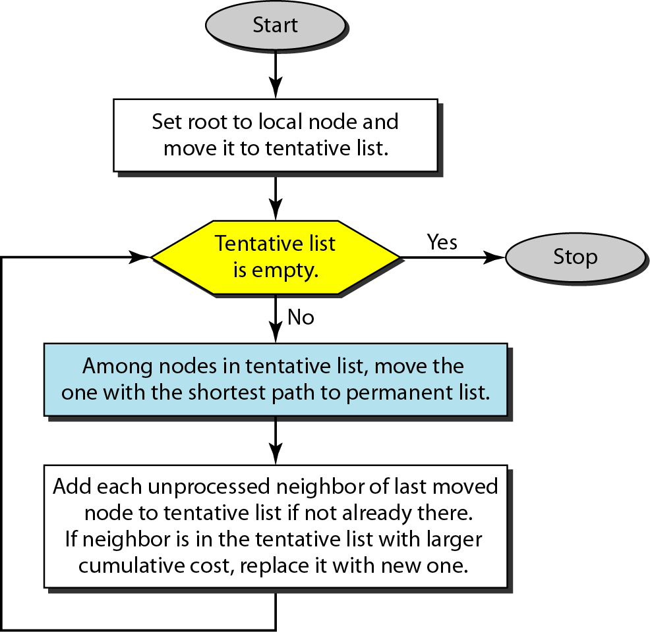
Example:
Consider the below graph with five nodes: A,B,C,D,E.
- Apply the Dijkstra’s algorithm to node A.
- To find the shortest path in each step, we need the cumulative cost from the root to each node, which is shown next to the node.

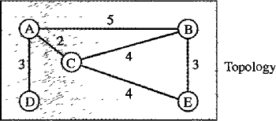
At the end of each step, we show the permanent (filled circles) and the tentative (open circles) nodes and lists with the cumulative costs.
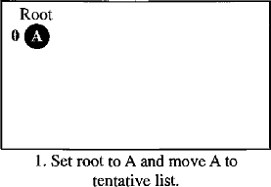
Step 1: We make node A the root of the tree and move it to the tentative list. Our two lists are Permanent list: Empty Tentative list: A(0)
Step 2: Node A has the shortest cumulative cost from all nodes in the tentative list.
We move A to the permanent list and add all neighbors of A to the tentative list. Our new lists are
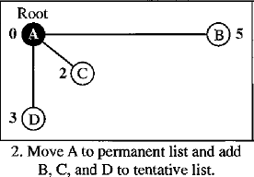
Permanent list: A(0) Tentative list: B(5), C(2), D(3)
Step 3: Node C has the shortest cumulative cost from all nodes in the tentative list.
- We move C to the permanent list.
- Node C has three neighbors, but node A is already processed, which makes the unprocessed neighbors just B and E.
- However, B is already in the tentative list with a cumulative cost of 5.
- Node A could also reach node B through C with a cumulative cost of 6.
- Since 5 is less than 6, we keep node B with a cumulative cost of 5 in the tentative list and do not replace it.
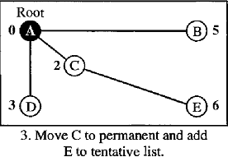
Our new lists are: Permanent list: A(0),C(2) Tentative list: B(5), D(3),E(6).

Step 4: Node D has the shortest cumulative cost of all the nodes in the tentative list.
- We move D to the permanent list. Node D has no unprocessed neighbor to be added to the tentative list.
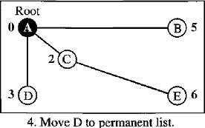
Our new lists are: Permanent List: A(0),C(2),D(3) Tentative List: B(5),E(6).
Step 5: Node B has the shortest cumulative cost of all the nodes in the tentative list.
- We move B to the permanent list. We need to add all unprocessed neighbors of B to the tentative list (i.e. just node E).
- E(6) is already in the list with a smaller cumulative cost.
- The cumulative cost to node E, as the neighbor of B, is 8. We keep node E(6) in the tentative list.
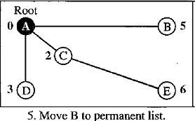
Our new lists are: Permanent list: A(0), B(5),C(2),D(3) Tentative list: E(6)
Step 6: Node E has the shortest cumulative cost from all nodes in the tentative list.
- Move E to the permanent list. Node E has no neighbor. Now the tentative list is empty.
- We stop the process here. The shortest path tree is ready for graph ABCDE.
The finalists are: Permanent list: A(0), B(5), C(2), D(3), E(6) Tentative list: Empty
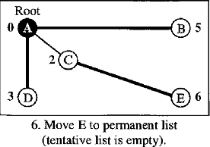

Calculation of Routing Table from Shortest Path Tree
- Each node uses the shortest path tree protocol to construct its routing table.
- The routing table shows the cost of reaching each node from the root. The below table shows routing table for Node A.
Node | Cost | Next Router
A | 0 | -
B | 5 | -
C | 2 | -
D | 3 | -
E | 6 | C

