UNIT-IV
Application Layer: Domain name space, Remote Logging, Telnet, electronic mail, SMTP, FTP, WWW, HTTP, SNMP.
Introduction to Sockets: Socket Types, API’s, socket addressing, socket lifecycle, socket states and security.
Socket options: getsockopt and setsockopt functions. Socket states, Generic socket option IPV6 socket option
ICMPV6 socket option IPV6 socket option and TCP socket options.

APPLICATION LAYER

DOMAIN NAME SYSTEM
The client/server programs can be divided into two categories:
- Programs that can be directly used by user.
- Programs that support other application programs.
Domain Name System (DNS) is a supporting program that is used by other programs such as E-mail.

Basic concept of DNS
The above figure shows a DNS client/server program can support an E-mail program to find the IP address of an E-mail recipient.
- A user of an E-mail program knows the E-mail address of the recipient but the IP protocol needs the IP address.
- The DNS client program sends a request to a DNS server to map the E-mail address to the corresponding IP address.
- To identify an entity TCP/IP protocols uses the IP address, which uniquely identifies the connection of a host to the Internet.
- People prefer to use names instead of numeric addresses. Hence we need a system that can map a name to an address or an address to a name. DNS is designed for this purpose.
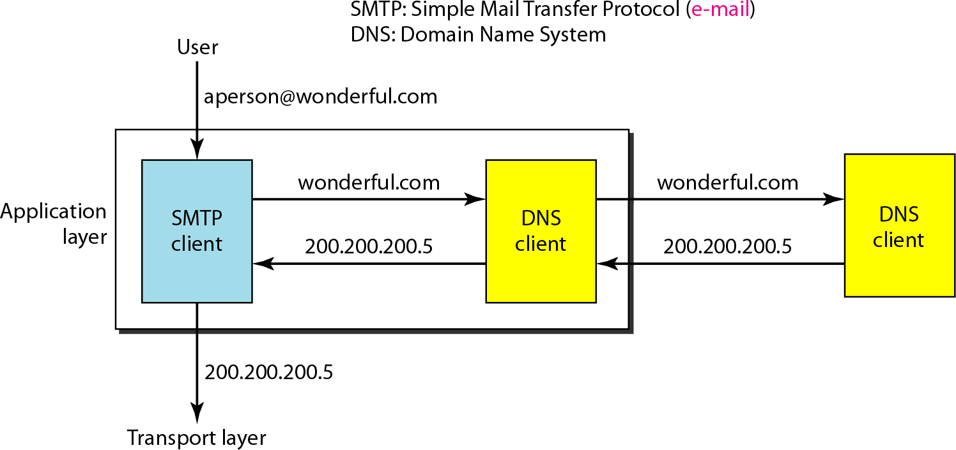
NAME SPACE
The names assigned to machines must be unique because the addresses are unique.
A name space that maps each address to a unique name can be organized in two ways:
- Flat Name Space
- Hierarchical Name Space

Flat Name Space
- In a flat name space, a name is assigned to an address.
- A name in this space is a sequence of characters without structure.
Disadvantage: Flat Name Space cannot be used in a large system such as the Internet because it must be centrally controlled to avoid ambiguity and duplication.

Hierarchical Name Space
- In Hierarchical name space, each name is made of several parts.
- The first part can define the nature of the organization, the second part can define the name of an organization, the third part can define departments in the organization etc.
- In this case, the authority to assign and control the name spaces can be decentralized.
- A central authority can assign the part of the name that defines the nature of the organization and the name of the organization only.
- The responsibility of the rest of the name can be given to the organization itself.
- The organization can add suffixes or prefixes to the name to define its host or resources.
- The management of the organization need not worry that the prefix chosen for a host is taken by another organization because, even if part of an address is the same, the whole address is different.

Example:
Assume three Education institutions named one of their computers Challenger.
The three colleges have given names by the central authority such as iitm.ac.in, berkeley.edu and smart.edu.
When these organizations add the name Challenger the names will be :
- challenger.iitm.ac.in
- challenger.berkeley.edu
- challenger.smart.edu
DOMAIN NAME SPACE
A domain name space was designed to have a Hierarchical Name Space.
In this design the names are defined in a tree structure with the root at the top. The tree can have only 128 levels: level 0 (root) to level 127.

Label
- Each node in the tree has a label, which is a string with a maximum of 63 characters. The root label is a null string (empty string).
- DNS requires that children of a node have different labels, which guarantees the uniqueness of the domain names.

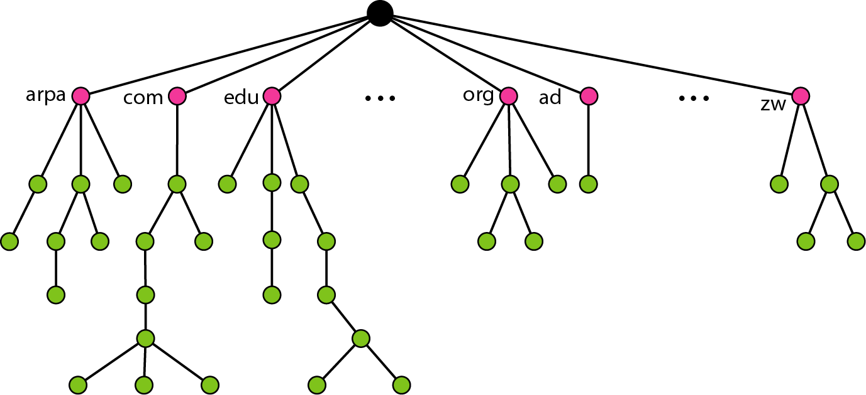

Domain Name
- Each node in the tree has a domain name. A full domain name is a sequence of labels separated by dots (.).
- Domain names are always read from the bottom to top.
- The last label is the label of the root (null). (i.e.) a full domain name always ends in a null label, which means the last character is a dot because the null string is nothing.

Fully Qualified Domain Name (FQDN)
- If a label is terminated by a null string, it is called a fully qualified domain name (FQDN).
- An FQDN is a domain name that contains the full name of a host.
- It contains all labels that uniquely define the name of the host.
- A DNS server can only match an FQDN to an address. Example: challenger.atc.fhda.edu.
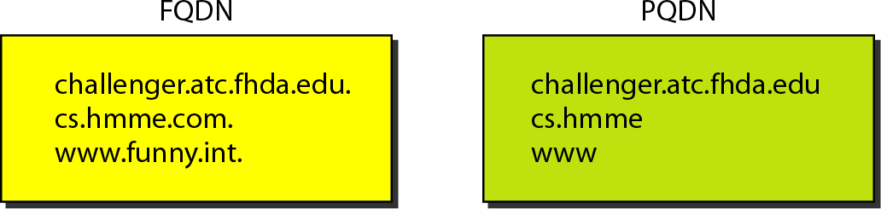

Partially Qualified Domain Name (PQDN)
- If a label is not terminated by a null string, it is called a PQDN.
- A PQDN starts from a node, but it does not reach the root.
- It is used when the name to be resolved belongs to the same site as the client.
- Here the resolver can supply the missing part, called the suffix, to create an FQDN. Example: challenger
If a user at the “fhda.edu.” site wants to get the IP address of the challenger computer, he or she can define the partial name “challenger”.
The DNS client adds the suffix “atc.fhda.edu.” before passing the address to the DNS server.
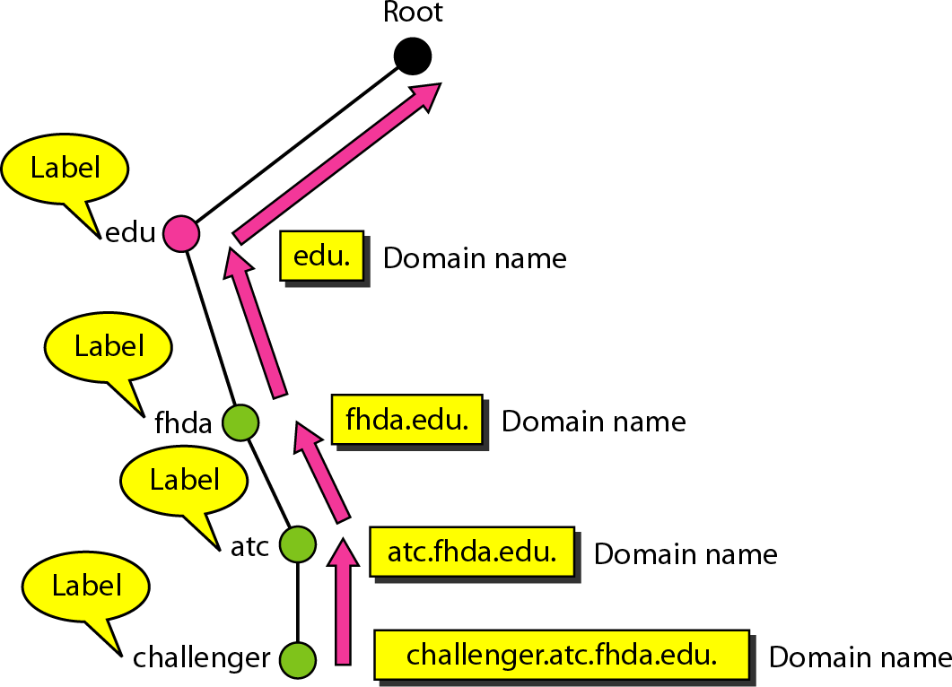
Note: The DNS client normally holds a list of suffixes such as:

atc.fhda.edu
- fhda.edu

null
These suffixes were added when the user defines an FQDN.

Domain
A domain is a sub-tree of the domain name space. The name of the domain is the domain name of the node at the top of the subtree. A domain may itself be divided into sub-domains.
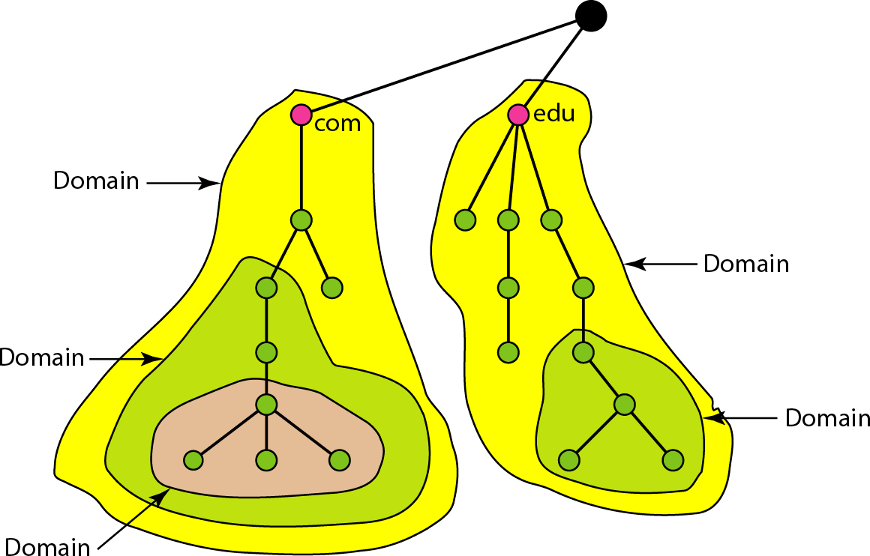
REMOTE LOGGING
In the Internet, users may want to run application programs at a remote site and create results that can be transferred to their local site.
Example: Students may want to connect to their university computer lab from their home to access application programs for doing homework assignments or projects.
A General purpose client/server program that allows a user to log-on to a remote computer to access any application program on that remote computer.
After logging on, a user can use the available services on the remote computer and transfer the results back to the local computer.

TELNET (TErminaL NETwork)
TELNET is a client/server application program. It is the standard TCP/IP protocol for virtual terminal service as proposed by the International Organization for Standards (ISO).
TELNET enables the establishment of a connection to a remote system in such a way that the local terminal appears to be a terminal at the remote system.

Timesharing Environment
TELNET works in Time Sharing Environment. The interaction between a user and the computer occurs through a terminal.

Logging
- In a timesharing environment, users are part of the system with some right to access resources. Each authorized user has Identification (UserID) and a password.
- To access the system the user logs into the system with a user id or log-in name.
- The system also includes password checking to prevent an unauthorized user from accessing the resources.

Local log-in
- When a user logs into a local timesharing system it is called local log-in.
- As a user types at a terminal the keystrokes are accepted by the terminal driver. The terminal driver passes the characters to the operating system.
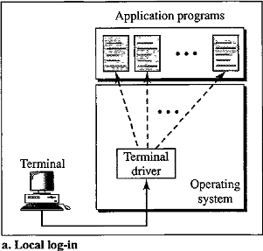
- The operating system interprets the combination of characters and invokes the desired application program or utility.

Remote Log-in
- When a user wants to access an application program or utility located on a remote machine, the user performs remote log-in. TELNET uses client and server programs.
- The user sends the keystrokes to the terminal driver, where the local operating system accepts the characters but does not interpret them.
- The characters are sent to the TELNET client, which transforms the characters to a universal character set called Network Virtual Terminal (NVT) characters and delivers them to the local TCP/IP protocol stack.
- The commands or text in NVT form travel through the Internet and arrive at the TCP/IP stack at the remote machine.
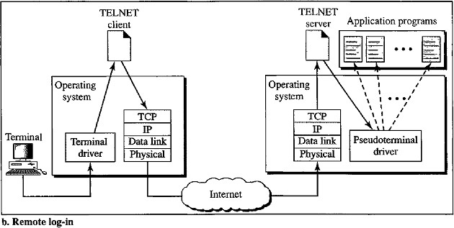

- The characters are delivered to the operating system and passed to the TELNET server, which changes the characters to the corresponding characters understandable by the remote computer.
- The characters cannot be passed directly to the operating system because the remote operating system is not designed to receive characters from a TELNET server. It is designed to receive characters from a terminal driver.
- Hence the characters can be passed to Pseudo-terminal driver which passes the characters to operating system.
- The operating system then passes the characters to the appropriate application program.

Network Virtual Terminal (NVT)
- TELNET defines a universal interface called the Network Virtual Terminal character set. Via this interface the client TELNET translates characters (data or commands) that come from the local terminal into NVT form and delivers them to the network.
- The server TELNET translates data and commands from NVT form into the form acceptable by the remote computer.

NVT Character Set
NVT uses two sets of characters, one for data and the other for control. Both are 8-bit.
- For data, NVT is an 8-bit character set in which the highest-order bit is 0 and the 7 lowest-order bits are the same as ASCII.
- To send control characters between computers (i.e.) from client to server or server to client NVT uses an 8-bit character set in which the highest-order bit is set to l.
Examples of NVT control characters such as EOF – End of File, EOR- End of Record,
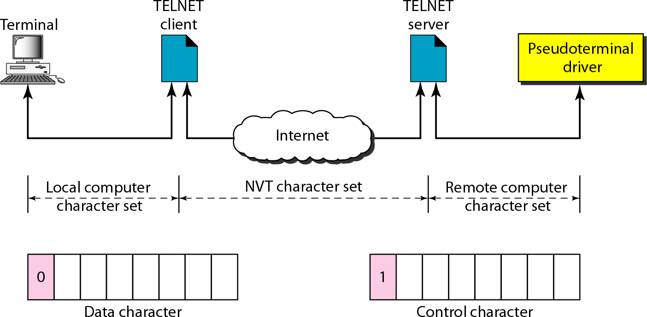
NOP- No operation etc.

Embedding
- TELNET uses only one TCP connection. The same connection is used for sending both data and control characters. TELNET accomplishes this by embedding the control characters in the data stream.
- To distinguish data from control characters, each sequence of control characters is preceded by a special control character called Interpret As Control (IAC).
- For TELNET, server uses the well-known port 23 and the client uses an ephemeral port. Example: a user wants a server to display a file (filel) on a remote server. User can type

Cat file1
Suppose the name of the file has been mistyped (filea instead of file1). The user uses the backspace key to correct this situation.

Cat filea <backspace>1

In the default implementation of TELNET the user cannot edit locally. The editing is done at the remote server.
The backspace character is translated into two remote characters (lAC EC), which are embedded in the data and sent to the remote server.
C | A | t |  | f | i | l | e | a | IAC | EC | 1

Options
Options are extra features available to a user with a more sophisticated terminal. TELNET allows the client and server negotiate options before or during the use of the service.

Option Negotiation
Option negotiation is done between the client and the server to use any of the options. Four control characters are used for this purpose: WILL, WONT, DO, DON’T.
A party can offer to enable or disable an option if it has the right to do so. The offering can be approved or disapproved by the other party.
- To offer enabling, the offering party sends the WILL command, which means "Will I enable the option?"
- The other party sends either the DO command, which means "Please do," or the DONT
command, which means "Please don't."
- To offer disabling, the offering party sends the WONT command, which means "I won't use this option any more."
- The answer must be the DONT command, which means "Don't use it anymore."

Suboption Negotiation
Some options require additional information such as defining type of terminal or speed of the terminal etc.
There are two suboption characters are defined: SB-Suboption begin, SE- Suboption End

Mode of Operation
Most TELNET implementations operate in one of three modes: Default mode, Character mode or Line mode.

Default Mode
- The default mode is used if no other modes are invoked through option negotiation.
- In this mode the echoing is done by the client.
- The user types a character and the client echoes the character on the screen (or printer) but does not send it until a whole line is completed.

Character Mode
- In the character mode each character typed is sent by the client to the server.
- The server normally echoes the character back to be displayed on the client screen.
- In this mode the echoing of the character can be delayed if the transmission time is long such as in a satellite connection.
- It also creates overhead (traffic) for the network because three TCP segments must be sent for each character of data.

Line Mode
- Line mode has been proposed to compensate for the deficiencies of the default mode and the character mode.
- In line mode, line editing (echoing, character erasing, line erasing, and so on) is done by the client. The client then sends the whole line to the server.
ELECTRONIC MAIL
Electronic mail (E-mail) is one of the most popular Internet services. E-mail allows a message to include text, audio, and video. There are Four Scenarios of E-mail:

First Scenario
- In the first scenario, the sender and the receiver of the E-mail are user application programs on the same system. They are directly connected to a shared system.
- The administrator has created one mailbox for each user where the received messages are stored.
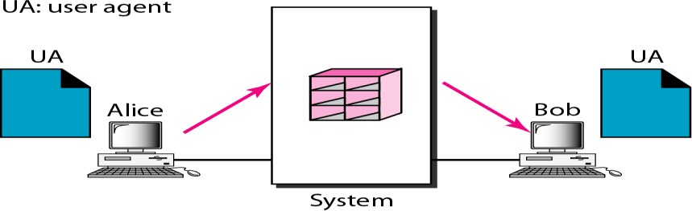
- A mailbox is part of a local hard drive and it a special file with permission restrictions. Only the owner of the mailbox has access to it.
Example: Consider the above figure, Alice and Bob are two users of mail server.
- When a user Alice needs to send a message to Bob, Alice runs a User Agent (UA) program to prepare the message and store it in Bob's mailbox.
- The message has the sender and recipient mailbox addresses (names of files).
- Bob can retrieve and read the contents of his mailbox using a User Agent.

Second Scenario
- In the second scenario, the sender and the receiver of the E-mail are user application programs on two different systems. The message needs to be sent over the Internet.
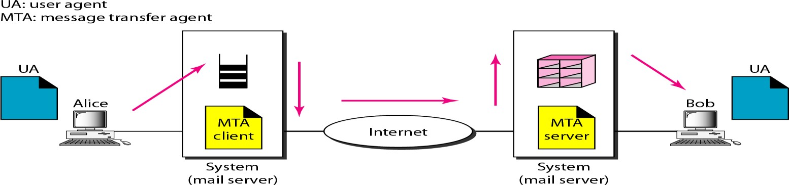
- We need User Agents (UAs) and Message Transfer Agents (MTA’s).
- Alice needs to use a user agent program to send her message to the mail server at her own site.
- The mail server at Alice site uses a queue to store messages waiting to be sent.

- Bob also needs a user agent program to retrieve messages stored in the mailbox of the system at his site.
- The message needs to be sent through the Internet from Alice's site to Bob's site. Here two Message Transfer Agents are needed: one for client and one for server.
- Most client/server programs on the Internet, the server needs to run all the time because it does not know when a client will ask for a connection.
- The client can be alerted by the system when there is a message in the queue to be sent.

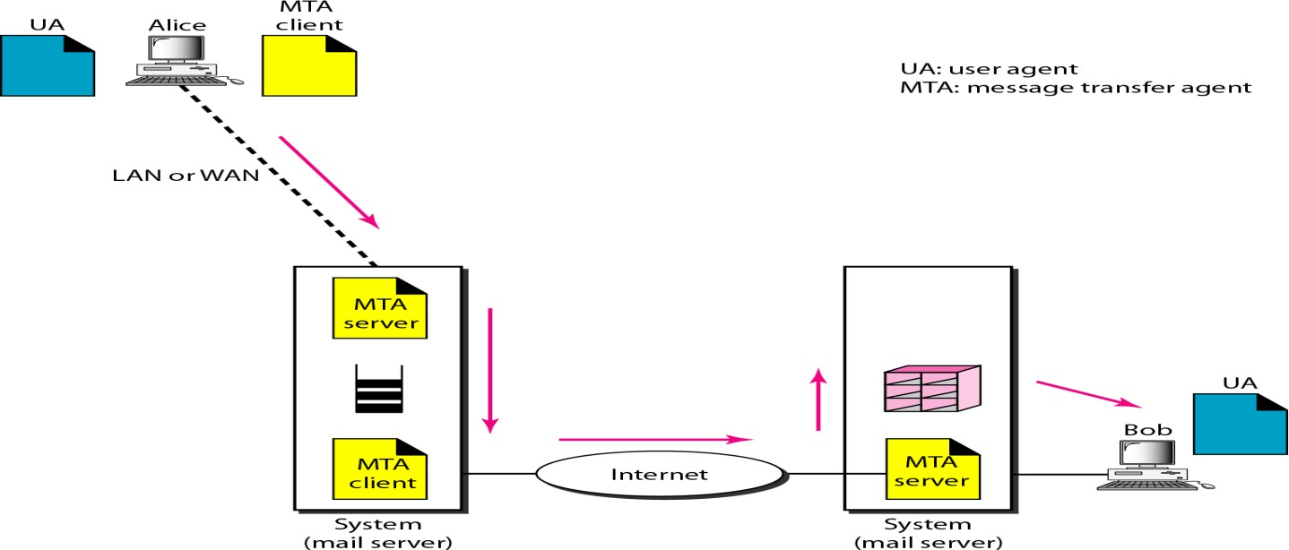
Third Scenario
- In the third scenario, Bob is directly connected to his system (i.e. Mail Server). Alice is separated from her system.
- Alice is connected to the mail server via WAN or LAN.
- In an organization that uses one mail server for handling E-mails, all users need to send their messages to this mail server.
- User agent of Alice prepares message and sends the message through the LAN or WAN.
- Whenever Alice has a message to send, Alice calls the user agent and user agent calls the MTA client.
- The MTA client establishes a connection with the MTA server on the system.
- The system at Alice's site queues all messages received. It then uses an MTA client to send the messages to the system at Bob's site. The system receives the message and stores it in Bob's mailbox.
- Bob uses his user agent to retrieve the message and reads it.
- It needs two MTA client and two MTA server programs.

Fourth Scenario
- It is the most common scenario, Alice and Bob both are connected to their mail server by a WAN or a LAN.
- After the message has arrived at Bob's mail server, Bob needs to retrieve it. Now Bob needs another set of client/server agents called Message Access Agents (MAA). Bob uses an MAA client to retrieve his messages.
- The client sends a request to the MAA server and requests the transfer of the messages.

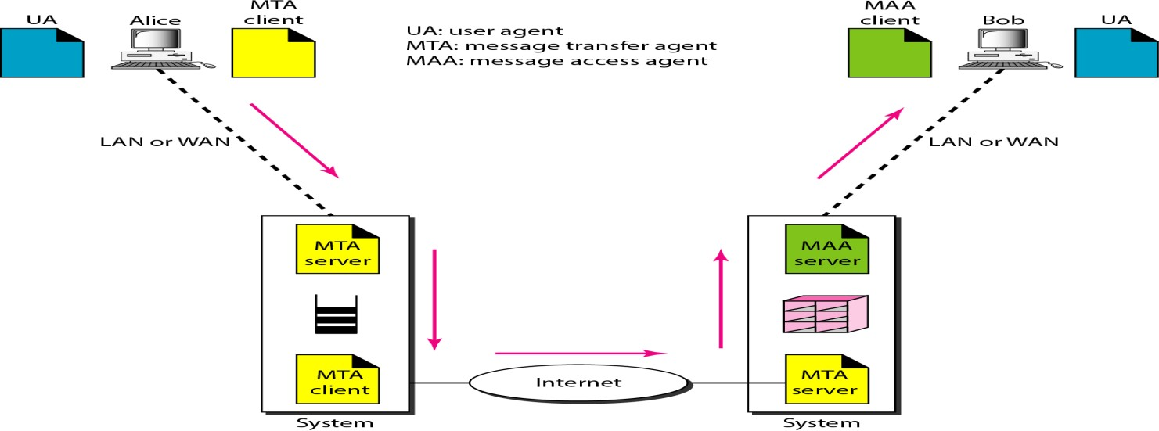

Architecture of E-mail
There are three major components in the architecture of E-mail:
    - User Agent
    - Message Transfer Agent
    - Message Access Agent
User Agent
User Agent provides services to the user to make the process of sending and receiving a message easier. Services provided by User agent are:
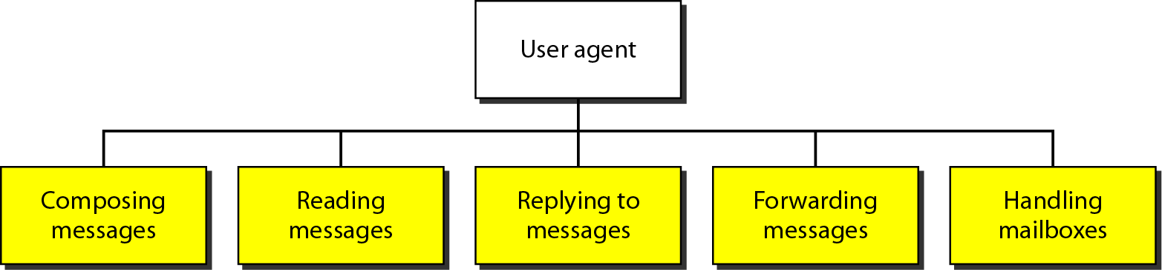

Composing Messages
A user agent helps the user to compose the E-mail message to be sent out. Most user agents provide a template on the screen to be filled in by the user.

Reading Messages
The user agent reads the incoming messages. When a user invokes a user agent, it first checks the mail in the incoming mailbox. Each E-mail contains the following fields:
- A number field.
- A flag field that shows the status of the mail such as new, already read but not replied to, or read and replied to.
- The size of the message.
- The sender.
- The optional subject field.

Replying to Messages
After reading a message, a user can use the user agent to reply to a message. A user agent allows the user to reply to the original sender or to reply to all recipients of the message.

Forwarding Messages
It means sending a message to a third party. A user agent allows receiver to forward message.

Handling Mailboxes
- A user agent normally creates two mailboxes: Inbox and Outbox.
- Inbox and Outbox is a file with a special format that can be handled by user agent.
- Inbox keeps all the received E-mails until they are deleted by the user.
- Outbox keeps all the sent E-mails until the user deletes them.
SIMPLE MAIL TRANSFER PROTOCOL (SMTP)
Message Transfer Agent: SMTP
- The actual mail transfer is done through message transfer agents (MTA).
- Simple Mail Transfer Protocol defines the MTA Client and MTA server in the internet.
- MTA Client is used to send mail and MTA Server is used to receive a mail. SMTP is used two times:
- Between sender and sender mail server.
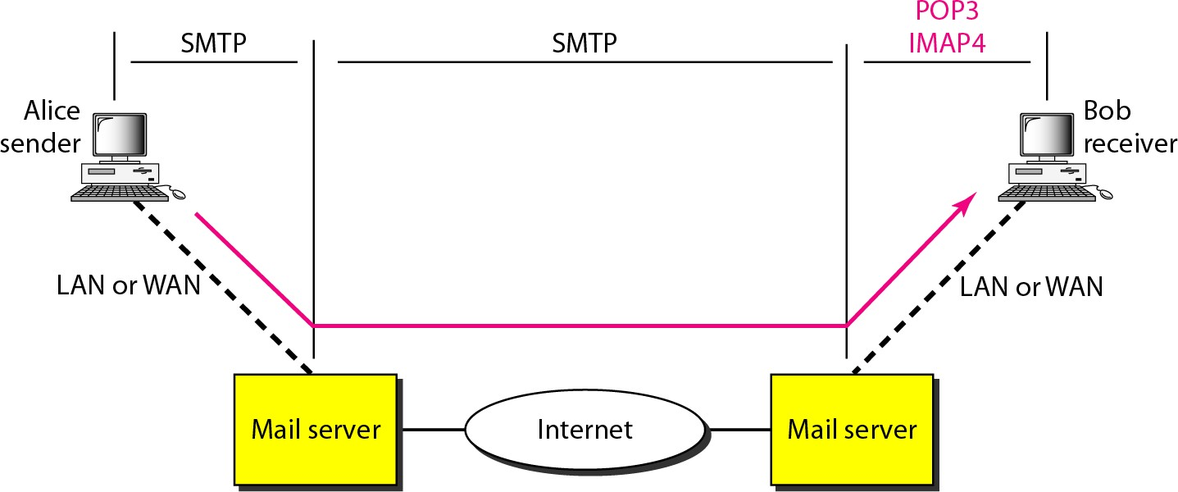
- Between sender mail server and receiver mail server.
SMTP uses commands and responses to transfer messages between an MTA client and an MTA server. Each command or reply is terminated by a two-character end-of-line token.
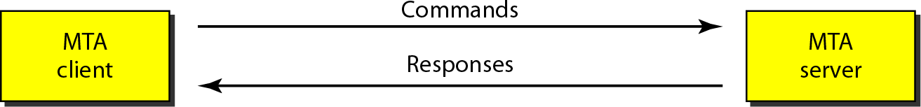

Commands
Commands are sent from the client to the server. It consists of a keyword followed by zero or more arguments.
There are five mandatory commands are used. Every implementation must support these five commands: HELO (Sender’s Host name), MAIL FROM, RCPT TO, DATA, QUIT.

Responses
Responses are sent from the server to the client. A response is a three digit code that may be followed by additional textual information.

Responses are divided into four categories: The leftmost digit of the code 2, 3, 4, and 5 defines the category.
- 2-Positive Completion Reply
- 3-Positive Intermediate Reply
- 4-Transient Negative Completion Reply
- 5-Permanent Negative Completion Reply

Mail Transfer Phases
The process of transferring a mail message occurs in three phases:
- Connection Establishment
- Mail Transfer
- Connection Termination
Message Access Agent: POP and IMAP
- The first and the second stages of mail delivery use SMTP.
- SMTP is not involved in the third stage because SMTP is a push protocol. It pushes the message from the client to the server.
- The third stage needs a pull protocol. The client must pull messages from the server. The direction of the bulk data is from the server to the client. The third stage uses a Message Access Agent.
FILE TRANSFER PROTOCOL (FTP)
File Transfer Protocol (FTP) is the standard mechanism provided by TCP/IP for copying a file from one host to another. FTP uses the services of TCP. FTP implemented to solve below problems.

Problems with File transfer
- Two systems may use different file name conventions.
- Two systems may have different ways to represent text and data.
- Two systems may have different directory structures.
FTP differs from other client/server applications in that it establishes two connections between the hosts. FTP uses two well-known ports these connections.
- Data transfer connection (Port 20 is used)
- Control connection (Port 21 is used)

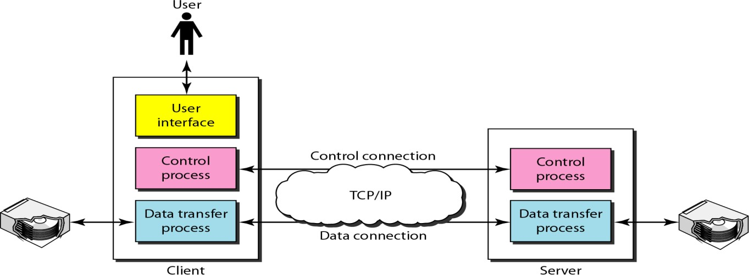
Basic Model of FTP
Consider the above figure that shows basic model of FTP that contains client and server components.
- Client has three components: User Interface, Client Control Process, and Client Data Transfer Process.
- Server has two components: Server Control Process and Server Data Transfer Process.
- The control connection is made between the control processes.
- The data connection is made between the data transfer processes.
- The control connection remains connected during the entire interactive FTP session.
- The data connection is opened and then closed for each file transferred.
- When a user starts an FTP session, the control connection opens. While the control connection is open, the data connection can be opened and closed multiple times if several files are transferred.

Communication over Control Connection
- FTP uses the same approach as SMTP to communicate across the control connection. FTP uses the 7-bit ASCII character set.
- Communication is achieved through commands and responses. FTP sends one command or response at a time.
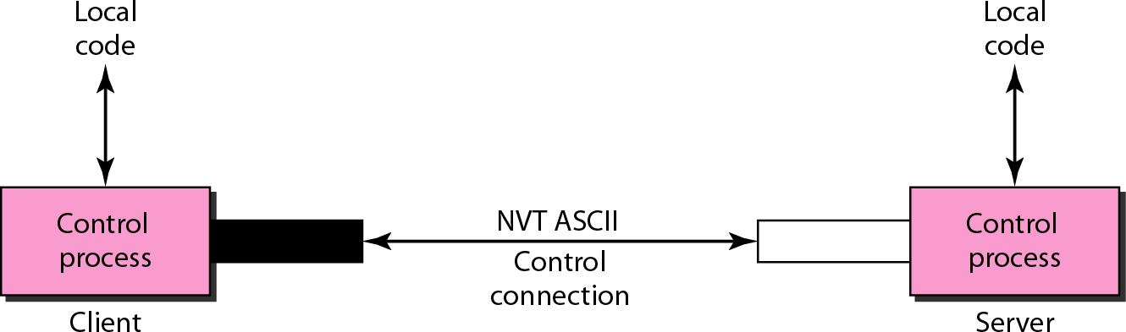
- Each command or response is only one short line. Each line is terminated with a two- character end-of-line token. (One character for carriage return and other for line feed).

Communication over Data Connection
In data connection transferring of files can be done. File transfer occurs over the data connection under the control of the commands sent over the control connection.
File transfer in FTP means one of the three things: Retrieve Store and List.
- A file is to be copied from the server to the client. This is called Retrieving a file. It is done under the supervision of the RETR command,
- A file is to be copied from the client to the server. This is called Storing a file. It is done under the supervision of the STOR command.
- A list of directory or file names is to be sent from the server to the client. This is done under the supervision of the LIST command.
The heterogeneity problem is resolved by defining three attributes of communication:
- File Type
- Data Structure
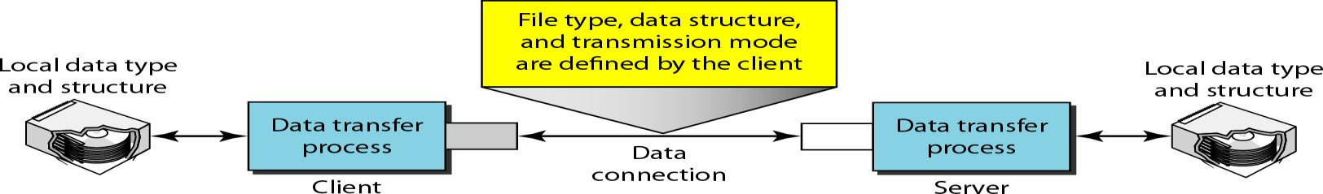
- Transmission Mode

File Type
FTP can transfer one of the following file types across the data connection: an ASCII file, image file or EBCDIC file (the file format used by IBM).

Data Structure
FTP can transfer a file across the data connection by using three types of data structure.
- File Structure: The file is a continuous stream of bytes.
- Record Structure: The file is divided into records. This can be used only with text files.
- Page Structure: The file is divided into pages and each page having a page number and a page header.

WORLD WIDE WEB (WWW)
World Wide Web (WWW) is a repository of information linked together from locations all over the world. WWW has a unique combination of flexibility, portability, and user-friendly features that distinguish it from other services provided by the Internet.
Architecture
The WWW is a distributed client/server service, in which a client using a browser can access a service using a server.
- The service provided is distributed over many locations called site.
- Each site holds one or more documents, referred to as Web pages.
- Each Web page can contain a link to other pages in the same site or at other sites is called Hyperlink.
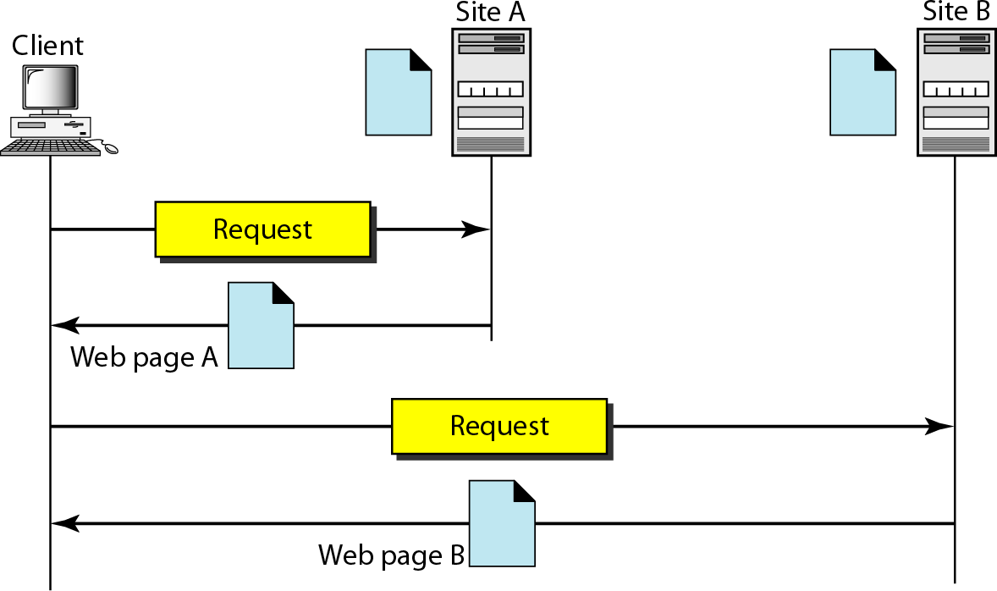
- The pages can be retrieved and viewed by using browsers.

Architecture of WWW contains four parts: 1. Client 2. Server 3. URL 4. Cookies Client (Browser)
A Client is a browser that interprets and displays a Web document.
Each browser consists of three parts: Controller, Client protocol, and Interpreters.
- The controller receives input from the keyboard or the mouse and uses the client programs to access the document.
- After the document has been accessed, the controller uses one of the interpreters to display the document on the screen.
- The interpreter can be HTML, Java, or JavaScript depending on the type of document.
- The client protocol can be FTP or HTTP.

Server
- The Web page is stored at the server. Each time a client request arrives, the corresponding document is sent to the client.
- To improve efficiency, servers normally store requested files in a cache in memory.
- A server uses multi-threading or multi-processing for answering more than one request at a time to increase the efficiency.

Uniform Resource Locator (URL)
The Uniform Resource Locator (URL) is a standard for specifying any kind of information on the Internet. A client that wants to access a Web page needs the address. To facilitate the access of documents distributed throughout the world, HTTP uses locators.
URL defines four things: Protocol, Host computer, Port, and Path.
- Protocol: It is the client/server program used to retrieve the document. Ex:FTP or HTTP.
- Host: The host is the computer on which the information is located. Web pages are usually stored in computers and computers are given alias names that usually begin with the characters "www". This is not mandatory.
- Port: The URL can optionally contain the port number of the server.
- Path: It is the pathname of the file where the information is located.
Note: The path can itself contain slashes that separate the directories from the subdirectories and files.

Cookies
Cookies are used to devise the following functionalities:
- Some websites need to allow access to registered clients only.
- Websites are being used as electronic stores (such as Flipkart or Amazon) that allow users to browse through the store, select wanted items, put them in an electronic cart, and pay at the end with a credit card.
- Some websites are used as portals: the user selects the Web pages he wants to see.
- Some websites are just advertising.

- .
HYPERTEXT TRANSFER PROTOCOL (HTTP)
The Hypertext Transfer Protocol (HTTP) is a protocol used mainly to access data on the World Wide Web. HTTP uses the services of TCP on well-known port 80.
HTTP functions as a combination of FTP and SMTP.

Similarity between HTTP and FTP
- HTTP is similar to FTP because it transfers files and uses the services of TCP.
- HTTP uses only TCP data connection to transfer the data between client and server and there is no control connection.

Similarity between HTTP and SMTP
- In HTTP, the data transferred between the client and the server look like SMTP messages.
- The format of the messages is controlled by MIME-like headers.
- HTTP messages are read and interpreted by the HTTP server and HTTP client (browser).
- SMTP messages are stored & forwarded, but HTTP messages are delivered immediately.
- The commands from the client to the server are embedded in a request message.
- The contents of the requested file or information are embedded in a response message.

HTTP Transaction
HTTP is a stateless protocol even though it uses TCP services. The client initializes the transaction by sending a request message. The server replies by sending a response.
HTTP uses two types of messages: Request, Response
- A request message consists of a request line, a header, and optional body.
- A response message consists of a status line, a header, and optional body.
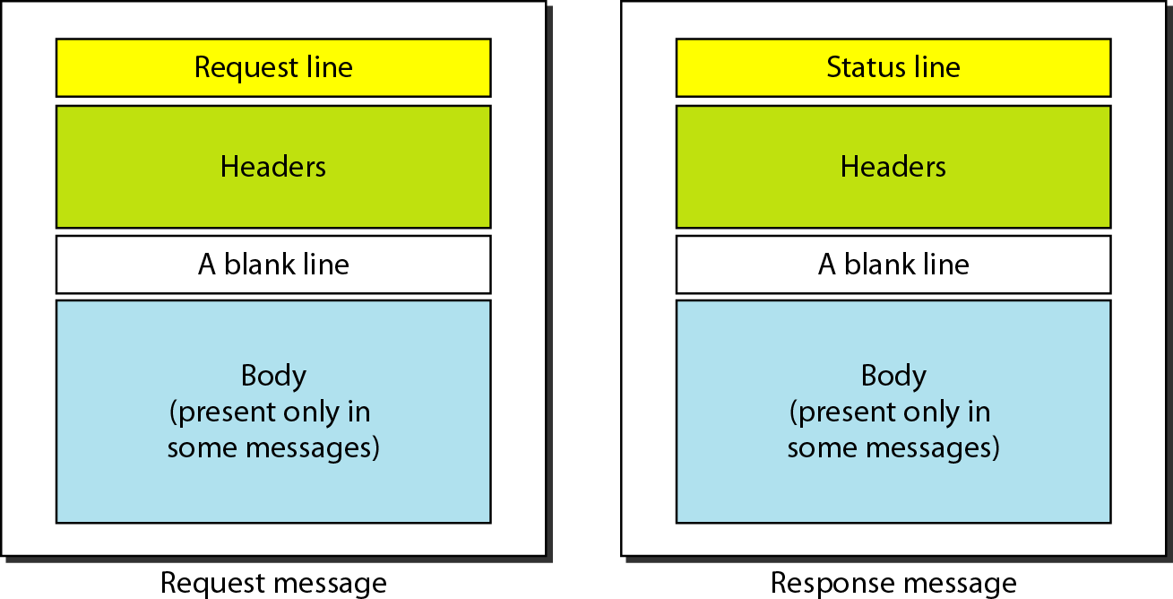

Request and Status Lines
- The first line in a request message is called a request line.
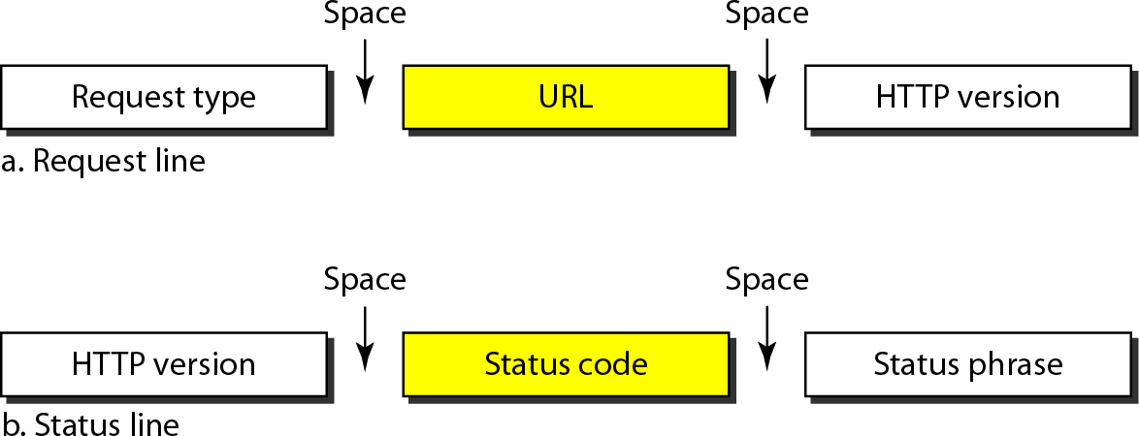
- The first line in the response message is called the status line.

Request type
This field is used in the request message. In version 1.1 of HTTP defines several request types. The request type is categorized into methods.
Methods | Action
GET | Requests a document from the server
POST | Sends some information from the client to the server
PUT | Sends a document from the server to the client
URL: By using URL, clients can access the webpage.
Version The most current version of HTTP is 1.1.
Status code is used in the response message. It consists of 3-digits. 100, 200, 300, 400, 500.
Status phrase: It explains the status code in text form, it is used in the response message.
Status Code | Status phrase | Description
100 | Continue, switch | Informational
200 | OK, CREATED, ACCEPTED | Successful request
300 | Moved Permanently or temporarily, Not modified. | Redirect Client to  another URL
400 | 400- Bad request, 404- Not found, | Error at client side
500 | 500- Internal server error 503-Service unavailable | Error at server side

Header
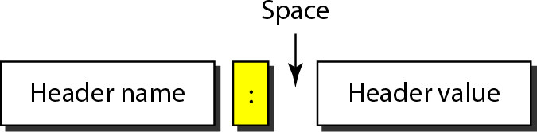
The header exchanges additional information between the client and the server. The header can consist of one or more header lines.
A Header line can be divided into 4 categories: 1. General 2.Request 3.Response 4.Entity.
- A request message can contain Request header, General header, Entity header.
- A response message can contain Response header, General header, Entity header.

General header
General header gives general information about the message such as Date, MIME version.

Request header
Request header specifies the client's configuration and the client's preferred document format. Example: Accept: Shows the medium format the client can accept
From: Shows the E-mail address of the user
Host: Shows the host and port number of the server Referrer: Specifies the URL of the linked document User agent: Identifies the client program.

Response header
This header specifies the server's configuration and special information about the request. Example: Age: shows the age of the document, public: shows the supported list of methods, server: shows the server name and address.

Entity header
The entity header gives information about the body of the document. some request messages such as POST or PUT methods may contain a body also use this type of header.

Examples: Etag- Gives an entity tag, Content-type- Specifies the medium type, Last- modified- Gives the date and time of the last change etc.

Body
The body can be present in a request or response message. Body contains the document to be sent or received.

Example of HTTP transaction
Consider the below figure that shows how to retrieve a document.
- We use the GET method to retrieve an image with the path /usr/bin/imagel.
- The request line shows the method (GET), the URL, and the HTTP version (1.1).
- Header has two lines that show the client can accept images in the GIF or JPEG format.
- The request does not have a body.
- The response message contains the status line and four lines of header.
- The header lines define the date, server, MIME version, and length of the document.
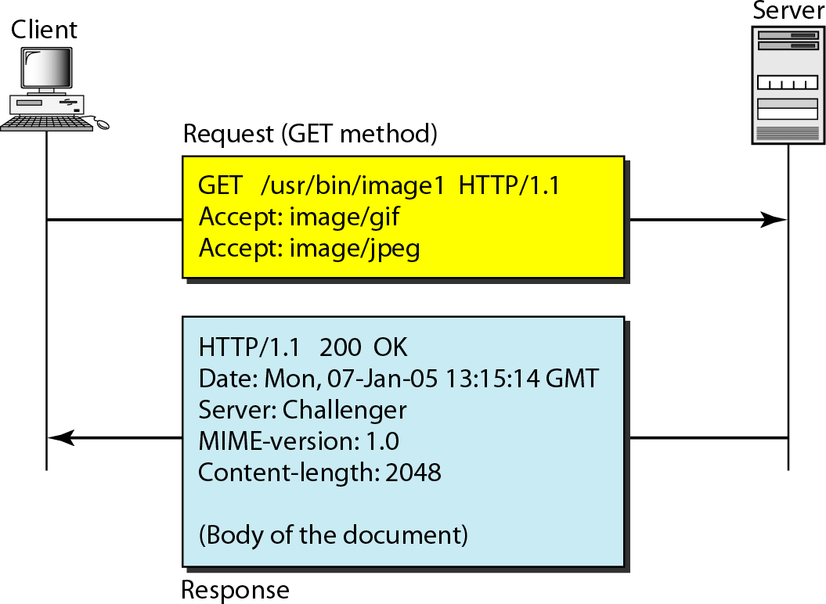
- The body of the document follows the header.

HTTP Connections
Non-persistent connection
Versions before 1.1 use Non-persistent method as the default connection. In this connection, one TCP connection is made for each request/response.
The steps involved in this strategy:
- The client opens a TCP connection and sends a request.
- The server sends the response and closes the connection.
- The client reads the data until it encounters an end-of-file marker after that the client closes the connection.
In this strategy, for N different pictures in different files, the connection must be opened and closed N times.
The Non-persistent strategy imposes high overhead on the server because the server needs N different buffers and requires a slow start procedure each time a connection is opened.

Persistent Connection
- Persistent connection is the default in HTTP version 1.1.
- In this connection, the server leaves the connection open for more requests after sending a response.
- Server can close the connection at the request of a client or if a time-out has been reached.

- The sender sends the length of the data with each response. If the sender does not know the length of the data then document is created dynamically or actively.
- The server informs the client that the length is not known and closes the connection after sending the data so the client knows that the end of the data has been reached.

Proxy Server
HTTP supports Proxy Servers. A Proxy server is a computer that keeps copies of responses to recent requests.
- The HTTP client sends a request to the proxy server. The proxy server checks its cache.
- If the response is not stored in the cache, the proxy server sends the request to the corresponding server.
- Incoming responses are sent to the proxy server and stored for future requests from other clients.
- Proxy server reduces the load on the original server, decreases traffic and improves latency.
- To use the proxy server, the client must be configured to access the proxy instead of the target server.

SIMPLE NETWORK MANAGEMENT PROTOCOL (SNMP)
The Simple Network Management Protocol (SNMP) is a framework for managing devices in an internet using the TCP/IP protocol suite. It provides a set of fundamental operations for monitoring and maintaining an internet.

Concept of SNMP
  - SNMP is an application level protocol that uses the concept of Manager and Agent.
  - A manager controls and monitors a set of agents.
  - A manager may be a host and an Agent may be a router.
  - SNMP can monitor devices made by different manufacturers and installed on different physical networks.
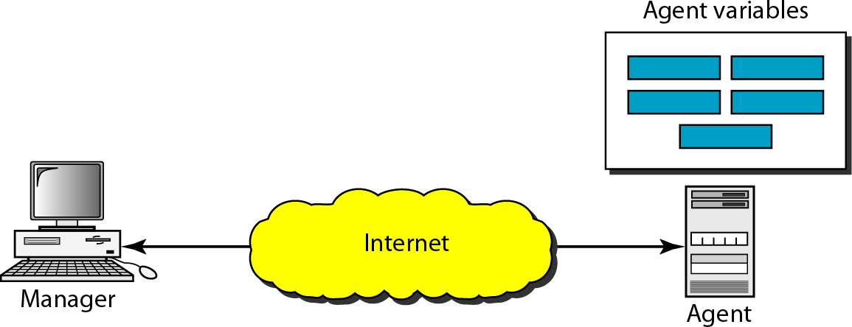
  - SNMP can be used in LANs and WANs connected by routers.

Managers and Agents
  - A Manager or a management station is a host that runs the SNMP client program.
  - An Agent or a Managed station is a router or a host that runs the SNMP server program.
Management is achieved through simple interaction between a manager and an agent.
  - Agent keeps performance information in a database.
  - Manager has access to the values in the database.
Example: A router can store in variables such as the number of packets received and forwarded. The manager can fetch and compare the values of these two variables to see if the router is congested or not.
Management with SNMP is based on three basic ideas:
  - A manager checks an agent by requesting information that reflects the behavior of the agent.
  - A manager forces an agent to perform a task by resetting values in the agent database.
  - An agent contributes to the management process by sending warning message to the manager of an unusual situation. The warning message is called the trap.

Management Components
  - SNMP uses two other protocols to do management tasks: Structure of Management Information (SMI) and Management Information Base (MIB).

Structure of Management Information (SMI)
The Structure of Management Information version 2 (SMIv2) is a component for network management. Functions of SMI are:
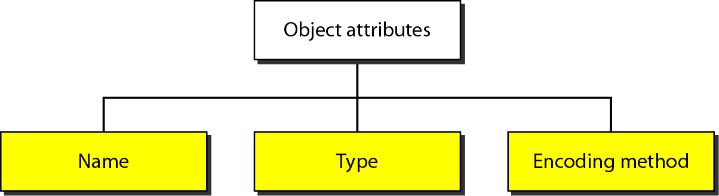

Name
  - SMI requires that each managed object (such as a router, a variable in a router, a value) have a unique name.
  - To name objects globally SMI uses an object identifier, which is a hierarchical identifier based on a tree structure. The tree structure starts with an unnamed root.
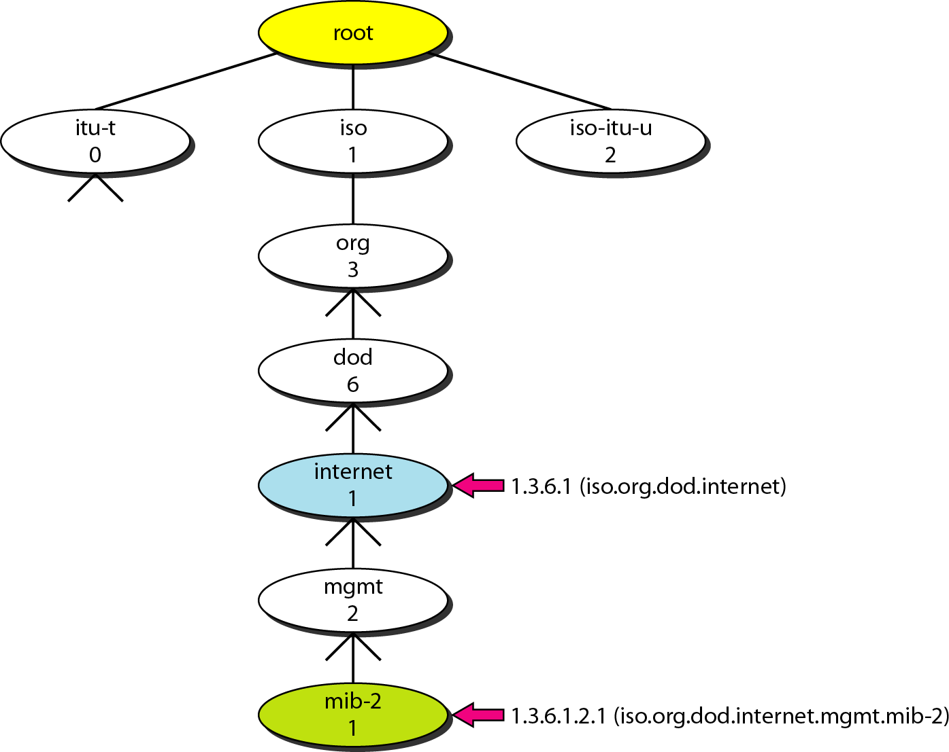

  - Each object can be defined by using a sequence of integers separated by dots.
  - Tree structure can also define an object by using a sequence of textual names separated by dots.
  - The integer-dot representation is used in SNMP. The name-dot notation is used by people.
Example: The following shows the same object in two different notations:

iso.org.dod.internet.mgmt.mib-2 → 1.3.6.1.2.1
Type
  - To define the data type, SMI uses fundamental Abstract Syntax Notation 1 (ASN.l).
  - SMI has two broad categories of data type: Simple and Structured.

Simple Type
The simple data types are atomic data types sucha as Integer32, Octet String, IP address etc.

Structured Type
By combining simple and structured data types, we can make new structured data types. SMI defines two structured data types: Sequence and Sequence of.
  - A Sequence data type is a combination of simple data types, not necessarily of the same type. It is similar to the concept of a struct used in C programming.
  - A Sequence of data type is a combination of simple data types all of the same type. It is similar to the concept of an array used in C-programming.

Encoding Method
SMI uses another standard Basic Encoding Rules (BER) to encode data to be transmitted over the network. BER specifies data to be encoded in following format: Tag, Length and Value.
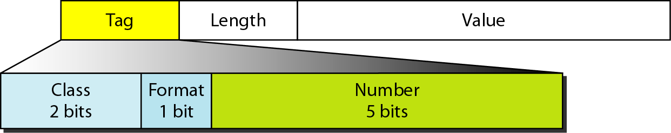

Tag
The tag is a 1-byte field that defines the type of data. It is composed of three subfields:
  - Class (2 bits): It defines the scope of the data.
Four classes are defined: 00- universal, 01-Application wide, 10- context specific, 11- private.
  - Format subfield indicates whether the data are simple (0) or structured (1).
  - Number subfield further divides simple or structured data into subgroups.
Example: In the universal class with simple format, INTEGER has a value of 2, OCTET STRING has a value of 4.

Length
  - The length field is 1 or more bytes.
  - If it is 1 byte, the most significant bit must be 0. Other 7 bits define the length of the data.
  - If it is more than 1 byte, the most significant bit of the first byte must be 1. The other 7 bits of the first byte define the number of bytes needed to define the length.
Value field codes the value of the data according to the rules defined in BER.

Example: Show the following in encoding representation:
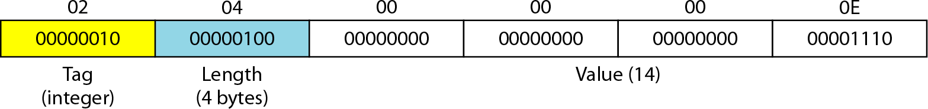
- Define INTEGER 14.
- Define OCTET STRING “HI”
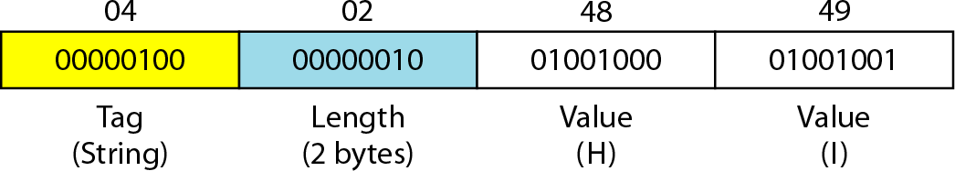

Management Information Base (MIB2)
  - MIB version 2 is the second component used in network management.
  - MIB creates a collection of named objects, their types and their relationships to each other in an entity to be managed.
  - Each agent has its own MIB2, which is a collection of all the objects that the manager can manage.
  - The objects in MIB2 are categorized under 10 different groups: system, interface, address translation, ip, icmp, tcp, udp, egp, transmission, and snmp.
  - These groups are under the MIB-2 object in the object identifier tree.
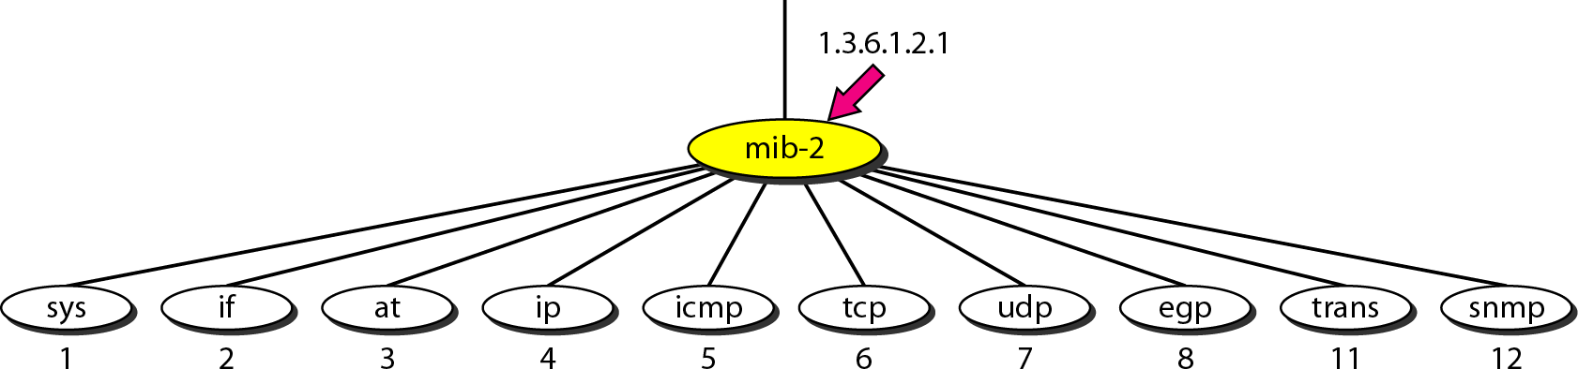
  - Each group has defined variables and tables.

Accessing MIB Variables
Let us take UDP group to show how to access different variables. To access any of the simple variables, we use the id of the group (1.3.6.1.2.1.7) followed by the id of the variable.
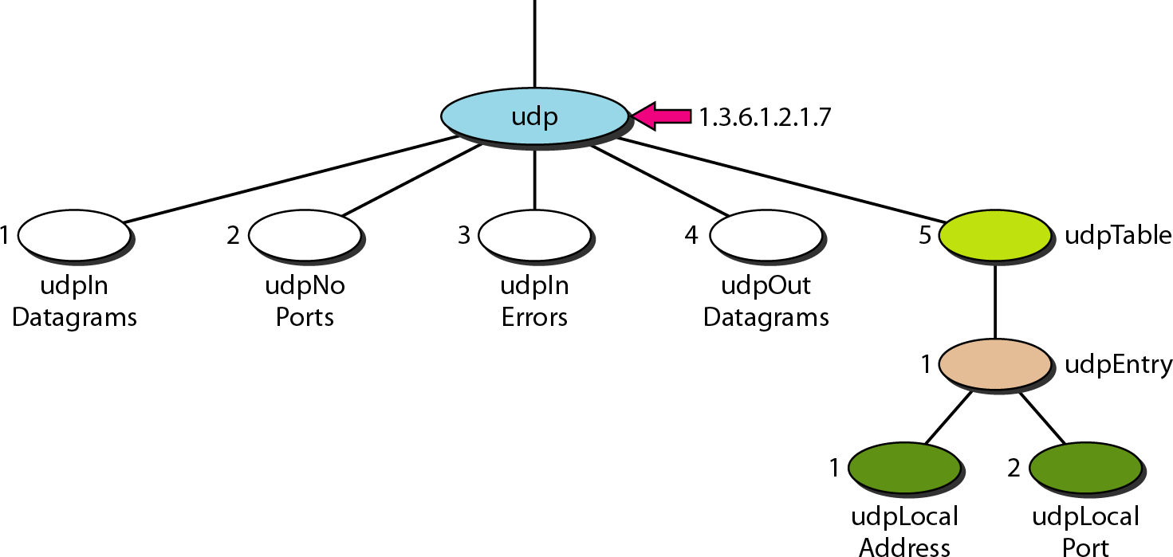
The following shows how to access each variable:
udpInDatagrams | → | 1.3.6.1.2.1.7.1
udpNoPorts | → | 1.3.6.1.2.1.7.2
udpInErrors | → | 1.3.6.1.2.1.7.3
udpOutDatagrams | → | 1.3.6.1.2.1.7.4

The object identifiers define the variable not instances (contents). An instance suffix “0” should be added to show the instance of each variable.
udpInDatagrams.0 | → | 1.3.6.1.2.1.7.1.0
udpNoPorts.0 | → | 1.3.6.1.2.1.7.2.0
udpInErrors.0 | → | 1.3.6.1.2.1.7.3.0
udpOutDatagrams.0 | → | 1.3.6.1.2.1.7.4.0

Tables
To identify a table, we first use the table id. To access the table, we have to define the table entries.
udpTable → 1.3.6.1.2.1.7.5
udpEntry → 1.3.6.1.2.1.7.5.1
To access the entry we need to define each entity (field) in the entry.
udpLocalAddress → 1.3.6.1.2.1.7.5.1.1
udpLocalPort → 1.3.6.1.2.1.7.5.1.2
  - To access a specific instance (row) of the table, we add the index to the above ids. To access the instance of the local address for the first row, we use the identifier augmented with the instance index:
udpLocalAddress.181.23.45.14.23 → 1.3.6.1.2.7.5.1.1.181.23.45.14.23

