  - have used laravel framework and Redis server in order to implement the solution for the given scenario.Laravel gives fast MVC design with secure .Redis server ,i have used my personel remote server ,35.162.31.222 .redis configurations are available in database.php under config folder.

2.please refer guide.txt and db_setup.txt

3.My approach
- Telecom gate way sends data over API ,http://localhost/azeem-test/code/web/az/blog/index?msisdn=60123456789&operatorid=3&shortcodeid=8&text=ON+GAMES
- We store the received data into redis cache only wit starting key letter is “T”
- There is a cronjob that runs every minute to store the data which are stored into redis-cache and it deletes the cached data once storing into DB ,http://localhost/azeem-test/code/web/az/blog/storedb

4.Answer for Ur questions.

Goal 1
I have used MVC framework business logics are separated by using lib folder(myfunctions.php)

please refer the following files.
blog/app/Http/Controller/
blog/app/Mo.php
blog/app/lib/myfunctions.php

Unit test
blog/tests/TokenTest.php

Goal2
http://localhost/azeem-tes/code/web/az/blog/stats

id,created_at are indexed
note :created_at is actual time that our system received , updated_at is inserted time into DB.

Getting max date and Min date by sorting with last 10k records ,please refer blog/app/lib/myfunctions.php.

Bonus1
curl http://localhost/object/code/web/az/blog/unprocessed-cache

Bonus 2
curl http://localhost/object/code/web/az/blog/delete-cache

5.As I had problem to connect virtualBox over vagrant ,sorry I couldn't do the virtual-box configuration given screen shot shows the issues that I faced.

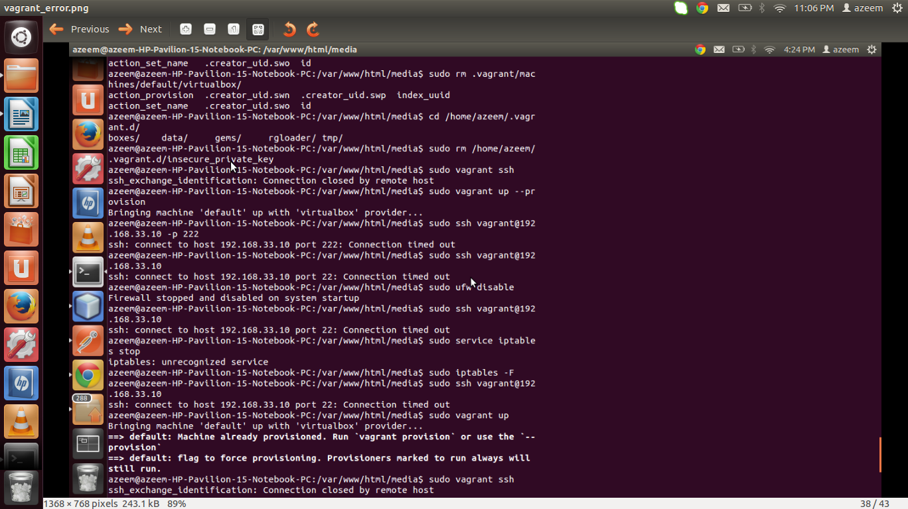

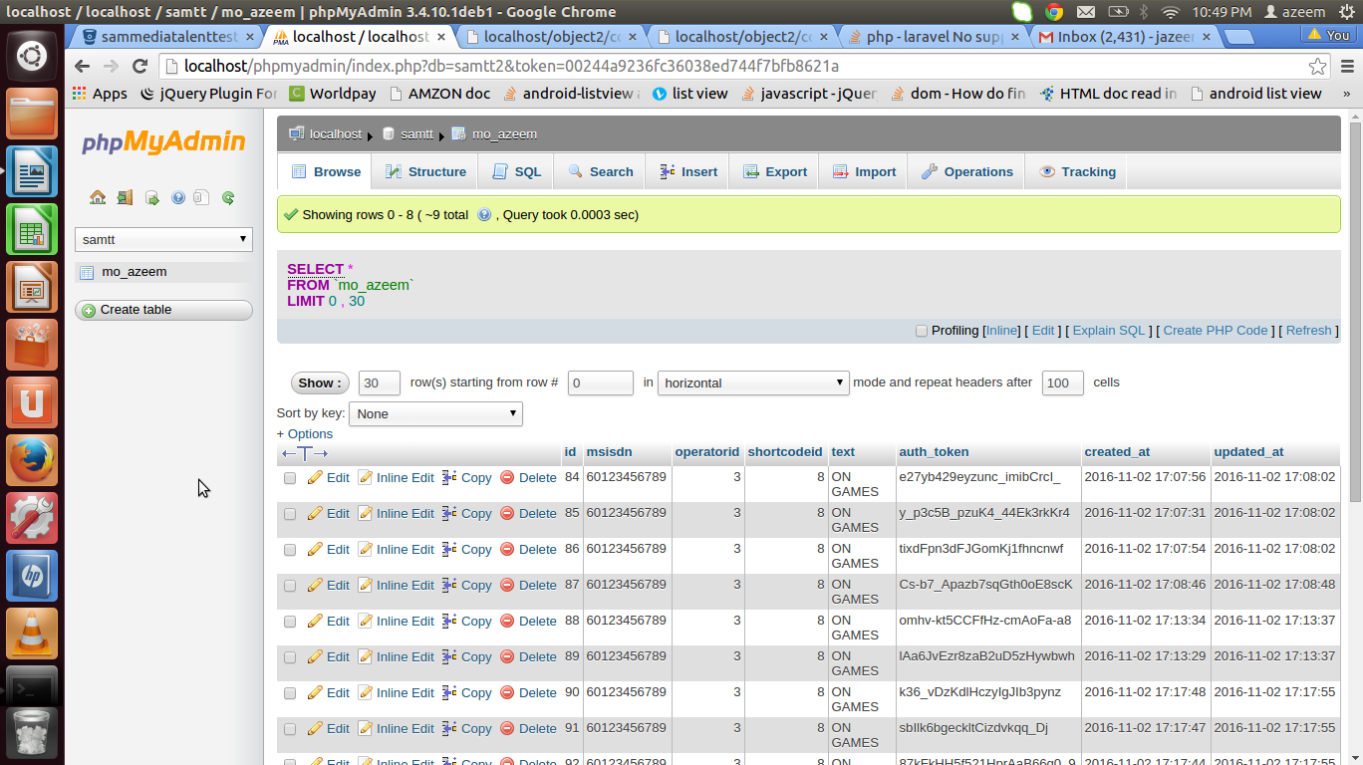

Some screens of my works are given below.

