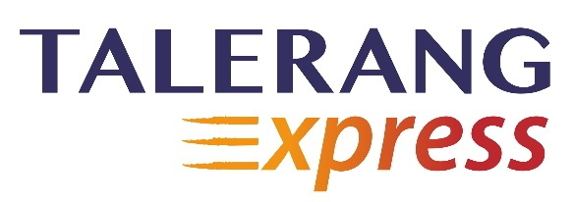

**Placement Express (Pre-Placement Program on Talerang Express):**

[**Click here to register for this program.**](http://www.talerang.com/express/placementregister.php) **Price: Rs. 3500/- + applicable taxes**

1. **Exclusive online training by the pioneers of work-readiness in India**

* Get access to a certificate course offering 30 hours of work-readiness training followed by placement preparation
* The course has been designed to complement the student’s college schedule. It can be paced by a student as 30 days - 1 hour per day
* Methodology includes e-learning through videos, webinars, Skype interactions with experts and case studies

1. **Personalized feedback and mentorship**

* 5 hours of submissions that the student can upload online and receive feedback within a period of 48 hours
* The student will receive coaching on picking the right job, assessing his / her skills, creating a resume and experiencing a mock interview

1. **Industry connect**

* Access to internships and jobs for students who demonstrate the required capability in the course
* Access to industry experts and veterans
* Live mock interview and mentoring session, as well as a walk-in meeting option at Talerang offices across the country

**Suggested weekly plan for the program:**

* **Week 1:** Take the **Work-Readiness Aptitude Predictor (WRAP)** as a first step!
* **Week 2:** Receive training through **interactive** **webinars** to bridge your skill gap. You will be required to submit *work on this which would be as an upload on the portal. (Submission 1)*
* **Week 3:** Take the **Skill-track selector assessment** to find out which skill-track is apt for you!
* **Week 4:** Submit in-depth project work on the skill track that was selected by you in the previous week. (PPT uploaded - Submission 2)
* **Week 5:** Make use of the **Resume creator tool** to build the perfect resume for yourself! (Submit it to Team Talerang for final edits and corrections - Submission 3)
* **Week 6:** Get access to an exclusive **mentoring session** with Team Talerang! We provide feedback on the project you have worked on during week 4. You can then sign-up for a **mock interview** (20-30 minutes) using the portal. Finally, you will be required to give us details for a reference check using Industry Connect (Submission 4).
* **Week 7 & 8:** The program ends with students getting access to relevant internships and jobs!