This document outlines the architecture of a web application that integrates various components such as an API server, a database, third-party services, a notification system, and a testing and deployment pipeline. The architecture is designed to provide a clear understanding of how these components interact with each other to deliver a seamless user experience.
Architecture Components
1. API Server (Express.js)
The API server is built using Express.js, a fast and minimalist web framework for Node.js. It serves as the backbone of the application, handling incoming requests, processing data, and communicating with the database and other services.
2. Database (MongoDB)
MongoDB is used as the database for storing application data. It is a NoSQL database that provides flexibility in data modeling and scalability. The API server interacts with MongoDB to perform CRUD (Create, Read, Update, Delete) operations on the data.
3. Third-Party Integrations (Google Maps)
The application integrates with Google Maps to provide location-based services. This integration allows users to access maps, geolocation, and other location-related functionalities directly within the application.
4. Notification System (Email Notifications)
To keep users informed, the application includes a notification system that sends email notifications. This system can be triggered by specific events within the application, ensuring that users receive timely updates and alerts.
5. Testing and Deployment Pipeline (GitHub)
The testing and deployment pipeline is managed through GitHub. Continuous Integration/Continuous Deployment (CI/CD) practices are implemented to automate testing and deployment processes. This ensures that code changes are tested and deployed efficiently, maintaining the integrity of the application.
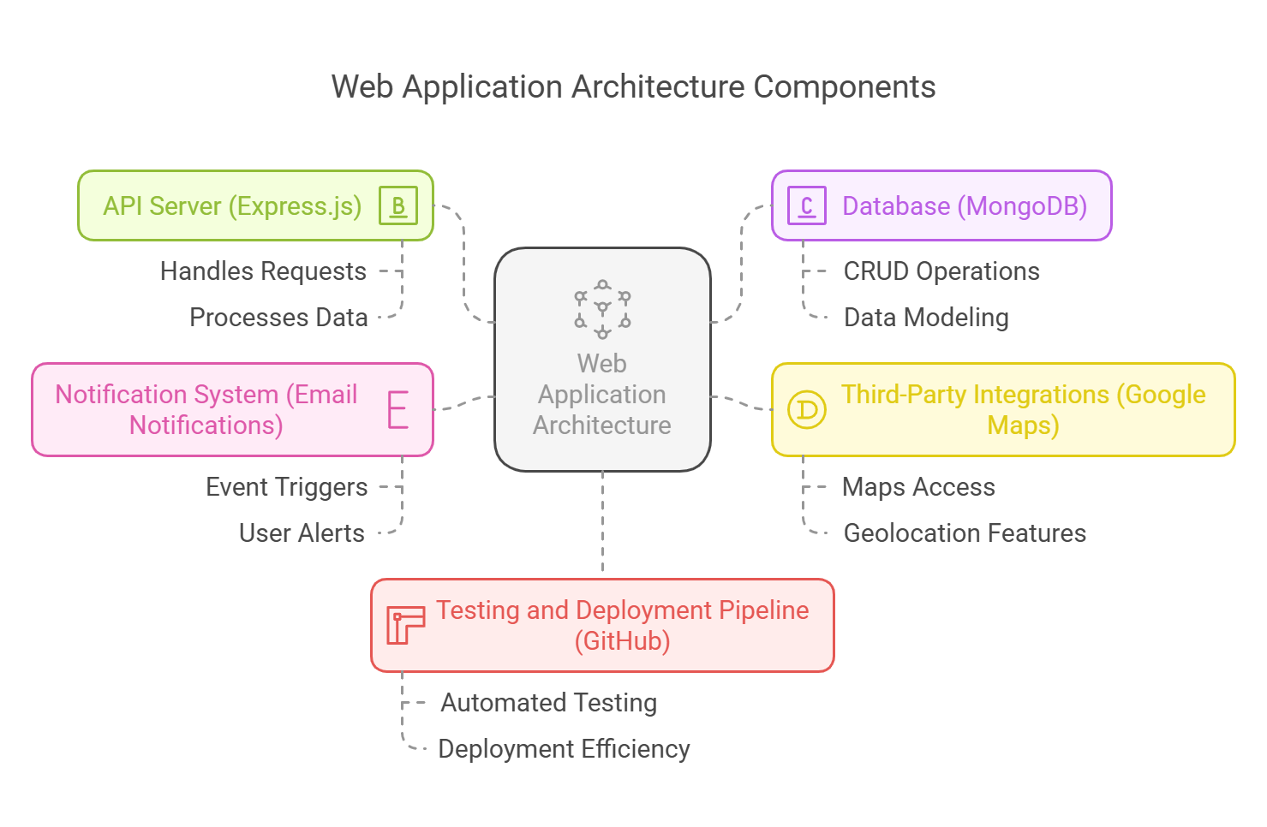
Conclusion
This architecture diagram provides a comprehensive overview of the components involved in the web application. Each component plays a crucial role in ensuring the application runs smoothly and efficiently, providing users with a robust experience. By leveraging modern technologies and best practices, the application is designed to be scalable, maintainable, and user-friendly.

