RECRUITMENT FRAUD DETECTION IN ONLINE JOB PORTALS

Graduation Project Report
Department of Computer Science / Information Technology
Final Year Project Submission

Prepared for partial fulfillment of the requirements for the Bachelor Degree

Prepared By: Student Team
Supervised By: ____________________
Academic Year: 2025 - 2026

ABSTRACT
This project presents a machine learning based recruitment fraud detection system for online job portals. The system preprocesses job advertisement text, transforms it using TF-IDF, and evaluates multiple classification models including Logistic Regression, Naive Bayes, Support Vector Machine, and Random Forest. The selected model is integrated into a Flask web application that supports shared authentication, role-based access, responsive multi-page navigation, administrative monitoring, and prediction logging. The system aims to reduce the risk of online recruitment scams and improve trust in digital hiring environments.

ACKNOWLEDGMENT
We would like to express our sincere gratitude to our supervisor, department staff, committee members, colleagues, and families for their support, guidance, and encouragement during the completion of this graduation project.

COMMITTEE REPORT
This project entitled “Recruitment Fraud Detection in Online Job Portals” has been reviewed by the graduation committee and found suitable for submission and oral discussion.
Committee Member | Role | Signature
____________________ | Chairperson | ____________________
____________________ | Member | ____________________
____________________ | Member | ____________________

TABLE OF CONTENT

CHAPTER 1

1.1 Introduction
Online recruitment platforms have made job searching and candidate selection faster, cheaper, and more accessible. At the same time, they have opened a new attack surface for cybercriminals who publish fraudulent job advertisements to steal personal information, collect illegal fees, or trick job seekers into financial transactions.

1.2 Previous Work
Previous work in fraud detection often relied on manual moderation, static keyword blacklists, and complaint-based review. While those methods are useful for basic filtering, they do not scale well and can miss evolving scam patterns that use professional language and realistic job descriptions.

1.3 Problem Statement
The rapid increase in online job postings makes manual inspection inefficient. Fraudulent recruitment posts can appear highly convincing, which creates a need for an automated system that can analyze textual content and classify suspicious advertisements using machine learning.

1.4 Scope
This project focuses on English-language text classification for job advertisements. The implemented system covers dataset preprocessing, feature extraction with TF-IDF, machine learning model comparison, a Flask-based web application, shared sign-in with role-based access control, multi-page responsive interfaces, and an administrative dashboard for prediction monitoring.

1.5 Objectives
- Develop a machine learning system that classifies job posts as legitimate or fraudulent.
- Compare multiple algorithms and select the best one using evaluation metrics.
- Provide a user-facing web interface with separate overview, prediction, and signals pages.
- Provide an administrator dashboard for monitoring prediction activity and stored results.
- Provide responsive navigation that adapts from desktop top navigation to a mobile sidebar menu.
- Document the system thoroughly for graduation-level evaluation.

1.6 Advantages
- Reduces the effort required for manual checking of suspicious posts.
- Helps protect job seekers from scams and identity theft.
- Provides reproducible model evaluation and system monitoring.
- Can be extended in the future to larger datasets and live APIs.

1.7 Disadvantages
- Prediction quality depends on the size and quality of the training dataset.
- The current implementation focuses on textual content and not multimedia or external link analysis.
- Fraud strategies may evolve and require retraining or feature updates.

1.8 Software requirements
Category | Tools / Technologies
Programming Language | Python 3.x
Web Framework | Flask
Machine Learning | scikit-learn, joblib
Data Processing | pandas, NumPy
Frontend | HTML, Tailwind CSS, JavaScript, Chart.js, responsive mobile sidebar UI
Database | SQLite
Documentation | DOCX report generated for graduation submission

1.9 HARDWARE REQUIREMENTS
Component | Requirement
Processor | Intel Core i3 or equivalent
RAM | Minimum 4 GB, recommended 8 GB
Storage | At least 20 GB free space
Internet | Required for package installation and dataset acquisition

1.10 Software Methodology
The project follows an incremental development methodology. Requirements were identified from the fraud-detection use case, a baseline dataset was prepared, multiple models were trained and compared, and the best-performing model was integrated into a Flask web application. Testing was performed using automated unit and route tests.

1.11 project plan
Phase | Description | Expected Output
Phase 1 | Problem analysis and proposal writing | Defined scope, objectives, risks
Phase 2 | Dataset preparation and preprocessing | Clean labeled job posting data
Phase 3 | Model development and evaluation | Best-performing ML model
Phase 4 | Web application implementation | Authentication, multi-page UI, prediction page, and admin dashboard
Phase 5 | Testing and documentation | Validated system and graduation report

The final trained model selected by the system is Logistic Regression with feature count 169.
Model | Accuracy | Precision | Recall | F1-Score
Logistic Regression | 1.0 | 1.0 | 1.0 | 1.0
Naive Bayes | 1.0 | 1.0 | 1.0 | 1.0
Support Vector Machine | 1.0 | 1.0 | 1.0 | 1.0
Random Forest | 0.5 | 0.5 | 1.0 | 0.6667

CHAPTER 2

2.1 Introduction
This chapter reviews the background and related work associated with online recruitment fraud detection. It also discusses examples of similar systems and how this project differs from them.

2.2 Related work
Related work in fraud detection includes spam classification, phishing email analysis, deceptive review detection, and suspicious account monitoring. Many of these approaches use machine learning to extract patterns from text. The current project adapts that general idea specifically to online job advertisements and combines it with an accessible web interface.

2.2.1 Similar Apps and websites
Platform / App | Relevance | Limitation Compared with This Project
LinkedIn | Major recruitment platform with reporting tools | Does not expose a student-built explainable fraud classifier
Indeed | Large-scale job listing system | Manual reporting is still heavily relied upon
Glassdoor | Company and job review platform | Not focused on automated fraud prediction
Research prototypes | Show text-classification approaches | Often lack an end-to-end deployable dashboard

CHAPTER 3

3.1 Introduction
This chapter describes how system requirements were identified and organized. It covers data collection assumptions, questionnaire-style elicitation, and the final functional and non-functional requirements.

3.2 Data Collection from Questionnaire
A questionnaire-based approach can be used to understand how job seekers and administrators perceive recruitment fraud. Because this project focuses on system implementation, the questionnaire summary below is presented as a requirements-oriented sample for academic documentation.
Question | Response Trend | Interpretation
Have you seen suspicious job posts online? | High | Users frequently encounter potential scams
Do you verify employer identity manually? | Medium | Users need automated assistance
Would you use a fraud prediction tool before applying? | Very High | There is demand for the solution
Should admins see a monitoring dashboard? | High | Administrative oversight is important

3.3 REQUIREMENTS ELICITATION
- The system shall allow users and administrators to authenticate through a shared sign-in page.
- The system shall allow separate user sign-up and admin sign-up flows.
- The system shall accept job description text as input.
- The system shall classify the input as legitimate or fraudulent.
- The system shall save prediction records to the database.
- The system shall display overview, prediction, and signals pages to authenticated users.
- The system shall display dashboard statistics to administrators only.
- The system shall adapt navigation for desktop and mobile devices.

3.4 REQUIREMENTS SPECIFICATION
Requirement Type | Requirement
Functional | Shared sign-in with role-based redirect for users and admins
Functional | Separate user sign-up and admin sign-up with admin code
Functional | Job text prediction using a trained ML model
Functional | Prediction logging and dashboard visualization
Functional | Separate overview, predict, signals, and dashboard pages
Non-functional | Responsive Tailwind CSS interface for mobile and desktop
Non-functional | Modular code structure and automated tests
Non-functional | Reasonable response time for single text predictions

CHAPTER 4

4.1 Introduction
This chapter presents the system analysis and design models used to describe the structure and behavior of the recruitment fraud detection system.

4.2 Structural Static Models

4.2.1 Class diagram
The class diagram describes the main software entities and their relationships, including user authentication, prediction processing, and database storage.
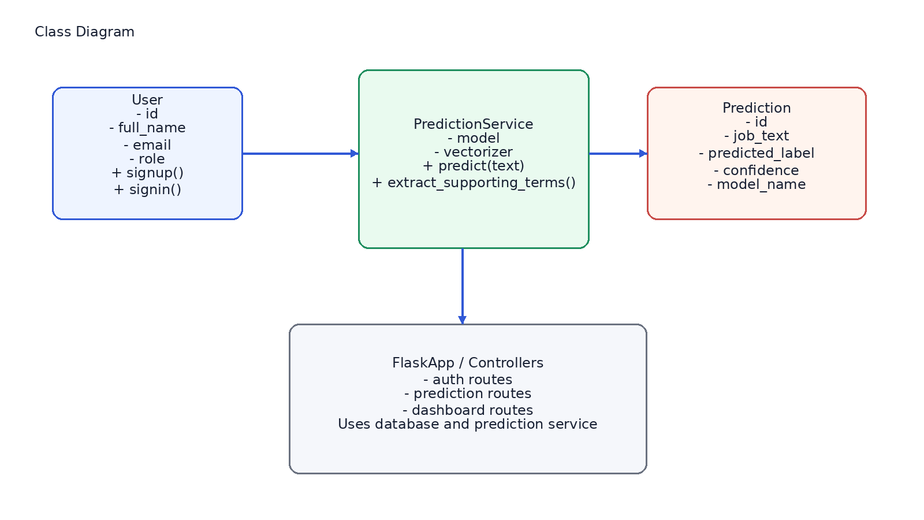

4.3 Dynamic Models

4.3.1 Sequence diagram
The sequence diagram shows the interaction between the user, Flask interface, prediction service, and database during the prediction workflow.
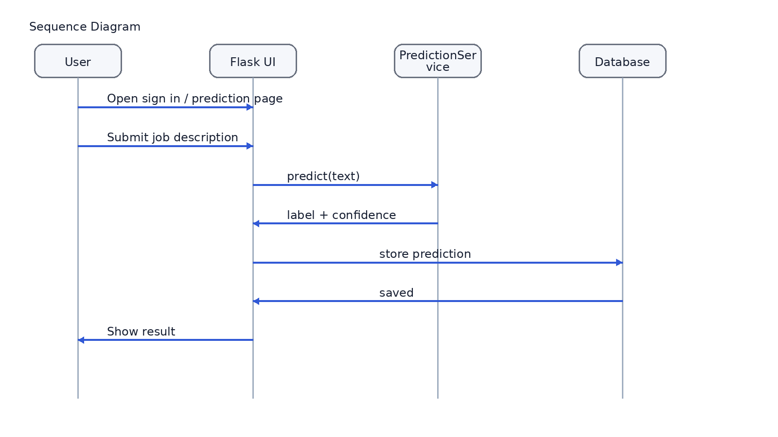

4.3.2 Activity Diagram
The activity diagram illustrates the flow from login to text submission and prediction storage.
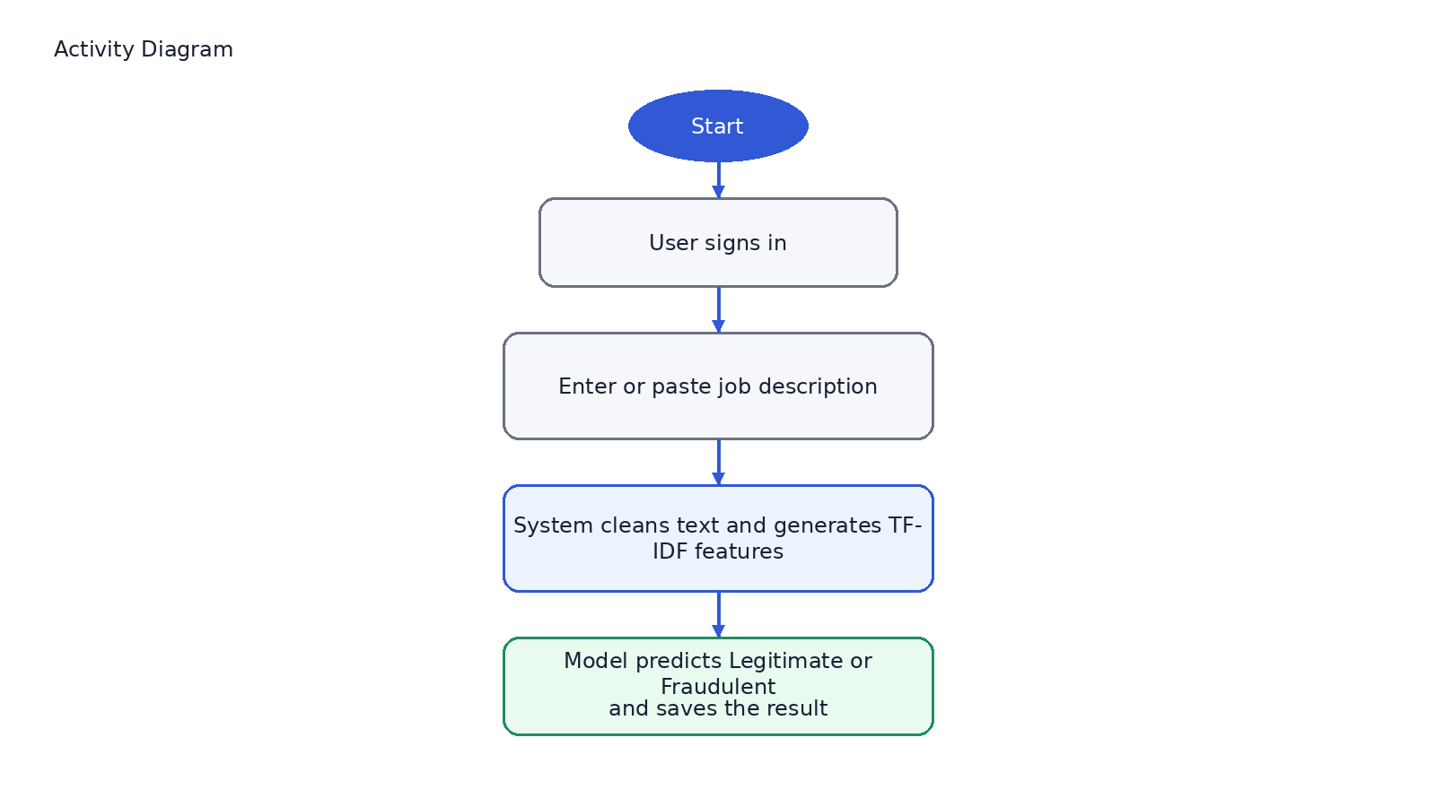

CHAPTER 5

5.1 Data Modeling
The application stores user records and prediction records in SQLite. User records support authentication and role-based access, while prediction records capture the analysis performed by the machine learning component.

5.2 Database Entities and Attributes (Schema)
Entity | Attributes
users | id, full_name, email, password_hash, role, created_at
predictions | id, job_text, predicted_label, model_name, confidence, input_length, created_at

5.3 Database Relationships Description
The current implementation stores users and predictions as separate entities. Predictions are generated through authenticated sessions and represent the system outputs produced during user interaction. In future work, explicit ownership between users and predictions can be added as a foreign-key relation for user-level audit trails.

5.4 Interfaces
Interface | Purpose | Main Elements
Shared sign-in page | Authenticate both users and admins | Email, password, role-based redirect
User sign-up page | Create standard user accounts | Name, email, password
Admin sign-up page | Create admin accounts | Name, email, password, admin code
Overview page | Summarize system purpose and quick metrics | Stat cards, process summary, navigation
Prediction page | Submit job text and view prediction | Textarea, sample inputs, result card
Signals page | Explain fraud and legitimate indicators | Reference cards and guidance text
Dashboard | Monitor stored outputs | Metric cards, chart, recent predictions table

CHAPTER 6

6.1 Database design
The database design is intentionally lightweight because the project is a graduation prototype. SQLite is sufficient for storing authentication records and prediction history while simplifying deployment and demonstration.
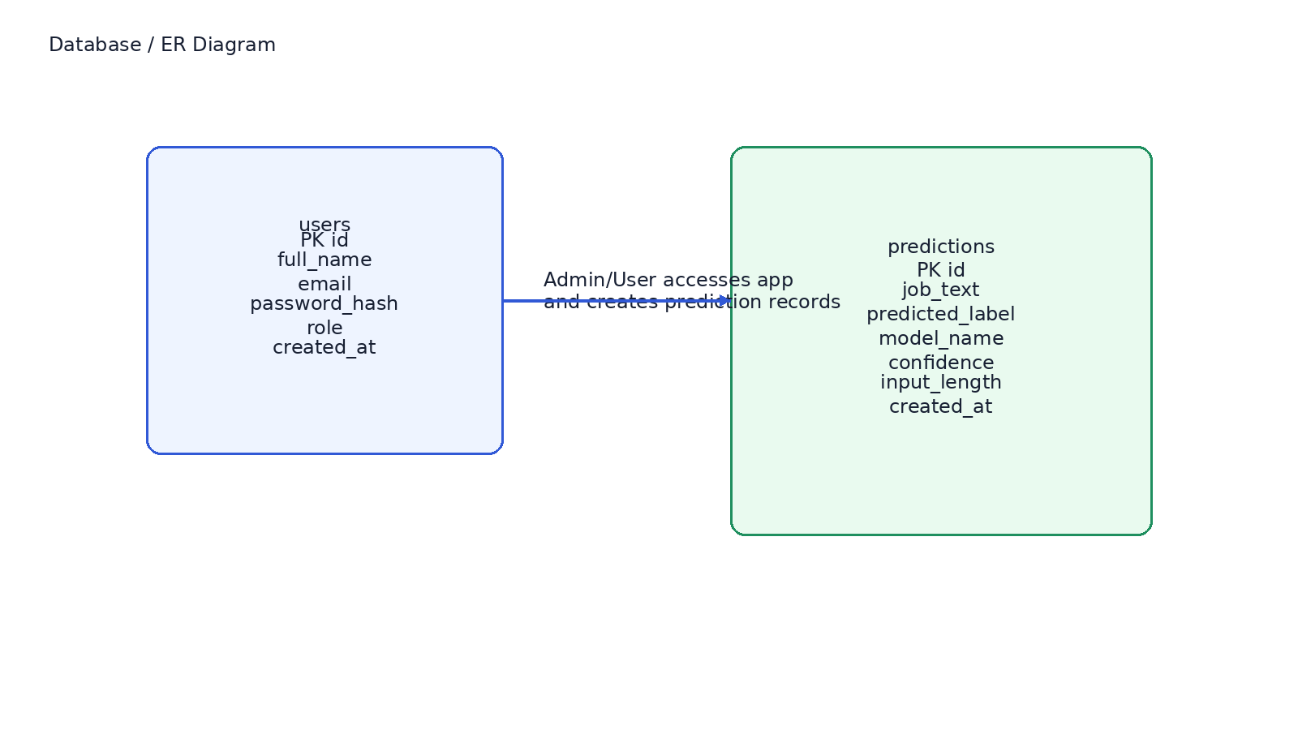
Design Decision | Reason
SQLite selected | Simple deployment and no external DB server required
users table | Supports role-based access control
predictions table | Stores results for analytics and auditing
model_name column | Tracks which ML model generated the result
input_length column | Supports basic dashboard statistics

CHAPTER 7

APPENDIX (CODES)
Selected code excerpts from the implementation are included below to demonstrate the structure of the developed system.

Main Flask Routes
from __future__ import annotations
import json
import os
from functools import wraps
from pathlib import Path
from typing import Any, Callable
from flask import Flask, flash, g, jsonify, redirect, render_template, request, session, url_for
from werkzeug.security import check_password_hash, generate_password_hash
from src.database import (
create_user,
ensure_demo_user,
get_dashboard_metrics,
get_label_counts,
get_model_usage,
get_recent_predictions,
get_user_by_email,
get_user_by_id,
initialize_database,
insert_prediction,
)
from src.predictor import ModelArtifactsMissingError, PredictionService
BASE_DIR = Path(__file__).resolve().parent
DEFAULT_EXAMPLES = [
{
"title": "Fraud-style example",
"text": "Urgent remote opportunity. Earn thousands weekly with no interview. Submit your passport copy and onboarding fee today to secure your slot.",
},
{
"title": "Legitimate-style example",
"text": "We are hiring a backend engineer to build Flask APIs, write automated tests, and collaborate with product managers in a full-time hybrid role.",
},
]
def load_model_metrics(model_dir: Path) -> dict[str, Any]:
metrics_path = model_dir / "model_metrics.json"
metadata_path = model_dir / "model_metadata.json"
if not metrics_path.exists() or not metadata_path.exists():
return {}
with open(metrics_path, "r", encoding="utf-8") as metrics_file:
metrics = json.load(metrics_file)
with open(metadata_path, "r", encoding="utf-8") as metadata_file:
metadata = json.load(metadata_file)
return {
"metrics": metrics,
"metadata": metadata,
}
def login_required(view: Callable) -> Callable:
@wraps(view)
def wrapped_view(*args, **kwargs):
if g.current_user is None:
flash("Please sign in first.", "error")
return redirect(url_for("user_signin"))
return view(*args, **kwargs)
return wrapped_view
def admin_required(view: Callable) -> Callable:
@wraps(view)
def wrapped_view(*args, **kwargs):
if g.current_user is None:
flash("Please sign in as admin first.", "error")
return redirect(url_for("user_signin"))
if g.current_user["role"] != "admin":
flash("Admin access is required for this page.", "error")
return redirect(url_for("index"))
return view(*args, **kwargs)
return wrapped_view
def create_app(test_config: dict[str, Any] | None = None) -> Flask:
app = Flask(__name__)
app.config["SECRET_KEY"] = os.getenv("SECRET_KEY", "recruitment-fraud-detection-secret")
app.config["DATABASE_PATH"] = str(BASE_DIR / "data" / "predictions.db")
app.config["MODEL_DIR"] = str(BASE_DIR / "models")
app.config["DEMO_EXAMPLES"] = DEFAULT_EXAMPLES
app.config["ADMIN_SIGNUP_CODE"] = os.getenv("ADMIN_SIGNUP_CODE", "admin123")
if test_config:
app.config.update(test_config)
initialize_database(app.config["DATABASE_PATH"])
ensure_demo_user(
app.config["DATABASE_PATH"],
full_name="Demo User",
email="user",
password_hash=generate_password_hash("user"),
role="user",
)
ensure_demo_user(
app.config["DATABASE_PATH"],
full_name="Demo Admin",
email="admin",
password_hash=generate_password_hash("admin"),
role="admin",
)
try:
predictor = PredictionService(model_dir=Pat

Prediction Service
from __future__ import annotations
import json
from pathlib import Path
from typing import Any
import joblib
import numpy as np
from src.data_preprocessing import clean_text
class ModelArtifactsMissingError(FileNotFoundError):
"""Raised when trained model files are not available."""
class PredictionService:
def __init__(self, model_dir: Path):
self.model_dir = Path(model_dir)
self.model_path = self.model_dir / "fraud_detector.joblib"
self.vectorizer_path = self.model_dir / "tfidf_vectorizer.joblib"
self.metadata_path = self.model_dir / "model_metadata.json"
if not self.model_path.exists() or not self.vectorizer_path.exists():
raise ModelArtifactsMissingError("Missing model artifacts.")
self.model = joblib.load(self.model_path)
self.vectorizer = joblib.load(self.vectorizer_path)
self.metadata = self._load_metadata()
def _load_metadata(self) -> dict:
if self.metadata_path.exists():
with open(self.metadata_path, "r", encoding="utf-8") as file:
return json.load(file)
return {}
def _extract_supporting_terms(self, transformed_text) -> list[str]:
feature_names = self.vectorizer.get_feature_names_out()
if hasattr(self.model, "coef_"):
scores = transformed_text.multiply(self.model.coef_[0]).toarray()[0]
elif hasattr(self.model, "feature_importances_"):
scores = transformed_text.multiply(self.model.feature_importances_).toarray()[0]
else:
return []
ranked_indices = np.argsort(scores)[::-1]
terms: list[str] = []
for index in ranked_indices:
if scores[index] <= 0:
continue
term = str(feature_names[index])
if term not in terms:
terms.append(term)
if len(terms) == 5:
break
return terms
def _build_risk_summary(self, label: str, supporting_terms: list[str]) -> list[str]:
if label == "Fraudulent":
summary = [
"The text contains language patterns frequently associated with scam recruitment posts.",

Database Layer
from __future__ import annotations
import sqlite3
from typing import Any
def get_connection(database_path: str) -> sqlite3.Connection:
connection = sqlite3.connect(database_path)
connection.row_factory = sqlite3.Row
return connection
def initialize_database(database_path: str) -> None:
with get_connection(database_path) as connection:
connection.execute(
"""
CREATE TABLE IF NOT EXISTS users (
id INTEGER PRIMARY KEY AUTOINCREMENT,
full_name TEXT NOT NULL,
email TEXT NOT NULL UNIQUE,
password_hash TEXT NOT NULL,
role TEXT NOT NULL CHECK(role IN ('user', 'admin')),
created_at TEXT NOT NULL DEFAULT CURRENT_TIMESTAMP
)
"""
)
connection.execute(
"""
CREATE TABLE IF NOT EXISTS predictions (
id INTEGER PRIMARY KEY AUTOINCREMENT,
job_text TEXT NOT NULL,
predicted_label TEXT NOT NULL,
model_name TEXT NOT NULL DEFAULT 'Unknown',
confidence REAL NOT NULL,
input_length INTEGER NOT NULL DEFAULT 0,
created_at TEXT NOT NULL DEFAULT CURRENT_TIMESTAMP
)
"""
)
existing_columns = {
row["name"]
for row in connection.execute("PRAGMA table_info(predictions)").fetchall()
}
if "model_name" not in existing_columns:
connection.execute(
"ALTER TABLE predictions ADD COLUMN model_name TEXT NOT NULL DEFAULT 'Unknown'"
)
if "input_length" not in existing_columns:
connection.execute(
"ALTER TABLE predictions ADD COLUMN input_length INTEGER NOT NULL DEFAULT 0"
)
connection.commit()
def create_user(
database_path: str,
full_name: str,
email: str,
password_hash: str,
role: str,
) -> int:
with get_connection(database_path) as connection:
cursor = connection.execute(
"""
INSERT INTO users (full_name, email, password_hash, role)
VALUES (?,

