Predictive Risk Model for Fireworks Storage
Method, mathematics, warehouse parameters, datasets and model training

1. What the model does
The digital twin predicts what the real-time sensor graph will look like before the sensors reach a risky state. It has two parts: (a) physics equations that describe how temperature and gas concentration behave in the warehouse, and (b) an online estimator that fits the rates in those equations to the live sensor data every second. Extending the fitted equations forward in time draws the predicted curve. The time at which the predicted curve crosses the risk-onset level is the early-warning time.
- Forecast horizon: 120 s ahead (the requirement is at least 10 s). A 10-second check compares the forecast made 10 s earlier with the actual sensor value now.
- Warning rule: warn when the predicted risk onset is 60 s or less away, so the alert comes about one minute before the risk rating starts to increase.
- Risk onset: the point where temperature exceeds 32 °C or the gas index exceeds 15, the levels at which the risk score begins to rise.

2. Mathematical model

2.1 Self-heating of the stored chemical
Heat release of an energetic material grows with temperature following the Arrhenius law. For a small temperature rise above the starting temperature T₀ (in kelvin) the rate is expanded to first order:
 | 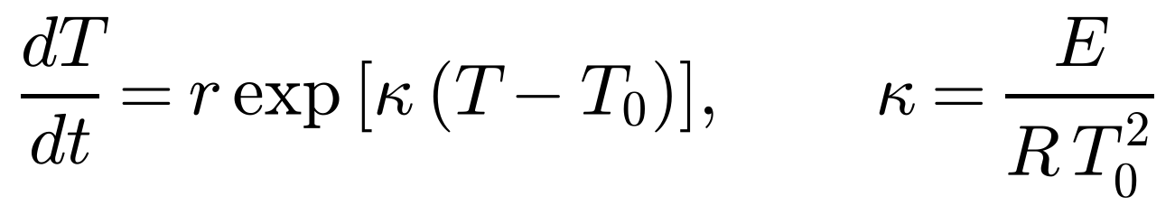 | (1)
 | 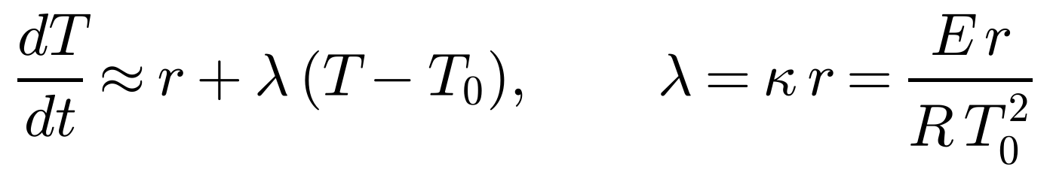 | (2)
 | 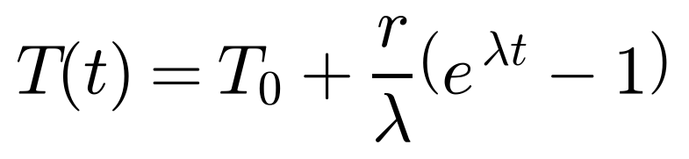 | (3)
Here r is the initial self-heating rate (°C/min), E the activation energy (J/mol) and R = 8.314 J/(mol·K). Equation (3) is exact for the linear form (2). It is valid for the onset region of heating (about 28 to 32 °C), which is exactly where the early warning is needed. It is not a model of full thermal runaway.

2.2 Gas leak in a well-mixed warehouse
For a leak of q litres per minute into a room of volume V litres with ventilation n (air changes per minute = ACH/60), the gas concentration C (as a fraction of air) follows a mass balance:
 | 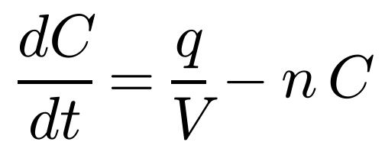 | (4)
 | 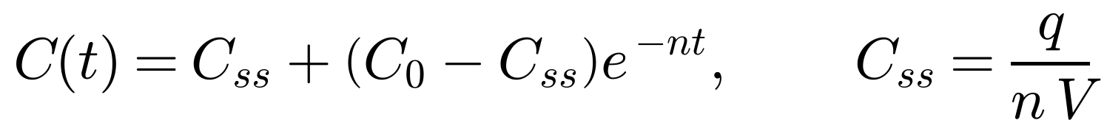 | (5)
Concentration in ppm is 10⁶ · C. A leak only raises the risk if its steady-state concentration reaches the risk-onset concentration C_{on}, so the minimum leak is
 | 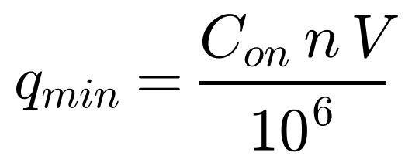 | (6)
(C_{on} in ppm, V in litres, n in 1/min gives q_{min} in L/min.) Leaks smaller than this are removed by ventilation and never cause the gas risk to rise.

2.3 Risk score
 | 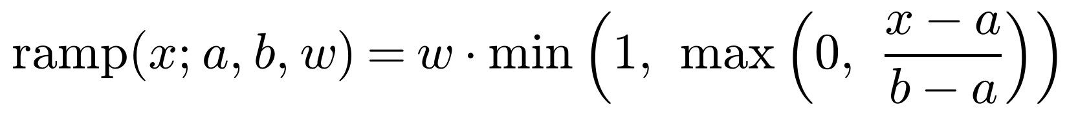 | (7)
(8)
a is where concern starts, b is the limit and w is the maximum points for that factor; the weights sum to 100. Levels: Normal 0–20, Attention 21–40, Warning 41–70, Critical 71–100.

3. Real-time prediction method
Every second, using the last W readings y₀ … y_{W−1} of a sensor:
- Estimate the rate by least squares:
 | 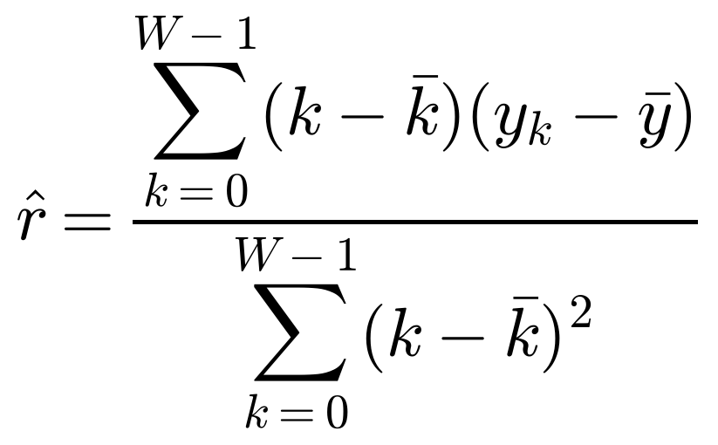 | (9)
- Set the model coefficients from the estimate: λ̂ for temperature, and for gas the leak input â (since dG/dt = a − nG) and the steady state G_{ss}:
 | 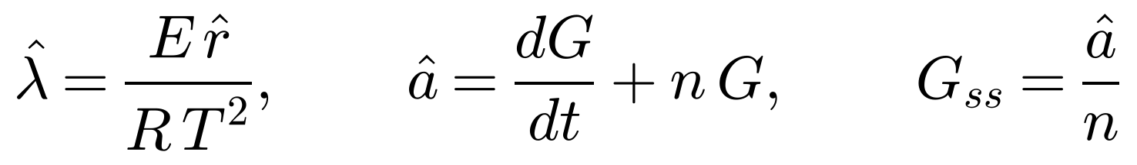 | (10)
- Forecast the sensor curves τ seconds ahead (this is the dashed predicted graph):
 | 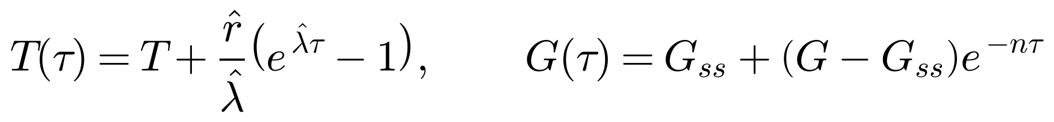 | (11)
- Find the time to risk onset (solve T(τ) = T_{on} and G(τ) = G_{on}):
 | 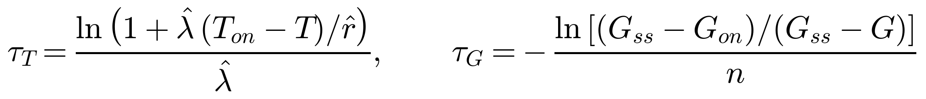 | (12)
- Warn when τ* ≤ L, with lead time L = 60 s. If G_{ss} ≤ G_{on} the leak is below the minimum and no gas onset is predicted.
(13)
Limits of the method. The forecast can only extrapolate trends the sensors have already started to show. Sudden events (a drop, a door opening) cannot be forecast this way. Rates must be estimated over a window long enough to rise above sensor noise; real heating takes minutes, so use a longer window and slower sampling than the 1 s demo.

4. Setting the parameters for a specific warehouse
The defaults in the dashboard are illustrative placeholders. For a real godown, each parameter has a defined source:
Parameter | How to obtain it | Notes
Self-heating rate r (°C/min) | Safety data sheet and calorimetry (DSC / accelerating-rate calorimetry) on the stored composition; or a controlled heating test with a safe sample | Use the rate at the storage temperature, not at ignition
Activation energy E (kJ/mol) | Arrhenius plot: measure rate k at several temperatures, plot ln k against 1/T; slope = −E/R | Equation (15) in Section 6
Ambient temperature T₀ | Average of logged readings from the godown | Use the seasonal maximum for a conservative model
Room volume V | Length × width × height from the godown drawing, minus the volume of stacked stock | In litres for equation (6)
Air changes per hour (ACH) | Tracer-gas decay test: ACH = (1/t)·ln(C₀/C_t), or ventilation openings and fan specification | Wind and door state change it
Gas full scale and risk level | Sensor datasheet (MQ-6: 200–10,000 ppm); risk level as a fraction of the gas lower explosive limit or toxic limit | The twin uses index 15 as onset
Leak rate q | Design leak for the model graph; estimated live from the sensor data in operation | Compare with q_min
Onset and limit temperatures, weights | Safe-storage limits from the SDS and licence conditions; weights from safety-officer ranking (AHP) or fitted to incident data | Review with the safety officer
Lead time L | Longer than the time needed to evacuate or intervene | Default 60 s

5. Where to find data
Honest starting point: a search found no public dataset of precursor sensor data (temperature, gas, handling) recorded before explosions in fireworks storage. Real explosions are rare and are not logged by sensors. The practical approach is to combine four sources: public proxy datasets to test the pipeline, accident databases for event labels, simulation from the physics model, and your own site and lab data.
Dataset | What it contains | Use in this project | Where
Smoke Detection Dataset (Kaggle, collected by S. Blattmann) | 62,630 rows at 1 Hz: temperature, humidity, TVOC, eCO₂, raw H₂, ethanol, pressure, particulates, Fire Alarm label | Test multi-sensor early-warning code on real fire time series | kaggle.com/datasets/deepcontractor/smoke-detection-dataset
UCI Gas Sensor Array under Dynamic Gas Mixtures | 16 metal-oxide sensors, about 12 h time series, ethylene with methane or CO (CC BY 4.0) | Fit gas-sensor transient response and time constants | archive.ics.uci.edu/dataset/322
UCI Gas Sensor Array Drift Dataset | 13,910 measurements, 16 sensors, 6 gases, 36 months | Study sensor drift and recalibration | archive.ics.uci.edu/dataset/224 (with concentrations: /270)
UCI Gas Sensor Array Temperature Modulation | 14 MOX sensors exposed to CO with reference temperature and humidity | Effect of temperature and humidity on gas readings | archive.ics.uci.edu/dataset/487
eMARS (EU Major Accident Reporting System) | Chemical and explosives accident and near-miss reports with causes and sequences; searchable and downloadable as Excel | Event labels, escalation sequences, causes | emars.jrc.ec.europa.eu (now also industry.eea.europa.eu/seveso/accidents)
ARIA (France), US Chemical Safety Board, SAFEX | Accident investigations and reports involving explosives and chemicals | Same as above, more cases | See the MINERVA list of chemical accident databases
Indian sources | TNPCB / National Green Tribunal reports, district accident records, PESO licence data (your Step 2 evidence) | Local event labels and licensed quantities | Government and tribunal records
Intel Berkeley Research Lab data | Temperature, humidity, light and voltage from 54 wireless sensors, 2004 | Practice with noise, drift and missing data in sensor networks | db.csail.mit.edu/labdata/labdata.html
Your own data | Godown baseline logs (temperature, humidity, gas, load, door, IMU) and controlled tests with safe material | The only data that matches your warehouse | Collected by the team

6. How to train the model
Training has two layers: fitting the physics parameters (Step 3) and training a classifier that answers “will risk onset occur within the next 60 s?” (Steps 4 to 7). The classifier learns what the equations miss: noise, drift and effects such as door openings.
- Define the target. For each time t_{i} the label is:
(14)
- Build the dataset. Generate many runs from the physics model with random parameters (r 0.2–3 °C/min, E 60–120 kJ/mol, ACH 0.5–6, V 800–2500 m³, leak 0–40 L/min, noise added), including runs with no event. Add real baseline logs from the site for the no-event class, and lab test runs. The code in Appendix A does this.
- Fit the physics parameters. E from the Arrhenius plot, and q and n from a controlled gas-release test:
 | 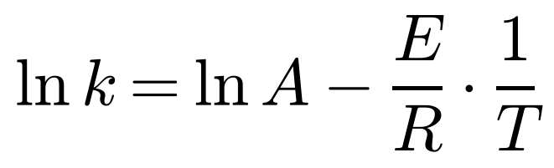 | (15)
 | 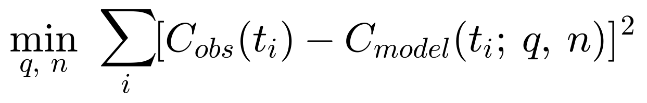 | (16)
- Compute features over a window of W readings: recent level, slope, and distance to the onset levels for temperature and gas (six features in the code).
- Train the classifier. Start with logistic regression as a baseline, then gradient boosting. A small LSTM or 1D-CNN is optional once there is a lot of real data. Split by run or by date, never by random rows, because neighbouring rows are almost identical and a random split inflates the scores.
- Evaluate. Report precision P = TP/(TP+FP), recall = TP/(TP+FN), AUC, the lead time t_{on} − t_{warn}, and false alarms per day. Compare with two baselines: persistence (no change) and straight-line extrapolation of the trend.
- Choose the threshold. Pick the alarm probability from the precision–recall curve so that false alarms per day are acceptable to the operators.
- Deploy and maintain. Export the trained coefficients or thresholds to the dashboard (or serve the model through a small Python service), log every warning, and retrain as real incident and near-miss data accumulate. The model supports the safety officer; it does not replace protective systems.

Example result on synthetic data
Model (test runs, split by run) | AUC | Precision | Recall | Notes
Logistic regression | 0.783 | 0.169 | 0.677 | Cannot capture the non-linear shape
Gradient boosting | 0.994 | 0.927 | 0.874 | Threshold 0.5

Event level for gradient boosting (alarm threshold 0.7, 100 test runs): all 68 events were warned before onset with a median lead of 55 s, and 1 of 32 no-event runs raised a false alarm. Parameter recovery: leak 10.0 L/min recovered as 10.0, ventilation 2.00 ACH as 1.97, activation energy 90.0 kJ/mol as 89.9.
Read this carefully: these numbers come from synthetic data labelled by the same physics model that generated it. They show that the training pipeline works. They are not evidence of accuracy in a real warehouse, which must be measured on real or controlled-test data.

7. Relation to the current dashboard
The dashboard currently uses the physics model and the warning rule of Section 3 with illustrative parameters. It has not yet been trained or validated on real data. The training procedure above is how the parameters and thresholds would be replaced with values calibrated for a specific warehouse.

Appendix A. Training and parameter-fitting code (Python)
Requires numpy, scipy and scikit-learn. It was run once on a standard Python environment to produce the results above.
import numpy as np
from scipy.optimize import curve_fit
from sklearn.ensemble import HistGradientBoostingClassifier
from sklearn.linear_model import LogisticRegression
from sklearn.metrics import precision_score, recall_score, roc_auc_score
rng = np.random.default_rng(0)
R, T_ON, G_ON, W, LEAD, N = 8.314, 32.0, 15.0, 60, 60, 600 # window, lead time, run length (s)

def simulate_run():
"""Physics-based synthetic run: self-heating + gas leak + sensor noise (1 Hz)."""
T0 = rng.uniform(24, 30); E = rng.uniform(60, 120) * 1000
event = rng.random() < 0.7
r = rng.uniform(0.2, 3.0) / 60 if event else 0.0 # degC/s
ach = rng.uniform(0.5, 6) / 3600; V = rng.uniform(800, 2500) * 1000; Cf = 1000
q = rng.uniform(0, 40) / 60 if event else 0.0 # L/s
t0 = rng.uniform(60, 240); t = np.arange(N) - t0; t = np.clip(t, 0, None)
lam = E * r / (R * (T0 + 273.15) ** 2)
T = T0 + (r / lam) * (np.exp(lam * t) - 1) if lam > 1e-12 else T0 + r * t
C = 1e6 * (q / (ach * V)) * (1 - np.exp(-ach * t)) # ppm
G = 100 * C / Cf
Tm = T + rng.normal(0, 0.15, N); Gm = G + rng.normal(0, 0.7, N)
onset = np.where((T > T_ON) | (G > G_ON))[0]
return Tm, Gm, (onset[0] if len(onset) else None)

def features(Tm, Gm):
X, idx = [], []
k = np.arange(W) - (W - 1) / 2
for i in range(W, N):
a, b = Tm[i - W:i], Gm[i - W:i]
sT, sG = (k * (a - a.mean())).sum() / (k ** 2).sum(), (k * (b - b.mean())).sum() / (k ** 2).sum()
X.append([a[-5:].mean(), b[-5:].mean(), sT * 60, sG, T_ON - a[-5:].mean(), G_ON - b[-5:].mean()]); idx.append(i)
return np.array(X), np.array(idx)

def dataset(n_runs):
X, y, g, ons = [], [], [], []
for run in range(n_runs):
Tm, Gm, on = simulate_run(); F, idx = features(Tm, Gm)
lab = np.zeros(len(idx), int) if on is None else ((on - idx > 0) & (on - idx <= LEAD)).astype(int)
X.append(F); y.append(lab); g += [run] * len(idx); ons.append((on, idx))
return np.vstack(X), np.concatenate(y), np.array(g), ons

Xtr, ytr, _, _ = dataset(300) # train on runs 0-299
Xte, yte, gte, ons = dataset(100) # test on NEW runs (split by run, never by row)
models = {'Logistic regression': LogisticRegression(max_iter=2000, class_weight='balanced'),
'Gradient boosting': HistGradientBoostingClassifier(max_depth=4, learning_rate=0.1)}
print(f"train rows {len(ytr)}, positives {ytr.mean():.3f}; test rows {len(yte)}")
for name, m in models.items():
m.fit(Xtr, ytr); p = m.predict_proba(Xte)[:, 1]; yhat = (p > 0.5).astype(int)
print(f"{name}: AUC {roc_auc_score(yte, p):.3f} precision {precision_score(yte, yhat):.3f} recall {recall_score(yte, yhat):.3f}")
# event-level: lead time before onset and false alarms in no-event runs
m = models['Gradient boosting']; p = m.predict_proba(Xte)[:, 1]; leads, fa, hrs, miss, ev = [], 0, 0, 0, 0
for run, (on, idx) in enumerate(ons):
pr = p[gte == run]; hit = np.where(pr > 0.7)[0]
if on is None:
fa += (len(hit) > 0); hrs += 1
else:
ev += 1; early = [idx[h] for h in hit if idx[h] < on]
if early: leads.append(on - early[0])
else: miss += 1
print(f"events {ev}, warned before onset {len(leads)}, missed {miss}, median lead {np.median(leads):.0f} s, "
f"false-alarm runs {fa}/{hrs} no-event runs")
# parameter fitting demo 1: gas leak test -> q and n (well-mixed model)
t = np.arange(0, 900.0); n_true, q_true, VL = 2.0 / 3600, 10 / 60, 1.5e6
C = 1e6 * q_true / (n_true * VL) * (1 - np.exp(-n_true * t)) + rng.normal(0, 3, t.size)
f = lambda t, q, n: 1e6 * q / (n * VL) * (1 - np.exp(-n * t))
(qf, nf), _ = curve_fit(f, t, C, p0=[0.1, 5e-4], bounds=([1e-4, 1e-5], [5, 0.05]))
print(f"gas fit: q {qf*60:.1f} L/min (true {q_true*60:.1f}), ACH {nf*3600:.2f}/h (true 2.00)")
# parameter fitting demo 2: Arrhenius plot -> E from heating rates measured at several temperatures
Tk = np.array([300, 310, 320, 330, 340.0]); E_true = 90e3
rate = 1e9 * np.exp(-E_true / (R * Tk)) * np.exp(rng.normal(0, 0.03, Tk.size))
slope = np.polyfit(1 / Tk, np.log(rate), 1)[0]
print(f"Arrhenius fit: E {(-slope * R) / 1000:.1f} kJ/mol (true 90.0)")

