## C:\Users\azer\Desktop\ui design\title.png

## Overview

*Launch Launch Launch Saturn V* is an interactive simulation application which has artistic environment and unique gameplay

## Scenario

1. The Car will do “stunt” jumping to pass to the other side and it will collide with packs of boxes
2. The car hit the switch to activate the robot
3. The robot will go down to the port to get into the ship
4. The ship will carry on the robot to the other side
5. Robot will hit the bridge to make it fall down so it can reach second switch
6. The robot hits the switch and it will activate the rocket
7. Final scene, Rocket flies

## Things made this project possible

* Bullet Physics
* Hydrax Ocean Simulation
* OGRE Rendering Engine
* irrKlang Audio Library
* Hikari Flash Library
* Maya 2012 and 3DS Max 2012
* Adobe Photoshop CS4

## Screenshots

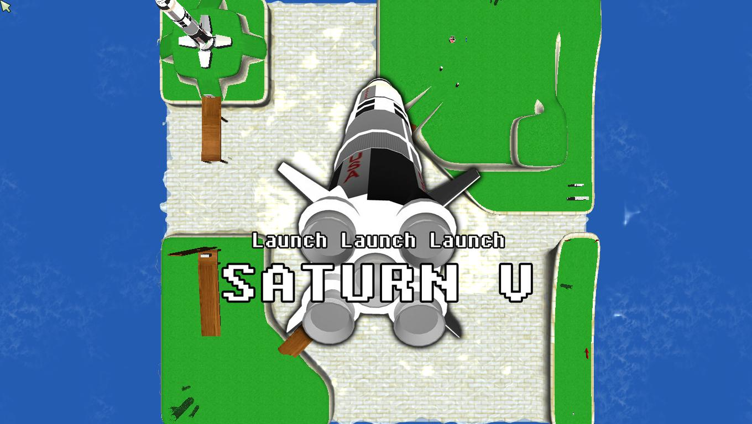

Figure 1. The Title

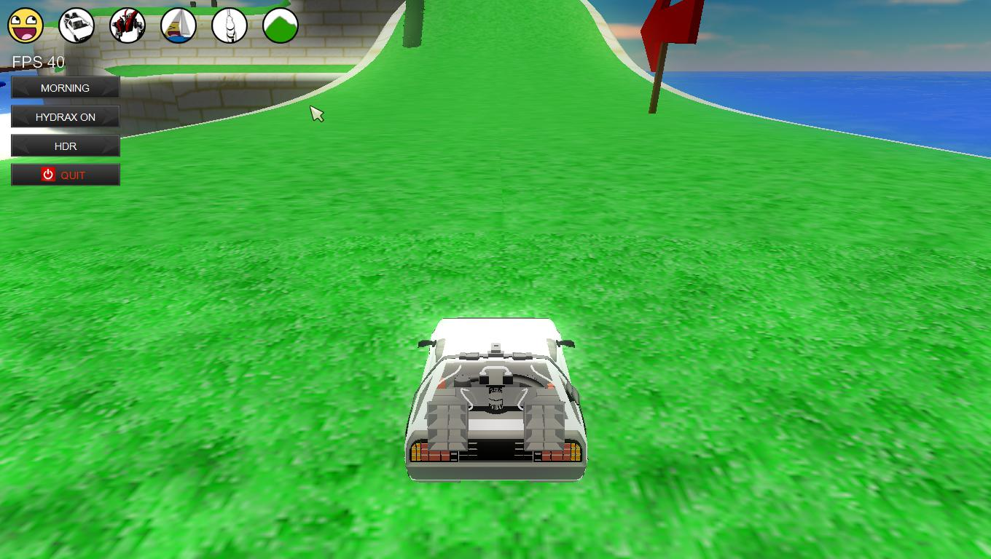

Figure 2. The Vehicle, Speeding up to jump to the other side

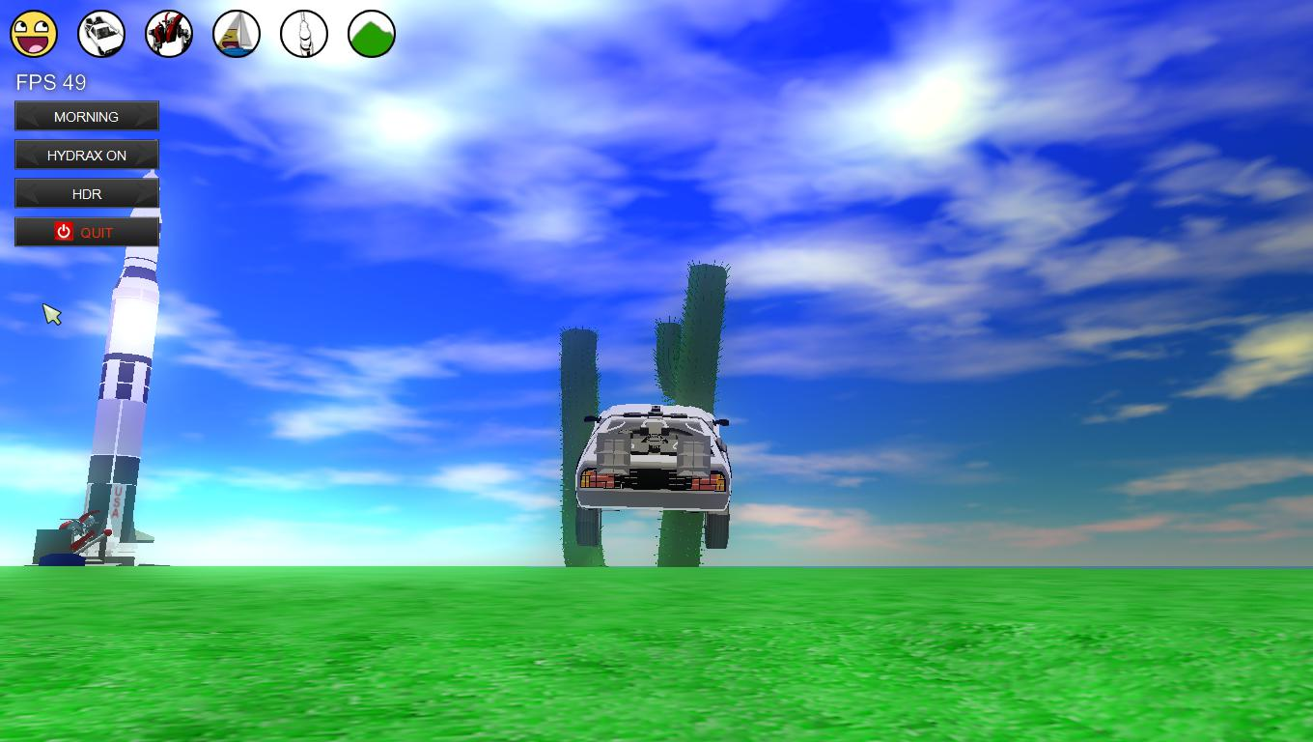

Figure 3. The Vehicle is reaching the first switch

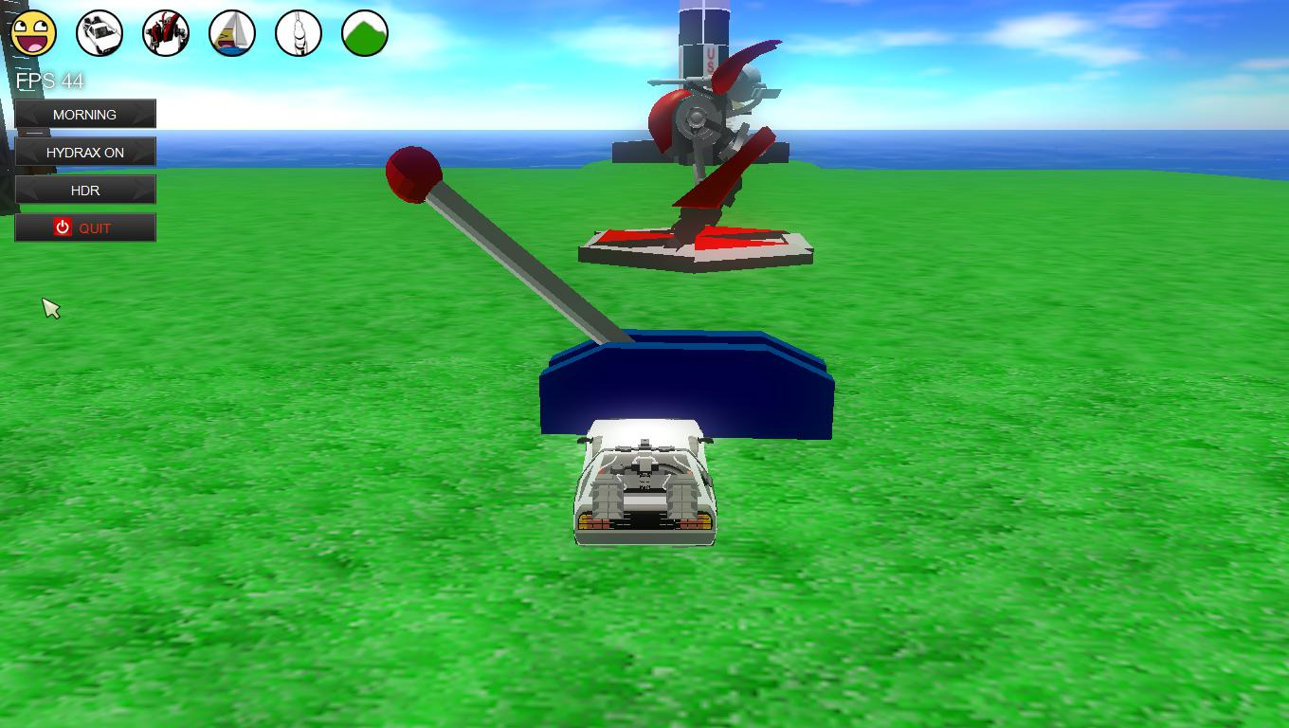

Figure 4. The vehicle hit the first switch

## C:\Users\azer\Desktop\screenshot\screenshot01192012_181338730.jpg

Figure 5. The Robot get into the ship

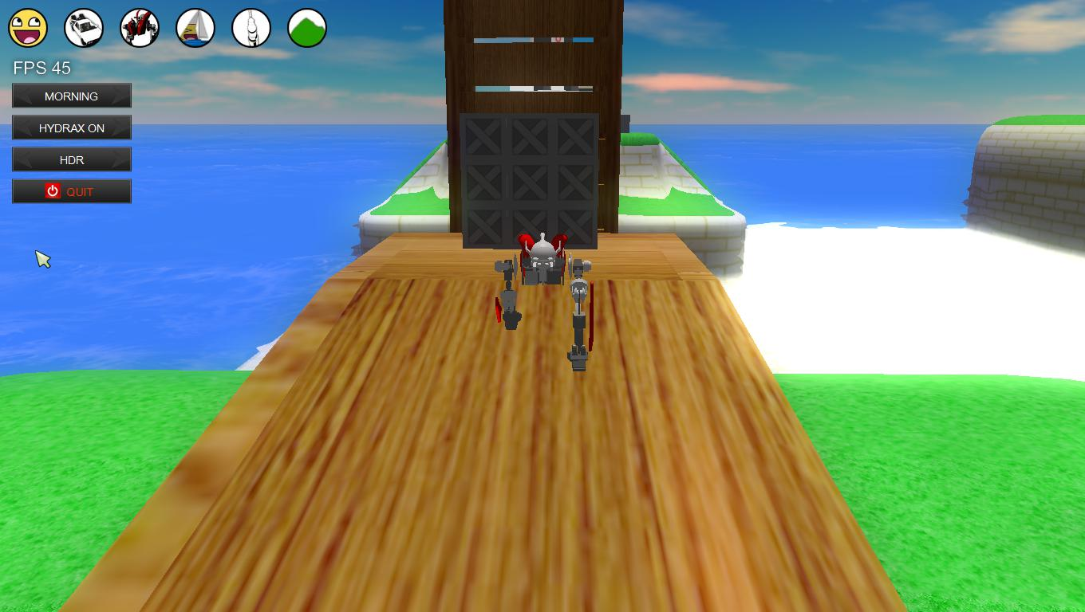

Figure 6. Robot and The bridge still stands

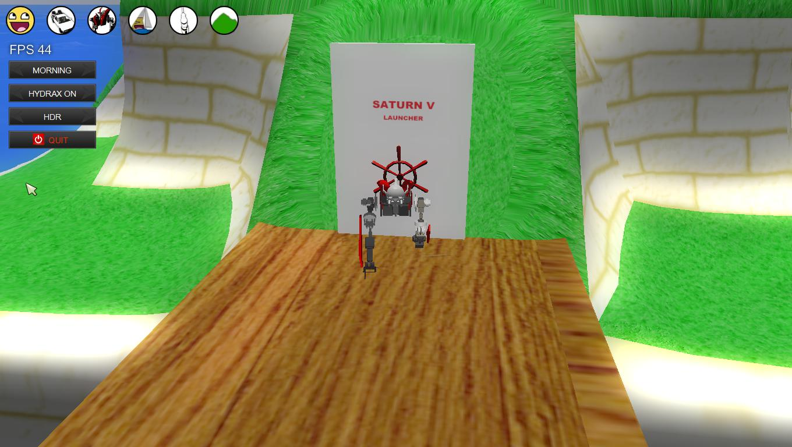

Figure . The robot hits the second switch

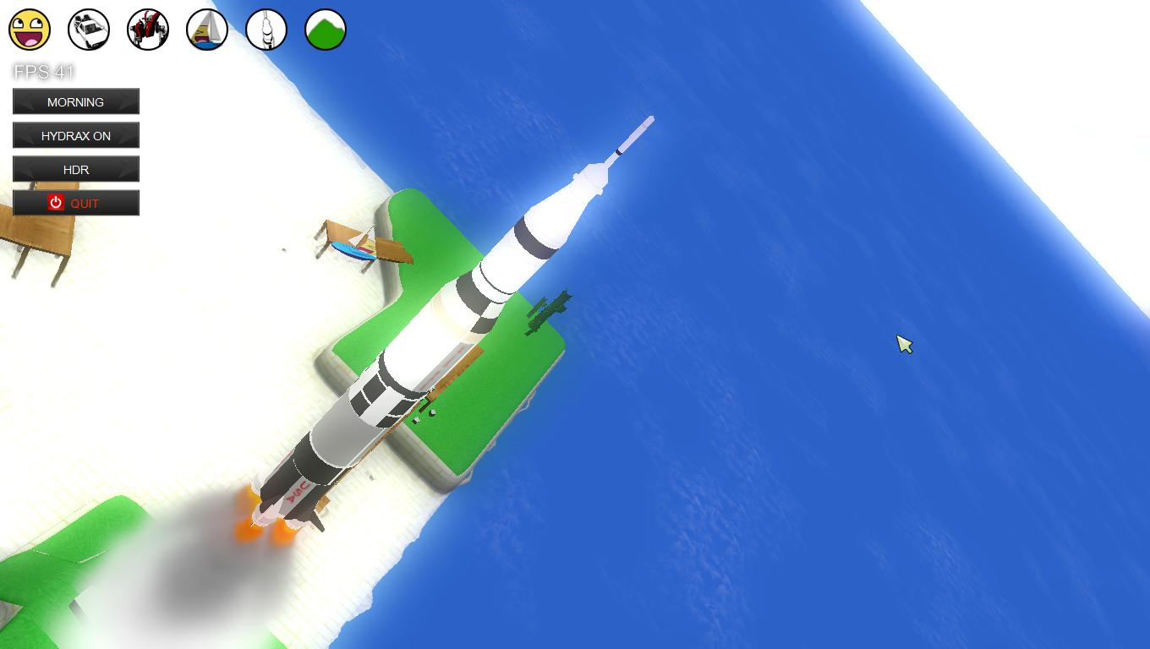

Figure . The Saturn V flies

## Features

* HDR
* Radial Blur
* Motion Blur
* Bloom
* Interactive Flash Animation
* Ocean Simulation
* Physics Engine

## Developer

Reza Adhitya Saputra

*reza.adhitya.saputra@gmail.com*

## Credits

3D Models and Images

1. Delorean *Back To The Future*, http://www.turbosquid.com/FullPreview/Index.cfm/ID/259460
2. Mech, http://www.turbosquid.com/FullPreview/Index.cfm/ID/474170
3. Saturn V Space Rocket, http://www.nasa.gov/multimedia/3d\_resources/assets/saturnv\_c.html
4. Smiley, http://commons.wikimedia.org/wiki/File:718smiley.png
5. Happy Smiley Face, http://commons.wikimedia.org/wiki/File:Happy\_smiley\_face.png

Sounds and Musics

1. Rush ~ Yoko Kanno and The Seatbelts