Spotter — Machine Learning Engineer Assessment
Freight Rate Prediction Model
Technical Report

1. Overview
This report documents the approach used to build a freight load rate prediction model, covering data exploration and quality issues, the train/validation split strategy, feature engineering, model selection, and results. The trained model was used to generate predicted rates for all 12,000 loads in validation.csv, and for a fixed Lexington → Fort Wayne lane across every day in December 2025, as required by the assessment.

2. Data Exploration — Key Findings
The labeled development data (train-test.csv) contains 48,000 loads spanning January 1 through October 31, 2025, with 14 columns including pickup/delivery locations, coordinates, distance, equipment type, weight, a market index, a quote signal, and the target variable, posted_rate. The unlabeled validation.csv contains 12,000 loads spanning November 1 through December 31, 2025 — entirely after the end of the training window.
Exploration surfaced four data-quality issues, summarized below.
Issue | Rows Affected | Resolution
Missing weight | 300 (train) / 165 (validation) | Imputed with train-set median; flagged with weight_was_missing indicator column.
Missing market_index | 374 (train) / 249 (validation) | Imputed with train-set median; flagged with market_index_was_missing indicator column.
Negative weight values | 292 (train) / 145 (validation) | Treated as sign-flip data entry errors, not true missingness; corrected with absolute value.
High-leverage rate outliers | ~1% of rows (rate-per-mile up to 14.1 vs. mean 2.2) | Left in training data after inspection — judged to be legitimate expedited/rush loads rather than corrupted data. Flagged as a model limitation (see Key Findings).

Aside from these issues, the data was clean: no duplicate load IDs, no zero/negative distances, and equipment values were consistent across three categories (Dry Van, Reefer, Flatbed) with no formatting inconsistencies.

3. Train / Validation Split Approach
The single most important modeling decision in this project was how to split train-test.csv. A random split was deliberately avoided.
- Why not random: validation.csv (the file the final predictions are scored against) is entirely in the future relative to train-test.csv — it covers November and December 2025, while the labeled data stops at October 31, 2025. A random split would let the model interpolate between dates it has already “seen” on both sides, which overstates how well it will generalize to genuinely unseen future months.
- Approach used: a chronological (time-based) split — January through August 2025 for training (38,477 rows), and September–October 2025 held out for internal validation (9,523 rows). This mirrors the real task: train on the past, evaluate on a forward time window, then finally predict on a further-forward window (Nov–Dec) exactly as validation.csv requires.
- Leakage control: any encoding derived from the data (e.g. pickup/delivery city frequency encoding) was computed using only the training portion and then applied to the holdout and validation sets, so no information from later time periods leaked into the features used to train the model.

4. Feature Engineering
Features provided to the model:
- Pickup/delivery coordinates (pickup_lat, pickup_lon, delivery_lat, delivery_lon)
- distance and weight (weight cleaned as described above)
- market_index and quote_signal (imputed where missing)
- Missingness indicator flags: weight_was_missing, market_index_was_missing
- Date-derived features: month, day_of_week, day_of_year
- One-hot encoded equipment type (Dry Van / Flatbed / Reefer)
- Frequency-encoded pickup and delivery cities (pickup_freq, delivery_freq), computed on the training fold only
Rate-per-mile was deliberately excluded as an input feature since it is derived directly from the target variable and would constitute leakage.

5. Model Selection
A gradient-boosted tree model (LightGBM Regressor) was selected as the primary model, with a linear regression trained as a baseline for comparison.
- Why gradient boosting: the feature set mixes numeric (distance, weight, market indices) and categorical (equipment, city) variables with likely nonlinear relationships and interactions (e.g. the effect of distance on rate probably differs by equipment type). Tree-based gradient boosting handles this naturally without extensive preprocessing, is robust to differing feature scales, and trains quickly on a 48,000-row dataset.
- Training setup: 500 max estimators with early stopping (30-round patience) on the September–October holdout, learning rate 0.05, max depth 6. The final model used for actual predictions was refit on the full January–October dataset (using the number of trees found by early stopping) to make use of all available labeled data before predicting on validation.csv and the December lane.

6. Results
Performance on the September–October chronological holdout:
Metric | Value | Notes
RMSE | $634.34 | Sensitive to a small number of large errors (see Key Findings).
MAE | $123.51 | Typical prediction is within ~$124 of the true rate.
MAPE | 5.57% | Typical prediction is within ~5.6% of the true rate.

The LightGBM model outperformed the linear regression baseline on the same holdout, confirming that the nonlinear relationships captured by the tree-based model add real predictive value over a simple linear fit.

7. Key Findings & Limitations
- Underprediction on rare, high-value long-haul loads: the largest holdout errors were concentrated in long-distance loads with unusually high posted rates (e.g. a $20,132 load predicted at $3,898). These loads are underrepresented in the training data, and the right-skewed distribution of posted_rate makes them hard for the model to weight correctly. This explains why RMSE is substantially higher than MAE — the typical prediction is accurate, but a small number of high-value outlier loads are predicted well below their true rate. A log-transform of the target (not applied in this version) is a natural next step to reduce this gap.
- Flat December forecast for the fixed lane: the Lexington → Fort Wayne December predictions are effectively flat at $875.13 across all 31 days (see chart below). Investigation confirmed this is not a bug — date-derived features (month, day_of_week, day_of_year) vary correctly across the 31 rows — but the model places very little importance on those features relative to market_index, quote_signal, and distance, which are held constant for this exercise (all 31 rows share the same fixed lane, equipment, and weight). In effect, the model is not capturing meaningful day-to-day or seasonal rate variation for a fixed lane, which is a genuine limitation of the current feature set rather than a data error.
- Assumption on lane-level inputs: the December file supplies only pickup, delivery, distance, equipment, weight, and date — it omits coordinates, market_index, and quote_signal, which the model requires. These were filled using the historical average values for the Lexington → Fort Wayne lane itself (32 historical loads on this exact lane were found in the training data), rather than global medians, to keep the prediction as lane-specific as possible.

8. December 2025 Prediction Chart
The chart below was generated by the provided score.py after validating both required output files (validation_predictions.csv and the completed December input file).
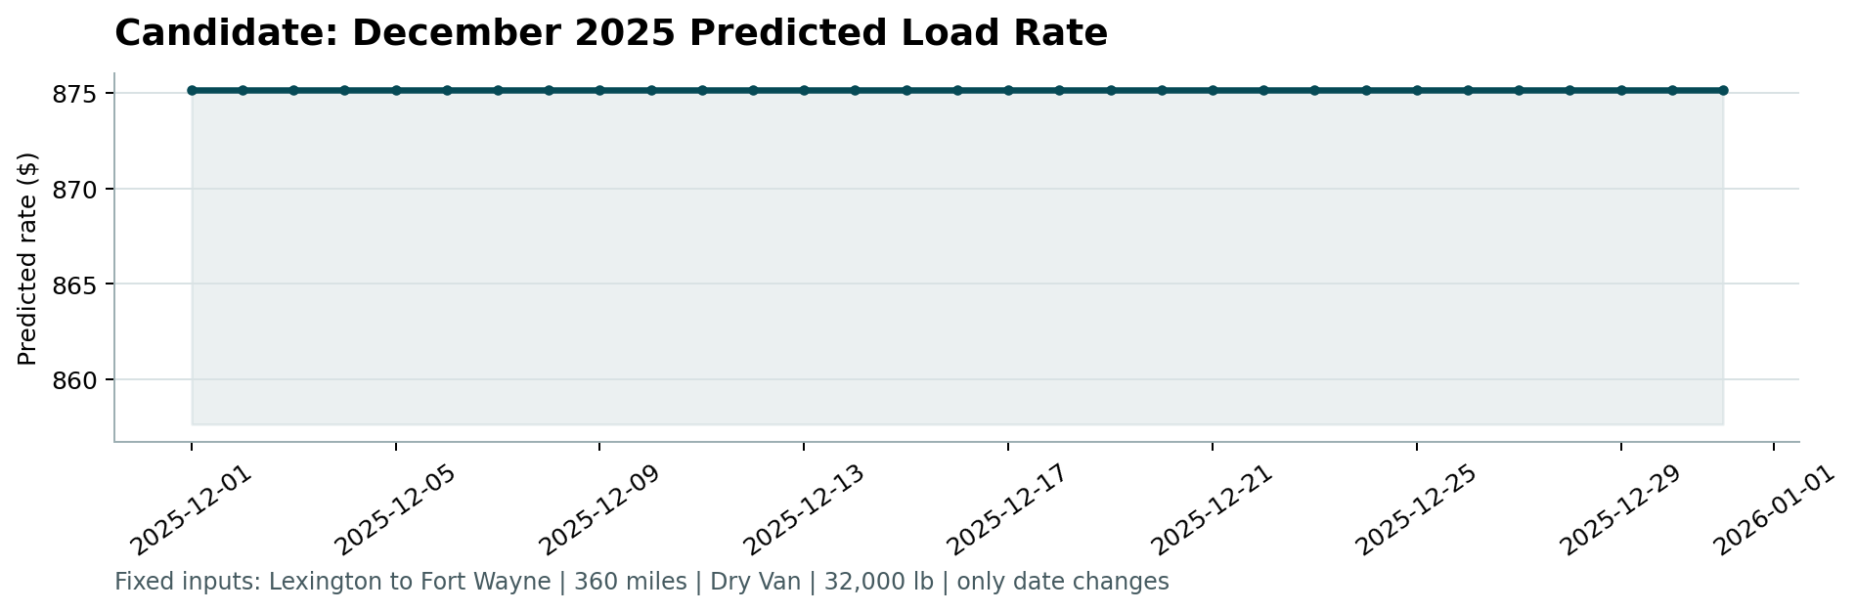
Figure 1. Candidate December 2025 predicted rate — Lexington to Fort Wayne, 360 miles, Dry Van, 32,000 lb (only date varies).

9. Conclusion
The final model was trained on the full labeled dataset (48,000 rows) after being validated on a chronological holdout designed to mimic the real forecasting gap between the labeled data and validation.csv. It achieved a 5.57% MAPE on unseen future data, with the main identified weakness being underprediction of rare, high-value long-haul loads and limited sensitivity to date-based seasonality for a fixed lane. Both required output files (validation_predictions.csv and the completed December chart input file) were validated successfully by score.py prior to submission.

