Practical Workbook
Object Oriented Concepts and Programming SE-201



Prepared By

Engr. Asma Khan Assistant Professor

Approved By

Prof. Dr. Shehnila Zardari Chairperson
DEPARTMENT OF SOFTWARE ENGINEERING, NED UNIVERSITY OF ENGINEERING & TECHNOLOGY

Contents

Lab # | Lab Objects Page # | Rubrics | Signature
1. | Introduction to Object Oriented Programming and C++ Error! Bookmark not defined.  Learning Repetition and Conditional Structures Error! Bookmark not defined.  Learning Pointers in C++ Error! Bookmark not defined.  Learning 1D and 2D Arrays and Vectors in C++ Error! Bookmark not defined.  Learning Classes and Objects Error! Bookmark not defined.  Understanding concept of Inheritance Error! Bookmark not defined.  Open Ended Lab Error! Bookmark not defined. Understanding Abstract Classes Error! Bookmark not defined.  Composition and Aggregation Error! Bookmark not defined.  Understanding Friend Functions Error! Bookmark not defined.  Understanding Operator Overloading Error! Bookmark not defined.  Complex Engineering Activity Error! Bookmark not defined.  DatabaseApp Development in CSharp Error! Bookmark not defined.  Final Exam Error! Bookmark not defined.
2. |  | ✓
3.
4. |  | ✓
5.
6. |  | ✓
7. |  | OEL
8.
9.
10.
11.
12. |  | CEA
13.
14. |  | FINAL
15.

LAB SESSION 1
Introduction to Object Oriented Programming and C++

Object-Oriented Programming (OOP) is a programming paradigm that organizes software design around objects, which represent real-world entities. Each object combines data (attributes) and behavior (methods) into a single unit called a class.

Core Concepts of OOP
- Encapsulation – Bundling data and methods together and restricting direct access to some of the object’s components.
- Abstraction – Hiding complex implementation details and showing only essential features.
- Inheritance – Allowing a class to acquire properties and behaviors of another class, promoting code reuse.
- Polymorphism – Enabling one interface to be used for different data types or objects, allowing flexibility in method usage.

Advantages of OOP
  - Improves code reusability and modularity
  - Makes programs easier to maintain and scale
  - Models real-world problems more naturally
  - Enhances security through data hiding
OOP is widely used in languages like C++, Java, C#, and Python for building large, complex, and maintainable software systems.

Objective:
For students to get some practice of:
    - Using basic C++ types and user-defined objects
      - Integer Types
      - Basic Integer Operators
    - C++ Input and Output
      - Formatting Output
      - Reading from the keyboard
    - Named constants and Expressions

C++ is a powerful and versatile programming language that has played a significant role in the development of software applications across various domains. Here's a brief overview of its importance and history:

Importance of C++:
Efficiency: C++ allows for low-level manipulation of hardware resources, making it suitable for performance-critical applications such as system software, game development, and embedded systems.

Portability: C++ code can be compiled to run on different platforms without modification, making it a popular choice for cross-platform development.

Flexibility: C++ supports both procedural and object-oriented programming paradigms, providing developers with a wide range of tools and techniques for building complex software systems.
Scalability: C++'s modular design and support for abstraction enable developers to build large-scale projects with ease, facilitating code reuse and maintenance.

Community and Ecosystem: C++ has a large and active community of developers, libraries, and frameworks, providing resources and support for building a wide range of applications.

History of C++:
Origin: C++ was created by Bjarne Stroustrup at Bell Labs in the early 1980s. It evolved from the C programming language with the addition of object-oriented features such as classes, inheritance, and polymorphism.

First Release: The first version of C++ was released in 1985 as "C with Classes." It introduced the concept of classes and basic object-oriented programming features.
Standardization: C++ underwent several revisions and standardizations over the years to improve the language's clarity, efficiency, and portability. The ANSI/ISO standard for C++ was first published in 1998 (known as C++98) and has since been updated with newer versions (C++03, C++11, C++14, C++17, C++20, and ongoing).

Adoption: C++ gained popularity rapidly due to its efficiency, flexibility, and wide range of applications. It became the language of choice for building operating systems, compilers, database systems, game engines, and more.

Modern Developments: With each new standard revision, C++ continues to evolve, incorporating new features and improvements to meet the needs of modern software development. Recent additions include features like lambda expressions, smart pointers, and constexpr functions.

Overall, C++ remains a crucial tool for software developers, offering a balance between performance, flexibility, and productivity for a wide range of applications. Its rich history and ongoing development make it a cornerstone of modern programming.
C++ is one the most popular language in the programming world. In this article we will be looking towards 10 basic C++ programs for beginners in CPP. C++ is a powerful general-purpose programming language that was developed in the early 1980s as an extension of the C programming language. It is widely used for developing a wide range of applications, including system software, game development, embedded systems, high-performance applications, and more.

C++ combines both high-level and low-level programming features, offering a balance between performance and abstraction. It supports procedural, object-oriented, and generic programming paradigms, giving developer’s flexibility in designing and implementing their solutions.

Variables and Data Types: C++ supports various data types such as int, float, double, char, bool, etc.
Variables are declared with a data type and a name:

int age;
float temperature;.
You can initialize variables upon declaration,
int count = 0;
Input and Output: Input is typically taken from the user via std::cin and output is displayed using std::cout.

int number;
std::cout << "Enter a number: "; std::cin >> number;
std::cout << << number << std::endl;
"You entered: "

Operators: C++ supports various operators such as :
arithmetic (+, -, *, /) assignment (=) comparison (==, !=, <, >) logical (&&, ||, !), etc.

a = 5, b = 3;
int

sum = a + b;
int

Control Structures:
C++ supports control structures like if, else, switch, while, for, etc., for decision-making and looping.
(condition) {
if
// code block
} {
// alternative code block
else

}

Functions:
Functions in C++ are blocks of code that perform a specific task. Functions can have parameters (input) and return values (output).

int add(int x, int y) {
return x + y;
}

Strings:
C++ provides a standard string class std::string to work with text. Strings can be concatenated using the + operator.

std::string greeting = "Hello";

Programming Exercise:
These questions cover various aspects of basic C++ programming, including arithmetic operations, input/output, and conversion between different units. They provide practice in implementing fundamental programming concepts. Use setw (width) manipulator for formatting output where required.

Question 1: Calculate Area of a Rectangle: Write a C++ program to calculate the area of a rectangle given its length and width.

Expected Output:
Area of the rectangle: 15

Question 2: Check Even or Odd: Write a C++ program to check if a given number is even or odd.

Expected Output: 7 is odd

Question 3: Generate Fibonacci Series: Write a C++ program to generate the Fibonacci series up to a given number of terms.

Expected Output: Fibonacci Series: 0 1 1 2 3 5 8 13 21 34

Question 4: Find Maximum Number: Write a C++ program to find the maximum number among three given numbers.

Expected Output: Maximum number: 20

Question 5: Reverse a String: Write a C++ program to reverse a given string.

Expected Output: Reversed string: olleh
Question 6: Check Prime Number: Write a C++ program to check if a given number is prime or not.

Expected Output: 7 is prime
Question 7: Calculate Factorial: Write a C++ program to calculate the factorial of a given number.

Expected Output: Factorial of 5: 120

Question 8: Calculate Simple Interest: Write a C++ program to calculate the simple interest given the principal amount, rate of interest, and time period.

Expected Output: Simple interest: 150

Question 9: Check Leap Year: Write a C++ program to check if a given year is a leap year or not.

Expected Output: 2024 is a leap year
Question 10: Check Armstrong Number: Write a C++ program to check if a given number is an Armstrong number or not.

Expected Output: 153 is an Armstrong number

Question 11: Sum and Average Calculation: Write a C++ program that prompts the user to enter two numbers, calculates their sum, and then computes their average.

Expected Output:
Enter first number: 25 Enter second number: 25 Sum is 50
Average is 25
Question 12: Time Conversion: Write a C++ program that prompts the user to enter time in seconds and then converts it into hours, minutes, and seconds.

Expected Output:
Enter the time in seconds: 3713 Hours in time is: 1
Minutes in time: 1 Seconds in time is: 53

Question 13: Amount in Rupees Breakdown: Write a C++ program that prompts the user to enter an amount in rupees and then breaks it down into denominations of 1000s, 500s, 100s, 50s, 10s, 5s, 2s, and 1s.

Expected Output:
Enter amount in rupees: 5788 1000’s in the given amount is: 5 500’s in the given amount is: 1 100’s in the given amount is: 2 50’s in the given amount is: 1 10’s in the given amount is: 3 5’s in the given amount is: 1
2’s in the given amount is: 2 1’s in the given amount is: 1
Question 14: Fahrenheit to Celsius Conversion: Write a C++ program that prompts the user to enter a temperature in Fahrenheit and then converts it into Celsius using the formula: Celsius = (Fahrenheit - 32) * 5 / 9.

Expected Output:
Enter the Fahrenheit temperature: 98.6 Celsius Temperature: 37.0
Question 15: Two-Digit Integer Reversal: Write a C++ program that inputs a two-digit integer value and outputs its reverse order.

LAB SESSION 2
Repetition and conditional structures in C++

Objective: The objective of this lab is to provide students with an opportunity to practice and reinforce their understanding of repetition and conditional structures in C++

Introduction: In this lab session, students will dive into the world of programming logic and decision-making.
Repetition and conditional structures are fundamental concepts in programming that allow them to control the flow of their code and execute certain blocks of instructions repeatedly or conditionally based on specific criteria.
Throughout this lab, the students will explore various techniques for implementing repetition using for loops, while loops, and conditional structures such as if, if-else, and if-else-if statements. These constructs are essential tools in a programmer's toolkit and are used extensively in real-world applications to automate tasks and solve complex problems.

By practicing these concepts through hands-on exercises and challenges, the students will enhance their problem-solving skills and develop a deeper understanding of how to write efficient and effective C++ code. So, let's get started and embark on this journey to master the art of programming logic!

Conditional Structures:
In OOP, conditional structures like if-else statements and switch-case statements are used to control the flow of execution based on certain conditions. These structures allow you to make decisions within your code and execute specific blocks of code based on whether certain conditions are true or false.
If-Else Statements: An if-else statement evaluates a condition and executes a block of code if the condition is true, and another block of code if the condition is false. This structure allows for branching based on a single condition.
if (condition) {
// Code to execute if condition is true
} else {
// Code to execute if condition is false
}

Switch-Case Statements: A switch-case statement evaluates an expression and compares it to multiple values (cases). It executes the block of code associated with the first case that matches the expression. Switch-case statements are often used when there are multiple possible conditions to check.
switch (expression) {
case value1:
// Code to execute if expression is equal to value1

break;
case value2:
// Code to execute if expression is equal to value2
break;
default:
// Code to execute if expression doesn't match any case
}
Loops: Loops are used to execute a block of code repeatedly as long as a specified condition is true. In OOP, loops such as for, while, and do-while are commonly used to iterate over collections, perform repetitive tasks, and control program flow.
For Loops: A for loop is used to iterate over a range of values or elements in a collection. It typically consists of an initialization step, a condition for continuing the loop, and an update step to modify the loop variable.
for (initialization; condition; update) {
// Code to execute repeatedly as long as condition is true
}

While Loops: A while loop executes a block of code as long as a specified condition is true. It continuously evaluates the condition before each iteration.
while (condition) {
// Code to execute repeatedly as long as condition is true
}

Do-While Loops: A do-while loop is similar to a while loop, but it executes the block of code at least once before checking the condition for subsequent iterations. This ensures that the block of code is executed at least once, regardless of whether the condition is initially true or false.
do {
// Code to execute at least once, then repeatedly as long as condition is true
} while (condition);

In OOP, conditional structures and loops are fundamental tools for controlling the flow of execution, making decisions, and performing repetitive tasks within classes and objects. They help in writing flexible, efficient, and expressive code that can adapt to various scenarios and conditions.

  - Any character is entered by the user; write a program to determine whether the character entered is a capital letter, a small case letter, a digit or a special symbol. The following table shows the range of ASCII values for various characters.

Characters | ASCII Values
A – Z | 65 – 90
a – z | 97 – 122
0 – 9 | 48 – 57

special symbols | 0 - 47, 58 - 64, 91 - 96, 123 – 127

  - Write a program to calculate the monthly telephone bills as per the following rule:

Minimum Rs. 200 for upto 100 calls. Plus Rs. 0.60 per call for next 50 calls. Plus Rs. 0.50 per call for next 50 calls.
Plus Rs. 0.40 per call for any call beyond 200 calls.

Q3) Write a program to check the strength of a password entered by the user. The strength of the password is determined based on the following criteria:
    - Minimum length of 8 characters.
    - Contains at least one uppercase letter, one lowercase letter, one digit, and one special character.

Q4) Write a program to encrypt and decrypt a text file using a simple encryption algorithm. The encryption algorithm involves shifting each character by a fixed number of positions in the ASCII character set.
Q5) Write a C++ program to generate the multiplication table of a given number.
Q6) Write a C++ program to create a simple menu-driven calculator that performs basic arithmetic operations (addition, subtraction, multiplication, division).
Q7) Write a C++ program to generate the Fibonacci series up to a given number of terms.
Q8) Write a C++ program to implement a number guessing game where the user tries to guess a randomly generated number.
Q9) Write a C++ program to implement a simple rock, paper, scissors game between the user and the computer.
Q10) Write a C++ program to display the name of the day of the week based on the day number entered by the user.
Q11) Write a C++ program to print the following patterns and shapes:


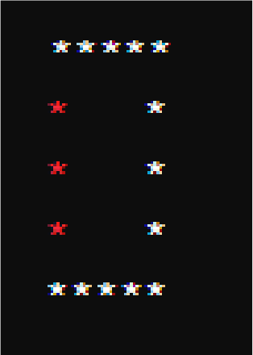
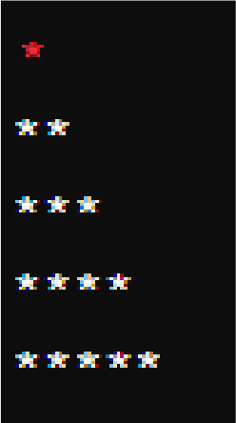
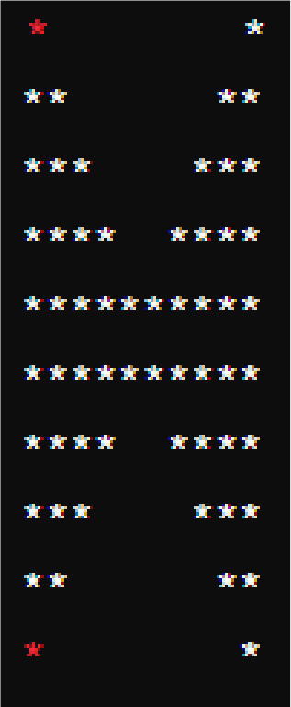
1
212
32123
4321234
543212345


NED University of Engineering & Technology Department of Software Engineering

Cognitive Domain Assessment Rubric Level C3 (for Laboratory Work)
Criteria | Level of Attainment
Criteria | (5) | (4) | (3) | (2) | (1) | (0)
Problem Identification | Able to correctly identify the problem(s) and all required data (input and output). | Able to correctly identify the problem(s) but not all the required data (input and output). | Able to partially identify both the problem(s) and the required data (input  and output). | Able to partially identify the problem(s) but cannot identify required data (input  and output). | Not able to correctly identify the problem(s) and  all required data (input  and output). | Not tried to identify the problem(s) and  all required data (input and output).
Problem Solving Skills | Uses an effective strategy to solve the problem(s) and clearly identifies the steps. | Uses an effective strategy to solve the problem(s) but cannot clearly  identify the steps. | Uses an adequate strategy to solve the problem(s) but misses some details. | Uses an inadequate strategy to solve the problem(s) and misses most details. | Uses an ineffective strategy to solve the problem(s) and completely  misses the steps. | Didn’t use any strategy to solve the problem(s) and completely  misses the steps.
Implementati on  & Debugging | Efficient implementat ion and excellent debugging skills. Code works without any  error. | Efficient implementat ion and good debugging skills.  Minor error in the code. | Adequate implementat ion  and fair debugging skills. Few errors in the code. | Inadequate implementat ion  and debugging skills.  Significant errors in the  code. | Incomplete implementat ion  and ineffective debugging skills. Major errors in the  code. | No implementat ion and debugging skills.
Deliverable(s) | Generates correct and complete output. | Generates correct but partially complete output. | Generates partially correct and partially complete  output. | Generates partially correct and incomplete output. | Cannot generate the desired output. | No output generated.
Depth of Knowledge | Thorough grasp of the concepts covered in the lab and can apply it in real-life situations. | Good grasp of the concepts covered in the lab but cannot effectively apply it in real-life  situations. | Fair grasp of the concepts covered in the lab and can vaguely identify a real-life application. | Limited grasp of the concepts covered in the lab and cannot identify any real-life application. | Does not grasp  the concepts covered in the  lab and cannot identify any real-life  application. | Didn’t try to grasp the concepts covered in the  lab and cannot identify any real-life  application.
Weighted CLO Score
Remarks and Signature

Object Oriented Concepts and Programming ,SE-201

LAB SESSION 3
Learning structures in C++

Objective:
The objective of this lab is to introduce students to the concept of structures in C++ and familiarize them with their usage. By the end of this lab, students should be able to understand how to define, initialize, and manipulate structures, as well as use them effectively in your programs.

Introduction to Structures:
In C++, a structure is a user-defined data type that allows you to group together variables of different data types under a single name. Structures are used to represent a collection of related data items, making it easier to manage and manipulate complex data structures in your programs.

Key Concepts:
Definition of Structures: Structures are defined using the struct keyword followed by the structure name and a set of members enclosed in curly braces.
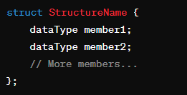
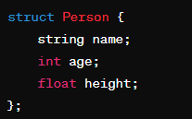

Structure Members: Each variable inside a structure is called a member or field, and they can have different data types.

Accessing Structure Members: Members of a structure can be accessed using the dot (.) operator.
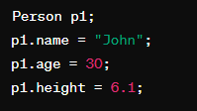
Nested Structures: Structures can be nested within other structures, allowing for the representation of hierarchical data.

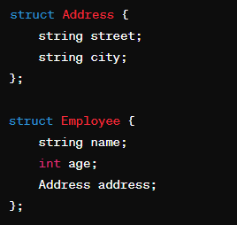
Arrays of Structures: Arrays of structures enable the storage of multiple instances of the same type of data. You can create arrays of structures to store multiple instances of the same type of data. Each element of the array is a structure variable. Arrays of structures are useful for managing collections of related data.

Pointers to Structures: Pointers can be used to dynamically access and manipulate structures. Pointers can be used to access structures dynamically and efficiently. Pointer notation (->) is used to access members of a structure through a pointer.

Use Cases of Structures:
Structures are commonly used to represent real-world entities such as employees, students, books, etc.
They are useful for organizing and managing data in a structured manner. Structures facilitate code readability, maintainability, and modularity.
By practicing these concepts through hands-on exercises and challenges, the students will enhance their problem-solving skills and develop a deeper understanding of how to write efficient and effective C++ code. So, let's get started and embark on this journey to master the art of programming logic!

Exercise:
  - Design a structure Employee with the following members:
    - id (int)
    - name (string)
    - designation (string)
    - salary (float) Write a program to:
- Add employee details.
- Display all employees.
- Search for an employee by ID.
- Update an employee's details.
- Delete an employee record.

  - Define a structure named Rectangle with members length and width. Create a variable of this structure type, input values for length and width, calculate the area, and display it.

Q3) Define a structure named Number with a single member num. Create two variables of this structure type, input values for them, swap their values using a function, and display the swapped values.

Q4 Define a structure named Student with members rollNumber, name, age, and marks. Create an array of 3 Student structures, input data for each student, display their details, and find the student with the highest marks.

Q5) Define a structure named Employee with members employeeID, name, department, and salary. Create an array of 5 Employee structures, input data for each employee, display their details, and calculate the average salary of all employees.

Q6) Define a structure named Book with members title, author, genre, and yearOfPublication. Create an array of 3 Book structures, input data for each book, display their details, and find the book with the earliest publication year.

Q7) Define a structure named Product with members productName, price, and quantity. Create a variable of this structure type, input data for the product, calculate the total cost, and display it.

Q.8)Define a structure called Book that has the following members:
- title (string)
- author (string)
- price (float) Write a program to:
- Accept details of 3 books from the user.
- Display the details of all books.

LAB SESSION 4
Learning Pointers in C++

Objective:
The objective of this lab session is to introduce students to the concept of pointers in C++ and help them understand how to work with pointers effectively. By the end of this lab, students should be able to:
Understand the concept of pointers and their importance in C++ programming. Declare, initialize, and dereference pointers.
Perform pointer arithmetic and understand pointer relationships. Use pointers to work with arrays and dynamic memory allocation.
Identify common pitfalls and best practices when working with pointers.

Introduction:
In C++, a pointer is a variable that stores the memory address of another variable. Pointers are powerful tools that enable us to work with memory directly and perform operations such as dynamic memory allocation, passing parameters by reference, and building complex data structures like linked lists and trees.

Declaration and Initialization:
To declare a pointer variable, you use the asterisk (*) symbol followed by the data type of the variable it points to. Here's an example:

*ptr;
int
This declares a pointer named ptr that can point to an integer variable.You can initialize a pointer with the address of another variable using the address-of operator (&):

num = 10;
int
int
*ptr = &num;
// ptr now points to the memory address of num

Dereferencing:
Dereferencing a pointer means accessing the value stored at the memory address it points to. This is done using the asterisk (*) symbol. For example:

num = 10;
int
int *ptr = &num; cout <<
"Value of num: "

<< *ptr << endl;
// Output: Value of num: 10

Here, *ptr retrieves the value stored at the memory address pointed to by ptr, which is 10.

Pointer Arithmetic:
Pointer arithmetic allows you to perform arithmetic operations on pointers. For example, you can increment or decrement a pointer, add an integer to a pointer, or subtract an integer from a pointer. Pointer arithmetic is often used when working with arrays and dynamic memory allocation.
arr[] = {1,
int
int
2 | , | 3 | , | 4 | , | 5 | };
// Pointer to the first element of the array

*ptr = arr;

cout << *ptr << endl;
// Output: 1
ptr++; // Move to the next element cout << *ptr << endl;
// Output: 2

Null Pointers:
A null pointer is a pointer that does not point to any memory location. It is represented by the value nullptr in C++. Null pointers are often used to indicate that a pointer is not currently pointing to valid memory.
*ptr = nullptr;
int

Dynamic Memory Allocation:
Pointers are commonly used for dynamic memory allocation using new and delete operators. Dynamic memory allocation allows you to allocate memory at runtime and is useful when the size of the memory needed is not known at compile time.

*pt
int
*ptr = new ; r = 10;
ptr;
// Free the allocated memory
// Assign a value to the memory location
// Allocate memory for an integer
int
delete

Common Pitfalls:
Dangling Pointers: Pointers that point to memory that has been deallocated.
Memory Leaks: Failure to deallocate memory that was previously allocated dynamically.
Uninitialized Pointers: Using pointers that have not been initialized, leading to undefined behavior.
Understanding pointers is essential for mastering C++ programming and enables you to work with memory more efficiently. However, pointers require careful handling to avoid common pitfalls and memory-related issues
Exercise:

- Write a function swap that takes two integer pointers as arguments and swaps the values they point to.

- Write a function reverseArray that takes an integer array and its size as arguments and reverses the elements of the array using pointers.

- Write a function findMax that takes an integer array and its size as arguments and returns a pointer to the maximum element in the array.

- Write a function removeDuplicates that takes an integer array and its size as arguments and removes duplicates, keeping only the first occurrence of each element.

- Write a function isPalindrome that takes a string as an argument and returns true if the string is a palindrome, false otherwise. Use pointers to check for palindrome.

NED University of Engineering & Technology Department of Software Engineering

Cognitive Domain Assessment Rubric Level C3 (for Laboratory Work)
Criteria | Level of Attainment
Criteria | (5) | (4) | (3) | (2) | (1) | (0)
Problem Identification | Able to correctly identify the problem(s) and all required data (input and output). | Able to correctly identify the problem(s) but not all the required data (input and output). | Able to partially identify both the problem(s) and the required data (input  and output). | Able to partially identify the problem(s) but cannot identify required data (input  and output). | Not able to correctly identify the problem(s) and  all required data (input  and output). | Not tried to identify the problem(s) and  all required data (input and output).
Problem Solving Skills | Uses an effective strategy to solve the problem(s) and clearly identifies the steps. | Uses an effective strategy to solve the problem(s) but cannot clearly  identify the steps. | Uses an adequate strategy to solve the problem(s) but misses some details. | Uses an inadequate strategy to solve the problem(s) and misses most details. | Uses an ineffective strategy to solve the problem(s) and completely  misses the steps. | Didn’t use any strategy to solve the problem(s) and completely  misses the steps.
Implementati on  & Debugging | Efficient implementat ion and excellent debugging skills. Code works without any  error. | Efficient implementat ion and good debugging skills.  Minor error in the code. | Adequate implementat ion  and fair debugging skills. Few errors in the code. | Inadequate implementat ion  and debugging skills.  Significant errors in the  code. | Incomplete implementat ion  and ineffective debugging skills. Major errors in the  code. | No implementat ion and debugging skills.
Deliverable(s) | Generates correct and complete output. | Generates correct but partially complete output. | Generates partially correct and partially complete  output. | Generates partially correct and incomplete output. | Cannot generate the desired output. | No output generated.
Depth of Knowledge | Thorough grasp of the concepts covered in the lab and can apply it in real-life situations. | Good grasp of the concepts covered in the lab but cannot effectively apply it in real-life  situations. | Fair grasp of the concepts covered in the lab and can vaguely identify a real-life application. | Limited grasp of the concepts covered in the lab and cannot identify any real-life application. | Does not grasp  the concepts covered in the  lab and cannot identify any real-life  application. | Didn’t try to grasp the concepts covered in the  lab and cannot identify any real-life  application.
Weighted CLO Score
Remarks and Signature

Object Oriented Concepts and Programming ,SE-201

LAB SESSION 5
1D,2D Arrays and Vectors in C++

Objective:
The objective of this lab session is to introduce students to the concept of 2D arrays in C++, their declaration, initialization, and manipulation. By the end of the session, participants should be able to understand the fundamentals of 2D arrays and solve basic problems using them.

Introduction:
A two-dimensional array, also known as a matrix, is a collection of elements arranged in rows and columns. In C++, 2D arrays provide a convenient way to store and manipulate data in a tabular format. Each element in a 2D array is identified by its row and column index. Understanding how to declare, initialize, and access elements in 2D arrays is essential for solving problems involving matrices and grids.
dataType arrayName[rows][columns];

Applications:
2D arrays are widely used in various applications, including:
- Image processing: Representing pixels of an image.
- Matrices: Performing mathematical operations like addition, multiplication, etc.
- Grid-based problems: Solving problems related to grids or game boards.

Memory Representation:
In memory, elements of a 2D array are stored in a contiguous block of memory. The elements are arranged row-wise or column-wise based on the programming language and compiler. Understanding 2D arrays is fundamental in programming as they are used in many real-world scenarios for data storage and manipulation. Mastering the concepts of 2D arrays enables programmers to solve a wide range of problems efficiently.

Details about 2D Arrays:
To declare a 2D array in C++, you specify the data type of the elements and the dimensions of the array.
matrix[ROW][COL];
int
You can initialize a 2D array at the time of declaration or later using nested loops
matrix[2][3] = {{1, 2, 3}, {4, 5, 6}};
int

Elements in a 2D array can be accessed using row and column indices
element = matrix[i][j];
int
To traverse through all elements of a 2D array, nested loops are commonly used.
for (int i = ; i < ROW; ++i) { for (int j = ; j < COL; ++j) {

}
}
// Access matrix[i][j] here
0
0

Exercise:
Question: Find the sum of all elements in a 2D array. Explanation:
To find the sum of all elements in a 2D array, we iterate through each element of the array and add it to a running total. This process ensures that we accumulate the sum of all elements. Let’s consider a 2D array matrix with dimensions ROW x COL.
matrix = [

[
[  [ | 1, 2, 3 | ],
[  [ | 4, 5, 6 | ],
 | 7, 8, 9 | ]

]
The sum of all elements in the matrix is 1 + 2 + 3 + 4 + 5 + 6 + 7 + 8 + 9 = 45.
Question: Calculate the transpose of a given matrix. Explanation:
The transpose of a matrix involves switching its rows with its columns. For each element at position (i, j) in the original matrix, the corresponding element in the transpose matrix is at position (j, i).
Matrix Representation:
Let's consider a 3x3 matrix

Original Matrix:
1 | 2 | 3
4 | 5 | 6
7 | 8 | 9
Solution: The transpose of the given matrix would be:

Transpose:
1 | 4 | 7
2 | 5 | 8
3 | 6 | 9
Question:Check if a matrix is symmetric or not. Explanation:
A matrix is symmetric if it is equal to its transpose. To check symmetry, we compare each element of the original matrix with its corresponding element in the transpose matrix.Let's consider a 3x3 matrix matrix.The given matrix is symmetric if it is equal to its transpose.

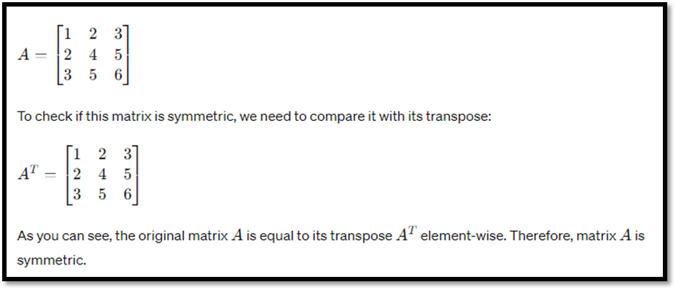

Question:Multiply two matrices and print the result. Explanation:
Matrix multiplication involves multiplying the elements of each row of the first matrix by the corresponding elements of each column of the second matrix and summing the results.Let's consider two matrices matrix1 and matrix2 of suitable dimensions.The resulting matrix will have dimensions equal to the number of rows of the first matrix and the number of columns of the second matrix.
Question:Find the largest element in each row of a matrix. Explanation:
For each row of the matrix, we iterate through its elements and find the maximum value. We store the maximum value of each row in a separate array.Let's consider a 3x3 matrix matrix.We find the maximum element in each row of the matrix and store it in an array maxInRow.

Vectors

Vectors in C++ (from the Standard Template Library, STL) are dynamic arrays that can grow and shrink automatically. Here are some common questions on vectors in C++:
A vector is a sequence container in the C++ STL that dynamically resizes as elements are added or removed.

#include <vector> vector<int> v;

vector<int> v = {1, 2, 3, 4, 5};

v.size(); // Returns the number of elements v.capacity(); // Returns the allocated storage capacity

for (size_t i = 0; i < v.size(); i++)
{

cout << v[i] << " "; }

for (int num : v)

{ cout << num << " "; }

v.insert(v.begin() + 2, 10); // Inserts 10 at index 2

How do you find an element in a vector?

auto it = std::find(v.begin(), v.end(), 5);
if (it != v.end()) std::cout << "Found!";

How do you use emplace_back()?
cpp CopyEdit
- emplace_back(42); // Constructs element in-place (better than push_back for objects)

Question Reverse the elements of a given vector without using the reverse() function.
Example Input: {1, 2, 3, 4, 5}
Output: {5, 4, 3, 2, 1}

LAB SESSION 6
Classes in C++

Objective:
The goal of this lab is to understand the concept of classes in Object-Oriented Programming (OOP). By the end of this lab, you should be able to:
- Create objects (instances) of a class
- Understand and implement constructors
- Define and use instance variables and methods
- Understand and implement class variables and methods

Introduction:
Classes
In Object-Oriented Programming (OOP), a class is a blueprint for creating objects. A class encapsulates data for the object and methods to manipulate that data. Classes define the properties and behaviors of the objects created from them.

Defining a Class
Here is a basic example of defining a class in C++:
#include <string>
#include <iostream>
{
public:
Person
class
// Constructor
(std::string name, age) : name(name), age(age) {}
int
Person

// Instance method
std::string greet() {

"Hello, my name is " + name +
return
" and I am "
}
+ std::to_string(age) + " years old.";

private:
std::string name;
int age;
};

int main() {

;
Person person1("Alice", 30)
// Creating an instance of the Person class
// Using the greet method
std::cout << person1.greet() << std::endl;
// Output: Hello, my name is Alice and I am 30 years old.
;

0
return
}

Explanation:
The Person class has a constructor that initializes the name and age attributes. The greet method returns a greeting message using the instance attributes.

Empty and Parameterized Constructor:
In C++, constructors are special member functions of a class that are automatically called when an object of that class is created. Constructors can be of two types: empty constructors and parameterized constructors.

Empty Constructor: An empty constructor does not take any arguments. It is called when an object is created without providing any values. In the example provided, the empty constructor of the Student class is invoked when emptyStudent is created. This constructor simply prints a message indicating that an empty student object has been created.
Parameterized Constructor: A parameterized constructor takes one or more arguments. It is called when an object is created with specific values provided as arguments. In the example, the parameterized constructor of the Student class is invoked when parameterizedStudent is created with the arguments "John" and 20. This constructor initializes the name and age member variables of the Student object with the provided values and prints a message indicating the creation of a student object with the given name and age.

Both constructors are useful for initializing objects with appropriate values based on different scenarios. The choice between an empty constructor and a parameterized constructor depends on the requirements of the class and the desired behavior when creating objects.
#include <string>
#include <iostream>

class |  | Student |  |  | {
public |  |  | :
 | // Empty constructor
 | Student |  |  | () {

std::cout <<
"An empty student object is created."
}
<< std::endl;

// Parameterized constructor
Student(std::string name, int age) :
name

(name), age(age) {
" is created."

std::cout << "A student object with name " << name << std::endl;
" and age "
}
<< age << <<

// Method to display student information
void displayInfo() {
std::cout << "Name: " << name <<
", Age: "
}

<< age << std::endl;

private:
std::string name;
int age;
};
int main() {
// Creating objects using different constructors
Student emptyStudent; // Creating an empty student object
Student parameterizedStudent("John", 20); // Creating a parameterized student object
// Displaying student information
std::cout << "Details of the parameterized student:" << std::endl;
parameterizedStudent.displayInfo();
;

0
return
}

Public and Private Access Specifiers :
Access specifiers define the accessibility of class members (variables and methods). The two most commonly used access specifiers are public and private.
public: Members declared as public are accessible from outside the class. private: Members declared as private are only accessible within the class.
#include <string>
#include <iostream>

{
Person
class
public:
// Public members
std::string name;

// Constructor
(std::string name, age) : name(name), age(age) {}
int
Person

void displayInfo() {
// Public method

std::cout << | "Name: " | << name << | ", Age: " | << age << std::endl;
}

private:
// Private member
age;
int
};

;
int main() |  | {
 | Person person("Alice", 30)

// Accessing public member
std::cout << << person.name << std::endl;
"Name: "
// OK

// std::cout << "Age: " << person.age << std::endl; // Error
// Trying to access private member (will cause a compilation error)

// Accessing private member via public method
person.displayInfo(); // Output: Name: Alice, Age: 30
;

0
return

}
Explanation:
name is a public member and can be accessed directly from outside the class.
age is a private member and can only be accessed indirectly through a public method.

Exercise:
  - Question: Create a class Rectangle with attributes length and width. Implement methods to calculate the area and perimeter of the rectangle.

  - ​Question: Create a class Circle with attribute radius. Implement methods to calculate the area and circumference of the circle.

  - ​Question: Create a class Employee with attributes name and salary. Implement a method to display the details of the employee.

  - Question: Create a class BankAccount with attributes accountNumber, accountHolder, and balance. Implement methods to deposit and withdraw money from the account.
  - ​Question: Create a class Car with attributes brand, model, and year. Implement a method to display the details of the car.
  - ​Question: Create a class Fraction with attributes numerator and denominator. Implement a method to simplify the fraction.

NED University of Engineering & Technology

Cognitive Domain Assessment Rubric Level C3 (for Laboratory Work)
Criteria | Level of Attainment
Criteria | (5) | (4) | (3) | (2) | (1) | (0)
Problem Identification | Able to correctly identify the problem(s) and all required data (input and output). | Able to correctly identify the problem(s) but not all the required data (input and output). | Able to partially identify both the problem(s) and the required data (input  and output). | Able to partially identify the problem(s) but cannot identify required data (input  and output). | Not able to correctly identify the problem(s) and  all required data (input  and output). | Not tried to identify the problem(s) and  all required data (input and output).
Problem Solving Skills | Uses an effective strategy to solve the problem(s) and clearly identifies the steps. | Uses an effective strategy to solve the problem(s) but cannot clearly  identify the steps. | Uses an adequate strategy to solve the problem(s) but misses some details. | Uses an inadequate strategy to solve the problem(s) and misses most details. | Uses an ineffective strategy to solve the problem(s) and completely  misses the steps. | Didn’t use any strategy to solve the problem(s) and completely  misses the steps.
Implementati on  & Debugging | Efficient implementat ion and excellent debugging skills. Code works without any  error. | Efficient implementat ion and good debugging skills.  Minor error in the code. | Adequate implementat ion  and fair debugging skills. Few errors in the code. | Inadequate implementat ion  and debugging skills.  Significant errors in the  code. | Incomplete implementat ion  and ineffective debugging skills. Major errors in the  code. | No implementat ion and debugging skills.
Deliverable(s) | Generates correct and complete output. | Generates correct but partially complete output. | Generates partially correct and partially complete  output. | Generates partially correct and incomplete output. | Cannot generate the desired output. | No output generated.
Depth of Knowledge | Thorough grasp of the concepts covered in the lab and can apply it in real-life situations. | Good grasp of the concepts covered in the lab but cannot effectively apply it in real-life  situations. | Fair grasp of the concepts covered in the lab and can vaguely identify a real-life application. | Limited grasp of the concepts covered in the lab and cannot identify any real-life application. | Does not grasp  the concepts covered in the  lab and cannot identify any real-life  application. | Didn’t try to grasp the concepts covered in the  lab and cannot identify any real-life  application.
Weighted CLO Score
Remarks and Signature
Department of Software Engineering
Object Oriented Concepts and Programming ,SE-201

LAB SESSION 7

Concept of Inheritance

Objective:
Understand and implement the concept of inheritance in object-oriented programming (OOCP).

Introduction:
Inheritance is a fundamental principle in OOP that allows a class to inherit properties and methods from another class. The class that is inherited from is called the base class (or parent class), and the class that inherits is called the derived class (or child class).This promotes code reusability, organization, and the creation of a hierarchical relationship between classes.
In this lab, you will:

- Learn the basic principles of inheritance.
- Create a base class with common attributes and methods.
- Create derived classes that inherit from the base class and extend or override its functionality.
- Understand how to use inheritance to write more efficient and maintainable code.

Key Concepts:
Base Class (Parent Class): The class whose properties and methods are inherited. Derived Class (Child Class): The class that inherits properties and methods from the base class.
Constructor ( init method): Initializes the object's state.
Method Overriding: A derived class can provide a specific implementation of a method that is already defined in its base class.

Example Scenario:
We will create a base class called Animal with attributes and methods common to all animals. Then, we will create derived classes Dog and Cat that inherit from the Animal class and add specific behaviors.

Step 1: Define the Base Class (Animal):
#include <iostream> #include <string> using namespace std;

class Animal {

protected: string name; string species;

public:
// Constructor
Animal(string n, string s) : name(n), species(s) {}
// Method to make sound (to be overridden by derived classes) void makeSound() {
cout << "Some generic sound" << endl;
}

// Method to display information void displayInfo() {
cout << "Name: " << name << ", Species: " << species << endl;
}
};

Step 2: Define the Derived Classes (Dog and Cat)

// Derived class Dog
class Dog : public Animal { private:
string breed;
public:
// Constructor
Dog(string n, string s, string b) : Animal(n, s), breed(b) {}
// Overriding the makeSound method void makeSound() {
cout << "Woof!" << endl;
}
// Method to display Dog-specific information void displayInfo() {
Animal::displayInfo(); // Call base class method cout << "Breed: " << breed << endl;
}
};

// Derived class Cat
class Cat : public Animal { private:

string color;

public:
// Constructor
Cat(string n, string s, string c) : Animal(n, s), color(c) {}
// Overriding the makeSound method void makeSound() {
cout << "Meow!" << endl;
}
// Method to display Cat-specific information void displayInfo() {
Animal::displayInfo(); // Call base class method cout << "Color: " << color << endl;
}
};

Step 3: Create Objects and Demonstrate Inheritance

int main() {
// Creating objects of Dog and Cat
Dog dog("Buddy", "Canine", "Golden Retriever"); Cat cat("Whiskers", "Feline", "Black");

// Displaying information and sounds of Dog cout << "Dog Info:" << endl; dog.displayInfo();
cout << "Dog makes sound: "; dog.makeSound();
cout << endl;

// Displaying information and sounds of Cat cout << "Cat Info:" << endl; cat.displayInfo();
cout << "Cat makes sound: "; cat.makeSound();
return 0;
}

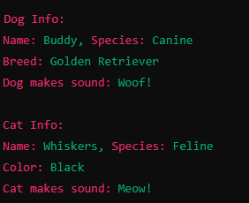

Explanation:
Base Class (Animal):
The Animal class has protected attributes name and species which can be accessed by derived classes It includes a constructor to initialize these attributes and a method makeSound that outputs a generic sound. The displayInfo method shows the animal's name and species.

Derived Classes (Dog and Cat):
Both Dog and Cat classes inherit from the Animal class using public inheritance (: public Animal).Each derived class has its own specific attribute: breed for Dog and color for Cat. The makeSound method is overridden to provide specific sounds for each class.
The displayInfo method is extended to include the specific attributes (breed and color).

Creating Objects and Demonstrating Inheritance:
Objects dog and cat are created with their specific attributes. The displayInfo method from the base class is called to show inherited attributes, and the overridden makeSound method.This example illustrates the basics of inheritance in C++, showcasing how a derived class can extend and customize the behavior of a base class.

Exercise:

Question 1: Basic Inheritance
Create a base class Vehicle with a method move() that prints "Vehicle is moving". Derive a class Car from Vehicle and override the move() method to print "Car is moving".

Question 2: Constructor in Derived Class
Create a base class Person with attributes name and age. Create a derived class Student with an additional attribute studentID. Initialize these attributes using constructors.

Question 3: Method Overriding
Create a base class Shape with a method draw() that prints "Drawing Shape". Create derived classes Circle and Square that override the draw() method to print "Drawing Circle" and "Drawing Square", respectively.

Question 4: Access Specifiers
Create a base class Base with a private attribute privateVar, a protected attribute protectedVar, and a public attribute publicVar. Create a derived class Derived and demonstrate access to these attributes. Write your observations.

Question 5
You are required to create a C++ program that demonstrates the concept of inheritance.Consider the following requirements:

Base Class - Shape:
Attributes:
- color (string)
- Constructor that initializes color.
- A pure virtual function area() which will return the area of the shape.
- A virtual function display() that prints the color of the shape.

Derived Classes:
Rectangle:
- Attributes:width (double),height (double)
- Constructor that initializes color, width, and height.
- Override area() to calculate and return the area of the rectangle.
- Override display() to print the color, width, height, and area of the rectangle.

Circle:

Attributes:
- radius (double)
- Constructor that initializes color and radius.
- Override area() to calculate and return the area of the circle.
- Override display() to print the color, radius, and area of the circle.

Main Function:
- Create instances of Rectangle and Circle with different attributes.
- Use a pointer to Shape to store the addresses of these instances and call their display() method.

LAB SESSION 8

Open Ended Lab

Objective
The objective of this lab session is to assess your understanding and application of Object-Oriented Programming (OOP) concepts, problem-solving skills, and coding techniques. You will be evaluated based on your ability to design and implement a system using OOP principles within the session.

Introduction
In this lab session, you will be presented with a general problem that you need to solve. Your solution will be assessed based on the following criteria: technique, problem-solving skills, OOP concepts, code efficiency, and code readability. Ensure that you apply the knowledge and skills covered in previous labs to complete the task effectively.

Problem Statement
You will need to design and implement a system using OOP principles. Each criterion will be scored as follows:
- 0: The criterion is not met.
- 1: The criterion is met.
Please review your previous lab notes and understand the key concepts of OOP, including class design, inheritance, encapsulation, and polymorphism, before attempting this assessment.


NED University of Engineering & Technology Department of Software Engineering
OEL RUBRICS
Object Oriented Concepts and Programming, SE-201

Criteria | Achieved (1) | Not Achieved (0) | Marks
Problem Identification | Able to correctly identify the problem(s) and all required data (input and output) | Not able to correctly identify the problem(s) and all required data (input and output).
Problem Solving Skills | Uses an effective strategy to solve the problem(s) and clearly identifies the steps | Uses an ineffective strategy to solve the problem(s) and completely misses the steps
Implementation & Debugging | Efficient implementation and excellent debugging skills. Solution works without any error | Incomplete implementation and ineffective debugging skills. Major errors in the implementation.
Deliverable(s) | Generates correct and complete  output. | Cannot generate the desired output.
Depth of Knowledge | Thorough grasp of the concepts covered in the lab and can apply it in real-life situations | Does not grasp the concepts covered in the lab and cannot identify any real-life application
Weighted CLO Score
Remarks and Signature

LAB SESSION 9

Understanding Abstract Classes

Objective:
Understand and implement the concept of Abstract Classes in object-oriented programming (OOCP).

Introduction:
Abstract classes in Object-Oriented Programming (OOP) are classes that cannot be instantiated on their own and are designed to be inherited by other classes. They serve as a blueprint for other classes, providing a template for them to follow. An abstract class typically includes one or more abstract methods, which are methods declared without any implementation. Derived classes that inherit from an abstract class must provide implementations for these abstract methods. The primary purpose of abstract classes is to define a common interface for all derived classes while allowing the implementation details to be handled by the subclasses. This promotes code reusability and ensures that certain methods are implemented in all derived classes.

Key Points:
Cannot Instantiate: You cannot create an object of an abstract class.
Abstract Methods: These are methods declared without implementation. Derived classes must implement these methods.

Concrete Methods: Abstract classes can also have concrete methods with implementation.

Purpose: Abstract classes are used to define a template for other classes, enforcing a contract for subclasses to follow.

Pure Virtual Functions:
A pure virtual function in C++ is a virtual function that has no implementation in the base class and must be overridden by derived classes. It is declared by assigning = 0 at the end of the function declaration. Classes containing one or more pure virtual functions are considered abstract classes and cannot be instantiated.

The primary purpose of pure virtual functions is to define an interface that must be implemented by derived classes, enforcing a contract that specific functions will be provided.

Key Points:

Declaration: A pure virtual function is declared with = 0 at the end of the function declaration.

Abstract Classes: A class containing at least one pure virtual function is abstract and cannot be instantiated.
Implementation in Derived Classes: Derived classes must provide implementations for all pure virtual functions from the base class.

Polymorphism: Pure virtual functions enable polymorphic behavior, allowing for runtime method binding.
#include <iostream>

// Abstract base class class Shape {
public:
// Pure virtual function (abstract method) virtual void draw() const = 0;
// Concrete method void info() const {
std::cout << "This is a shape." << std::endl;
}

// Virtual destructor virtual ~Shape() {}
};
// Derived class Circle
class Circle : public Shape { public:
// Implementing the pure virtual function void draw() const override {
std::cout << "Drawing a Circle." << std::endl;
}
};

// Derived class Square
class Square : public Shape { public:
// Implementing the pure virtual function void draw() const override {
std::cout << "Drawing a Square." << std::endl;
}
};

int main() {
// Shape shape; // This line would cause a compilation error because Shape is abstract

// Create instances of derived classes Shape* circle = new Circle(); Shape* square = new Square();
// Call the draw method on each derived class object circle->draw(); // Outputs: Drawing a Circle. square->draw(); // Outputs: Drawing a Square.

// Call the info method from the base class circle->info(); // Outputs: This is a shape. square->info(); // Outputs: This is a shape.
// Clean up delete circle; delete square;

return 0;
}
Explanation:

Abstract Base Class Shape:
Contains a pure virtual function draw(), making it an abstract class. This function must be implemented by all derived classes.
Includes a concrete method info() with a defined implementation that can be used by all derived classes.
Provides a virtual destructor to ensure proper cleanup of derived class objects.

Derived Class Circle:
Inherits from Shape.
Implements the pure virtual function draw() with the override keyword. This provides the specific behavior for drawing a circle.

Derived Class Square:
Inherits from Shape.
Implements the pure virtual function draw() with the override keyword. This provides the specific behavior for drawing a square.

Main Function:
Demonstrates that attempting to instantiate a Shape object directly would result in a compilation error because Shape is abstract.
Creates objects of Circle and Square, assigns them to variables of type Shape, and calls their draw() methods, demonstrating polymorphism.
Calls the info() method, which is a concrete method from the base class, on both Circle and Square objects, demonstrating that derived classes can use concrete methods from the base class.

Summary:
A pure virtual function in C++ is a way to enforce that derived classes provide specific functionality. By defining an interface with pure virtual functions in an abstract base class, you ensure that any class derived from it implements these functions, thereby enabling polymorphic behavior.

Exercise:
Question 1: Shape Area Calculation Problem Statement:
Create an abstract class Shape with a pure virtual function area(). Derive two classes Circle and Rectangle from Shape. Implement the area() function in both derived classes. Write a program to calculate the area of a circle and a rectangle.
Question 2: Employee Salary Calculation Problem Statement:
Create an abstract class Employee with a pure virtual function calculateSalary(). Derive two classes PermanentEmployee and ContractEmployee from Employee. Implement the calculateSalary() function in both derived classes. Write a program to calculate the salary of a permanent employee and a contract employee.
Question 3: Vehicle Fuel Efficiency Problem Statement:
Create an abstract class Vehicle with a pure virtual function fuelEfficiency(). Derive two classes Car and Truck from Vehicle. Implement the fuelEfficiency() function in both derived classes. Write a program to calculate the fuel efficiency of a car and a truck.
Question 4: Payment Processing System Problem Statement:
Create an abstract class Payment with a pure virtual function processPayment(). Derive two classes CreditCardPayment and PaypalPayment from Payment. Implement the processPayment() function in both derived classes. Write a program to process a payment through credit card and PayPal.
Question 5: Animal Sound Simulation Problem Statement:
Create an abstract class Animal with a pure virtual function makeSound(). Derive two classes Dog and Cat from Animal. Implement the makeSound() function in both derived classes. Write a program to simulate the sounds of a dog and a cat.

LAB SESSION 10

Working with C# Controls and Tools

Objective:
To learn about use of different controls like buttons, text boxes, combo box and timer controls in C# applications and how to apply graphics and Mouse events.

Introduction:

Example:
Create a simple C# that will place one combo box filled with the names of different shapes by using item property of combo box and application should be able to draw the selected shape of combo box control by creating graphic ,pen and solid brush objects.
namespace ListboxnCombo
{
public partial class Form1 : Form
{
public Form1()
{
InitializeComponent();
}

private void comboBox1_SelectedIndexChanged(object sender, EventArgs e)
{
Graphics g = base.CreateGraphics(); Pen p = new Pen(Color.Blue);
SolidBrush sb = new SolidBrush(Color.Brown); g.Clear(Color.White);

switch (comboBox1.SelectedIndex)
{
case 0:
g.FillEllipse(sb, 50, 50, 150, 150); break;
case 1:
g.DrawRectangle(p, 50, 50, 150, 150); break;
case 2:
g.DrawEllipse(p, 50, 80, 150, 170); break;
case 3:
g.DrawRectangle(p, 50, 50, 50, 50); break;

}

}

}
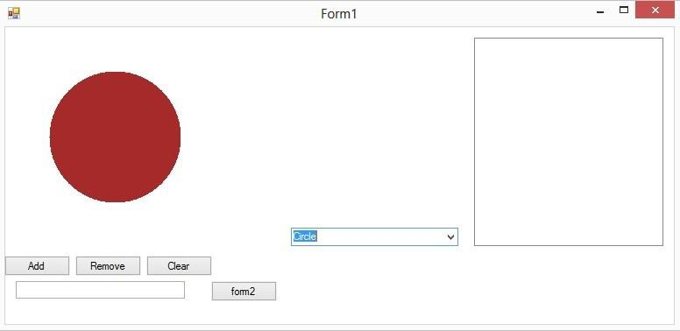
}

Timer Control:
he Timer Control plays an important role in the development of programs both Client side and Server side development. A Timer control raises an event at a given interval of time without using a secondary thread. If you need to execute some code after certain interval of time continuously, you can use a timer control.
Timer Class Properties
Enabled property of timer represents if the timer is running. We can set this property to true to start a timer and false to stop a timer.
Interval property represents time on in milliseconds, before the Tick event is raised relative to the last occurrence of the Tick event. One second equals to 1000 milliseconds. So if you want a timer event to be fired every 5 seconds, you need to set Interval property to 5000.
Timer t = new Timer(); Namespace: System.Timers Assembly: System (in System.dll)

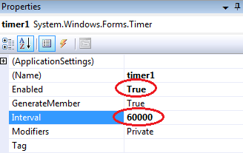

Exercise:
Task 2:
Create an array of Buttons that would display buttons dynamically at run time. Sample Code:
private void Form1_Load(object sender, EventArgs e)
{
Button[] b = new Button[5];

for (int i = 1; i <= b.Length-1; i++)
{
b[i] = new Button(); b[i].Text = "Button" + i; b[i].Size = new Size(70, 30);
b[i].Location = new Point(i + 70, i + 100); b[i].Left = 50*i;
b[i].Top = i * 70;
b[i].Click += new System.EventHandler(button1_Click); this.Controls.Add(b[i]);

}
}

Task 3:
Create a slideshow of pictures by using picture box control and timer control. Make a folder on any drive containing all of your pictures, you want to include in a slideshow. Rename all the pictures starting with 1.jpg, 2.jpg… n.jpg.

Task 4:
Using Mouse up, down and Mouse move events, Create an application that can draw freehand drawing.
Sample Code:
int readypaint = 1;
private void Form1_Load(object sender, EventArgs e)
{
timer1.Start();
}
private void Form1_MouseUp(object sender, MouseEventArgs e)
{
readypaint = 0;
}

private void Form1_MouseMove(object sender, MouseEventArgs e)
{
if (readypaint == 1)
{
Graphics g = CreateGraphics(); Pen p = new Pen(Color.Red); g.DrawEllipse(p, e.X, e.Y, 10,10);
}
}

private void Form1_MouseDown(object sender, MouseEventArgs e)
{
readypaint = 1;
}

LAB SESSION 11

Composition & Aggregation in OOP
Objective:
Understand the concepts of composition and aggregation in Object-Oriented Programming (OOP) using C++ and learn how to implement these concepts in practical scenarios.

Introduction:
Composition and Aggregation are two types of associations that represent relationships between objects. Composition is a strong form of association with a strict lifecycle dependency between the parent and child objects. If the parent object is destroyed, the child objects are also destroyed. Aggregation is a weaker form of association where the child objects can exist independently of the parent object.

Feature | Composition | Aggregation
Definition | A strong form of association where the lifetime of the contained object is managed by the container object. | A weaker form of association where the contained objects can exist independently of the  container object.
Lifetime Dependency | Contained objects do not exist independently. When the container is destroyed, contained objects are also destroyed. | Contained objects can exist independently. When the container is destroyed,  contained objects may continue to exist.
Ownership | The container class owns the  contained objects. | The container class does not  own the contained objects.
Example | A Person class containing a Heart object. When the Person is destroyed, the Heart is also destroyed. | A Library class containing a collection of Book objects. The Books can exist independently  of the Library.
Code Example (C++) | cpp class Heart { /*...*/ }; class Person  { private: Heart heart; public: Person()  : heart() {} /*...*/ }; | cpp class Book { /*...*/ }; class Library { private: vector<Book> books; public: void addBook(const Book& book) { books.push_back(book); }  /*...*/ };
UML  Representati on | Filled diamond (black diamond) | Empty diamond (white diamond)
Strength of | Strong relationship | Weak relationship

Relationship
Reusability | Low reusability of the contained object outside the container | High reusability of the contained object outside the  container
Implementati  on Complexity | Generally more complex due to lifecycle management | Generally simpler due to independent lifecycle  management

Composition in C++
In composition, the contained objects are usually part of the parent object. This is often described as a "has-a" relationship.
Aggregation in C++
In aggregation, the contained objects can exist independently of the parent object. This is also a "has-a" relationship but with a weaker dependency.
Part 1: Composition
Create a Date class that contains day, month, and year.
Create a Person class that contains a name, age, and a Date object representing the birthdate.
#include <iostream> using namespace std;

class Date { private:
int day, month, year; public:
Date(int d, int m, int y) : day(d), month(m), year(y) {} void display() {
cout << day << "/" << month << "/" << year << endl;
}
};
class Person { private:
string name; int age;
Date birthdate;

public:
Person(string n, int a, Date b) : name(n), age(a), birthdate(b) {} void display() {
cout << "Name: " << name << ", Age: " << age << ", Birthdate: "; birthdate.display();
}
};
int main() {
Date birthDate(1, 1, 2000);
Person person("John Doe", 24, birthDate); person.display();
return 0;
}

Part 2: Aggregation
Create a Car class that contains a model, manufacturer, and year. Create a Garage class that contains a collection of Car objects. #include <vector>
#include <iostream> using namespace std;

class Car { private:
string model;
string manufacturer; int year;
public:
Car(string m, string manu, int y) : model(m), manufacturer(manu), year(y) {} void display() {
cout << "Model: " << model << ", Manufacturer: " << manufacturer << ", Year: " << year << endl;
}
};

class Garage { private:
vector<Car> cars; public:
void addCar(Car car) { cars.push_back(car);
}
void displayCars() {
for (auto &car : cars) { car.display();
}
}
};
int main() {
Car car1("Model S", "Tesla", 2020); Car car2("Mustang", "Ford", 2018);

Garage garage; garage.addCar(car1); garage.addCar(car2);

garage.displayCars(); return 0;
}

Choosing Between Composition and Aggregation
When designing a system, it is crucial to understand the relationship between objects to decide whether to use composition or aggregation:

Use composition when:
The contained object is part of the container object and its existence is meaningless outside the container.
You want to enforce a strong lifecycle dependency where the destruction of the container object should also destroy the contained objects.

Use aggregation when:
The contained objects can logically exist independently of the container. You need to allow for the reuse of the contained objects in different contexts.

By carefully considering these factors, you can design your classes and their relationships in a way that best fits the logical and functional requirements of your system. This ensures that your code is both robust and maintainable, adhering to good object-oriented design principles.

Practice Questions Question 1: Composition
Create a Book class that has title, author, and a Date object for the publication date. Implement a method to display the book details.

Question 2: Aggregation
Create a Library class that can hold multiple Book objects. Implement methods to add books and display all books in the library.

LAB SESSION 12

Friend Functions in C++
Objective
The objective of this lab is to understand and apply the concept of friend functions in C++. By the end of this lab, you should be able to define and use friend functions to access private and protected members of a class.

Introduction
In C++, friend functions are functions that are not member functions of a class but have access to the class's private and protected members. Friend functions are useful when you need to allow a non-member function to access private data of a class, which can be helpful in certain scenarios such as interfacing with external functions.

Theory
Friend Functions
A friend function is defined outside the class but has the right to access all private and protected members of the class. A friend function is declared using the keyword friend inside the class.

class ClassName {
friend returnType friendFunctionName(arguments);
// Other class members
};

Example:
#include <iostream> using namespace std;
class Box { private:
double width; public:
Box(double w) : width(w) {}

// Friend function declaration friend void printWidth(Box box);
};

// Friend function definition void printWidth(Box box) {
cout << "Width of box: " << box.width << endl;
}

int main() {
Box box(10.5); printWidth(box); return 0;
}
In this example, printWidth is a friend function of the class Box and can access its private member width.

Conclusion
Friend functions provide a way to access the private and protected members of a class without being a member of the class. This can be particularly useful when you need to interface with external functions or perform operations that require access to private data.

Exercise:
- Write a class Circle with a private member radius. Write a friend function to calculate the area of the circle.

- Implement a class Rectangle with private members length and width. Write a friend function to calculate the perimeter of the rectangle.

LAB SESSION 13
Operator Overloading in C++
Objective
The objective of this lab is to understand and apply the concept of operator overloading in C++. By the end of this lab, you should be able to overload operators to perform custom operations on objects of user-defined classes.

Introduction
Operator overloading allows the redefinition of the behavior of operators for user-defined types. This makes it possible to use operators like +, -, *, and others with class objects, making the code more intuitive and easier to understand.

Theory
Operator Overloading
Operator overloading allows you to define how operators work with class objects. The operator keyword is used to define an operator function.

Syntax:

returnType operator operatorSymbol(arguments);

Example

#include <iostream> using namespace std;
class Complex { private:
float real; float imag;
public:
Complex() : real(0), imag(0) {} Complex(float r, float i) : real(r), imag(i) {}

// Overloading the '+' operator
Complex operator + (const Complex& obj) { Complex temp;
temp.real = real + obj.real; temp.imag = imag + obj.imag; return temp;
}
void display() {

cout << real << " + " << imag << "i" << endl;
}
};

int main() {
Complex c1(3.5, 2.5), c2(1.5, 4.5);
Complex c3 = c1 + c2; c3.display();
return 0;
}
In this example, the + operator is overloaded to add two Complex objects.

Conclusion
Operator overloading provides a powerful way to define custom operations for user-defined types. By overloading operators, you can make your code more intuitive and easier to read, while still performing complex operations on class objects.

Exercise:
- Overload the * operator to multiply two Matrix objects (define a simple Matrix class with a 2D array).

LAB SESSION 14

Database App Development in C#

The main objective of this lab is to be able to use databases C# applications using ADO.Net classes and Microsoft SQL Server and Microsoft Access. We will use data access components tools to connect to, retrieve and update data in database. We will explore how we can leverage the built-in capabilities of ADO .NET to extract and manipulate data as well as insert, update and delete data in SQL Server. With this, we will take a look at CurrencyManager object to navigate the records in our bound controls.

Program 1
This simple application how to create database connectivity in C # application.

Steps
Create a Database consisting of four tables containing necessary attributes of these tables along with the connectivity’s .
- Department.
- Teachers.
- Student.
- Subjects
- Courses
- Program

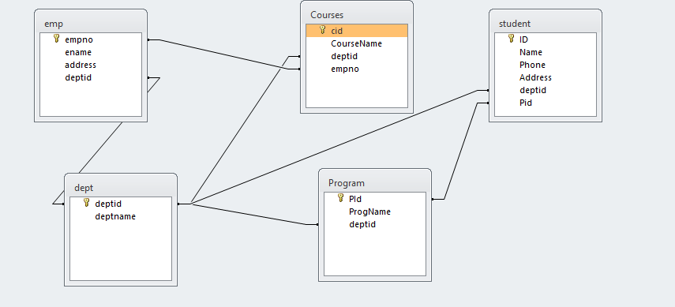
- Start a new Windows Application project. Design GUI as shown below:

- As this in untyped connection, we have to import System.Data.Oledb name space
- We’ll declare connection, Data Adapter, Data Set and an integer variable as globel:

OleDbConnection con = new OleDbConnection("Provider=Microsoft.jet.Oledb.4.0;Data Source= e:\SalesDatabase.mdb;");
OleDbDataAdapter adap = new OleDbDataAdapter("select * from student", "Provider=Microsoft.jet.Oledb.4.0;Data Source=e:/std.mdb;");
DataSet d = new DataSet("student"); Int intCurrentIndex =0;

- Data Adapter acts as a bridge between application and connection. For that a Data Adapter must know which database and what table(s) to use as we’ll use Data Adapter to fill our Data Set: On form’s load event, write following line of code:
- ​

da.Fill(ds);
‘DS is the name of Data Set
Do It Yourself: Code click events of “<” button and “>>” button yourself. Program 2
This simple application demonstrates How to Use DataGridView control to display data:
- Open a new form and place DataGrid Control and a Button on your form.
- As in previous example import Oledb namespace and declare Connection, Data Adapter and Data Set as global variables.
- Go to Load Event of your for and enter the following coding:

string constr = "Provider=Microsoft.Jet.Oledb.4.0; Data source =e:/std.mdb"; OleDbConnection con = new OleDbConnection(constr);
string strsql = "select * from student"; OleDbDataAdapter adap = new OleDbDataAdapter(strsql, con); DataSet d1 = new DataSet("student");
con.Open(); adap.Fill(d1, "student");
dataGrid1.DataSource = d1;

- Save and execute your work.

Program 3:

Enhance your form according to snapshot:( Data Manipulation )
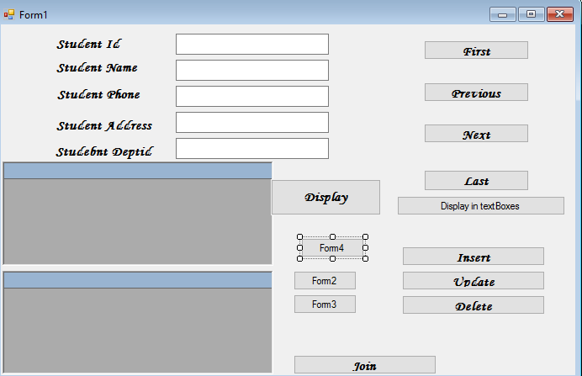

Solution:
OleDbConnection con = new OleDbConnection("Provider=Microsoft.Jet.OLEDB.4.0; Data source=f:/std.mdb");
DataSet d1 = new DataSet("student"); int counter = 0;
private void button1_Click(object sender, EventArgs e)
{

}

private void button6_Click(object sender, EventArgs e)
{

textBox1.Text = d1.Tables[0].Rows[0]["ID"].ToString(); textBox2.Text = d1.Tables[0].Rows[0]["Name"].ToString(); textBox3.Text = d1.Tables[0].Rows[0]["Phone"].ToString(); textBox4.Text = d1.Tables[0].Rows[0]["Address"].ToString(); textBox5.Text = d1.Tables[0].Rows[0]["deptid"].ToString();

}

private void Form1_Load(object sender, EventArgs e)
{
con.Open();

}

private void button2_Click(object sender, EventArgs e)
{
if (counter > 0)
{
counter = 0;

textBox1.Text = d1.Tables[0].Rows[counter]["ID"].ToString(); textBox2.Text = d1.Tables[0].Rows[counter]["Name"].ToString(); textBox3.Text = d1.Tables[0].Rows[counter]["Phone"].ToString(); textBox4.Text = d1.Tables[0].Rows[counter]["Address"].ToString(); textBox5.Text = d1.Tables[0].Rows[counter]["deptid"].ToString();

}
}

private void button3_Click(object sender, EventArgs e)
{
if (counter > 0)
{
counter = counter - 1;
textBox1.Text = d1.Tables[0].Rows[counter]["ID"].ToString(); textBox2.Text = d1.Tables[0].Rows[counter]["Name"].ToString(); textBox3.Text = d1.Tables[0].Rows[counter]["Phone"].ToString(); textBox4.Text = d1.Tables[0].Rows[counter]["Address"].ToString(); textBox5.Text = d1.Tables[0].Rows[counter]["deptid"].ToString();
}
else
{
MessageBox.Show(" U are lready on the first record");
}
}
private void button4_Click(object sender, EventArgs e)
{
if (counter < d1.Tables[0].Rows.Count - 1)
{
counter = counter + 1;

textBox1.Text = d1.Tables[0].Rows[counter]["ID"].ToString(); textBox2.Text = d1.Tables[0].Rows[counter]["Name"].ToString(); textBox3.Text = d1.Tables[0].Rows[counter]["Phone"].ToString(); textBox4.Text = d1.Tables[0].Rows[counter]["Address"].ToString(); textBox5.Text = d1.Tables[0].Rows[counter]["deptid"].ToString();
}
}

private void button5_Click(object sender, EventArgs e)
{
if (counter < d1.Tables[0].Rows.Count - 1)
{
counter = d1.Tables[0].Rows.Count - 1;
textBox1.Text = d1.Tables[0].Rows[counter]["ID"].ToString(); textBox2.Text = d1.Tables[0].Rows[counter]["Name"].ToString(); textBox3.Text = d1.Tables[0].Rows[counter]["Phone"].ToString(); textBox4.Text = d1.Tables[0].Rows[counter]["Address"].ToString(); textBox5.Text = d1.Tables[0].Rows[counter]["deptid"].ToString();
}
}

private void button7_Click(object sender, EventArgs e)
{

OleDbDataAdapter adap1 = new OleDbDataAdapter(" Select student.ID , dept.deptid from student inner join dept on dept.deptid=student.deptid ", con);
DataSet d2 = new DataSet(); adap1.Fill(d2,"student"); dataGrid1.DataSource = d2;
OleDbDataAdapter adap2 = new OleDbDataAdapter("select Courses.CourseName,emp.ename from emp inner join courses on emp.empno=courses.empno", con);

adap2.Fill(d2,"emp"); dataGrid2.DataSource=d2;

}

private void button8_Click(object sender, EventArgs e)
{
OleDbCommand com1 = new OleDbCommand("Insert into student(ID,Name,Phone,Address,deptid) values(' " + textBox1.Text + " ',' " + textBox2.Text + " ',' " + textBox3.Text + " ',' " + textBox4.Text + " ',' " + textBox5.Text + " ')", con);
com1.ExecuteNonQuery();

MessageBox.Show("One record has been added");
}

private void button10_Click(object sender, EventArgs e)
{
OleDbCommand com2 = new OleDbCommand("DELETE FROM student where ID = '" + textBox1.Text + " '", con);
com2.ExecuteNonQuery(); MessageBox.Show("One record has been deleted ");

}

private void button11_Click(object sender, EventArgs e)
{

Form2 f2 = new Form2(); f2.Show();
}

private void button9_Click(object sender, EventArgs e)
{
OleDbCommand com3 = new OleDbCommand("UPDATE student set Address='Lahore' where ID= '" + textBox1.Text + " ' ", con);

com3.ExecuteNonQuery();
MessageBox.Show(" One record has been updated");

}

private void button12_Click(object sender, EventArgs e)
{
Form3 f3 = new Form3(); f3.Show();

}

private void button13_Click(object sender, EventArgs e)
{
Form4 f4 = new Form4(); f4.Show();
}
}
}

Exercise:

Question #1: Design this interface for second Form.

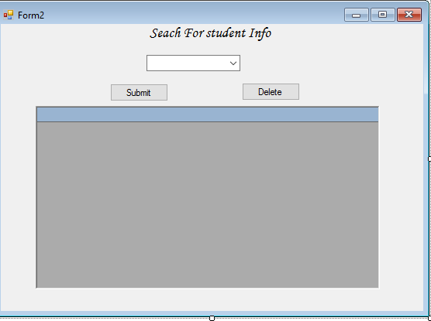
Question #2: Design this interface for third form And write down necessary coding

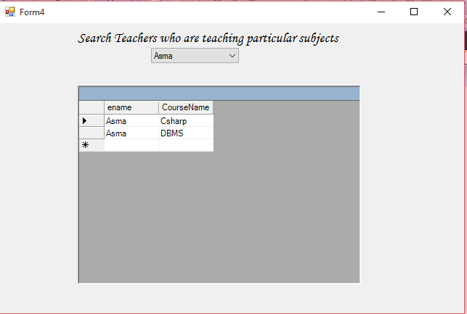

Program 5:
This database application demonstrates the use of ADO.Net classes using Access Database.Steps:

- For this example we have created MS-ACCESS database named Csharp1.mdb. The table structure for the bank table used in this example is show below:
The properties of the fields are as follows
  - AccountNo - Number - Long Integer
  - Name - string
  - BranchCode - int
  - AccountType - int
  - ATMReq - int
  - Balance - Number - Decimal

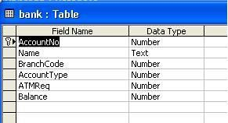

- Create a new Windows Application project. From toolbox’s Data tab, select OleDbDataAdapter component and configure it to establish connection with your database.

- Design your GUI as shown below:
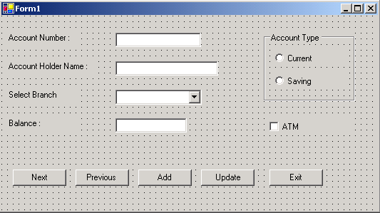

- In this application, we will be working with individual data bound controls.

- Select first Textbox control on your form.

- Open DataBinding section on control’s Properties window, locate the Text item, and expand its list of possible settings. Select the one you want to display in your control as shown below:

IProperties
q. x]


) FormI System.Windows.Forms.Forn J
13 (DataBindings)
(Advanced)
Tag (None)
- nk.AccountNo •
13···□DataSetll
i mt·1■■·!1i,iHM
.....[!] AccountType
.....[!] ATMReq
i:'1Balance
• •
B·rfilbank
[i]�il�I(©]

