**# DHL LEAD GENERATION**

**## Installation**

* Run xxx.exe
* Follow the displayed instruction to install the program.
* A xxx folder will appear in the user’s current directory.
* Open the folder and run xxx.exe.
* The following UI will display on the user screen.

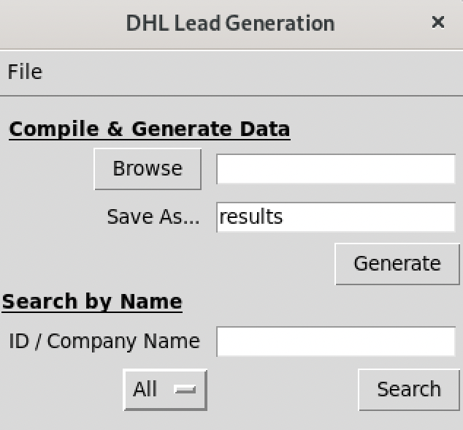

**## Compile & Generate Date**

* Click browse to select the required data for lead generation.
  + - All files must be in the same directory to be selected at the same time.
    - The selected files names will appear on the text box next to the browse button.
* Click the Generate button to process and score the selected data.
  + The generated lead / output is save as results.xlsv by default in the same directory.
  + User may change the output filename by editing the text inside the text box next to the “Save As…” label.
  + User may change the output columns by editing the column names in the columns.csv. Data columns not listed in the columns.csv will not included in the output.
  + User may change the output sheet columns by edit the columns in the output_columns.csv.
  + The column names in the output_columns.csv must be same those in columns.csv.
  + User may adjust the points and weightage for data scoring in weighted_adjustment.xlsx.

**## Search**

* Enter the company name / id on the text box next to the ID/Company Name label and click Search button to get the company additional info.
  + User may find out if the company has additional info from the lead generated excel sheet, under column named options. If the cell displayed True, that’s mean the company has additional info.
  + User may filter the company info by selecting the dropdown list under the ID/Company Name label.