Procedural Content Generation in Video Games

Aidan Zizys
WRIT 220
Miriam Novick
April 18, 2020

Executive Summary
Video games have become more costly and more time consuming to make, which stretches development studios thin, yet the consumer expectation of these games to have increasingly large and detailed worlds increases every year. There is a need for new tools that can empower artists and developers to create the content needed for these games. While there are techniques which can do this already, common procedural content generation techniques generally lack the direction and control necessary to create the kinds of experiences players want. Spatial algorithms are examined as a solution for creating natural and human-made environments for video games, specifically in their ability to create authentic and detailed worlds for the player to explore.

Table of Contents
- Introduction | 1
- Problem | 1
- The Challenge of Making Engaging Worlds | 1
- Procedural Content Generation as a Solution | 1
- Solution | 2
- Spatial Algorithms | 2
- Future Algorithmic Solutions | 4
- Conclusion  References | 5  7

- Introduction
The purpose of this research report is to understand why video games have become more expensive and time consuming to make, what it is doing to the developers that make those games, and explore the use of procedural content generation techniques that can automate some of the work load while still keeping control in the hands of artists and developers.
- Problem
  - The Challenge of Making Engaging Worlds
Making a successful game requires too much from the people making it. Developers for Fortnite are having a hard time keeping up with the continued production of the successful juggernaut. Many are reported to be working 70-hour weeks to produce the content to keep the game feeling fresh, some even working 100-hour weeks (Gilbert, 2019). One developer was quoted with having said that, “I hardly sleep. I’m grumpy at home. I have no energy to go out. Getting a weekend away from work is a major achievement.” This is a feeling echoed across many studios. Employees of Electronic Arts working on the games Mass Effect: Andromeda and Anthem were reportedly put on “stress leave” due to the long hours and working conditions (Gilbert, 2019). For Take Two’s Red Dead Redemption, the game took nearly eight years to complete, where developers were furiously working to build a world more realistic than any that had been made before (Takahashi, 2019). Developer Rob Nelson noted in a GameStar interview that, “We [built] everything by hand. There are no procedural things that appear here, sometimes there.” (Schmidt & Graf, 2018). The time and cost required to build the worlds and environments that players enjoy is taking too high of a toll on developers and the studios that employ them. As the cost for making these games increases, so too will the demands on employees to build them, whatever the cost.
  - Procedural Content Generation as a Solution
In this light, procedural content generation (PCG) can be a reasonable solution. Procedural content generation is the process of creating the things that players experience in a game such as art, sound, worlds, stories, and gameplay challenges. In their 2017 GDC talk, Guerilla Games highlighted that PCG played a large part in building and populating the world of Horizon Zero Dawn, their large open-world role-playing game (GDC, 2019). PCG allowed the team to create a large lifelike world, where environments felt unique and varied, without needing nearly a decade to create it (GDC, 2019). In large scale games which require a large amount of highly detailed content, PCG techniques can be appropriate solutions.
However, many games which feature PCG techniques have also been criticized for seeming lifeless and un-realistic if the implementation does not meet a threshold of quality, and so with each solution there are also trade-offs to consider. Van der Linden et al. (5) notes that many generic procedural generation methods lack direct control, and the maps produced by this method often have a chaotic feel. While playing No Man’s Sky (2016), Douglas Heaven notes that there are an uninterpretable number of planets (reportedly 18 quadrillion), many of which no other human has ever seen, yet exploring them can feel like a chore rather than fulfilling the fantasy of exploring the galaxy (2016). Researcher Michael Cook of Falmouth University, when interviewed for Heaven’s article, noted that he felt tired of seeing new planets, landscapes, and creatures (2016). He notes that, “[what] actually gets us to engage with something is how well-crafted it is and how well it resonates,” as opposed to how many things there are to see or how big those things are (Heaven, 2016).
Given that the type of procedural content generation solution must be carefully chosen in order to meet a certain threshold of quality, this paper will propose that studios adopt the use of spatial algorithms to create realistic worlds, or algorithms that are concerned with spatial organization. These more detailed generators have been outlined in Hendrikx et al.’s 2013 survey of the field of PCG solutions, and the focus on this solution comes out of their recommendations for future research (15). This solution represents a form of procedural generation techniques that are efficient and easy enough to implement while also providing the necessary artistic control to create realistic worlds.
- Solution
  - Spatial Algorithms
To better understand the potential of spatial algorithms, Van der Linden et al. analyze various spatial algorithms that show promise in generating dungeons, which can refer to caves, caverns, or (abandoned) human-made structures (2013, 3). These spaces require more control since it is more about providing a structured space for deterministic gameplay to play out, rather than allowing for player-driven gameplay, and so they limit the scope of their survey to efficient spatial algorithms that can provide a high degree of control but still create highly realistic environments.
One of the sub-techniques of spatial algorithms proposed in Van der Linden et al. is generative grammars, which is a process used to create phrases from a finite set of words, terminating at predetermined symbols. Generative grammars can similarly be used to create graph grammars that form a set of relationships between spaces such as hallways and room nodes (Van der Linden et al., 2013, 6). These relationships are stored in a graph like structure, which is something used to describe the relationship between objects in a network, be it physical or social or digital. Much like the spaces that we engage with most, our urban spaces, a method which considers such spatial rules and codifies them in a way an artist can manipulate allows developers the freedom to more easily create game spaces that conform to a set of creative parameters without needing to be hand-crafted by an artist (Van der Linden et al., 2013, 7).
Genetic algorithms, or algorithms that, over many iterations, provide a solution that meets a fitness criterion, can be used as another type of spatial algorithms. Genetic algorithms are used to transform a game story into a tree structure using key symbols that act as nodes and bridges, which can in turn act as the organizational logic for a game world. For example, key location names can be used to create the nodes of the game world, and descriptors in the text that refer to characters traveling between those nodes can be used to describe the connections between them (Van der Linden et al., 2013, 9).
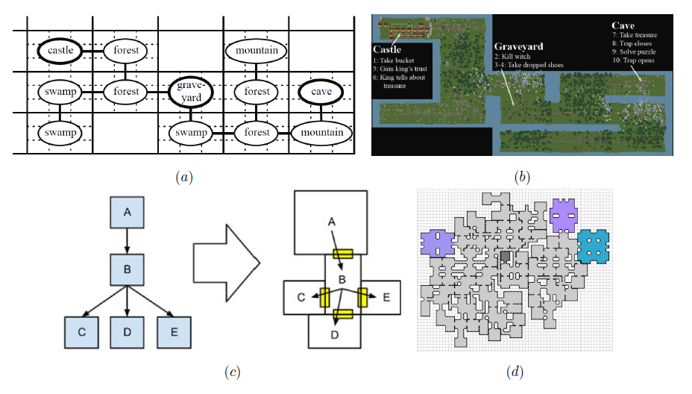
Figure 1: (a) The transformation of a story into a spatial graph using a generative grammar, and (b) its transformation into a game world. (c) A new graph transformed into a distribution of rooms, and (d) the continuation of this process to create a large map (Van der Linden et al., 9).
Although initially applied to dungeons, generating worlds in a way that matches the game story has the added benefit that the generated world closely resembles the specific details and organization that the story describes, and allows for a closer linking of the created world and the details that bring the player into it. This method is not without its faults. Further work to include the ability to use story and gameplay details to determine the decorations and general ambiance effects of the spaces they create is needed, opposed to simply generating the way the spaces are organized and connected.
An example of these tools in action is found in Emilien et al.’s 2012 paper, where they explore a series of spatial algorithms to create more realistic rural settlements that resembles their natural development around geographic features (1). Early towns and cities were not usually organized and connected in controlled and predetermined ways, and so their more focused approach uses a series of spatial algorithms to determine the optimal location for settlements and roads which creates a village skeleton (Emilien et al, 3). The algorithm determines village types, then building seeding determines the spread of buildings across the terrain (Emilien et al, 2012, 3). A further interest function is used to determine the interest in settlements, including attraction based on sociability, access to worship, accessibility, terrain slopes, access to water, natural fortifications, and topographic height (Emilien et al, 2012, 4). They then use a series of algorithms to determine the increased road expansion from settlements being populated, the division of corners into land plots of many different types, and the logical extension of plots outwards from those corners (Emilien et al, 2012, 5). Finally, they use a generative grammar algorithm to create 3D house models that conform to the contours of the terrain (Emilien et al, 2012, 5).
This combination of spatial techniques in Emilien et al. more closely resembles the simulation of real-world urban growth albeit in a developer-controlled way. Using their methods, developers can retain control over the interest weights and the settlement seed that populates the world and can fine tune the worlds they create to resemble the places where their stories are going to be experienced.
  - Future Algorithmic Solution
Spatial algorithms are not perfect though, and there is room to improve upon these techniques. Other types of algorithms can give developers the ability the create worlds that not only resemble our own but are built on the same principles that govern our natural world. For the creation of a natural world, Onrust et al. argue that general procedural methods are ill-equipped to generate realistic vegetation in virtual spaces (2017, 2). For example, these methods have a hard time creating the unique patchiness of plant distribution. Onrust et al. instead opt to use ecological input maps to generate accurate plant distribution across varied terrain types (2017, 2). As a technique that simulates real world systems, this solution offers a more complex approach to generating realistic worlds. In brief, their approach generates a map of possible vegetation locations within a given terrain and identify every location for a plant to grow using a technique called a point distribution (Onrust et al., 2017, 5). They proceed to use real-world vegetation models to assign coverage and patchiness data into the map, and then classify the various species of plant within the virtual space (Onrust et al., 2017, 6-8).
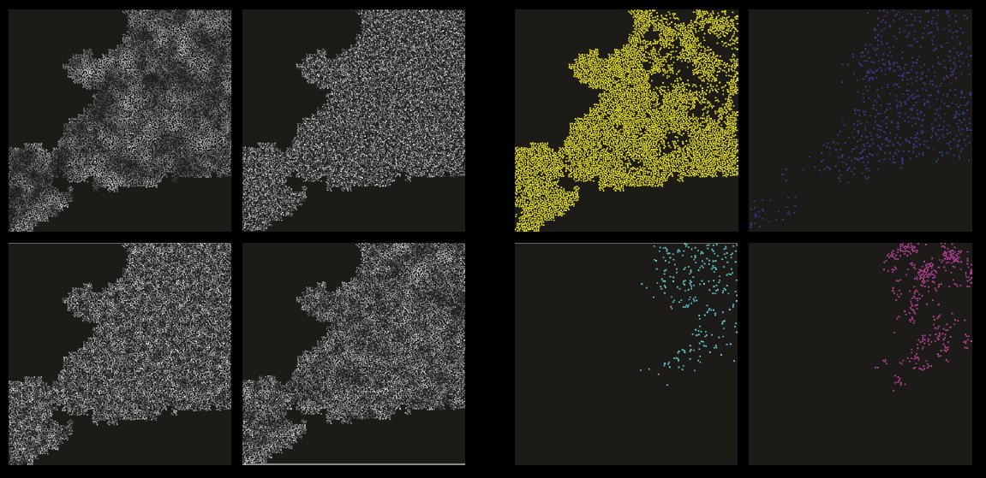
Figure 2: Visual representation of the described process, from point distribution of plants, to species allocation. Square of four (left) is the distribution of plant locations, Square of four (right) is species allocation (Onrust et al., 8).
Throughout this process, they are using scientific models which describe plant growth in the real-world to inform the growth of vegetation in their simulation. Such an approach can act as a promising future for procedural generation methods as they can create virtual environments that mimic our own.
- Conclusion
In season 2 episode 6 of Revisionist History, Malcolm Gladwell dissects why blues and country makes us cry and rock and roll does not, and he comes to the conclusion that, “beauty and authenticity can create a mood, they set the stage, but I think the thing that pushes us over the top into tears is details. We cry when melancholy collides with specificity” (2017, timestamp: 15:48). The world of Red Dead Redemption 2 is so engaging because of the details that pull us in, not because of its size or its graphical fidelity. The small, sometimes overlooked details that convince us that the game world that we are digitally exploring is somehow a real place that has existed outside of our enjoying it, and will continue to exist long after we put down the controller, are what bring us deeper into these worlds. Yet in so many cases it has become far too expensive or time consuming to manually create these kinds of places to explore. That is why this paper has explored spatial algorithms, and the potential of using authentic modeling of natural and human-made environments, as a solution for procedurally generating video game content, because these techniques can autonomously create worlds that feel hand-crafted. For many studios, the solution has been to build smaller worlds that they can more easily manage, however this kind of solution has opened the doors for more studios to create the worlds of their dreams.

References
Emilien, A., Bernhardt, A., Peytavie, A., Cani, M., Galin, E (2012). Procedural Generation of Villages on Arbitrary Terrains. Visual Computer, Springer Verlag, 28 (2012), pp.809-818. 10.1007/s00371-012-0699-7. hal-00694525
Gilbert, Ben (2019, May 9). Grueling, 100-hour work weeks and ‘crunch culture’ are pushing the video game industry to a breaking point. Here’s what’s going on. Business Insider. https://www.businessinsider.com/video-game-development-problems-crunch-culture-ea-rockstar-epic-explained-2019-5

Gladwell, Malcolm (Host). (2017, July 19). King of Tears [Audio Podcast]. Retrieved from http://revisionisthistory.com/
Heaven, Douglas (2016, Sept 6). When infinity gets boring: What went wrong with No Man’s Sky. NewScientist. https://www.newscientist.com/article/2104873-when-infinity-gets-boring-what-went-wrong-with-no-mans-sky/
Hendrikx, M., Meijer, S., van der Velden, J., and Iosup, A. (2013). Procedural content generation for games: a survey. ACM Trans. Multimedia Comput. Commun. Appl. 9, 1, Article 1 (February 2013), 22 pages. http://doi.acm.org/10.1145/2422956.2422957
Linden, R., Lopes, R., Bidarra, R. (2013). Procedural Generation of Dungeons. IEEE Transactions on Computational Intelligence and AI in Games. (2013). 21 pages, DOI 10.1109/TCIAIG.2013.2290371
Onrust, B., Bidarra, R., Rooseboom, R., Koppel, J (2017). Ecologically Sound Procedural Generation of Natural Environments. International Journal of Computer Games Technology. (May 2017), 17 pages. https://doi.org/10.1155/2017/7057141
Schmidt, K., Graf, M (2018, May 9). Red Dead Redemption 2 – How Rockstar wants to reinvent the Open World. GameStar. https://www.gamestar.de/artikel/red-dead-redemption-2-wie-rockstar-die-open-world-neu-erfindet,3329270.html
Takahashi, D. (2019, February 6). Red Dead Redemption 2 sells massive 23 million copies, but Take-Two stock still falls 13%. VentureBeat. https://venturebeat.com/2019/02/06/red-dead-redemption-2-gallops-to-23-million-copies-in-a-quarter-stock-falls-13/

