**Importing Station Data to ArcGIS projects**

Janel Day, with notes and edits by Jon Spencer

Arizona Geological Survey (AZGS)

2014

**Introduction**

Excel spreadsheets are prepared by geologists working in the field and using GPS units to record the locations of stations where structure measurements, samples, and notes are taken. The imported tables consist of the following:

1. Stations
2. Notes
3. Samples
4. Structure Measurements
5. Structure Types

At the AZGS in 2014, only the Stations table contains GPS locations of stations. All tables except Structure types contain Station numbers. All tables are imported into the ArcGIS database, and then the Notes, Samples, and Structure Measurements tables are joined to the Stations table so that the Notes, Samples, and Structure Measurements tables have GPS locations associated with each record. The Structure Measurements table is joined to the Structure Types table so that all Structure Measurements correspond to a cartographic object (symbol) that will be displayed on the resulting map.

**Station Data Preparation**

Open ArcMapC:\Program Files (x86)\ArcGIS\Desktop10.2\bin\Icons\ArcMap_MXD_File16.png or ArcCatalogC:\Program Files (x86)\ArcGIS\Desktop10.2\bin\Icons\ArcCatalog16.png. If you open ArcMap, you can open ArcCatalog in ArcMap by clicking the ArcCatalog iconC:\Program Files (x86)\ArcGIS\Desktop10.2\bin\Icons\ArcCatalog16.png.

1. Create *New Personal Geodatabase* that has the same name as the Excel table.

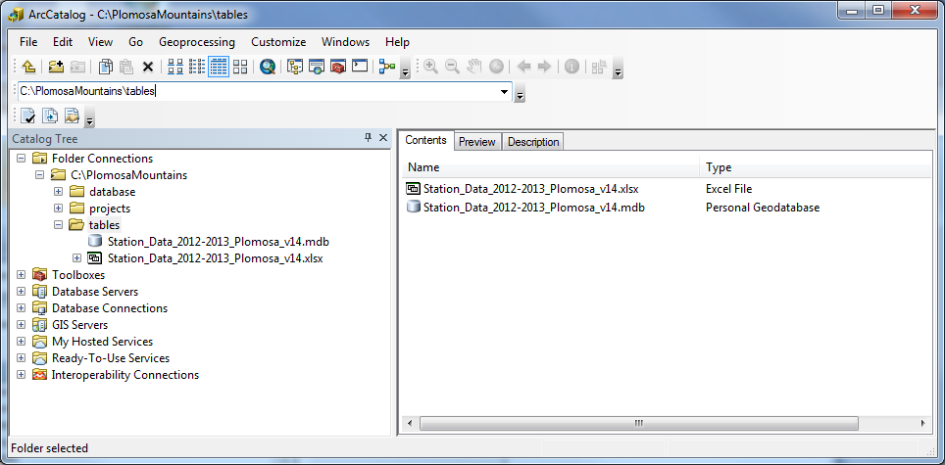

1. *Export* Excel sheets to Geodatabase. (note: attempts by JES to do this with an .xlsx file failed, but conversion to an .xls file worked. This might be because the .xlsx file contained named ranges). Also, sheet with field notes that includes a memo field must be converted in Access so that the field with notes is designated as a memo field, then imported to Arc.

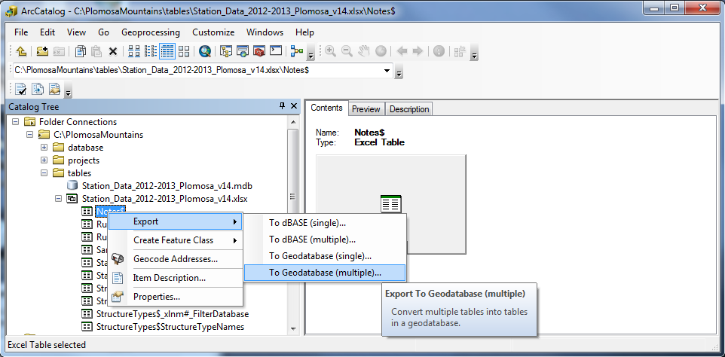

1. Add all worksheets with the “$” at the end of the name as Input Table; click **OK**.

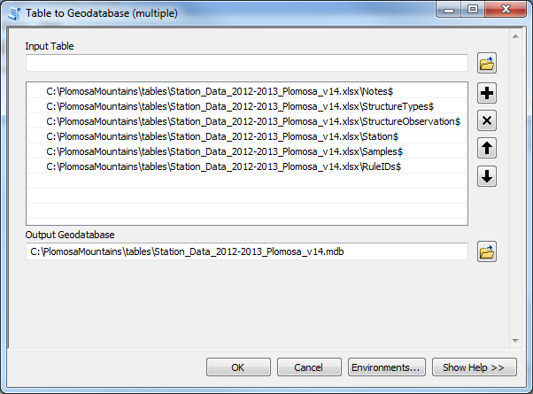

1. *Create Feature Class* from “Stations\_” table in the geodatabase. (note: data export does not support blob fields – use Feature Class to Feature Class tool in ArcToolbox instead).

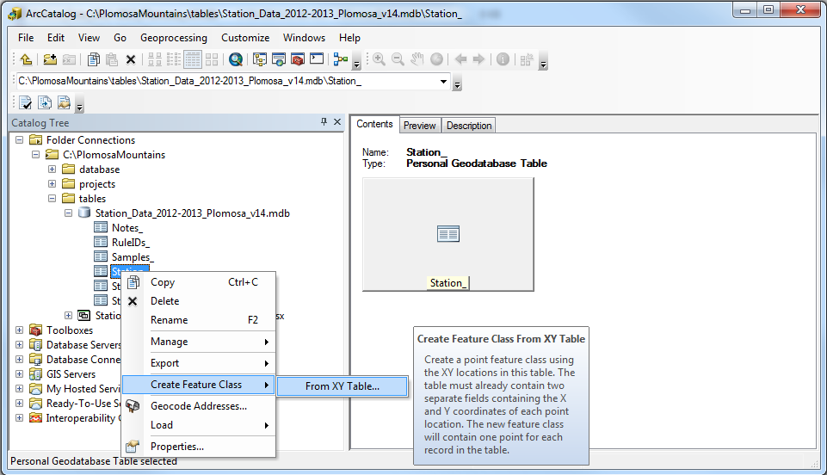

1. Fill in required information; save output to the same geodatabase you created above. Name the feature class as “Stations\_FC”.

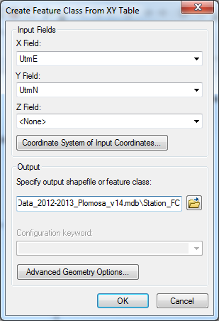

1. Open ArcMapC:\Program Files (x86)\ArcGIS\Desktop10.2\bin\Icons\ArcMap_MXD_File16.png if it’s not already open.
2. Add Data.
3. Select all tables and “Station\_FC”, click **Add**.

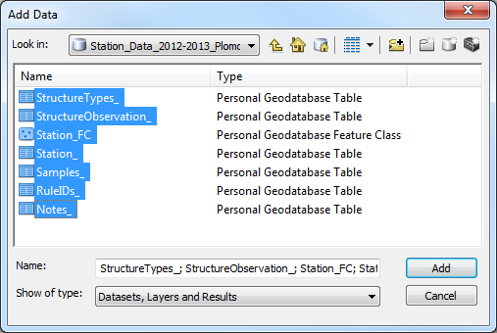

1. The result:

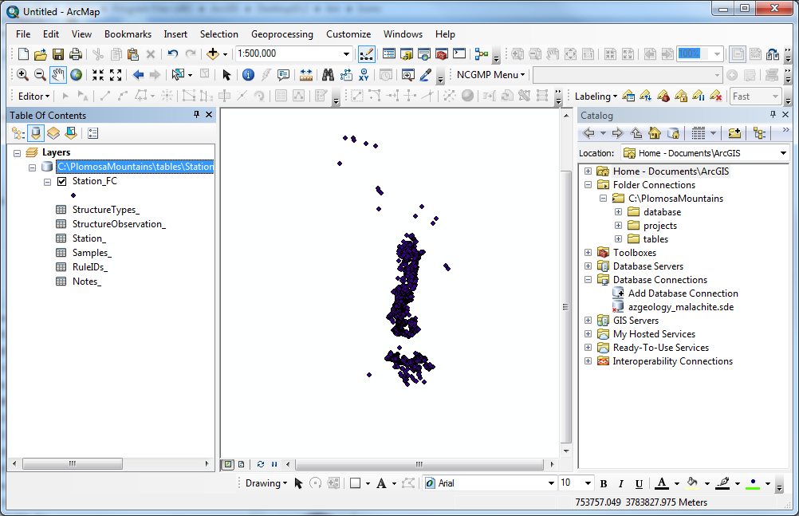

1. Join “Station\_FC” to “StructureObservation\_” table. First, right-click on “StructureObservation\_” -> Joins and Relates -> Join...

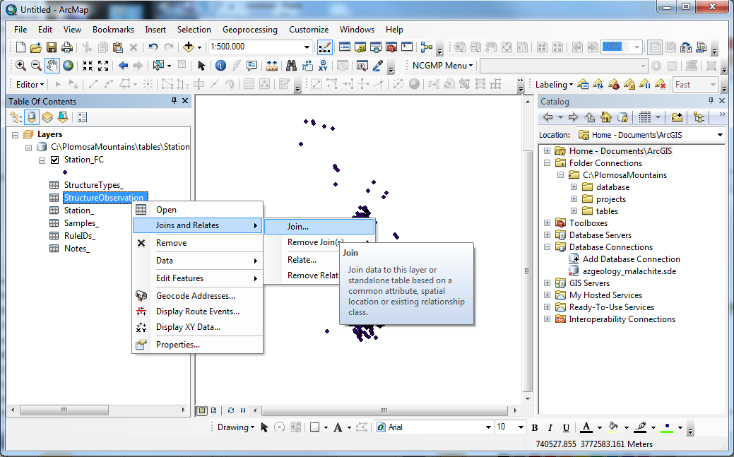

1. Fill in form, joining on *StationID* field, and click **OK**.

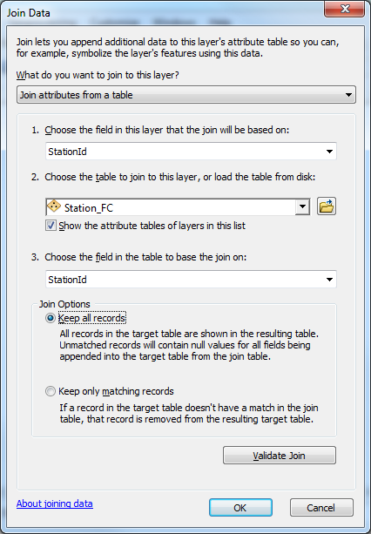

1. Open “StructureObservation\_” table after the join. You should see data from both tables:

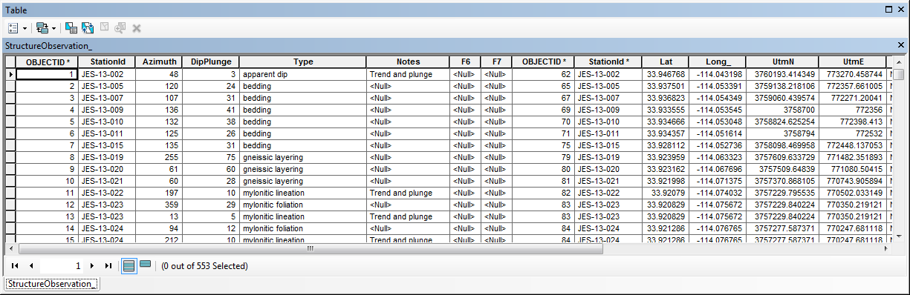

1. *Display XY Data* by right-clicking on “StructureObservation\_” and selecting *Display XY Data…* Fill in form and click **OK**.

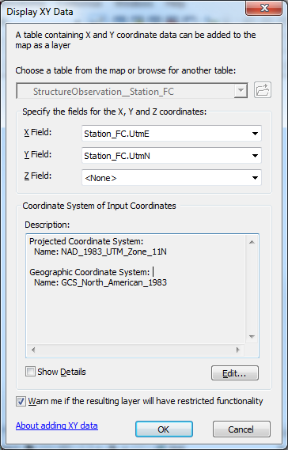

1. An ‘event layer’ is added to the map:

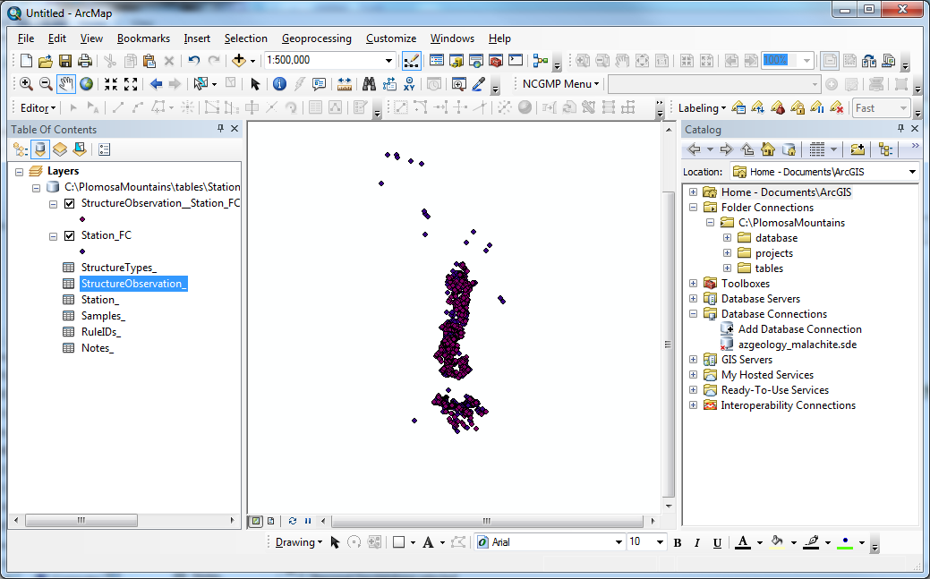

1. To ‘preserve’ this data, export event layer, save output to the same geodatabase you created above. Name the feature class as “StructureObservation\_FC”. (note: data export does not support blob fields – use Feature Class to Feature Class tool in ArcToolbox instead).

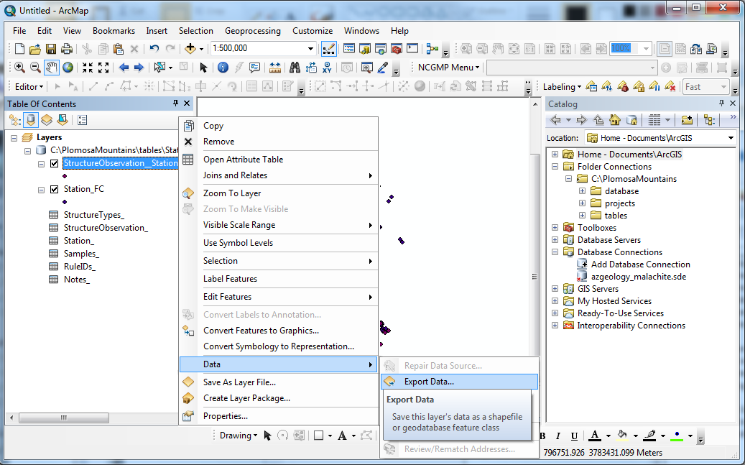

1. A new layer should be added to your map. After “StructureObservation\_FC” appears in the Table of Contents, you can remove the event layer:

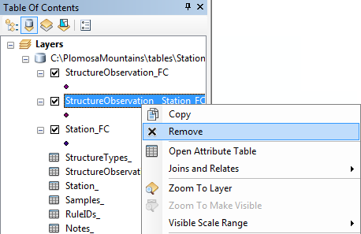

1. If you collected sample data, repeat Steps 10-14, joining “Station\_FC” to “Samples\_”.

**Adding Geologic Map Database to ArcMap**

1. If you’ve already created an ArcMap project with an NCGMP Geologic Map Database, proceed to the next Section.
2. In ArcMapC:\Program Files (x86)\ArcGIS\Desktop10.2\bin\Icons\ArcMap_MXD_File16.png, select *Open NCGMP Database* from the NCGMP toolbar.

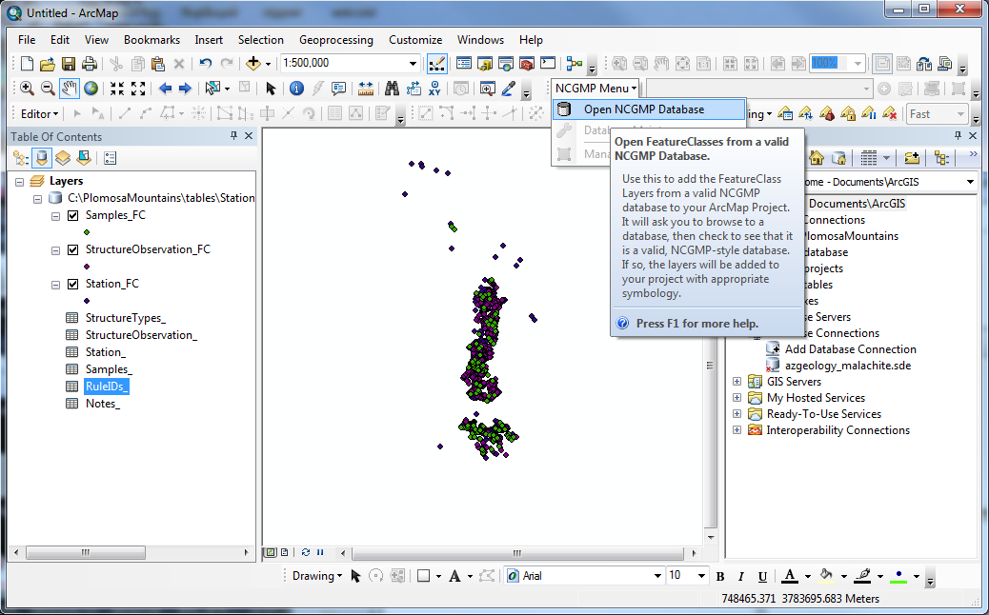

1. Navigate to the directory where your NCGMP is. Click *once* on the database and click **Select**. Wait a minute or so for ArcMap to load the feature classes and tables.

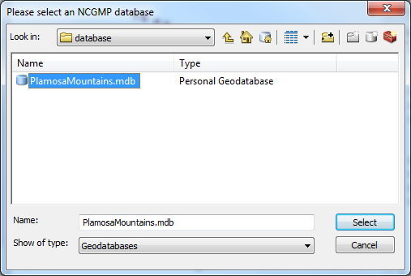

**Prepare the Geologic Map Database for data transfer**

1. Begin an ArcMap Edit Session before proceeding. From the *Editor* toolbar, select the NCGMP Geologic Map Database as the Source (“source” is the target database, not the source of the structure data you have been entering in the previous ten pages):

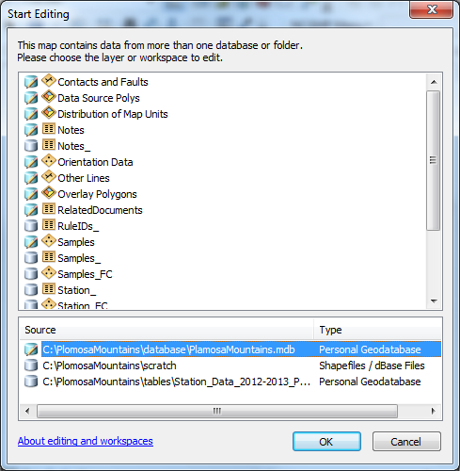

1. If this is the first time editing this database, a *New Database* window pops up. Enter a project name and three-letter project abbreviation and click **Continue**.

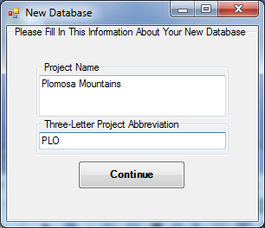

1. Click on Manage available Data Sources on the NCGMP Toolbar.



1. A new window pops up. Enter a short description in Source field and longer (or same) description in the Notes field. (Note: this information is written to the DataSources table in the same database).

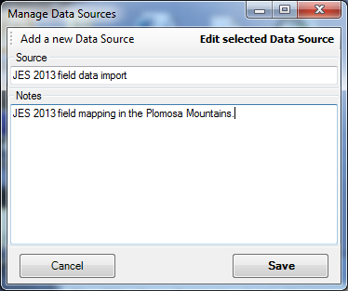

1. Select the source from the Select an Active Data Source drop-down menu.



1. Now it’s time to transfer the data.

**Adding Station (and Related) Data to the Geologic Map Database**

This section describes how to transfer data from “Stations\_FC”, “StructureObservation\_FC”, “Samples\_FC”, and “Notes\_”.

1. To load data into the NCGMP database, Open ArcToolboxC:\Program Files (x86)\ArcGIS\Desktop10.2\bin\Icons\GeoprocessingArcToolboxWindowShow16.png and find the *Append* tool and double-click on it. Click **Show Help >>** to learn more about the tool and each parameter.

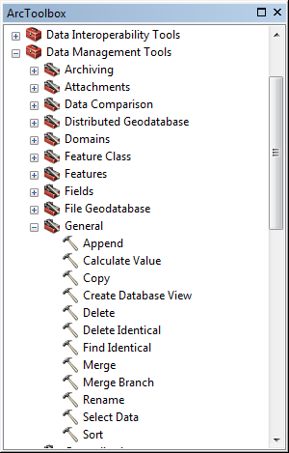 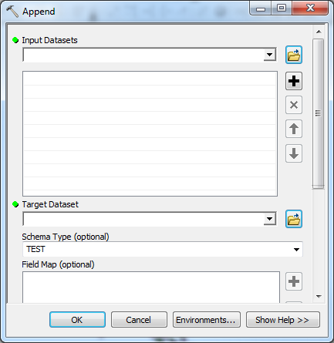

1. Add “Stations\_FC” as *Input Dataset*.
2. Add “Stations” as *Target Dataset*
3. Select “*No\_TEST*” for *Schema* *Type*
4. “Map” fields from input (“Stations\_FC”) dataset to target (“Stations”) dataset. To do this:
   1. Right-click on the field name and select *Add Input Field*
   2. Select the value for that field by clicking on the text and clicking **OK**
   3. Field Map for “Stations” and “Stations\_FC” in Stations Field Map Mapping Table.

**Stations Field Map Mapping Table**

|  |  |
| --- | --- |
| Field Map Value (Target Dataset Field Name) | Field Map Value (Input Dataset Field Name) |
| StationPoint\_ID | .\StationFC.StationID |
| FieldID | .\StationFC.StationID |
| Label | n/a (calculated later, as needed) |
| Symbol | n/a (calculated later, as needed) |
| PlotAtScale | n/a (calculated later, as needed) |
| LocationConfidenceMeters | n/a |
| Latitude | .\StationFC.Lat |
| Longitude | .\StationFC.Long\_ |
| DataSourceID | n/a (calculated during import in edit session) |

1. After completing field map per table above, click **OK** to run the append tool.

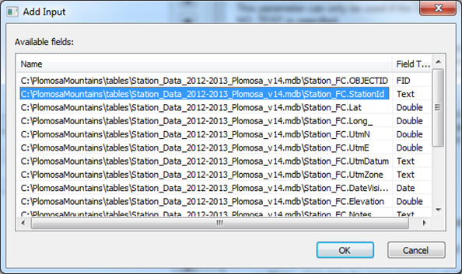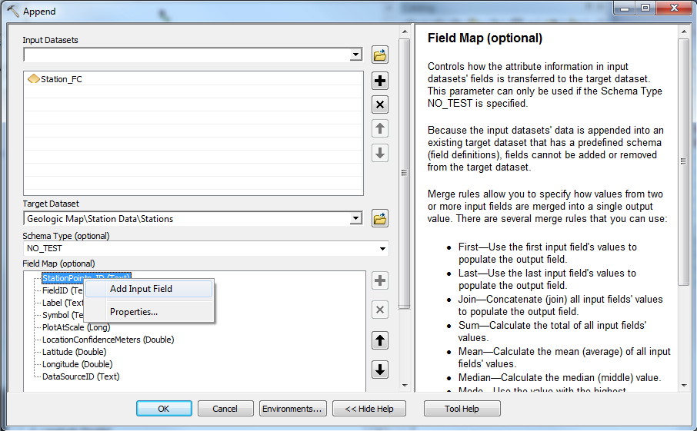

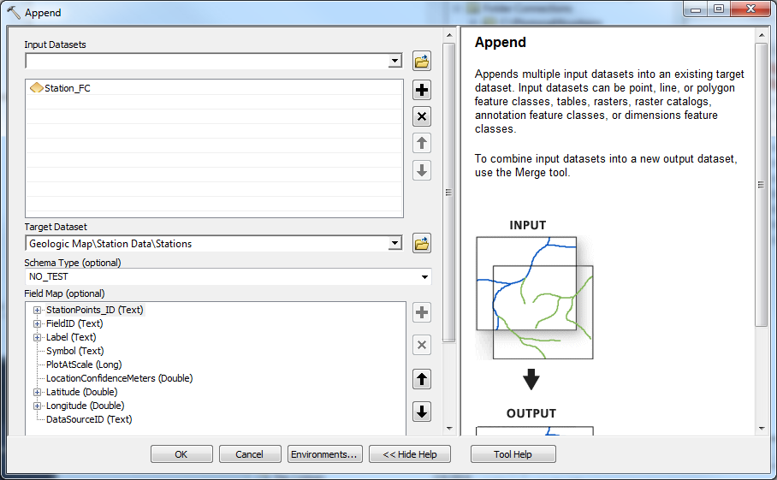

1. After the tool runs to completion, open the “Stations” table to confirm that data was transferred.
2. Transferring structure data from “StructureObservation\_FC” to “Orientation Data Points” (ArcMap layer name “Orientation Data”) requires some additional steps. Structure data that needs to be transferred is stored in three different locations: “StructureObservation\_FC”, “RuleIDs\_”, “StructureTypes\_”.
   1. First, join “RuleIDs\_” table to “StructureTypes\_” table, select fields as displayed in Join Data window image. Validate join is an option. It confirms number of matching records.

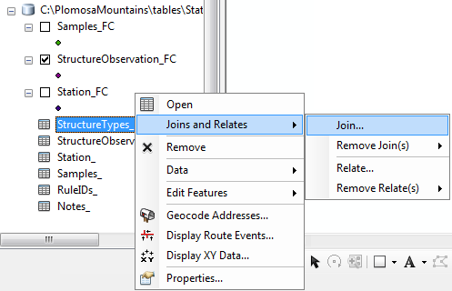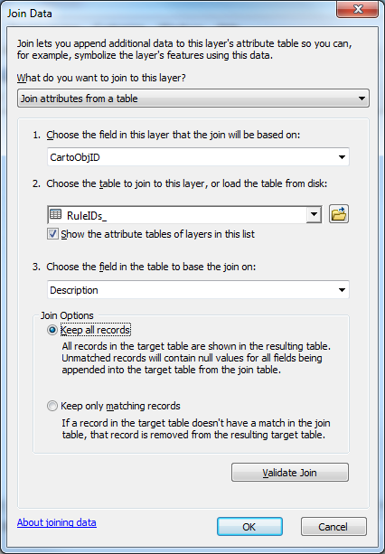

* 1. Then join “StructureTypes\_” (*TypeName* field) to “StructureObservation\_FC” (*Type* field)
  2. Run append tool with “StructureObservation\_FC” as the input dataset and “OrientationDataPoints”/“Orientation Data” as the Target Dataset. Remember to select *NO\_TEST* for Schema Type and map fields as shown in the Orientation Data Points Field Map Mapping Table below.

**Orientation Data Points Field Map Mapping Table**

Input dataset = *StructureObservation\_FC,*

Target dataset = *OrientationDataPoints* (ArcMap Layer name = *Orientation Data*)

|  |  |
| --- | --- |
| Field Map Value (Target Dataset Field Name) | Field Map Value (Input Dataset Field Name) |
| OrientationDataPoints\_ID | n/a (calculated during import in edit session) |
| StationID | .\.StructureObservation\_\_StationID |
| Type | .\.StructureObservation\_\_Type |
| IdentityConfidence | n/a (calculated later) |
| Label | n/a (calculated later, as needed) |
| PlotAtScale | n/a (calculated later, as needed) |
| Azimuth | .\.StructureObservation\_\_Azimuth |
| Inclination | .\.StructureObservation\_\_DipPlunge |
| OrientationConfidenceDegrees | n/a |
| Notes | .\.StructureObservation\_\_Notes or .\Station\_FC\_Notes |
| DataSourceID | n/a (calculated during import in edit session) |
| SymbolRotation | n/a (calculated during import in edit session) |
| Symbol | .\.RuleIDs\_.RuleID (G:\symbology\symbology.mdb) |

1. Repeat steps 1 – 7 for “Samples\_FC”, and “Notes\_”. Refer to field mapping tables for field mapping specifics.

**Samples Field Map Mapping Table**

Input dataset = *Samples\_FC,*

Target dataset = *SamplePoints* (ArcMap Layer name = Samples)

|  |  |
| --- | --- |
| Field Map Value (Target Dataset Field Name) | Field Map Value (Input Dataset Field Name) |
| SamplePoints\_ID | n/a (calculated during import in edit session) |
| FieldID | .\.Samples\_\_SampleID |
| StationID | .\.Samples\_\_StationID |
| Label | n/a (calculated later) |
| Symbol | n/a (calculated later, as needed) |
| PlotAtScale | n/a (calculated later, as needed) |
| LocationConfidenceMeters | n/a |
| Notes | .\Sample\_FC\_Description |
| DataSourceID | n/a (calculated during import in edit session) |

**Notes Field Map Mapping Table**

Input dataset = *Notes\_,* Target dataset = *Notes*

|  |  |
| --- | --- |
| Field Map Value (Target Dataset Field Name) | Field Map Value (Input Dataset Field Name) |
| Notes\_ID | n/a (calculated during import in edit session) |
| OwnerID | StationID |
| Type | .\.Unit\_ID\_or\_Label |
| Notes | .\.Description |
| DataSourceID | n/a (calculated during import in edit session) |

10. Structure data display

Assuming strike/azimuth data has been collected, after the data is transferred into the NCGMP Geologic Map database OrientationDataPoints feature class, structure symbols should display in ArcMap so that they correctly represent the orientation of the structures observed in the field.

The image on the right is an example of symbols that display properly. The image on the left is an example of all structures striking north (highly unlikely) or that the symbols need to rotate.

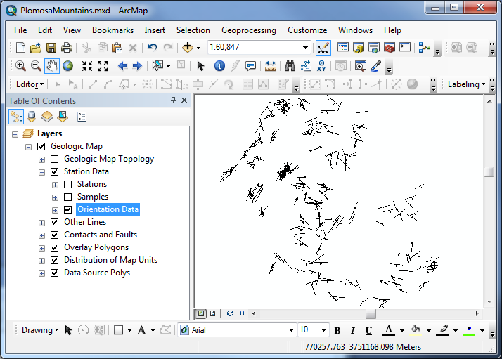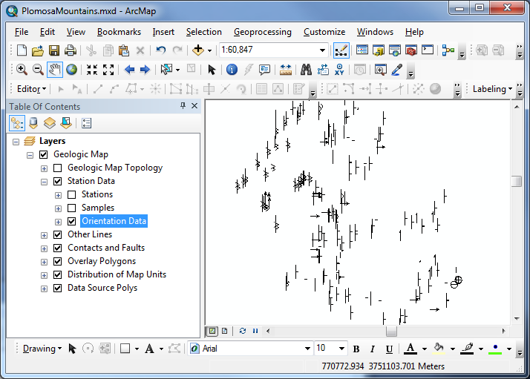

Symbols rotate based on a value in the SymbolRotation field. This value is calculated from the Azimuth. Using the field calculator, calculate the SymbolRotation = 360 – Azimuth.

