# New Geologic Map Database

## First, know the spatial reference you need, then:

### File geodatabase option

Copy file geodatabase from *G:\templates\ncgmp\database* ; paste into *G:\geologic map data* and rename it appropriately, no spaces in name preferable (i.e. “GeneWash”)

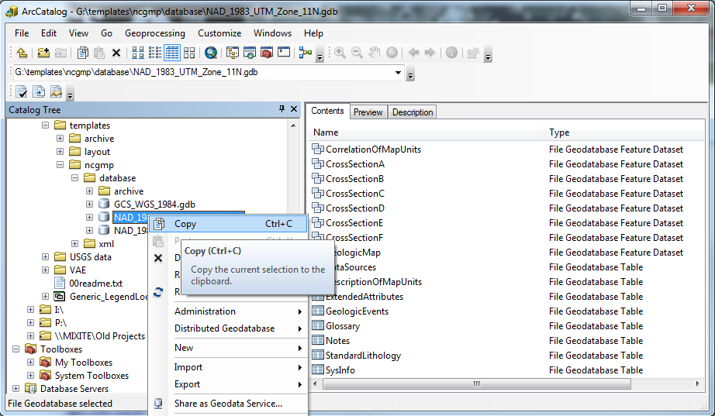

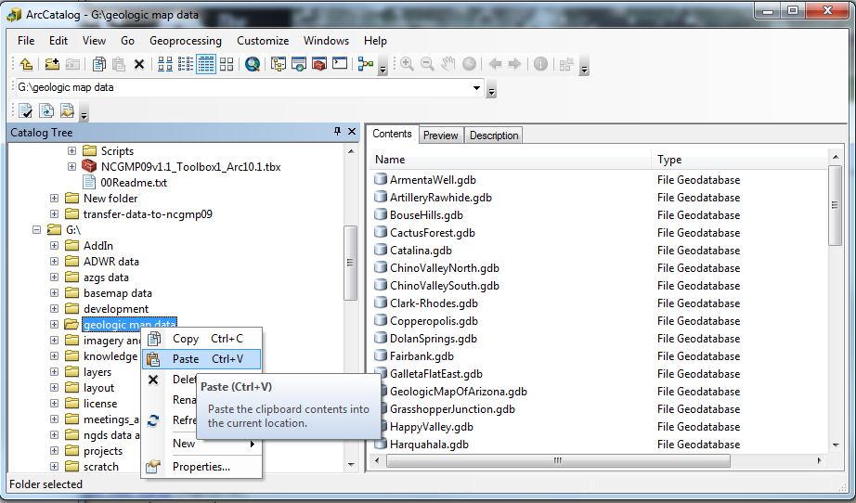

### Enterprise geodatabase option