1. What is the total revenue generated by male vs. female customers?
select gender, sum(purchase_amount) as revenue
from customer_data
group by gender;
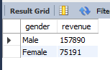

2. Which customers used a discount but still spent more than the average purchase amount?
select customer_id,purchase_amount from customer_data
where discount_applied = 'Yes' and purchase_amount > (select avg(purchase_amount) from customer_data);
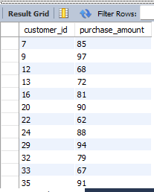

3. Which are the top 5 products with the highest average review rating?
select item_purchased, round(avg(review_rating),1) as "Average Product Rating"
from customer_data
group by item_purchased
order by avg(review_rating) desc limit 5;
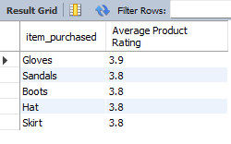

4. Compare the average Purchase Amounts between Standard and Express Shipping.
select shipping_type, round(avg(purchase_amount),2)
from customer_data
where shipping_type in ('Standard','Express')
group by shipping_type;
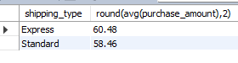

5. Do subscribed customers spend more? Compare average spend and total revenue between subscribers and non-subscribers.
select subscription_status,
count(customer_id) as total_customers,
round(avg(purchase_amount),2) as avg_spend,
round(sum(purchase_amount),2) as total_revenue
from customer_data
group by subscription_status
order by total_revenue,avg_spend desc;
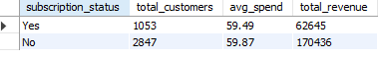

6. Which 5 products have the highest percentage of purchases with discounts applied?
select item_purchased,
round(100 * sum(case when discount_applied = 'Yes' then 1 else 0 end)/count(*),2) as discount_rate
from customer_data
group by item_purchased
order by discount_rate desc
limit 5;
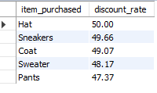

7. Segment customers into New, Returning, and Loyal based on their total number of previous purchases, and show the count of each segment.
with customer_type as(
select customer_id,previous_purchases,
case
when previous_purchases = 1 then 'New'
when previous_purchases between 2 and 10 then 'Returning'
else 'Loyal'
end as customer_segment
from customer_data
)
select customer_segment,count(*) as Total_customer
from customer_type
group by customer_segment;
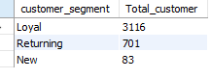

8. What are the top 3 most purchased products within each category?
with item_counts as(
select category,
item_purchased ,
count(customer_id) as total_orders,
row_number() over(partition by category order by count(customer_id) desc) as item_rank
from customer_data
group by category, item_purchased
)
select item_rank,category,item_purchased,total_orders
from item_counts
where item_rank<=3;
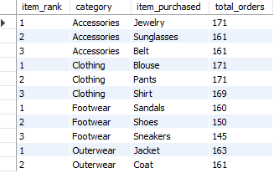

9. Are customers who are repeat buyers (more than 5 previous purchases) also likely to subscribe?
select subscription_status,
count(customer_id) as total_count
from customer_data
where previous_purchases > 5
group by subscription_status;
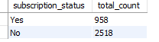

10. What is the revenue contribution of each age group?
select age_group,
sum(purchase_amount) as total_revenue
from customer_data
group by age_group
order by total_revenue desc;
