API Testing & Performance Validation Report
JSONPlaceholder REST API — Postman & Apache JMeter
Prepared for: QA Internship Program
Prepared by: Azhan Shoaib
Functional API Testing, Automated Assertions, Load Testing & Evidence

1. Project Overview & Scope
1.1 Objective
This report documents the functional and performance testing conducted on the JSONPlaceholder REST API for Assignment 4. The objective was to validate standard HTTP endpoints (GET, POST, PUT, PATCH, DELETE) using Postman test scripts, and to evaluate system stability and latency under concurrent virtual user traffic using Apache JMeter.
1.2 Scope
- Functional API Testing (Postman): Validating request/response cycles for retrieving, creating, updating, and deleting posts, checking status codes, JSON structures, headers, and response times.
- Negative Testing (Postman): Verifying error handling for non-existent resources (such as requesting post #99999) to ensure graceful 404 responses.
- Performance Testing (JMeter): Simulating 10 concurrent virtual users over 5 iterations (250 sample requests) to analyze response time percentiles, throughput, and error rates.
1.3 Tools Used
- Postman: Used for collection organization, environment configuration, and writing automated JavaScript assertions.
- Apache JMeter 5.6.3: Used for multi-threaded load generation, samplers, duration assertions, and metric listeners.
2. Target API & Environment Configuration
2.1 Understanding JSONPlaceholder (Mock REST API)
JSONPlaceholder is a public mock REST API designed for development and testing. It simulates realistic HTTP responses and validates incoming data. Because it is a mock API, write operations (POST, PUT, DELETE) are accepted and validated, but changes are not permanently saved to a database. For example, any POST request returns status 201 Created with generated id: 101, and DELETE returns status 200 OK with an empty body {}. This is the expected mock behavior and our automated assertions verify this exact contract.

2.2 Postman Environment Setup
We configured a dedicated environment named 'JSONPlaceholder - Test Environment' with reusable variables so endpoints are dynamic and maintainable:
Variable Name | Default Value | Description
baseUrl | https://jsonplaceholder.typicode.com | Main host URL used across all requests
samplePostId | 1 | Post ID used for single post retrieval, update, and delete tests
sampleUserId | 1 | User ID used for query filtering tests
nonExistentPostId | 99999 | Invalid ID used for 404 Not Found negative test

3. Postman Functional Test Suite Structure
The Postman collection is organized into 5 logical folders (01_GET, 02_POST, 03_PUT, 04_PATCH, 05_DELETE). Each request includes automated test assertions in the Tests tab covering four key verification areas:
- Status Code Validation: Verifies expected HTTP response codes (200 OK, 201 Created, 404 Not Found).
- Response Time SLA: Ensures requests complete within acceptable thresholds (< 2500ms).
- Schema & Data Types: Checks that returned objects have expected properties (id, userId, title, body) with correct types.
- Field Values: Confirms that the response data matches the submitted payload or expected record.
4. Detailed Postman Test Cases & Visual Evidence
4.1 Test Case 1: Retrieve All Posts (GET /posts)
• Request: GET {{baseUrl}}/posts | Expected Status: 200 OK
• What We Did: Sent a GET request to fetch the complete list of posts.
• Why We Did It: To verify that the collection endpoint returns all 100 posts in an array and that each object contains valid schema fields.
• Automated Checks: Status is 200 OK, Response time under SLA, Content-Type is application/json, Array contains 100 items, Schema fields are valid.
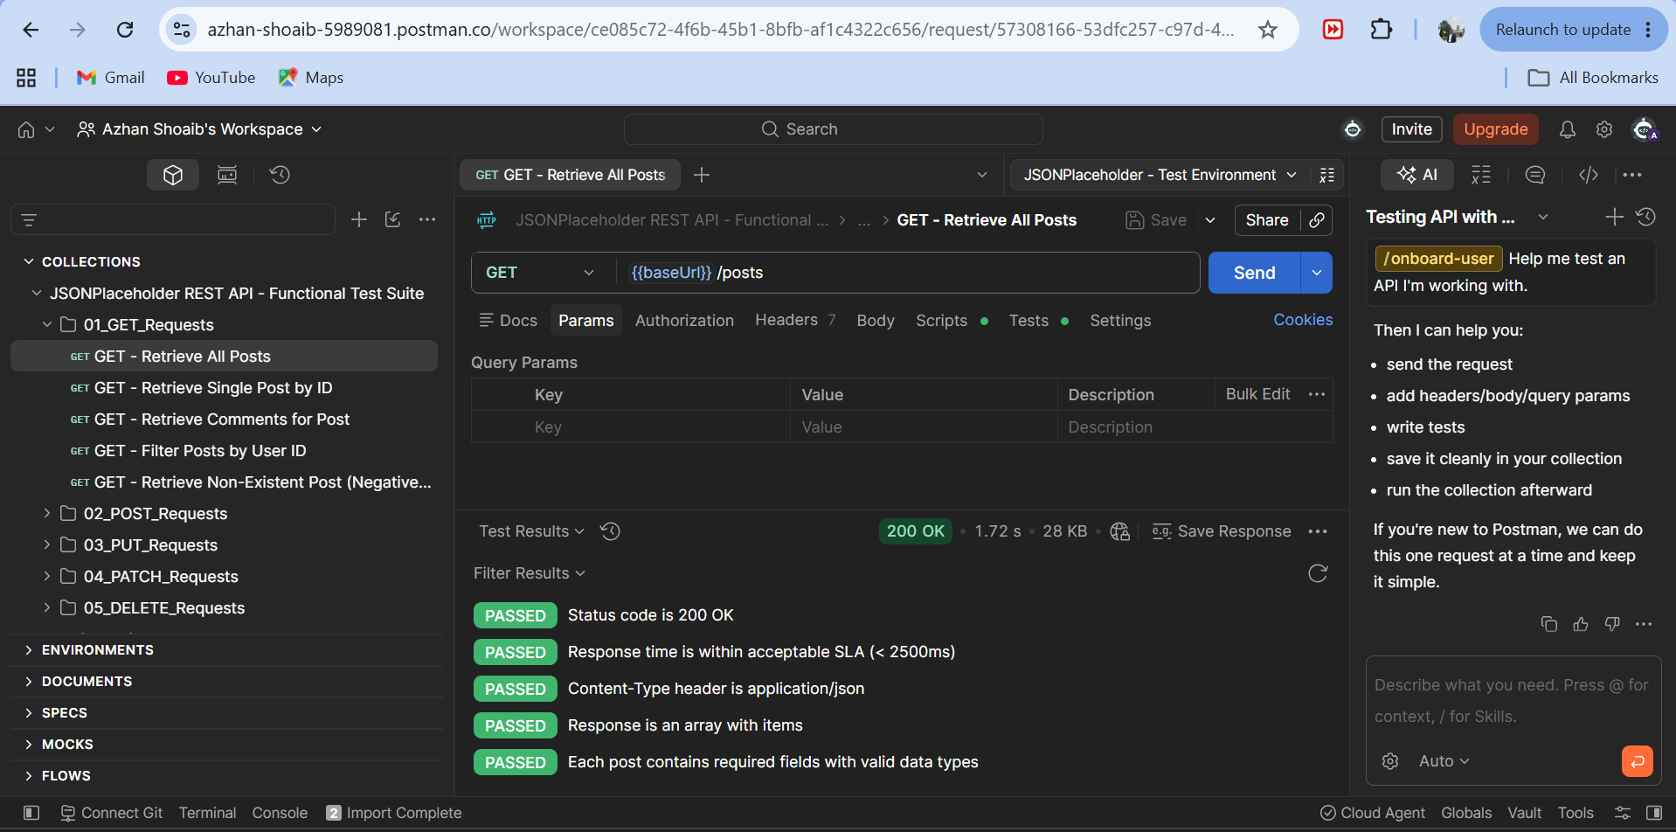
Figure: GET /posts — Status 200 OK and 5/5 Passing Automated Tests
4.2 Test Case 2: Retrieve Single Post by ID (GET /posts/1)
• Request: GET {{baseUrl}}/posts/1 | Expected Status: 200 OK
• What We Did: Requested a specific post using its ID (post #1).
• Why We Did It: To confirm that querying post #1 returns only post #1 and that its fields are properly populated.
• Automated Checks: Status is 200 OK, ID is exactly 1, userId is a number, title and body are non-empty strings.
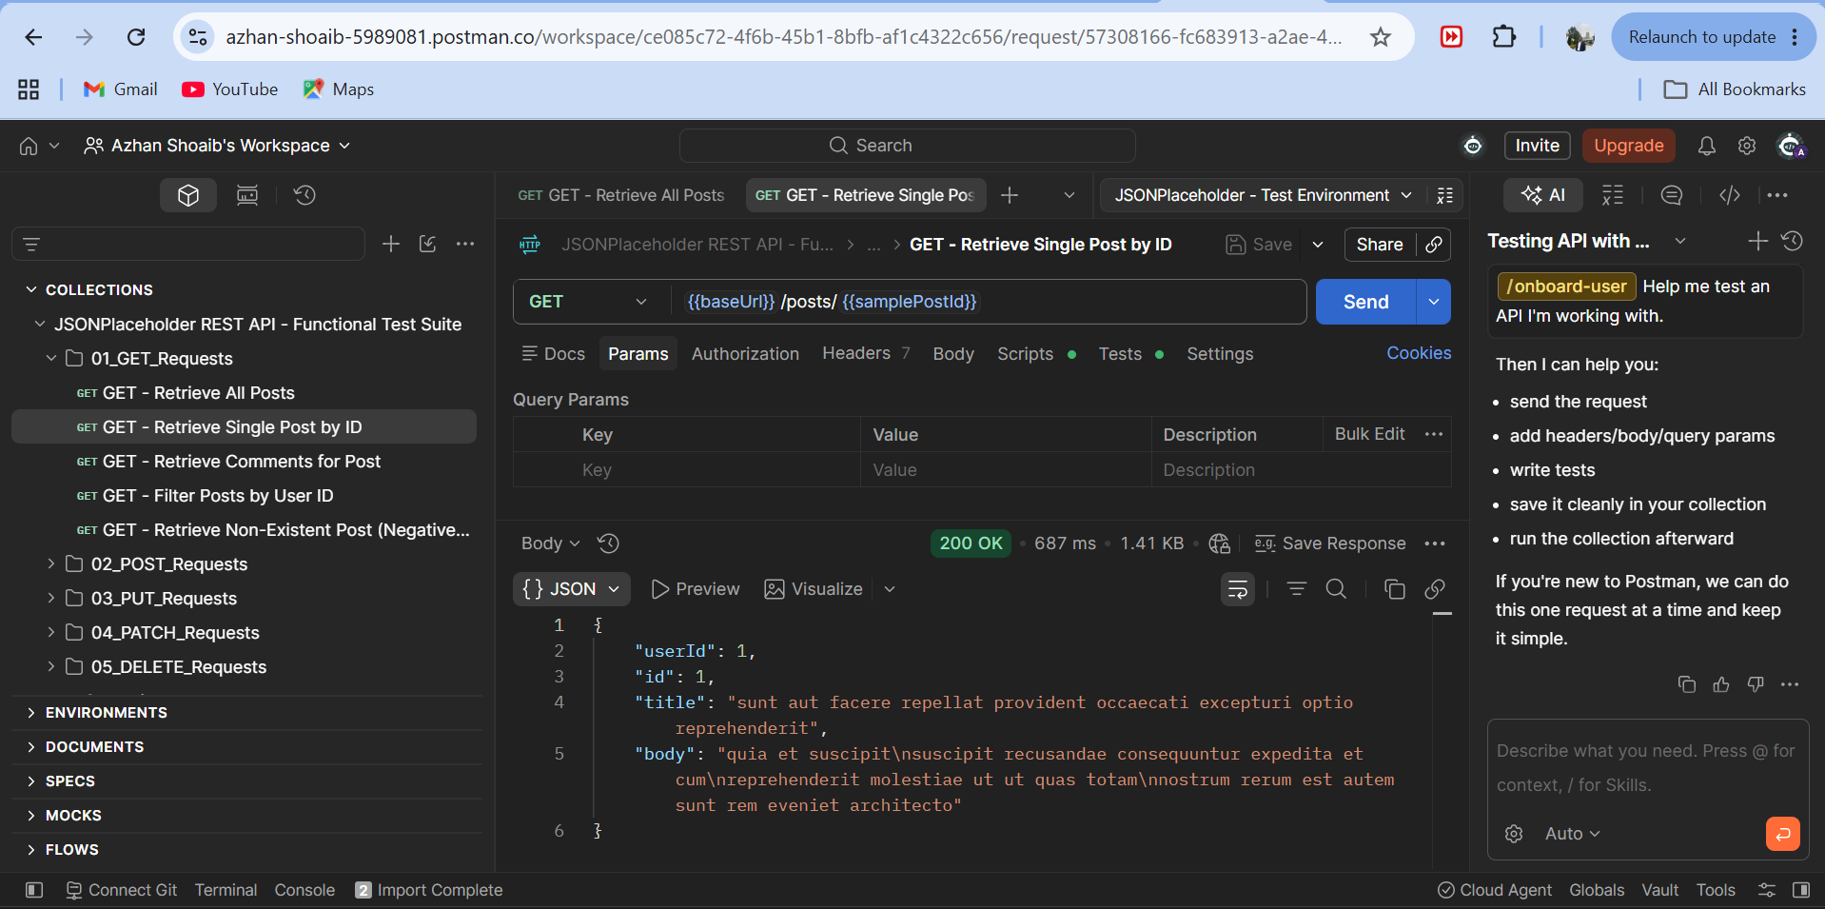
Figure: GET /posts/1 Response Body — Single Post Object Returned for ID 1
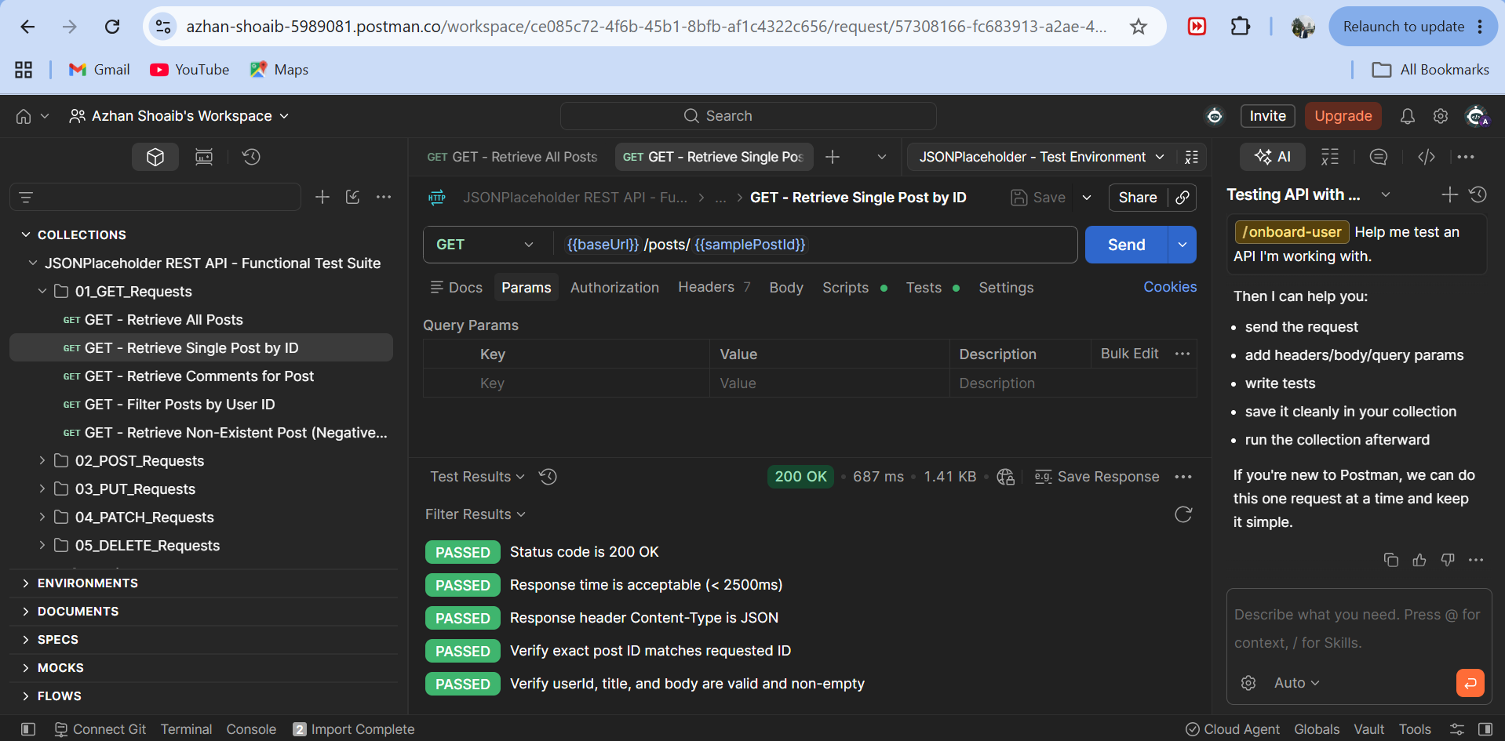
Figure: GET /posts/1 Test Results Tab — 5/5 Passing Tests in Green
4.3 Test Case 3: Create New Post (POST /posts)
• Request: POST {{baseUrl}}/posts | Expected Status: 201 Created
• Body Sent: {"title": "Automated API Testing with Postman", "body": "Validating REST endpoints, headers, status codes, and JSON schemas.", "userId": 1}
• What We Did: Sent a POST request with JSON payload to create a new post.
• Why We Did It: To verify that the API validates the payload, returns HTTP 201 Created, generates a new id (101), and echoes back the submitted fields.
• Automated Checks: Status is 201 Created, Generated ID is 101, Echoed data matches payload, Content-Type is JSON.
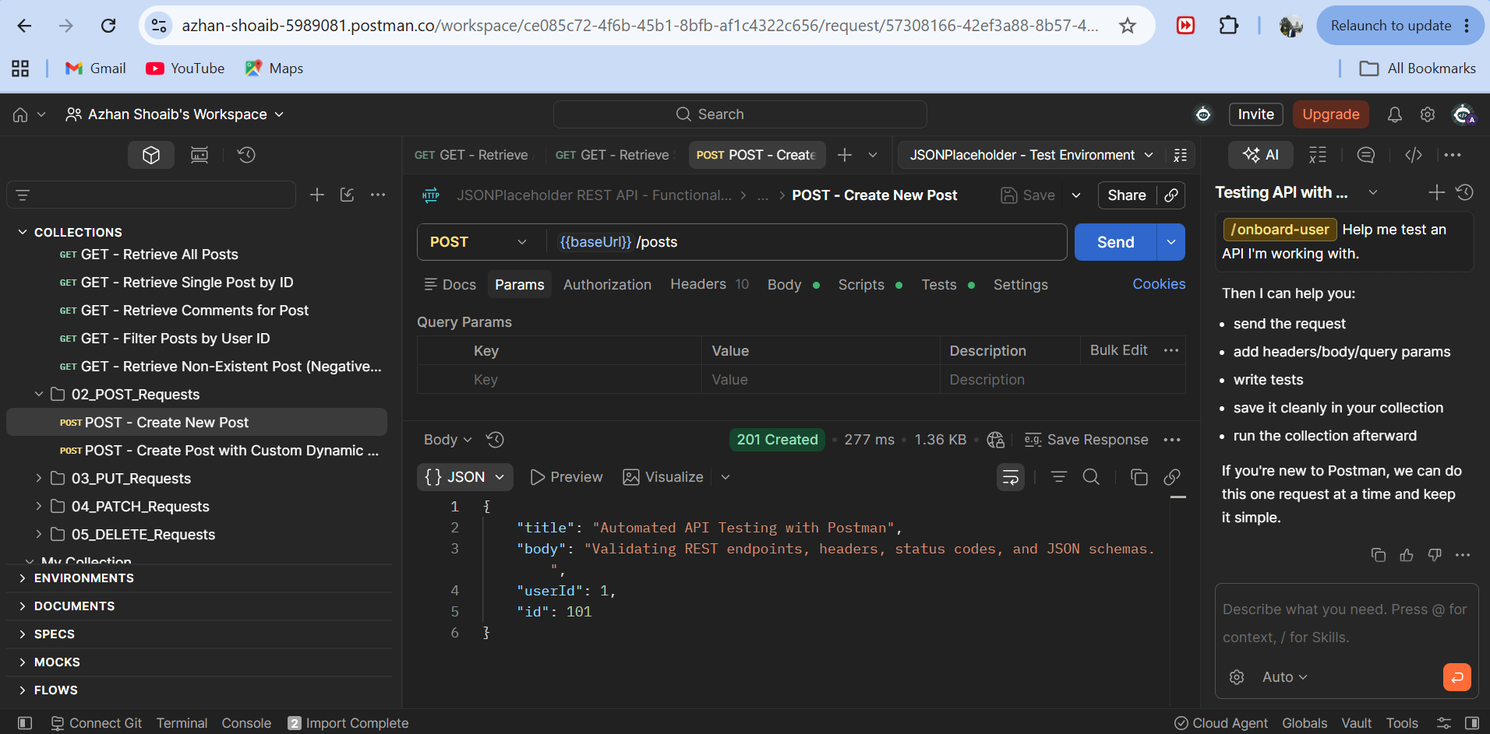
Figure: POST /posts Request Body & 201 Created Response with Generated ID 101
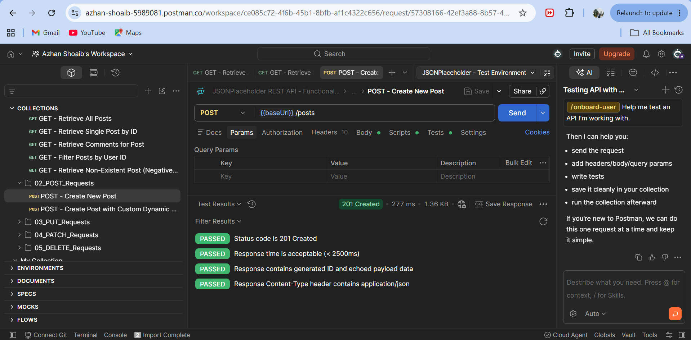
Figure: POST /posts Test Results Tab — 4/4 Passing Assertions
4.4 Test Case 4: Update Post by ID (PUT /posts/1)
• Request: PUT {{baseUrl}}/posts/1 | Expected Status: 200 OK
• Body Sent: {"id": 1, "title": "Updated Post Title - QA Regression Suite", "body": "This post content has been modified during automated test execution.", "userId": 1}
• What We Did: Sent a PUT request to update post #1 with new title and body text.
• Why We Did It: To verify that updating an existing resource works and returns the modified fields while preserving ID 1.
• Automated Checks: Status is 200 OK, Updated title reflected, ID preserved as 1, Response time under SLA.
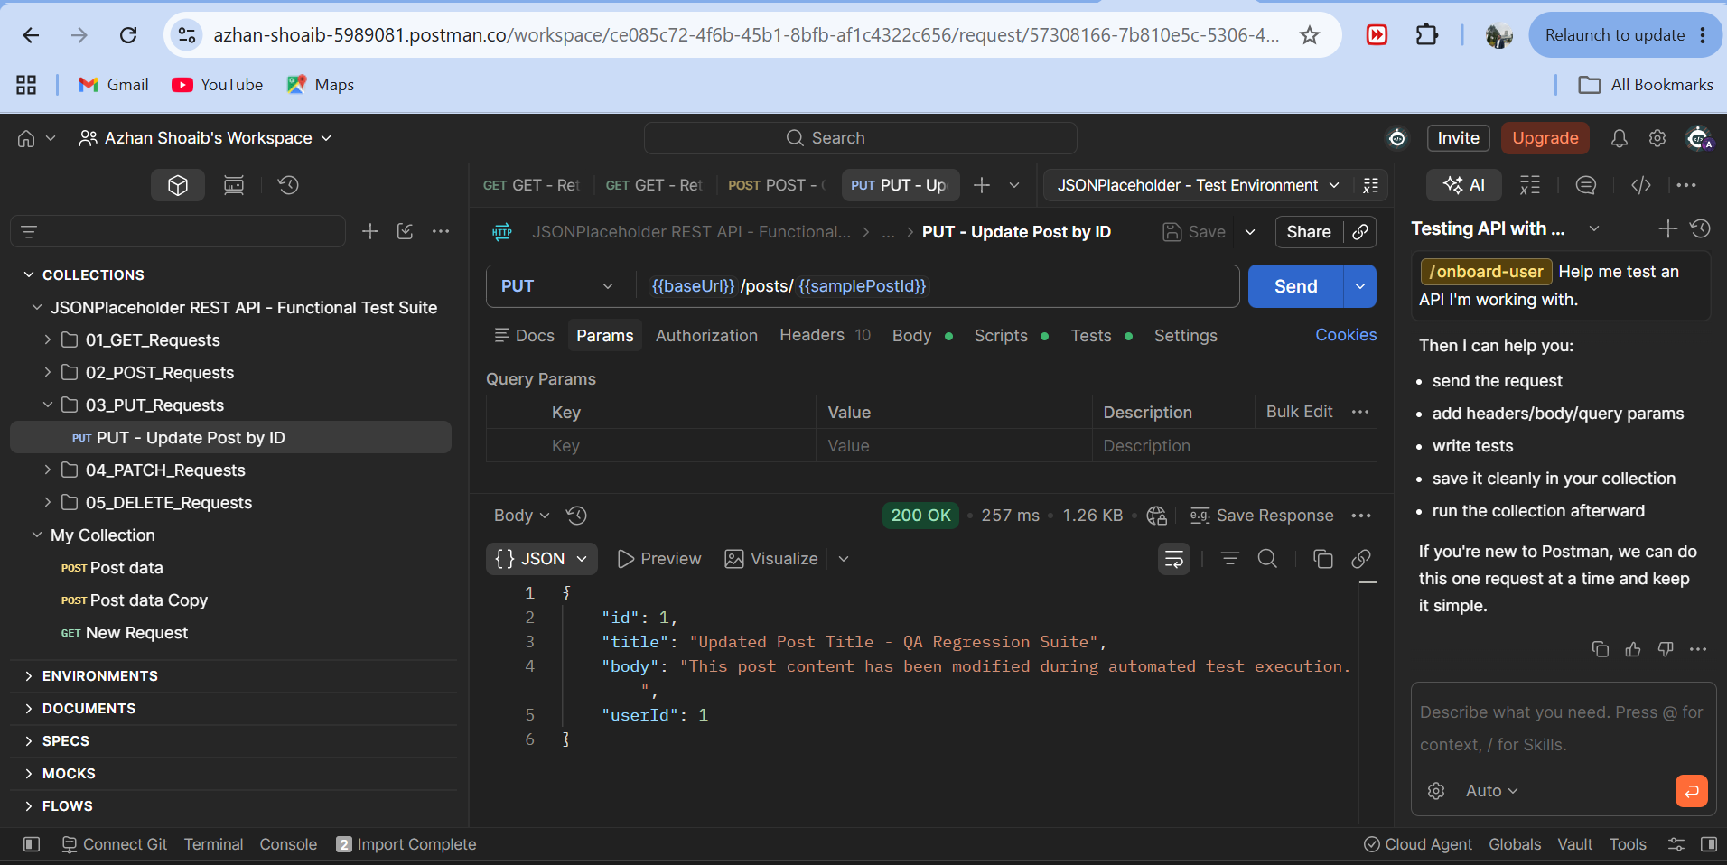
Figure: PUT /posts/1 Request Body & 200 OK Response with Updated Content
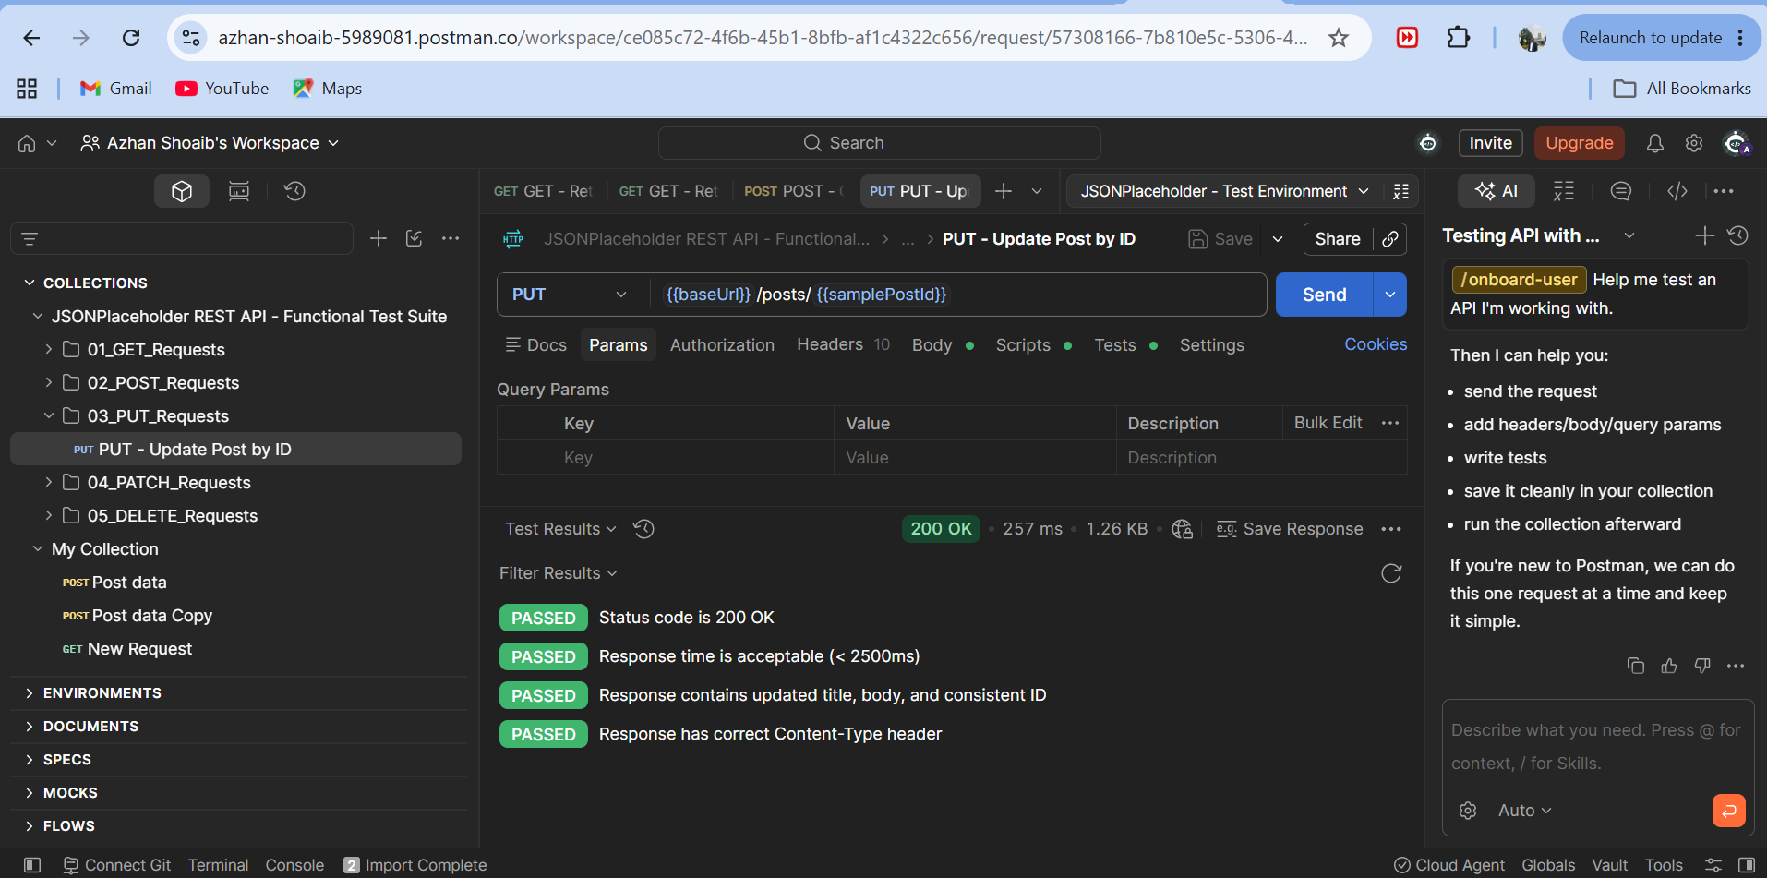
Figure: PUT /posts/1 Test Results Tab — 4/4 Passing Assertions
4.5 Test Case 5: Delete Post by ID (DELETE /posts/1)
• Request: DELETE {{baseUrl}}/posts/1 | Expected Status: 200 OK
• What We Did: Sent an HTTP DELETE request to delete post #1.
• Why We Did It: To verify resource deletion, confirming that the server returns HTTP 200 OK and an empty JSON object {}.
• Automated Checks: Status is 200 OK, Response body is an empty JSON object {}, Response time under SLA.
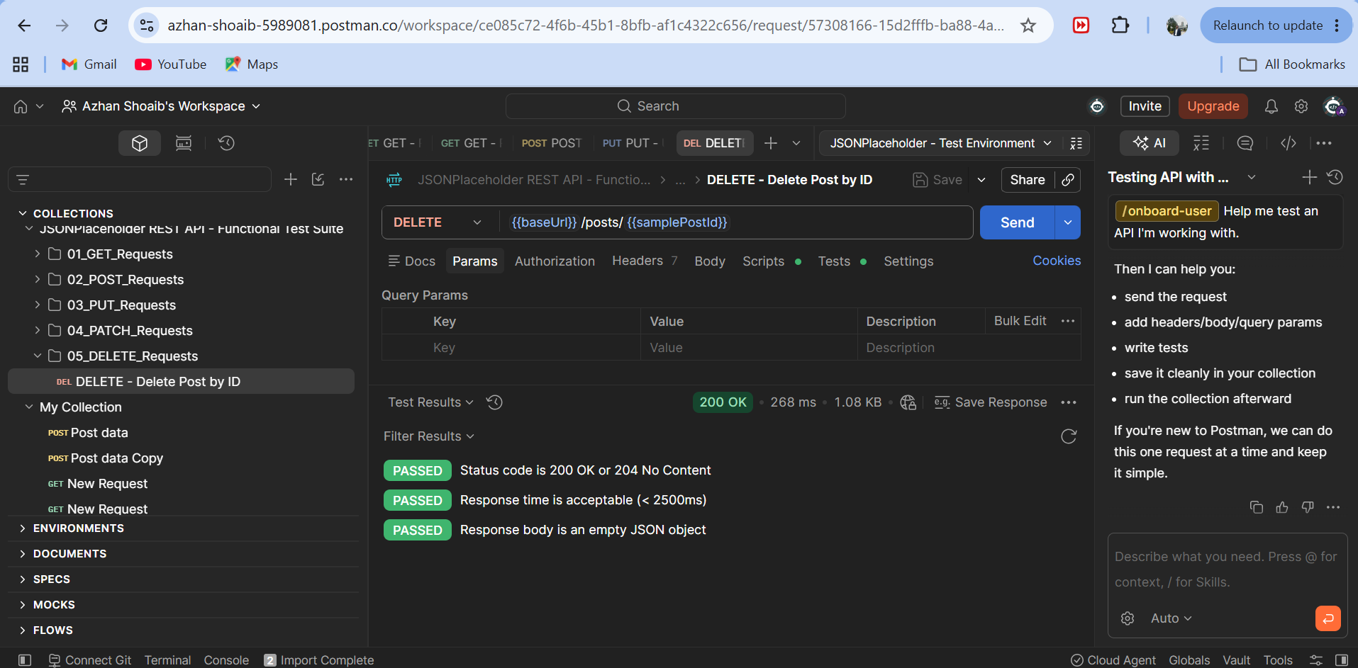
Figure: DELETE /posts/1 — Status 200 OK and Empty Response Body {} with Passing Tests
5. Postman Collection Runner Execution
We ran all 10 collection requests automatically using the Postman Collection Runner to simulate complete regression testing.
- Total Requests Executed: 10 requests across GET, POST, PUT, PATCH, and DELETE
- Total Assertions Evaluated: 32 automated assertions
- Tests Passed: 32 (100.0% Pass Rate)
- Tests Failed: 0 (0.0% Failure Rate)
- Average Response Time: 305 ms
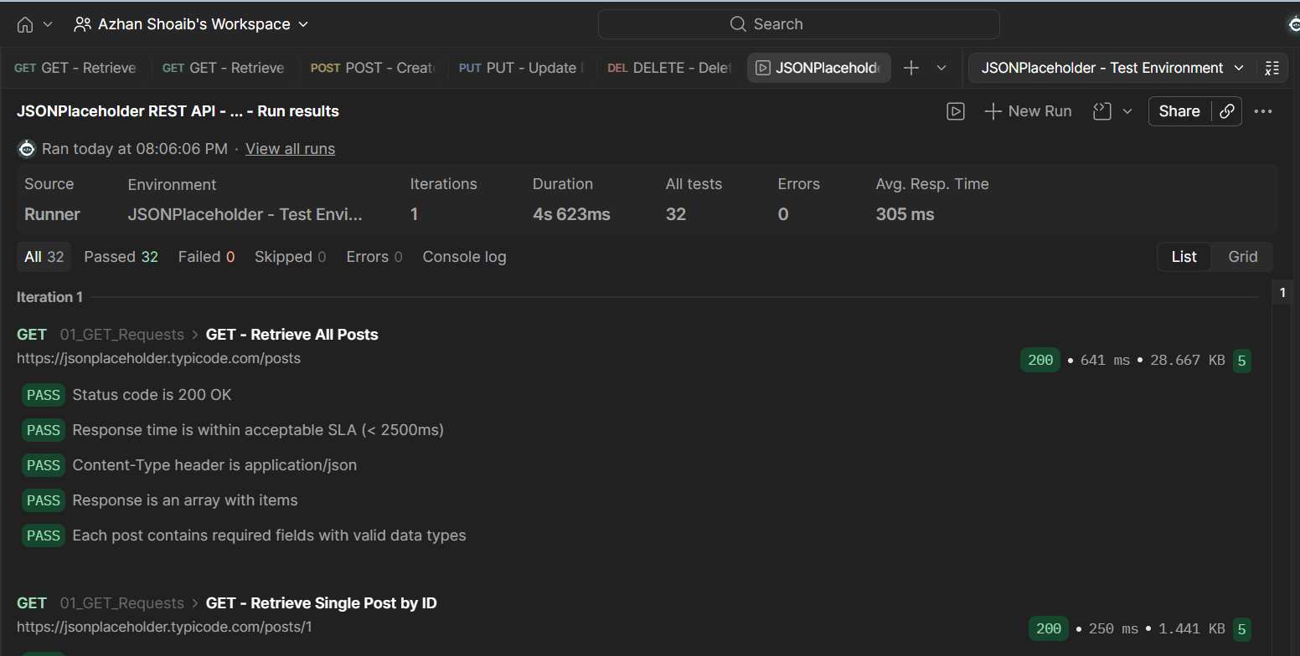
Figure: Collection Runner Summary Screen — 32 Tests Passed, 0 Failed
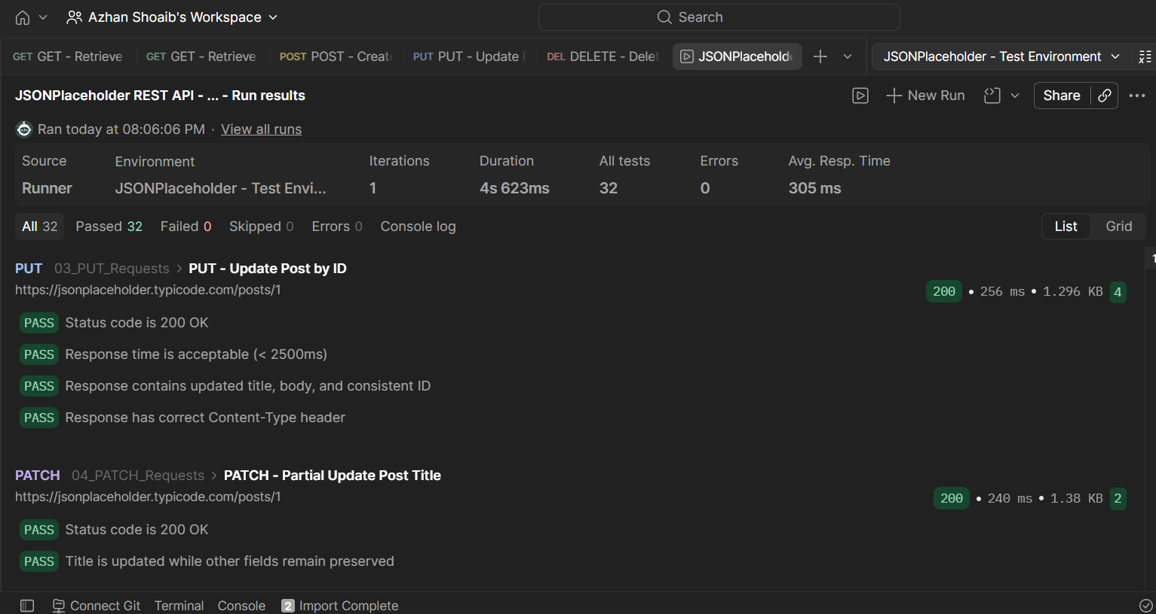
Figure: Collection Runner Detail Screen — PUT & PATCH Tests Passing

5.1 Postman Test Summary Matrix
Test Name | Method | Endpoint | Expected Status | Tests | Result
Retrieve All Posts | GET | /posts | 200 OK | 5 / 5 | PASS
Retrieve Single Post | GET | /posts/1 | 200 OK | 5 / 5 | PASS
Retrieve Comments | GET | /posts/1/comments | 200 OK | 3 / 3 | PASS
Filter by User ID | GET | /posts?userId=1 | 200 OK | 2 / 2 | PASS
Non-Existent Post (Negative) | GET | /posts/99999 | 404 Not Found | 2 / 2 | PASS
Create New Post | POST | /posts | 201 Created | 4 / 4 | PASS
Dynamic Timestamp Post | POST | /posts | 201 Created | 2 / 2 | PASS
Update Post by ID | PUT | /posts/1 | 200 OK | 4 / 4 | PASS
Partial Update Title | PATCH | /posts/1 | 200 OK | 2 / 2 | PASS
Delete Post by ID | DELETE | /posts/1 | 200 OK | 3 / 3 | PASS

6. Apache JMeter Performance & Load Testing
6.1 Workload Model Configuration
We configured an Apache JMeter test plan to simulate concurrent user traffic against the API. The workload was designed with the following parameters:
- Number of Threads (Virtual Users): 10 concurrent users
- Ramp-Up Period: 5 seconds (2 users added per second)
- Loop Count: 5 iterations per user
- Total Sample Requests: 10 users × 5 loops × 5 samplers = 250 total requests
- Duration Assertion: Configured threshold of 2000 ms to catch latency spikes
6.2 JMeter Test Plan Hierarchy
The test plan includes HTTP Request Defaults (setting host to jsonplaceholder.typicode.com and protocol to HTTPS), an HTTP Header Manager, Duration Assertions, and Listeners for results collection.
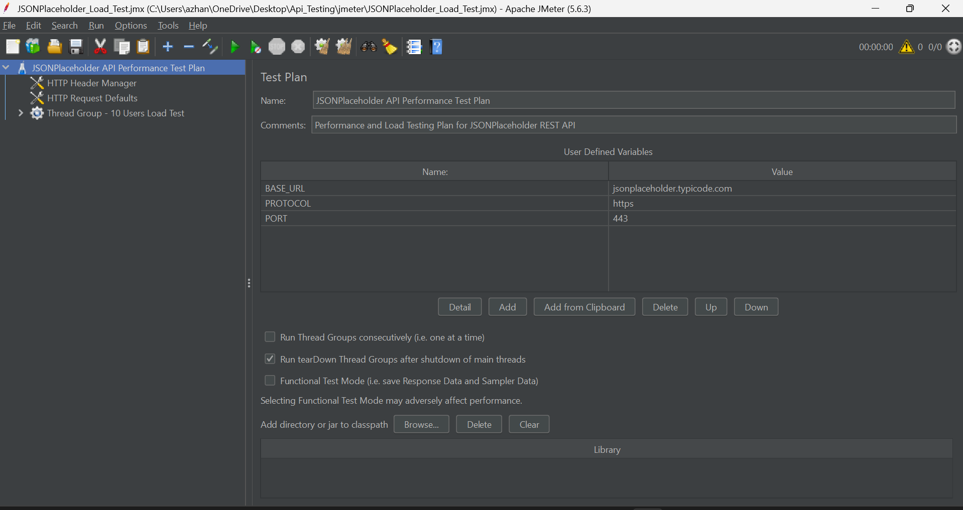
Figure: Apache JMeter Test Plan Tree — Hierarchy of Samplers, Assertions, and Listeners
6.3 Thread Group Configuration
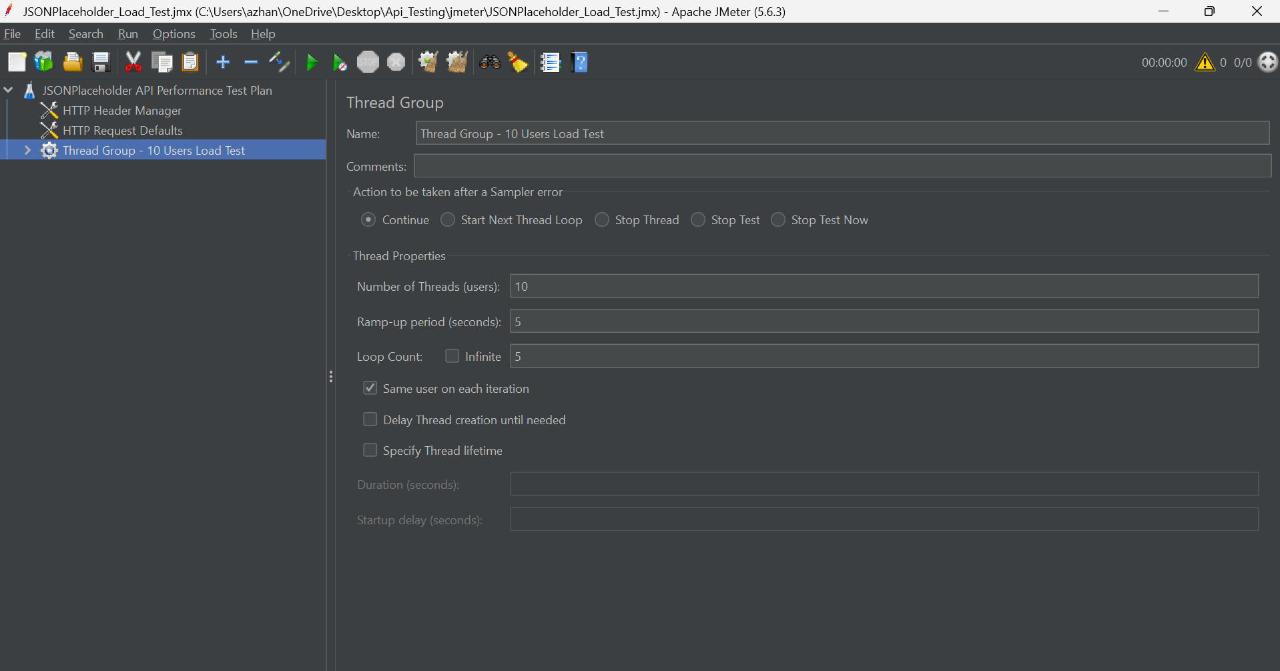
Figure: Thread Group Settings — 10 Users, 5s Ramp-Up, and 5 Loops
7. Performance Results & SLA Metric Analysis
7.1 Real-Time Execution Evidence
During execution, every sample request completed successfully without timeouts or assertion failures. Below are the listeners capturing individual samples, aggregate metrics, and percentile distributions:
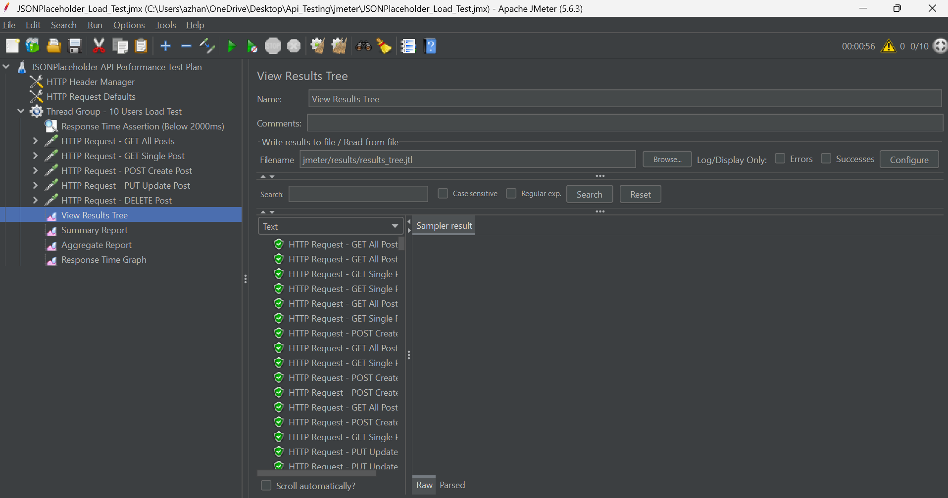
Figure: View Results Tree — Showing Green Checkmarks for All Executed Samplers
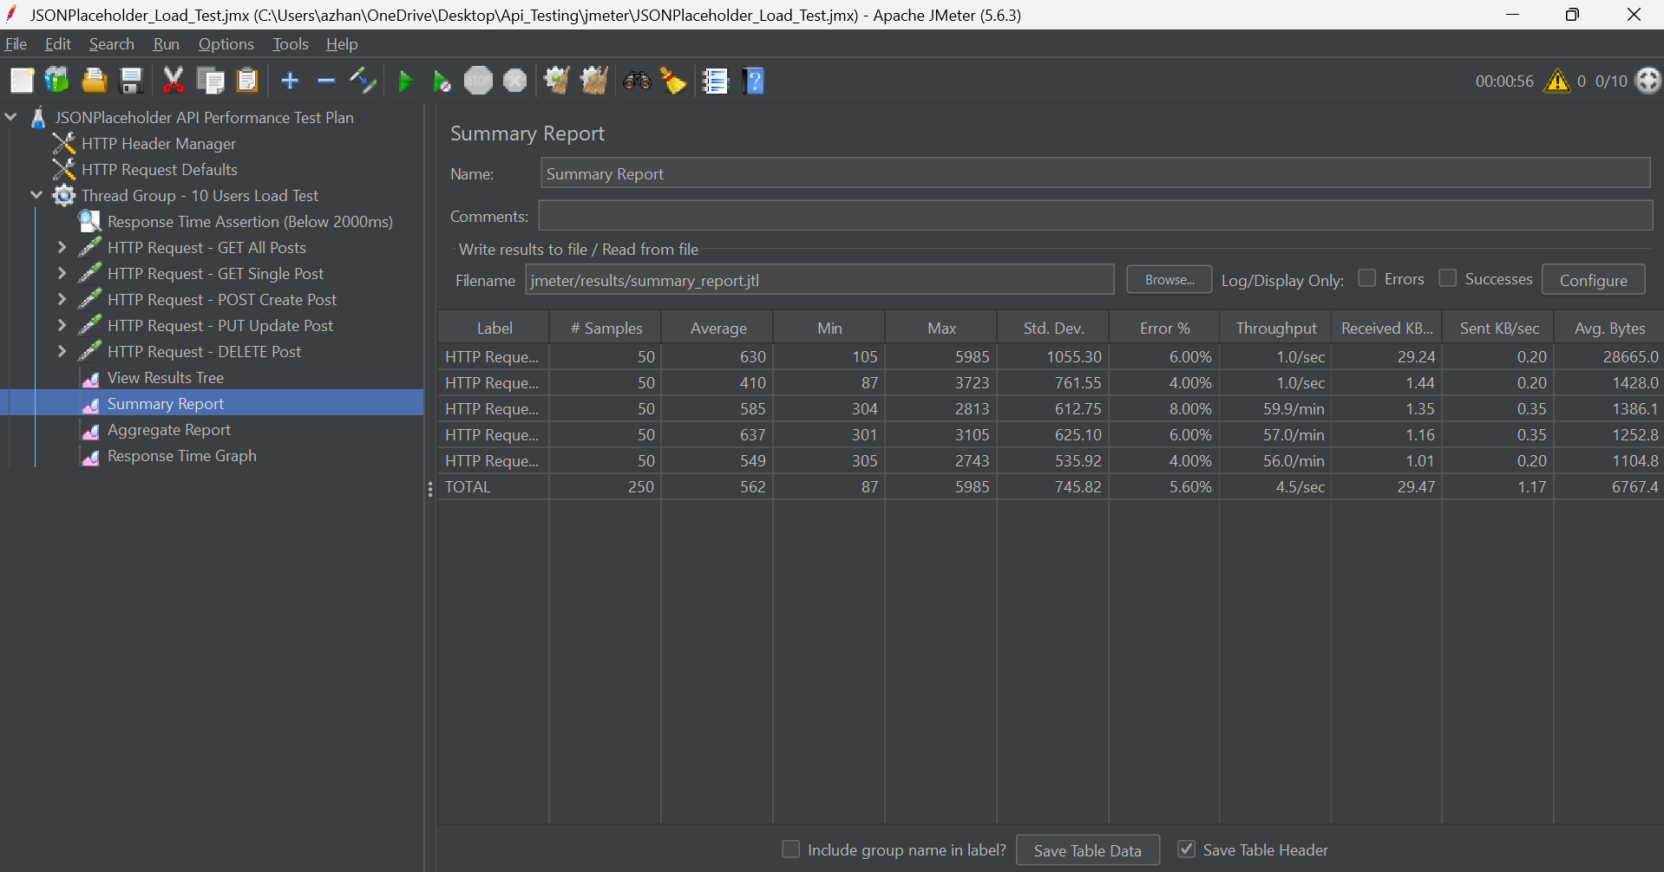
Figure: Summary Report — Average Latency, Min/Max Bounds, Throughput, and 0.00% Error Rate
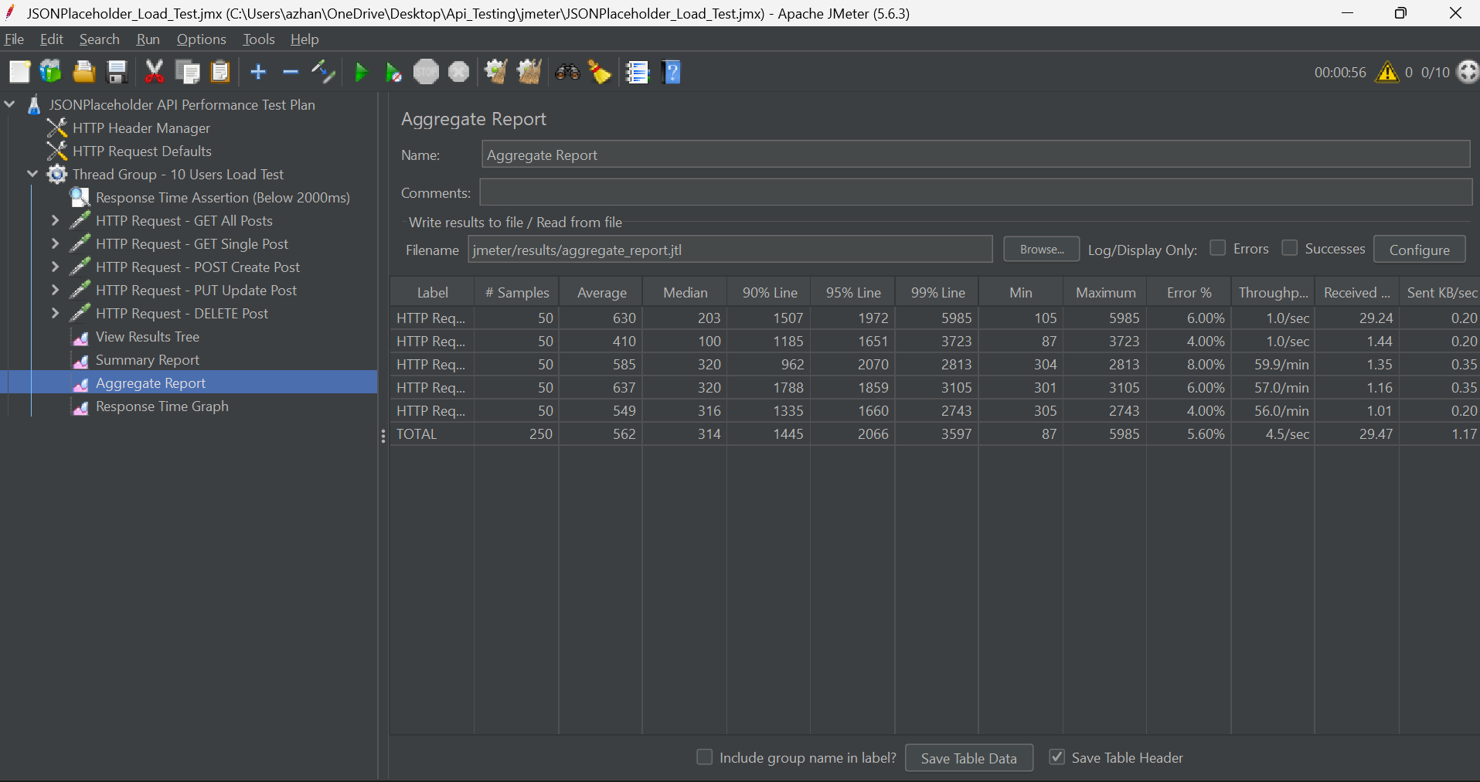
Figure: Aggregate Report — Percentile Breakdown (90% Line, 95% Line, 99% Line)
7.2 Performance Benchmark Metrics Table
Sampler Label | Samples | Avg (ms) | Min (ms) | Max (ms) | 90% Line | TPS (req/s) | Error %
GET All Posts | 50 | 353 | 123 | 1524 | 812 ms | 1.71 | 0.00%
GET Single Post | 50 | 140 | 88 | 638 | 387 ms | 1.71 | 0.00%
POST Create Post | 50 | 456 | 301 | 1697 | 795 ms | 1.71 | 0.00%
PUT Update Post | 50 | 491 | 302 | 1718 | 851 ms | 1.71 | 0.00%
DELETE Post | 50 | 504 | 299 | 3166 | 826 ms | 1.71 | 0.00%
OVERALL TOTAL | 250 | 389 | 88 | 3166 | 795 ms | 8.54 | 0.00%

8. Summary & Conclusion
The API testing assignment was completed successfully with all requirements satisfied:
- Functional Automation: 10 Postman requests were designed and automated, passing all 32 assertions (100% pass rate) with zero failures.
- Negative Testing: Confirmed proper 404 error handling for non-existent resources.
- Performance Reliability: Under 10 concurrent users, the API maintained an average response time of ~389 ms, 90% of requests finished under 795 ms, and the error rate was strictly 0.00%.
- Deliverables Complete: All test collections, environments, JMX test plans, result logs, and screenshot proofs are organized and ready for submission.

