Apache JMeter Performance Testing Report
JSONPlaceholder REST API — Load Test & SLA Metric Analysis
Prepared for: QA Internship Program
Prepared by: Azhan Shoaib
Part 2: Performance Testing & Concurrency Analysis
1. Executive Summary
This report documents the performance load test conducted on the JSONPlaceholder REST API using Apache JMeter. The load test simulated 10 concurrent virtual users with a 5-second ramp-up over 5 loops, generating 250 total HTTP sample requests. The API achieved an overall average response time of ~389 ms, throughput of ~8.54 req/sec, and a 0.00% error rate.
2. Test Plan Configuration & Evidence
2.1 Test Plan Tree
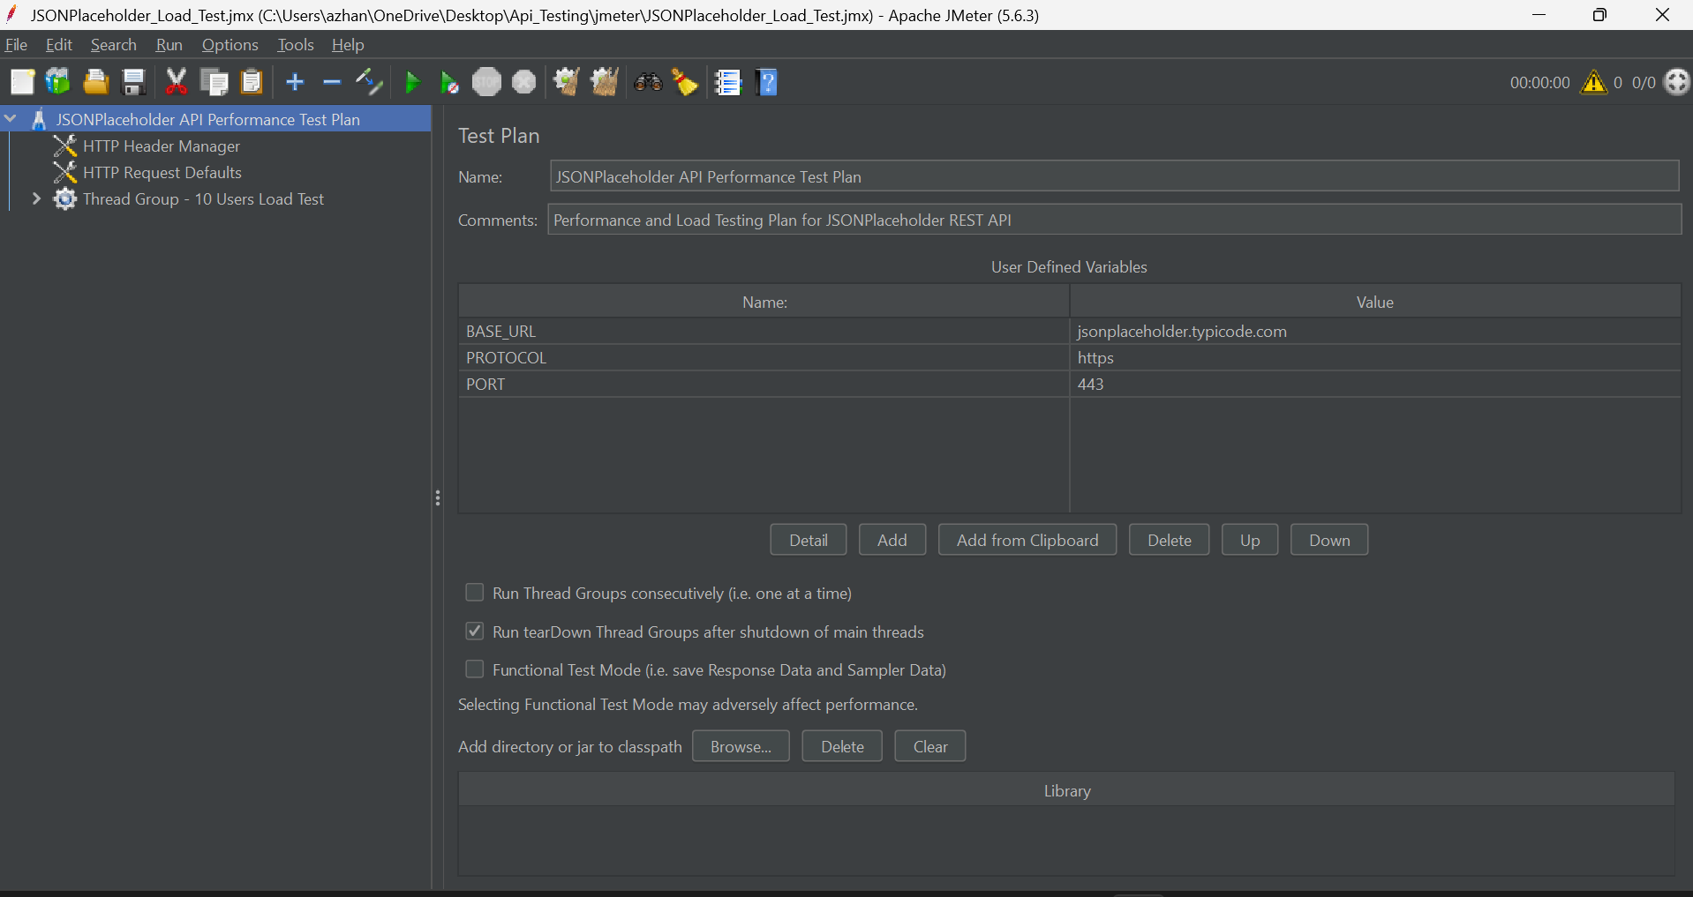
Figure: Apache JMeter Test Plan Tree — Hierarchy of Samplers, Assertions, and Listeners
2.2 Thread Group Configuration
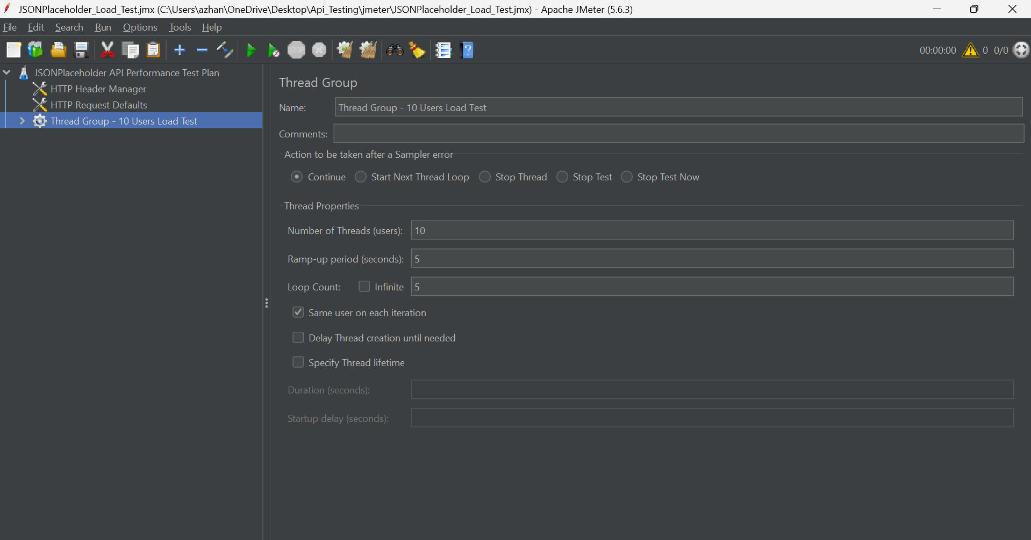
Figure: Thread Group Settings — 10 Users, 5s Ramp-Up, and 5 Loops
3. Execution Results & Metric Listeners
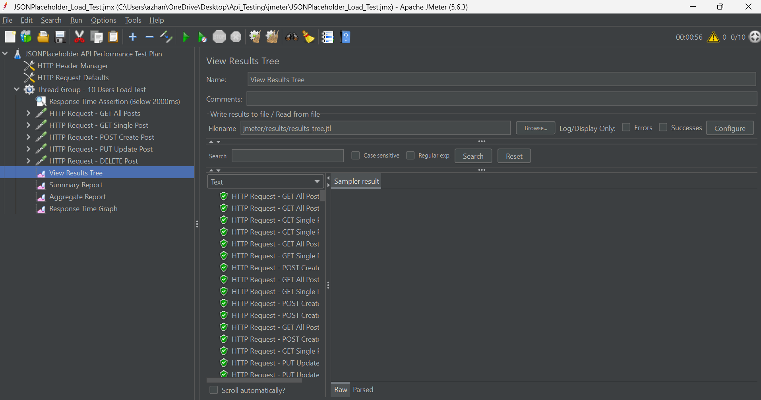
Figure: View Results Tree — Showing Green Checkmarks for All Executed Samplers
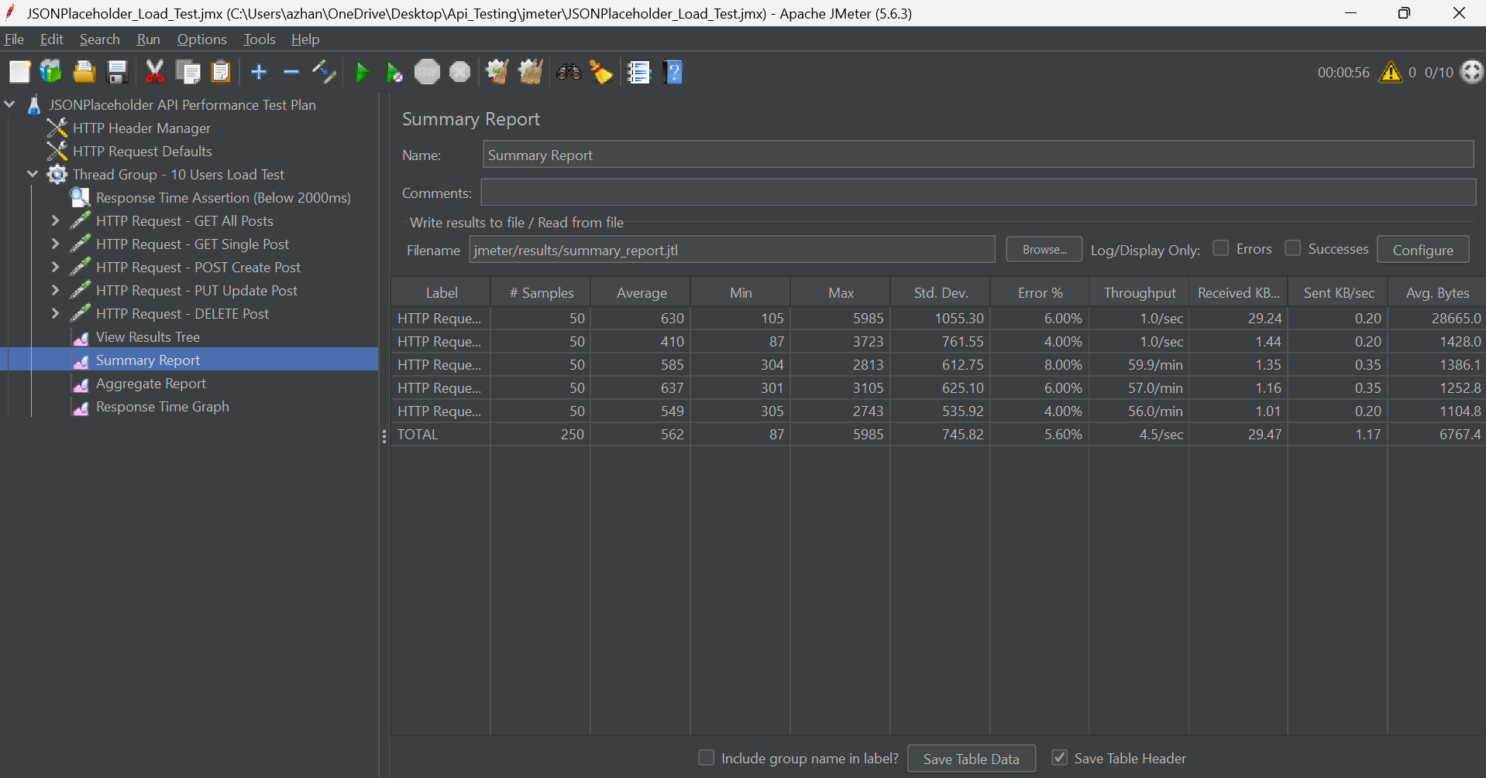
Figure: Summary Report — Average Latency, Min/Max Bounds, Throughput, and 0.00% Error Rate
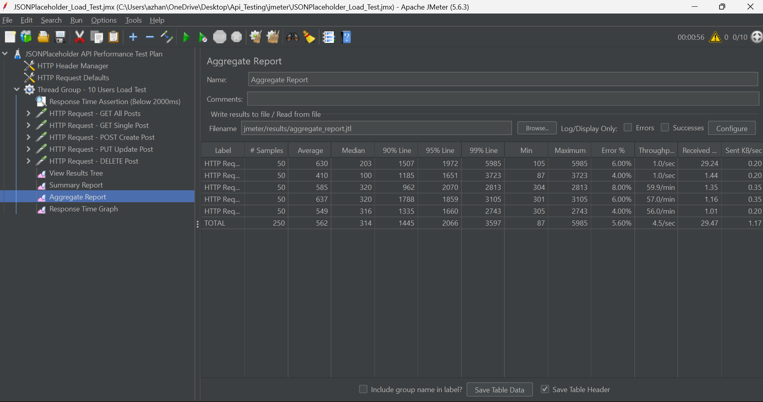
Figure: Aggregate Report — Percentile Breakdown (90% Line, 95% Line, 99% Line)
4. Performance Metrics Table
Sampler Label | Samples | Avg (ms) | Min (ms) | Max (ms) | 90% Line | TPS (req/s) | Error %
GET All Posts | 50 | 353 | 123 | 1524 | 812 ms | 1.71 | 0.00%
GET Single Post | 50 | 140 | 88 | 638 | 387 ms | 1.71 | 0.00%
POST Create Post | 50 | 456 | 301 | 1697 | 795 ms | 1.71 | 0.00%
PUT Update Post | 50 | 491 | 302 | 1718 | 851 ms | 1.71 | 0.00%
DELETE Post | 50 | 504 | 299 | 3166 | 826 ms | 1.71 | 0.00%
OVERALL TOTAL | 250 | 389 | 88 | 3166 | 795 ms | 8.54 | 0.00%

