Postman Functional API Testing Report
JSONPlaceholder REST API — Automated Assertions & Evidence
Prepared for: QA Internship Program
Prepared by: Azhan Shoaib
Part 1: Functional Testing & Postman Collection Runner
1. Executive Summary
This report documents the functional API testing performed for the JSONPlaceholder REST API using Postman. The objective was to validate standard HTTP methods (GET, POST, PUT, PATCH, and DELETE) by checking status codes, response payloads, JSON schemas, headers, and response times. All 10 requests ran successfully with 32 out of 32 assertions passing.
2. Detailed Test Cases & Execution Evidence
2.1 Test Case 1: Retrieve All Posts (GET /posts)
• Request: GET {{baseUrl}}/posts | Status: 200 OK | Assertions: 5/5 Passed
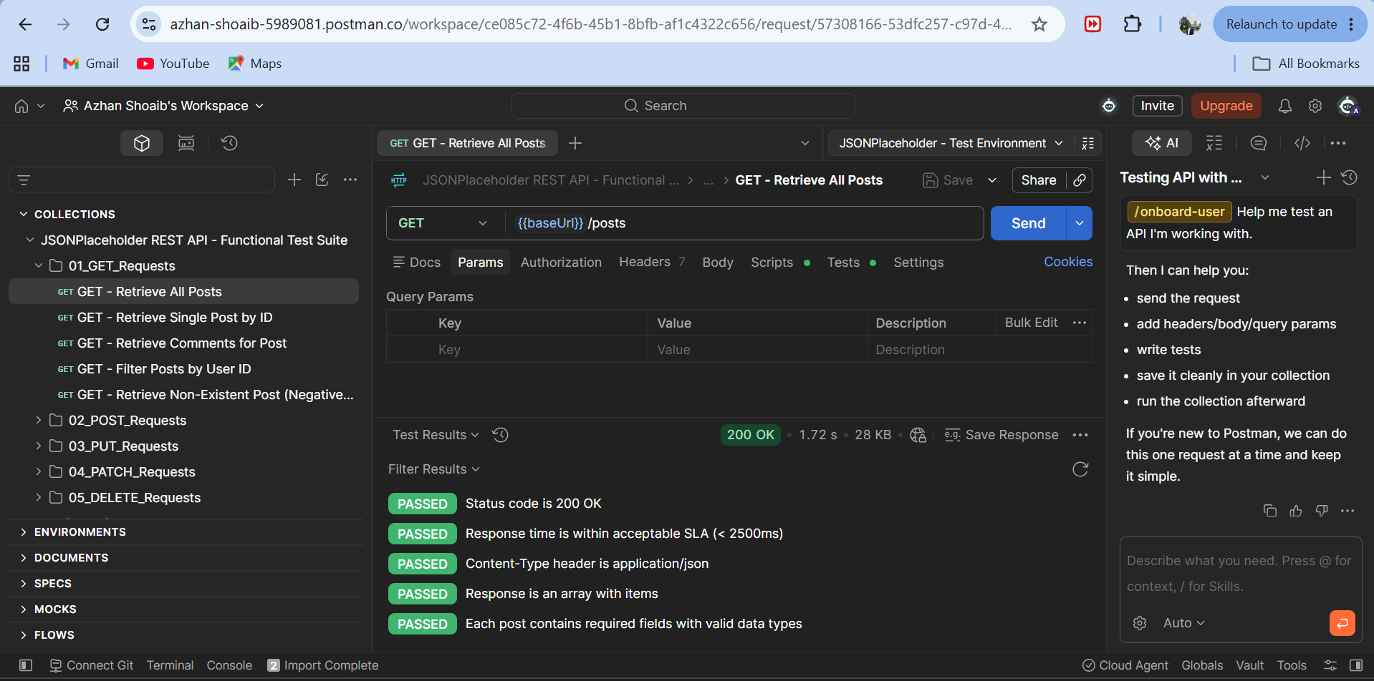
Figure: GET /posts — Status 200 OK and 5/5 Passing Automated Tests
2.2 Test Case 2: Retrieve Single Post by ID (GET /posts/1)
• Request: GET {{baseUrl}}/posts/1 | Status: 200 OK | Assertions: 5/5 Passed
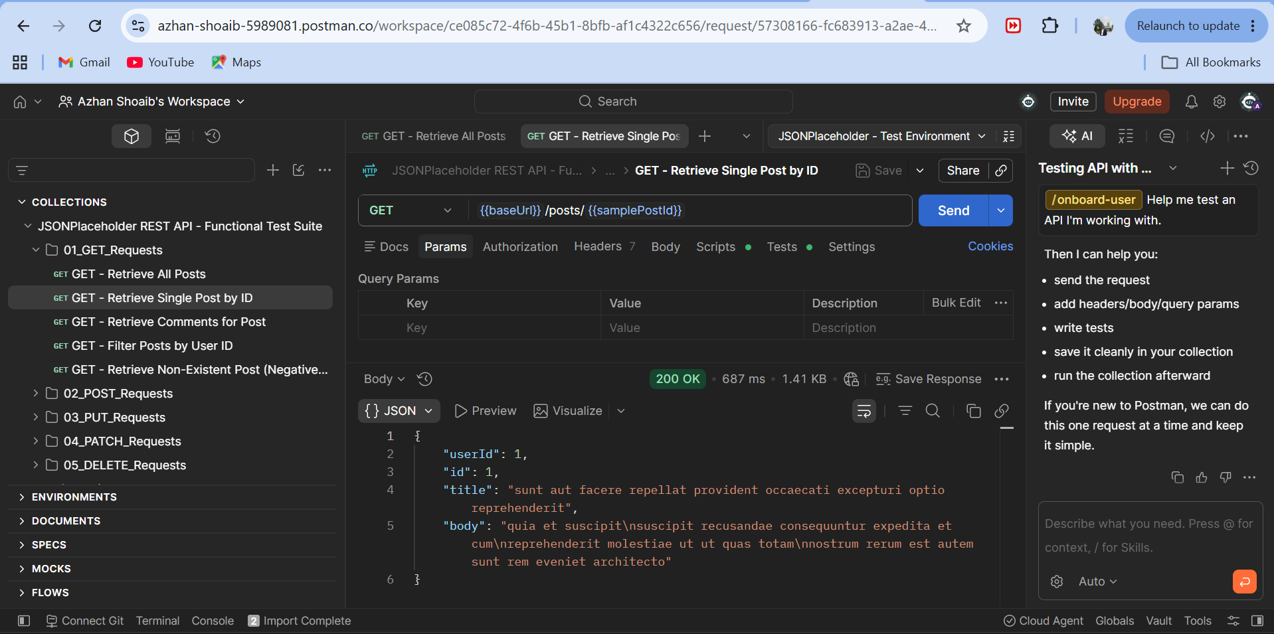
Figure: GET /posts/1 Response Body — Single Post Object Returned
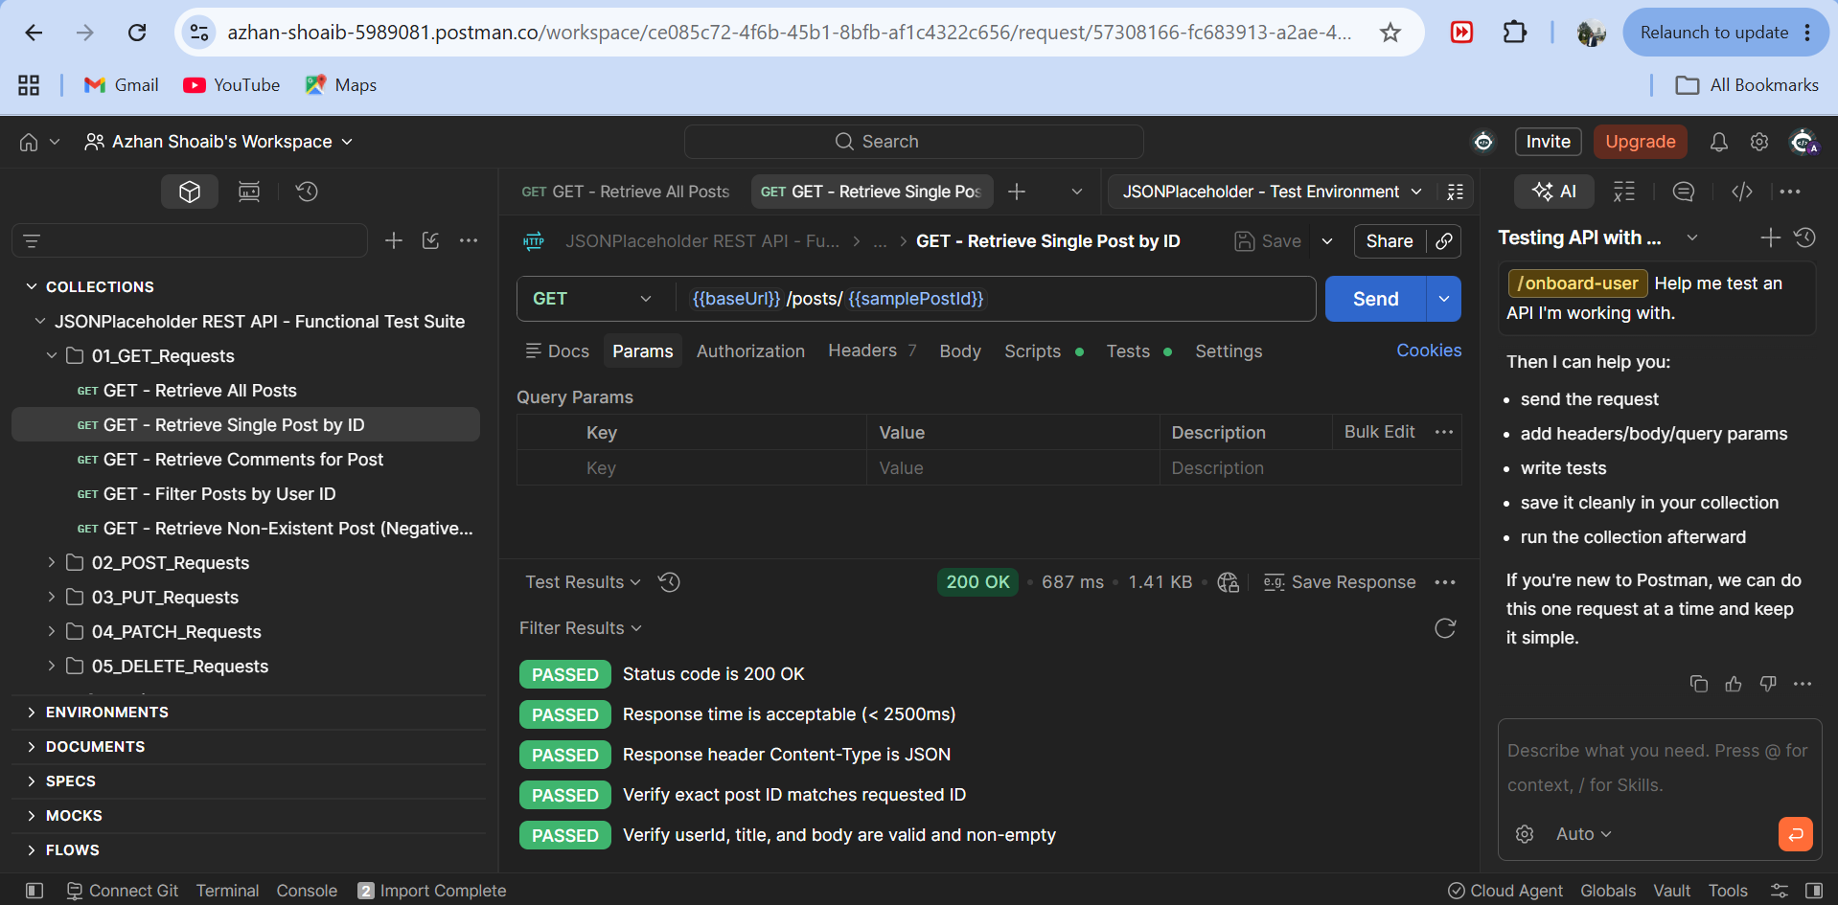
Figure: GET /posts/1 Test Results Tab — 5/5 Passing Tests
2.3 Test Case 3: Create New Post (POST /posts)
• Request: POST {{baseUrl}}/posts | Status: 201 Created | Assertions: 4/4 Passed
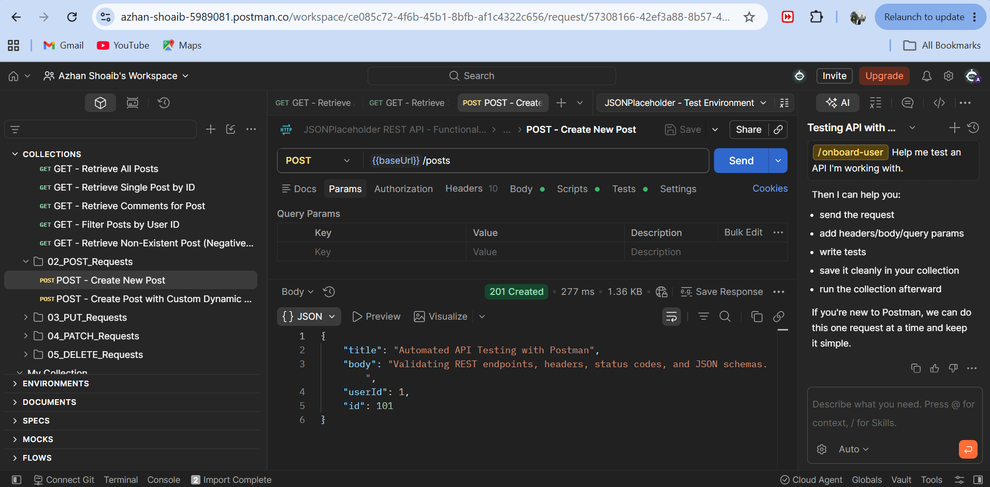
Figure: POST /posts Request Body & 201 Created Response with Generated ID 101
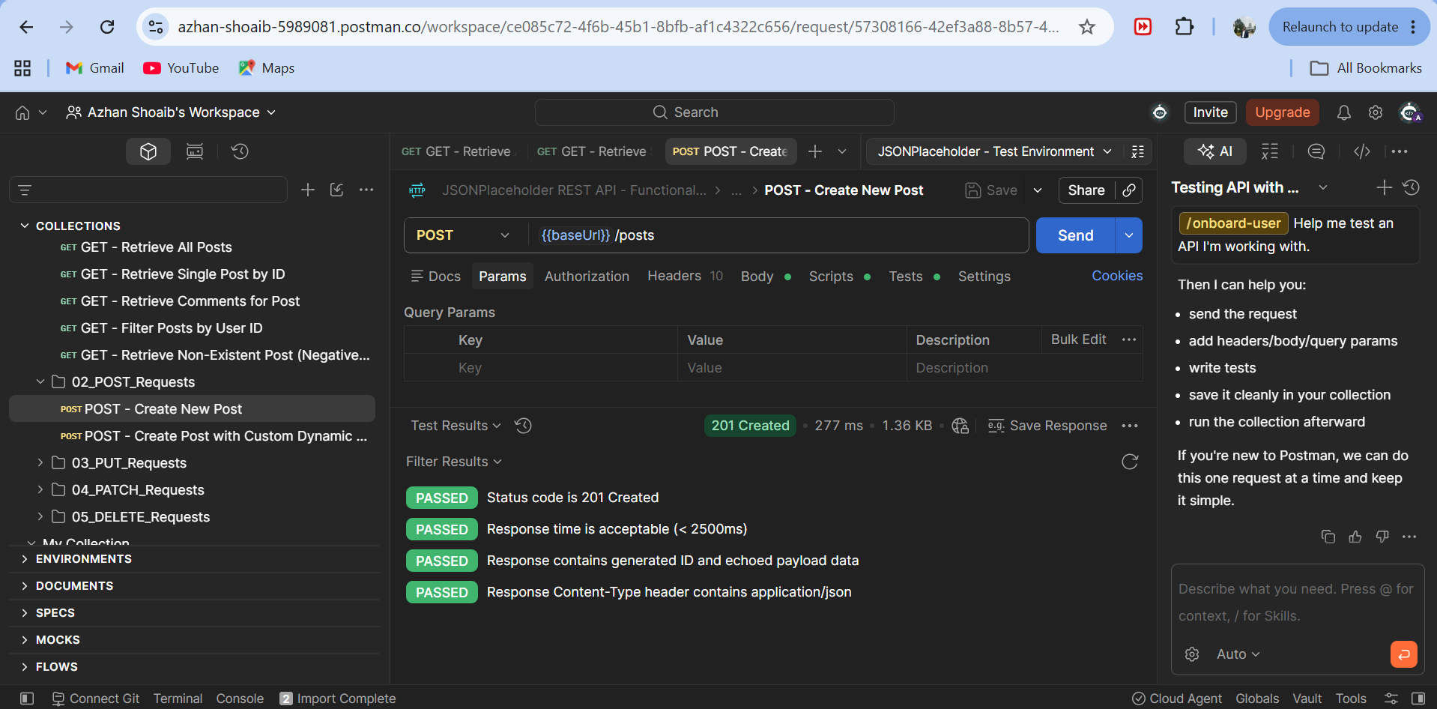
Figure: POST /posts Test Results Tab — 4/4 Passing Assertions
2.4 Test Case 4: Update Post by ID (PUT /posts/1)
• Request: PUT {{baseUrl}}/posts/1 | Status: 200 OK | Assertions: 4/4 Passed
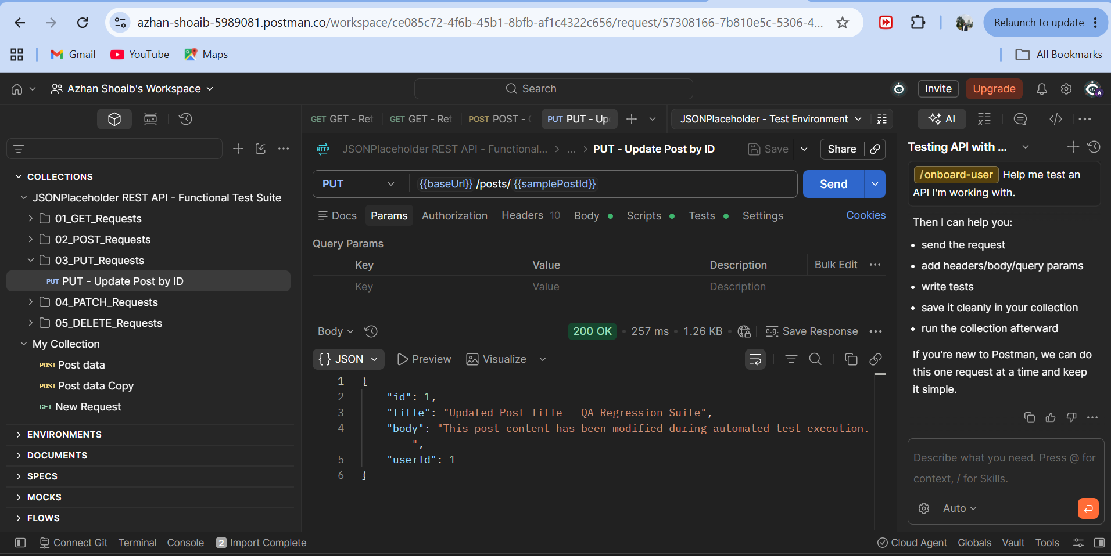
Figure: PUT /posts/1 Request Body & 200 OK Response with Updated Content
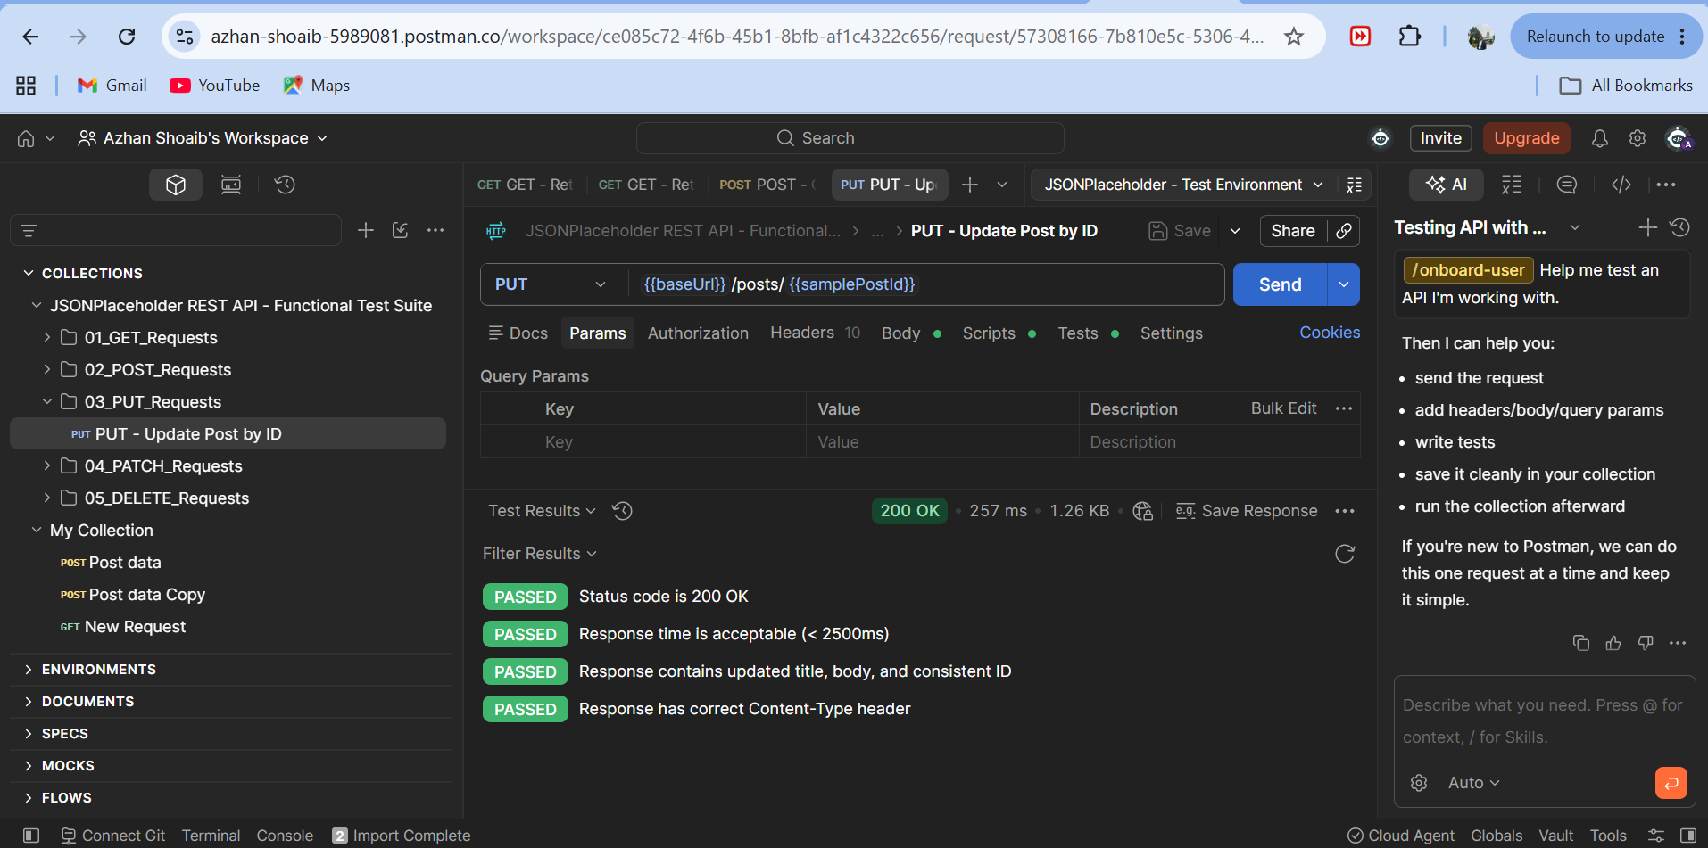
Figure: PUT /posts/1 Test Results Tab — 4/4 Passing Assertions
2.5 Test Case 5: Delete Post by ID (DELETE /posts/1)
• Request: DELETE {{baseUrl}}/posts/1 | Status: 200 OK | Assertions: 3/3 Passed
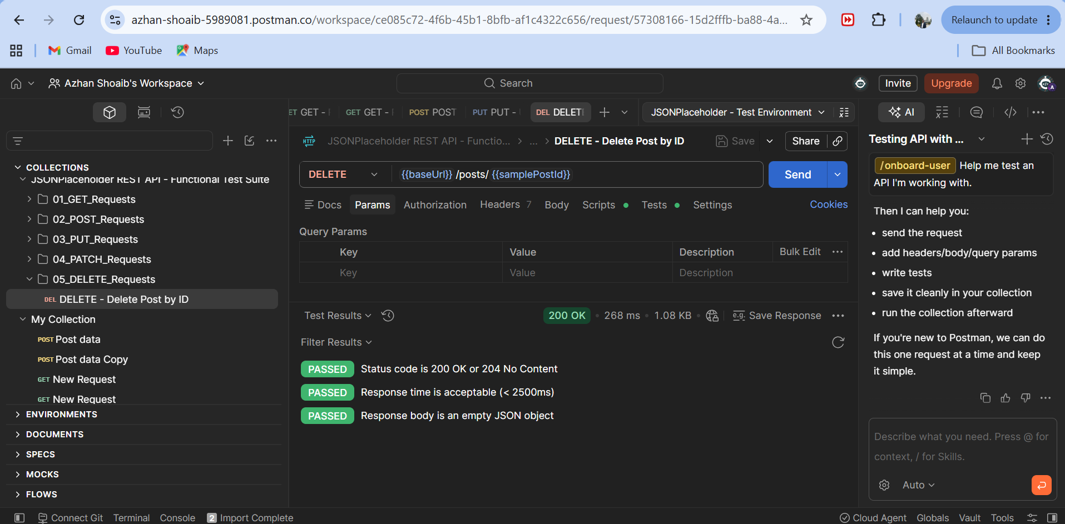
Figure: DELETE /posts/1 — Status 200 OK and Empty Response Body {}
3. Collection Runner Execution
The full collection was executed via Postman Collection Runner with 32 passed assertions and 0 failures.
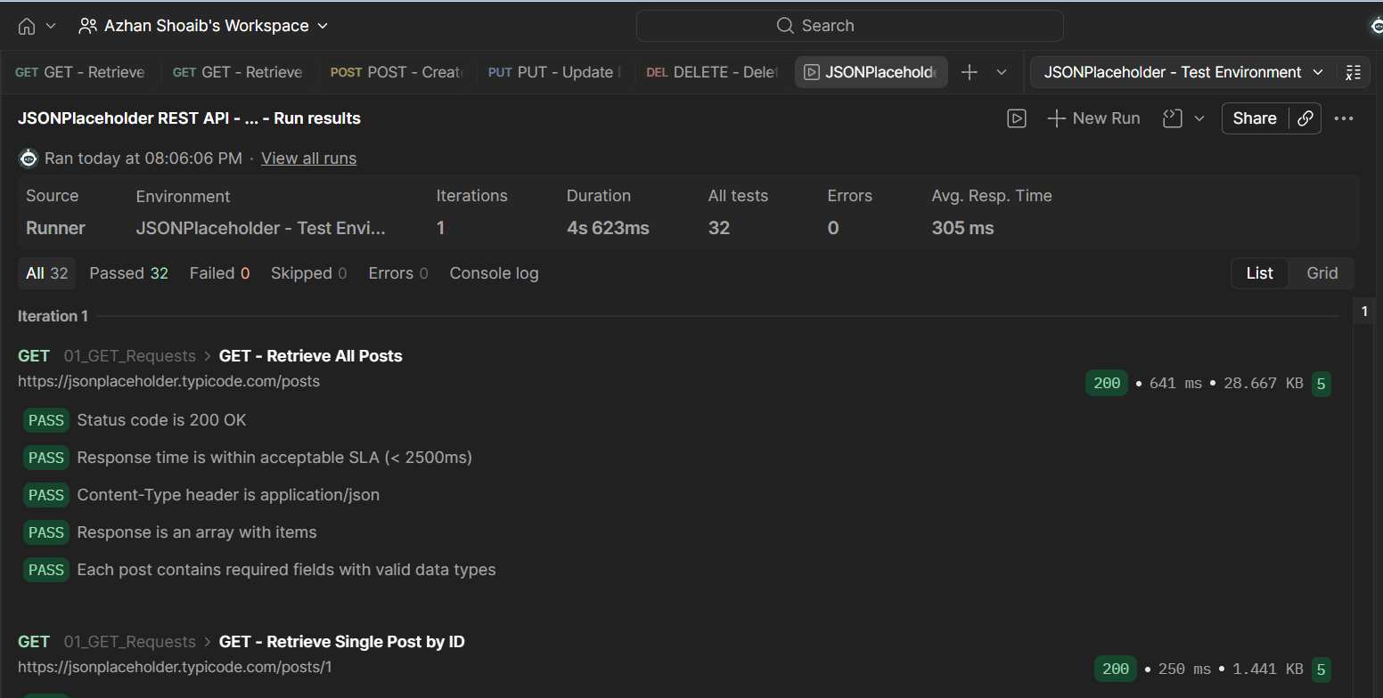
Figure: Collection Runner Summary Screen — 32 Tests Passed, 0 Failed
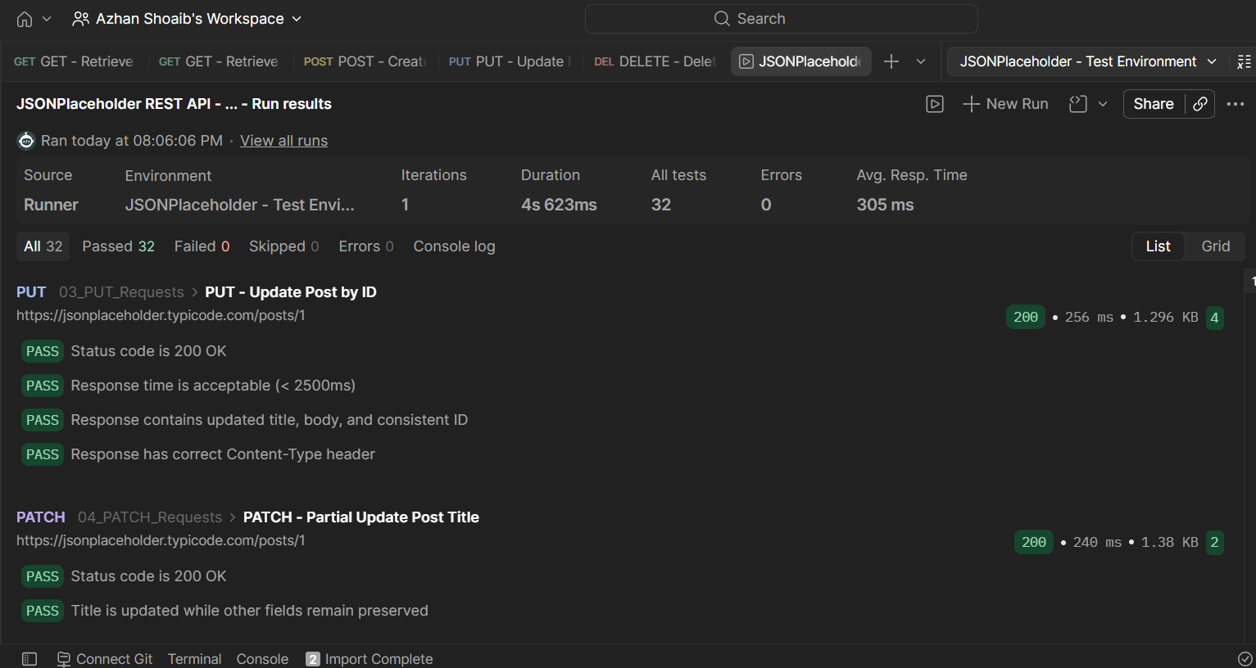
Figure: Collection Runner Detail Screen — PUT & PATCH Tests Passing

