WVU CS350 Assignment 3:
Image Enhancement via Client-Server Communication
Paul Prince
Dr. Don Adjeroh, Spring 2010


Enhanced Image

  Original |   Mean |   Median | 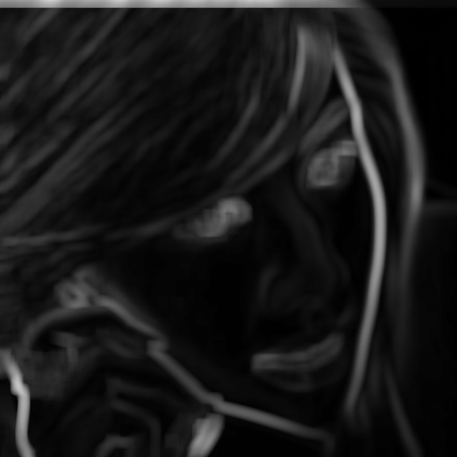  Variance

Introduction

Target Platform
I try to write portable code, however there may be dependencies specific to a Linux operating environment. I also test all submissions on the WVU CSEE shell server. Consult the included files “Makefile” and “run_tests.sh” for assistance building and running the programs.

Image Formats
Currently, the code still supports only PGM greyscale images, i.e. PBM Type 5 images.
If time permits, I may extend it to additional formats before final submission.

Description of Algorithms

Window Selection
Same as in Assignment 2:
We attempt to select a square window centered around a given center pixel. If any of the edges of this window fall outside the boundaries of the input image, we crop off the overhanging portions of the window.

Standard Deviation Calculations
Again, same as in Assignment 2, Knuth & Welford's “online” algorithm for calculating population variance in a single pass over the items.

Median Calculations
As yet, unchanged from Assignment 2: use the standard library's qsort() routine to find medians naïvely.
This is an aspect of the program I hope to improve before final submission. However, the current method should be numerically accurate, even if inefficient.

Enhanced Value Calculation
Counter to the apparent “conventional wisdom” regarding this assignment, I am currently calculating the enhanced pixel value in the child threads, and not in the parent/main thread.
The constant values have been updated according to Assignment 3.
I will modify this behavior if required.

Global Statistics
I notice on my grade sheet from Assignment 2 that I lost a few of points in the global statistics portion. I am reviewing my code to ensure that any errors are corrected before final submission of Assignment 3.

