Objective: Deploy a Flask backend and an Express frontend on AWS across three configurations — single EC2, separate EC2 instances, and Docker containers using ECR/ECS/VPC.
Note: If you are new to AWS, create an AWS account and take advantage of the one-year free tier, which provides access to a limited set of resources and services at no cost. For more details, refer to the official AWS Free Tier page: https://aws.amazon.com/free.

Tasks
- Deploy your Flask backend and Express frontend on a single Amazon EC2 instance.
- Deploy your Flask backend and Express frontend on separate EC2 instances.
- Deploy your Flask backend and Express frontend as Docker containers using AWS ECR, ECS, and VPC services.

Deploy your Flask backend and Express frontend on a single Amazon EC2 instance.
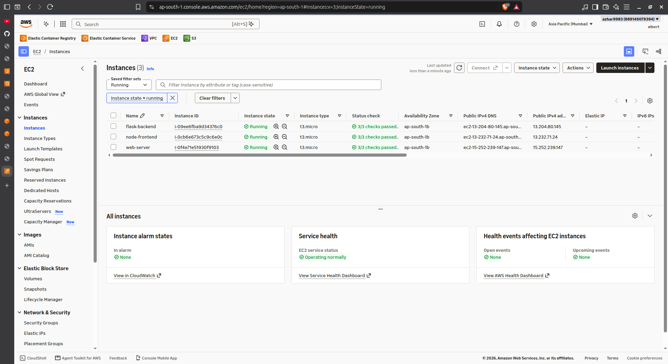
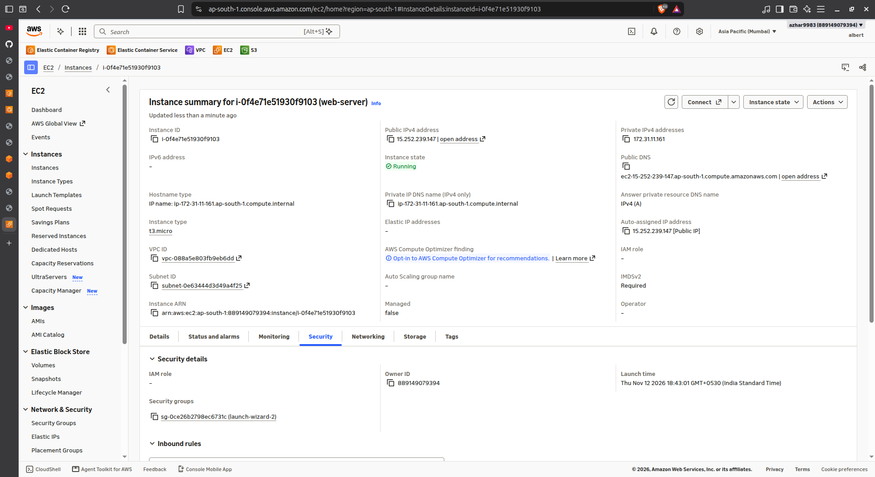
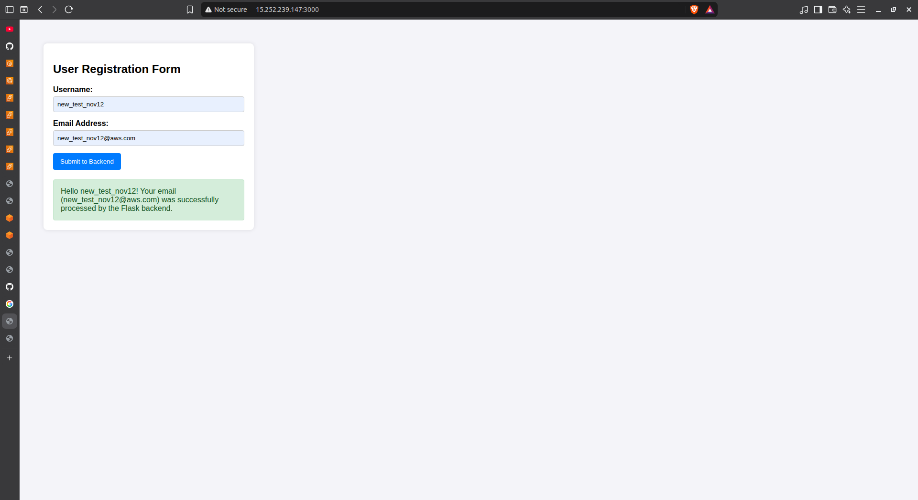
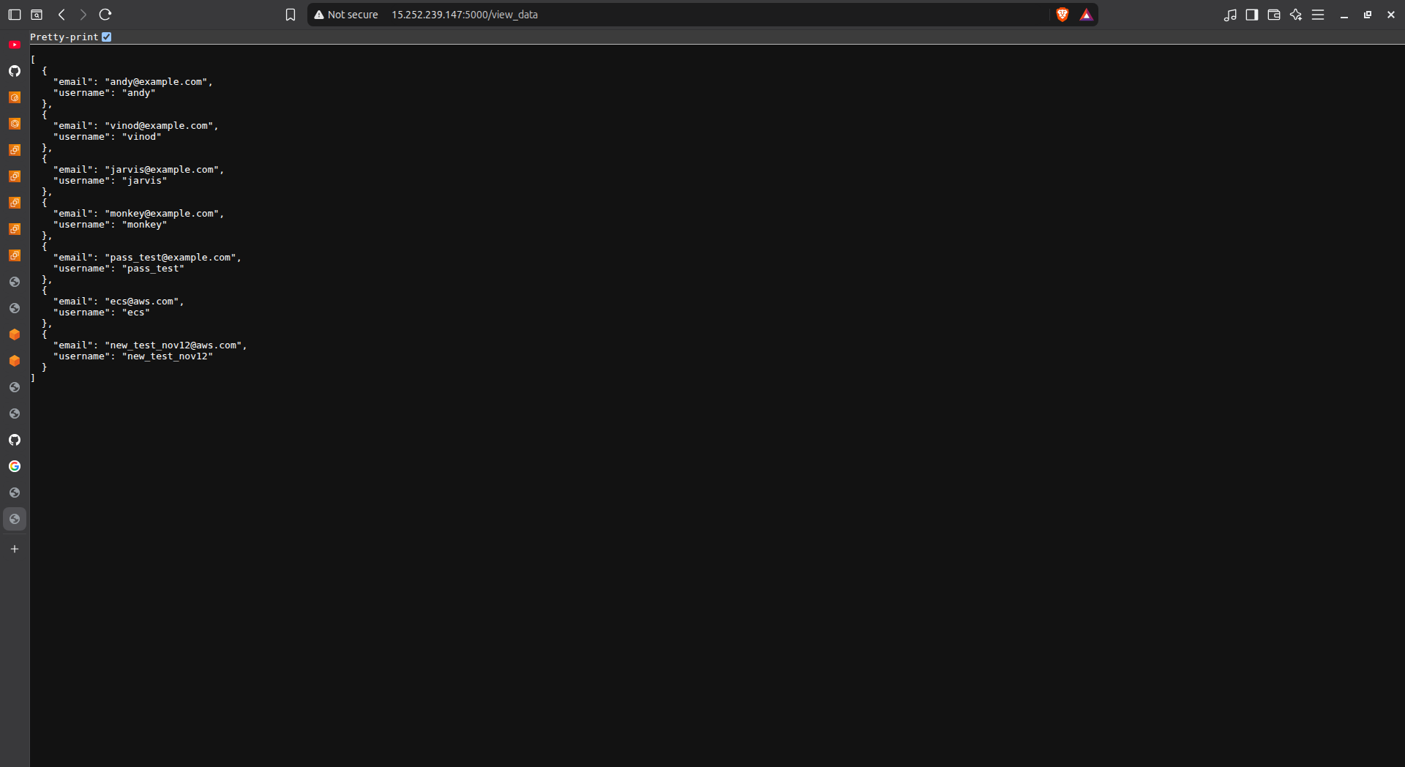
Deploy your Flask backend and Express frontend on separate EC2 instances

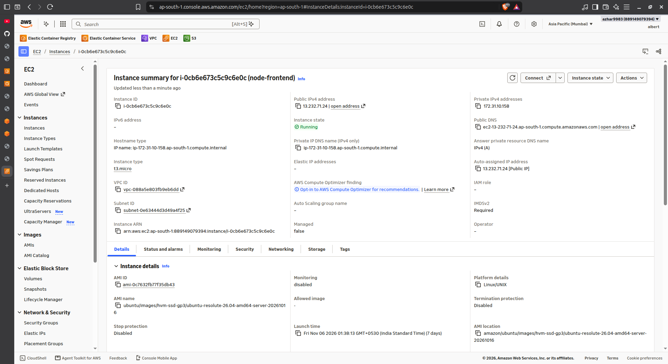
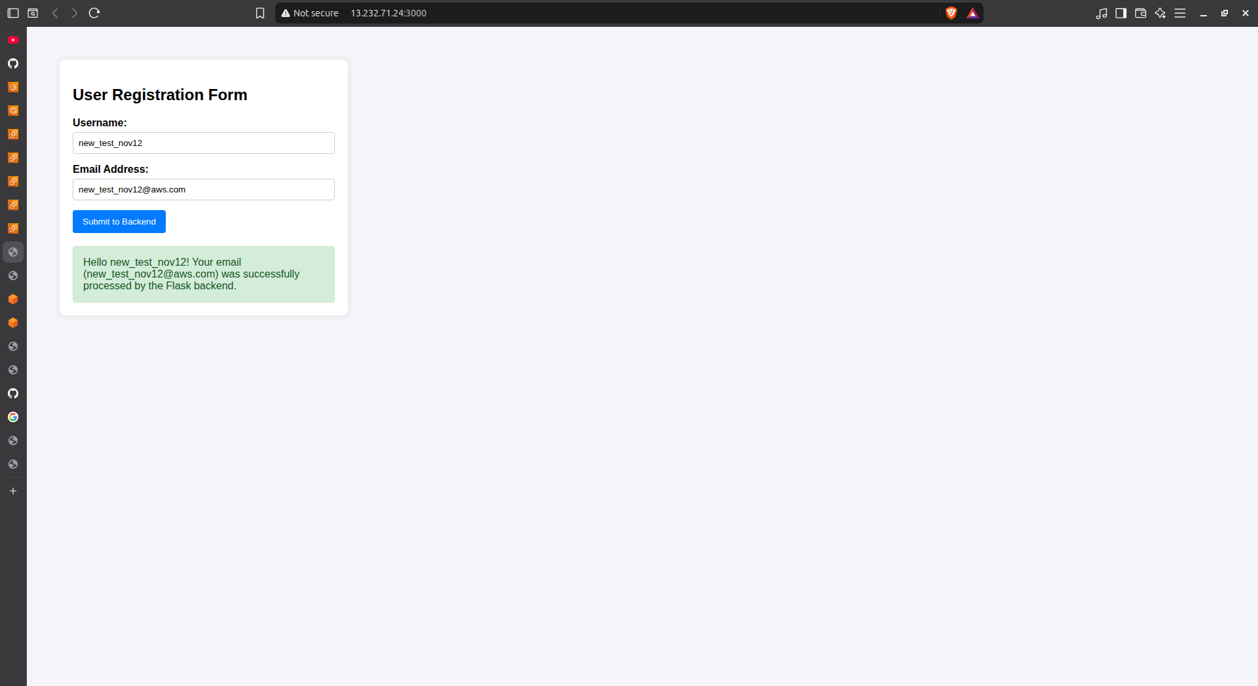
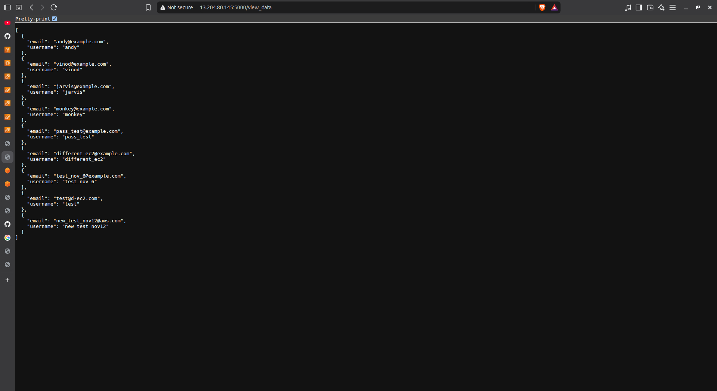
Deploy your Flask backend and Express frontend as Docker containers using AWS ECR, ECS, and VPC services



