Documentation

Introduction : This web Application will work like if you want to get specific information about fruits or Food and about your meals.

Example : you entered -> rice

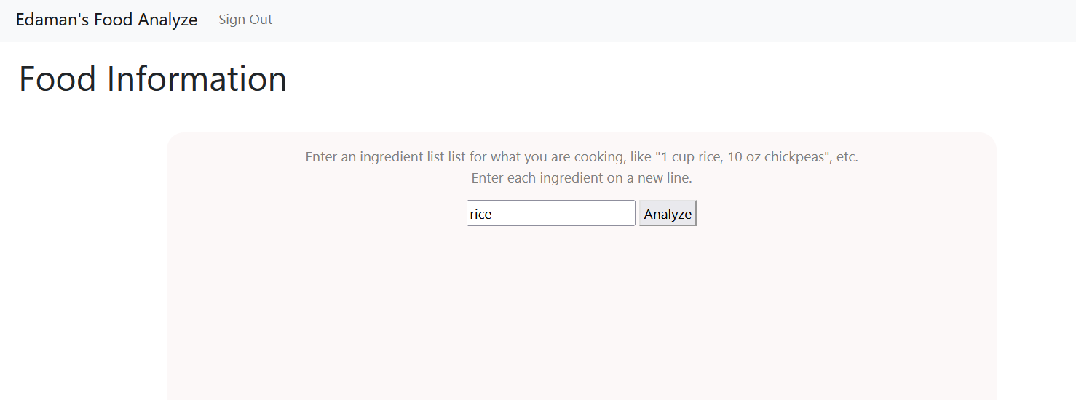

When you click Analyze button All the information about rice like how much calories and fat in it will display .

Now let’s see how I build this web application

First we need an Api for this application so I use :- Edaman’s Nutrition Api

<https://api.edamam.com/api/nutrition-data>,

Api_Id=”68f57d61”,

Api_Key=”7a5f77e09863df370a83b7523d9c6c90”,

Let’s see how I create login page .



First we need to Add Model from database that we will use in controller also

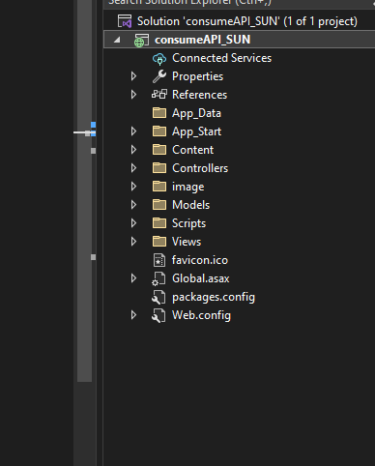

Right click on model folder if we don’t have model folder so first create.

Then click to add we you’ll see ADO.NET Entity Data Model click on it and give any name

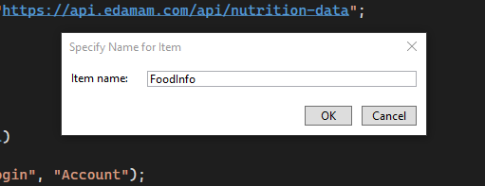 Press ok.

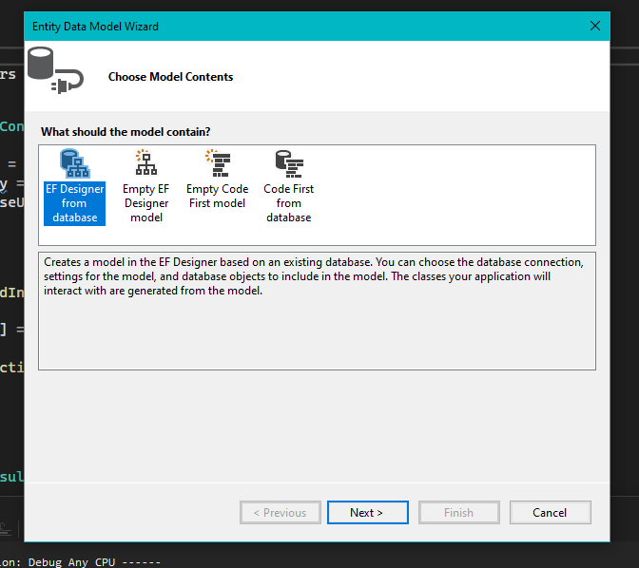 Press Next.

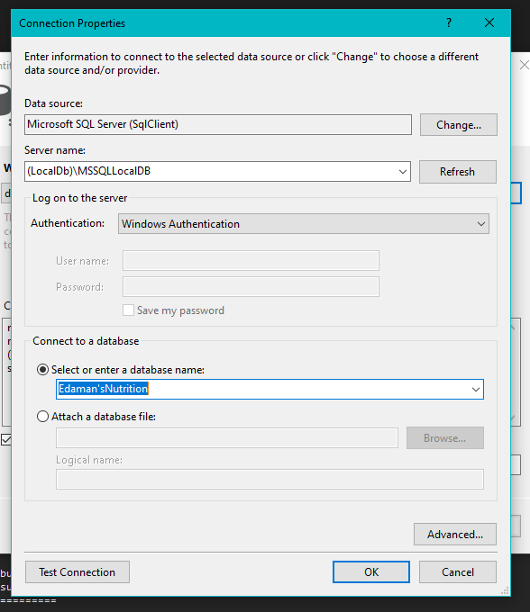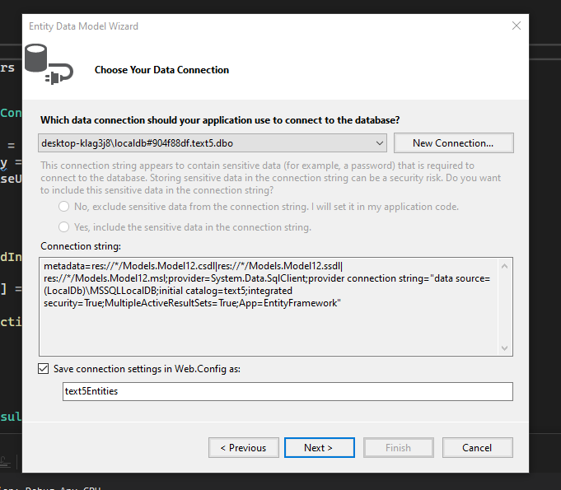

Click on , New Connection and fill Server Name and Select Database Name

Then Text Connection press Ok.

Then Check Tables & Click on Finish.

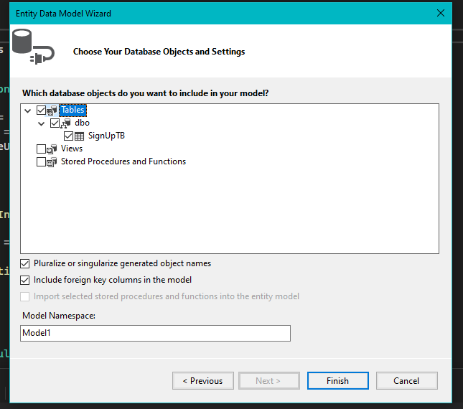

Now Create Controller with Any Meaningful name



Right click on controller 🡪 Add 🡪 Controller

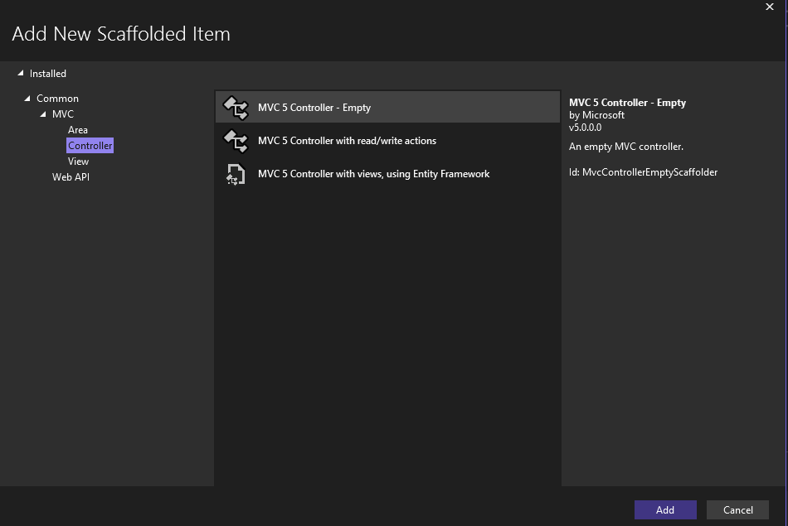 Choose Empty Controller and Add.

Give any Meaningful name

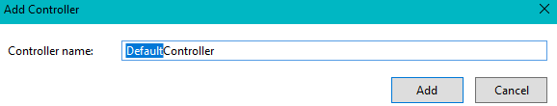

Now in this Controller We need to create our Model’s Object

Ex. Entities db = new Entities();

// Add require Namespaces and installed packages.

Then create Action Method for Login and create view for login method

Same for new user Registration

Create one more login method with post method, In this Action method we will check the user name and password whether true or not if true then we Redirect to another action method another Action we have to create is Logout Method.

(we use session for login and logout method)

Let’s talk about another action method.

First understand if user login successfully then we will let user use our application so here new picture comes for that we have to create one more Controller but this is for our main application after the login page.

Before Food Controller we have to add one class FoodInfo(any name) that has same fields what we have to display or our Api Contains.



Add Food Controller



In new Food Controller

Create ActionResult method GetFoodInfo and create view for it.

Create one more ActionResult GetFoodInfo but Post type, via this post method we will fetch and view desire output based on what user entered. (we created view for all the action method)…….

**For Cunsume API**

HttpResponseMessage response = await client.GetAsync($"https://api.edamam.com/api/nutrition-data?app_id=68f57d61&app_key=%207a5f77e09863df370a83b7523d9c6c90&nutrition-type=cooking&ingr={num}%20{unit}%20{name}");

Num: num is like variable where we store Quantity of the Food.

Unit: unit is like variable where we store unit of the Food.

Name: name is like variable where we store Name of the Food.

For Consuming Api We have to use method to get data from api.

--------------------------Method for getting Api Data--------------------------

using System;

using System.Collections.Generic;

using System.Linq;

using System.Web;

namespace consumeAPI_SUN.Models

{

public class Nutrient

{

public string Label { get; set; }

public double Quantity { get; set; }

public string Unit { get; set; }

}

public class ParsedIngredient

{

public double Quantity { get; set; }

public string Measure { get; set; }

public string FoodMatch { get; set; }

public string Food { get; set; }

}

public class IngredientSection

{

public List<ParsedIngredient> Parsed { get; set; }

}

public class FoodInfo

{

public int Qty { get; set; }

public string Unit { get; set; }

public string text { get; set; }

public double calories { get; set; }

public double Weight { get; set; }

public double totalWeight { get; set; }

public Dictionary<string, Nutrient> TotalNutrients { get; set; }

public double Magnesium { get; set; }

public double MG { get; set; }

public float calcium { get; set; }

public List<IngredientSection> Ingredients { get; set; }

}

}

-----------------------------------------------------------------------------------

Once we Successfully consume api then create user-friendly interface .

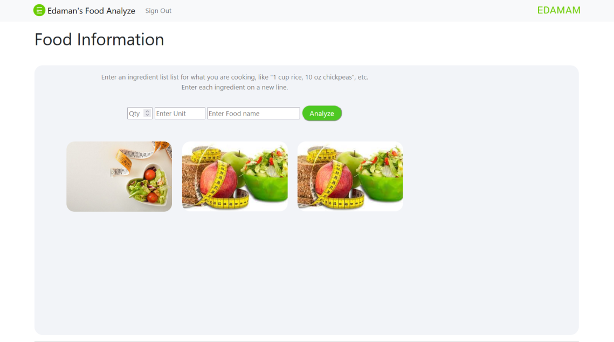

When I click on Analyze after filling value I get.

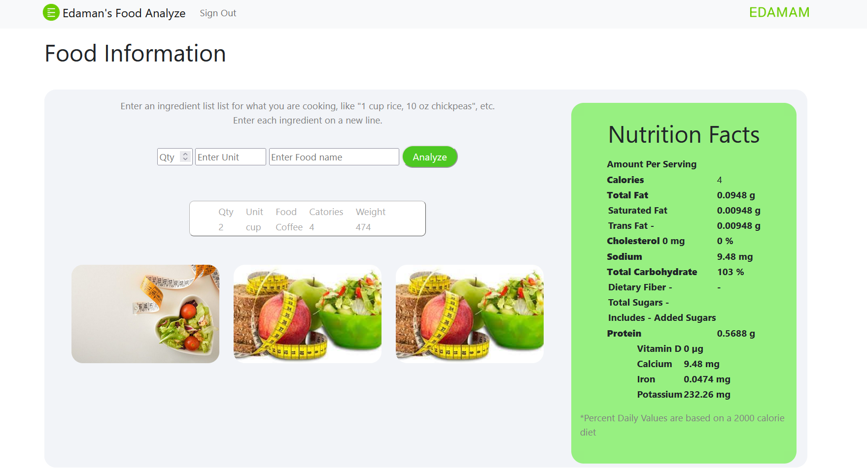

END…