**About: The Prink**

We are a startup in Gifting Industry launched in March 2020, operating from Trichy, Tamilnadu, India. Our prime product is **Prink Bomb** pop up greeting card along with other customized gifts. We currently host our website in Shopify. We wanted to add more customization and features to our website.

Website: [www.theprink.in](http://www.theprink.in)

Every product of ours is customizable and so users need to upload their photos for customization.

**Requirements**

We want to build a module where users can choose a photo from photo gallery, that is Pre-uploaded pictures which will have many categories like Birthday wishes, Mother’s Day wishes etc. (Fig3: attached below for reference). And so either a user can upload a photo or select a photo from photo gallery or insert a message.

Once the photos are uploaded/selected from the photo gallery, user should be able to preview their final product output. User interface should be easy enough to edit the pictures.

Each product will have different product output.

Sample products are Customized mug, Photo frame, Clock..etc.

**Example requirement flow:** Prink Bomb Single

About the Product – Prink Bomb Single

It is a customized pop up cube, where users can customize 4 sides of the cube. It comes with 3 variants – Prink Bomb Single (1 Cube), Prink Bomb Trio (3 cubes) & Prink Super Bomb (9 cubes)

Fig 1: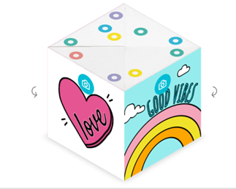 Fig 2: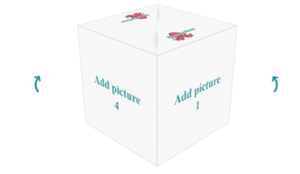

Fig 3: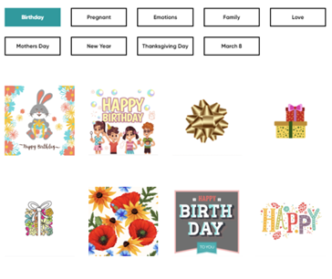

1. When a user selects “Add to cart” option, they should be re-directed to a page where they can upload photos to the sides of the cubes (Attached above Fig1 and Fig2 for reference). User should be able to rotate a cube and customize each sides of the cube (4 sides, excluding top & bottom) by one of the below methods

* Upload multiple pictures at the same time from local (PC/Mobile/Tablet)
* Select a photo from photo gallery or Add text/message to the sides of the cubes instead of photos.
* User should able to upload directly from Facebook / Instagram. [ If they choose this option, social login should be enabled & a profile should have been created. (This feature isn’t mandatory for this requirement) ]
* Users must be able to see their uploaded photos during and after their shopping in cube shape at the checkout.
* Uploaded photos must be retained if users exits or refreshes the page and visits again.

**Note:**

* Since cube’s dimension is 1:1 in ratio. If uploaded photo is in different dimension, then by default they must be only able to choose a portion of their upload photos to make it 1:1 (by zooming In/Out). Therefore uploaded photo’s dimension will always be 1:1.
* User must be able to move to next page only when all the mandatory uploads are done.

For Prink Bomb Single – 1 cube & 4 Pictures are mandatory

For Prink Bomb Trio – 3 cubes & 12 Pictures are mandatory

For Prink Super Bomb – 9 cubes & 20/36 Pictures are mandatory

In the back end, we should be able to access photos of each order and abandoned cart with order number & email id/Phone number.

This module should be integrated well with the other apps in shopify.

This sample is for one product, we need to use this same feature for some more products as well with little variations in user interface.

Sample competitor website - <https://gb.boomber.com/product/cube-trio/constructor>

1. Would need themes where users should be able to sort the Products by occasion, price, type or relationship.
2. Should able to collect other details from the users during checkout. Example: WhatsApp number of buyer, Occasion of purchase, Details of the Sender.
3. Expected delivery date for all products - Small Value Box should be inserted near the product, where user can enter a pin-code to know the expected delivery date or a Select the delivery date. (for each pin codes we will share the data on number of days required).
4. Website should be optimized for Google SEO and need to decrease the loading time of it.
5. Any other suggestions to improve our website are welcome.
6. Need to include message and additional add to cart options like Gift wrap, Chocolate at checkout
7. [Requirement not confirmed yet] Users should be given options like in check box to send their images through WhatsApp option.

* For WhatsApp option - Once the order is placed we should send the sms, with the link to send photos in WhatsApp, where it will have both order number and the product name with default texts.

Ex:

Thank you for your order of ‘Prink Bomb’. Your order number is XXXXX. <https://theprink.in/Whatsapp/asdfs> Click on the above link to open WhatsApp and send 20 photos.

[Requirement not confirmed yet] Possibility to move the full store to mobile app

80% of our lifetime traffic is through mobile.