**Assignment – Week 2**

Azhar Harisandi

22320011

1. **Problems**
2. By using bisection method, find the root of the following functions:
$f\left(x\right)=x^{2}-3x-2$

$f\left(x\right)=x^{3}+x^{2}-3x-2$

3. By using numerical integration, find the area under the following curve

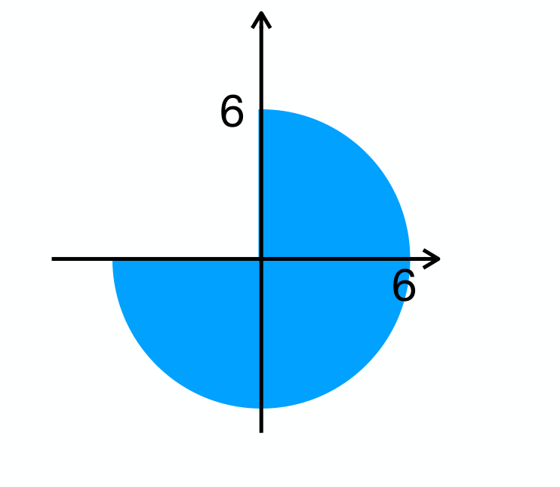

1. A ball at 1200K is allowed to cool down in air at an ambient temperature of 300K. Assuming heat is only due to radiation, the differential equation for the temperature of the ball is given by :
$$\frac{dθ}{dt}= -2.2067 ×{10}^{-12} \left(θ^{4}- 81×{10}^{9}\right); θ\left(0\right)=1200K$$

2. **Solutions**
3. Flowchart for bisection method

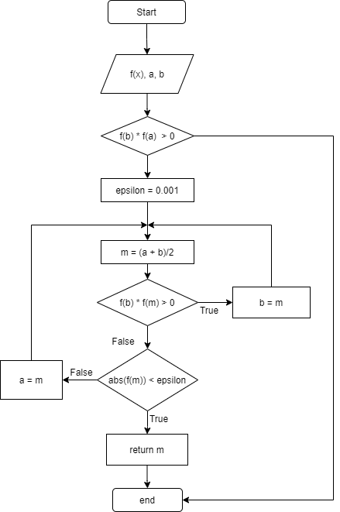

Code snippets for bisection method

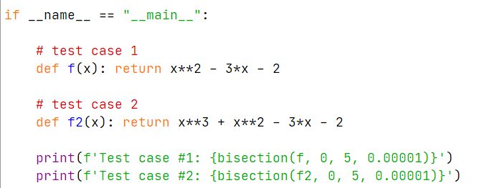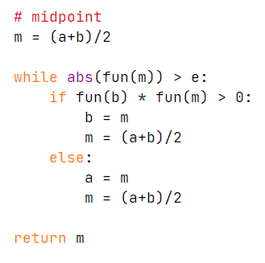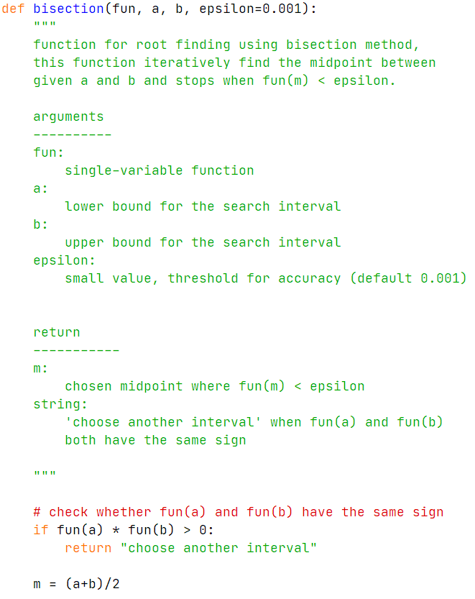

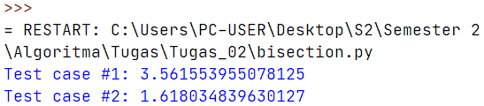

1. Parameterize the curve in terms of angle (from north)

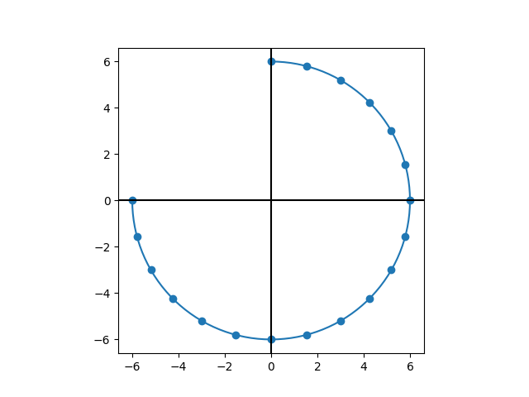

circle(t) = (x(t), y(t))

Where

x(t) = radius.sin(t)

y(t) = radius.cos(t)

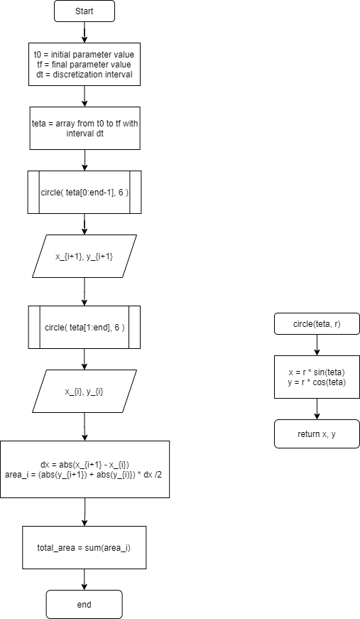Parametrized curve shown by continuous line, discretized interval (every 15 degree) shown in blue dots.

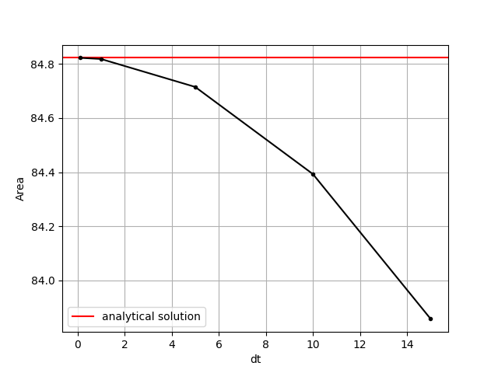

Comparison between analytical solution (red line) and various discretization interval (0.1, 1, 5, 10, 15)

Code snippets for numerical integration

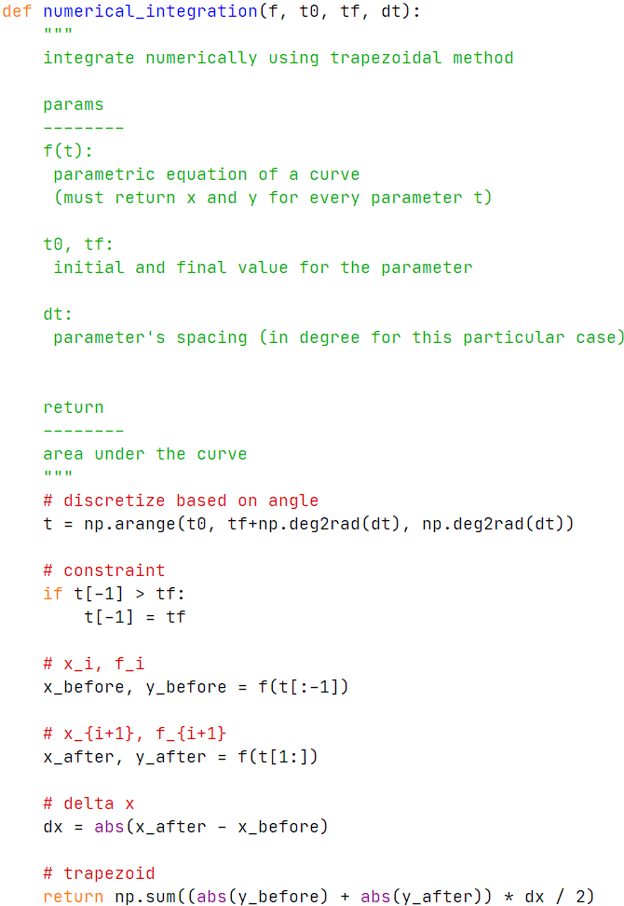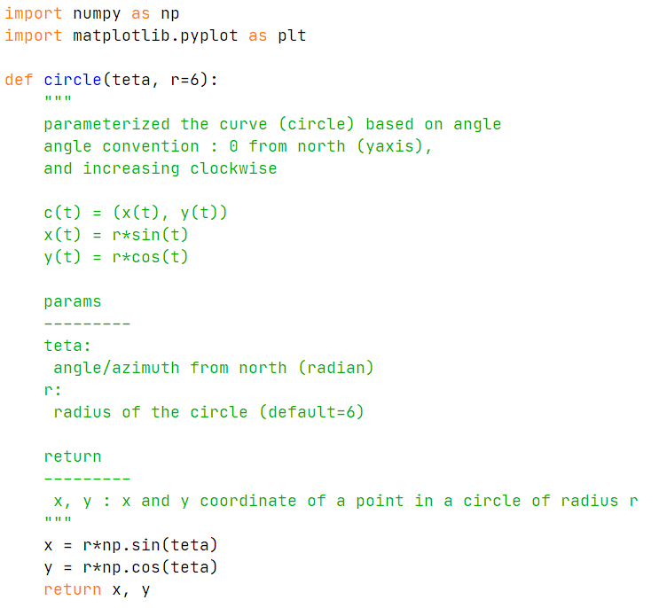

1. Runge-Kutta 4th order flowchart

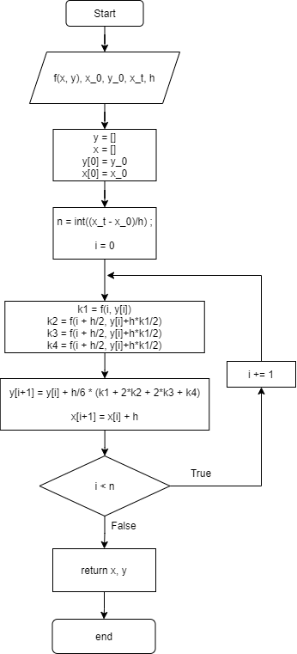

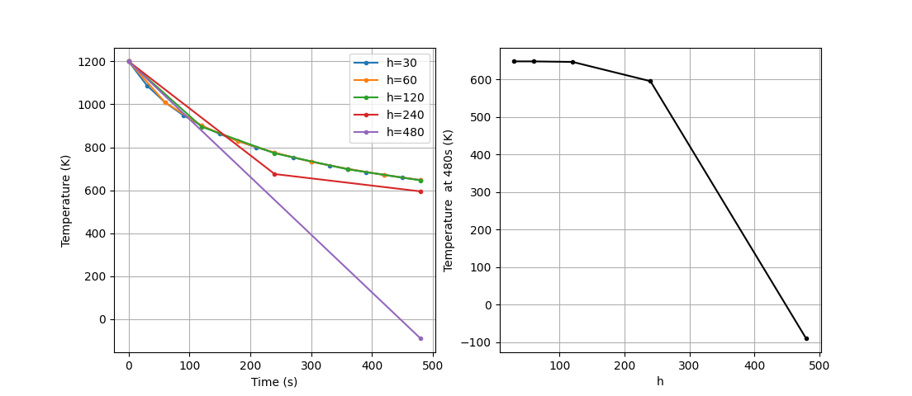Graph showing step size versus integration result

Code snippets

