**Assignment 3.2**

1. Execute code of MapReduce program

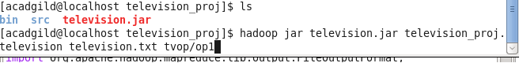

2 . Started Execution steps

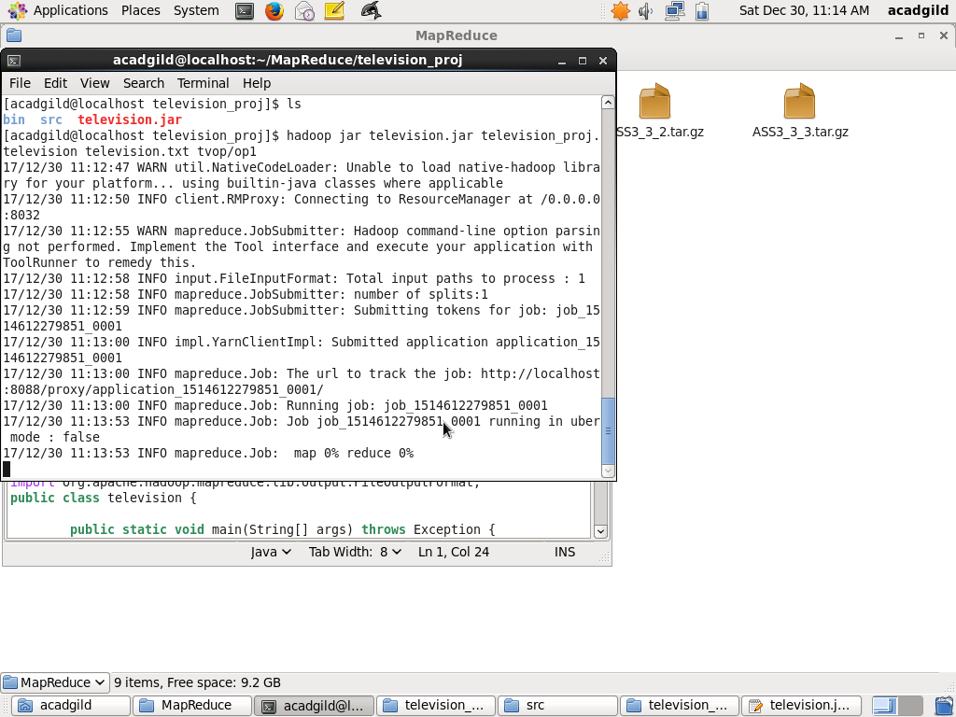

1. Result after execution steps completed:

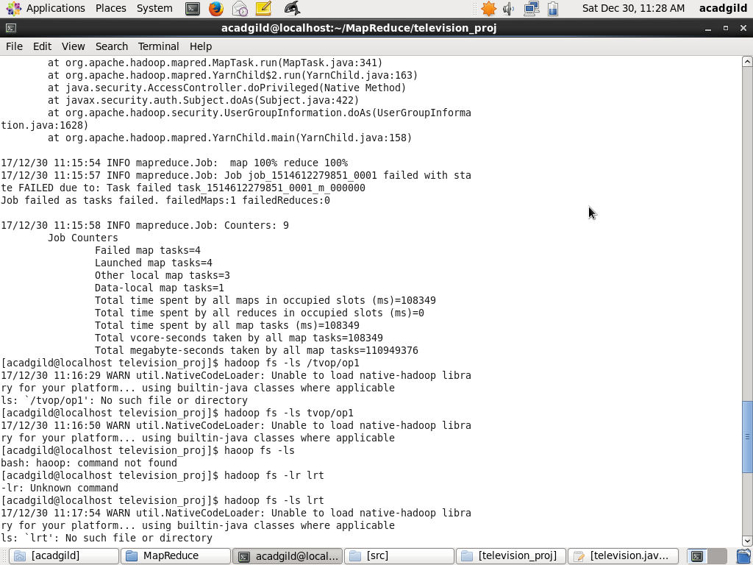

1. Output Folder tvop created:

