**Word-count pig program**

wordcount = LOAD 'WORD-COUNT.txt' AS (words:chararray);

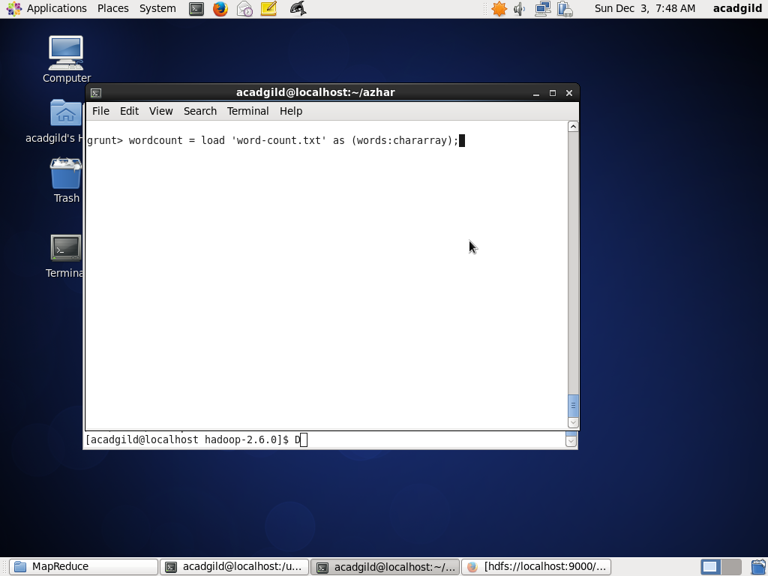

cwords = FOREACH wordcount GENERATE FLATTEN(TOKENIZE(words)) as c_words;

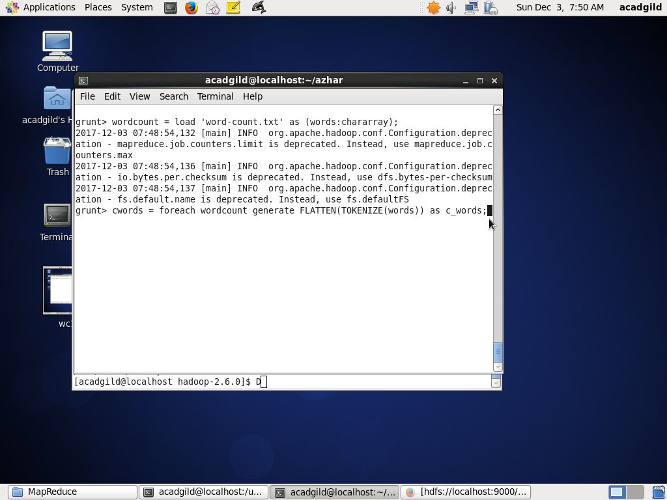

grp_words = GROUP cwords ALL;

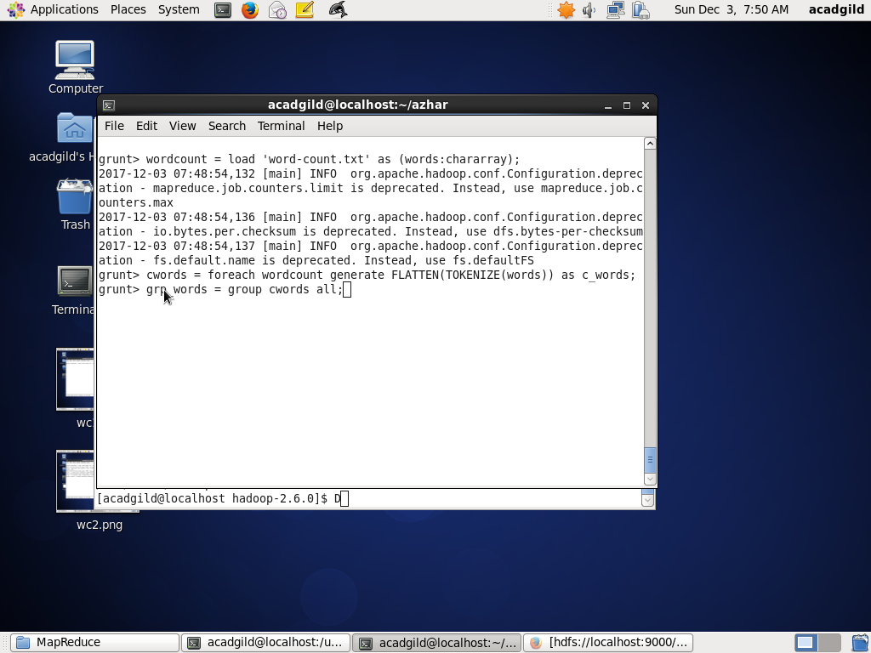

count_words = FOREACH grp_words GENERATE COUNT(cwords.c_words) as count;

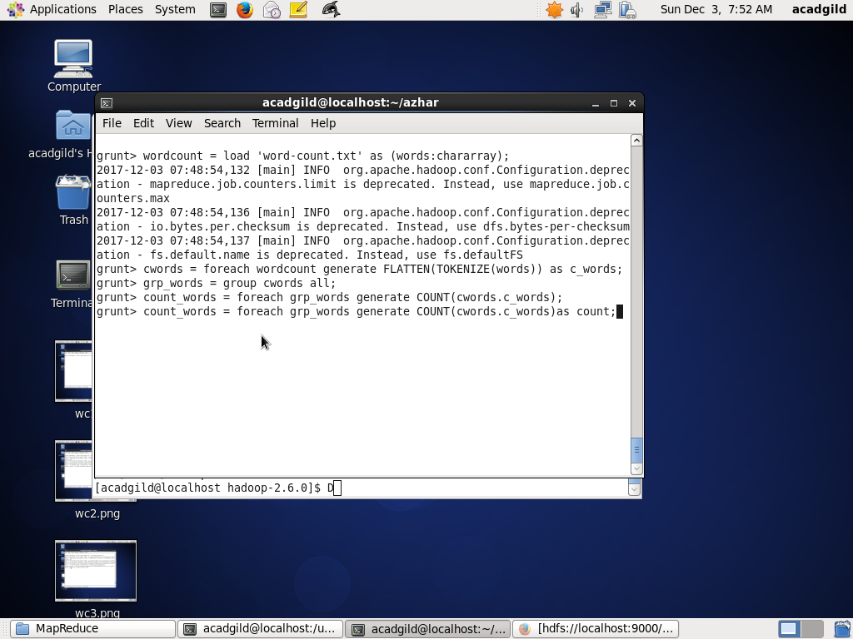

DUMP count_words;

