**Assignment 5.1:**

We have employee_details and employee_expenses files. Use local mode while running Pig and

write Pig Latin script to get below results:

https://github.com/prateekATacadgild/DatasetsForCognizant/blob/master/employee_details.t

xt

https://github.com/prateekATacadgild/DatasetsForCognizant/blob/master/employee_expense

s.txt

(a) Top 5 employees (employee id and employee name) with highest rating. (In case two

employees have same rating, employee with name coming first in dictionary should get

preference)

**Solution:**

emp1 = load 'emp_det.txt' USING PigStorage(',') AS (empid:int , empname:chararray, empsal: int, emprat: int);

order_emp1= order emp1 by emprat,empname;

limit_emp1 = limit order_emp1 5;

out_emp1 = foreach limit_emp1 generate empid,empname;

store out_emp1 into 'output_ass5.1.1';

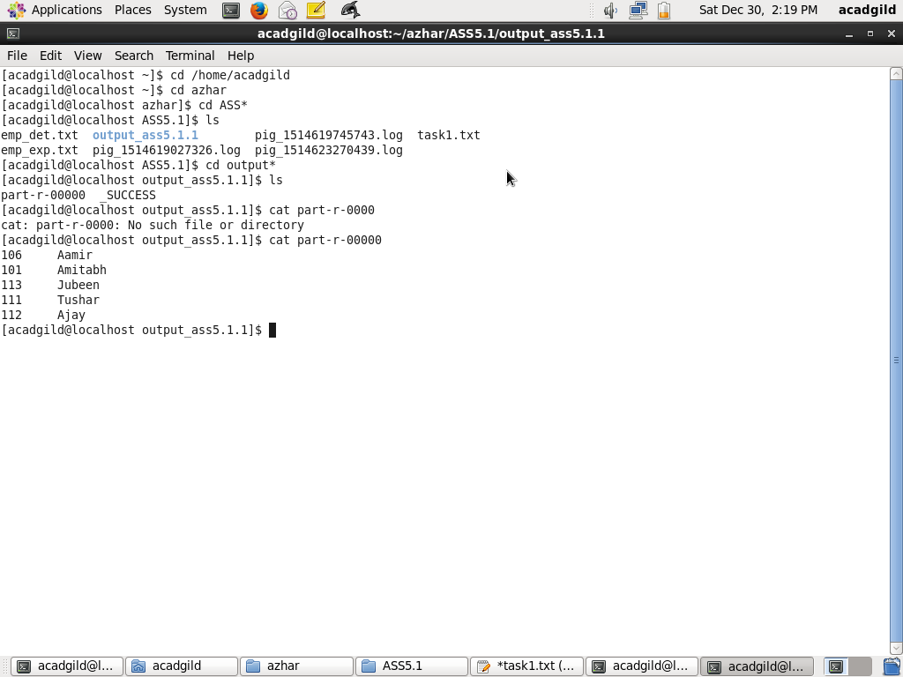

(b) Top 3 employees (employee id and employee name) with highest salary, whose employee id

is an odd number. (In case two employees have same salary, employee with name coming first

in dictionary should get preference)

**Solution:**

emp1 = load 'emp_det.txt' USING PigStorage(',') AS (empid:int , empname:chararray, empsal: int, emprat: int);

order_emp1_sal= order emp1 by empsal desc,empname;

fil_emp1 = filter order_emp1_sal by empid%2 > 0;

lim_emp1_sal = limit fil_emp1 3;

ans_emp1_sal = foreach lim_emp1_sal generate empid,empname;

store ans_emp1_sal into 'ASS5.1.2';

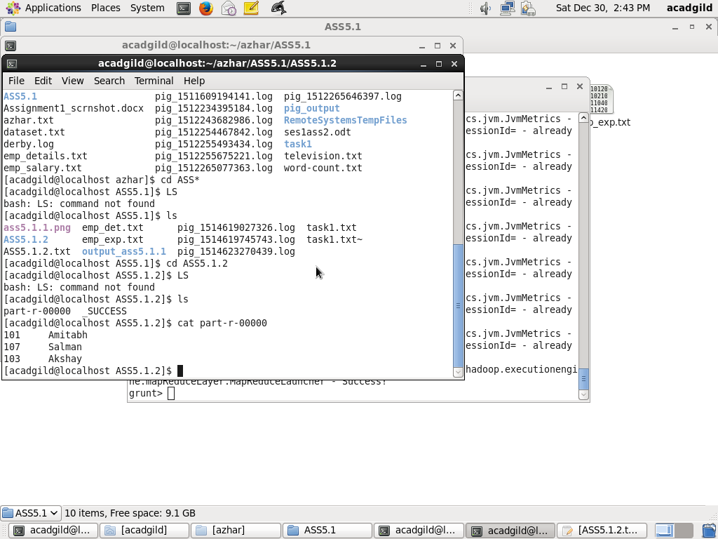

(c) Employee (employee id and employee name) with maximum expense (In case two

employees have same expense, employee with name coming first in dictionary should get

preference)

**Solution:**

emp1 = load 'emp_det.txt' USING PigStorage(',') AS (empid:int , empname:chararray, empsal: int, emprat: int);

exp = load 'emp_exp.txt' USING PigStorage() AS (empid:int , empexp: int);

join_emp_exp = join emp1 by empid,exp by empid;

ord_emp_exp = order join_emp_exp by exp::empexp desc,emp1::empname;

res_emp_exp = foreach ord_emp_exp generate emp1::empid,emp1::empname;

store res_emp_exp into 'ASS5.1.3';

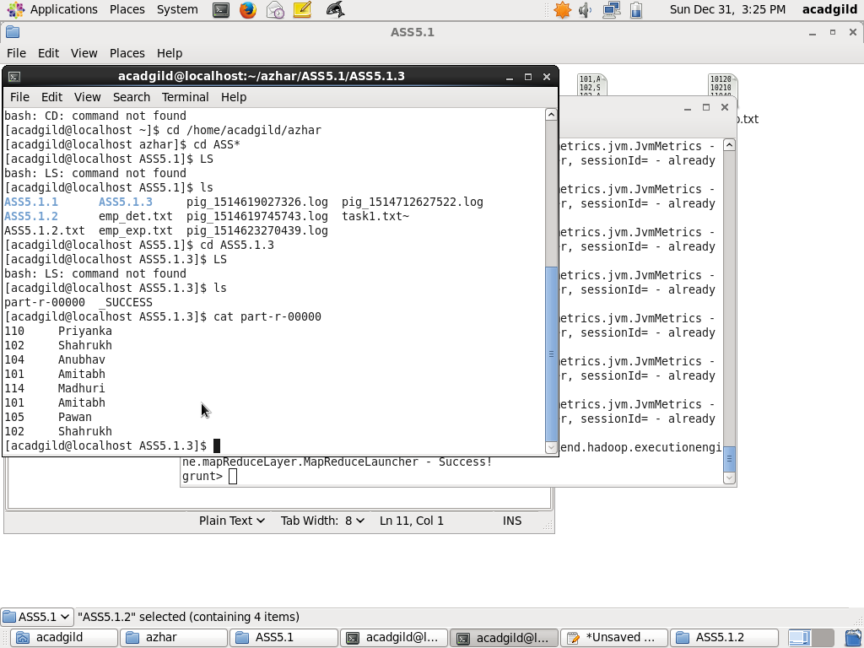

(d) List of employees (employee id and employee name) having entries in employee_expenses

file.

**Solution:**

emp1 = load 'emp_det.txt' USING PigStorage(',') AS (empid:int , empname:chararray, empsal: int, emprat: int);

exp = load 'emp_exp.txt' USING PigStorage() AS (empid:int , empexp: int);

join_emp_exp = join emp1 by empid,exp by empid;

store join_emp_exp into 'ASS5.1.4';

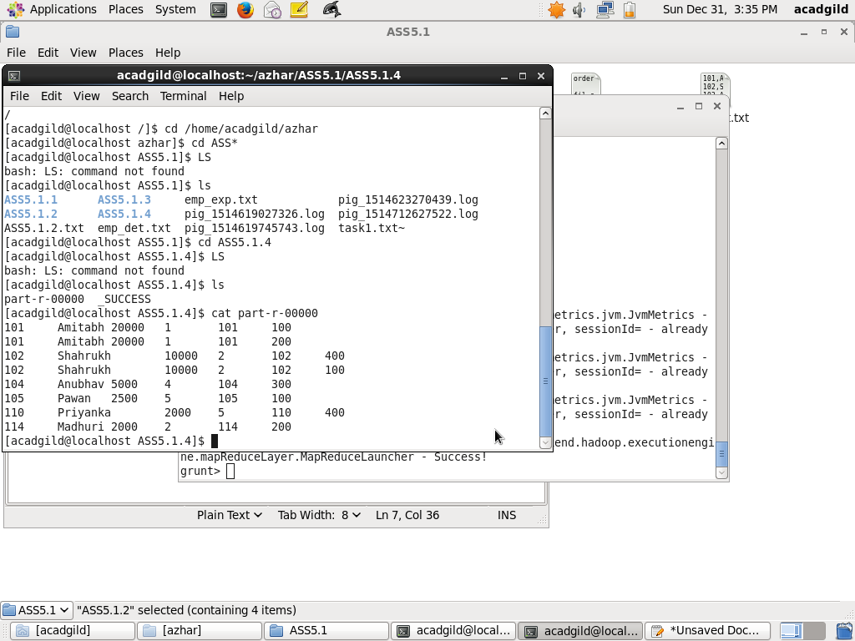

(e) List of employees (employee id and employee name) having no entry in employee_expenses

file.

**Solution:**

emp1 = load 'emp_det.txt' USING PigStorage(',') AS (empid:int , empname:chararray, empsal: int, emprat: int);

exp = load 'emp_exp.txt' USING PigStorage() AS (empid:int , empexp: chararray);

leftjoin_emp_exp = join emp1 by empid left,exp by empid;

fil_emp_exp = filter leftjoin_emp_exp by IsEmpty(exp::empexp);