ASS8.1

Get a list of employees who receive a salary less than 100, compared

to their immediate employee with higher salary in the same unit

select id,name,lead(salary) over (partition by dept order by salary) as salary,dept from empdet where salary<100;

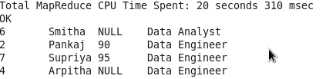

• List of all employees who draw higher salary than the average salary

of that department

