**Project 1.2 - State-Wise Development Analysis in India**

Contents

1. Project Overview ................................................................................................................................... 2

2. Product/Service Description ................................................................................................................. 2

2.1 Assumptions ........................................................................................................................................ 2

2.2 Constraints .......................................................................................................................................... 2

3. Requirements ........................................................................................................................................ 2

4. Dataset .................................................................................................................................................. 2

5. Problem statement ............................................................................................................................... 2

Problem Statement1 - Find out the districts who achieved 100 percent objective in BPL cards Export the results to mysql using sqoop......................................................................................................................... 3

Task 1 – Place Dataset in the target using flume, ..................................................................................... 4

Task2 – Create folders in the HDFS to store the outputs, ........................................................................ 4

Task3 – Create Database and the Tables in the mysql ............................................................................. 5

Task4 - PIG query to process XML and store into PIG table ..................................................................... 6

Task5 – Find the districts who achieved 100 percent objective in BPL cards ........................................... 7

Task6 – Verifying the stored results in the HDFS ...................................................................................... 7

Task7 – Export the results into mysql using sqoop ................................................................................. 10

Task8 – verify the data exported to mysql ............................................................................................. 11

Problem statemet2 - Write a Pig UDF to filter the districts which have reached 80% of objectives of BPL cards. Export the results to MySQL using Sqoop. ....................................................................................... 13

Task1 – Create a PIG UDF using Java ...................................................................................................... 13

Task2 - Write PIG query to find out the districts who achieved 80 percent objective in BPL cards....... 14

Task3 – verify the result stored in the HDFS ........................................................................................... 14

Task4 – Export the results into mysql table using sqoop command, ..................................................... 23

Task5 – Verify the result in the mysql ..................................................................................................... 24

1. Project Overview

To develop the System to analyze the log data (In XML format) of government progress of various development activities.

1.1 Purpose and Scope of this Specification

The following requirement will be addressed in phase 1 of Project:

* • Developing system to handle the incoming log feed and store the information in HadoopCluster (Flume)
* • Analyze the data and understand the progress
* • Store the results in Hbase/RDBMS

Out of scope

We can use this data and visualization and get more insights

2. Product/Service Description

2.1 Assumptions

Log will be generated in XML format and stored in a server.

2.2 Constraints

Describe any item that will constrain the design options, including

* • This system may not be used for searching for now. But it will be used for analysis and saving the relevant information as of now.
* • System will be using mySql as a database

3. Requirements

* • The FLUME job which will format the data and place the data to HDFS
* • Pig/MapReduce job for parsing the XML data.
* • Create Pig scripts/MapReduce jobs to analyze the data
* • Create the Sqoop job to store the data in database

Priority Definitions

The following definitions are intended as a guideline to prioritize requirements.

* • **Priority 1** – Create FLUME job for fetching log files from spool directory the data
* • **Priority 2** – MapReduce/pig job to preprocess

4. Dataset

Download the dataset using the below link:

Link: https://drive.google.com/file/d/0Bxr27gVaXO5sUjd2RWFQS3hQQUE/view?usp=sharing

Refer the below steps to understand the actual steps to create the above project.

**Step 1:**

Copy dataset from local file system to HDFS using flume.

Note: use the conf file by downloading from below link.

filecopy.conf

**Command:**

***flume-ng agent –n agent1 –c conf –f <path to filecopy.conf>***

**Step 2:**

Input file is in the XML format use Map reduce or pig to parse the data and get the results for the below problem statements.

5. Problem statement

1. Find out the districts who achieved 100 percent objective in BPL cards Export the results to mysql using sqoop

2. Write a Pig UDF to filter the districts which have reached 80% of objectives of BPL cards. Export the results to MySQL using Sqoop.

**PROJECT EXECUTION**

Problem Statement1 - Find out the districts who achieved 100 percent objective in BPL cards Export the results to mysql using sqoop

Task 1 – Place Dataset in the target using flume

Place the flume config file provided at the location, **/home/acadgild/apache-flume-1.6.0-bin/conf**

Copy the dataset downloaded from the link from local file system to HDFS using flume using the below command,

***flume-ng agent -n agent1 -c conf -f /home/acadgild/apache-flume-1.6.0-bin/conf/filecopy.conf***

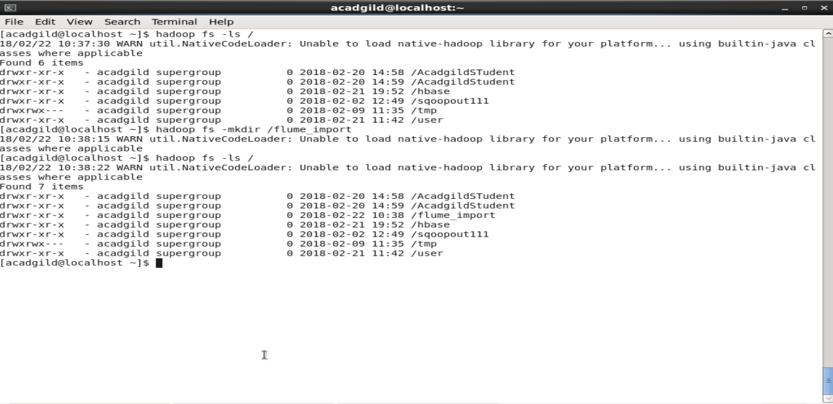

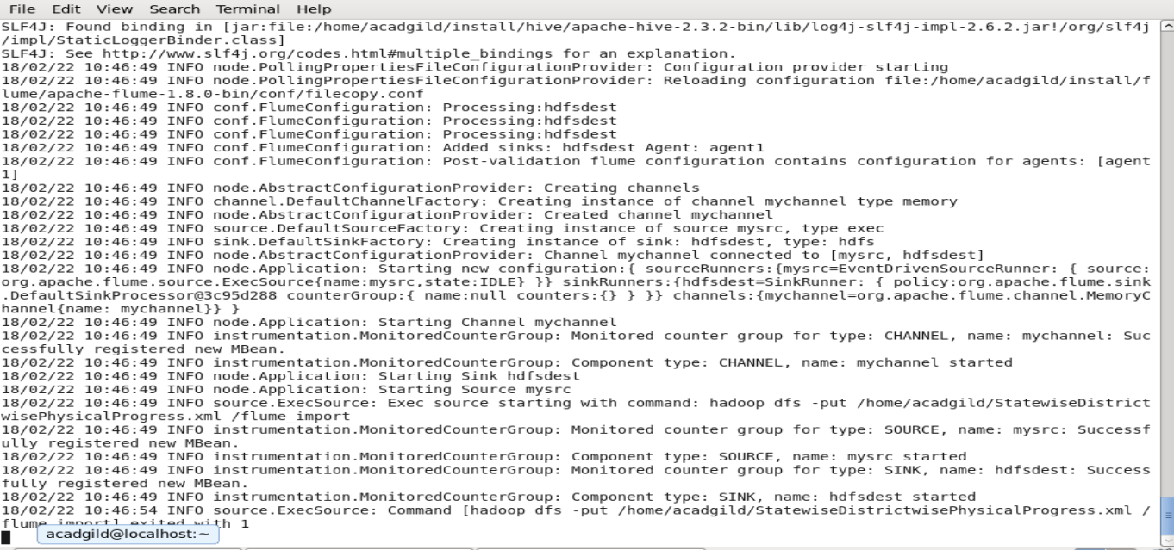

Verify whether the file is copied in the target,

***Hadoop fs –ls /flume_import***

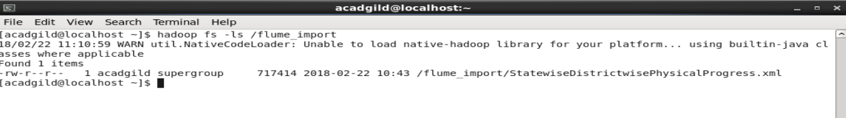

Task2 – Create folders in the HDFS to store the outputs,

Create 2 folders in the HDFS where we are going to store the output from PIG execution,

***hadoop fs -mkdir districts_100per_objectives***

***hadoop fs -mkdir districts_80per_objectives***

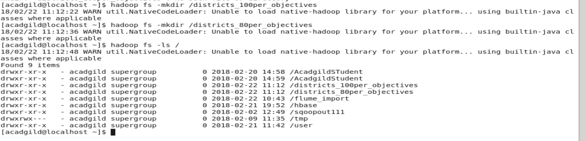

Task3 – Create Database and the Tables in the mysql

Start mysql> sudo service mysqld start

Login as root user,

***create database project_bpl_cards;***

***use project_bpl_cards;***

***create table districts_100percent_objective (district_name varchar(50));***

***create table districts_80percent_objective (district_name varchar(50));***

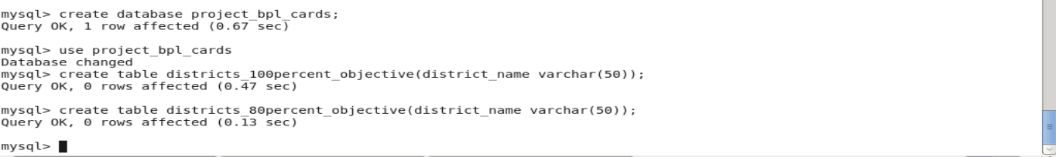

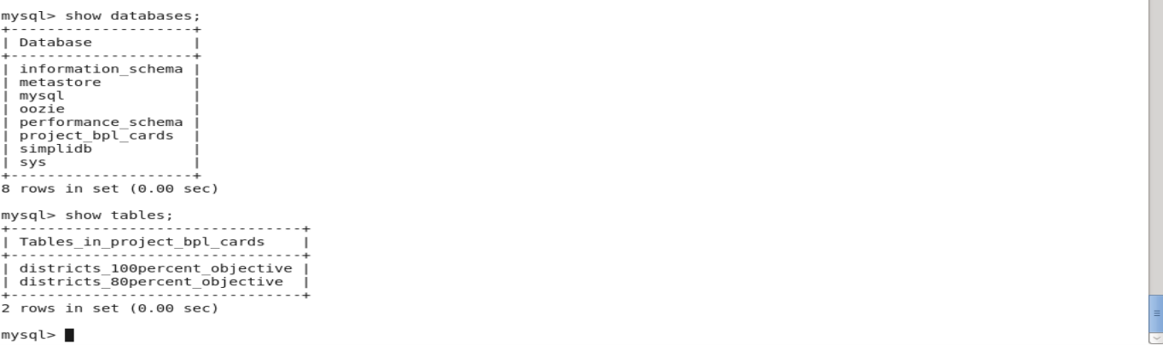

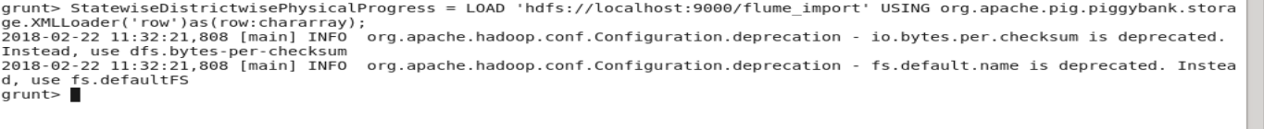

Task4 - PIG query to process XML and store into PIG table

In this section we are going to Load data from HDFS to PIG alias ***StatewiseDistrictwisePhysicalProgress*** using below query:

**PIG Queries,**

***DEFINE XPath org.apache.pig.piggybank.evaluation.xml.XPath;***

***StatewiseDistrictwisePhysicalProgress = LOAD 'hdfs://localhost:9000/flume_import' USING org.apache.pig.piggybank.storage.XMLLoader('row') as (row:chararray);***

Next, iterate over each row and load into alias ***StatewiseDistrictwisePhysicalProgress*** which has schema fields same as XML schema hyphen (-) are replaced with underscore (_)

***PhysicalProgress = FOREACH StatewiseDistrictwisePhysicalProgress GENERATE XPath(row, 'row/State_Name') AS State_name,***

***XPath(row, 'row/District_Name') AS District_name,***

***XPath(row, 'row/Project_Objectives_IHHL_BPL') AS Project_Objectives_IHHL_BPL,***

***XPath(row, 'row/Project_Objectives_IHHL_APL') AS Project_Objectives_IHHL_APL,***

***XPath(row, 'row/Project_Objectives_IHHL_TOTAL') AS Project_Objectives_IHHL_TOTAL,***

***XPath(row, 'row/Project_Objectives_SCW') AS Project_Objectives_SCW,***

***XPath(row, 'row/Project_Objectives_Anganwadi_Toilets') AS Project_Objectives_Anganwadi_Toilets,***

***XPath(row, 'row/Project_Objectives_RSM') AS Project_Objectives_RSM,***

***XPath(row, 'row/Project_Objectives_PC') AS Project_Objectives_PC,***

***XPath(row, 'row/Project_Performance-IHHL_BPL') AS Project_Performance_IHHL_BPL,***

***XPath(row, 'row/Project_Performance-IHHL_APL') AS Project_Performance_IHHL_APL,***

***XPath(row, 'row/Project_Performance-IHHL_TOTAL') AS Project_Performance_IHHL_TOTAL,***

***XPath(row, 'row/Project_Performance-SCW') AS Project_Performance_SCW,***

***XPath(row, 'row/Project_Performance-School_Toilets') AS Project_Performance_School_Toilets,***

***XPath(row, 'row/Project_Performance-Anganwadi_Toilets') AS Project_Performance_Anganwadi_Toilets,***

***XPath(row, 'row/Project_Performance-RSM') AS Project_Performance_RSM,***

***XPath(row, 'row/Project_Performance-PC') AS Project_Performance_PC;***

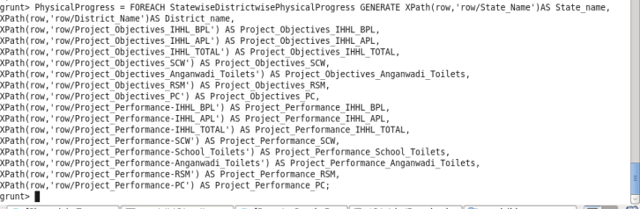

**Task5 – Find the districts who achieved 100 percent objective in BPL cards**

Filter the records by ***Project_Objectives_IHHL_BPL*** is equal to ***Project_Performance_IHHL_BPL***

***PhysicalProgress_100_percentage_bpl = FILTER PhysicalProgress BY Project_Objectives_IHHL_BPL == Project_Performance_IHHL_BPL;***

Select only District_Name column,

***districts_100_percentage_bpl = FOREACH PhysicalProgress_100_percentage_bpl GENERATE District_name;***

Now store the data we received from the PIG alias ***districts_100_percentage_bpl*** into the HDFS location where we created at the Task2

***STORE districts_100_percentage_bpl INTO 'hdfs://localhost:9000/districts_100per_objectives';***

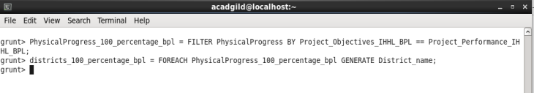

**Task6 – Verifying the stored results in the HDFS**

***hadoop fs -ls /districts_100per_objectives***

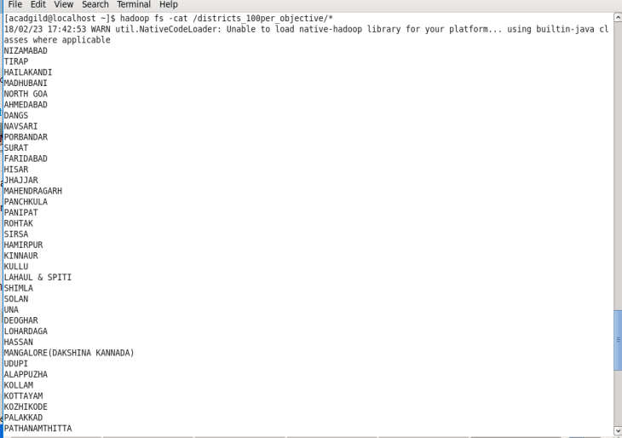

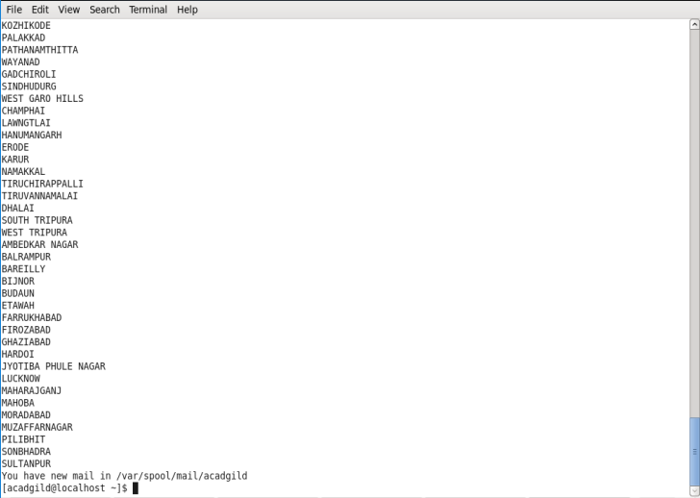

**Task7 – Export the results into mysql using sqoop**

Sqoop command to export,

***sqoop export --connect jdbc:mysql://localhost/project_bpl_cards --username root --password acadgild --table districts_100percent_objective --export-dir '/districts_100per_objectives' --input-fields-terminated-by ',' -m1 --columns district_name***

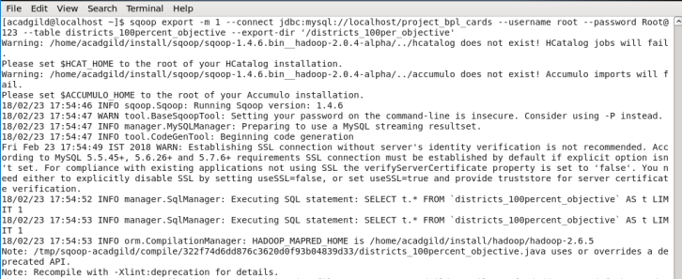

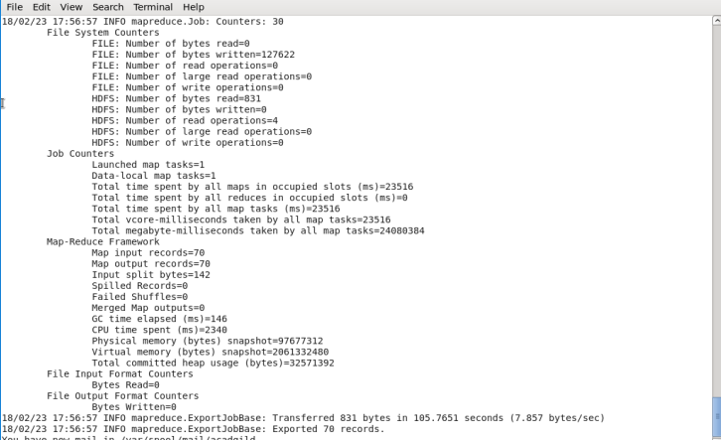

**Task8 – verify the data exported to mysql**

Use the following command in mysql to verify results in mysql

***Select COUNT( district_name) FROM districts_100percent_objective;***

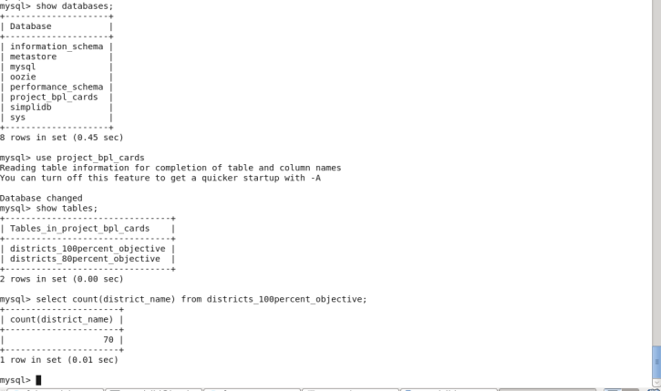

***select * from districts_100percent_objective;***

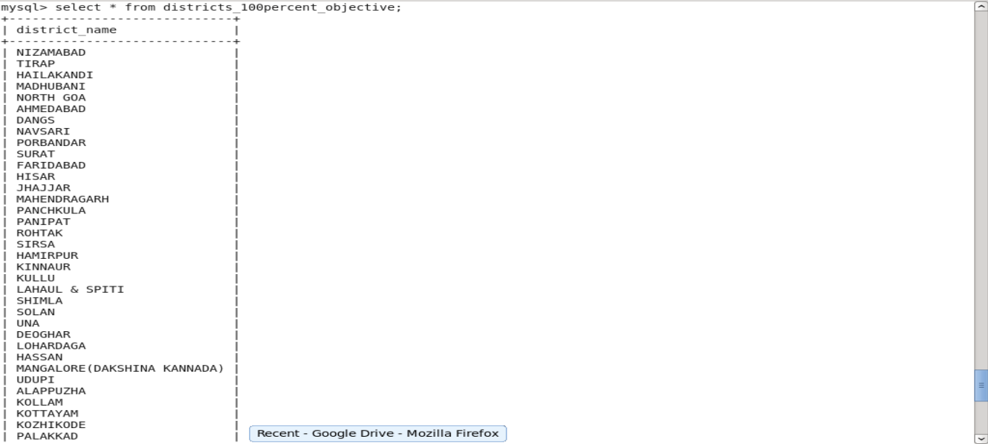

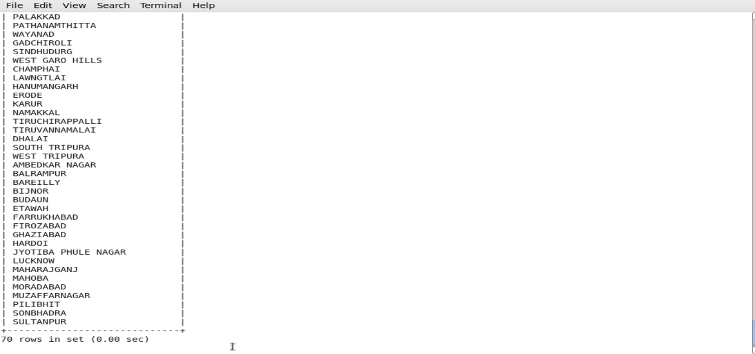

Thus, as per the problem statement 1, we have successfully exported the result from HDFS to mysql database **project_bpl_cards** and into the table **districts_100percent_objective.**

**Problem statemet2 - Write a Pig UDF to filter the districts which have reached 80% of objectives of BPL cards. Export the results to MySQL using Sqoop.**

**Task1 – Create a PIG UDF using Java**

Write a Java class **StateAnalysis** in eclipse which will filter those tuples for which 80 percent objective in BPL cards are achieved. The logic put in exec method is value of **Project_Performance_IHHL_BPL** is equal to more than 80% of **Project_Objectives_IHHL_BPL.**

Java Code

**package StateAnalysis;**

**import java.io.IOException;**

**import org.apache.pig.FilterFunc;**

**import org.apache.pig.backend.executionengine.ExecException;**

**import org.apache.pig.data.Tuple;**

**public class** StateAnalysis **extends** FilterFunc

{

@Override

**public** Boolean exec(Tuple input) **throws** IOException

{

try

{

**if**(input == **null** || input.size() == 0)

{

return false;

}

Object valueTuple = input.get(0);

**if** (valueTuple **instanceof** Tuple)

{

Object value1 = ((Tuple) valueTuple).get(0);

Object value2 = ((Tuple) valueTuple).get(1);

**long** objective_value = Long.*valueOf*((String) value1);

**long** performance_value = Long.*valueOf*((String) value2);

**if**(performance_value>objective_value*80/100)

{

return true;

}

}

}

catch(ExecException ee)

{

throw ee;

}

return false;

}

}

Compile this project and Export the project as .jar file to the acadgild local file system. Here we named the jar file as ***Statewise.jar.***

Task2 - Write PIG query to find out the districts who achieved 80 percent objective in BPL cards

***REGISTER /home/acadgild/azhar/Project2.jar;***

Next, using the UDF filter those tuple for which **Project_Performance_IHHL_BPL** is equal to more than 80% of **Project_Objectives_IHHL_BPL**

***physicalprogress_80_per_bpl = FILTER PhysicalProgress BY StateAnalysis.StateAnalysis(TOTUPLE(Project_Objectives_IHHL_BPL, Project_Performance_IHHL_BPL));***

Next, select only **District_Name** field using command below:

***district_80_percent_bpl = FOREACH physicalprogress_80_per_bpl GENERATE District_Name;***

Now store the data we received from the PIG alias ***district_80_percent_bpl*** into the HDFS location where we created at the Task2

***STORE district_80_percent_bpl INTO 'hdfs://localhost:9000/districts_having_80percent_objectives';***



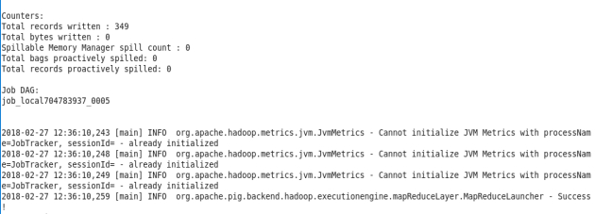

Task3 – verify the result stored in the HDFS

The following command shows that folders are created under districts_having_100percent_objectives,

***hadoop fs -ls / districts_80per_objectives***

***hadoop fs –ls / districts_80per_objectives/part-m-00000***

The output file has been generated in the HDFS location,

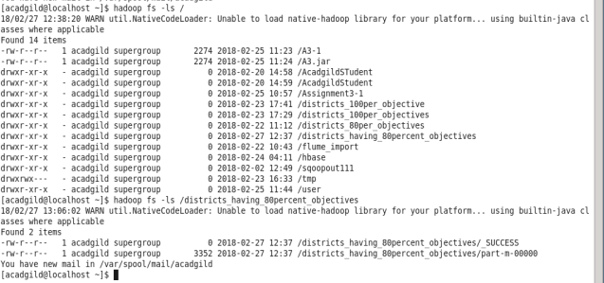

***hadoop fs -cat /districts_80per_objectives/\****

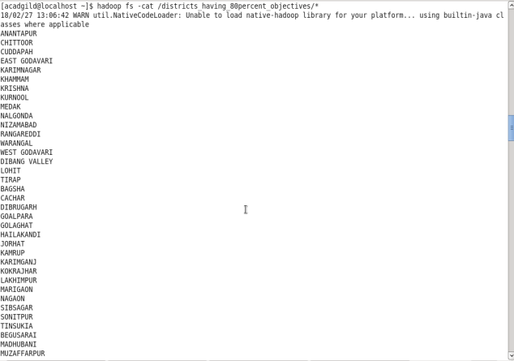

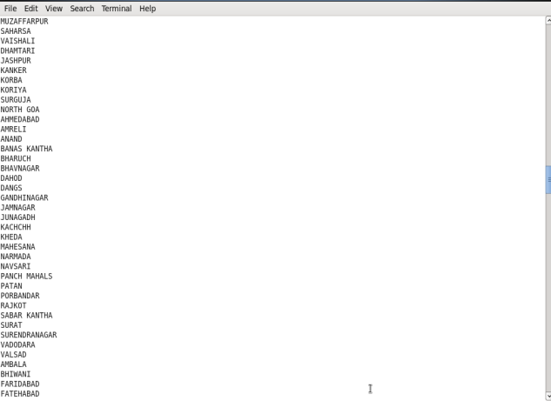

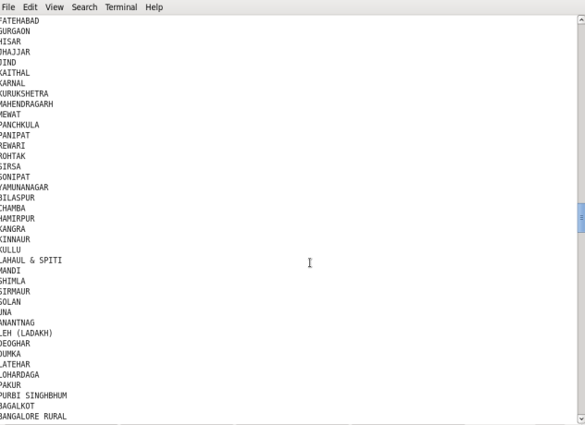

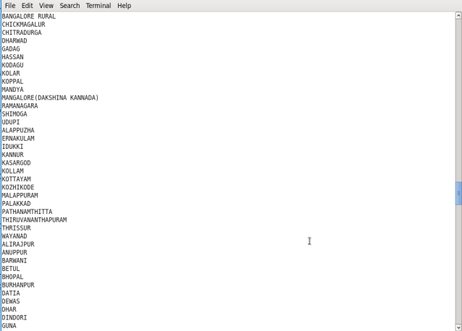

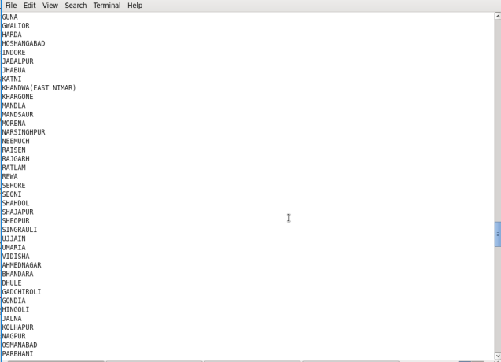

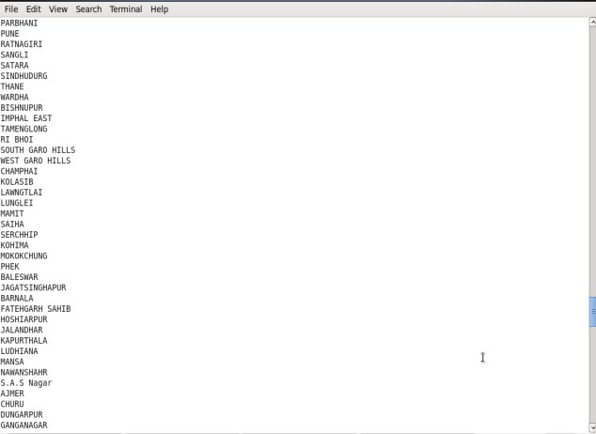

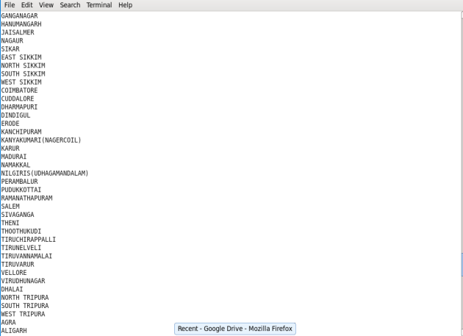

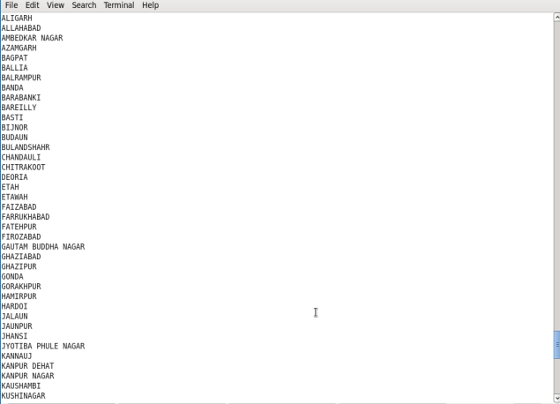

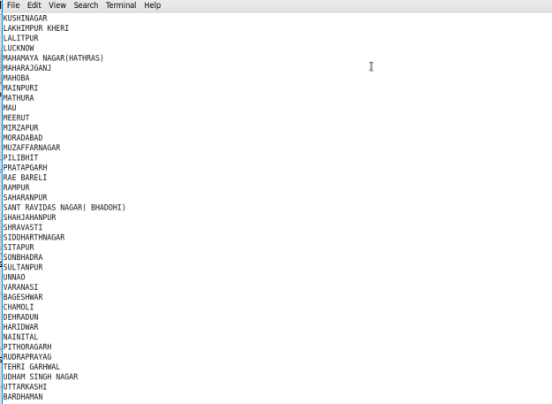

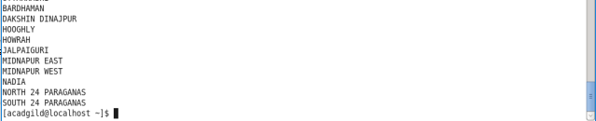

Task4 – Export the results into mysql table using sqoop command

In this task we are going use the sqoop to export the desired output stored in the HDFS location **hdfs://localhost:9000/districts_having_80percent_objectives** to the mysql table **districts_having_80percent_objectives** we created in the database **project_bpl_cards**

Sqoop command,

***sqoop export –m 1 --connect jdbc:mysql://localhost/*project_bpl_cards *--username root --password Root@123 --table* districts_80percent_objective *--export-dir '/districts_having_80per_objectives' ;***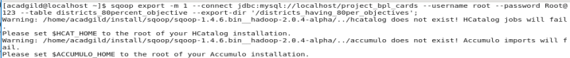

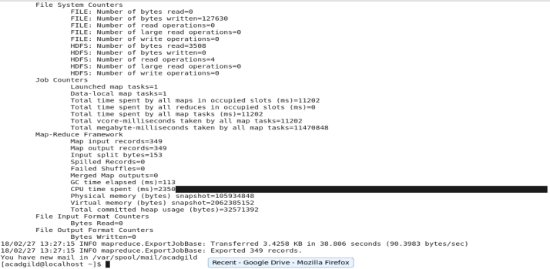

Task5 – Verify the result in the mysql

***Select COUNT( district_name) FROM districts_80percent_objective;***

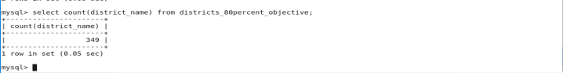

Now, verify the data present in the table

***Select * from districts_80percent_objective;***

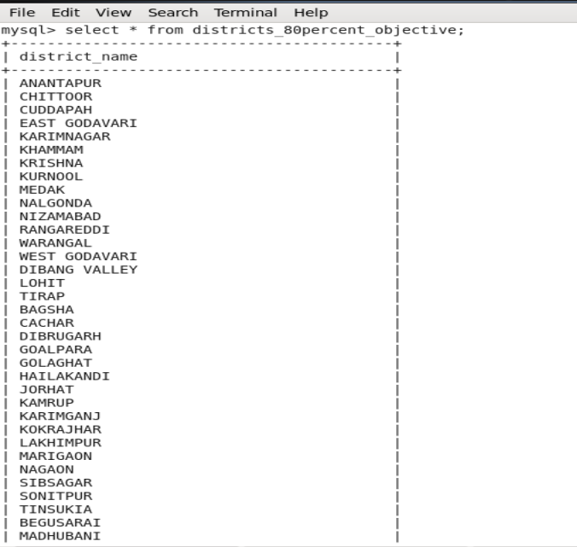

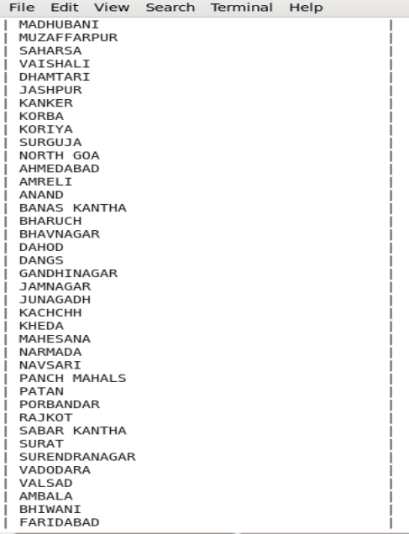

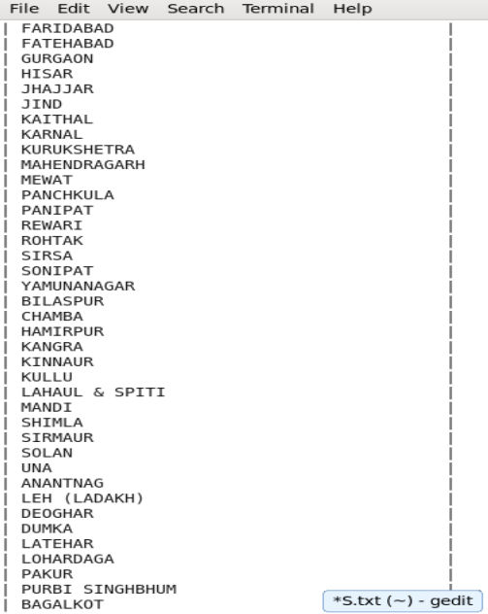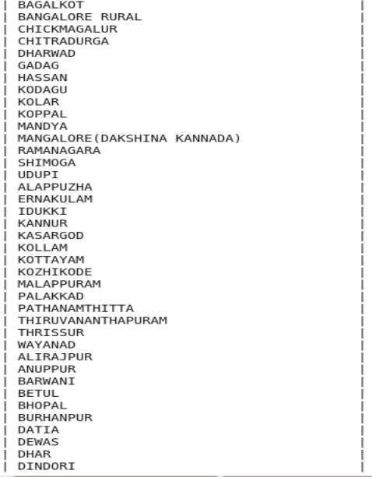

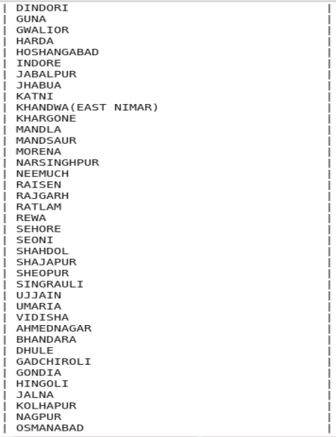

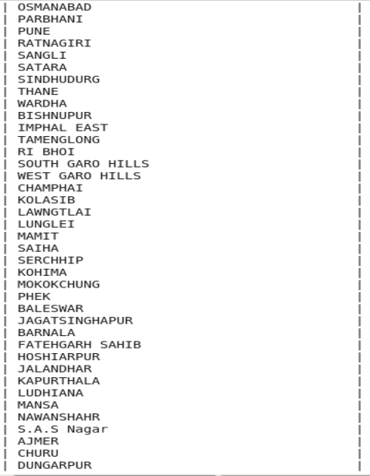

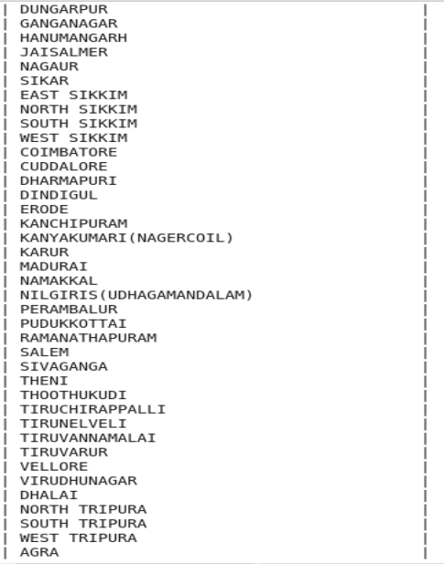

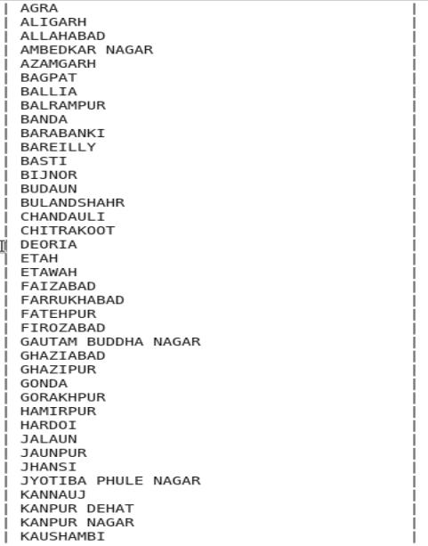

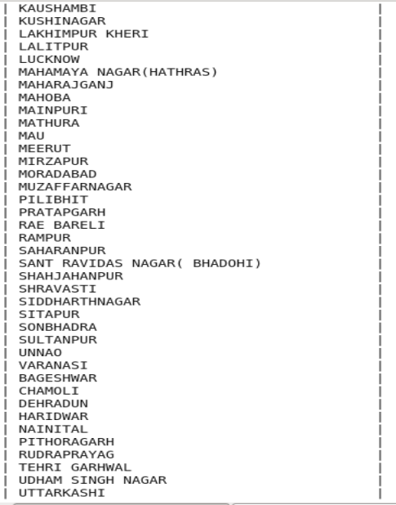

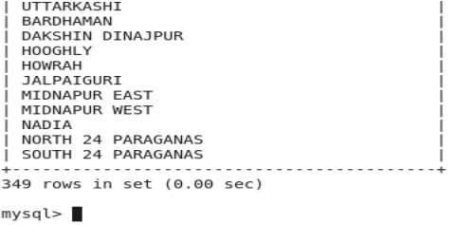

Hence, using PIG UDF we have got the required result and stored into the **mysql** table using **sqoop** commands.