**Pre-tool installations:**

**Account to open:**

1. **Github account:** How to open show here,
2. **AWS Account:**  Create an AWS Free tier Account.

**STEP 01:**  
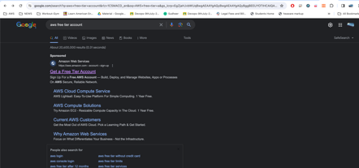

**STEP 02:**

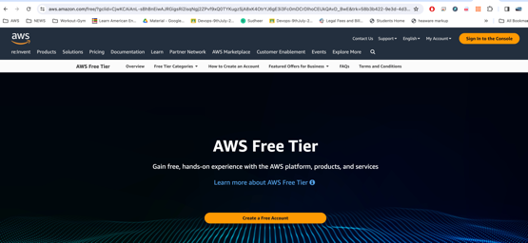

AWS Account creation:

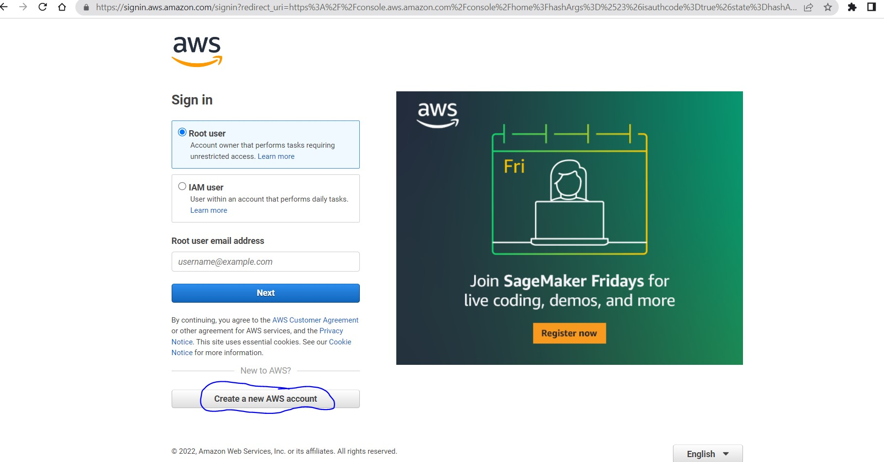

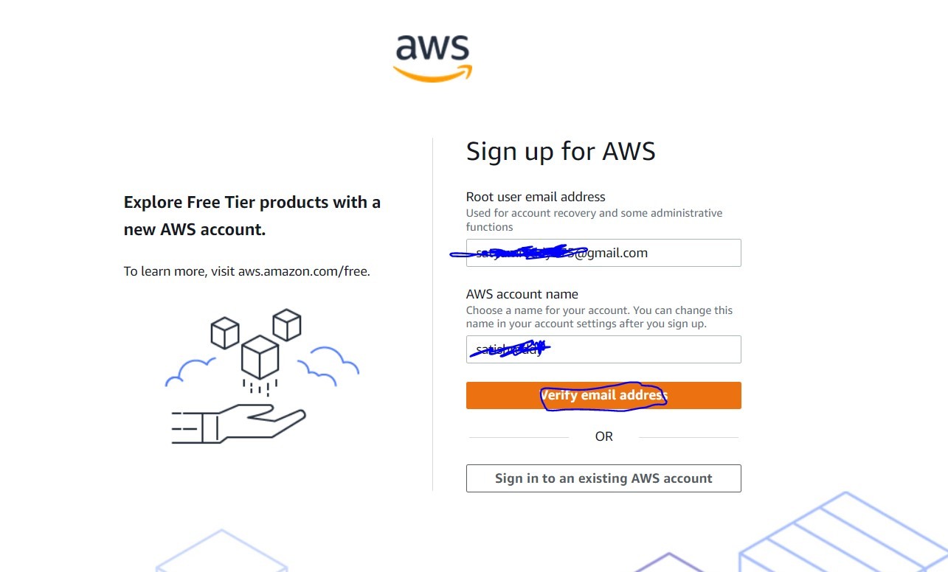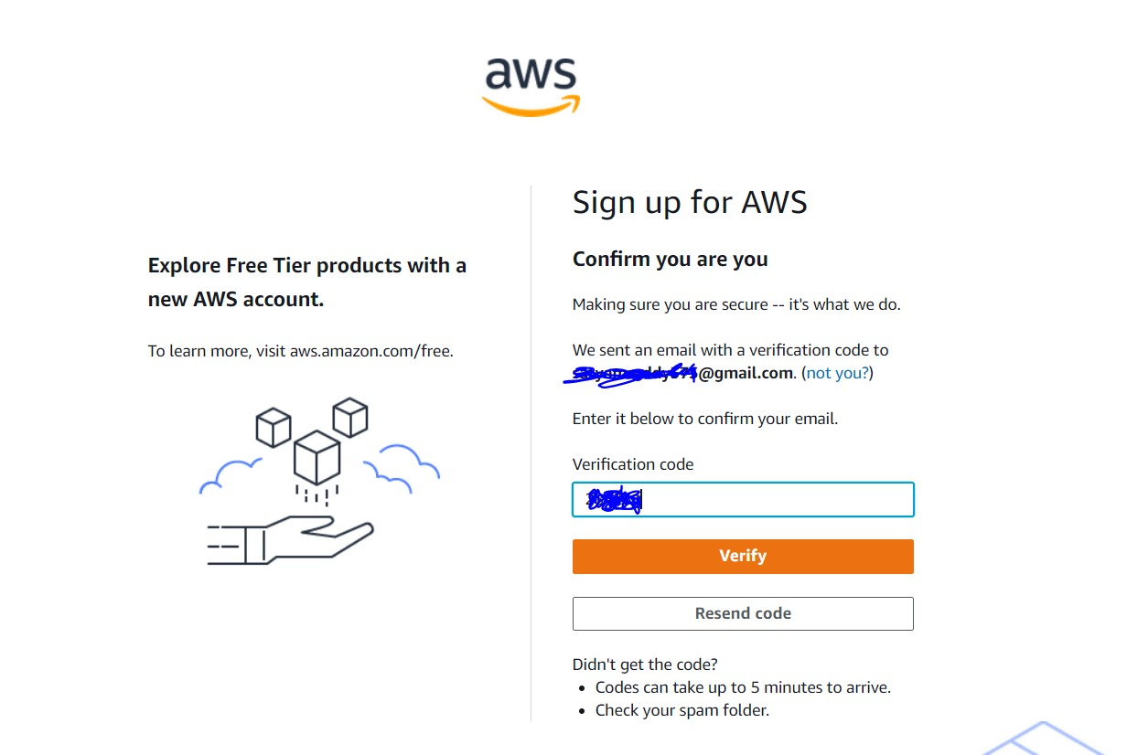

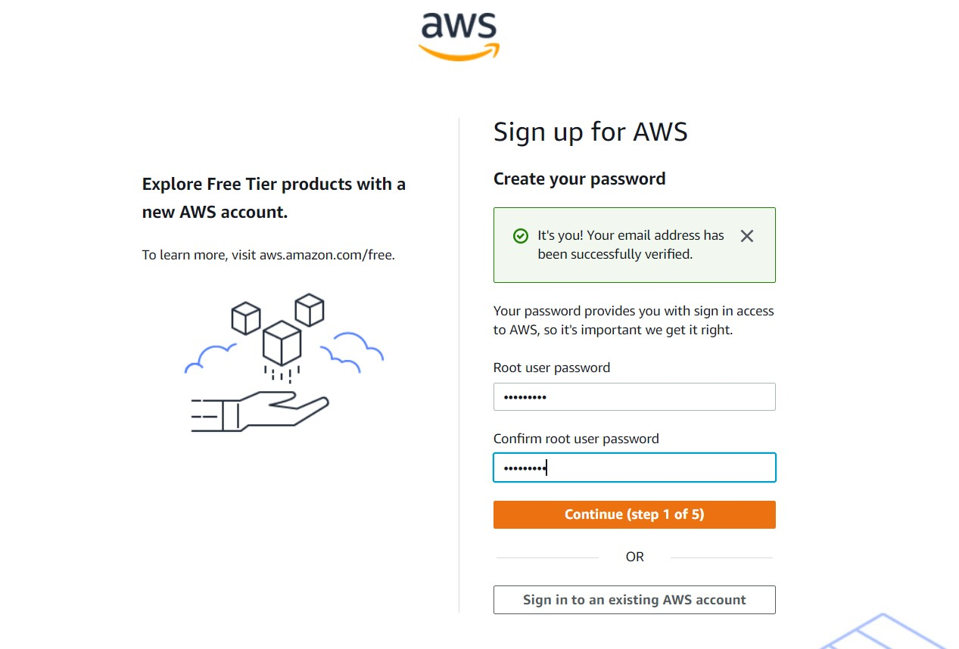

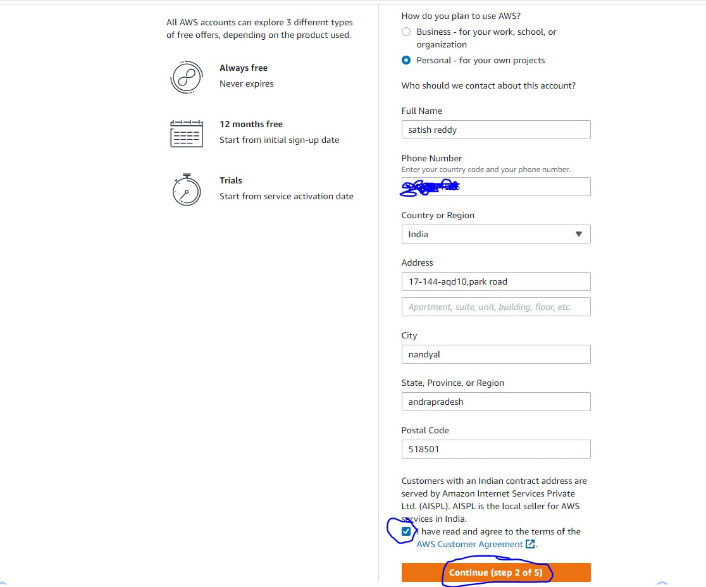

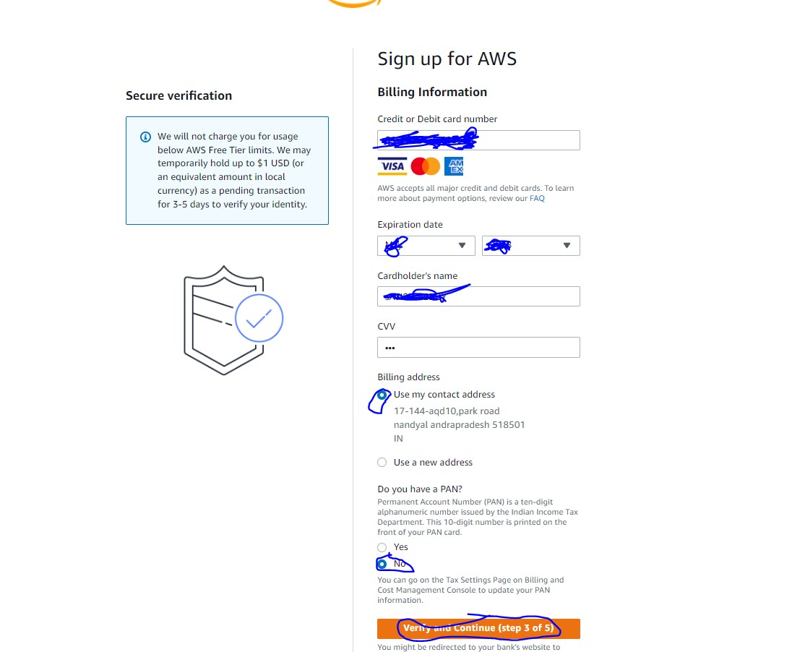

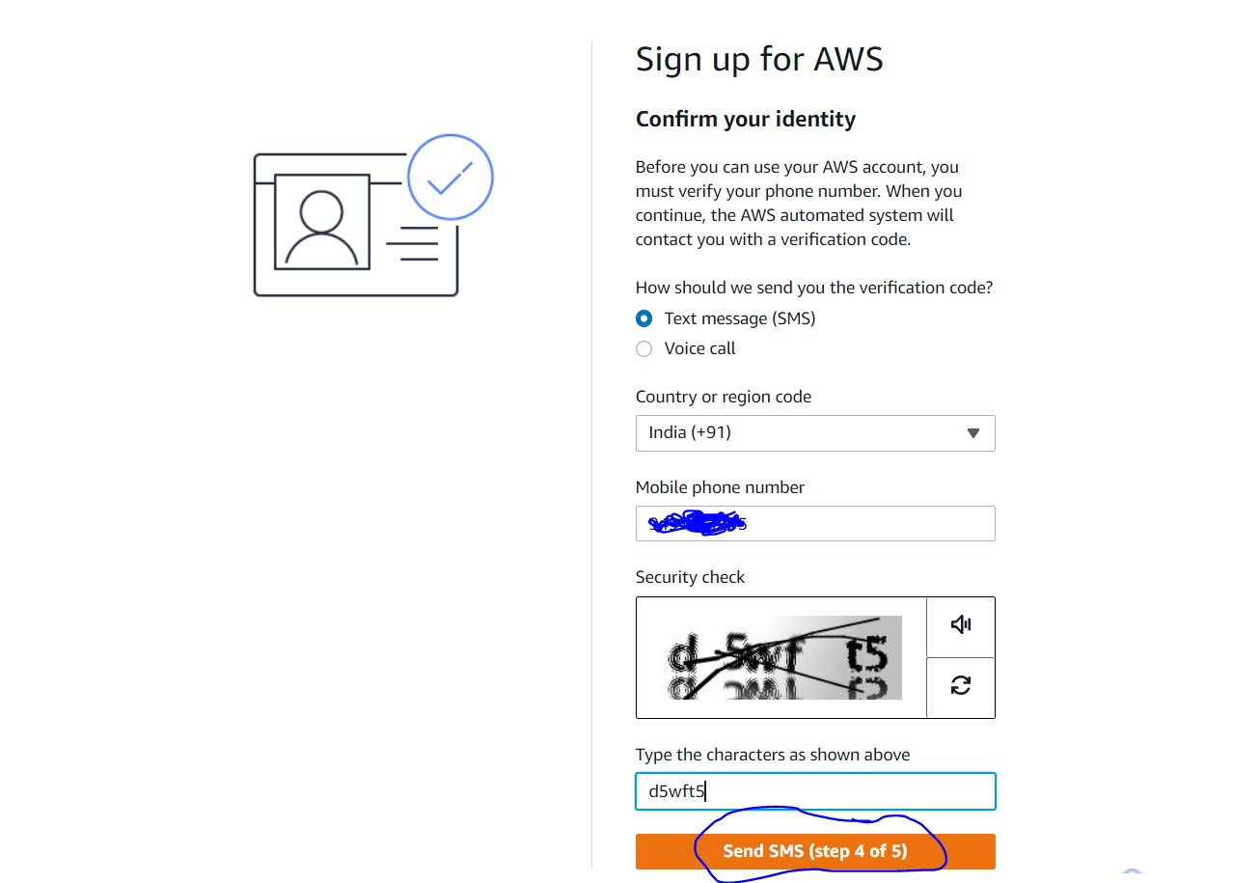

1. **DockerHub account:**

**Software’s to install:**

1. **MobaXterm or Putty**
2. **Gitbash**
3. **Any text editor, lets use Visual code studio:**